**A**

**PROJECT REPORT**

**ON**

**MOVIE BOOKING SYSTEM**

**Submitted**

**By**

Team Name BAG|

StartDate2019.05.16-End Date2019.05.22

**Rachel** (闫梦帆) R8J9400109

**Mina**  (平静怡) R8J9400122

**Allen** (刘子钰) R8J9400128

**Eternal** (柴煜昌) R8J9400114

**External Guide**





**PROJECT INDEX**

|  |  |  |
| --- | --- | --- |
| S no. | Particulars | Page no. |
| 1 | About the team information summary and technical support | 1 |
| 2 | About the project index | 2-3 |
| 3 | About the team description & overview | 4 |
| 4 | About the certificate | 5 |
| 5 | About the acknowledgment | 6 |
| 6 | About the hrms, s/w requirement, SDLC | 7-8 |
| 7 | About the modules:-  Login module  Browse module  Search module  Booking module  Payment and order module | 8-9 |
| 8 | Use case Diagram | 10 |
| 9 | DFD of Login Module | 11 |
| 10 | Development  Testing  Implementation&Maintenance | 12 |
| 11 | DFD of Payroll module | 12-13 |
| 12 | **Snapshots**  Login Module  Browse Module  Search Module  Booking Module  Payment and order Module | 14  15-16  17  17-18  18 |
| 13 | Source code of Login module  Login.java  Insert.java  Homepage11.java  Homepage22.java  Upcoming.java  Pika.java  Pika2.java  search.java  privateroom.java  Book1.java  seats.java  Total.java  Pay.java | 19-158 |

**TEAM DESCRIPTION & OVERVIEW**

Our team name is BAG because we are made of boys and girls. We have four members including two girls and two boys. The group leader is Rachel and She is mainly responsible for the planning of the whole project process, the design of part of the project interface and the completion of part of the report. Mina is the technical backbone of this project, responsible for most of the project interface and function realization, and also explore and overcome a variety of technical difficulties. Eternal was responsible for the compilation of a few projects and assisted Mina to complete the whole project. Allen is mainly responsible for the design of the project and making the PPT. Also, Allen and Rachel assist in the coding of the project and completing the final debugging.

The name of our project is movie booking system. Therefore, the project can make it convenient for users to buy tickets and improve their movie-watching experience. The project consists of five modules, namely login module, browse module, search module, reservation module, payment module and order module.

Our team has both boys and girls, so we can make up for each other's innate shortcomings, so that the whole team has a more tenacious vitality. Therefore, our team embodies the agile thinking, strong communication ability and teamwork ability, which promotes the completion of our project.

**CERTIFICATE**

This is to certify that this report,titled movie booking system,embodies the orginal work done by Rachel,Mina,Allen and Eternal in partial fulfillment of their course requirement at NIIT.

Instructor:Mr.Ashok

Coodinator:Mr.Delucia

**ACKNOWLEDGEMENT**

The success and achievements of the project are attributed to various efforts, such as the active cooperation and hard work of the team members, the careful guidance of the two teachers, the patient answers of other students, and the great support from the school.I would like to thank you for all your help and cooperation with the project and our work.

Mr.Ashok and Mr.Delucia, thank you for giving us the time and opportunity to make the project, as well as the support and guidance from all of us, which enabled me to complete the project on time.I am very grateful to the classmates who help us. They always take time out of their busy schedule to answer our questions.My heartfelt thanks to project members Mina,Allen and Eternal for their full cooperation in the whole project, especially for Mina's hard work of staying up all night, during which we had a heated discussion.We are grateful and lucky to get your continuous encouragement, support and guidance, which helped us successfully complete the project work.

At the same time, I would like to express my sincere respect to the project staff for their timely support.

Rachel

**PROJECT REPORT**

**MOVIE BOOKING SYSTEM**

With the continuous increase of the number and types of films, the continuous development of the film industry, and the increasingly difficult management of film studios, according to this realistic need, the design and production of a movie ticket booking system has become a very valuable work. The network booking system to the movie city management has the traditional management mode incomparable advantages, it by virtue of its information update speed, information storage, high security, simple application and other characteristics for the movie city has brought great convenience. With the continuous development of the film industry, people's requirements for the spiritual life are constantly improved, and the management system of the movie city will certainly play an increasingly important role in the development of the film industry.

**Software Requirements**

* NetBeans IDE 8.2
* MySQL Workbench 8.0

We need to input a large amount of film and television information and keep it up to date. At the same time, we also need to constantly update the number and location of movies. The realization of the movie ticket reservation system greatly facilitates the management of the movie city, and directly facilitates the customers from the purchase of tickets, thus greatly improving the viewing experience of customers.

**SDLC of the Project**

This project is based on JFrame, which is the object of the window on the screen. It can carry out a series of operations according to the functions provided by the project interface and the user's own needs. The sustainable development strategy review will be discussed in the following areas.

**Requirement Analysis**

* **The process of booking tickets in movie studios is too complicated, and there may be various problems in the process of purchasing tickets:** Booking in the cinema requires a long queue, poor user experience, may appear booking errors, user complaints, unnecessary contradictions between users and staff, and so on. Therefore, a system is needed to subtract the link of queuing for tickets in the cinema, and the booking can be completed on the mobile terminal.
* **For movie studios, the input of economic cost, work efficiency and service quality are also very important:** The use of this system can reduce the labor input of the movie city in the booking process, and better focus on improving the viewing experience of users, which is also conducive to improving the popularity of the movie city and increasing the revenue.
* **It is not convenient for movie-watching users to check film and television information and book tickets in the movie city:** the online booking system can make it convenient for users to check the time and times of movies anytime and anywhere, and make reservations according to their own schedule. The film and television information can be widely circulated to enhance the information liquidity.
* **Users can choose private cinemas according to their own needs for a more comfortable viewing experience:** We set up private movie theaters, which users can choose to enter, search for the movies they want to see, and then reserve them for use throughout the day.

**Software Design**

The software will be designed according to the various modules required to full fill all the requirements uncovered in our requirements analysis. The whole system can be divided into a number of modules. The following modules can be recognized in our project:

* Login module
* Browse module
* Search module
* Booking module
* Payment and order module

**Login module**

This module ensures that all users accessing the system are authenticated. All links and navigation paths can be used for other operations only after the authorized person enters a valid set of user ids and passwords. Therefore, this module ACTS as an entry point to the system and can only be accessed by authorized personnel. Users who do not have an account will be authorized through registration, thus logging into the system. Users can also change their passwords as they wish.

**Browse module**

This module aims to provide movie and television information for movie city users. In this module, we are divided into two parts: the hot movie and the upcoming movie. We provide a large number of film information, placement posters, including film profiles.

**Search module**

This module is aimed at users who choose the function of private cinema. Users can search the provided movie and select what they want to see, and then click the preorder button.

**Booking module**

* Private cinema

Users can choose to enter the private cinema according to their own needs, which is divided into four, eight and twelve, which can enjoy a more high-end experience.

* public theater

This module is designed to provide usage options for authorized users. Moviegoers will select according to the film and television information provided by us, enter into the predetermined interface, and start to select the viewing time, time and drinks. Then the seat selection system is entered, and the user will select the seat according to the comments on the screen.

**Payment and order module**

In this module, we are mainly used to pay and view orders. After the user selects the movie venue and seat according to his/her own situation, the payment interface will appear. After the user enters the user name and password, the order will appear in the form, including the movie name, viewing time, seat information and order number.

**Database Design**

|  |  |  |  |  |
| --- | --- | --- | --- | --- |
| Bookinguser | | | | |
| **Field Name** | **Data Type** | **Size** | **Primary Key** | **Null** |
| UserName | Varchar | 20 | Y | N |
| mpnumber | Varchar | 11 |  |  |
| Email | Varchar | 20 |  |  |
| Userpw1 | Varchar | 20 |  |  |
| Paypw1 | Varchar | 20 |  |  |

|  |  |  |  |  |
| --- | --- | --- | --- | --- |
| Information | | | | |
| **Field Name** | **Data Type** | **Size** | **Primary Key** | **Null** |
| moviename | Varchar | 30 |  |  |
| moviedate | Varchar | 20 |  |  |
| movietime | Varchar | 10 |  |  |
| movietype | Varchar | 10 |  |  |
| drink | Varchar | 20 |  |  |
| seats | Varchar | 50 |  |  |
| total | Varchar | 10 |  |  |
| ordernumber | Varchar | 30 |  |  |
| ordertime | Varchar | 30 |  |  |

|  |  |  |  |  |
| --- | --- | --- | --- | --- |
| Movies | | | | |
| **Field Name** | **Data Type** | **Size** | **Primary Key** | **Null** |
| moviename | Varchar | 30 |  |  |
| movietime | Varchar | 10 |  |  |
| mark | Varchar | 05 |  |  |
| price | Varchar | 05 |  |  |

**Use Case diagram**

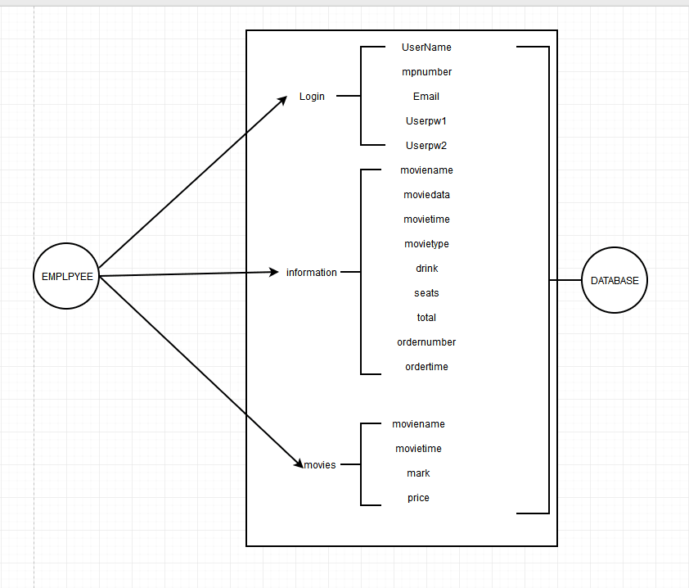

**DFD of Login module**

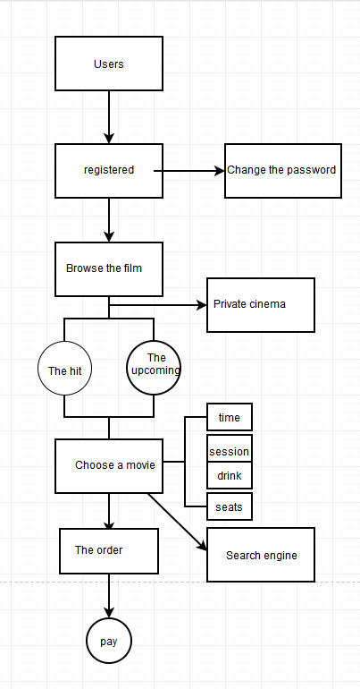

**Development**

After designing the structure of all modules and database, we simply used the combination of Java and MySQL to save data into the database, and Java used some methods to complete the corresponding operation.

**Testing**

**Login password failed**

After entering the wrong user name and password, you will be prompted with an error. You cannot log in. Only when the user name and password are completely correct, you can log in the movie booking system.

**At the time of registration**

The registered mobile phone number should be no more than 11 digits, and the email address should be no more than 12 digits, and the format of registered email address must meet the requirements.

**Select module debugging**

When selecting seats, moviegoers can choose their favorite seats according to their own needs, and they can also make changes. The selected seats cannot be changed after payment is confirmed.

**Payment password error**

After the movie-going user selects the movie and seats, he/she needs to enter the user name and payment password for payment. If the input is wrong, the payment cannot be made.

**Implementation and Maintenance**

The implementation of the product includes user manual input and click, including user registration, login, movie selection, show selection, seat selection, payment steps. The product database records the user's information, and the final order is tabulated. If there is any problem, we will timely update and maintain our products according to user feedback.

**DEVELOPING A LOGIN MODULE**

The development of this module includes the login interface and the new user registration interface. New users need to input their user name, password, mobile phone number and email address for registration. After successful registration, enter the user name and password in the login interface for login and subsequent operations.

The development of this module includes writing code for the following files

* **Login.java**
* **Insert.java**

**MOVIE INFORMATION MODULE**

The film and television information interface of the product will be updated and modified in a timely manner according to the release information of the films on the current timeline and in the partner cinemas. In this interface, users will be provided with the positioning and introduction of actors, directors and films of the film, which is convenient for users to select and choose.

The development of this module includes writing code for the following files

* **Homepage11.java**
* **Homepage22.java**
* **Upcoming.java**
* **Pika.java**
* **Pika2.java**

**SELECT AND PAYMENT MODULE**

We provide users with a variety of time, seat and beverage options. After the user confirms the choice, they enter the payment interface, enter the user name and password to make payment. Then we will randomly generate the order number and present the relevant order information in the form of a form.

The development of this module includes writing code for the following files

* **search.java**
* **privateroom.java**
* **Book1.java**
* **seats.java**
* **Total.java**
* **Pay.java**

|  |  |  |  |  |
| --- | --- | --- | --- | --- |
| **Work Done By** | **Work task** | **Starting Date** | **Ending Date** | **Duration(day)** |
| Rachel+Allen | Report Wring | 18May 08 | 23May 08 | 05 |
| Mina | Programing | 09May08 | 16May 20 | 07 |
| Mina+Rachel | Design | 07May09 | 11June08 | 02 |
| Eternal + Allen | Testing | 16May08 | 18 June08 | 02 |
|  |  |  |  | Total Day = 16 |

**Login module**

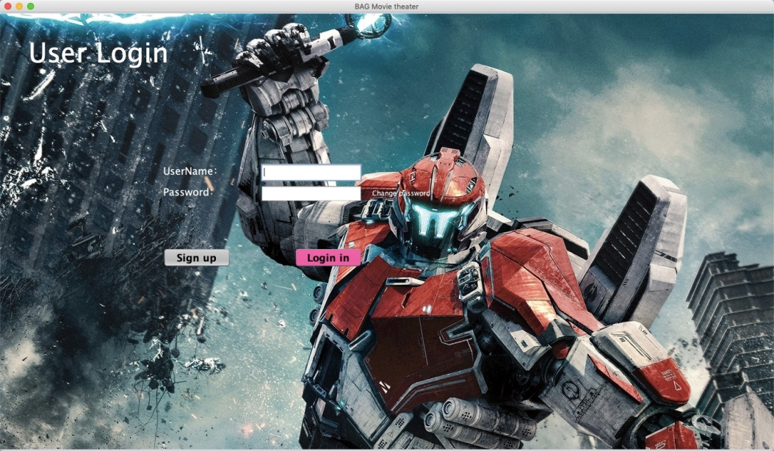

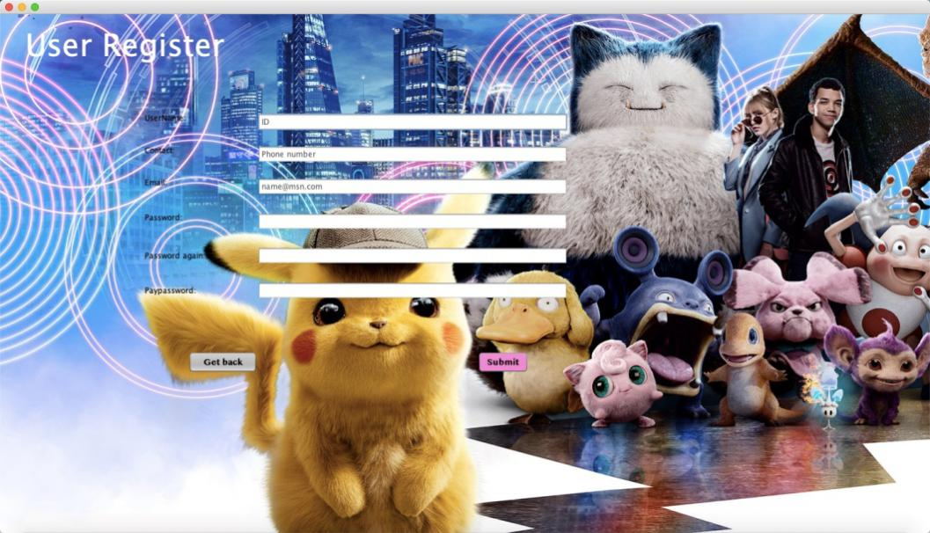

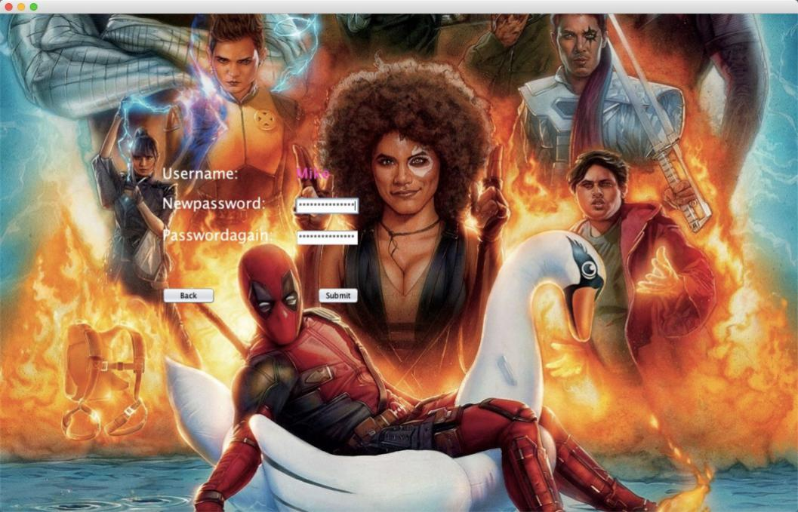

**Browse module**

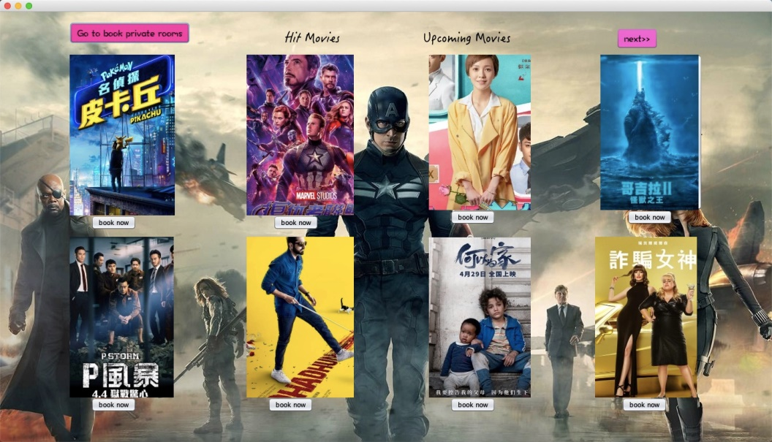

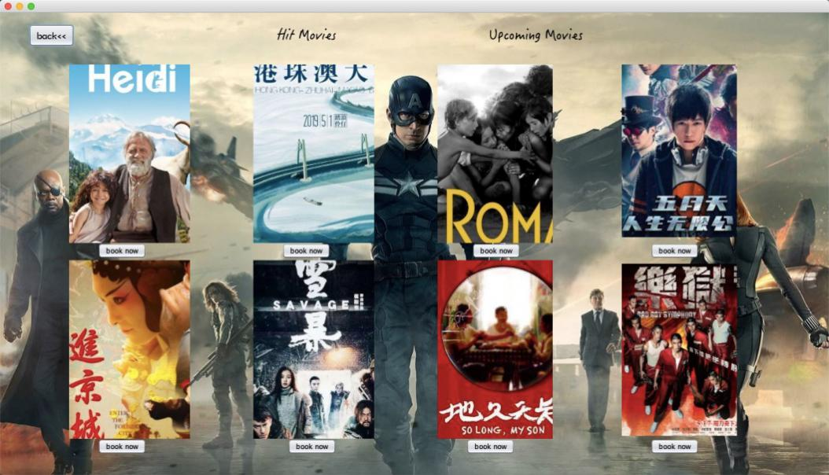

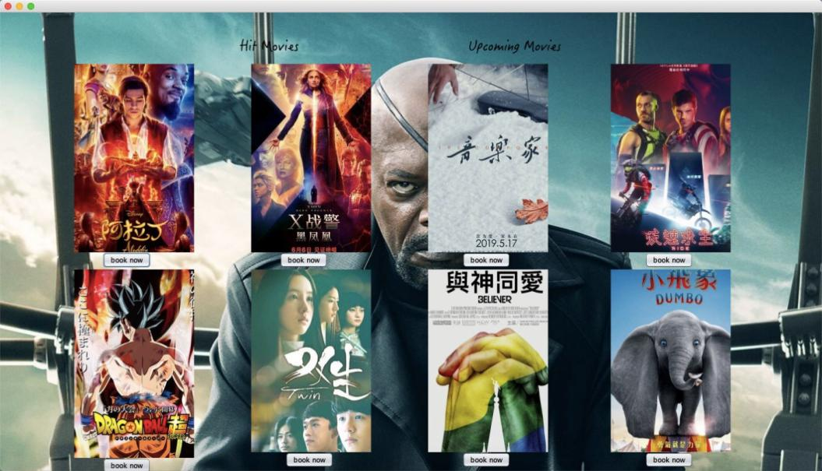

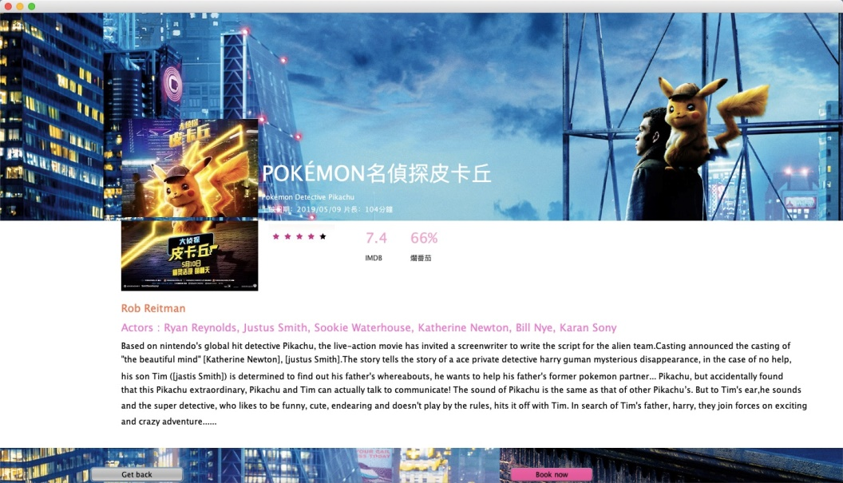

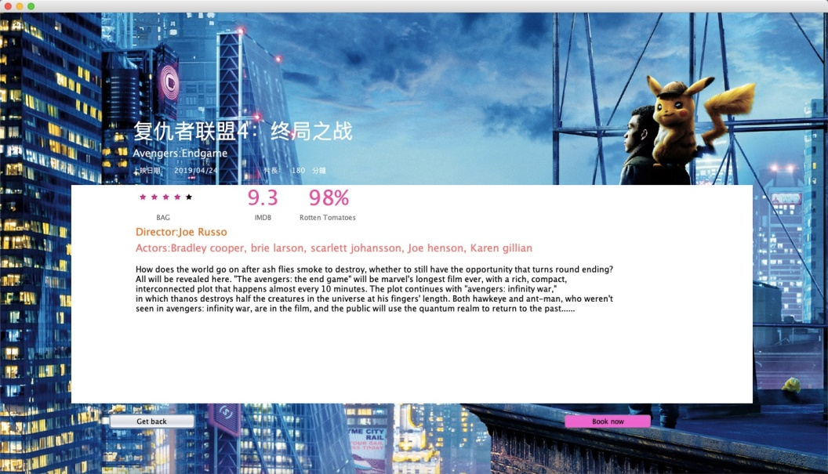

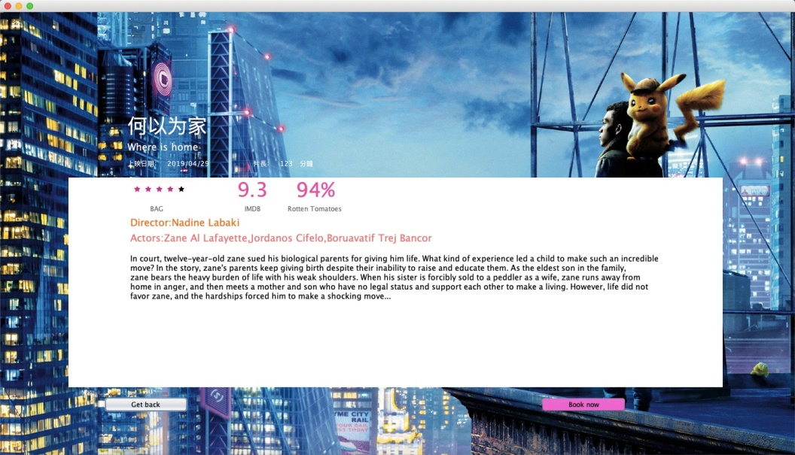

**Search module**

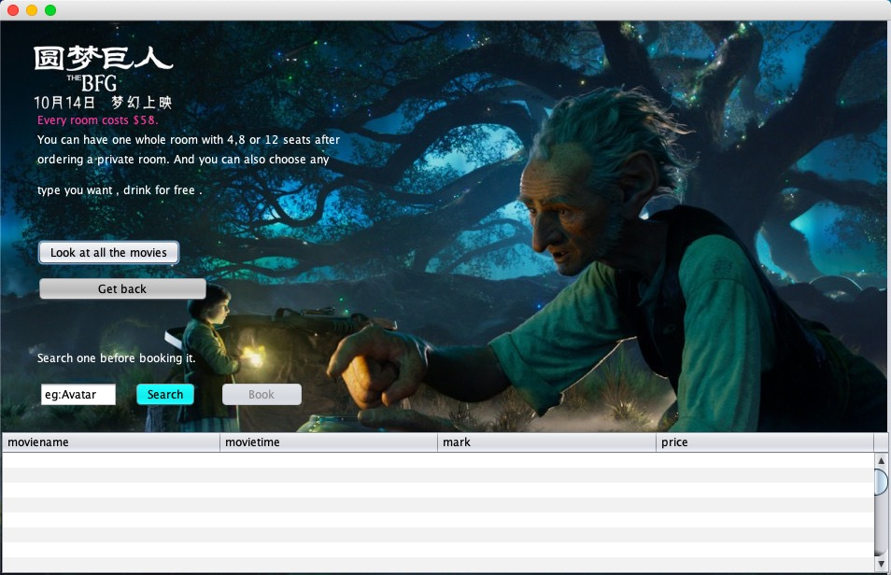

**Booking module**

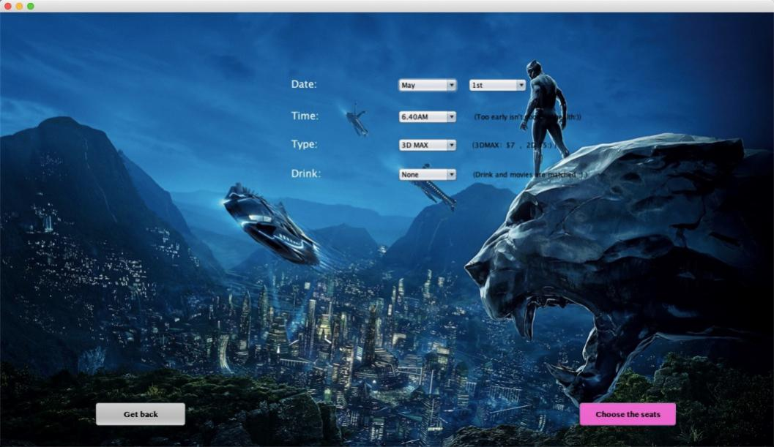

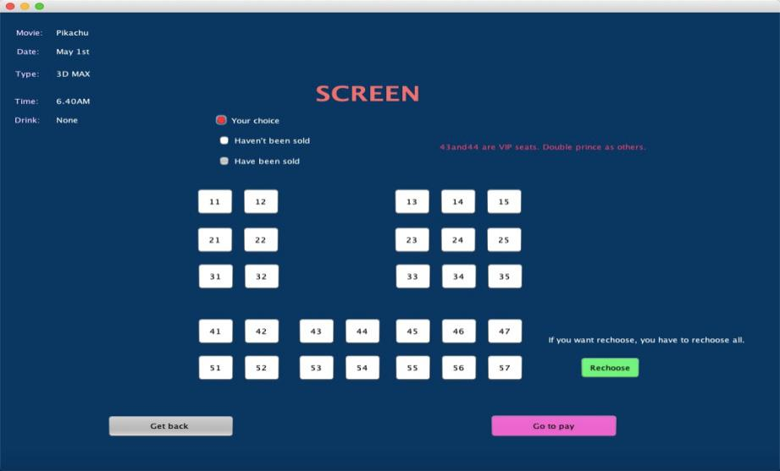

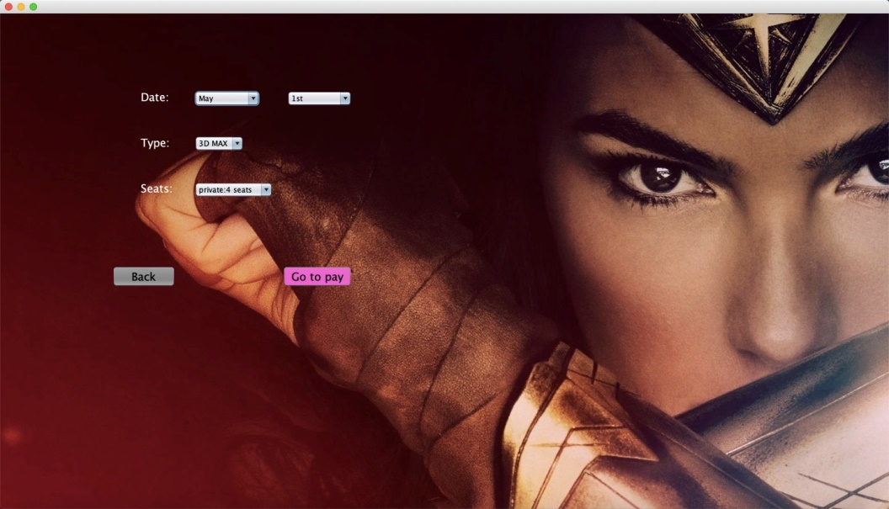

**Payment and order module**

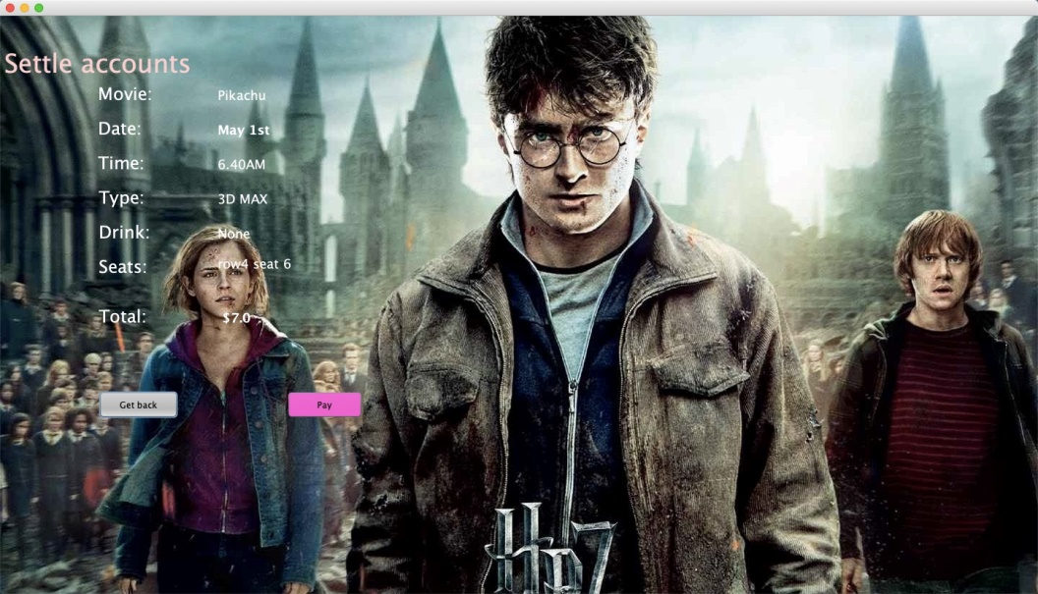

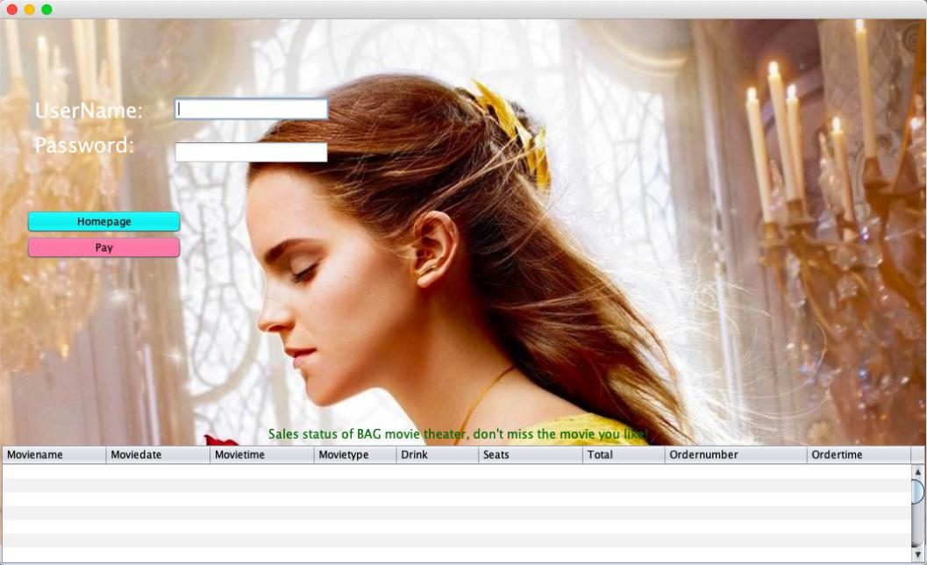

**Code of Login.java**

package moviebooking;

import java.awt.HeadlessException;

import java.io.IOException;

import java.sql.*;

import javax.swing.JOptionPane;

public class login extends javax.swing.JFrame {

public login() {

initComponents();

}

@SuppressWarnings("unchecked")

private void initComponents() {

java.awt.GridBagConstraints gridBagConstraints;

jPanel1 = new javax.swing.JPanel();

jLabel2 = new javax.swing.JLabel();

jLabel3 = new javax.swing.JLabel();

t1 = new javax.swing.JTextField();

p1 = new javax.swing.JPasswordField();

jButton1 = new javax.swing.JButton();

jButton2 = new javax.swing.JButton();

jLabel4 = new javax.swing.JLabel();

jLabel5 = new javax.swing.JLabel();

jLabel1 = new javax.swing.JLabel();

setDefaultCloseOperation(javax.swing.WindowConstants.EXIT_ON_CLOSE);

setTitle("BAG Movie theater");

getContentPane().setLayout(new java.awt.GridBagLayout());

jPanel1.setOpaque(false);

jLabel2.setFont(new java.awt.Font("Lucida Grande", 0, 18)); // NOI18N

jLabel2.setForeground(new java.awt.Color(255, 255, 255));

jLabel2.setText("UserName：");

jLabel3.setFont(new java.awt.Font("Lucida Grande", 0, 18)); // NOI18N

jLabel3.setForeground(new java.awt.Color(255, 255, 255));

jLabel3.setText("Password：");

jButton1.setBackground(new java.awt.Color(255, 51, 153));

jButton1.setFont(new java.awt.Font("Lucida Grande", 1, 18)); // NOI18N

jButton1.setText("Login in");

jButton1.addMouseListener(new java.awt.event.MouseAdapter() {

public void mouseClicked(java.awt.event.MouseEvent evt) {

jButton1MouseClicked(evt);

}

});

jButton1.addActionListener(new java.awt.event.ActionListener() {

public void actionPerformed(java.awt.event.ActionEvent evt) {

jButton1ActionPerformed(evt);

}

});

jButton2.setBackground(new java.awt.Color(153, 153, 153));

jButton2.setFont(new java.awt.Font("Lucida Grande", 1, 18)); // NOI18N

jButton2.setText("Sign up");

jButton2.addActionListener(new java.awt.event.ActionListener() {

public void actionPerformed(java.awt.event.ActionEvent evt) {

jButton2ActionPerformed(evt);

}

});

jLabel4.setFont(new java.awt.Font("Lucida Grande", 0, 48)); // NOI18N

jLabel4.setForeground(new java.awt.Color(255, 255, 255));

jLabel4.setText("User Login");

jLabel5.setForeground(new java.awt.Color(255, 255, 255));

jLabel5.setText("Change password");

jLabel5.addMouseListener(new java.awt.event.MouseAdapter() {

public void mouseClicked(java.awt.event.MouseEvent evt) {

jLabel5MouseClicked(evt);

}

});

javax.swing.GroupLayout jPanel1Layout = new javax.swing.GroupLayout(jPanel1);

jPanel1.setLayout(jPanel1Layout);

jPanel1Layout.setHorizontalGroup(

jPanel1Layout.createParallelGroup(javax.swing.GroupLayout.Alignment.LEADING)

.addGroup(jPanel1Layout.createSequentialGroup()

.addGroup(jPanel1Layout.createParallelGroup(javax.swing.GroupLayout.Alignment.LEADING)

.addGroup(jPanel1Layout.createSequentialGroup()

.addGap(288, 288, 288)

.addGroup(jPanel1Layout.createParallelGroup(javax.swing.GroupLayout.Alignment.LEADING, false)

.addGroup(jPanel1Layout.createSequentialGroup()

.addGroup(jPanel1Layout.createParallelGroup(javax.swing.GroupLayout.Alignment.LEADING)

.addComponent(jLabel2)

.addComponent(jLabel3, javax.swing.GroupLayout.PREFERRED_SIZE, 151, javax.swing.GroupLayout.PREFERRED_SIZE))

.addGap(21, 21, 21)

.addGroup(jPanel1Layout.createParallelGroup(javax.swing.GroupLayout.Alignment.LEADING)

.addComponent(p1, javax.swing.GroupLayout.PREFERRED_SIZE, 179, javax.swing.GroupLayout.PREFERRED_SIZE)

.addComponent(t1, javax.swing.GroupLayout.PREFERRED_SIZE, 179, javax.swing.GroupLayout.PREFERRED_SIZE)))

.addGroup(jPanel1Layout.createSequentialGroup()

.addComponent(jButton2, javax.swing.GroupLayout.PREFERRED_SIZE, 119, javax.swing.GroupLayout.PREFERRED_SIZE)

.addPreferredGap(javax.swing.LayoutStyle.ComponentPlacement.RELATED, javax.swing.GroupLayout.DEFAULT_SIZE, Short.MAX_VALUE)

.addComponent(jButton1, javax.swing.GroupLayout.PREFERRED_SIZE, 119, javax.swing.GroupLayout.PREFERRED_SIZE)))

.addGap(18, 18, 18)

.addComponent(jLabel5))

.addGroup(jPanel1Layout.createSequentialGroup()

.addGap(50, 50, 50)

.addComponent(jLabel4)))

.addContainerGap(598, Short.MAX_VALUE))

);

jPanel1Layout.setVerticalGroup(

jPanel1Layout.createParallelGroup(javax.swing.GroupLayout.Alignment.LEADING)

.addGroup(jPanel1Layout.createSequentialGroup()

.addGap(41, 41, 41)

.addComponent(jLabel4)

.addGap(163, 163, 163)

.addGroup(jPanel1Layout.createParallelGroup(javax.swing.GroupLayout.Alignment.BASELINE)

.addComponent(t1, javax.swing.GroupLayout.PREFERRED_SIZE, 32, javax.swing.GroupLayout.PREFERRED_SIZE)

.addComponent(jLabel2, javax.swing.GroupLayout.PREFERRED_SIZE, 34, javax.swing.GroupLayout.PREFERRED_SIZE))

.addPreferredGap(javax.swing.LayoutStyle.ComponentPlacement.RELATED)

.addGroup(jPanel1Layout.createParallelGroup(javax.swing.GroupLayout.Alignment.BASELINE)

.addComponent(p1, javax.swing.GroupLayout.PREFERRED_SIZE, 30, javax.swing.GroupLayout.PREFERRED_SIZE)

.addComponent(jLabel3)

.addComponent(jLabel5))

.addGap(81, 81, 81)

.addGroup(jPanel1Layout.createParallelGroup(javax.swing.GroupLayout.Alignment.BASELINE)

.addComponent(jButton2)

.addComponent(jButton1))

.addContainerGap(324, Short.MAX_VALUE))

);

gridBagConstraints = new java.awt.GridBagConstraints();

gridBagConstraints.gridx = 1;

gridBagConstraints.gridy = 1;

gridBagConstraints.fill = java.awt.GridBagConstraints.BOTH;

getContentPane().add(jPanel1, gridBagConstraints);

jLabel1.setIcon(new javax.swing.ImageIcon(getClass().getResource("/pic/t.jpg"))); // NOI18N

gridBagConstraints = new java.awt.GridBagConstraints();

gridBagConstraints.gridx = 1;

gridBagConstraints.gridy = 1;

gridBagConstraints.fill = java.awt.GridBagConstraints.BOTH;

getContentPane().add(jLabel1, gridBagConstraints);

pack();

}// </editor-fold>

private void jButton1MouseClicked(java.awt.event.MouseEvent evt) {

PreparedStatement pst = null;

ResultSet rs = null;

Connection con = null;

try {

DriverManager.getConnection("jdbc:mysql://localhost:3306:/LoginDB?useSSL=false","root", "jing.,18x");

con = DB.getConnection();

String sql = "select * from bookinguser where UserName=? and Userpw1=?";

pst = con.prepareStatement(sql);

pst.setString(1, t1.getText());

pst.setString(2, p1.getText());

rs = pst.executeQuery();

if (t1.getText().length() == 0) {

JOptionPane.showMessageDialog(this, "Empty User Name", "Warning", JOptionPane.WARNING_MESSAGE);

} else if (p1.getPassword().length == 0) {

JOptionPane.showMessageDialog(this, "Empty Password", "Warning", JOptionPane.WARNING_MESSAGE);

} else if (rs.next()) {

String username = t1.getText();

Homepage11 s;

s = new Homepage11();

s.setLocationRelativeTo(null);

s.setVisible(true);

dispose();

} else {

JOptionPane.showMessageDialog(this, "Incorrect User Name or Password", "Error", JOptionPane.ERROR_MESSAGE);

}

} catch (HeadlessException | IOException | SQLException e) {

JOptionPane.showMessageDialog(this, e);

e.printStackTrace();

}

}

private void jButton1ActionPerformed(java.awt.event.ActionEvent evt) {

}

private void jButton2ActionPerformed(java.awt.event.ActionEvent evt) {

insert a = new insert();

a.pack();

a.setLocationRelativeTo(null);

a.setVisible(true);

}

private void jLabel5MouseClicked(java.awt.event.MouseEvent evt) {

PreparedStatement pst = null;

ResultSet rs = null;

Connection con = null;

try {

DriverManager.getConnection("jdbc:mysql://localhost:3306:/LoginDB?useSSL=false","root", "jing.,18x");

con = DB.getConnection();

String sql = "select * from bookinguser where UserName=? and Userpw1=?";

pst = con.prepareStatement(sql);

pst.setString(1, t1.getText());

pst.setString(2, p1.getText());

rs = pst.executeQuery();

if (t1.getText().length() == 0) {

JOptionPane.showMessageDialog(this, "Empty User Name", "Warning", JOptionPane.WARNING_MESSAGE);

} else if (p1.getPassword().length == 0) {

JOptionPane.showMessageDialog(this, "Empty Password", "Warning", JOptionPane.WARNING_MESSAGE);

} else if (rs.next()) {

String username = t1.getText();

change a = new change(t1.getText());

a.setLocationRelativeTo(null);

a.setVisible(true);

dispose();

} else {

JOptionPane.showMessageDialog(this, "Incorrect User Name or Password", "Error", JOptionPane.ERROR_MESSAGE);

}

} catch (HeadlessException | IOException | SQLException e) {

JOptionPane.showMessageDialog(this, e);

e.printStackTrace();

}

}

public static void main(String args[]) {

try {

for (javax.swing.UIManager.LookAndFeelInfo info : javax.swing.UIManager.getInstalledLookAndFeels()) {

if ("Nimbus".equals(info.getName())) {

javax.swing.UIManager.setLookAndFeel(info.getClassName());

break;

}

}

} catch (ClassNotFoundException | InstantiationException | IllegalAccessException | javax.swing.UnsupportedLookAndFeelException ex) {

java.util.logging.Logger.getLogger(login.class.getName()).log(java.util.logging.Level.SEVERE, null, ex);

}

java.awt.EventQueue.invokeLater(() -> {

login a=new login();

a.setLocationRelativeTo(null);

a.setVisible(true);

});

}

private javax.swing.JButton jButton1;

private javax.swing.JButton jButton2;

private javax.swing.JLabel jLabel1;

private javax.swing.JLabel jLabel2;

private javax.swing.JLabel jLabel3;

private javax.swing.JLabel jLabel4;

private javax.swing.JLabel jLabel5;

private javax.swing.JPanel jPanel1;

private javax.swing.JPasswordField p1;

private javax.swing.JTextField t1;

}

**Code of insert.java**

package moviebooking;

import java.awt.HeadlessException;

import java.io.IOException;

import java.sql.Connection;

import java.sql.PreparedStatement;

import java.sql.ResultSet;

import java.sql.SQLException;

import java.util.logging.Level;

import java.util.logging.Logger;

import java.util.regex.Matcher;

import java.util.regex.Pattern;

import javax.swing.*;

public class insert extends javax.swing.JFrame {

JFrame jf,jf2;

JPanel jp,jp2;

JLabel l1,l2;

public insert() {

initComponents();

}

private void initComponents() {

java.awt.GridBagConstraints gridBagConstraints;

jPanel1 = new javax.swing.JPanel();

jLabel2 = new javax.swing.JLabel();

jLabel3 = new javax.swing.JLabel();

U1 = new javax.swing.JTextField();

jLabel4 = new javax.swing.JLabel();

jLabel5 = new javax.swing.JLabel();

jLabel6 = new javax.swing.JLabel();

jLabel7 = new javax.swing.JLabel();

C1 = new javax.swing.JTextField();

E1 = new javax.swing.JTextField();

P1 = new javax.swing.JPasswordField();

Pa1 = new javax.swing.JPasswordField();

jButton1 = new javax.swing.JButton();

jButton2 = new javax.swing.JButton();

jLabel8 = new javax.swing.JLabel();

Pp1 = new javax.swing.JPasswordField();

jLabel1 = new javax.swing.JLabel();

setDefaultCloseOperation(javax.swing.WindowConstants.EXIT_ON_CLOSE);

getContentPane().setLayout(new java.awt.GridBagLayout());

jPanel1.setOpaque(false);

jLabel2.setFont(new java.awt.Font("Lucida Grande", 0, 48)); // NOI18N

jLabel2.setForeground(new java.awt.Color(255, 255, 255));

jLabel2.setText("User Register");

jLabel3.setText("UserName:");

U1.setForeground(new java.awt.Color(102, 102, 102));

U1.setText("ID");

jLabel4.setText("Contact:");

jLabel5.setText("Email:");

jLabel6.setText("Password:");

jLabel7.setText("Password again:");

C1.setForeground(new java.awt.Color(102, 102, 102));

C1.setText("Phone number");

C1.addActionListener(new java.awt.event.ActionListener() {

public void actionPerformed(java.awt.event.ActionEvent evt) {

C1ActionPerformed(evt);

}

});

E1.setForeground(new java.awt.Color(102, 102, 102));

E1.setText("name@msn.com");

P1.addActionListener(new java.awt.event.ActionListener() {

public void actionPerformed(java.awt.event.ActionEvent evt) {

P1ActionPerformed(evt);

}

});

jButton1.setBackground(new java.awt.Color(153, 153, 153));

jButton1.setFont(new java.awt.Font("Malayalam MN", 1, 14)); // NOI18N

jButton1.setText("Get back");

jButton1.addActionListener(new java.awt.event.ActionListener() {

public void actionPerformed(java.awt.event.ActionEvent evt) {

jButton1ActionPerformed(evt);

}

});

jButton2.setBackground(new java.awt.Color(255, 102, 204));

jButton2.setFont(new java.awt.Font("Malayalam MN", 1, 14)); // NOI18N

jButton2.setText("Submit");

jButton2.addActionListener(new java.awt.event.ActionListener() {

public void actionPerformed(java.awt.event.ActionEvent evt) {

jButton2ActionPerformed(evt);

}

});

jLabel8.setText("Paypassword:");

javax.swing.GroupLayout jPanel1Layout = new javax.swing.GroupLayout(jPanel1);

jPanel1.setLayout(jPanel1Layout);

jPanel1Layout.setHorizontalGroup(

jPanel1Layout.createParallelGroup(javax.swing.GroupLayout.Alignment.LEADING)

.addGroup(jPanel1Layout.createSequentialGroup()

.addGroup(jPanel1Layout.createParallelGroup(javax.swing.GroupLayout.Alignment.LEADING)

.addGroup(jPanel1Layout.createSequentialGroup()

.addGap(224, 224, 224)

.addGroup(jPanel1Layout.createParallelGroup(javax.swing.GroupLayout.Alignment.LEADING)

.addComponent(jLabel3)

.addComponent(jLabel4)

.addComponent(jLabel5)

.addComponent(jLabel6)

.addComponent(jLabel7)

.addComponent(jLabel8))

.addGap(81, 81, 81)

.addGroup(jPanel1Layout.createParallelGroup(javax.swing.GroupLayout.Alignment.TRAILING, false)

.addComponent(Pa1, javax.swing.GroupLayout.Alignment.LEADING)

.addComponent(P1, javax.swing.GroupLayout.Alignment.LEADING)

.addComponent(E1, javax.swing.GroupLayout.Alignment.LEADING, javax.swing.GroupLayout.DEFAULT_SIZE, 480, Short.MAX_VALUE)

.addComponent(C1, javax.swing.GroupLayout.Alignment.LEADING)

.addComponent(U1, javax.swing.GroupLayout.Alignment.LEADING)

.addComponent(Pp1)))

.addGroup(jPanel1Layout.createSequentialGroup()

.addGap(39, 39, 39)

.addComponent(jLabel2))

.addGroup(jPanel1Layout.createSequentialGroup()

.addGap(292, 292, 292)

.addComponent(jButton1, javax.swing.GroupLayout.PREFERRED_SIZE, 106, javax.swing.GroupLayout.PREFERRED_SIZE)

.addGap(342, 342, 342)

.addComponent(jButton2)))

.addContainerGap(1034, Short.MAX_VALUE))

);

jPanel1Layout.setVerticalGroup(

jPanel1Layout.createParallelGroup(javax.swing.GroupLayout.Alignment.LEADING)

.addGroup(jPanel1Layout.createSequentialGroup()

.addGap(18, 18, 18)

.addComponent(jLabel2)

.addGap(77, 77, 77)

.addGroup(jPanel1Layout.createParallelGroup(javax.swing.GroupLayout.Alignment.LEADING)

.addComponent(jLabel3)

.addComponent(U1, javax.swing.GroupLayout.PREFERRED_SIZE, javax.swing.GroupLayout.DEFAULT_SIZE, javax.swing.GroupLayout.PREFERRED_SIZE))

.addGap(23, 23, 23)

.addGroup(jPanel1Layout.createParallelGroup(javax.swing.GroupLayout.Alignment.LEADING)

.addComponent(jLabel4)

.addComponent(C1, javax.swing.GroupLayout.PREFERRED_SIZE, javax.swing.GroupLayout.DEFAULT_SIZE, javax.swing.GroupLayout.PREFERRED_SIZE))

.addGap(23, 23, 23)

.addGroup(jPanel1Layout.createParallelGroup(javax.swing.GroupLayout.Alignment.LEADING)

.addComponent(jLabel5)

.addComponent(E1, javax.swing.GroupLayout.PREFERRED_SIZE, javax.swing.GroupLayout.DEFAULT_SIZE, javax.swing.GroupLayout.PREFERRED_SIZE))

.addGap(27, 27, 27)

.addGroup(jPanel1Layout.createParallelGroup(javax.swing.GroupLayout.Alignment.LEADING)

.addComponent(jLabel6)

.addComponent(P1, javax.swing.GroupLayout.PREFERRED_SIZE, javax.swing.GroupLayout.DEFAULT_SIZE, javax.swing.GroupLayout.PREFERRED_SIZE))

.addGap(26, 26, 26)

.addGroup(jPanel1Layout.createParallelGroup(javax.swing.GroupLayout.Alignment.BASELINE)

.addComponent(jLabel7)

.addComponent(Pa1, javax.swing.GroupLayout.PREFERRED_SIZE, javax.swing.GroupLayout.DEFAULT_SIZE, javax.swing.GroupLayout.PREFERRED_SIZE))

.addGap(27, 27, 27)

.addGroup(jPanel1Layout.createParallelGroup(javax.swing.GroupLayout.Alignment.BASELINE)

.addComponent(jLabel8)

.addComponent(Pp1, javax.swing.GroupLayout.PREFERRED_SIZE, javax.swing.GroupLayout.DEFAULT_SIZE, javax.swing.GroupLayout.PREFERRED_SIZE))

.addGap(81, 81, 81)

.addGroup(jPanel1Layout.createParallelGroup(javax.swing.GroupLayout.Alignment.BASELINE)

.addComponent(jButton1)

.addComponent(jButton2))

.addContainerGap(535, Short.MAX_VALUE))

);

gridBagConstraints = new java.awt.GridBagConstraints();

gridBagConstraints.gridx = 1;

gridBagConstraints.gridy = 1;

gridBagConstraints.fill = java.awt.GridBagConstraints.BOTH;

getContentPane().add(jPanel1, gridBagConstraints);

jLabel1.setIcon(new javax.swing.ImageIcon(getClass().getResource("/pic/insert.jpg"))); // NOI18N

gridBagConstraints = new java.awt.GridBagConstraints();

gridBagConstraints.gridx = 1;

gridBagConstraints.gridy = 1;

gridBagConstraints.fill = java.awt.GridBagConstraints.BOTH;

getContentPane().add(jLabel1, gridBagConstraints);

pack();

}// </editor-fold>

private void C1ActionPerformed(java.awt.event.ActionEvent evt) {

}

private void P1ActionPerformed(java.awt.event.ActionEvent evt) {

}

private void jButton2ActionPerformed(java.awt.event.ActionEvent evt) {

try {

String str="INSERT INTO bookinguser(UserName,mpnumber,Email,Userpw1,Userpw2,Paypw1)VALUES (?,?,?,?,?,?)";

Connection con;

PreparedStatement ps;

String sql="select *from bookinguser where UserName=?";

PreparedStatement pt;

con=DB.getConnection();

pt=con.prepareStatement(sql);

pt.setString(1,U1.getText());

ResultSet rs=pt.executeQuery();

if(rs.next()){

jf=new JFrame("INSERT RESULT");

jp=new JPanel();

l1=new JLabel("The Username already exists");

jf.add(jp);

jp.add(l1);

jf.pack();

jf.setSize(400, 100);

jf.setLocationRelativeTo(null);

jf.setVisible(true);

return;

}

String st,regex;

Pattern pattern;

Matcher matcher;

st=C1.getText();

regex="^[0-9]{11}$";

pattern=Pattern.compile(regex);

matcher=pattern.matcher(st);

if(!matcher.matches()){

jf=new JFrame("INSERT RESULT");

jp=new JPanel();

l1=new JLabel("Please enter the 11-digit number as required");

jf.add(jp);

jp.add(l1);

jf.pack();

jf.setSize(400, 100);

jf.setLocationRelativeTo(null);

jf.setVisible(true);

return;

}

String ui,regex1;

Pattern pattern1;

Matcher matcher1;

ui=E1.getText();

regex1="[a-zA-Z_]{0,}[0-9]{0,}@(([a-zA-z0-9]-*){1,}\\.){1,3}[a-zA-z\\-]{1,}";

pattern1=Pattern.compile(regex1);

matcher1=pattern1.matcher(ui);

if(!matcher1.matches()){

jf=new JFrame("INSERT RESULT");

jp=new JPanel();

l1=new JLabel("Please enter an correct e-mail!");

jf.add(jp);

jp.add(l1);

jf.pack();

jf.setSize(400, 100);

jf.setLocationRelativeTo(null);

jf.setVisible(true);

return;

}

String uu,regex2;

Pattern pattern2;

Matcher matcher2;

uu=P1.getText();

regex2="[a-zA-Z0-9]{0,12}";

pattern2=Pattern.compile(regex2);

matcher2=pattern2.matcher(uu);

if(!matcher2.matches()){

jf=new JFrame("INSERT RESULT");

jp=new JPanel();

l1=new JLabel("Password cannot be longer than 12 characters!");

jf.add(jp);

jp.add(l1);

jf.pack();

jf.setSize(400, 100);

jf.setLocationRelativeTo(null);

jf.setVisible(true);

return;

}

if(P1.getText().equals(Pa1.getText())){

try {

ps = con.prepareStatement(str);

ps.setString(1,U1.getText());

ps.setString(2,C1.getText());

ps.setString(3,E1.getText());

ps.setString(4,P1.getText());

ps.setString(5,Pa1.getText());

ps.setString(6, Pp1.getText());

int rt=ps.executeUpdate();

if(rt>0){

jf=new JFrame("INSERT RESULT");

jp=new JPanel();

l1=new JLabel("Successfully!");

jf.add(jp);

jp.add(l1);

jf.pack();

jf.setSize(400, 100);

jf.setLocationRelativeTo(null);

jf.setVisible(true);

}

} catch (HeadlessException | SQLException ex) {

Logger.getLogger(insert.class.getName()).log(Level.SEVERE, null, ex);

}}

else{

jf2=new JFrame("INSERT RESULT");

jp2=new JPanel();

l2=new JLabel("Passwords aren't matched");

jf2.add(jp2);

jp2.add(l2);

jf2.pack();

jf2.setSize(400, 100);

jf2.setLocationRelativeTo(null);

jf2.setVisible(true);

}

} catch (SQLException ex) {

Logger.getLogger(insert.class.getName()).log(Level.SEVERE, null, ex);

} catch (IOException ex) {

Logger.getLogger(insert.class.getName()).log(Level.SEVERE, null, ex);

}

}

private void jButton1ActionPerformed(java.awt.event.ActionEvent evt) {

login b=new login();

b.setVisible(true); }

public static void main(String args[]) {

try {

for (javax.swing.UIManager.LookAndFeelInfo info : javax.swing.UIManager.getInstalledLookAndFeels()) {

if ("Nimbus".equals(info.getName())) {

javax.swing.UIManager.setLookAndFeel(info.getClassName());

break;

}

}

} catch (ClassNotFoundException | InstantiationException | IllegalAccessException | javax.swing.UnsupportedLookAndFeelException ex) {

java.util.logging.Logger.getLogger(insert.class.getName()).log(java.util.logging.Level.SEVERE, null, ex);

}

java.awt.EventQueue.invokeLater(() -> {

insert a =new insert();

a.setLocationRelativeTo(null);

a.setVisible(true);

});

}

private javax.swing.JTextField C1;

private javax.swing.JTextField E1;

private javax.swing.JPasswordField P1;

private javax.swing.JPasswordField Pa1;

private javax.swing.JPasswordField Pp1;

private javax.swing.JTextField U1;

private javax.swing.JButton jButton1;

private javax.swing.JButton jButton2;

private javax.swing.JLabel jLabel1;

private javax.swing.JLabel jLabel2;

private javax.swing.JLabel jLabel3;

private javax.swing.JLabel jLabel4;

private javax.swing.JLabel jLabel5;

private javax.swing.JLabel jLabel6;

private javax.swing.JLabel jLabel7;

private javax.swing.JLabel jLabel8;

private javax.swing.JPanel jPanel1;

// End of variables declaration

}

**Code of Homepage11.java**

package moviebooking;

import javax.swing.JFrame;

public class Homepage11 extends javax.swing.JFrame {

public Homepage11() {

initComponents();

}

private void initComponents() {

jPanel1 = new javax.swing.JPanel();

jLabel1 = new javax.swing.JLabel();

jLabel2 = new javax.swing.JLabel();

jLabel3 = new javax.swing.JLabel();

jLabel4 = new javax.swing.JLabel();

jLabel5 = new javax.swing.JLabel();

jButton1 = new javax.swing.JButton();

jLabel6 = new javax.swing.JLabel();

jLabel7 = new javax.swing.JLabel();

jLabel8 = new javax.swing.JLabel();

jButton2 = new javax.swing.JButton();

jButton3 = new javax.swing.JButton();

jButton4 = new javax.swing.JButton();

jButton5 = new javax.swing.JButton();

jButton6 = new javax.swing.JButton();

jButton7 = new javax.swing.JButton();

jButton8 = new javax.swing.JButton();

jLabel9 = new javax.swing.JLabel();

jButton9 = new javax.swing.JButton();

jButton10 = new javax.swing.JButton();

jButton11 = new javax.swing.JButton();

jLabel10 = new javax.swing.JLabel();

setDefaultCloseOperation(javax.swing.WindowConstants.EXIT_ON_CLOSE);

jPanel1.setOpaque(false);

jPanel1.setLayout(new org.netbeans.lib.awtextra.AbsoluteLayout());

jLabel1.setFont(new java.awt.Font("HanziPen TC", 0, 24)); // NOI18N

jLabel1.setText("Upcoming Movies");

jLabel1.addMouseListener(new java.awt.event.MouseAdapter() {

public void mouseClicked(java.awt.event.MouseEvent evt) {

jLabel1MouseClicked(evt);

}

});

jPanel1.add(jLabel1, new org.netbeans.lib.awtextra.AbsoluteConstraints(790, 30, -1, -1));

jLabel2.setFont(new java.awt.Font("HanziPen TC", 3, 24)); // NOI18N

jLabel2.setText("Hit Movies");

jPanel1.add(jLabel2, new org.netbeans.lib.awtextra.AbsoluteConstraints(530, 30, -1, -1));

jLabel3.setIcon(new javax.swing.ImageIcon(getClass().getResource("/pic/皮卡丘.png"))); // NOI18N

jLabel3.addMouseListener(new java.awt.event.MouseAdapter() {

public void mouseClicked(java.awt.event.MouseEvent evt) {

jLabel3MouseClicked(evt);

}

});

jPanel1.add(jLabel3, new org.netbeans.lib.awtextra.AbsoluteConstraints(130, 80, 238, -1));

jLabel4.setIcon(new javax.swing.ImageIcon(getClass().getResource("/pic/333.png"))); // NOI18N

jLabel4.addMouseListener(new java.awt.event.MouseAdapter() {

public void mouseClicked(java.awt.event.MouseEvent evt) {

jLabel4MouseClicked(evt);

}

});

jPanel1.add(jLabel4, new org.netbeans.lib.awtextra.AbsoluteConstraints(460, 80, 200, 300));

jLabel5.setIcon(new javax.swing.ImageIcon(getClass().getResource("/pic/前任.png"))); // NOI18N

jLabel5.setText("jLabel5");

jLabel5.addMouseListener(new java.awt.event.MouseAdapter() {

public void mouseClicked(java.awt.event.MouseEvent evt) {

jLabel5MouseClicked(evt);

}

});

jPanel1.add(jLabel5, new org.netbeans.lib.awtextra.AbsoluteConstraints(800, 80, 190, 290));

jButton1.setIcon(new javax.swing.ImageIcon(getClass().getResource("/pic/哥斯拉.png"))); // NOI18N

jButton1.setText("jButton1");

jButton1.addMouseListener(new java.awt.event.MouseAdapter() {

public void mouseClicked(java.awt.event.MouseEvent evt) {

jButton1MouseClicked(evt);

}

});

jButton1.addActionListener(new java.awt.event.ActionListener() {

public void actionPerformed(java.awt.event.ActionEvent evt) {

jButton1ActionPerformed(evt);

}

});

jPanel1.add(jButton1, new org.netbeans.lib.awtextra.AbsoluteConstraints(1120, 80, 190, 290));

jLabel6.setIcon(new javax.swing.ImageIcon(getClass().getResource("/pic/反贪.png"))); // NOI18N

jLabel6.addMouseListener(new java.awt.event.MouseAdapter() {

public void mouseClicked(java.awt.event.MouseEvent evt) {

jLabel6MouseClicked(evt);

}

});

jPanel1.add(jLabel6, new org.netbeans.lib.awtextra.AbsoluteConstraints(130, 420, 220, 300));

jLabel7.setIcon(new javax.swing.ImageIcon(getClass().getResource("/pic/ti a.png"))); // NOI18N

jLabel7.setText("jLabel7");

jLabel7.addMouseListener(new java.awt.event.MouseAdapter() {

public void mouseClicked(java.awt.event.MouseEvent evt) {

jLabel7MouseClicked(evt);

}

});

jPanel1.add(jLabel7, new org.netbeans.lib.awtextra.AbsoluteConstraints(460, 420, 200, 300));

jLabel8.setIcon(new javax.swing.ImageIcon(getClass().getResource("/pic/he.png"))); // NOI18N

jLabel8.setText("jLabel8");

jLabel8.addMouseListener(new java.awt.event.MouseAdapter() {

public void mouseClicked(java.awt.event.MouseEvent evt) {

jLabel8MouseClicked(evt);

}

});

jPanel1.add(jLabel8, new org.netbeans.lib.awtextra.AbsoluteConstraints(800, 420, 190, 300));

jButton2.setText("book now");

jButton2.addMouseListener(new java.awt.event.MouseAdapter() {

public void mouseClicked(java.awt.event.MouseEvent evt) {

jButton2MouseClicked(evt);

}

});

jPanel1.add(jButton2, new org.netbeans.lib.awtextra.AbsoluteConstraints(170, 380, -1, -1));

jButton3.setText("book now");

jButton3.addMouseListener(new java.awt.event.MouseAdapter() {

public void mouseClicked(java.awt.event.MouseEvent evt) {

jButton3MouseClicked(evt);

}

});

jPanel1.add(jButton3, new org.netbeans.lib.awtextra.AbsoluteConstraints(510, 380, -1, -1));

jButton4.setText("book now");

jButton4.addMouseListener(new java.awt.event.MouseAdapter() {

public void mouseClicked(java.awt.event.MouseEvent evt) {

jButton4MouseClicked(evt);

}

});

jPanel1.add(jButton4, new org.netbeans.lib.awtextra.AbsoluteConstraints(840, 370, -1, -1));

jButton5.setText("book now");

jButton5.addMouseListener(new java.awt.event.MouseAdapter() {

public void mouseClicked(java.awt.event.MouseEvent evt) {

jButton5MouseClicked(evt);

}

});

jPanel1.add(jButton5, new org.netbeans.lib.awtextra.AbsoluteConstraints(1170, 370, -1, -1));

jButton6.setText("book now");

jButton6.addMouseListener(new java.awt.event.MouseAdapter() {

public void mouseClicked(java.awt.event.MouseEvent evt) {

jButton6MouseClicked(evt);

}

});

jPanel1.add(jButton6, new org.netbeans.lib.awtextra.AbsoluteConstraints(500, 720, -1, -1));

jButton7.setText("book now");

jButton7.addMouseListener(new java.awt.event.MouseAdapter() {

public void mouseClicked(java.awt.event.MouseEvent evt) {

jButton7MouseClicked(evt);

}

});

jPanel1.add(jButton7, new org.netbeans.lib.awtextra.AbsoluteConstraints(840, 720, -1, -1));

jButton8.setText("book now");

jButton8.addMouseListener(new java.awt.event.MouseAdapter() {

public void mouseClicked(java.awt.event.MouseEvent evt) {

jButton8MouseClicked(evt);

}

});

jPanel1.add(jButton8, new org.netbeans.lib.awtextra.AbsoluteConstraints(170, 720, -1, -1));

jLabel9.setIcon(new javax.swing.ImageIcon(getClass().getResource("/moviebooking/zha.png"))); // NOI18N

jLabel9.addMouseListener(new java.awt.event.MouseAdapter() {

public void mouseClicked(java.awt.event.MouseEvent evt) {

jLabel9MouseClicked(evt);

}

});

jPanel1.add(jLabel9, new org.netbeans.lib.awtextra.AbsoluteConstraints(1110, 420, 190, 300));

jButton9.setText("book now");

jButton9.addMouseListener(new java.awt.event.MouseAdapter() {

public void mouseClicked(java.awt.event.MouseEvent evt) {

jButton9MouseClicked(evt);

}

});

jPanel1.add(jButton9, new org.netbeans.lib.awtextra.AbsoluteConstraints(1160, 720, -1, -1));

jButton10.setBackground(new java.awt.Color(255, 51, 204));

jButton10.setFont(new java.awt.Font("Wawati TC", 0, 18)); // NOI18N

jButton10.setText("next>>");

jButton10.addMouseListener(new java.awt.event.MouseAdapter() {

public void mouseClicked(java.awt.event.MouseEvent evt) {

jButton10MouseClicked(evt);

}

});

jPanel1.add(jButton10, new org.netbeans.lib.awtextra.AbsoluteConstraints(1150, 30, -1, -1));

jButton11.setBackground(new java.awt.Color(255, 0, 153));

jButton11.setFont(new java.awt.Font("Wawati TC", 0, 18)); // NOI18N

jButton11.setText("Go to book private rooms");

jButton11.addMouseListener(new java.awt.event.MouseAdapter() {

public void mouseClicked(java.awt.event.MouseEvent evt) {

jButton11MouseClicked(evt);

}

});

jPanel1.add(jButton11, new org.netbeans.lib.awtextra.AbsoluteConstraints(130, 20, -1, -1));

jLabel10.setIcon(new javax.swing.ImageIcon(getClass().getResource("/pic/漫威.jpg"))); // NOI18N

jLabel10.setText("jLabel10");

jPanel1.add(jLabel10, new org.netbeans.lib.awtextra.AbsoluteConstraints(-220, 0, -1, -1));

javax.swing.GroupLayout layout = new javax.swing.GroupLayout(getContentPane());

getContentPane().setLayout(layout);

layout.setHorizontalGroup(

layout.createParallelGroup(javax.swing.GroupLayout.Alignment.LEADING)

.addGroup(layout.createSequentialGroup()

.addComponent(jPanel1, javax.swing.GroupLayout.PREFERRED_SIZE, javax.swing.GroupLayout.DEFAULT_SIZE, javax.swing.GroupLayout.PREFERRED_SIZE)

.addGap(1860, 1860, 1860))

);

layout.setVerticalGroup(

layout.createParallelGroup(javax.swing.GroupLayout.Alignment.LEADING)

.addGroup(layout.createSequentialGroup()

.addComponent(jPanel1, javax.swing.GroupLayout.PREFERRED_SIZE, javax.swing.GroupLayout.DEFAULT_SIZE, javax.swing.GroupLayout.PREFERRED_SIZE)

.addGap(1289, 1289, 1289))

);

pack();

}// </editor-fold>

private void jButton1ActionPerformed(java.awt.event.ActionEvent evt) {

}

private void jButton10MouseClicked(java.awt.event.MouseEvent evt) {

Homepage22 h2 = new Homepage22();

h2.show();

}

private void jLabel3MouseClicked(java.awt.event.MouseEvent evt) {

pika a = new pika("POKÉMON名偵探皮卡丘", "Pokémon Detective Pikachu", "Rob Reitman", 7.4);

a.setVisible(true);

}

private void jButton2MouseClicked(java.awt.event.MouseEvent evt) {

Book1 a = new Book1("Pikachu");

a.setLocationRelativeTo(null);

a.setVisible(true);

}

private void jButton3MouseClicked(java.awt.event.MouseEvent evt) {

Book1 a = new Book1("Captain America");

a.setLocationRelativeTo(null);

a.setVisible(true);

}

private void jButton4MouseClicked(java.awt.event.MouseEvent evt) {

Book1 a = new Book1("Always miss you");

a.setLocationRelativeTo(null);

a.setVisible(true);

}

private void jLabel1MouseClicked(java.awt.event.MouseEvent evt) {

Upcoming h1 = new Upcoming();

h1.setLocationRelativeTo(null);

h1.setVisible(true);

}

private void jButton5MouseClicked(java.awt.event.MouseEvent evt) {

Book1 a = new Book1("Godzilla:King of the Monsters");

a.setLocationRelativeTo(null);

a.setVisible(rootPaneCheckingEnabled);

}

private void jButton6MouseClicked(java.awt.event.MouseEvent evt) {

Book1 a = new Book1("Tuner");

a.setLocationRelativeTo(null);

a.setVisible(true);

}

private void jButton7MouseClicked(java.awt.event.MouseEvent evt) {

Book1 a = new Book1("where is home");

a.setLocationRelativeTo(null);

a.setVisible(true);

}

private void jLabel4MouseClicked(java.awt.event.MouseEvent evt) {

pika2 a = new pika2("复仇者联盟4：终局之战", "Avengers:Endgame", "2019/04/24", 180, 9.3, "98%", "Director:Joe Russo",

"Actors:Bradley Cooper, Brie Larson, Scarlett Johansson, Joe Henson, Karen Gillian",

"<html><body>How does the world go on after ash flies smoke to destroy, whether to still have the opportunity that turns round ending?<br>"

+ " All will be revealed here. \"The avengers: the end game\" will be marvel's longest film ever, with a rich, compact, <br>"

+ "interconnected plot that happens almost every 10 minutes. The plot continues with \"avengers: infinity war,\"<br>"

+ " in which thanos destroys half the creatures in the universe at his fingers' length. Both hawkeye and ant-man, who weren't <br>"

+ "seen in avengers: infinity war, are in the film, and the public will use the quantum realm to return to the past......</body></html>"

);

a.setLocationRelativeTo(null);

a.setExtendedState(JFrame.MAXIMIZED_BOTH);

a.setVisible(true);

}

private void jLabel5MouseClicked(java.awt.event.MouseEvent evt) {

pika2 a = new pika2("下一任：前任", "Always Miss You", "2019/05/01", 90, 4.3, "33%", "Director:Hongyi Chen",

"Actors:Guo Caijie, Zheng Kai, Li dongxue, Xie Yilin, Liu Xinyou, Qiu Xinyi, Li Ronghao",

"<html><body>Lin xintian is dark love huang kequn for a long time, after growing up two people miss countless times, encounter<br>"

+ " a few predestined love less than again, think this lifetime won't goodbye. In the end, with their efforts and persistence, <br>"

+ "they came together......</body></html>");

a.setLocationRelativeTo(null);

a.setExtendedState(JFrame.MAXIMIZED_BOTH);

a.setVisible(true);

}

private void jButton8MouseClicked(java.awt.event.MouseEvent evt) {

Book1 a = new Book1("反贪风暴");

a.setLocationRelativeTo(null);

a.setVisible(true);

}

private void jLabel7MouseClicked(java.awt.event.MouseEvent evt) {

pika2 a = new pika2("调音师", "AndhaDhun", "2019/04/03", 139, 9.1, "92%", "Director:Sriram Raghavan",

"Actors:Ayusman Khurana, Tabu, Radhika Apte, Anr Dehawan",

"<html><body>A pretend blind pianist akash (ayoob, weissman khurana, act the role ofing), accidentally broke into the sex <br>"

+ "scene and saw thehostess sago (Mr) and his lover, Nora (manassas, va) clean up the male host Mr Plummer (anil into) body,<br>"

+ " left the crime scene after akash, between the \"blind\" and \"blind\", but I didn't think snake housewife sago and her<br>"

+ " lover already ahead. Sago worked to akash restaurant, in front of akash and restaurant owners has played a \"husband stood<br>"

+ " me up on their wedding anniversary, but also directly to akash home, tolerates his temptation, screaming masks, poison,<br>"

+ " face to face even pulled a gun directly......</body><html>");

a.setLocationRelativeTo(null);

a.setExtendedState(JFrame.MAXIMIZED_BOTH);

a.setVisible(true);

}

private void jLabel8MouseClicked(java.awt.event.MouseEvent evt) {

pika2 a = new pika2("何以为家", "Where is home", "2019/04/29", 123, 9.3, "94%", "Director:Nadine Labaki",

"Actors:Zane Al Lafayette,Jordanos Cifelo,Boruavatif Trej Bancor",

"<html><body>In court, twelve-year-old zane sued his biological parents for giving him life. What kind of experience led a child to make such an incredible<br>"

+ " move? In the story, zane's parents keep giving birth despite their inability to raise and educate them. As the eldest son in the family,<br>"

+ " zane bears the heavy burden of life with his weak shoulders. When his sister is forcibly sold to a peddler as a wife, zane runs away from<br>"

+ " home in anger, and then meets a mother and son who have no legal status and support each other to make a living. However, life did not <br>"

+ "favor zane, and the hardships forced him to make a shocking move...</body></html>");

a.setLocationRelativeTo(null);

a.setExtendedState(JFrame.MAXIMIZED_BOTH);

a.setVisible(true);

}

private void jLabel6MouseClicked(java.awt.event.MouseEvent evt) {

pika2 a = new pika2("反贪风暴4", "P Storm", "2019/04/04", 100, 9.1, "67%", "Director:DeLu Lin",

"Actors:Louis Koo,Cheng Jiaying,Lin Feng,Lin Jiadong,Zhou Xiuna,Zhang Zhilin",

"<html><body>Icac received the informant liao yuping (zhou xiuna) real name report, report is in prison rich second generation<br> "

+ "Cao Yuanyuan (Lin feng) suspected of bribery prison supervision shen jiquan (tan yaowen) and punishment teacher,<br>"

+ " chief investigation director lu zhilian (Louis koo) decided to go deep into the tiger's den, undercover prison.<br>"

+ " In the jail, the former superintendent huang wenbin that is sent into the jail by lu zhilian (Lin jiadong is acted <br>"

+ "the role of) and cao yuanyuan two big gang potential become fire and water, lu zhilian takes the opportunity to<br>"

+ " approach cao yuanyuan to gain trust......</body></html>");

a.setLocationRelativeTo(null);

a.setExtendedState(JFrame.MAXIMIZED_BOTH);

a.setVisible(true);

}

private void jButton1MouseClicked(java.awt.event.MouseEvent evt) {

pika2 a = new pika2("哥斯拉2：怪兽之王", "Godzilla: King of the Monsters", "2019/05/30", 112, 8.6, "84%", "Director:Alex Garcia",

"Actors:Kyle Chandler, Millie Bobby Brown, Bradley Whitford, Vera Famega, Ken Watanabe, Sally Hawkins",

"<html><body>The emperor project mystery government will continue to research and contact more monsters, including godzilla, laton,<br>"

+ " mothra, and the king of kidora! In particular, godzilla will face off against his ultimate enemy, the tri-headed king of beasts,<br>"

+ " guido! When these mythical giants rise again, they will once again play the role of king, and the fate of mankind <br>"

+ "is in their hands</body></html>");

a.setLocationRelativeTo(null);

a.setExtendedState(JFrame.MAXIMIZED_BOTH);

a.setVisible(true);

}

private void jButton9MouseClicked(java.awt.event.MouseEvent evt) {

Book1 a;

a = new Book1("The Hustle");

a.setLocationRelativeTo(null);

a.setVisible(true);

}

private void jLabel9MouseClicked(java.awt.event.MouseEvent evt) {

pika2 a = new pika2("詐騙女神", "The Hustle(2019)", "2019/05/09", 94, 5, "43%", "Director:Chris Addison",

"Actors: Anne hathaway,Rebel Wilson, Alex Sharp, Sarah Stephanie, Deepak Anand, Meena Rayann",

"<html><body> A new female version of the 1988 comedy \"how to fool people\" starring Michael kown and Steve Martin will also guest star in <br>"

+ "the stage version. Film description of two female cheats, to cheat gold bad man, take men heart. The comedy follows Anne hathaway <br>"

+ "and rebel Wilson as a con-woman and a millionaire hooker who hook up with bad guys from around the world. Rebel Wilson and<br>"

+ " Anne hathaway are a pair of stunning fraudsters who set out to outfox each other in a seaside town in<br> "

+ "southern France.</body></html>");

a.setLocationRelativeTo(null);

a.setExtendedState(JFrame.MAXIMIZED_BOTH);

a.setVisible(true);

}

private void jButton11MouseClicked(java.awt.event.MouseEvent evt) {

search s;

s = new search();

s.setLocationRelativeTo(null);

s.setVisible(true);

}

try {

for (javax.swing.UIManager.LookAndFeelInfo info : javax.swing.UIManager.getInstalledLookAndFeels()) {

if ("Nimbus".equals(info.getName())) {

javax.swing.UIManager.setLookAndFeel(info.getClassName());

break;

}

}

} catch (ClassNotFoundException ex) {

java.util.logging.Logger.getLogger(Homepage11.class.getName()).log(java.util.logging.Level.SEVERE, null, ex);

} catch (InstantiationException ex) {

java.util.logging.Logger.getLogger(Homepage11.class.getName()).log(java.util.logging.Level.SEVERE, null, ex);

} catch (IllegalAccessException ex) {

java.util.logging.Logger.getLogger(Homepage11.class.getName()).log(java.util.logging.Level.SEVERE, null, ex);

} catch (javax.swing.UnsupportedLookAndFeelException ex) {

java.util.logging.Logger.getLogger(Homepage11.class.getName()).log(java.util.logging.Level.SEVERE, null, ex);

}

java.awt.EventQueue.invokeLater(() -> {

new Homepage11().setVisible(true);

});

}

private javax.swing.JButton jButton1;

private javax.swing.JButton jButton10;

private javax.swing.JButton jButton11;

private javax.swing.JButton jButton2;

private javax.swing.JButton jButton3;

private javax.swing.JButton jButton4;

private javax.swing.JButton jButton5;

private javax.swing.JButton jButton6;

private javax.swing.JButton jButton7;

private javax.swing.JButton jButton8;

private javax.swing.JButton jButton9;

private javax.swing.JLabel jLabel1;

private javax.swing.JLabel jLabel10;

private javax.swing.JLabel jLabel2;

private javax.swing.JLabel jLabel3;

private javax.swing.JLabel jLabel4;

private javax.swing.JLabel jLabel5;

private javax.swing.JLabel jLabel6;

private javax.swing.JLabel jLabel7;

private javax.swing.JLabel jLabel8;

private javax.swing.JLabel jLabel9;

private javax.swing.JPanel jPanel1;

}

**Code of Homepage22.java**

package moviebooking;

import javax.swing.JFrame;

public class Homepage22 extends javax.swing.JFrame {

/** Creates new form Homepage22 */

public Homepage22() {

initComponents();

}

private void initComponents() {

jPanel1 = new javax.swing.JPanel();

jLabel2 = new javax.swing.JLabel();

jLabel1 = new javax.swing.JLabel();

jLabel3 = new javax.swing.JLabel();

jLabel4 = new javax.swing.JLabel();

jLabel5 = new javax.swing.JLabel();

jLabel6 = new javax.swing.JLabel();

jLabel7 = new javax.swing.JLabel();

jLabel8 = new javax.swing.JLabel();

jLabel9 = new javax.swing.JLabel();

jButton3 = new javax.swing.JButton();

jButton4 = new javax.swing.JButton();

jButton5 = new javax.swing.JButton();

jButton6 = new javax.swing.JButton();

jButton7 = new javax.swing.JButton();

jButton8 = new javax.swing.JButton();

jButton9 = new javax.swing.JButton();

jButton10 = new javax.swing.JButton();

jLabel11 = new javax.swing.JLabel();

jButton1 = new javax.swing.JButton();

jLabel10 = new javax.swing.JLabel();

setDefaultCloseOperation(javax.swing.WindowConstants.EXIT_ON_CLOSE);

jPanel1.setLayout(new org.netbeans.lib.awtextra.AbsoluteLayout());

jLabel2.setFont(new java.awt.Font("HanziPen TC", 3, 24)); // NOI18N

jLabel2.setText("Hit Movies");

jPanel1.add(jLabel2, new org.netbeans.lib.awtextra.AbsoluteConstraints(480, 20, -1, -1));

jLabel1.setFont(new java.awt.Font("HanziPen TC", 0, 24)); // NOI18N

jLabel1.setText("Upcoming Movies");

jLabel1.addMouseListener(new java.awt.event.MouseAdapter() {

public void mouseClicked(java.awt.event.MouseEvent evt) {

jLabel1MouseClicked(evt);

}

});

jPanel1.add(jLabel1, new org.netbeans.lib.awtextra.AbsoluteConstraints(850, 20, -1, -1));

jLabel3.setIcon(new javax.swing.ImageIcon(getClass().getResource("/pic/海.png"))); // NOI18N

jLabel3.setText("jLabel3");

jLabel3.addMouseListener(new java.awt.event.MouseAdapter() {

public void mouseClicked(java.awt.event.MouseEvent evt) {

jLabel3MouseClicked(evt);

}

});

jPanel1.add(jLabel3, new org.netbeans.lib.awtextra.AbsoluteConstraints(120, 90, 210, 310));

jLabel4.setIcon(new javax.swing.ImageIcon(getClass().getResource("/pic/港珠澳.png"))); // NOI18N

jLabel4.setText("jLabel4");

jLabel4.addMouseListener(new java.awt.event.MouseAdapter() {

public void mouseClicked(java.awt.event.MouseEvent evt) {

jLabel4MouseClicked(evt);

}

});

jPanel1.add(jLabel4, new org.netbeans.lib.awtextra.AbsoluteConstraints(440, 90, 210, 310));

jLabel5.setIcon(new javax.swing.ImageIcon(getClass().getResource("/pic/A02E7CAA-E93A-4F01-A11D-B016BC5A117B.png"))); // NOI18N

jLabel5.setText("jLabel5");

jLabel5.addMouseListener(new java.awt.event.MouseAdapter() {

public void mouseClicked(java.awt.event.MouseEvent evt) {

jLabel5MouseClicked(evt);

}

});

jPanel1.add(jLabel5, new org.netbeans.lib.awtextra.AbsoluteConstraints(760, 90, 200, 310));

jLabel6.setIcon(new javax.swing.ImageIcon(getClass().getResource("/pic/2499790F-CF87-4B70-8BEC-1175D2799073.png"))); // NOI18N

jLabel6.setText("jLabel6");

jLabel6.addMouseListener(new java.awt.event.MouseAdapter() {

public void mouseClicked(java.awt.event.MouseEvent evt) {

jLabel6MouseClicked(evt);

}

});

jPanel1.add(jLabel6, new org.netbeans.lib.awtextra.AbsoluteConstraints(1080, 430, 200, 310));

jLabel7.setIcon(new javax.swing.ImageIcon(getClass().getResource("/pic/进.png"))); // NOI18N

jLabel7.setText("jLabel7");

jLabel7.addMouseListener(new java.awt.event.MouseAdapter() {

public void mouseClicked(java.awt.event.MouseEvent evt) {

jLabel7MouseClicked(evt);

}

});

jPanel1.add(jLabel7, new org.netbeans.lib.awtextra.AbsoluteConstraints(120, 430, 210, 310));

jLabel8.setIcon(new javax.swing.ImageIcon(getClass().getResource("/pic/ABFAB4BF-07B3-435C-881B-79EA86BA966E.png"))); // NOI18N

jLabel8.setText("jLabel8");

jLabel8.addMouseListener(new java.awt.event.MouseAdapter() {

public void mouseClicked(java.awt.event.MouseEvent evt) {

jLabel8MouseClicked(evt);

}

});

jPanel1.add(jLabel8, new org.netbeans.lib.awtextra.AbsoluteConstraints(440, 430, 210, 310));

jLabel9.setIcon(new javax.swing.ImageIcon(getClass().getResource("/pic/地久.png"))); // NOI18N

jLabel9.setText("jLabel9");

jLabel9.addMouseListener(new java.awt.event.MouseAdapter() {

public void mouseClicked(java.awt.event.MouseEvent evt) {

jLabel9MouseClicked(evt);

}

});

jPanel1.add(jLabel9, new org.netbeans.lib.awtextra.AbsoluteConstraints(760, 430, 200, 310));

jButton3.setText("book now");

jButton3.addMouseListener(new java.awt.event.MouseAdapter() {

public void mouseClicked(java.awt.event.MouseEvent evt) {

jButton3MouseClicked(evt);

}

});

jPanel1.add(jButton3, new org.netbeans.lib.awtextra.AbsoluteConstraints(1130, 400, -1, -1));

jButton4.setText("book now");

jButton4.addMouseListener(new java.awt.event.MouseAdapter() {

public void mouseClicked(java.awt.event.MouseEvent evt) {

jButton4MouseClicked(evt);

}

});

jPanel1.add(jButton4, new org.netbeans.lib.awtextra.AbsoluteConstraints(820, 400, -1, -1));

jButton5.setText("book now");

jButton5.addMouseListener(new java.awt.event.MouseAdapter() {

public void mouseClicked(java.awt.event.MouseEvent evt) {

jButton5MouseClicked(evt);

}

});

jPanel1.add(jButton5, new org.netbeans.lib.awtextra.AbsoluteConstraints(170, 400, -1, -1));

jButton6.setText("book now");

jButton6.addMouseListener(new java.awt.event.MouseAdapter() {

public void mouseClicked(java.awt.event.MouseEvent evt) {

jButton6MouseClicked(evt);

}

});

jPanel1.add(jButton6, new org.netbeans.lib.awtextra.AbsoluteConstraints(170, 740, -1, -1));

jButton7.setText("book now");

jButton7.addMouseListener(new java.awt.event.MouseAdapter() {

public void mouseClicked(java.awt.event.MouseEvent evt) {

jButton7MouseClicked(evt);

}

});

jPanel1.add(jButton7, new org.netbeans.lib.awtextra.AbsoluteConstraints(500, 740, -1, -1));

jButton8.setText("book now");

jButton8.addMouseListener(new java.awt.event.MouseAdapter() {

public void mouseClicked(java.awt.event.MouseEvent evt) {

jButton8MouseClicked(evt);

}

});

jPanel1.add(jButton8, new org.netbeans.lib.awtextra.AbsoluteConstraints(810, 740, -1, -1));

jButton9.setText("book now");

jButton9.addMouseListener(new java.awt.event.MouseAdapter() {

public void mouseClicked(java.awt.event.MouseEvent evt) {

jButton9MouseClicked(evt);

}

});

jPanel1.add(jButton9, new org.netbeans.lib.awtextra.AbsoluteConstraints(490, 400, -1, -1));

jButton10.setFont(new java.awt.Font("Wawati TC", 0, 18)); // NOI18N

jButton10.setText("back<<");

jButton10.addMouseListener(new java.awt.event.MouseAdapter() {

public void mouseClicked(java.awt.event.MouseEvent evt) {

jButton10MouseClicked(evt);

}

});

jPanel1.add(jButton10, new org.netbeans.lib.awtextra.AbsoluteConstraints(50, 20, -1, -1));

jLabel11.setIcon(new javax.swing.ImageIcon(getClass().getResource("/pic/五月天.png"))); // NOI18N

jLabel11.addMouseListener(new java.awt.event.MouseAdapter() {

public void mouseClicked(java.awt.event.MouseEvent evt) {

jLabel11MouseClicked(evt);

}

});

jPanel1.add(jLabel11, new org.netbeans.lib.awtextra.AbsoluteConstraints(1080, 90, 200, 300));

jButton1.setText("book now");

jButton1.addMouseListener(new java.awt.event.MouseAdapter() {

public void mouseClicked(java.awt.event.MouseEvent evt) {

jButton1MouseClicked(evt);

}

});

jPanel1.add(jButton1, new org.netbeans.lib.awtextra.AbsoluteConstraints(1130, 740, -1, -1));

jLabel10.setIcon(new javax.swing.ImageIcon(getClass().getResource("/pic/漫威.jpg"))); // NOI18N

jLabel10.setText("jLabel10");

jPanel1.add(jLabel10, new org.netbeans.lib.awtextra.AbsoluteConstraints(-230, -30, -1, -1));

javax.swing.GroupLayout layout = new javax.swing.GroupLayout(getContentPane());

getContentPane().setLayout(layout);

layout.setHorizontalGroup(

layout.createParallelGroup(javax.swing.GroupLayout.Alignment.LEADING)

.addGroup(layout.createSequentialGroup()

.addComponent(jPanel1, javax.swing.GroupLayout.PREFERRED_SIZE, javax.swing.GroupLayout.DEFAULT_SIZE, javax.swing.GroupLayout.PREFERRED_SIZE)

.addGap(0, 0, Short.MAX_VALUE))

);

layout.setVerticalGroup(

layout.createParallelGroup(javax.swing.GroupLayout.Alignment.LEADING)

.addGroup(layout.createSequentialGroup()

.addComponent(jPanel1, javax.swing.GroupLayout.PREFERRED_SIZE, javax.swing.GroupLayout.DEFAULT_SIZE, javax.swing.GroupLayout.PREFERRED_SIZE)

.addGap(0, 874, Short.MAX_VALUE))

);

pack();

}// </editor-fold>

private void jButton10MouseClicked(java.awt.event.MouseEvent evt) {

Homepage11 h1=new Homepage11();

h1.setLocationRelativeTo(null);

h1.setVisible(true);

dispose();

}

private void jLabel1MouseClicked(java.awt.event.MouseEvent evt) {

Upcoming h1=new Upcoming();

h1.setLocationRelativeTo(null);

h1.setVisible(true);

dispose();

}

private void jButton5MouseClicked(java.awt.event.MouseEvent evt) {

Book1 a =new Book1("Heidi");

a.setLocationRelativeTo(null);

a.setVisible(true);

}

private void jLabel3MouseClicked(java.awt.event.MouseEvent evt) {

Heidi h=new Heidi();

h.setVisible(true);

}

private void jButton9MouseClicked(java.awt.event.MouseEvent evt) {

Book1 a=new Book1("HZM Bridge");

a.setLocationRelativeTo(null);

a.setVisible(true);

}

private void jButton4MouseClicked(java.awt.event.MouseEvent evt) {

Book1 a=new Book1("Roma");

a.setLocationRelativeTo(null);

a.setVisible(true);

}

private void jButton6MouseClicked(java.awt.event.MouseEvent evt) {

// TODO add your handling code here:

Book1 a=new Book1("Enter the Forbiden City");

a.setLocationRelativeTo(null);

a.setVisible(true);

}

private void jButton7MouseClicked(java.awt.event.MouseEvent evt) {

Book1 a=new Book1("Savage");

a.setLocationRelativeTo(null);

a.setVisible(true);

}

private void jLabel4MouseClicked(java.awt.event.MouseEvent evt) {

pika2 a=new pika2("港珠澳大桥","HZM Bridge","2019/05/01",70,9.3,"92%","Director:Dong Yan",

" ",

"<html><body>In this film, the installation process of E30 immersed tube in the last section of the construction of <br>"

+ "hong kong-zhuhai-macao bridge is the main line of narration, showing the Chinese bridge Liang builders self-reliance,<br>"

+ " \"pioneer spirit of innovation and arduous struggle, shows the bridge project involves hydrology, geology, white <br>"

+ "dolphins, typhoon and satisfy the navigation, maritime, aviation limit higher for the construction of the complex <br>"

+ "problem, and the bridge main body engineering bridge, the island, the three most tunnel design idea and the key <br>"

+ "technology of the world's leading, like a kaleidoscope.......</body></html>"

);

a.setLocationRelativeTo(null);

a.setExtendedState(JFrame.MAXIMIZED_BOTH);

a.setVisible(true);

}

private void jLabel5MouseClicked(java.awt.event.MouseEvent evt) {

// TODO add your handling code here:

pika2 a=new pika2("罗马","Roma","2019/05/10",135,9.1,"92%","Director:Alfonso Cuarón",

"Actors:Yariza Barrisio, Marina De Tavila",

"<html><body>Cleo is a native Mexican girl who works as a nanny for Sophia's family. Sophia has four children whose father, <br>"

+ "Antonio, is spending less and less time at home. On the surface, the Sophia family lived a very happy life -- a beautiful<br>"

+ " house and a good income. But cracks have appeared. Antonio is planning to leave his family under the pretext of work. Cleo<br>"

+ " also had her problems, becoming pregnant after a less-than-pleasant date with Fermin. When she told Fermin the news, he<br> "

+ "disappeared immediately.......</body></html>"

);

a.setLocationRelativeTo(null);

a.setExtendedState(JFrame.MAXIMIZED_BOTH);

a.setVisible(true);

}

private void jButton3MouseClicked(java.awt.event.MouseEvent evt) {

Book1 a=new Book1("Mayday Life");

a.setLocationRelativeTo(null);

a.setVisible(true);

dispose();

}

private void jLabel7MouseClicked(java.awt.event.MouseEvent evt) {

pika2 a=new pika2("进京城","Enter the Forbidden City","2019/05/10",113,9.1,"92%","Director:Alfonso Cuarón",

"Actors:Fu Dalong, Ma Yili, Ma Jinghan, Wang Ziwen, Jiao huang, Yao Anlian",

"<html><body>Promising talent wusheng actor wang changsheng is yangzhou spring taiban star of hope.In the qianlong emperor sent chicken under<br>"

+ " the jiangnan select opera into Beijing, wang changsheng is quite favored by the grid, but determined and his fiancee fang <br>"

+ "chunrong agreed to elope. This move let spring taiban into a huge crisis, also let spring taiban owner jiang chun xiejin, lying sick<br>"

+ " bed. On the other side, the name moves the famous son yue nine of capital city, however because the same trade designs frame and be driven<br>"

+ " out of capital by the imperial court, be forced south to escape .......</body></html>"

);

a.setLocationRelativeTo(null);

a.setExtendedState(JFrame.MAXIMIZED_BOTH);

a.setVisible(true);

}

private void jLabel8MouseClicked(java.awt.event.MouseEvent evt) {

// TODO add your handling code here:

pika2 a=new pika2("雪暴","Savage","2019/04/30",111,7.4,"67%","Director:Siwei Cui",

"Actors:Zhang Zhen, Ni Ni, Liao Fan, Huang Jue, Li Guangjie",

"<html><body>In a remote border town in the far north, a gang of gangsters do everything they can to rob gold. To give the avenge of sacrifice<br>"

+ " comite in arms, police wang kanghao (zhang zhen is acted the role of) collect evidence secretly, be familiar with terrain, be in finally<br>"

+ " when the blizzard of a disaster level comes, with the bandit of murder for money produced the front of breathtaking<br>"

+ " and exciting duel.......</body></html>"

);

}

private void jLabel9MouseClicked(java.awt.event.MouseEvent evt) {

// TODO add your handling code here:

pika2 a=new pika2("地久天长"," So Long My Son","2019/03/22",175,8.6,"87%","Director:Xiaoshuai Wang",

"Actors:Wang Jingchun, Yong Mei, Qi Xi, Wang Yuan, Du Jiang, Ai La, Xu Cheng",

"<html><body>Young liu yaojun and shen yingming two families were friends, often dance together playing CARDS, two children liu xing and shen<br>"

+ " hao was born and grew up together, but in the suburbs play, yao jun's son liu xing died unexpectedly, this matter completely <br>"

+ "changed the fate of the two families. Liu and his wife left their hometown to hide in a fishing village in fujian province. Shenyang husband<br>"

+ " and wife official career is accomplished, because the accident in those days has another secret feeling however, the life did not get<br>"

+ " quiet all the time. Years later, they meet again, the old face, the hidden truth will eventually come out........</body></html>"

);

}

private void jButton8MouseClicked(java.awt.event.MouseEvent evt) {

// TODO add your handling code here:

Book1 a=new Book1("So long My son");

a.setLocationRelativeTo(null);

a.setVisible(true);

dispose();

}

private void jLabel11MouseClicked(java.awt.event.MouseEvent evt) {

// TODO add your handling code here:

pika2 a=new pika2("五月天人生无限公司","Mayday Life","2019/05/24",112,7.1,"54%","Director:Yiren Chen",

"Actors:五月天阿信、怪兽、石头、玛莎、冠佑",

"<html><body>What is the experience of a movie with more than 4 million actors? Life unlimited, everyone who participated in <br>"

+ "the lead. Every \"overtime night\" is so unforgettable, inside and outside the concert, your life story can have<br>"

+ " what change and invariable? Mayday \"life unlimited company\" tour, spanning four continents, lasted a year and a <br>"

+ "half, hundreds of Tours, more than 4 million viewers, constantly breaking records, constantly creating new moved........</body></html>"

);

a.setLocationRelativeTo(null);

a.setExtendedState(JFrame.MAXIMIZED_BOTH);

a.setVisible(true);

}

private void jLabel6MouseClicked(java.awt.event.MouseEvent evt) {

// TODO add your handling code here:

pika2 a;

a = new pika2("樂獄","Bad Boy Symphony","2019/05/17",94,0,"0%","Director:Qiming Sun",

"Actors:林哲熹 ，紀言愷 ，范少勳 ，金士傑 ，包小松 ，宋少卿",

" different life background and enter the new juvenile prison second hospital. Starring the new generation of tomorrow stars<br>"

+ "<html><body>Bad Boy Symphony is adapted from Taiwan real life facts, the story describes a group of youth is strong young, each have<br>"

+ " Lin zhexi, JR ji yankai, fan shaoxun, cheng yuanyuan, ouyang lun, liu guoshao, qiu junru, kang xiang, Chen haosen, lian kai, xi<br>"

+ " jingyan. In particular, we will invite veteran performers like jin shijie, xiao qiang, song shaoqing and bao xiaosong to <br>"

+ "perform. Juvenile prison new two courtyard, a juvenile delinquent lei yuwei who has repeatedly failed to escape from prison, to <br>"

+ "join the classical music ensemble, know when the whole world to give up you, only you can not give up their own, strive for early<br>"

+ " parole out of prison. But found that the band members do not even know the staff, and often fight........</body></html>"

);

a.setLocationRelativeTo(null);

a.setExtendedState(JFrame.MAXIMIZED_BOTH);

a.setVisible(true);

}

private void jButton1MouseClicked(java.awt.event.MouseEvent evt) {

// TODO add your handling code here:

Book1 a=new Book1("Bad BoySymphony");

a.setLocationRelativeTo(null);

a.setVisible(true);

dispose();

}

try {

for (javax.swing.UIManager.LookAndFeelInfo info : javax.swing.UIManager.getInstalledLookAndFeels()) {

if ("Nimbus".equals(info.getName())) {

javax.swing.UIManager.setLookAndFeel(info.getClassName());

break;

}

}

} catch (ClassNotFoundException ex) {

java.util.logging.Logger.getLogger(Homepage22.class.getName()).log(java.util.logging.Level.SEVERE, null, ex);

} catch (InstantiationException ex) {

java.util.logging.Logger.getLogger(Homepage22.class.getName()).log(java.util.logging.Level.SEVERE, null, ex);

} catch (IllegalAccessException ex) {

java.util.logging.Logger.getLogger(Homepage22.class.getName()).log(java.util.logging.Level.SEVERE, null, ex);

} catch (javax.swing.UnsupportedLookAndFeelException ex) {

java.util.logging.Logger.getLogger(Homepage22.class.getName()).log(java.util.logging.Level.SEVERE, null, ex);

}

java.awt.EventQueue.invokeLater(new Runnable() {

public void run() {

new Homepage22().setVisible(true);

}

});

}

private javax.swing.JButton jButton1;

private javax.swing.JButton jButton10;

private javax.swing.JButton jButton3;

private javax.swing.JButton jButton4;

private javax.swing.JButton jButton5;

private javax.swing.JButton jButton6;

private javax.swing.JButton jButton7;

private javax.swing.JButton jButton8;

private javax.swing.JButton jButton9;

private javax.swing.JLabel jLabel1;

private javax.swing.JLabel jLabel10;

private javax.swing.JLabel jLabel11;

private javax.swing.JLabel jLabel2;

private javax.swing.JLabel jLabel3;

private javax.swing.JLabel jLabel4;

private javax.swing.JLabel jLabel5;

private javax.swing.JLabel jLabel6;

private javax.swing.JLabel jLabel7;

private javax.swing.JLabel jLabel8;

private javax.swing.JLabel jLabel9;

private javax.swing.JPanel jPanel1;

// End of variables declaration

}

**Code of Upcoming.java**

package moviebooking;

import javax.swing.JFrame;

public class Upcoming extends javax.swing.JFrame {

public Upcoming() {

initComponents();

}

private void initComponents() {

jPanel1 = new javax.swing.JPanel();

jLabel2 = new javax.swing.JLabel();

jLabel1 = new javax.swing.JLabel();

jLabel3 = new javax.swing.JLabel();

jLabel4 = new javax.swing.JLabel();

jLabel5 = new javax.swing.JLabel();

jLabel6 = new javax.swing.JLabel();

jLabel7 = new javax.swing.JLabel();

jButton4 = new javax.swing.JButton();

jButton5 = new javax.swing.JButton();

jButton6 = new javax.swing.JButton();

jButton7 = new javax.swing.JButton();

jButton8 = new javax.swing.JButton();

jLabel9 = new javax.swing.JLabel();

jButton1 = new javax.swing.JButton();

jLabel8 = new javax.swing.JLabel();

jButton2 = new javax.swing.JButton();

jLabel10 = new javax.swing.JLabel();

jButton3 = new javax.swing.JButton();

jLabel11 = new javax.swing.JLabel();

setDefaultCloseOperation(javax.swing.WindowConstants.EXIT_ON_CLOSE);

jPanel1.setOpaque(false);

jPanel1.setLayout(new org.netbeans.lib.awtextra.AbsoluteLayout());

jLabel2.setFont(new java.awt.Font("HanziPen TC", 0, 24)); // NOI18N

jLabel2.setText("Hit Movies");

jLabel2.addMouseListener(new java.awt.event.MouseAdapter() {

public void mouseClicked(java.awt.event.MouseEvent evt) {

jLabel2MouseClicked(evt);

}

});

jPanel1.add(jLabel2, new org.netbeans.lib.awtextra.AbsoluteConstraints(420, 40, -1, -1));

jLabel1.setFont(new java.awt.Font("HanziPen TC", 3, 24)); // NOI18N

jLabel1.setText("Upcoming Movies");

jPanel1.add(jLabel1, new org.netbeans.lib.awtextra.AbsoluteConstraints(820, 40, -1, -1));

jLabel3.setIcon(new javax.swing.ImageIcon(getClass().getResource("/pic/DF8E8A10-D54C-434C-BE22-50E1488EB8EF.png"))); // NOI18N

jLabel3.setText("jLabel3");

jLabel3.addMouseListener(new java.awt.event.MouseAdapter() {

public void mouseClicked(java.awt.event.MouseEvent evt) {

jLabel3MouseClicked(evt);

}

});

jPanel1.add(jLabel3, new org.netbeans.lib.awtextra.AbsoluteConstraints(130, 90, 210, 330));

jLabel4.setIcon(new javax.swing.ImageIcon(getClass().getResource("/pic/8DC26B7E-79B3-4A4D-A4D1-13F22D75DDF6.png"))); // NOI18N

jLabel4.setText("jLabel4");

jLabel4.addMouseListener(new java.awt.event.MouseAdapter() {

public void mouseClicked(java.awt.event.MouseEvent evt) {

jLabel4MouseClicked(evt);

}

});

jPanel1.add(jLabel4, new org.netbeans.lib.awtextra.AbsoluteConstraints(440, 90, 210, 330));

jLabel5.setIcon(new javax.swing.ImageIcon(getClass().getResource("/pic/83FFD732-9B36-4DFF-9283-A4652AE52A45.png"))); // NOI18N

jLabel5.setText("jLabel5");

jLabel5.addMouseListener(new java.awt.event.MouseAdapter() {

public void mouseClicked(java.awt.event.MouseEvent evt) {

jLabel5MouseClicked(evt);

}

});

jPanel1.add(jLabel5, new org.netbeans.lib.awtextra.AbsoluteConstraints(750, 90, 210, 330));

jLabel6.setIcon(new javax.swing.ImageIcon(getClass().getResource("/pic/D97DC416-5437-4E6F-8217-76E98C314D49.png"))); // NOI18N

jLabel6.setText("jLabel6");

jPanel1.add(jLabel6, new org.netbeans.lib.awtextra.AbsoluteConstraints(130, 450, 210, 330));

jLabel7.setIcon(new javax.swing.ImageIcon(getClass().getResource("/pic/B7F71CBF-3BA9-444C-BF46-DC5BA300A0DD.png"))); // NOI18N

jPanel1.add(jLabel7, new org.netbeans.lib.awtextra.AbsoluteConstraints(440, 450, 210, 320));

jButton4.setText("book now");

jPanel1.add(jButton4, new org.netbeans.lib.awtextra.AbsoluteConstraints(180, 420, -1, -1));

jButton5.setText("book now");

jPanel1.add(jButton5, new org.netbeans.lib.awtextra.AbsoluteConstraints(490, 420, -1, -1));

jButton6.setText("book now");

jPanel1.add(jButton6, new org.netbeans.lib.awtextra.AbsoluteConstraints(180, 780, -1, -1));

jButton7.setText("book now");

jPanel1.add(jButton7, new org.netbeans.lib.awtextra.AbsoluteConstraints(500, 770, -1, -1));

jButton8.setText("book now");

jPanel1.add(jButton8, new org.netbeans.lib.awtextra.AbsoluteConstraints(810, 420, -1, -1));

jLabel9.setIcon(new javax.swing.ImageIcon(getClass().getResource("/pic/D0DD891A002B3149A23A96ACD4F4202B.jpg"))); // NOI18N

jPanel1.add(jLabel9, new org.netbeans.lib.awtextra.AbsoluteConstraints(750, 450, 210, 320));

jButton1.setText("book now");

jPanel1.add(jButton1, new org.netbeans.lib.awtextra.AbsoluteConstraints(810, 770, -1, -1));

jLabel8.setIcon(new javax.swing.ImageIcon(getClass().getResource("/moviebooking/10A7DF55-47D0-4104-B425-73F12FC1956C.png"))); // NOI18N

jLabel8.addMouseListener(new java.awt.event.MouseAdapter() {

public void mouseClicked(java.awt.event.MouseEvent evt) {

jLabel8MouseClicked(evt);

}

});

jPanel1.add(jLabel8, new org.netbeans.lib.awtextra.AbsoluteConstraints(1070, 90, 210, 330));

jButton2.setText("book now");

jPanel1.add(jButton2, new org.netbeans.lib.awtextra.AbsoluteConstraints(1130, 420, -1, -1));

jLabel10.setIcon(new javax.swing.ImageIcon(getClass().getResource("/moviebooking/4E6E74A5-DDEE-4B0D-AC92-56DEA031D12E.png"))); // NOI18N

jPanel1.add(jLabel10, new org.netbeans.lib.awtextra.AbsoluteConstraints(1070, 450, 210, 320));

jButton3.setText("book now");

jPanel1.add(jButton3, new org.netbeans.lib.awtextra.AbsoluteConstraints(1130, 770, -1, -1));

jLabel11.setIcon(new javax.swing.ImageIcon(getClass().getResource("/pic/timgOOBITL0N.jpg"))); // NOI18N

jLabel11.setText("jLabel11");

jPanel1.add(jLabel11, new org.netbeans.lib.awtextra.AbsoluteConstraints(-190, -100, -1, -1));

javax.swing.GroupLayout layout = new javax.swing.GroupLayout(getContentPane());

getContentPane().setLayout(layout);

layout.setHorizontalGroup(

layout.createParallelGroup(javax.swing.GroupLayout.Alignment.LEADING)

.addComponent(jPanel1, javax.swing.GroupLayout.PREFERRED_SIZE, 1620, javax.swing.GroupLayout.PREFERRED_SIZE)

);

layout.setVerticalGroup(

layout.createParallelGroup(javax.swing.GroupLayout.Alignment.LEADING)

.addGroup(layout.createSequentialGroup()

.addComponent(jPanel1, javax.swing.GroupLayout.PREFERRED_SIZE, javax.swing.GroupLayout.DEFAULT_SIZE, javax.swing.GroupLayout.PREFERRED_SIZE)

.addGap(0, 0, Short.MAX_VALUE))

);

pack();

}// </editor-fold>

private void jLabel2MouseClicked(java.awt.event.MouseEvent evt) {

Homepage11 h1=new Homepage11();

h1.show();

this.dispose();

}

private void jLabel3MouseClicked(java.awt.event.MouseEvent evt) {

// TODO add your handling code here:

pika2 a = new pika2("阿拉丁", "Aladdin", "2019/05/24", 134, 8.6, "79%", "Director:Guy Ritchie",

"Actors:Will Smith, Mona Masoud, Naomi Scott, Marwan Kenzary",

"<html><body>In the ancient Arab kingdom that is full of different region amorous feelings, kind-hearted poor<br>"

+ " boy Aladdin and brave jasmine princess romantic encounter, below the help of the divine lamp demon <br>"

+ "that can satisfy master 3 wishes, two people set foot on the magical adventure that seeks true <br>"

+ "love and ego.......</body></html>"

);

a.setLocationRelativeTo(null);

a.setExtendedState(JFrame.MAXIMIZED_BOTH);

a.setVisible(true);

}

private void jLabel4MouseClicked(java.awt.event.MouseEvent evt) {

// TODO add your handling code here:

pika2 a = new pika2("X战警：黑凤凰", "X-Men: Dark Phoenix", "2019/06/06", 114, 0.0, "0%", "Director:Simon Kinberg",

"Actors:James Mcavoy, Michael Fassbender, Jennifer Lawrence, Nicholas Holt, Sophie Turner, Jessica Chastain",

"<html><body>The x-men will face their most powerful and feared enemy: one of their own, jean grey. During a space rescue mission, <br>"

+ "jean is hit by a mysterious cosmic force and nearly dies. When she returned home, the force made her both incredibly powerful<br> "

+ "and extremely unstable. During her struggle with internal energy, jean unleashed forces she could neither control nor comprehend.<br>"

+ " As she continued to lose control, jean hurt her closest relatives. The move breaks the bonds that bind the x-men together.......</body></html>"

);

a.setLocationRelativeTo(null);

a.setExtendedState(JFrame.MAXIMIZED_BOTH);

a.setVisible(true);

}

private void jLabel5MouseClicked(java.awt.event.MouseEvent evt) {

// TODO add your handling code here:

pika2 a = new pika2("音乐家", "The Composer", "2019/05/17", 104, 0.0, "0%", "Director:西尔扎提·亚合甫",

"Actors:Hu Jun Yuan Quan",

"<html><body>Xian xinghai, a people's musician, came to almaty during the great patriotic war of the Soviet union. In the last<br>"

+ " years of his life, xian xinghai never forgot his original intention despite all the hardships. His heart was tied to <br>"

+ "yan 'an and he inspired the Chinese people to fight against fascism with his music creation.......</body></html>"

);

a.setLocationRelativeTo(null);

a.setExtendedState(JFrame.MAXIMIZED_BOTH);

a.setVisible(true);

}

private void jLabel8MouseClicked(java.awt.event.MouseEvent evt) {

// TODO add your handling code here:

pika2 a = new pika2("疾速求生", "John Wick: Chapter 2", "2019/02/17", 116, 7.9, "65%", "Director:Chad Stahelski",

"Actors:Keanu Reeves, Ian McShane, Ruby Rose, Bridget Munna, Laurence Fishburne, Peter Sterman",

"<html><body>John wake (keanu reeves) also reraises a healthy dog after a series of storms. Bent on retirement, John wake is once again <br>"

+ "haunted by his previous career. His former employer is now being hunted down, trapped by his previous promise. John wake can only<br>"

+ " fly to Rome to help him out. In the ancient city of Rome, John wake meets the world's most powerful killer, so he takes up a <br>"

+ "gun to protect himself.......</body></html>"

);

a.setLocationRelativeTo(null);

a.setExtendedState(JFrame.MAXIMIZED_BOTH);

a.setVisible(true);

}

try {

for (javax.swing.UIManager.LookAndFeelInfo info : javax.swing.UIManager.getInstalledLookAndFeels()) {

if ("Nimbus".equals(info.getName())) {

javax.swing.UIManager.setLookAndFeel(info.getClassName());

break;

}

}

} catch (ClassNotFoundException ex) {

java.util.logging.Logger.getLogger(Upcoming.class.getName()).log(java.util.logging.Level.SEVERE, null, ex);

} catch (InstantiationException ex) {

java.util.logging.Logger.getLogger(Upcoming.class.getName()).log(java.util.logging.Level.SEVERE, null, ex);

} catch (IllegalAccessException ex) {

java.util.logging.Logger.getLogger(Upcoming.class.getName()).log(java.util.logging.Level.SEVERE, null, ex);

} catch (javax.swing.UnsupportedLookAndFeelException ex) {

java.util.logging.Logger.getLogger(Upcoming.class.getName()).log(java.util.logging.Level.SEVERE, null, ex);

}

java.awt.EventQueue.invokeLater(new Runnable() {

public void run() {

new Upcoming().setVisible(true);

}

});

}

// Variables declaration - do not modify

private javax.swing.JButton jButton1;

private javax.swing.JButton jButton2;

private javax.swing.JButton jButton3;

private javax.swing.JButton jButton4;

private javax.swing.JButton jButton5;

private javax.swing.JButton jButton6;

private javax.swing.JButton jButton7;

private javax.swing.JButton jButton8;

private javax.swing.JLabel jLabel1;

private javax.swing.JLabel jLabel10;

private javax.swing.JLabel jLabel11;

private javax.swing.JLabel jLabel2;

private javax.swing.JLabel jLabel3;

private javax.swing.JLabel jLabel4;

private javax.swing.JLabel jLabel5;

private javax.swing.JLabel jLabel6;

private javax.swing.JLabel jLabel7;

private javax.swing.JLabel jLabel8;

private javax.swing.JLabel jLabel9;

private javax.swing.JPanel jPanel1;

// End of variables declaration

}

**Code of Pika.java**

package moviebooking;

public class pika extends javax.swing.JFrame {

private String tname1,tname2,tdirector;

private double tmark;

public pika(String name1,String name2,String director,double mark) {

this.tname1=name1;

this.tname2=name2;

this.tdirector=director;

this.tmark=mark;

initComponents();

t1.setText(name1);

t2.setText(name2);

t3.setText(""+mark);

t4.setText(director);

}

pika(String 复仇者联盟4终局之战) {

throw new UnsupportedOperationException("Not supported yet."); //To change body of generated methods, choose Tools | Templates.

}

private void initComponents() {

java.awt.GridBagConstraints gridBagConstraints;

jPanel1 = new javax.swing.JPanel();

jPanel2 = new javax.swing.JPanel();

jLabel4 = new javax.swing.JLabel();

t3 = new javax.swing.JLabel();

jLabel8 = new javax.swing.JLabel();

jLabel9 = new javax.swing.JLabel();

jLabel10 = new javax.swing.JLabel();

t4 = new javax.swing.JLabel();

actor = new javax.swing.JLabel();

jLabel13 = new javax.swing.JLabel();

jLabel14 = new javax.swing.JLabel();

jLabel15 = new javax.swing.JLabel();

jLabel16 = new javax.swing.JLabel();

jLabel17 = new javax.swing.JLabel();

jLabel18 = new javax.swing.JLabel();

jLabel3 = new javax.swing.JLabel();

jLabel2 = new javax.swing.JLabel();

t1 = new javax.swing.JLabel();

t2 = new javax.swing.JLabel();

jLabel6 = new javax.swing.JLabel();

j1 = new javax.swing.JButton();

jButton1 = new javax.swing.JButton();

jLabel1 = new javax.swing.JLabel();

setDefaultCloseOperation(javax.swing.WindowConstants.EXIT_ON_CLOSE);

getContentPane().setLayout(new java.awt.GridBagLayout());

jPanel1.setOpaque(false);

jPanel2.setBackground(new java.awt.Color(255, 255, 255));

jLabel4.setIcon(new javax.swing.ImageIcon(getClass().getResource("/pic/down.png"))); // NOI18N

t3.setFont(new java.awt.Font("Lucida Grande", 0, 24)); // NOI18N

t3.setForeground(new java.awt.Color(255, 153, 204));

t3.setText("7.4");

jLabel8.setFont(new java.awt.Font("Lucida Grande", 0, 24)); // NOI18N

jLabel8.setForeground(new java.awt.Color(255, 153, 204));

jLabel8.setText("66%");

jLabel9.setForeground(new java.awt.Color(51, 51, 51));

jLabel9.setText("IMDB");

jLabel10.setForeground(new java.awt.Color(51, 51, 51));

jLabel10.setText("爛番茄");

t4.setFont(new java.awt.Font("Lucida Grande", 0, 18)); // NOI18N

t4.setForeground(new java.awt.Color(255, 102, 51));

t4.setText("Director:Rob Reitman");

actor.setFont(new java.awt.Font("Lucida Grande", 0, 18)); // NOI18N

actor.setForeground(new java.awt.Color(255, 102, 204));

actor.setText("Actors : Ryan Reynolds, Justus Smith, Sookie Waterhouse, Katherine Newton, Bill Nye, Karan Sony");

jLabel13.setFont(new java.awt.Font("Lucida Grande", 0, 14)); // NOI18N

jLabel13.setText("Based on nintendo's global hit detective Pikachu, the live-action movie has invited a screenwriter to write the script for the alien team.Casting announced the casting of \n");

jLabel14.setFont(new java.awt.Font("Lucida Grande", 0, 14)); // NOI18N

jLabel14.setText("\"the beautiful mind\" [Katherine Newton], [justus Smith].The story tells the story of a ace private detective harry guman mysterious disappearance, in the case of no help,");

jLabel15.setFont(new java.awt.Font("Lucida Grande", 0, 14)); // NOI18N

jLabel15.setText("his son Tim ([jastis Smith]) is determined to find out his father's whereabouts, he wants to help his father's former pokemon partner... Pikachu, but accidentally found ");

jLabel16.setFont(new java.awt.Font("Lucida Grande", 0, 14)); // NOI18N

jLabel16.setText("that this Pikachu extraordinary, Pikachu and Tim can actually talk to communicate! The sound of Pikachu is the same as that of other Pikachu’s. But to Tim's ear,he sounds");

jLabel17.setFont(new java.awt.Font("Lucida Grande", 0, 14)); // NOI18N

jLabel17.setText("and the super detective, who likes to be funny, cute, endearing and doesn't play by the rules, hits it off with Tim. In search of Tim's father, harry, they join forces on exciting");

jLabel18.setFont(new java.awt.Font("Lucida Grande", 0, 14)); // NOI18N

jLabel18.setText("and crazy adventure......");

jLabel3.setIcon(new javax.swing.ImageIcon(getClass().getResource("/pic/xx.png"))); // NOI18N

javax.swing.GroupLayout jPanel2Layout = new javax.swing.GroupLayout(jPanel2);

jPanel2.setLayout(jPanel2Layout);

jPanel2Layout.setHorizontalGroup(

jPanel2Layout.createParallelGroup(javax.swing.GroupLayout.Alignment.LEADING)

.addGroup(jPanel2Layout.createSequentialGroup()

.addGap(207, 207, 207)

.addGroup(jPanel2Layout.createParallelGroup(javax.swing.GroupLayout.Alignment.LEADING)

.addGroup(jPanel2Layout.createSequentialGroup()

.addComponent(jLabel4)

.addGap(18, 18, 18)

.addComponent(jLabel3)

.addGap(52, 52, 52)

.addGroup(jPanel2Layout.createParallelGroup(javax.swing.GroupLayout.Alignment.LEADING)

.addComponent(t3)

.addComponent(jLabel9))

.addGap(39, 39, 39)

.addGroup(jPanel2Layout.createParallelGroup(javax.swing.GroupLayout.Alignment.LEADING)

.addComponent(jLabel8)

.addComponent(jLabel10)))

.addComponent(jLabel14)

.addComponent(jLabel13)

.addComponent(jLabel15)

.addComponent(jLabel16)

.addComponent(jLabel17)

.addComponent(jLabel18)

.addComponent(actor)

.addComponent(t4))

.addGap(541, 541, 541))

);

jPanel2Layout.setVerticalGroup(

jPanel2Layout.createParallelGroup(javax.swing.GroupLayout.Alignment.LEADING)

.addGroup(jPanel2Layout.createSequentialGroup()

.addGroup(jPanel2Layout.createParallelGroup(javax.swing.GroupLayout.Alignment.LEADING)

.addComponent(jLabel4)

.addGroup(jPanel2Layout.createSequentialGroup()

.addGroup(jPanel2Layout.createParallelGroup(javax.swing.GroupLayout.Alignment.LEADING)

.addGroup(jPanel2Layout.createSequentialGroup()

.addGap(14, 14, 14)

.addGroup(jPanel2Layout.createParallelGroup(javax.swing.GroupLayout.Alignment.BASELINE)

.addComponent(t3)

.addComponent(jLabel8)))

.addGroup(jPanel2Layout.createSequentialGroup()

.addContainerGap()

.addComponent(jLabel3)))

.addPreferredGap(javax.swing.LayoutStyle.ComponentPlacement.UNRELATED)

.addGroup(jPanel2Layout.createParallelGroup(javax.swing.GroupLayout.Alignment.LEADING)

.addComponent(jLabel10)

.addComponent(jLabel9))))

.addGap(18, 18, 18)

.addComponent(t4)

.addPreferredGap(javax.swing.LayoutStyle.ComponentPlacement.RELATED, 11, Short.MAX_VALUE)

.addComponent(actor)

.addPreferredGap(javax.swing.LayoutStyle.ComponentPlacement.UNRELATED)

.addComponent(jLabel13)

.addPreferredGap(javax.swing.LayoutStyle.ComponentPlacement.RELATED)

.addComponent(jLabel14)

.addPreferredGap(javax.swing.LayoutStyle.ComponentPlacement.UNRELATED)

.addComponent(jLabel15)

.addPreferredGap(javax.swing.LayoutStyle.ComponentPlacement.RELATED)

.addComponent(jLabel16)

.addPreferredGap(javax.swing.LayoutStyle.ComponentPlacement.RELATED)

.addComponent(jLabel17, javax.swing.GroupLayout.PREFERRED_SIZE, 25, javax.swing.GroupLayout.PREFERRED_SIZE)

.addPreferredGap(javax.swing.LayoutStyle.ComponentPlacement.RELATED)

.addComponent(jLabel18)

.addGap(37, 37, 37))

);

jLabel2.setIcon(new javax.swing.ImageIcon(getClass().getResource("/pic/up.png"))); // NOI18N

t1.setFont(new java.awt.Font("Lucida Grande", 0, 36)); // NOI18N

t1.setForeground(new java.awt.Color(255, 255, 255));

t1.setText("POKÉMON名偵探皮卡丘");

t2.setForeground(new java.awt.Color(255, 255, 255));

t2.setText("Pokémon Detective Pikachu");

jLabel6.setForeground(new java.awt.Color(255, 255, 255));

jLabel6.setText("上映日期：2019/05/09 片長：104分鐘");

j1.setBackground(new java.awt.Color(153, 153, 153));

j1.setText("Get back");

j1.addMouseListener(new java.awt.event.MouseAdapter() {

public void mouseClicked(java.awt.event.MouseEvent evt) {

j1MouseClicked(evt);

}

});

jButton1.setBackground(new java.awt.Color(255, 51, 153));

jButton1.setText("Book now");

jButton1.addMouseListener(new java.awt.event.MouseAdapter() {

public void mouseClicked(java.awt.event.MouseEvent evt) {

jButton1MouseClicked(evt);

}

});

javax.swing.GroupLayout jPanel1Layout = new javax.swing.GroupLayout(jPanel1);

jPanel1.setLayout(jPanel1Layout);

jPanel1Layout.setHorizontalGroup(

jPanel1Layout.createParallelGroup(javax.swing.GroupLayout.Alignment.LEADING)

.addComponent(jPanel2, javax.swing.GroupLayout.Alignment.TRAILING, javax.swing.GroupLayout.DEFAULT_SIZE, javax.swing.GroupLayout.DEFAULT_SIZE, Short.MAX_VALUE)

.addGroup(jPanel1Layout.createSequentialGroup()

.addGroup(jPanel1Layout.createParallelGroup(javax.swing.GroupLayout.Alignment.LEADING)

.addGroup(jPanel1Layout.createSequentialGroup()

.addGap(208, 208, 208)

.addComponent(jLabel2)

.addPreferredGap(javax.swing.LayoutStyle.ComponentPlacement.RELATED)

.addGroup(jPanel1Layout.createParallelGroup(javax.swing.GroupLayout.Alignment.LEADING)

.addComponent(t2)

.addComponent(t1)

.addComponent(jLabel6)))

.addGroup(jPanel1Layout.createSequentialGroup()

.addGap(154, 154, 154)

.addComponent(j1, javax.swing.GroupLayout.PREFERRED_SIZE, 160, javax.swing.GroupLayout.PREFERRED_SIZE)

.addGap(556, 556, 556)

.addComponent(jButton1, javax.swing.GroupLayout.PREFERRED_SIZE, 144, javax.swing.GroupLayout.PREFERRED_SIZE)))

.addContainerGap(javax.swing.GroupLayout.DEFAULT_SIZE, Short.MAX_VALUE))

);

jPanel1Layout.setVerticalGroup(

jPanel1Layout.createParallelGroup(javax.swing.GroupLayout.Alignment.LEADING)

.addGroup(javax.swing.GroupLayout.Alignment.TRAILING, jPanel1Layout.createSequentialGroup()

.addContainerGap(317, Short.MAX_VALUE)

.addGroup(jPanel1Layout.createParallelGroup(javax.swing.GroupLayout.Alignment.TRAILING)

.addComponent(jLabel2)

.addGroup(jPanel1Layout.createSequentialGroup()

.addComponent(t1)

.addPreferredGap(javax.swing.LayoutStyle.ComponentPlacement.UNRELATED)

.addComponent(t2)

.addPreferredGap(javax.swing.LayoutStyle.ComponentPlacement.RELATED)

.addComponent(jLabel6)

.addGap(6, 6, 6)))

.addPreferredGap(javax.swing.LayoutStyle.ComponentPlacement.RELATED)

.addComponent(jPanel2, javax.swing.GroupLayout.PREFERRED_SIZE, javax.swing.GroupLayout.DEFAULT_SIZE, javax.swing.GroupLayout.PREFERRED_SIZE)

.addGap(32, 32, 32)

.addGroup(jPanel1Layout.createParallelGroup(javax.swing.GroupLayout.Alignment.BASELINE)

.addComponent(j1)

.addComponent(jButton1))

.addGap(140, 140, 140))

);

gridBagConstraints = new java.awt.GridBagConstraints();

gridBagConstraints.gridx = 1;

gridBagConstraints.gridy = 1;

gridBagConstraints.fill = java.awt.GridBagConstraints.BOTH;

getContentPane().add(jPanel1, gridBagConstraints);

jLabel1.setIcon(new javax.swing.ImageIcon(getClass().getResource("/pic/pika.jpg"))); // NOI18N

gridBagConstraints = new java.awt.GridBagConstraints();

gridBagConstraints.gridx = 1;

gridBagConstraints.gridy = 1;

gridBagConstraints.fill = java.awt.GridBagConstraints.BOTH;

getContentPane().add(jLabel1, gridBagConstraints);

pack();

}// </editor-fold>

private void j1MouseClicked(java.awt.event.MouseEvent evt) {

Homepage11 a =new Homepage11();

a.setVisible(true);

dispose();

}

private void jButton1MouseClicked(java.awt.event.MouseEvent evt) {

Book1 a=new Book1("Picachu");

a.setLocationRelativeTo(null);

a.setVisible(true);

dispose();

}

public static void main(String args[]) {

try {

for (javax.swing.UIManager.LookAndFeelInfo info : javax.swing.UIManager.getInstalledLookAndFeels()) {

if ("Nimbus".equals(info.getName())) {

javax.swing.UIManager.setLookAndFeel(info.getClassName());

break;

}

}

} catch (ClassNotFoundException ex) {

java.util.logging.Logger.getLogger(pika.class.getName()).log(java.util.logging.Level.SEVERE, null, ex);

} catch (InstantiationException ex) {

java.util.logging.Logger.getLogger(pika.class.getName()).log(java.util.logging.Level.SEVERE, null, ex);

} catch (IllegalAccessException ex) {

java.util.logging.Logger.getLogger(pika.class.getName()).log(java.util.logging.Level.SEVERE, null, ex);

} catch (javax.swing.UnsupportedLookAndFeelException ex) {

java.util.logging.Logger.getLogger(pika.class.getName()).log(java.util.logging.Level.SEVERE, null, ex);

}

java.awt.EventQueue.invokeLater(new Runnable() {

public void run() {

new pika("","","",1).setVisible(true);

}

});

}

// Variables declaration - do not modify

private javax.swing.JLabel actor;

private javax.swing.JButton j1;

private javax.swing.JButton jButton1;

private javax.swing.JLabel jLabel1;

private javax.swing.JLabel jLabel10;

private javax.swing.JLabel jLabel13;

private javax.swing.JLabel jLabel14;

private javax.swing.JLabel jLabel15;

private javax.swing.JLabel jLabel16;

private javax.swing.JLabel jLabel17;

private javax.swing.JLabel jLabel18;

private javax.swing.JLabel jLabel2;

private javax.swing.JLabel jLabel3;

private javax.swing.JLabel jLabel4;

private javax.swing.JLabel jLabel6;

private javax.swing.JLabel jLabel8;

private javax.swing.JLabel jLabel9;

private javax.swing.JPanel jPanel1;

private javax.swing.JPanel jPanel2;

private javax.swing.JLabel t1;

private javax.swing.JLabel t2;

private javax.swing.JLabel t3;

private javax.swing.JLabel t4;

// End of variables declaration

}

**Code of Pika2.java**

package moviebooking;

public class pika2 extends javax.swing.JFrame {

private String name;

public pika2(String a1,String a2,String a3,int a4,double a5,String a6,String a7,String a8,String a9) {

this.name =a2;

initComponents();

t1.setText(a1);t2.setText(a2);t3.setText(a3);t4.setText(a4+"");t5.setText(a5+"");

t6.setText(a6);t7.setText(a7);t8.setText(a8);t9.setText(a9);

private void initComponents() {

java.awt.GridBagConstraints gridBagConstraints;

jPanel1 = new javax.swing.JPanel();

jPanel2 = new javax.swing.JPanel();

t7 = new javax.swing.JLabel();

t8 = new javax.swing.JLabel();

jLabel13 = new javax.swing.JLabel();

jLabel3 = new javax.swing.JLabel();

t5 = new javax.swing.JLabel();

jLabel14 = new javax.swing.JLabel();

t6 = new javax.swing.JLabel();

jLabel16 = new javax.swing.JLabel();

t9 = new javax.swing.JLabel();

t1 = new javax.swing.JLabel();

t2 = new javax.swing.JLabel();

jLabel6 = new javax.swing.JLabel();

t3 = new javax.swing.JLabel();

jLabel8 = new javax.swing.JLabel();

t4 = new javax.swing.JLabel();

jLabel10 = new javax.swing.JLabel();

jButton1 = new javax.swing.JButton();

jButton2 = new javax.swing.JButton();

jLabel1 = new javax.swing.JLabel();

setDefaultCloseOperation(javax.swing.WindowConstants.EXIT_ON_CLOSE);

getContentPane().setLayout(new java.awt.GridBagLayout());

jPanel1.setOpaque(false);

jPanel2.setBackground(new java.awt.Color(255, 255, 255));

jPanel2.setForeground(new java.awt.Color(153, 153, 255));

t7.setFont(new java.awt.Font("Lucida Grande", 0, 18)); // NOI18N

t7.setForeground(new java.awt.Color(255, 102, 0));

t7.setText("Director:Rob Reitman");

t8.setFont(new java.awt.Font("Lucida Grande", 0, 18)); // NOI18N

t8.setForeground(new java.awt.Color(255, 102, 102));

t8.setText("Actors : Ryan Reynolds, Justus Smith, Sookie Waterhouse, Katherine Newton, Bill Nye, Karan Sony");

jLabel13.setIcon(new javax.swing.ImageIcon(getClass().getResource("/pic/xx.png"))); // NOI18N

jLabel3.setForeground(new java.awt.Color(102, 102, 102));

jLabel3.setText("BAG");

t5.setFont(new java.awt.Font("Lucida Sans", 0, 36)); // NOI18N

t5.setForeground(new java.awt.Color(255, 51, 153));

t5.setText("7.4");

jLabel14.setForeground(new java.awt.Color(102, 102, 102));

jLabel14.setText("IMDB");

t6.setFont(new java.awt.Font("Lucida Grande", 0, 36)); // NOI18N

t6.setForeground(new java.awt.Color(255, 51, 153));

t6.setText("66%");

jLabel16.setForeground(new java.awt.Color(102, 102, 102));

jLabel16.setText("Rotten Tomatoes");

t9.setFont(new java.awt.Font("Lucida Grande", 0, 14)); // NOI18N

t9.setText("jLabel17");

javax.swing.GroupLayout jPanel2Layout = new javax.swing.GroupLayout(jPanel2);

jPanel2.setLayout(jPanel2Layout);

jPanel2Layout.setHorizontalGroup(

jPanel2Layout.createParallelGroup(javax.swing.GroupLayout.Alignment.LEADING)

.addGroup(jPanel2Layout.createSequentialGroup()

.addGroup(jPanel2Layout.createParallelGroup(javax.swing.GroupLayout.Alignment.LEADING)

.addGroup(jPanel2Layout.createSequentialGroup()

.addGap(148, 148, 148)

.addComponent(jLabel3)

.addGap(147, 147, 147)

.addComponent(jLabel14)

.addGap(49, 49, 49)

.addComponent(jLabel16))

.addGroup(jPanel2Layout.createSequentialGroup()

.addGap(112, 112, 112)

.addGroup(jPanel2Layout.createParallelGroup(javax.swing.GroupLayout.Alignment.LEADING)

.addComponent(t7)

.addGroup(jPanel2Layout.createSequentialGroup()

.addComponent(jLabel13)

.addGap(80, 80, 80)

.addComponent(t5)

.addGap(50, 50, 50)

.addComponent(t6))

.addComponent(t8)

.addComponent(t9, javax.swing.GroupLayout.PREFERRED_SIZE, 972, javax.swing.GroupLayout.PREFERRED_SIZE))))

.addContainerGap(101, Short.MAX_VALUE))

);

jPanel2Layout.setVerticalGroup(

jPanel2Layout.createParallelGroup(javax.swing.GroupLayout.Alignment.LEADING)

.addGroup(jPanel2Layout.createSequentialGroup()

.addGroup(jPanel2Layout.createParallelGroup(javax.swing.GroupLayout.Alignment.LEADING)

.addComponent(jLabel13)

.addGroup(jPanel2Layout.createParallelGroup(javax.swing.GroupLayout.Alignment.BASELINE)

.addComponent(t6)

.addComponent(t5)))

.addPreferredGap(javax.swing.LayoutStyle.ComponentPlacement.RELATED)

.addGroup(jPanel2Layout.createParallelGroup(javax.swing.GroupLayout.Alignment.LEADING)

.addComponent(jLabel14)

.addComponent(jLabel16)

.addComponent(jLabel3))

.addPreferredGap(javax.swing.LayoutStyle.ComponentPlacement.RELATED)

.addComponent(t7)

.addPreferredGap(javax.swing.LayoutStyle.ComponentPlacement.RELATED)

.addComponent(t8)

.addGap(18, 18, 18)

.addComponent(t9)

.addContainerGap(157, Short.MAX_VALUE))

);

t1.setFont(new java.awt.Font("Lucida Grande", 0, 36)); // NOI18N

t1.setForeground(new java.awt.Color(255, 255, 255));

t1.setText("POKÉMON名偵探皮卡丘");

t2.setFont(new java.awt.Font("Lucida Grande", 0, 18)); // NOI18N

t2.setForeground(new java.awt.Color(255, 255, 255));

t2.setText("Pokémon Detective Pikachu");

jLabel6.setForeground(new java.awt.Color(255, 255, 255));

jLabel6.setText("上映日期：");

t3.setForeground(new java.awt.Color(255, 255, 255));

t3.setText("2019/05/09");

jLabel8.setForeground(new java.awt.Color(255, 255, 255));

jLabel8.setText("片長：");

t4.setForeground(new java.awt.Color(255, 255, 255));

t4.setText("104");

jLabel10.setForeground(new java.awt.Color(255, 255, 255));

jLabel10.setText("分鐘");

jButton1.setText("Get back");

jButton1.addMouseListener(new java.awt.event.MouseAdapter() {

public void mouseClicked(java.awt.event.MouseEvent evt) {

jButton1MouseClicked(evt);

}

});

jButton2.setBackground(new java.awt.Color(255, 51, 204));

jButton2.setText("Book now");

jButton2.addMouseListener(new java.awt.event.MouseAdapter() {

public void mouseClicked(java.awt.event.MouseEvent evt) {

jButton2MouseClicked(evt);

}

});

javax.swing.GroupLayout jPanel1Layout = new javax.swing.GroupLayout(jPanel1);

jPanel1.setLayout(jPanel1Layout);

jPanel1Layout.setHorizontalGroup(

jPanel1Layout.createParallelGroup(javax.swing.GroupLayout.Alignment.LEADING)

.addGroup(jPanel1Layout.createSequentialGroup()

.addGroup(jPanel1Layout.createParallelGroup(javax.swing.GroupLayout.Alignment.LEADING)

.addGroup(jPanel1Layout.createSequentialGroup()

.addGap(231, 231, 231)

.addGroup(jPanel1Layout.createParallelGroup(javax.swing.GroupLayout.Alignment.LEADING)

.addComponent(t1)

.addComponent(t2)

.addGroup(jPanel1Layout.createSequentialGroup()

.addComponent(jLabel6)

.addPreferredGap(javax.swing.LayoutStyle.ComponentPlacement.UNRELATED)

.addComponent(t3)

.addGap(80, 80, 80)

.addComponent(jLabel8)

.addPreferredGap(javax.swing.LayoutStyle.ComponentPlacement.UNRELATED)

.addComponent(t4)

.addPreferredGap(javax.swing.LayoutStyle.ComponentPlacement.UNRELATED)

.addComponent(jLabel10))))

.addGroup(jPanel1Layout.createSequentialGroup()

.addGap(124, 124, 124)

.addComponent(jPanel2, javax.swing.GroupLayout.PREFERRED_SIZE, javax.swing.GroupLayout.DEFAULT_SIZE, javax.swing.GroupLayout.PREFERRED_SIZE))

.addGroup(jPanel1Layout.createSequentialGroup()

.addGap(189, 189, 189)

.addComponent(jButton1, javax.swing.GroupLayout.PREFERRED_SIZE, 151, javax.swing.GroupLayout.PREFERRED_SIZE)

.addGap(640, 640, 640)

.addComponent(jButton2, javax.swing.GroupLayout.PREFERRED_SIZE, 154, javax.swing.GroupLayout.PREFERRED_SIZE)))

.addContainerGap(611, Short.MAX_VALUE))

);

jPanel1Layout.setVerticalGroup(

jPanel1Layout.createParallelGroup(javax.swing.GroupLayout.Alignment.LEADING)

.addGroup(javax.swing.GroupLayout.Alignment.TRAILING, jPanel1Layout.createSequentialGroup()

.addContainerGap(285, Short.MAX_VALUE)

.addComponent(t1)

.addPreferredGap(javax.swing.LayoutStyle.ComponentPlacement.RELATED)

.addComponent(t2)

.addPreferredGap(javax.swing.LayoutStyle.ComponentPlacement.UNRELATED)

.addGroup(jPanel1Layout.createParallelGroup(javax.swing.GroupLayout.Alignment.BASELINE)

.addComponent(jLabel6)

.addComponent(t3)

.addComponent(jLabel8)

.addComponent(t4)

.addComponent(jLabel10))

.addGap(18, 18, 18)

.addComponent(jPanel2, javax.swing.GroupLayout.PREFERRED_SIZE, javax.swing.GroupLayout.DEFAULT_SIZE, javax.swing.GroupLayout.PREFERRED_SIZE)

.addGap(18, 18, 18)

.addGroup(jPanel1Layout.createParallelGroup(javax.swing.GroupLayout.Alignment.BASELINE)

.addComponent(jButton1)

.addComponent(jButton2))

.addContainerGap(318, Short.MAX_VALUE))

);

gridBagConstraints = new java.awt.GridBagConstraints();

gridBagConstraints.gridx = 1;

gridBagConstraints.gridy = 1;

gridBagConstraints.fill = java.awt.GridBagConstraints.BOTH;

getContentPane().add(jPanel1, gridBagConstraints);

jLabel1.setIcon(new javax.swing.ImageIcon(getClass().getResource("/pic/pika.jpg"))); // NOI18N

gridBagConstraints = new java.awt.GridBagConstraints();

gridBagConstraints.gridx = 1;

gridBagConstraints.gridy = 1;

gridBagConstraints.fill = java.awt.GridBagConstraints.BOTH;

getContentPane().add(jLabel1, gridBagConstraints);

pack();

} private void jButton1MouseClicked(java.awt.event.MouseEvent evt) {

dispose();

}

private void jButton2MouseClicked(java.awt.event.MouseEvent evt) {

Book1 a=new Book1(name);

a.setVisible(true);

}

public static void main(String args[]) {

try {

for (javax.swing.UIManager.LookAndFeelInfo info : javax.swing.UIManager.getInstalledLookAndFeels()) {

if ("Nimbus".equals(info.getName())) {

javax.swing.UIManager.setLookAndFeel(info.getClassName());

break;

}

}

} catch (ClassNotFoundException ex) {

java.util.logging.Logger.getLogger(pika2.class.getName()).log(java.util.logging.Level.SEVERE, null, ex);

} catch (InstantiationException ex) {

java.util.logging.Logger.getLogger(pika2.class.getName()).log(java.util.logging.Level.SEVERE, null, ex);

} catch (IllegalAccessException ex) {

java.util.logging.Logger.getLogger(pika2.class.getName()).log(java.util.logging.Level.SEVERE, null, ex);

} catch (javax.swing.UnsupportedLookAndFeelException ex) {

java.util.logging.Logger.getLogger(pika2.class.getName()).log(java.util.logging.Level.SEVERE, null, ex);

}

java.awt.EventQueue.invokeLater(new Runnable() {

public void run() {

new pika2("","","",1,1.0,"","","","").setVisible(true);

}

});

}

private javax.swing.JButton jButton1;

private javax.swing.JButton jButton2;

private javax.swing.JLabel jLabel1;

private javax.swing.JLabel jLabel10;

private javax.swing.JLabel jLabel13;

private javax.swing.JLabel jLabel14;

private javax.swing.JLabel jLabel16;

private javax.swing.JLabel jLabel3;

private javax.swing.JLabel jLabel6;

private javax.swing.JLabel jLabel8;

private javax.swing.JPanel jPanel1;

private javax.swing.JPanel jPanel2;

private javax.swing.JLabel t1;

private javax.swing.JLabel t2;

private javax.swing.JLabel t3;

private javax.swing.JLabel t4;

private javax.swing.JLabel t5;

private javax.swing.JLabel t6;

private javax.swing.JLabel t7;

private javax.swing.JLabel t8;

private javax.swing.JLabel t9;

// End of variables declaration

}

**Code of search.java**

package moviebooking;

import java.io.IOException;

import java.sql.Connection;

import java.sql.PreparedStatement;

import java.sql.ResultSet;

import java.sql.SQLException;

import java.sql.Statement;

import java.util.logging.Level;

import java.util.logging.Logger;

import javax.swing.JFrame;

import javax.swing.JLabel;

import javax.swing.JPanel;

public class search extends javax.swing.JFrame {

private String moviename;

JFrame jf;

JPanel jp;

JLabel jl;

public search() {

initComponents();

b1.setEnabled(false);

}

private void initComponents() {

java.awt.GridBagConstraints gridBagConstraints;

jPanel1 = new javax.swing.JPanel();

jScrollPane1 = new javax.swing.JScrollPane();

jTable1 = new javax.swing.JTable();

jButton1 = new javax.swing.JButton();

jLabel1 = new javax.swing.JLabel();

jLabel3 = new javax.swing.JLabel();

jLabel4 = new javax.swing.JLabel();

t1 = new javax.swing.JTextField();

b1 = new javax.swing.JButton();

jButton2 = new javax.swing.JButton();

jLabel5 = new javax.swing.JLabel();

jLabel6 = new javax.swing.JLabel();

jButton3 = new javax.swing.JButton();

jLabel2 = new javax.swing.JLabel();

setDefaultCloseOperation(javax.swing.WindowConstants.EXIT_ON_CLOSE);

getContentPane().setLayout(new java.awt.GridBagLayout());

jPanel1.setOpaque(false);

jTable1.setModel(new javax.swing.table.DefaultTableModel(

new Object [][] {

{null, null, null, null},

{null, null, null, null},

{null, null, null, null},

{null, null, null, null},

{null, null, null, null},

{null, null, null, null},

{null, null, null, null},

{null, null, null, null},

{null, null, null, null},

{null, null, null, null},

{null, null, null, null},

{null, null, null, null},

{null, null, null, null},

{null, null, null, null},

{null, null, null, null},

{null, null, null, null},

{null, null, null, null},

{null, null, null, null},

{null, null, null, null},

{null, null, null, null},

{null, null, null, null},

{null, null, null, null},

{null, null, null, null},

{null, null, null, null},

{null, null, null, null},

{null, null, null, null},

{null, null, null, null},

{null, null, null, null},

{null, null, null, null},

{null, null, null, null},

{null, null, null, null},

{null, null, null, null},

{null, null, null, null},

{null, null, null, null},

{null, null, null, null},

{null, null, null, null},

{null, null, null, null},

{null, null, null, null},

{null, null, null, null},

{null, null, null, null},

{null, null, null, null},

{null, null, null, null},

{null, null, null, null},

{null, null, null, null},

{null, null, null, null},

{null, null, null, null},

{null, null, null, null},

{null, null, null, null},

{null, null, null, null},

{null, null, null, null}

},

new String [] {

"moviename", "movietime", "mark", "price"

}

));

jTable1.addMouseListener(new java.awt.event.MouseAdapter() {

public void mouseClicked(java.awt.event.MouseEvent evt) {

jTable1MouseClicked(evt);

}

});

jScrollPane1.setViewportView(jTable1);

jButton1.setBackground(new java.awt.Color(0, 204, 204));

jButton1.setText("Search");

jButton1.addMouseListener(new java.awt.event.MouseAdapter() {

public void mouseClicked(java.awt.event.MouseEvent evt) {

jButton1MouseClicked(evt);

}

});

jLabel1.setForeground(new java.awt.Color(255, 255, 255));

jLabel1.setText("You can have one whole room with 4,8 or 12 seats after ");

jLabel3.setForeground(new java.awt.Color(255, 255, 255));

jLabel3.setText("ordering a private room. And you can also choose any");

jLabel4.setForeground(new java.awt.Color(255, 255, 255));

jLabel4.setText("type you want , drink for free .");

t1.setText("eg:Avatar");

b1.setBackground(new java.awt.Color(255, 51, 153));

b1.setText("Book");

b1.addMouseListener(new java.awt.event.MouseAdapter() {

public void mouseClicked(java.awt.event.MouseEvent evt) {

b1MouseClicked(evt);

}

});

jButton2.setText("Look at all the movies");

jButton2.addMouseListener(new java.awt.event.MouseAdapter() {

public void mouseClicked(java.awt.event.MouseEvent evt) {

jButton2MouseClicked(evt);

}

});

jLabel5.setForeground(new java.awt.Color(255, 51, 153));

jLabel5.setText("Every room costs $58.");

jLabel6.setForeground(new java.awt.Color(255, 255, 255));

jLabel6.setText("Search one before booking it.");

jButton3.setBackground(new java.awt.Color(153, 153, 153));

jButton3.setText("Get back");

jButton3.addMouseListener(new java.awt.event.MouseAdapter() {

public void mouseClicked(java.awt.event.MouseEvent evt) {

jButton3MouseClicked(evt);

}

});

jButton3.addActionListener(new java.awt.event.ActionListener() {

public void actionPerformed(java.awt.event.ActionEvent evt) {

jButton3ActionPerformed(evt);

}

});

javax.swing.GroupLayout jPanel1Layout = new javax.swing.GroupLayout(jPanel1);

jPanel1.setLayout(jPanel1Layout);

jPanel1Layout.setHorizontalGroup(

jPanel1Layout.createParallelGroup(javax.swing.GroupLayout.Alignment.LEADING)

.addComponent(jScrollPane1, javax.swing.GroupLayout.DEFAULT_SIZE, 954, Short.MAX_VALUE)

.addGroup(jPanel1Layout.createSequentialGroup()

.addGap(40, 40, 40)

.addGroup(jPanel1Layout.createParallelGroup(javax.swing.GroupLayout.Alignment.LEADING)

.addGroup(jPanel1Layout.createSequentialGroup()

.addGroup(jPanel1Layout.createParallelGroup(javax.swing.GroupLayout.Alignment.LEADING)

.addComponent(jLabel4)

.addComponent(jLabel5)

.addComponent(jLabel3, javax.swing.GroupLayout.PREFERRED_SIZE, 349, javax.swing.GroupLayout.PREFERRED_SIZE)

.addComponent(jLabel1)

.addGroup(jPanel1Layout.createParallelGroup(javax.swing.GroupLayout.Alignment.TRAILING)

.addComponent(jButton3, javax.swing.GroupLayout.PREFERRED_SIZE, 183, javax.swing.GroupLayout.PREFERRED_SIZE)

.addComponent(jButton2, javax.swing.GroupLayout.Alignment.LEADING)))

.addContainerGap(javax.swing.GroupLayout.DEFAULT_SIZE, Short.MAX_VALUE))

.addGroup(jPanel1Layout.createSequentialGroup()

.addGroup(jPanel1Layout.createParallelGroup(javax.swing.GroupLayout.Alignment.TRAILING)

.addComponent(jLabel6)

.addGroup(jPanel1Layout.createSequentialGroup()

.addComponent(t1, javax.swing.GroupLayout.PREFERRED_SIZE, 84, javax.swing.GroupLayout.PREFERRED_SIZE)

.addGap(18, 18, 18)

.addComponent(jButton1)))

.addGap(26, 26, 26)

.addComponent(b1, javax.swing.GroupLayout.PREFERRED_SIZE, 89, javax.swing.GroupLayout.PREFERRED_SIZE)

.addGap(0, 0, Short.MAX_VALUE))))

);

jPanel1Layout.setVerticalGroup(

jPanel1Layout.createParallelGroup(javax.swing.GroupLayout.Alignment.LEADING)

.addGroup(jPanel1Layout.createSequentialGroup()

.addGap(99, 99, 99)

.addComponent(jLabel5)

.addPreferredGap(javax.swing.LayoutStyle.ComponentPlacement.RELATED)

.addComponent(jLabel1)

.addPreferredGap(javax.swing.LayoutStyle.ComponentPlacement.RELATED)

.addComponent(jLabel3)

.addGap(18, 18, 18)

.addComponent(jLabel4)

.addGap(46, 46, 46)

.addComponent(jButton2)

.addPreferredGap(javax.swing.LayoutStyle.ComponentPlacement.UNRELATED)

.addComponent(jButton3)

.addPreferredGap(javax.swing.LayoutStyle.ComponentPlacement.RELATED, 42, Short.MAX_VALUE)

.addComponent(jLabel6)

.addGap(18, 18, 18)

.addGroup(jPanel1Layout.createParallelGroup(javax.swing.GroupLayout.Alignment.BASELINE)

.addComponent(t1, javax.swing.GroupLayout.PREFERRED_SIZE, javax.swing.GroupLayout.DEFAULT_SIZE, javax.swing.GroupLayout.PREFERRED_SIZE)

.addComponent(jButton1)

.addComponent(b1))

.addGap(25, 25, 25)

.addComponent(jScrollPane1, javax.swing.GroupLayout.PREFERRED_SIZE, 155, javax.swing.GroupLayout.PREFERRED_SIZE))

);

gridBagConstraints = new java.awt.GridBagConstraints();

gridBagConstraints.gridx = 1;

gridBagConstraints.gridy = 1;

gridBagConstraints.fill = java.awt.GridBagConstraints.BOTH;

getContentPane().add(jPanel1, gridBagConstraints);

jLabel2.setIcon(new javax.swing.ImageIcon("/Users/jenie/Desktop/60F163CE-D913-44F6-A8E2-8CF13E32E681.png")); // NOI18N

gridBagConstraints = new java.awt.GridBagConstraints();

gridBagConstraints.gridx = 1;

gridBagConstraints.gridy = 1;

gridBagConstraints.fill = java.awt.GridBagConstraints.BOTH;

getContentPane().add(jLabel2, gridBagConstraints);

pack();

}// </editor-fold>

private void jButton1MouseClicked(java.awt.event.MouseEvent evt) {

PreparedStatement pst = null;

Connection con = null;

try {

con = DB.getConnection();

String sql2 = null;

sql2 = "select * from movies where moviename =?";

pst = con.prepareStatement(sql2);

pst.setString(1, t1.getText());

System.out.println(pst);

ResultSet rs1 = pst.executeQuery();

int i = 0, j = 0;

if (rs1.next()) {

jTable1.setValueAt(rs1.getString(1), i, j);

jTable1.setValueAt(rs1.getString(2), i, j + 1);

jTable1.setValueAt(rs1.getString(3), i, j + 2);

jTable1.setValueAt(rs1.getString(4), i, j + 3);

i = i + 1;

j = 0;

this.moviename=t1.getText();

b1.setEnabled(true);

} else {

jf = new JFrame("RESULT");

jp = new JPanel();

jl = new JLabel("Sorry!No such movie here!");

jf.add(jp);

jp.add(jl);

jf.pack();

jf.setSize(400, 100);

jf.setLocationRelativeTo(null);

jf.setVisible(true);

b1.setEnabled(false);

}

rs1.close();

} catch (SQLException ex) {

Logger.getLogger(Pay.class.getName()).log(Level.SEVERE, null, ex);

} catch (IOException ex) {

Logger.getLogger(search.class.getName()).log(Level.SEVERE, null, ex);

}

}

private void jTable1MouseClicked(java.awt.event.MouseEvent evt) {

// TODO add your handling code here:

}

private void b1MouseClicked(java.awt.event.MouseEvent evt) {

// TODO add your handling code here:

privateroom a= new privateroom(moviename);

a.setLocationRelativeTo(null);

a.setVisible(true);

}

private void jButton2MouseClicked(java.awt.event.MouseEvent evt) {

// TODO add your handling code here:

PreparedStatement pst=null;

ResultSet rs=null;

Connection con=null;

try{

con = DB.getConnection();

Statement statement =con.createStatement();

String sql2=null;

sql2="select * from movies";

ResultSet rs1 = statement.executeQuery(sql2);

int i = 0, j = 0;

while (rs1.next()) {

jTable1.setValueAt(rs1.getString(1), i, j);

jTable1.setValueAt(rs1.getString(2), i, j + 1);

jTable1.setValueAt(rs1.getString(3), i, j + 2);

jTable1.setValueAt(rs1.getString(4), i, j + 3);

i = i + 1;

j = 0;

}

rs1.close();

statement.close();

} catch (SQLException ex) {

Logger.getLogger(Pay.class.getName()).log(Level.SEVERE, null, ex);

} catch (IOException ex) {

Logger.getLogger(search.class.getName()).log(Level.SEVERE, null, ex);

}

}

private void jButton3ActionPerformed(java.awt.event.ActionEvent evt) {

// TODO add your handling code here:

}

private void jButton3MouseClicked(java.awt.event.MouseEvent evt) {

// TODO add your handling code here:

dispose();

}

public static void main(String args[]) {

try {

for (javax.swing.UIManager.LookAndFeelInfo info : javax.swing.UIManager.getInstalledLookAndFeels()) {

if ("Nimbus".equals(info.getName())) {

javax.swing.UIManager.setLookAndFeel(info.getClassName());

break;

}

}

} catch (ClassNotFoundException ex) {

java.util.logging.Logger.getLogger(search.class.getName()).log(java.util.logging.Level.SEVERE, null, ex);

} catch (InstantiationException ex) {

java.util.logging.Logger.getLogger(search.class.getName()).log(java.util.logging.Level.SEVERE, null, ex);

} catch (IllegalAccessException ex) {

java.util.logging.Logger.getLogger(search.class.getName()).log(java.util.logging.Level.SEVERE, null, ex);

} catch (javax.swing.UnsupportedLookAndFeelException ex) {

java.util.logging.Logger.getLogger(search.class.getName()).log(java.util.logging.Level.SEVERE, null, ex);

}

java.awt.EventQueue.invokeLater(new Runnable() {

public void run() {

new search().setVisible(true);

}

});

}

private javax.swing.JButton b1;

private javax.swing.JButton jButton1;

private javax.swing.JButton jButton2;

private javax.swing.JButton jButton3;

private javax.swing.JLabel jLabel1;

private javax.swing.JLabel jLabel2;

private javax.swing.JLabel jLabel3;

private javax.swing.JLabel jLabel4;

private javax.swing.JLabel jLabel5;

private javax.swing.JLabel jLabel6;

private javax.swing.JPanel jPanel1;

private javax.swing.JScrollPane jScrollPane1;

private javax.swing.JTable jTable1;

private javax.swing.JTextField t1;

// End of variables declaration

}

**Code of privateroom.java**

package moviebooking;

public class privateroom extends javax.swing.JFrame {

private String name;

public privateroom(String moviename) {

this.name=moviename;

initComponents();

}

private void initComponents() {

java.awt.GridBagConstraints gridBagConstraints;

jPanel1 = new javax.swing.JPanel();

jButton1 = new javax.swing.JButton();

jLabel2 = new javax.swing.JLabel();

j1 = new javax.swing.JComboBox<>();

j2 = new javax.swing.JComboBox<>();

jLabel3 = new javax.swing.JLabel();

j3 = new javax.swing.JComboBox<>();

jLabel4 = new javax.swing.JLabel();

j4 = new javax.swing.JComboBox<>();

jButton2 = new javax.swing.JButton();

jLabel1 = new javax.swing.JLabel();

setDefaultCloseOperation(javax.swing.WindowConstants.EXIT_ON_CLOSE);

getContentPane().setLayout(new java.awt.GridBagLayout());

jPanel1.setOpaque(false);

jButton1.setBackground(new java.awt.Color(255, 51, 204));

jButton1.setFont(new java.awt.Font("Lucida Grande", 0, 18)); // NOI18N

jButton1.setText("Go to pay");

jButton1.addMouseListener(new java.awt.event.MouseAdapter() {

public void mouseClicked(java.awt.event.MouseEvent evt) {

jButton1MouseClicked(evt);

}

});

jLabel2.setFont(new java.awt.Font("Lucida Grande", 0, 18)); // NOI18N

jLabel2.setForeground(new java.awt.Color(255, 255, 255));

jLabel2.setText("Date:");

j1.setModel(new javax.swing.DefaultComboBoxModel<>(new String[] { "May", "June", "July" }));

j2.setModel(new javax.swing.DefaultComboBoxModel<>(new String[] { "1st", "2nd", "3rd", "4th", "5th", "7th", "9th", "13th", "17th", "20th", "22th", "23th", "25th", "28th", "29th" }));

jLabel3.setFont(new java.awt.Font("Lucida Grande", 0, 18)); // NOI18N

jLabel3.setForeground(new java.awt.Color(255, 255, 255));

jLabel3.setText("Type:");

j3.setModel(new javax.swing.DefaultComboBoxModel<>(new String[] { "3D MAX", "2D" }));

jLabel4.setFont(new java.awt.Font("Lucida Grande", 0, 18)); // NOI18N

jLabel4.setForeground(new java.awt.Color(255, 255, 255));

jLabel4.setText("Seats:");

j4.setModel(new javax.swing.DefaultComboBoxModel<>(new String[] { "private:4 seats", "private:8 seats", "private:12 seats" }));

jButton2.setBackground(new java.awt.Color(102, 102, 102));

jButton2.setFont(new java.awt.Font("Lucida Grande", 0, 18)); // NOI18N

jButton2.setText("Back");

jButton2.addMouseListener(new java.awt.event.MouseAdapter() {

public void mouseClicked(java.awt.event.MouseEvent evt) {

jButton2MouseClicked(evt);

}

});

javax.swing.GroupLayout jPanel1Layout = new javax.swing.GroupLayout(jPanel1);

jPanel1.setLayout(jPanel1Layout);

jPanel1Layout.setHorizontalGroup(

jPanel1Layout.createParallelGroup(javax.swing.GroupLayout.Alignment.LEADING)

.addGroup(jPanel1Layout.createSequentialGroup()

.addGap(182, 182, 182)

.addGroup(jPanel1Layout.createParallelGroup(javax.swing.GroupLayout.Alignment.TRAILING)

.addComponent(jButton1)

.addGroup(jPanel1Layout.createSequentialGroup()

.addGroup(jPanel1Layout.createParallelGroup(javax.swing.GroupLayout.Alignment.TRAILING)

.addComponent(jButton2, javax.swing.GroupLayout.PREFERRED_SIZE, 102, javax.swing.GroupLayout.PREFERRED_SIZE)

.addGroup(jPanel1Layout.createParallelGroup(javax.swing.GroupLayout.Alignment.LEADING)

.addComponent(jLabel2, javax.swing.GroupLayout.PREFERRED_SIZE, 56, javax.swing.GroupLayout.PREFERRED_SIZE)

.addComponent(jLabel3)

.addComponent(jLabel4)))

.addGap(31, 31, 31)

.addGroup(jPanel1Layout.createParallelGroup(javax.swing.GroupLayout.Alignment.LEADING)

.addGroup(jPanel1Layout.createSequentialGroup()

.addComponent(j1, javax.swing.GroupLayout.PREFERRED_SIZE, 106, javax.swing.GroupLayout.PREFERRED_SIZE)

.addGap(44, 44, 44)

.addComponent(j2, javax.swing.GroupLayout.PREFERRED_SIZE, 105, javax.swing.GroupLayout.PREFERRED_SIZE))

.addComponent(j3, javax.swing.GroupLayout.PREFERRED_SIZE, javax.swing.GroupLayout.DEFAULT_SIZE, javax.swing.GroupLayout.PREFERRED_SIZE)

.addComponent(j4, javax.swing.GroupLayout.PREFERRED_SIZE, javax.swing.GroupLayout.DEFAULT_SIZE, javax.swing.GroupLayout.PREFERRED_SIZE))))

.addContainerGap(1990, Short.MAX_VALUE))

);

jPanel1Layout.setVerticalGroup(

jPanel1Layout.createParallelGroup(javax.swing.GroupLayout.Alignment.LEADING)

.addGroup(jPanel1Layout.createSequentialGroup()

.addGap(124, 124, 124)

.addGroup(jPanel1Layout.createParallelGroup(javax.swing.GroupLayout.Alignment.BASELINE)

.addComponent(jLabel2)

.addComponent(j1, javax.swing.GroupLayout.PREFERRED_SIZE, javax.swing.GroupLayout.DEFAULT_SIZE, javax.swing.GroupLayout.PREFERRED_SIZE)

.addComponent(j2, javax.swing.GroupLayout.PREFERRED_SIZE, javax.swing.GroupLayout.DEFAULT_SIZE, javax.swing.GroupLayout.PREFERRED_SIZE))

.addGap(48, 48, 48)

.addGroup(jPanel1Layout.createParallelGroup(javax.swing.GroupLayout.Alignment.LEADING)

.addComponent(jLabel3)

.addComponent(j3, javax.swing.GroupLayout.PREFERRED_SIZE, javax.swing.GroupLayout.DEFAULT_SIZE, javax.swing.GroupLayout.PREFERRED_SIZE))

.addGap(49, 49, 49)

.addGroup(jPanel1Layout.createParallelGroup(javax.swing.GroupLayout.Alignment.BASELINE)

.addComponent(jLabel4)

.addComponent(j4, javax.swing.GroupLayout.PREFERRED_SIZE, javax.swing.GroupLayout.DEFAULT_SIZE, javax.swing.GroupLayout.PREFERRED_SIZE))

.addGap(111, 111, 111)

.addGroup(jPanel1Layout.createParallelGroup(javax.swing.GroupLayout.Alignment.BASELINE)

.addComponent(jButton2)

.addComponent(jButton1))

.addContainerGap(1155, Short.MAX_VALUE))

);

gridBagConstraints = new java.awt.GridBagConstraints();

gridBagConstraints.gridx = 1;

gridBagConstraints.gridy = 1;

gridBagConstraints.fill = java.awt.GridBagConstraints.BOTH;

getContentPane().add(jPanel1, gridBagConstraints);

jLabel1.setIcon(new javax.swing.ImageIcon(getClass().getResource("/pic/93C73574-E0EB-4316-B296-3D73378AD5AA.png"))); // NOI18N

gridBagConstraints = new java.awt.GridBagConstraints();

gridBagConstraints.gridx = 1;

gridBagConstraints.gridy = 1;

gridBagConstraints.fill = java.awt.GridBagConstraints.BOTH;

getContentPane().add(jLabel1, gridBagConstraints);

pack();

}// </editor-fold>

private void jButton1MouseClicked(java.awt.event.MouseEvent evt) {

String a =(String)j1.getSelectedItem();

String b=(String)j2.getSelectedItem();

String c=a+b;

String type=(String)j3.getSelectedItem();

String seats=(String)j4.getSelectedItem();

Total m =new Total(1,58.0,0,c,"Allday",type,"Allfree",seats,name);

m.setLocationRelativeTo(null);

m.setVisible(true);

}

private void jButton2MouseClicked(java.awt.event.MouseEvent evt) {

// TODO add your handling code here:

dispose();

}

public static void main(String args[]) {

try {

for (javax.swing.UIManager.LookAndFeelInfo info : javax.swing.UIManager.getInstalledLookAndFeels()) {

if ("Nimbus".equals(info.getName())) {

javax.swing.UIManager.setLookAndFeel(info.getClassName());

break;

}

}

} catch (ClassNotFoundException ex) {

java.util.logging.Logger.getLogger(privateroom.class.getName()).log(java.util.logging.Level.SEVERE, null, ex);

} catch (InstantiationException ex) {

java.util.logging.Logger.getLogger(privateroom.class.getName()).log(java.util.logging.Level.SEVERE, null, ex);

} catch (IllegalAccessException ex) {

java.util.logging.Logger.getLogger(privateroom.class.getName()).log(java.util.logging.Level.SEVERE, null, ex);

} catch (javax.swing.UnsupportedLookAndFeelException ex) {

java.util.logging.Logger.getLogger(privateroom.class.getName()).log(java.util.logging.Level.SEVERE, null, ex);

}

java.awt.EventQueue.invokeLater(new Runnable() {

public void run() {

new privateroom("").setVisible(true);

}

});

}

// Variables declaration - do not modify

private javax.swing.JComboBox<String> j1;

private javax.swing.JComboBox<String> j2;

private javax.swing.JComboBox<String> j3;

private javax.swing.JComboBox<String> j4;

private javax.swing.JButton jButton1;

private javax.swing.JButton jButton2;

private javax.swing.JLabel jLabel1;

private javax.swing.JLabel jLabel2;

private javax.swing.JLabel jLabel3;

private javax.swing.JLabel jLabel4;

private javax.swing.JPanel jPanel1;

// End of variables declaration

}

**Code of Book1.java**

package moviebooking;

import javax.swing.JFrame;

public class Book1 extends javax.swing.JFrame {

private String name;

public Book1(String moviename) {

this.name=moviename;

initComponents();

}

private void initComponents() {

java.awt.GridBagConstraints gridBagConstraints;

jMenu1 = new javax.swing.JMenu();

jPanel1 = new javax.swing.JPanel();

jButton1 = new javax.swing.JButton();

jPanel2 = new javax.swing.JPanel();

cb2 = new javax.swing.JComboBox<>();

jButton2 = new javax.swing.JButton();

jLabel2 = new javax.swing.JLabel();

cb1 = new javax.swing.JComboBox<>();

cb4 = new javax.swing.JComboBox<>();

jLabel3 = new javax.swing.JLabel();

cb5 = new javax.swing.JComboBox<>();

jLabel5 = new javax.swing.JLabel();

jLabel4 = new javax.swing.JLabel();

cb3 = new javax.swing.JComboBox<>();

jLabel6 = new javax.swing.JLabel();

jLabel7 = new javax.swing.JLabel();

jLabel8 = new javax.swing.JLabel();

jLabel1 = new javax.swing.JLabel();

jMenu1.setText("jMenu1");

setDefaultCloseOperation(javax.swing.WindowConstants.EXIT_ON_CLOSE);

getContentPane().setLayout(new java.awt.GridBagLayout());

jPanel1.setOpaque(false);

jButton1.setBackground(new java.awt.Color(153, 153, 153));

jButton1.setFont(new java.awt.Font("Malayalam MN", 1, 14)); // NOI18N

jButton1.setText("Get back");

jButton1.addMouseListener(new java.awt.event.MouseAdapter() {

public void mouseClicked(java.awt.event.MouseEvent evt) {

jButton1MouseClicked(evt);

}

});

jPanel2.setOpaque(false);

javax.swing.GroupLayout jPanel2Layout = new javax.swing.GroupLayout(jPanel2);

jPanel2.setLayout(jPanel2Layout);

jPanel2Layout.setHorizontalGroup(

jPanel2Layout.createParallelGroup(javax.swing.GroupLayout.Alignment.LEADING)

.addGap(0, 279, Short.MAX_VALUE)

);

jPanel2Layout.setVerticalGroup(

jPanel2Layout.createParallelGroup(javax.swing.GroupLayout.Alignment.LEADING)

.addGap(0, 157, Short.MAX_VALUE)

);

cb2.setModel(new javax.swing.DefaultComboBoxModel<>(new String[] { "1st", "2nd", "3rd", "4th", "5th", "6th", "7th", "8th", "9th", "25th" }));

jButton2.setBackground(new java.awt.Color(255, 51, 204));

jButton2.setFont(new java.awt.Font("Malayalam MN", 1, 14)); // NOI18N

jButton2.setText("Choose the seats");

jButton2.addMouseListener(new java.awt.event.MouseAdapter() {

public void mouseClicked(java.awt.event.MouseEvent evt) {

jButton2MouseClicked(evt);

}

});

jLabel2.setFont(new java.awt.Font("Lucida Grande", 0, 18)); // NOI18N

jLabel2.setForeground(new java.awt.Color(255, 255, 255));

jLabel2.setText("Date:");

cb1.setModel(new javax.swing.DefaultComboBoxModel<>(new String[] { "May", "June", "July" }));

cb1.setToolTipText(cb1.getActionCommand());

cb4.setModel(new javax.swing.DefaultComboBoxModel<>(new String[] { "3D MAX", "2D" }));

jLabel3.setFont(new java.awt.Font("Lucida Grande", 0, 18)); // NOI18N

jLabel3.setForeground(new java.awt.Color(255, 255, 255));

jLabel3.setText("Type:");

cb5.setModel(new javax.swing.DefaultComboBoxModel<>(new String[] { "None", "Coffee ($2.5)", "Coke ($1.0)", "Milk ($1.5)", "Tea ($2.0)", "Milktea ($1.8)", " " }));

jLabel5.setFont(new java.awt.Font("Lucida Grande", 0, 18)); // NOI18N

jLabel5.setForeground(new java.awt.Color(255, 255, 255));

jLabel5.setText("Drink:");

jLabel4.setFont(new java.awt.Font("Lucida Grande", 0, 18)); // NOI18N

jLabel4.setForeground(new java.awt.Color(255, 255, 255));

jLabel4.setText("Time:");

cb3.setModel(new javax.swing.DefaultComboBoxModel<>(new String[] { "6.40AM", "8.30AM", "09.30AM", "13.20PM", "14.40PM", "15.20PM", "16.40PM", "20.50PM", "23.30PM" }));

jLabel6.setText("（3DMAX：$7 , 2D:$5:) ）");

jLabel7.setText("(Drink and movies are matched :) )");

jLabel8.setText("(Too early isn't good for health:))");

javax.swing.GroupLayout jPanel1Layout = new javax.swing.GroupLayout(jPanel1);

jPanel1.setLayout(jPanel1Layout);

jPanel1Layout.setHorizontalGroup(

jPanel1Layout.createParallelGroup(javax.swing.GroupLayout.Alignment.LEADING)

.addGroup(jPanel1Layout.createSequentialGroup()

.addGap(167, 167, 167)

.addComponent(jButton1, javax.swing.GroupLayout.PREFERRED_SIZE, 162, javax.swing.GroupLayout.PREFERRED_SIZE)

.addPreferredGap(javax.swing.LayoutStyle.ComponentPlacement.RELATED, javax.swing.GroupLayout.DEFAULT_SIZE, Short.MAX_VALUE)

.addComponent(jButton2, javax.swing.GroupLayout.PREFERRED_SIZE, 174, javax.swing.GroupLayout.PREFERRED_SIZE)

.addGap(171, 171, 171))

.addGroup(jPanel1Layout.createSequentialGroup()

.addContainerGap()

.addComponent(jPanel2, javax.swing.GroupLayout.PREFERRED_SIZE, javax.swing.GroupLayout.DEFAULT_SIZE, javax.swing.GroupLayout.PREFERRED_SIZE)

.addGap(229, 229, 229)

.addGroup(jPanel1Layout.createParallelGroup(javax.swing.GroupLayout.Alignment.LEADING)

.addComponent(jLabel2)

.addComponent(jLabel4)

.addComponent(jLabel3)

.addComponent(jLabel5))

.addGap(135, 135, 135)

.addGroup(jPanel1Layout.createParallelGroup(javax.swing.GroupLayout.Alignment.LEADING)

.addGroup(jPanel1Layout.createSequentialGroup()

.addComponent(cb5, javax.swing.GroupLayout.PREFERRED_SIZE, 106, javax.swing.GroupLayout.PREFERRED_SIZE)

.addGap(27, 27, 27)

.addComponent(jLabel7))

.addGroup(jPanel1Layout.createSequentialGroup()

.addGroup(jPanel1Layout.createParallelGroup(javax.swing.GroupLayout.Alignment.LEADING, false)

.addComponent(cb4, 0, javax.swing.GroupLayout.DEFAULT_SIZE, Short.MAX_VALUE)

.addComponent(cb3, javax.swing.GroupLayout.PREFERRED_SIZE, 106, javax.swing.GroupLayout.PREFERRED_SIZE)

.addComponent(cb1, 0, javax.swing.GroupLayout.DEFAULT_SIZE, Short.MAX_VALUE))

.addGroup(jPanel1Layout.createParallelGroup(javax.swing.GroupLayout.Alignment.LEADING)

.addGroup(jPanel1Layout.createSequentialGroup()

.addGap(18, 18, 18)

.addGroup(jPanel1Layout.createParallelGroup(javax.swing.GroupLayout.Alignment.LEADING)

.addComponent(jLabel6)

.addComponent(cb2, javax.swing.GroupLayout.PREFERRED_SIZE, 105, javax.swing.GroupLayout.PREFERRED_SIZE)))

.addGroup(jPanel1Layout.createSequentialGroup()

.addGap(29, 29, 29)

.addComponent(jLabel8)))))

.addContainerGap(315, Short.MAX_VALUE))

);

jPanel1Layout.setVerticalGroup(

jPanel1Layout.createParallelGroup(javax.swing.GroupLayout.Alignment.LEADING)

.addGroup(jPanel1Layout.createSequentialGroup()

.addGroup(jPanel1Layout.createParallelGroup(javax.swing.GroupLayout.Alignment.LEADING)

.addGroup(jPanel1Layout.createSequentialGroup()

.addContainerGap(javax.swing.GroupLayout.DEFAULT_SIZE, Short.MAX_VALUE)

.addComponent(jPanel2, javax.swing.GroupLayout.PREFERRED_SIZE, javax.swing.GroupLayout.DEFAULT_SIZE, javax.swing.GroupLayout.PREFERRED_SIZE)

.addPreferredGap(javax.swing.LayoutStyle.ComponentPlacement.RELATED, javax.swing.GroupLayout.DEFAULT_SIZE, Short.MAX_VALUE))

.addGroup(jPanel1Layout.createSequentialGroup()

.addGap(115, 115, 115)

.addGroup(jPanel1Layout.createParallelGroup(javax.swing.GroupLayout.Alignment.BASELINE)

.addComponent(cb1, javax.swing.GroupLayout.PREFERRED_SIZE, javax.swing.GroupLayout.DEFAULT_SIZE, javax.swing.GroupLayout.PREFERRED_SIZE)

.addComponent(cb2, javax.swing.GroupLayout.PREFERRED_SIZE, javax.swing.GroupLayout.DEFAULT_SIZE, javax.swing.GroupLayout.PREFERRED_SIZE)

.addComponent(jLabel2))

.addGap(30, 30, 30)

.addGroup(jPanel1Layout.createParallelGroup(javax.swing.GroupLayout.Alignment.BASELINE)

.addComponent(jLabel4)

.addComponent(cb3, javax.swing.GroupLayout.PREFERRED_SIZE, javax.swing.GroupLayout.DEFAULT_SIZE, javax.swing.GroupLayout.PREFERRED_SIZE)

.addComponent(jLabel8))

.addGap(25, 25, 25)

.addGroup(jPanel1Layout.createParallelGroup(javax.swing.GroupLayout.Alignment.BASELINE)

.addComponent(jLabel3, javax.swing.GroupLayout.PREFERRED_SIZE, 19, javax.swing.GroupLayout.PREFERRED_SIZE)

.addComponent(cb4, javax.swing.GroupLayout.PREFERRED_SIZE, javax.swing.GroupLayout.DEFAULT_SIZE, javax.swing.GroupLayout.PREFERRED_SIZE)

.addComponent(jLabel6))

.addGap(26, 26, 26)

.addGroup(jPanel1Layout.createParallelGroup(javax.swing.GroupLayout.Alignment.BASELINE)

.addComponent(jLabel5)

.addComponent(cb5, javax.swing.GroupLayout.PREFERRED_SIZE, javax.swing.GroupLayout.DEFAULT_SIZE, javax.swing.GroupLayout.PREFERRED_SIZE)

.addComponent(jLabel7))

.addPreferredGap(javax.swing.LayoutStyle.ComponentPlacement.RELATED, 381, Short.MAX_VALUE)))

.addGroup(jPanel1Layout.createParallelGroup(javax.swing.GroupLayout.Alignment.BASELINE)

.addComponent(jButton1, javax.swing.GroupLayout.PREFERRED_SIZE, 44, javax.swing.GroupLayout.PREFERRED_SIZE)

.addComponent(jButton2, javax.swing.GroupLayout.PREFERRED_SIZE, 44, javax.swing.GroupLayout.PREFERRED_SIZE))

.addGap(36, 36, 36))

);

gridBagConstraints = new java.awt.GridBagConstraints();

gridBagConstraints.gridx = 1;

gridBagConstraints.gridy = 1;

gridBagConstraints.fill = java.awt.GridBagConstraints.BOTH;

getContentPane().add(jPanel1, gridBagConstraints);

jLabel1.setIcon(new javax.swing.ImageIcon(getClass().getResource("/pic/black.jpg"))); // NOI18N

gridBagConstraints = new java.awt.GridBagConstraints();

gridBagConstraints.gridx = 1;

gridBagConstraints.gridy = 1;

gridBagConstraints.fill = java.awt.GridBagConstraints.BOTH;

getContentPane().add(jLabel1, gridBagConstraints);

pack();

}// </editor-fold>

private void jButton1MouseClicked(java.awt.event.MouseEvent evt) {

// TODO add your handling code here:

dispose();

}

private void jButton2MouseClicked(java.awt.event.MouseEvent evt) {

// TODO add your handling code here:

String m=this.name;//电影名称

String a=(String) cb1.getSelectedItem();

String b=(String) cb2.getSelectedItem();

String c=a+" "+b;

String d=(String) cb3.getSelectedItem();

String f=(String) cb4.getSelectedItem();

String e=(String) cb5.getSelectedItem();

seats h=new seats(c,d,f,e,m);//转到选座位界面

h.setLocationRelativeTo(null);

//h.setExtendedState(JFrame.MAXIMIZED_BOTH);

h.setVisible(true);

}

public static void main(String args[]) {

try {

for (javax.swing.UIManager.LookAndFeelInfo info : javax.swing.UIManager.getInstalledLookAndFeels()) {

if ("Nimbus".equals(info.getName())) {

javax.swing.UIManager.setLookAndFeel(info.getClassName());

break;

}

}

} catch (ClassNotFoundException ex) {

java.util.logging.Logger.getLogger(Book1.class.getName()).log(java.util.logging.Level.SEVERE, null, ex);

} catch (InstantiationException ex) {

java.util.logging.Logger.getLogger(Book1.class.getName()).log(java.util.logging.Level.SEVERE, null, ex);

} catch (IllegalAccessException ex) {

java.util.logging.Logger.getLogger(Book1.class.getName()).log(java.util.logging.Level.SEVERE, null, ex);

} catch (javax.swing.UnsupportedLookAndFeelException ex) {

java.util.logging.Logger.getLogger(Book1.class.getName()).log(java.util.logging.Level.SEVERE, null, ex);

}

java.awt.EventQueue.invokeLater(new Runnable() {

public void run() {

Book1 a=new Book1("");

a.setExtendedState(JFrame.MAXIMIZED_BOTH);

a.setLocationRelativeTo(null);

a.setVisible(true);

}

});

}

// Variables declaration - do not modify

private javax.swing.JComboBox<String> cb1;

private javax.swing.JComboBox<String> cb2;

private javax.swing.JComboBox<String> cb3;

private javax.swing.JComboBox<String> cb4;

private javax.swing.JComboBox<String> cb5;

private javax.swing.JButton jButton1;

private javax.swing.JButton jButton2;

private javax.swing.JLabel jLabel1;

private javax.swing.JLabel jLabel2;

private javax.swing.JLabel jLabel3;

private javax.swing.JLabel jLabel4;

private javax.swing.JLabel jLabel5;

private javax.swing.JLabel jLabel6;

private javax.swing.JLabel jLabel7;

private javax.swing.JLabel jLabel8;

private javax.swing.JMenu jMenu1;

private javax.swing.JPanel jPanel1;

private javax.swing.JPanel jPanel2;

// End of variables declaration

}

**Code of seats.java**

package moviebooking;

import java.awt.*;

import javax.swing.JFrame;

public class seats extends javax.swing.JFrame {

private int count=0;

private final String d;

private final String t;

private final String ty;

private final String dr;

private final String mo;

private final double typ;

private final double drp;

private String s1="";

public String []b=new String[29];

public seats(String date,String time,String type,String drink,String movie) {

initComponents();

j1.setText(movie);

j2.setText(date);

j3.setText(type);

j4.setText(time);

j5.setText(drink);

this.d=date;

this.t=time;

this.ty=type;

this.dr=drink;

this.mo=movie;

if("3D MAX".equals(ty))

typ=7;

else typ=5;

switch (dr) {

case "None":

drp=0;

break;

case "Coffee ($2.5)":

drp=2.5;

break;

case "Coke ($1.0)":

drp=1.0;

break;

case "Milk ($1.5)":

drp=1.5;

break;

case "Tea ($2.0)":

drp=2.0;

break;

case "Milktea ($1.8)":

drp=1.8;

break;

default:

drp=0;

break;

}

}

private void initComponents() {

jPanel1 = new javax.swing.JPanel();

jLabel2 = new javax.swing.JLabel();

b15 = new javax.swing.JButton();

b11 = new javax.swing.JButton();

b31 = new javax.swing.JButton();

b12 = new javax.swing.JButton();

b14 = new javax.swing.JButton();

b13 = new javax.swing.JButton();

b21 = new javax.swing.JButton();

b22 = new javax.swing.JButton();

b23 = new javax.swing.JButton();

b34 = new javax.swing.JButton();

b33 = new javax.swing.JButton();

b32 = new javax.swing.JButton();

b24 = new javax.swing.JButton();

b25 = new javax.swing.JButton();

b35 = new javax.swing.JButton();

jButton1 = new javax.swing.JButton();

jButton2 = new javax.swing.JButton();

b57 = new javax.swing.JButton();

b46 = new javax.swing.JButton();

b45 = new javax.swing.JButton();

b56 = new javax.swing.JButton();

b55 = new javax.swing.JButton();

b54 = new javax.swing.JButton();

b47 = new javax.swing.JButton();

b52 = new javax.swing.JButton();

b53 = new javax.swing.JButton();

b43 = new javax.swing.JButton();

b41 = new javax.swing.JButton();

b44 = new javax.swing.JButton();

b51 = new javax.swing.JButton();

b42 = new javax.swing.JButton();

jButton4 = new javax.swing.JButton();

jButton5 = new javax.swing.JButton();

jButton6 = new javax.swing.JButton();

jLabel3 = new javax.swing.JLabel();

jLabel4 = new javax.swing.JLabel();

jLabel5 = new javax.swing.JLabel();

jLabel6 = new javax.swing.JLabel();

j1 = new javax.swing.JLabel();

jLabel7 = new javax.swing.JLabel();

jLabel9 = new javax.swing.JLabel();

jLabel10 = new javax.swing.JLabel();

j2 = new javax.swing.JLabel();

j4 = new javax.swing.JLabel();

j5 = new javax.swing.JLabel();

jLabel1 = new javax.swing.JLabel();

j3 = new javax.swing.JLabel();

jToggleButton1 = new javax.swing.JToggleButton();

jLabel8 = new javax.swing.JLabel();

jLabel11 = new javax.swing.JLabel();

jLabel12 = new javax.swing.JLabel();

jLabel13 = new javax.swing.JLabel();

jLabel14 = new javax.swing.JLabel();

jLabel15 = new javax.swing.JLabel();

jLabel16 = new javax.swing.JLabel();

jLabel17 = new javax.swing.JLabel();

jLabel18 = new javax.swing.JLabel();

jLabel19 = new javax.swing.JLabel();

jLabel20 = new javax.swing.JLabel();

jLabel21 = new javax.swing.JLabel();

jLabel22 = new javax.swing.JLabel();

jLabel23 = new javax.swing.JLabel();

setDefaultCloseOperation(javax.swing.WindowConstants.EXIT_ON_CLOSE);

jPanel1.setBackground(new java.awt.Color(0, 51, 102));

jLabel2.setBackground(new java.awt.Color(255, 153, 153));

jLabel2.setFont(new java.awt.Font("Lucida Grande", 1, 36)); // NOI18N

jLabel2.setForeground(new java.awt.Color(255, 102, 102));

jLabel2.setText(" SCREEN");

b15.setBackground(java.awt.Color.white);

b15.setText("15");

b15.addMouseListener(new java.awt.event.MouseAdapter() {

public void mouseClicked(java.awt.event.MouseEvent evt) {

b15MouseClicked(evt);

}

});

b15.addActionListener(new java.awt.event.ActionListener() {

public void actionPerformed(java.awt.event.ActionEvent evt) {

b15ActionPerformed(evt);

}

});

b11.setBackground(java.awt.Color.white);

b11.setText("11");

b11.addMouseListener(new java.awt.event.MouseAdapter() {

public void mouseClicked(java.awt.event.MouseEvent evt) {

b11MouseClicked(evt);

}

});

b11.addActionListener(new java.awt.event.ActionListener() {

public void actionPerformed(java.awt.event.ActionEvent evt) {

b11ActionPerformed(evt);

}

});

b31.setBackground(java.awt.Color.white);

b31.setText("31");

b31.addMouseListener(new java.awt.event.MouseAdapter() {

public void mouseClicked(java.awt.event.MouseEvent evt) {

b31MouseClicked(evt);

}

});

b31.addActionListener(new java.awt.event.ActionListener() {

public void actionPerformed(java.awt.event.ActionEvent evt) {

b31ActionPerformed(evt);

}

});

b12.setBackground(java.awt.Color.white);

b12.setText("12");

b12.addMouseListener(new java.awt.event.MouseAdapter() {

public void mouseClicked(java.awt.event.MouseEvent evt) {

b12MouseClicked(evt);

}

});

b12.addActionListener(new java.awt.event.ActionListener() {

public void actionPerformed(java.awt.event.ActionEvent evt) {

b12ActionPerformed(evt);

}

});

b14.setBackground(java.awt.Color.white);

b14.setText("14");

b14.addMouseListener(new java.awt.event.MouseAdapter() {

public void mouseClicked(java.awt.event.MouseEvent evt) {

b14MouseClicked(evt);

}

});

b14.addActionListener(new java.awt.event.ActionListener() {

public void actionPerformed(java.awt.event.ActionEvent evt) {

b14ActionPerformed(evt);

}

});

b13.setBackground(java.awt.Color.white);

b13.setText("13");

b13.addMouseListener(new java.awt.event.MouseAdapter() {

public void mouseClicked(java.awt.event.MouseEvent evt) {

b13MouseClicked(evt);

}

});

b13.addActionListener(new java.awt.event.ActionListener() {

public void actionPerformed(java.awt.event.ActionEvent evt) {

b13ActionPerformed(evt);

}

});

b21.setBackground(java.awt.Color.white);

b21.setText("21");

b21.addMouseListener(new java.awt.event.MouseAdapter() {

public void mouseClicked(java.awt.event.MouseEvent evt) {

b21MouseClicked(evt);

}

});

b21.addActionListener(new java.awt.event.ActionListener() {

public void actionPerformed(java.awt.event.ActionEvent evt) {

b21ActionPerformed(evt);

}

});

b22.setBackground(java.awt.Color.white);

b22.setText("22");

b22.addMouseListener(new java.awt.event.MouseAdapter() {

public void mouseClicked(java.awt.event.MouseEvent evt) {

b22MouseClicked(evt);

}

});

b22.addActionListener(new java.awt.event.ActionListener() {

public void actionPerformed(java.awt.event.ActionEvent evt) {

b22ActionPerformed(evt);

}

});

b23.setBackground(java.awt.Color.white);

b23.setText("23");

b23.addMouseListener(new java.awt.event.MouseAdapter() {

public void mouseClicked(java.awt.event.MouseEvent evt) {

b23MouseClicked(evt);

}

});

b23.addActionListener(new java.awt.event.ActionListener() {

public void actionPerformed(java.awt.event.ActionEvent evt) {

b23ActionPerformed(evt);

}

});

b34.setBackground(java.awt.Color.white);

b34.setText("34");

b34.addMouseListener(new java.awt.event.MouseAdapter() {

public void mouseClicked(java.awt.event.MouseEvent evt) {

b34MouseClicked(evt);

}

});

b34.addActionListener(new java.awt.event.ActionListener() {

public void actionPerformed(java.awt.event.ActionEvent evt) {

b34ActionPerformed(evt);

}

});

b33.setBackground(java.awt.Color.white);

b33.setText("33");

b33.addMouseListener(new java.awt.event.MouseAdapter() {

public void mouseClicked(java.awt.event.MouseEvent evt) {

b33MouseClicked(evt);

}

});

b33.addActionListener(new java.awt.event.ActionListener() {

public void actionPerformed(java.awt.event.ActionEvent evt) {

b33ActionPerformed(evt);

}

});

b32.setBackground(java.awt.Color.white);

b32.setText("32");

b32.addMouseListener(new java.awt.event.MouseAdapter() {

public void mouseClicked(java.awt.event.MouseEvent evt) {

b32MouseClicked(evt);

}

});

b32.addActionListener(new java.awt.event.ActionListener() {

public void actionPerformed(java.awt.event.ActionEvent evt) {

b32ActionPerformed(evt);

}

});

b24.setBackground(java.awt.Color.white);

b24.setText("24");

b24.addMouseListener(new java.awt.event.MouseAdapter() {

public void mouseClicked(java.awt.event.MouseEvent evt) {

b24MouseClicked(evt);

}

});

b24.addActionListener(new java.awt.event.ActionListener() {

public void actionPerformed(java.awt.event.ActionEvent evt) {

b24ActionPerformed(evt);

}

});

b25.setBackground(java.awt.Color.white);

b25.setText("25");

b25.addMouseListener(new java.awt.event.MouseAdapter() {

public void mouseClicked(java.awt.event.MouseEvent evt) {

b25MouseClicked(evt);

}

});

b25.addActionListener(new java.awt.event.ActionListener() {

public void actionPerformed(java.awt.event.ActionEvent evt) {

b25ActionPerformed(evt);

}

});

b35.setBackground(java.awt.Color.white);

b35.setText("35");

b35.addMouseListener(new java.awt.event.MouseAdapter() {

public void mouseClicked(java.awt.event.MouseEvent evt) {

b35MouseClicked(evt);

}

});

b35.addActionListener(new java.awt.event.ActionListener() {

public void actionPerformed(java.awt.event.ActionEvent evt) {

b35ActionPerformed(evt);

}

});

jButton1.setBackground(new java.awt.Color(153, 153, 153));

jButton1.setText("Get back ");

jButton1.addMouseListener(new java.awt.event.MouseAdapter() {

public void mouseClicked(java.awt.event.MouseEvent evt) {

jButton1MouseClicked(evt);

}

});

jButton2.setBackground(new java.awt.Color(255, 51, 204));

jButton2.setText("Go to pay");

jButton2.addMouseListener(new java.awt.event.MouseAdapter() {

public void mouseClicked(java.awt.event.MouseEvent evt) {

jButton2MouseClicked(evt);

}

});

jButton2.addActionListener(new java.awt.event.ActionListener() {

public void actionPerformed(java.awt.event.ActionEvent evt) {

jButton2ActionPerformed(evt);

}

});

b57.setBackground(java.awt.Color.white);

b57.setText("57");

b57.addMouseListener(new java.awt.event.MouseAdapter() {

public void mouseClicked(java.awt.event.MouseEvent evt) {

b57MouseClicked(evt);

}

});

b57.addActionListener(new java.awt.event.ActionListener() {

public void actionPerformed(java.awt.event.ActionEvent evt) {

b57ActionPerformed(evt);

}

});

b46.setBackground(java.awt.Color.white);

b46.setText("46");

b46.addMouseListener(new java.awt.event.MouseAdapter() {

public void mouseClicked(java.awt.event.MouseEvent evt) {

b46MouseClicked(evt);

}

});

b46.addActionListener(new java.awt.event.ActionListener() {

public void actionPerformed(java.awt.event.ActionEvent evt) {

b46ActionPerformed(evt);

}

});

b45.setBackground(java.awt.Color.white);

b45.setText("45");

b45.addMouseListener(new java.awt.event.MouseAdapter() {

public void mouseClicked(java.awt.event.MouseEvent evt) {

b45MouseClicked(evt);

}

});

b45.addActionListener(new java.awt.event.ActionListener() {

public void actionPerformed(java.awt.event.ActionEvent evt) {

b45ActionPerformed(evt);

}

});

b56.setBackground(java.awt.Color.white);

b56.setText("56");

b56.addMouseListener(new java.awt.event.MouseAdapter() {

public void mouseClicked(java.awt.event.MouseEvent evt) {

b56MouseClicked(evt);

}

});

b56.addActionListener(new java.awt.event.ActionListener() {

public void actionPerformed(java.awt.event.ActionEvent evt) {

b56ActionPerformed(evt);

}

});

b55.setBackground(java.awt.Color.white);

b55.setText("55");

b55.addMouseListener(new java.awt.event.MouseAdapter() {

public void mouseClicked(java.awt.event.MouseEvent evt) {

b55MouseClicked(evt);

}

});

b55.addActionListener(new java.awt.event.ActionListener() {

public void actionPerformed(java.awt.event.ActionEvent evt) {

b55ActionPerformed(evt);

}

});

b54.setBackground(java.awt.Color.white);

b54.setText("54");

b54.addMouseListener(new java.awt.event.MouseAdapter() {

public void mouseClicked(java.awt.event.MouseEvent evt) {

b54MouseClicked(evt);

}

});

b54.addActionListener(new java.awt.event.ActionListener() {

public void actionPerformed(java.awt.event.ActionEvent evt) {

b54ActionPerformed(evt);

}

});

b47.setBackground(java.awt.Color.white);

b47.setText("47");

b47.addMouseListener(new java.awt.event.MouseAdapter() {

public void mouseClicked(java.awt.event.MouseEvent evt) {

b47MouseClicked(evt);

}

});

b47.addActionListener(new java.awt.event.ActionListener() {

public void actionPerformed(java.awt.event.ActionEvent evt) {

b47ActionPerformed(evt);

}

});

b52.setBackground(java.awt.Color.white);

b52.setText("52");

b52.addMouseListener(new java.awt.event.MouseAdapter() {

public void mouseClicked(java.awt.event.MouseEvent evt) {

b52MouseClicked(evt);

}

});

b52.addActionListener(new java.awt.event.ActionListener() {

public void actionPerformed(java.awt.event.ActionEvent evt) {

b52ActionPerformed(evt);

}

});

b53.setBackground(java.awt.Color.white);

b53.setText("53");

b53.addMouseListener(new java.awt.event.MouseAdapter() {

public void mouseClicked(java.awt.event.MouseEvent evt) {

b53MouseClicked(evt);

}

});

b53.addActionListener(new java.awt.event.ActionListener() {

public void actionPerformed(java.awt.event.ActionEvent evt) {

b53ActionPerformed(evt);

}

});

b43.setBackground(java.awt.Color.white);

b43.setText("43");

b43.addMouseListener(new java.awt.event.MouseAdapter() {

public void mouseClicked(java.awt.event.MouseEvent evt) {

b43MouseClicked(evt);

}

});

b43.addActionListener(new java.awt.event.ActionListener() {

public void actionPerformed(java.awt.event.ActionEvent evt) {

b43ActionPerformed(evt);

}

});

b41.setBackground(java.awt.Color.white);

b41.setText("41");

b41.addMouseListener(new java.awt.event.MouseAdapter() {

public void mouseClicked(java.awt.event.MouseEvent evt) {

b41MouseClicked(evt);

}

});

b41.addActionListener(new java.awt.event.ActionListener() {

public void actionPerformed(java.awt.event.ActionEvent evt) {

b41ActionPerformed(evt);

}

});

b44.setBackground(java.awt.Color.white);

b44.setText("44");

b44.addMouseListener(new java.awt.event.MouseAdapter() {

public void mouseClicked(java.awt.event.MouseEvent evt) {

b44MouseClicked(evt);

}

});

b44.addActionListener(new java.awt.event.ActionListener() {

public void actionPerformed(java.awt.event.ActionEvent evt) {

b44ActionPerformed(evt);

}

});

b51.setBackground(java.awt.Color.white);

b51.setText("51");

b51.addMouseListener(new java.awt.event.MouseAdapter() {

public void mouseClicked(java.awt.event.MouseEvent evt) {

b51MouseClicked(evt);

}

});

b51.addActionListener(new java.awt.event.ActionListener() {

public void actionPerformed(java.awt.event.ActionEvent evt) {

b51ActionPerformed(evt);

}

});

b42.setBackground(java.awt.Color.white);

b42.setText("42");

b42.addMouseListener(new java.awt.event.MouseAdapter() {

public void mouseClicked(java.awt.event.MouseEvent evt) {

b42MouseClicked(evt);

}

});

b42.addActionListener(new java.awt.event.ActionListener() {

public void actionPerformed(java.awt.event.ActionEvent evt) {

b42ActionPerformed(evt);

}

});

jButton4.setBackground(new java.awt.Color(255, 0, 0));

jButton5.setBackground(new java.awt.Color(255, 255, 255));

jButton6.setBackground(new java.awt.Color(153, 153, 153));

jButton6.setForeground(new java.awt.Color(153, 153, 153));

jLabel3.setForeground(new java.awt.Color(255, 255, 255));

jLabel3.setText("Your choice");

jLabel4.setForeground(new java.awt.Color(255, 255, 255));

jLabel4.setText("Haven't been sold");

jLabel5.setForeground(new java.awt.Color(255, 255, 255));

jLabel5.setText("Have been sold");

jLabel6.setForeground(new java.awt.Color(255, 204, 255));

jLabel6.setText("Movie:");

j1.setForeground(new java.awt.Color(255, 255, 255));

j1.setText("movie");

jLabel7.setForeground(new java.awt.Color(255, 204, 255));

jLabel7.setText("Date:");

jLabel9.setForeground(new java.awt.Color(255, 204, 255));

jLabel9.setText("Time:");

jLabel10.setForeground(new java.awt.Color(255, 204, 255));

jLabel10.setText("Drink:");

j2.setForeground(new java.awt.Color(255, 255, 255));

j2.setText("month");

j4.setForeground(new java.awt.Color(255, 255, 255));

j4.setText("time");

j5.setForeground(new java.awt.Color(255, 255, 255));

j5.setText("drink");

jLabel1.setForeground(new java.awt.Color(255, 204, 255));

jLabel1.setText("Type:");

j3.setForeground(new java.awt.Color(255, 255, 255));

j3.setText("type");

jToggleButton1.setBackground(new java.awt.Color(0, 255, 102));

jToggleButton1.setText("Rechoose");

jToggleButton1.addMouseListener(new java.awt.event.MouseAdapter() {

public void mouseClicked(java.awt.event.MouseEvent evt) {

jToggleButton1MouseClicked(evt);

}

});

jLabel8.setForeground(new java.awt.Color(255, 51, 102));

jLabel8.setText("43and44 are VIP seats. Double prince as others.");

jLabel11.setForeground(new java.awt.Color(255, 255, 255));

jLabel11.setText("If you want rechoose, you have to rechoose all.");

jLabel12.setForeground(new java.awt.Color(255, 255, 255));

jLabel12.setText("Row 1");

jLabel13.setForeground(new java.awt.Color(255, 255, 255));

jLabel13.setText("Row 2");

jLabel14.setForeground(new java.awt.Color(255, 255, 255));

jLabel14.setText("Row 3");

jLabel15.setForeground(new java.awt.Color(255, 255, 255));

jLabel15.setText("Row 4");

jLabel16.setForeground(new java.awt.Color(255, 255, 255));

jLabel16.setText("Row 5");

jLabel17.setForeground(new java.awt.Color(255, 0, 153));

jLabel17.setText("1");

jLabel18.setForeground(new java.awt.Color(255, 0, 153));

jLabel18.setText("2");

jLabel19.setForeground(new java.awt.Color(255, 0, 153));

jLabel19.setText("5");

jLabel20.setForeground(new java.awt.Color(255, 0, 153));

jLabel20.setText("6");

jLabel21.setForeground(new java.awt.Color(255, 0, 153));

jLabel21.setText("7");

jLabel22.setForeground(new java.awt.Color(255, 0, 153));

jLabel22.setText("4");

jLabel23.setForeground(new java.awt.Color(255, 0, 153));

jLabel23.setText("3");

javax.swing.GroupLayout jPanel1Layout = new javax.swing.GroupLayout(jPanel1);

jPanel1.setLayout(jPanel1Layout);

jPanel1Layout.setHorizontalGroup(

jPanel1Layout.createParallelGroup(javax.swing.GroupLayout.Alignment.LEADING)

.addGroup(jPanel1Layout.createSequentialGroup()

.addGroup(jPanel1Layout.createParallelGroup(javax.swing.GroupLayout.Alignment.LEADING)

.addGroup(jPanel1Layout.createSequentialGroup()

.addGap(299, 299, 299)

.addComponent(jButton5, javax.swing.GroupLayout.PREFERRED_SIZE, 16, javax.swing.GroupLayout.PREFERRED_SIZE)

.addGap(6, 6, 6)

.addComponent(jLabel4))

.addGroup(jPanel1Layout.createSequentialGroup()

.addGap(299, 299, 299)

.addComponent(jButton6, javax.swing.GroupLayout.PREFERRED_SIZE, 16, javax.swing.GroupLayout.PREFERRED_SIZE)

.addGap(6, 6, 6)

.addComponent(jLabel5))

.addGroup(jPanel1Layout.createSequentialGroup()

.addGap(220, 220, 220)

.addComponent(jLabel14)

.addPreferredGap(javax.swing.LayoutStyle.ComponentPlacement.UNRELATED)

.addComponent(b31, javax.swing.GroupLayout.PREFERRED_SIZE, 51, javax.swing.GroupLayout.PREFERRED_SIZE)

.addGap(12, 12, 12)

.addComponent(b32, javax.swing.GroupLayout.PREFERRED_SIZE, 51, javax.swing.GroupLayout.PREFERRED_SIZE)

.addGap(156, 156, 156)

.addComponent(b33, javax.swing.GroupLayout.PREFERRED_SIZE, 51, javax.swing.GroupLayout.PREFERRED_SIZE)

.addGap(12, 12, 12)

.addComponent(b34, javax.swing.GroupLayout.PREFERRED_SIZE, 51, javax.swing.GroupLayout.PREFERRED_SIZE)

.addGap(12, 12, 12)

.addComponent(b35, javax.swing.GroupLayout.PREFERRED_SIZE, 51, javax.swing.GroupLayout.PREFERRED_SIZE))

.addGroup(jPanel1Layout.createSequentialGroup()

.addGap(20, 20, 20)

.addGroup(jPanel1Layout.createParallelGroup(javax.swing.GroupLayout.Alignment.TRAILING)

.addGroup(jPanel1Layout.createSequentialGroup()

.addGroup(jPanel1Layout.createParallelGroup(javax.swing.GroupLayout.Alignment.LEADING)

.addComponent(jLabel9)

.addComponent(jLabel10))

.addGap(22, 22, 22)

.addGroup(jPanel1Layout.createParallelGroup(javax.swing.GroupLayout.Alignment.LEADING)

.addComponent(j4, javax.swing.GroupLayout.PREFERRED_SIZE, 157, javax.swing.GroupLayout.PREFERRED_SIZE)

.addComponent(j5, javax.swing.GroupLayout.PREFERRED_SIZE, 157, javax.swing.GroupLayout.PREFERRED_SIZE)

.addComponent(j3, javax.swing.GroupLayout.PREFERRED_SIZE, 113, javax.swing.GroupLayout.PREFERRED_SIZE)))

.addGroup(jPanel1Layout.createParallelGroup(javax.swing.GroupLayout.Alignment.LEADING, false)

.addGroup(jPanel1Layout.createSequentialGroup()

.addComponent(jLabel7)

.addPreferredGap(javax.swing.LayoutStyle.ComponentPlacement.RELATED, javax.swing.GroupLayout.DEFAULT_SIZE, Short.MAX_VALUE)

.addComponent(j2, javax.swing.GroupLayout.PREFERRED_SIZE, 157, javax.swing.GroupLayout.PREFERRED_SIZE))

.addGroup(jPanel1Layout.createSequentialGroup()

.addComponent(jLabel6)

.addGap(18, 18, 18)

.addComponent(j1, javax.swing.GroupLayout.PREFERRED_SIZE, 157, javax.swing.GroupLayout.PREFERRED_SIZE))))

.addGroup(jPanel1Layout.createParallelGroup(javax.swing.GroupLayout.Alignment.LEADING)

.addGroup(jPanel1Layout.createSequentialGroup()

.addGap(61, 61, 61)

.addComponent(jButton4, javax.swing.GroupLayout.PREFERRED_SIZE, 16, javax.swing.GroupLayout.PREFERRED_SIZE)

.addGap(6, 6, 6)

.addComponent(jLabel3))

.addGroup(jPanel1Layout.createSequentialGroup()

.addPreferredGap(javax.swing.LayoutStyle.ComponentPlacement.RELATED)

.addComponent(jLabel2, javax.swing.GroupLayout.PREFERRED_SIZE, 522, javax.swing.GroupLayout.PREFERRED_SIZE))))

.addGroup(jPanel1Layout.createSequentialGroup()

.addGap(147, 147, 147)

.addGroup(jPanel1Layout.createParallelGroup(javax.swing.GroupLayout.Alignment.TRAILING)

.addComponent(jButton1, javax.swing.GroupLayout.PREFERRED_SIZE, 174, javax.swing.GroupLayout.PREFERRED_SIZE)

.addGroup(jPanel1Layout.createSequentialGroup()

.addComponent(jLabel16)

.addPreferredGap(javax.swing.LayoutStyle.ComponentPlacement.UNRELATED)

.addComponent(b51, javax.swing.GroupLayout.PREFERRED_SIZE, 51, javax.swing.GroupLayout.PREFERRED_SIZE)))

.addGap(12, 12, 12)

.addGroup(jPanel1Layout.createParallelGroup(javax.swing.GroupLayout.Alignment.LEADING)

.addGroup(jPanel1Layout.createSequentialGroup()

.addComponent(b52, javax.swing.GroupLayout.PREFERRED_SIZE, 51, javax.swing.GroupLayout.PREFERRED_SIZE)

.addGap(24, 24, 24)

.addComponent(b53, javax.swing.GroupLayout.PREFERRED_SIZE, 51, javax.swing.GroupLayout.PREFERRED_SIZE)

.addGap(12, 12, 12)

.addComponent(b54, javax.swing.GroupLayout.PREFERRED_SIZE, 51, javax.swing.GroupLayout.PREFERRED_SIZE)

.addGap(18, 18, 18)

.addComponent(b55, javax.swing.GroupLayout.PREFERRED_SIZE, 51, javax.swing.GroupLayout.PREFERRED_SIZE)

.addGap(12, 12, 12)

.addComponent(b56, javax.swing.GroupLayout.PREFERRED_SIZE, 51, javax.swing.GroupLayout.PREFERRED_SIZE)

.addGap(12, 12, 12)

.addComponent(b57, javax.swing.GroupLayout.PREFERRED_SIZE, 51, javax.swing.GroupLayout.PREFERRED_SIZE)

.addGap(77, 77, 77)

.addComponent(jToggleButton1))

.addGroup(javax.swing.GroupLayout.Alignment.TRAILING, jPanel1Layout.createSequentialGroup()

.addComponent(jButton2, javax.swing.GroupLayout.PREFERRED_SIZE, 175, javax.swing.GroupLayout.PREFERRED_SIZE)

.addGap(31, 31, 31))))

.addGroup(jPanel1Layout.createSequentialGroup()

.addGap(220, 220, 220)

.addComponent(jLabel15)

.addPreferredGap(javax.swing.LayoutStyle.ComponentPlacement.UNRELATED)

.addComponent(b41, javax.swing.GroupLayout.PREFERRED_SIZE, 51, javax.swing.GroupLayout.PREFERRED_SIZE)

.addGap(12, 12, 12)

.addComponent(b42, javax.swing.GroupLayout.PREFERRED_SIZE, 51, javax.swing.GroupLayout.PREFERRED_SIZE)

.addGap(24, 24, 24)

.addComponent(b43, javax.swing.GroupLayout.PREFERRED_SIZE, 51, javax.swing.GroupLayout.PREFERRED_SIZE)

.addGap(12, 12, 12)

.addComponent(b44, javax.swing.GroupLayout.PREFERRED_SIZE, 51, javax.swing.GroupLayout.PREFERRED_SIZE)

.addGap(18, 18, 18)

.addComponent(b45, javax.swing.GroupLayout.PREFERRED_SIZE, 51, javax.swing.GroupLayout.PREFERRED_SIZE)

.addGap(12, 12, 12)

.addComponent(b46, javax.swing.GroupLayout.PREFERRED_SIZE, 51, javax.swing.GroupLayout.PREFERRED_SIZE)

.addGap(12, 12, 12)

.addComponent(b47, javax.swing.GroupLayout.PREFERRED_SIZE, 51, javax.swing.GroupLayout.PREFERRED_SIZE)

.addGap(34, 34, 34)

.addComponent(jLabel11))

.addGroup(jPanel1Layout.createSequentialGroup()

.addGap(21, 21, 21)

.addGroup(jPanel1Layout.createParallelGroup(javax.swing.GroupLayout.Alignment.TRAILING)

.addGroup(jPanel1Layout.createSequentialGroup()

.addGroup(jPanel1Layout.createParallelGroup(javax.swing.GroupLayout.Alignment.TRAILING)

.addGroup(jPanel1Layout.createSequentialGroup()

.addComponent(jLabel1)

.addGap(215, 215, 215))

.addGroup(jPanel1Layout.createSequentialGroup()

.addComponent(jLabel13)

.addPreferredGap(javax.swing.LayoutStyle.ComponentPlacement.UNRELATED)))

.addComponent(b21, javax.swing.GroupLayout.PREFERRED_SIZE, 51, javax.swing.GroupLayout.PREFERRED_SIZE)

.addGap(12, 12, 12)

.addComponent(b22, javax.swing.GroupLayout.PREFERRED_SIZE, 51, javax.swing.GroupLayout.PREFERRED_SIZE))

.addGroup(jPanel1Layout.createSequentialGroup()

.addComponent(jLabel12)

.addPreferredGap(javax.swing.LayoutStyle.ComponentPlacement.UNRELATED)

.addComponent(b11, javax.swing.GroupLayout.PREFERRED_SIZE, 51, javax.swing.GroupLayout.PREFERRED_SIZE)

.addPreferredGap(javax.swing.LayoutStyle.ComponentPlacement.UNRELATED)

.addComponent(b12, javax.swing.GroupLayout.PREFERRED_SIZE, 51, javax.swing.GroupLayout.PREFERRED_SIZE)))

.addGap(156, 156, 156)

.addGroup(jPanel1Layout.createParallelGroup(javax.swing.GroupLayout.Alignment.LEADING)

.addGroup(jPanel1Layout.createParallelGroup(javax.swing.GroupLayout.Alignment.LEADING)

.addGroup(javax.swing.GroupLayout.Alignment.TRAILING, jPanel1Layout.createSequentialGroup()

.addComponent(b23, javax.swing.GroupLayout.PREFERRED_SIZE, 51, javax.swing.GroupLayout.PREFERRED_SIZE)

.addGap(12, 12, 12)

.addComponent(b24, javax.swing.GroupLayout.PREFERRED_SIZE, 51, javax.swing.GroupLayout.PREFERRED_SIZE)

.addGap(12, 12, 12)

.addComponent(b25, javax.swing.GroupLayout.PREFERRED_SIZE, 51, javax.swing.GroupLayout.PREFERRED_SIZE))

.addGroup(javax.swing.GroupLayout.Alignment.TRAILING, jPanel1Layout.createSequentialGroup()

.addComponent(b13, javax.swing.GroupLayout.PREFERRED_SIZE, 51, javax.swing.GroupLayout.PREFERRED_SIZE)

.addPreferredGap(javax.swing.LayoutStyle.ComponentPlacement.UNRELATED)

.addComponent(b14, javax.swing.GroupLayout.PREFERRED_SIZE, 51, javax.swing.GroupLayout.PREFERRED_SIZE)

.addPreferredGap(javax.swing.LayoutStyle.ComponentPlacement.UNRELATED)

.addComponent(b15, javax.swing.GroupLayout.PREFERRED_SIZE, 51, javax.swing.GroupLayout.PREFERRED_SIZE)))

.addGroup(jPanel1Layout.createSequentialGroup()

.addGap(63, 63, 63)

.addComponent(jLabel8))))

.addGroup(jPanel1Layout.createSequentialGroup()

.addGap(290, 290, 290)

.addComponent(jLabel17)

.addGap(55, 55, 55)

.addComponent(jLabel18)

.addGap(69, 69, 69)

.addComponent(jLabel23)

.addGap(56, 56, 56)

.addComponent(jLabel22)

.addGap(60, 60, 60)

.addComponent(jLabel19)

.addGap(56, 56, 56)

.addComponent(jLabel20)

.addGap(50, 50, 50)

.addComponent(jLabel21)))

.addContainerGap(48, Short.MAX_VALUE))

);

jPanel1Layout.setVerticalGroup(

jPanel1Layout.createParallelGroup(javax.swing.GroupLayout.Alignment.LEADING)

.addGroup(jPanel1Layout.createSequentialGroup()

.addGap(28, 28, 28)

.addGroup(jPanel1Layout.createParallelGroup(javax.swing.GroupLayout.Alignment.LEADING)

.addComponent(jLabel6)

.addComponent(j1))

.addGap(18, 18, 18)

.addGroup(jPanel1Layout.createParallelGroup(javax.swing.GroupLayout.Alignment.BASELINE)

.addComponent(jLabel7)

.addComponent(j2))

.addGap(24, 24, 24)

.addGroup(jPanel1Layout.createParallelGroup(javax.swing.GroupLayout.Alignment.TRAILING)

.addGroup(jPanel1Layout.createSequentialGroup()

.addGroup(jPanel1Layout.createParallelGroup(javax.swing.GroupLayout.Alignment.BASELINE)

.addComponent(jLabel1)

.addComponent(j3))

.addGap(33, 33, 33)

.addGroup(jPanel1Layout.createParallelGroup(javax.swing.GroupLayout.Alignment.BASELINE)

.addComponent(j4)

.addComponent(jLabel9)))

.addComponent(jLabel2))

.addGroup(jPanel1Layout.createParallelGroup(javax.swing.GroupLayout.Alignment.LEADING)

.addGroup(jPanel1Layout.createSequentialGroup()

.addGap(18, 18, 18)

.addGroup(jPanel1Layout.createParallelGroup(javax.swing.GroupLayout.Alignment.BASELINE)

.addComponent(j5)

.addComponent(jLabel10)))

.addGroup(jPanel1Layout.createSequentialGroup()

.addGap(16, 16, 16)

.addGroup(jPanel1Layout.createParallelGroup(javax.swing.GroupLayout.Alignment.LEADING)

.addComponent(jButton4, javax.swing.GroupLayout.Alignment.TRAILING, javax.swing.GroupLayout.PREFERRED_SIZE, 18, javax.swing.GroupLayout.PREFERRED_SIZE)

.addComponent(jLabel3, javax.swing.GroupLayout.Alignment.TRAILING))))

.addGroup(jPanel1Layout.createParallelGroup(javax.swing.GroupLayout.Alignment.LEADING)

.addGroup(jPanel1Layout.createSequentialGroup()

.addGroup(jPanel1Layout.createParallelGroup(javax.swing.GroupLayout.Alignment.LEADING)

.addGroup(jPanel1Layout.createSequentialGroup()

.addGap(18, 18, 18)

.addComponent(jButton5, javax.swing.GroupLayout.PREFERRED_SIZE, 18, javax.swing.GroupLayout.PREFERRED_SIZE))

.addGroup(jPanel1Layout.createSequentialGroup()

.addGap(20, 20, 20)

.addComponent(jLabel4)))

.addGap(18, 18, 18)

.addGroup(jPanel1Layout.createParallelGroup(javax.swing.GroupLayout.Alignment.LEADING)

.addComponent(jButton6, javax.swing.GroupLayout.PREFERRED_SIZE, 18, javax.swing.GroupLayout.PREFERRED_SIZE)

.addGroup(jPanel1Layout.createSequentialGroup()

.addGap(2, 2, 2)

.addComponent(jLabel5))))

.addGroup(jPanel1Layout.createSequentialGroup()

.addGroup(jPanel1Layout.createParallelGroup(javax.swing.GroupLayout.Alignment.LEADING)

.addGroup(jPanel1Layout.createSequentialGroup()

.addGap(31, 31, 31)

.addComponent(jLabel8)

.addGap(65, 65, 65)

.addGroup(jPanel1Layout.createParallelGroup(javax.swing.GroupLayout.Alignment.BASELINE)

.addComponent(b13, javax.swing.GroupLayout.PREFERRED_SIZE, 46, javax.swing.GroupLayout.PREFERRED_SIZE)

.addComponent(b14, javax.swing.GroupLayout.PREFERRED_SIZE, 46, javax.swing.GroupLayout.PREFERRED_SIZE)

.addComponent(b15, javax.swing.GroupLayout.PREFERRED_SIZE, 46, javax.swing.GroupLayout.PREFERRED_SIZE)))

.addGroup(javax.swing.GroupLayout.Alignment.TRAILING, jPanel1Layout.createSequentialGroup()

.addPreferredGap(javax.swing.LayoutStyle.ComponentPlacement.RELATED)

.addGroup(jPanel1Layout.createParallelGroup(javax.swing.GroupLayout.Alignment.BASELINE)

.addComponent(b12, javax.swing.GroupLayout.PREFERRED_SIZE, 46, javax.swing.GroupLayout.PREFERRED_SIZE)

.addComponent(b11, javax.swing.GroupLayout.PREFERRED_SIZE, 46, javax.swing.GroupLayout.PREFERRED_SIZE)

.addComponent(jLabel12))))

.addGap(21, 21, 21)

.addGroup(jPanel1Layout.createParallelGroup(javax.swing.GroupLayout.Alignment.LEADING)

.addGroup(jPanel1Layout.createParallelGroup(javax.swing.GroupLayout.Alignment.BASELINE)

.addComponent(b21, javax.swing.GroupLayout.PREFERRED_SIZE, 46, javax.swing.GroupLayout.PREFERRED_SIZE)

.addComponent(jLabel13))

.addComponent(b22, javax.swing.GroupLayout.PREFERRED_SIZE, 46, javax.swing.GroupLayout.PREFERRED_SIZE)

.addComponent(b23, javax.swing.GroupLayout.PREFERRED_SIZE, 46, javax.swing.GroupLayout.PREFERRED_SIZE)

.addComponent(b24, javax.swing.GroupLayout.PREFERRED_SIZE, 46, javax.swing.GroupLayout.PREFERRED_SIZE)

.addComponent(b25, javax.swing.GroupLayout.PREFERRED_SIZE, 46, javax.swing.GroupLayout.PREFERRED_SIZE))))

.addGap(18, 18, 18)

.addGroup(jPanel1Layout.createParallelGroup(javax.swing.GroupLayout.Alignment.LEADING)

.addGroup(jPanel1Layout.createParallelGroup(javax.swing.GroupLayout.Alignment.BASELINE)

.addComponent(b31, javax.swing.GroupLayout.PREFERRED_SIZE, 46, javax.swing.GroupLayout.PREFERRED_SIZE)

.addComponent(jLabel14))

.addComponent(b32, javax.swing.GroupLayout.PREFERRED_SIZE, 46, javax.swing.GroupLayout.PREFERRED_SIZE)

.addComponent(b33, javax.swing.GroupLayout.PREFERRED_SIZE, 46, javax.swing.GroupLayout.PREFERRED_SIZE)

.addComponent(b34, javax.swing.GroupLayout.PREFERRED_SIZE, 46, javax.swing.GroupLayout.PREFERRED_SIZE)

.addComponent(b35, javax.swing.GroupLayout.PREFERRED_SIZE, 46, javax.swing.GroupLayout.PREFERRED_SIZE))

.addGap(50, 50, 50)

.addGroup(jPanel1Layout.createParallelGroup(javax.swing.GroupLayout.Alignment.LEADING)

.addGroup(jPanel1Layout.createParallelGroup(javax.swing.GroupLayout.Alignment.BASELINE)

.addComponent(b41, javax.swing.GroupLayout.PREFERRED_SIZE, 46, javax.swing.GroupLayout.PREFERRED_SIZE)

.addComponent(jLabel15))

.addComponent(b42, javax.swing.GroupLayout.PREFERRED_SIZE, 46, javax.swing.GroupLayout.PREFERRED_SIZE)

.addComponent(b43, javax.swing.GroupLayout.PREFERRED_SIZE, 46, javax.swing.GroupLayout.PREFERRED_SIZE)

.addComponent(b44, javax.swing.GroupLayout.PREFERRED_SIZE, 46, javax.swing.GroupLayout.PREFERRED_SIZE)

.addComponent(b45, javax.swing.GroupLayout.PREFERRED_SIZE, 46, javax.swing.GroupLayout.PREFERRED_SIZE)

.addComponent(b46, javax.swing.GroupLayout.PREFERRED_SIZE, 46, javax.swing.GroupLayout.PREFERRED_SIZE)

.addComponent(b47, javax.swing.GroupLayout.PREFERRED_SIZE, 46, javax.swing.GroupLayout.PREFERRED_SIZE)

.addComponent(jLabel11, javax.swing.GroupLayout.Alignment.TRAILING))

.addGap(18, 18, 18)

.addGroup(jPanel1Layout.createParallelGroup(javax.swing.GroupLayout.Alignment.LEADING)

.addGroup(jPanel1Layout.createParallelGroup(javax.swing.GroupLayout.Alignment.BASELINE)

.addComponent(b51, javax.swing.GroupLayout.PREFERRED_SIZE, 46, javax.swing.GroupLayout.PREFERRED_SIZE)

.addComponent(jLabel16))

.addComponent(b52, javax.swing.GroupLayout.PREFERRED_SIZE, 46, javax.swing.GroupLayout.PREFERRED_SIZE)

.addComponent(b53, javax.swing.GroupLayout.PREFERRED_SIZE, 46, javax.swing.GroupLayout.PREFERRED_SIZE)

.addComponent(b54, javax.swing.GroupLayout.PREFERRED_SIZE, 46, javax.swing.GroupLayout.PREFERRED_SIZE)

.addComponent(b55, javax.swing.GroupLayout.PREFERRED_SIZE, 46, javax.swing.GroupLayout.PREFERRED_SIZE)

.addComponent(b56, javax.swing.GroupLayout.PREFERRED_SIZE, 46, javax.swing.GroupLayout.PREFERRED_SIZE)

.addGroup(jPanel1Layout.createParallelGroup(javax.swing.GroupLayout.Alignment.BASELINE)

.addComponent(b57, javax.swing.GroupLayout.PREFERRED_SIZE, 46, javax.swing.GroupLayout.PREFERRED_SIZE)

.addComponent(jToggleButton1, javax.swing.GroupLayout.PREFERRED_SIZE, 38, javax.swing.GroupLayout.PREFERRED_SIZE)))

.addGap(18, 18, 18)

.addGroup(jPanel1Layout.createParallelGroup(javax.swing.GroupLayout.Alignment.LEADING)

.addComponent(jLabel17)

.addComponent(jLabel21)

.addComponent(jLabel20)

.addComponent(jLabel19)

.addComponent(jLabel18)

.addComponent(jLabel23)

.addComponent(jLabel22))

.addGap(25, 25, 25)

.addGroup(jPanel1Layout.createParallelGroup(javax.swing.GroupLayout.Alignment.BASELINE)

.addComponent(jButton1, javax.swing.GroupLayout.PREFERRED_SIZE, 39, javax.swing.GroupLayout.PREFERRED_SIZE)

.addComponent(jButton2, javax.swing.GroupLayout.PREFERRED_SIZE, 40, javax.swing.GroupLayout.PREFERRED_SIZE))

.addContainerGap(109, Short.MAX_VALUE))

);

javax.swing.GroupLayout layout = new javax.swing.GroupLayout(getContentPane());

getContentPane().setLayout(layout);

layout.setHorizontalGroup(

layout.createParallelGroup(javax.swing.GroupLayout.Alignment.LEADING)

.addGroup(layout.createSequentialGroup()

.addContainerGap()

.addComponent(jPanel1, javax.swing.GroupLayout.PREFERRED_SIZE, javax.swing.GroupLayout.DEFAULT_SIZE, javax.swing.GroupLayout.PREFERRED_SIZE)

.addContainerGap(javax.swing.GroupLayout.DEFAULT_SIZE, Short.MAX_VALUE))

);

layout.setVerticalGroup(

layout.createParallelGroup(javax.swing.GroupLayout.Alignment.LEADING)

.addGroup(javax.swing.GroupLayout.Alignment.TRAILING, layout.createSequentialGroup()

.addComponent(jPanel1, javax.swing.GroupLayout.PREFERRED_SIZE, javax.swing.GroupLayout.DEFAULT_SIZE, javax.swing.GroupLayout.PREFERRED_SIZE)

.addGap(0, 0, Short.MAX_VALUE))

);

pack();

}// </editor-fold>

private void jToggleButton1MouseClicked(java.awt.event.MouseEvent evt) {

int p=0;

p=n(b11)+n(b12)+n(b13)+n(b14)+n(b15)+n(b21)+n(b22)+n(b23)+n(b24)+n(b25)+n(b31)+n(b32)+

n(b33)+n(b34)+n(b35)+n(b41)+n(b42)+n(b43)+n(b44)+n(b45)+n(b46)+n(b47)+n(b51)+n(b52)+

n(b53)+n(b54)+n(b55)+n(b56)+n(b57);

this.count=p;

this.s1="";

}

private void b42ActionPerformed(java.awt.event.ActionEvent evt) {

counts(b42);

}

private void b42MouseClicked(java.awt.event.MouseEvent evt) {

b42.setBackground(shrink(b42));

}

private void b51ActionPerformed(java.awt.event.ActionEvent evt) {

counts(b51);

}

private void b51MouseClicked(java.awt.event.MouseEvent evt) {

b51.setBackground(shrink(b51));

}

private void b44ActionPerformed(java.awt.event.ActionEvent evt) {

counts(b44);

}

private void b44MouseClicked(java.awt.event.MouseEvent evt) {

b44.setBackground(shrink(b44));

}

private void b41ActionPerformed(java.awt.event.ActionEvent evt) {

counts(b41);

}

private void b41MouseClicked(java.awt.event.MouseEvent evt) {

b41.setBackground(shrink(b41));

}

private void b43ActionPerformed(java.awt.event.ActionEvent evt) {

counts(b43);

}

private void b43MouseClicked(java.awt.event.MouseEvent evt) {

b43.setBackground(shrink(b43));

}

private void b53ActionPerformed(java.awt.event.ActionEvent evt) {

counts(b53);

}

private void b53MouseClicked(java.awt.event.MouseEvent evt) {

b53.setBackground(shrink(b53));

}

private void b52ActionPerformed(java.awt.event.ActionEvent evt) {

counts(b52);

}

private void b52MouseClicked(java.awt.event.MouseEvent evt) {

b52.setBackground(shrink(b52));

}

private void b47ActionPerformed(java.awt.event.ActionEvent evt) {

counts(b47);

}

private void b47MouseClicked(java.awt.event.MouseEvent evt) {

b47.setBackground(shrink(b47));

}

private void b54ActionPerformed(java.awt.event.ActionEvent evt) {

counts(b54);

}

private void b54MouseClicked(java.awt.event.MouseEvent evt) {

b54.setBackground(shrink(b54));

}

private void b55ActionPerformed(java.awt.event.ActionEvent evt) {

counts(b55);

}

private void b55MouseClicked(java.awt.event.MouseEvent evt) {

b55.setBackground(shrink(b55));

}

private void b56ActionPerformed(java.awt.event.ActionEvent evt) {

counts(b56);

}

private void b56MouseClicked(java.awt.event.MouseEvent evt) {

b56.setBackground(shrink(b56));

}

private void b45ActionPerformed(java.awt.event.ActionEvent evt) {

counts(b45);

}

private void b45MouseClicked(java.awt.event.MouseEvent evt) {

b45.setBackground(shrink(b45));

}

private void b46ActionPerformed(java.awt.event.ActionEvent evt) {

counts(b46);

}

private void b46MouseClicked(java.awt.event.MouseEvent evt) {

b46.setBackground(shrink(b46));

}

private void b57ActionPerformed(java.awt.event.ActionEvent evt) {

counts(b57);

}

private void b57MouseClicked(java.awt.event.MouseEvent evt) {

b57.setBackground(shrink(b57));

counts(b57);

}

private void jButton2ActionPerformed(java.awt.event.ActionEvent evt) {

m(b11,0,1,1);

m(b12,1,1,2);m(b13,2,1,3);m(b14,3,1,4);m(b15,4,1,5);m(b33,12,3,3);m(b34,13,3,4);m(b35,14,3,5);

m(b21,5,2,1);m(b22,6,2,2);m(b23,7,2,3);m(b24,8,2,4);m(b25,9,2,5);m(b31,10,3,1);m(b32,11,3,2);

m(b41,15,4,1);m(b42,16,4,2);m(b43,17,4,3);m(b44,18,4,4);m(b45,19,4,5);m(b46,20,4,6);m(b47,21,4,7);m(b51,22,5,1);

m(b52,23,5,2);m(b53,24,5,3);m(b54,25,5,4);m(b55,26,5,5);m(b56,27,5,6);m(b57,28,5,7);

Total j;

if(b43.getBackground()==Color.RED)

this.count++;

if(b44.getBackground()==Color.RED)

this.count++;

for(int i=0;i<29;i++)

{s1+=b[i];}

j = new Total(count,typ,drp,d,t,ty,dr,s1,mo);

//j.setExtendedState(JFrame.MAXIMIZED_BOTH);

j.setLocationRelativeTo(null);

j.setVisible(rootPaneCheckingEnabled);

System.out.print(count);

}

private void jButton2MouseClicked(java.awt.event.MouseEvent evt) {

}

private void jButton1MouseClicked(java.awt.event.MouseEvent evt) {

dispose();

}

private void b35ActionPerformed(java.awt.event.ActionEvent evt) {

counts(b35);

}

private void b35MouseClicked(java.awt.event.MouseEvent evt) {

b35.setBackground(shrink(b35));

}

private void b25ActionPerformed(java.awt.event.ActionEvent evt) {

counts(b25);

}

private void b25MouseClicked(java.awt.event.MouseEvent evt) {

b25.setBackground(shrink(b25));

}

private void b24ActionPerformed(java.awt.event.ActionEvent evt) {

counts(b24);

}

private void b24MouseClicked(java.awt.event.MouseEvent evt) {

b24.setBackground(shrink(b24));

}

private void b32ActionPerformed(java.awt.event.ActionEvent evt) {

counts(b32);

}

private void b32MouseClicked(java.awt.event.MouseEvent evt) {

b32.setBackground(shrink(b32));

}

private void b33ActionPerformed(java.awt.event.ActionEvent evt) {

counts(b33);

}

private void b33MouseClicked(java.awt.event.MouseEvent evt) {

b33.setBackground(shrink(b33));

}

private void b34ActionPerformed(java.awt.event.ActionEvent evt) {

counts(b34);

}

private void b34MouseClicked(java.awt.event.MouseEvent evt) {

b34.setBackground(shrink(b34));

}

private void b23ActionPerformed(java.awt.event.ActionEvent evt) {

counts(b23);

}

private void b23MouseClicked(java.awt.event.MouseEvent evt) {

b23.setBackground(shrink(b23));

}

private void b22ActionPerformed(java.awt.event.ActionEvent evt) {

counts(b22);

}

private void b22MouseClicked(java.awt.event.MouseEvent evt) {

b22.setBackground(shrink(b22));

}

private void b21ActionPerformed(java.awt.event.ActionEvent evt) {

counts(b21);

}

private void b21MouseClicked(java.awt.event.MouseEvent evt) {

b21.setBackground(shrink(b21));

}

private void b13ActionPerformed(java.awt.event.ActionEvent evt) {

counts(b13);

}

private void b13MouseClicked(java.awt.event.MouseEvent evt) {

b13.setBackground(shrink(b13));

}

private void b14ActionPerformed(java.awt.event.ActionEvent evt) {

counts(b14);

}

private void b14MouseClicked(java.awt.event.MouseEvent evt) {

b14.setBackground(shrink(b14));

}

private void b12ActionPerformed(java.awt.event.ActionEvent evt) {

counts(b12);

}

private void b12MouseClicked(java.awt.event.MouseEvent evt) {

b12.setBackground(shrink(b12));

}

private void b31ActionPerformed(java.awt.event.ActionEvent evt) {

counts(b31);

}

private void b31MouseClicked(java.awt.event.MouseEvent evt) {

b31.setBackground(shrink(b31));

}

private void b11ActionPerformed(java.awt.event.ActionEvent evt) {

counts(b11);

}

private void b11MouseClicked(java.awt.event.MouseEvent evt) {

// TODO add your handling code here:

b11.setBackground(shrink(b11));

}

private void b15ActionPerformed(java.awt.event.ActionEvent evt) {

counts(b15);

}

private void b15MouseClicked(java.awt.event.MouseEvent evt) {

b15.setBackground(shrink(b15));

}

public int n(javax.swing.JButton a)

{

int c=0;

if(a.getBackground()==Color.red)

c++;

a.setEnabled(true);

return c;

}

public Color shrink(javax.swing.JButton a){

if (a.getBackground()==Color.RED)

return Color.WHITE;

else if (a.getBackground()==Color.WHITE)

return Color.RED;

else return Color.WHITE;

}

public void counts (javax.swing.JButton b){

if(b.getBackground()==Color.RED)

count--;

else if(b.getBackground()==Color.WHITE)

count++;

}

public void m(javax.swing.JButton a,int c,int r,int n)

{

if(a.getBackground()==Color.RED)

{

a.setEnabled(false);

b[c]="row"+r+" seat "+n;

}

else b[c]="";

}

public static void main(String args[]) {

try {

for (javax.swing.UIManager.LookAndFeelInfo info : javax.swing.UIManager.getInstalledLookAndFeels()) {

if ("Nimbus".equals(info.getName())) {

javax.swing.UIManager.setLookAndFeel(info.getClassName());

break;

}

}

} catch (ClassNotFoundException | InstantiationException | IllegalAccessException | javax.swing.UnsupportedLookAndFeelException ex) {

java.util.logging.Logger.getLogger(seats.class.getName()).log(java.util.logging.Level.SEVERE, null, ex);

java.awt.EventQueue.invokeLater(() -> {

seats n =new seats("","","","","");

//n.setExtendedState(JFrame.MAXIMIZED_BOTH);

n.setVisible(true);

});

}

// Variables declaration - do not modify

private javax.swing.JButton b11;

private javax.swing.JButton b12;

private javax.swing.JButton b13;

private javax.swing.JButton b14;

private javax.swing.JButton b15;

private javax.swing.JButton b21;

private javax.swing.JButton b22;

private javax.swing.JButton b23;

private javax.swing.JButton b24;

private javax.swing.JButton b25;

private javax.swing.JButton b31;

private javax.swing.JButton b32;

private javax.swing.JButton b33;

private javax.swing.JButton b34;

private javax.swing.JButton b35;

private javax.swing.JButton b41;

private javax.swing.JButton b42;

private javax.swing.JButton b43;

private javax.swing.JButton b44;

private javax.swing.JButton b45;

private javax.swing.JButton b46;

private javax.swing.JButton b47;

private javax.swing.JButton b51;

private javax.swing.JButton b52;

private javax.swing.JButton b53;

private javax.swing.JButton b54;

private javax.swing.JButton b55;

private javax.swing.JButton b56;

private javax.swing.JButton b57;

private javax.swing.JLabel j1;

private javax.swing.JLabel j2;

private javax.swing.JLabel j3;

private javax.swing.JLabel j4;

private javax.swing.JLabel j5;

private javax.swing.JButton jButton1;

private javax.swing.JButton jButton2;

private javax.swing.JButton jButton4;

private javax.swing.JButton jButton5;

private javax.swing.JButton jButton6;

private javax.swing.JLabel jLabel1;

private javax.swing.JLabel jLabel10;

private javax.swing.JLabel jLabel11;

private javax.swing.JLabel jLabel12;

private javax.swing.JLabel jLabel13;

private javax.swing.JLabel jLabel14;

private javax.swing.JLabel jLabel15;

private javax.swing.JLabel jLabel16;

private javax.swing.JLabel jLabel17;

private javax.swing.JLabel jLabel18;

private javax.swing.JLabel jLabel19;

private javax.swing.JLabel jLabel2;

private javax.swing.JLabel jLabel20;

private javax.swing.JLabel jLabel21;

private javax.swing.JLabel jLabel22;

private javax.swing.JLabel jLabel23;

private javax.swing.JLabel jLabel3;

private javax.swing.JLabel jLabel4;

private javax.swing.JLabel jLabel5;

private javax.swing.JLabel jLabel6;

private javax.swing.JLabel jLabel7;

private javax.swing.JLabel jLabel8;

private javax.swing.JLabel jLabel9;

private javax.swing.JPanel jPanel1;

private javax.swing.JToggleButton jToggleButton1;

// End of variables declaration

}

**Code of Total.java**

package moviebooking;

import java.io.IOException;

import java.sql.Connection;

import java.sql.Date;

import java.sql.PreparedStatement;

import java.sql.ResultSet;

import java.sql.SQLException;

import java.text.SimpleDateFormat;

import java.util.Calendar;

import java.util.logging.Level;

import java.util.logging.Logger;

import javax.swing.JFrame;

import javax.swing.JLabel;

import javax.swing.JPanel;

public class Total extends javax.swing.JFrame{

private final int t;

public static double a;

private String l1,l2,l3,l4,l5,l6,l7;

JFrame jf;

JPanel jp;

public Total(int tot,double typ,double drp,String date,String time,String type,String drink,String s,String movie) {

this.t=tot;

Total.a = typ*t+drp;

initComponents();

j1.setText(" $"+a);

j2.setText(date);

j3.setText(time);

j4.setText(type);

j5.setText(drink);

j6.setText(s);

j7.setText(movie);

System.out.print("price:"+a);

}

private void initComponents() {

java.awt.GridBagConstraints gridBagConstraints;

jPanel1 = new javax.swing.JPanel();

jLabel1 = new javax.swing.JLabel();

jLabel2 = new javax.swing.JLabel();

jLabel3 = new javax.swing.JLabel();

jLabel4 = new javax.swing.JLabel();

jLabel5 = new javax.swing.JLabel();

jLabel6 = new javax.swing.JLabel();

jLabel7 = new javax.swing.JLabel();

jButton1 = new javax.swing.JButton();

jButton2 = new javax.swing.JButton();

j2 = new javax.swing.JLabel();

j3 = new javax.swing.JLabel();

j4 = new javax.swing.JLabel();

j5 = new javax.swing.JLabel();

j6 = new javax.swing.JLabel();

j1 = new javax.swing.JLabel();

jLabel8 = new javax.swing.JLabel();

j7 = new javax.swing.JLabel();

jLabel10 = new javax.swing.JLabel();

setDefaultCloseOperation(javax.swing.WindowConstants.EXIT_ON_CLOSE);

getContentPane().setLayout(new java.awt.GridBagLayout());

jPanel1.setBackground(new java.awt.Color(0, 51, 153));

jPanel1.setForeground(java.awt.Color.white);

jPanel1.setOpaque(false);

jLabel1.setFont(new java.awt.Font("Lucida Grande", 0, 36)); // NOI18N

jLabel1.setForeground(new java.awt.Color(255, 204, 204));

jLabel1.setText("Settle accounts");

jLabel2.setBackground(new java.awt.Color(255, 153, 153));

jLabel2.setFont(new java.awt.Font("Lucida Grande", 0, 24)); // NOI18N

jLabel2.setForeground(new java.awt.Color(255, 255, 255));

jLabel2.setText("Date:");

jLabel3.setFont(new java.awt.Font("Lucida Grande", 0, 24)); // NOI18N

jLabel3.setForeground(new java.awt.Color(255, 255, 255));

jLabel3.setText("Time:");

jLabel4.setFont(new java.awt.Font("Lucida Grande", 0, 24)); // NOI18N

jLabel4.setForeground(new java.awt.Color(255, 255, 255));

jLabel4.setText("Type:");

jLabel5.setFont(new java.awt.Font("Lucida Grande", 0, 24)); // NOI18N

jLabel5.setForeground(new java.awt.Color(255, 255, 255));

jLabel5.setText("Drink:");

jLabel6.setFont(new java.awt.Font("Lucida Grande", 0, 24)); // NOI18N

jLabel6.setForeground(new java.awt.Color(255, 255, 255));

jLabel6.setText("Seats:");

jLabel7.setFont(new java.awt.Font("Lucida Grande", 0, 24)); // NOI18N

jLabel7.setForeground(new java.awt.Color(255, 255, 255));

jLabel7.setText("Total:");

jButton1.setBackground(new java.awt.Color(153, 153, 153));

jButton1.setText("Get back");

jButton1.addMouseListener(new java.awt.event.MouseAdapter() {

public void mouseClicked(java.awt.event.MouseEvent evt) {

jButton1MouseClicked(evt);

}

});

jButton2.setBackground(new java.awt.Color(255, 51, 204));

jButton2.setText("Pay");

jButton2.addActionListener(new java.awt.event.ActionListener() {

public void actionPerformed(java.awt.event.ActionEvent evt) {

jButton2ActionPerformed(evt);

}

});

j2.setFont(new java.awt.Font("Lucida Grande", 1, 18)); // NOI18N

j2.setForeground(new java.awt.Color(255, 255, 255));

j2.setText("Date");

j3.setFont(new java.awt.Font("Lucida Grande", 0, 18)); // NOI18N

j3.setForeground(new java.awt.Color(255, 255, 255));

j3.setText("Time");

j4.setFont(new java.awt.Font("Lucida Grande", 0, 18)); // NOI18N

j4.setForeground(new java.awt.Color(255, 255, 255));

j4.setText("Type");

j5.setFont(new java.awt.Font("Lucida Grande", 0, 18)); // NOI18N

j5.setForeground(new java.awt.Color(255, 255, 255));

j5.setText("Drink");

j6.setFont(new java.awt.Font("Lucida Grande", 0, 18)); // NOI18N

j6.setForeground(new java.awt.Color(255, 255, 255));

j6.setText("Seats");

j1.setFont(new java.awt.Font("Lucida Grande", 1, 18)); // NOI18N

j1.setForeground(new java.awt.Color(255, 255, 255));

j1.setText("Total");

jLabel8.setFont(new java.awt.Font("Lucida Grande", 0, 24)); // NOI18N

jLabel8.setForeground(new java.awt.Color(255, 255, 255));

jLabel8.setText("Movie:");

j7.setFont(new java.awt.Font("Lucida Grande", 0, 18)); // NOI18N

j7.setForeground(new java.awt.Color(255, 255, 255));

j7.setText("movie");

javax.swing.GroupLayout jPanel1Layout = new javax.swing.GroupLayout(jPanel1);

jPanel1.setLayout(jPanel1Layout);

jPanel1Layout.setHorizontalGroup(

jPanel1Layout.createParallelGroup(javax.swing.GroupLayout.Alignment.LEADING)

.addGroup(jPanel1Layout.createSequentialGroup()

.addGroup(jPanel1Layout.createParallelGroup(javax.swing.GroupLayout.Alignment.LEADING)

.addGroup(jPanel1Layout.createSequentialGroup()

.addGap(136, 136, 136)

.addGroup(jPanel1Layout.createParallelGroup(javax.swing.GroupLayout.Alignment.LEADING)

.addComponent(jLabel8)

.addComponent(jLabel2)

.addGroup(jPanel1Layout.createParallelGroup(javax.swing.GroupLayout.Alignment.TRAILING)

.addComponent(jLabel4)

.addComponent(jLabel3))

.addGroup(jPanel1Layout.createSequentialGroup()

.addGap(1, 1, 1)

.addGroup(jPanel1Layout.createParallelGroup(javax.swing.GroupLayout.Alignment.LEADING)

.addComponent(jLabel6)

.addComponent(jLabel5)

.addComponent(jLabel7)

.addComponent(jButton1, javax.swing.GroupLayout.PREFERRED_SIZE, 110, javax.swing.GroupLayout.PREFERRED_SIZE))))

.addGroup(jPanel1Layout.createParallelGroup(javax.swing.GroupLayout.Alignment.LEADING)

.addGroup(jPanel1Layout.createSequentialGroup()

.addGap(55, 55, 55)

.addGroup(jPanel1Layout.createParallelGroup(javax.swing.GroupLayout.Alignment.LEADING)

.addComponent(j4, javax.swing.GroupLayout.PREFERRED_SIZE, 116, javax.swing.GroupLayout.PREFERRED_SIZE)

.addComponent(j2, javax.swing.GroupLayout.PREFERRED_SIZE, 116, javax.swing.GroupLayout.PREFERRED_SIZE)

.addComponent(j7)

.addComponent(j3, javax.swing.GroupLayout.PREFERRED_SIZE, 116, javax.swing.GroupLayout.PREFERRED_SIZE)

.addComponent(j5, javax.swing.GroupLayout.PREFERRED_SIZE, 116, javax.swing.GroupLayout.PREFERRED_SIZE)

.addComponent(j6, javax.swing.GroupLayout.PREFERRED_SIZE, 635, javax.swing.GroupLayout.PREFERRED_SIZE)

.addComponent(j1, javax.swing.GroupLayout.PREFERRED_SIZE, 116, javax.swing.GroupLayout.PREFERRED_SIZE)))

.addGroup(jPanel1Layout.createSequentialGroup()

.addGap(151, 151, 151)

.addComponent(jButton2, javax.swing.GroupLayout.PREFERRED_SIZE, 105, javax.swing.GroupLayout.PREFERRED_SIZE))))

.addGroup(jPanel1Layout.createSequentialGroup()

.addContainerGap()

.addComponent(jLabel1)))

.addContainerGap(662, Short.MAX_VALUE))

);

jPanel1Layout.setVerticalGroup(

jPanel1Layout.createParallelGroup(javax.swing.GroupLayout.Alignment.LEADING)

.addGroup(javax.swing.GroupLayout.Alignment.TRAILING, jPanel1Layout.createSequentialGroup()

.addGap(44, 44, 44)

.addComponent(jLabel1)

.addPreferredGap(javax.swing.LayoutStyle.ComponentPlacement.RELATED, 42, Short.MAX_VALUE)

.addGroup(jPanel1Layout.createParallelGroup(javax.swing.GroupLayout.Alignment.BASELINE)

.addComponent(jLabel8)

.addComponent(j7))

.addGap(18, 18, 18)

.addGroup(jPanel1Layout.createParallelGroup(javax.swing.GroupLayout.Alignment.BASELINE)

.addComponent(j2)

.addComponent(jLabel2))

.addGap(18, 18, 18)

.addGroup(jPanel1Layout.createParallelGroup(javax.swing.GroupLayout.Alignment.BASELINE)

.addComponent(jLabel3)

.addComponent(j3))

.addGap(18, 18, 18)

.addGroup(jPanel1Layout.createParallelGroup(javax.swing.GroupLayout.Alignment.BASELINE)

.addComponent(jLabel4)

.addComponent(j4))

.addGap(18, 18, 18)

.addGroup(jPanel1Layout.createParallelGroup(javax.swing.GroupLayout.Alignment.BASELINE)

.addComponent(jLabel5)

.addComponent(j5))

.addGap(18, 18, 18)

.addGroup(jPanel1Layout.createParallelGroup(javax.swing.GroupLayout.Alignment.LEADING)

.addGroup(jPanel1Layout.createSequentialGroup()

.addComponent(jLabel6)

.addGap(39, 39, 39)

.addGroup(jPanel1Layout.createParallelGroup(javax.swing.GroupLayout.Alignment.BASELINE)

.addComponent(jLabel7)

.addComponent(j1))

.addGap(89, 89, 89)

.addGroup(jPanel1Layout.createParallelGroup(javax.swing.GroupLayout.Alignment.BASELINE)

.addComponent(jButton1, javax.swing.GroupLayout.PREFERRED_SIZE, 38, javax.swing.GroupLayout.PREFERRED_SIZE)

.addComponent(jButton2, javax.swing.GroupLayout.PREFERRED_SIZE, 38, javax.swing.GroupLayout.PREFERRED_SIZE)))

.addComponent(j6))

.addGap(439, 439, 439))

);

gridBagConstraints = new java.awt.GridBagConstraints();

gridBagConstraints.gridx = 1;

gridBagConstraints.gridy = 1;

gridBagConstraints.fill = java.awt.GridBagConstraints.BOTH;

gridBagConstraints.ipadx = 30;

gridBagConstraints.ipady = 36;

gridBagConstraints.anchor = java.awt.GridBagConstraints.NORTHWEST;

gridBagConstraints.insets = new java.awt.Insets(1, 1, 0, 0);

getContentPane().add(jPanel1, gridBagConstraints);

jLabel10.setIcon(new javax.swing.ImageIcon("/Users/jenie/jjj.png")); // NOI18N

gridBagConstraints = new java.awt.GridBagConstraints();

gridBagConstraints.gridx = 1;

gridBagConstraints.gridy = 1;

gridBagConstraints.fill = java.awt.GridBagConstraints.BOTH;

getContentPane().add(jLabel10, gridBagConstraints);

pack();

}// </editor-fold>

private void jButton1MouseClicked(java.awt.event.MouseEvent evt) {

dispose();

}

private void jButton2ActionPerformed(java.awt.event.ActionEvent evt) {

l1=j7.getText();l2=j2.getText();l3=j3.getText();

l4=j4.getText();l5=j5.getText();l6=j6.getText();l7=j1.getText();

final long h =System.currentTimeMillis();

String l;

l = "N"+h;

Calendar c = Calendar.getInstance();//可以对每个时间域单独修改

int year = c.get(Calendar.YEAR);

int month = c.get(Calendar.MONTH);

int date2 = c.get(Calendar.DATE);

int hour = c.get(Calendar.HOUR_OF_DAY);

int minute = c.get(Calendar.MINUTE);

int second = c.get(Calendar.SECOND);

System.out.println(year + "/" + month + "/" + date2 + " " +hour + ":" +minute + ":" + second);

String d =month+"/"+date2+" "+hour+":"+minute;

Pay m =new Pay(l1,l2,l3,l4,l5,l6,l7,l,d);

m.setLocationRelativeTo(null);

m.setVisible(rootPaneCheckingEnabled);

}

public static void main(String args[]) {

try {

for (javax.swing.UIManager.LookAndFeelInfo info : javax.swing.UIManager.getInstalledLookAndFeels()) {

if ("Nimbus".equals(info.getName())) {

javax.swing.UIManager.setLookAndFeel(info.getClassName());

break;

}

}

} catch (ClassNotFoundException | InstantiationException | IllegalAccessException | javax.swing.UnsupportedLookAndFeelException ex) {

java.util.logging.Logger.getLogger(Total.class.getName()).log(java.util.logging.Level.SEVERE, null, ex);

}

java.awt.EventQueue.invokeLater(() -> {

Total a1 = new Total(1,1.0,1.0,"","","","","","");

a1.pack();

a1.setLocationRelativeTo(null);

a1.setVisible(true);

});

}

private javax.swing.JLabel j1;

private javax.swing.JLabel j2;

private javax.swing.JLabel j3;

private javax.swing.JLabel j4;

private javax.swing.JLabel j5;

private javax.swing.JLabel j6;

private javax.swing.JLabel j7;

private javax.swing.JButton jButton1;

private javax.swing.JButton jButton2;

private javax.swing.JLabel jLabel1;

private javax.swing.JLabel jLabel10;

private javax.swing.JLabel jLabel2;

private javax.swing.JLabel jLabel3;

private javax.swing.JLabel jLabel4;

private javax.swing.JLabel jLabel5;

private javax.swing.JLabel jLabel6;

private javax.swing.JLabel jLabel7;

private javax.swing.JLabel jLabel8;

private javax.swing.JPanel jPanel1;

// End of variables declaration

}

**Code of Pay.java**

package moviebooking;

import java.awt.HeadlessException;

import java.io.IOException;

import java.sql.Connection;

import java.sql.PreparedStatement;

import java.sql.ResultSet;

import java.sql.SQLException;

import java.sql.Statement;

import java.util.logging.Level;

import java.util.logging.Logger;

import javax.swing.JFrame;

import javax.swing.JLabel;

import javax.swing.JOptionPane;

import javax.swing.JPanel;

public class Pay extends javax.swing.JFrame {

JFrame jf;

JPanel jp;

JLabel l1;

private String b1,b2,b3,b4,b5,b6,b7,b8,b9;

public Pay(String a1,String a2,String a3,String a4,String a5,String a6,String a7,String a8,String a9) {

this.b1=a1;this.b2=a2;this.b3=a3;this.b4=a4;this.b5=a5;this.b6=a6;this.b7=a7;this.b8=a8;this.b9=a9;

initComponents();

}

private void initComponents() {

jPanel1 = new javax.swing.JPanel();

jLabel1 = new javax.swing.JLabel();

jLabel2 = new javax.swing.JLabel();

u1 = new javax.swing.JTextField();

p1 = new javax.swing.JPasswordField();

jButton1 = new javax.swing.JButton();

jPanel2 = new javax.swing.JPanel();

jScrollPane1 = new javax.swing.JScrollPane();

jTable1 = new javax.swing.JTable();

jLabel4 = new javax.swing.JLabel();

jButton3 = new javax.swing.JButton();

jLabel3 = new javax.swing.JLabel();

setDefaultCloseOperation(javax.swing.WindowConstants.EXIT_ON_CLOSE);

jPanel1.setBackground(new java.awt.Color(102, 102, 102));

jPanel1.setOpaque(false);

jPanel1.setLayout(new org.netbeans.lib.awtextra.AbsoluteLayout());

jLabel1.setFont(new java.awt.Font("Lucida Grande", 0, 24)); // NOI18N

jLabel1.setForeground(new java.awt.Color(255, 255, 255));

jLabel1.setText("UserName:");

jPanel1.add(jLabel1, new org.netbeans.lib.awtextra.AbsoluteConstraints(40, 90, -1, -1));

jLabel2.setFont(new java.awt.Font("Lucida Grande", 0, 24)); // NOI18N

jLabel2.setForeground(new java.awt.Color(255, 255, 255));

jLabel2.setText("Password:");

jPanel1.add(jLabel2, new org.netbeans.lib.awtextra.AbsoluteConstraints(40, 130, -1, -1));

jPanel1.add(u1, new org.netbeans.lib.awtextra.AbsoluteConstraints(200, 90, 180, -1));

jPanel1.add(p1, new org.netbeans.lib.awtextra.AbsoluteConstraints(200, 140, 180, -1));

jButton1.setBackground(new java.awt.Color(255, 102, 153));

jButton1.setText("Pay");

jButton1.addMouseListener(new java.awt.event.MouseAdapter() {

public void mouseClicked(java.awt.event.MouseEvent evt) {

jButton1MouseClicked(evt);

}

});

jPanel1.add(jButton1, new org.netbeans.lib.awtextra.AbsoluteConstraints(30, 250, 180, -1));

javax.swing.GroupLayout jPanel2Layout = new javax.swing.GroupLayout(jPanel2);

jPanel2.setLayout(jPanel2Layout);

jPanel2Layout.setHorizontalGroup(

jPanel2Layout.createParallelGroup(javax.swing.GroupLayout.Alignment.LEADING)

.addGap(0, 300, Short.MAX_VALUE)

);

jPanel2Layout.setVerticalGroup(

jPanel2Layout.createParallelGroup(javax.swing.GroupLayout.Alignment.LEADING)

.addGap(0, 0, Short.MAX_VALUE)

);

jPanel1.add(jPanel2, new org.netbeans.lib.awtextra.AbsoluteConstraints(480, 380, 300, 0));

jTable1.setModel(new javax.swing.table.DefaultTableModel(

new Object [][] {

{null, null, null, null, null, null, null, null, null},

{null, null, null, null, null, null, null, null, null},

{null, null, null, null, null, null, null, null, null},

{null, null, null, null, null, null, null, null, null},

{null, null, null, null, null, null, null, null, null},

{null, null, null, null, null, null, null, null, null},

{null, null, null, null, null, null, null, null, null},

{null, null, null, null, null, null, null, null, null},

{null, null, null, null, null, null, null, null, null},

{null, null, null, null, null, null, null, null, null},

{null, null, null, null, null, null, null, null, null},

{null, null, null, null, null, null, null, null, null},

{null, null, null, null, null, null, null, null, null},

{null, null, null, null, null, null, null, null, null},

{null, null, null, null, null, null, null, null, null},

{null, null, null, null, null, null, null, null, null},

{null, null, null, null, null, null, null, null, null},

{null, null, null, null, null, null, null, null, null},

{null, null, null, null, null, null, null, null, null},

{null, null, null, null, null, null, null, null, null},

{null, null, null, null, null, null, null, null, null},

{null, null, null, null, null, null, null, null, null},

{null, null, null, null, null, null, null, null, null},

{null, null, null, null, null, null, null, null, null},

{null, null, null, null, null, null, null, null, null},

{null, null, null, null, null, null, null, null, null},

{null, null, null, null, null, null, null, null, null},

{null, null, null, null, null, null, null, null, null},

{null, null, null, null, null, null, null, null, null},

{null, null, null, null, null, null, null, null, null},

{null, null, null, null, null, null, null, null, null},

{null, null, null, null, null, null, null, null, null},

{null, null, null, null, null, null, null, null, null},

{null, null, null, null, null, null, null, null, null},

{null, null, null, null, null, null, null, null, null},

{null, null, null, null, null, null, null, null, null},

{null, null, null, null, null, null, null, null, null},

{null, null, null, null, null, null, null, null, null},

{null, null, null, null, null, null, null, null, null},

{null, null, null, null, null, null, null, null, null},

{null, null, null, null, null, null, null, null, null},

{null, null, null, null, null, null, null, null, null},

{null, null, null, null, null, null, null, null, null},

{null, null, null, null, null, null, null, null, null},

{null, null, null, null, null, null, null, null, null},

{null, null, null, null, null, null, null, null, null}

},

new String [] {

"Moviename", "Moviedate", "Movietime", "Movietype", "Drink", "Seats", "Total", "Ordernumber", "Ordertime"

}

));

jScrollPane1.setViewportView(jTable1);

if (jTable1.getColumnModel().getColumnCount() > 0) {

jTable1.getColumnModel().getColumn(3).setPreferredWidth(50);

jTable1.getColumnModel().getColumn(4).setPreferredWidth(50);

jTable1.getColumnModel().getColumn(6).setPreferredWidth(50);

jTable1.getColumnModel().getColumn(7).setPreferredWidth(120);

}

jPanel1.add(jScrollPane1, new org.netbeans.lib.awtextra.AbsoluteConstraints(0, 490, 1070, 140));

jLabel4.setFont(new java.awt.Font("Lucida Grande", 0, 14)); // NOI18N

jLabel4.setForeground(new java.awt.Color(0, 102, 0));

jLabel4.setText("Sales status of BAG movie theater, don't miss the movie you like!");

jPanel1.add(jLabel4, new org.netbeans.lib.awtextra.AbsoluteConstraints(310, 470, -1, -1));

jButton3.setBackground(new java.awt.Color(0, 204, 204));

jButton3.setText("Homepage");

jButton3.addMouseListener(new java.awt.event.MouseAdapter() {

public void mouseClicked(java.awt.event.MouseEvent evt) {

jButton3MouseClicked(evt);

}

});

jPanel1.add(jButton3, new org.netbeans.lib.awtextra.AbsoluteConstraints(30, 220, 180, -1));

jLabel3.setIcon(new javax.swing.ImageIcon(getClass().getResource("/pic/mo.png"))); // NOI18N

jPanel1.add(jLabel3, new org.netbeans.lib.awtextra.AbsoluteConstraints(0, 0, -1, -1));

javax.swing.GroupLayout layout = new javax.swing.GroupLayout(getContentPane());

getContentPane().setLayout(layout);

layout.setHorizontalGroup(

layout.createParallelGroup(javax.swing.GroupLayout.Alignment.LEADING)

.addComponent(jPanel1, javax.swing.GroupLayout.Alignment.TRAILING, javax.swing.GroupLayout.DEFAULT_SIZE, javax.swing.GroupLayout.DEFAULT_SIZE, Short.MAX_VALUE)

);

layout.setVerticalGroup(

layout.createParallelGroup(javax.swing.GroupLayout.Alignment.LEADING)

.addComponent(jPanel1, javax.swing.GroupLayout.Alignment.TRAILING, javax.swing.GroupLayout.DEFAULT_SIZE, javax.swing.GroupLayout.DEFAULT_SIZE, Short.MAX_VALUE)

);

pack();

}// </editor-fold>

private void jButton1MouseClicked(java.awt.event.MouseEvent evt) {

PreparedStatement pst=null;

ResultSet rs=null;

Connection con=null;

try

{

//Class.forName("com.mysql.jdbc.Driver");

//Connection con = DriverManager.getConnection("jdbc:mysql://localhost:3306:/LoginDB?useSSL=false","root", "jing.,18x");

con = DB.getConnection();

String sql = "select * from bookinguser where UserName=? and Userpw1=?";

pst=con.prepareStatement(sql);

pst.setString(1,u1.getText());

pst.setString(2,p1.getText());

rs=pst.executeQuery();

if(u1.getText().length()==0)

{

JOptionPane.showMessageDialog(this, "Empty User Name","Warning",JOptionPane.WARNING_MESSAGE);

}

else if(p1.getPassword().length==0)

{

JOptionPane.showMessageDialog(this, "Empty Password","Warning",JOptionPane.WARNING_MESSAGE);

}

else if (rs.next())

{

jf=new JFrame("Pay");

jp=new JPanel();

l1=new JLabel("Finished!");

jf.add(jp);

jp.add(l1);

jf.pack();

jf.setSize(400, 100);

jf.setLocationRelativeTo(null);

jf.setVisible(true);

jButton1.setEnabled(false);

try {

String str;

str = "INSERT INTO information(moviename,moviedate,movietime,movietype,drink,seats,total,ordernumber,ordertime)VALUES (?,?,?,?,?,?,?,?,?)";

PreparedStatement ps;

PreparedStatement pt;

con=DB.getConnection();

ps = con.prepareStatement(str);

ps.setString(1,b1);

ps.setString(2,b2);

ps.setString(3,b3);

ps.setString(4,b4);

ps.setString(5,b5);

ps.setString(6,b6);

ps.setString(7,b7);

ps.setString(8,b8);

ps.setString(9,b9);

int rt=ps.executeUpdate();

} catch (SQLException ex) {

Logger.getLogger(Total.class.getName()).log(Level.SEVERE, null, ex);

} catch (IOException ex) {

Logger.getLogger(Total.class.getName()).log(Level.SEVERE, null, ex);

}

try{

Statement statement =con.createStatement();

String sql2=null;

sql2="select * from information";

ResultSet rs1 = statement.executeQuery(sql2);

int i = 0, j = 0;

while (rs1.next()) {

jTable1.setValueAt(rs1.getString(1), i, j);

jTable1.setValueAt(rs1.getString(2), i, j + 1);

jTable1.setValueAt(rs1.getString(3), i, j + 2);

jTable1.setValueAt(rs1.getString(4), i, j + 3);

jTable1.setValueAt(rs1.getString(5), i, j + 4);

jTable1.setValueAt(rs1.getString(6), i, j + 5);

jTable1.setValueAt(rs1.getString(7), i, j + 6);

jTable1.setValueAt(rs1.getString(8), i, j + 7);

jTable1.setValueAt(rs1.getString(9), i, j + 8);

i = i + 1;

j = 0;

}

rs1.close();

statement.close();

} catch (SQLException ex) {

Logger.getLogger(Pay.class.getName()).log(Level.SEVERE, null, ex);

}

}

else

{

JOptionPane.showMessageDialog(this, "Incorrect User Name or Password","Error",JOptionPane.ERROR_MESSAGE);

}

}

catch(HeadlessException | IOException | SQLException e)

{

JOptionPane.showMessageDialog(this, e);

e.printStackTrace();

}

}

private void jButton3MouseClicked(java.awt.event.MouseEvent evt) {

Homepage11 a =new Homepage11();

a.setVisible(true);

dispose();

}

try {

for (javax.swing.UIManager.LookAndFeelInfo info : javax.swing.UIManager.getInstalledLookAndFeels()) {

if ("Nimbus".equals(info.getName())) {

javax.swing.UIManager.setLookAndFeel(info.getClassName());

break;

}

}

} catch (ClassNotFoundException | InstantiationException | IllegalAccessException | javax.swing.UnsupportedLookAndFeelException ex) {

java.util.logging.Logger.getLogger(Pay.class.getName()).log(java.util.logging.Level.SEVERE, null, ex);

}

java.awt.EventQueue.invokeLater(() -> {

Pay m =new Pay("","","","","","","","","");

m.setLocationRelativeTo(null);

m.setVisible(true);

});

}

private javax.swing.JButton jButton1;

private javax.swing.JButton jButton3;

private javax.swing.JLabel jLabel1;

private javax.swing.JLabel jLabel2;

private javax.swing.JLabel jLabel3;

private javax.swing.JLabel jLabel4;

private javax.swing.JPanel jPanel1;

private javax.swing.JPanel jPanel2;

private javax.swing.JScrollPane jScrollPane1;

private javax.swing.JTable jTable1;

private javax.swing.JPasswordField p1;

private javax.swing.JTextField u1;

// End of variables declaration

}