🔐 Full Reconnaissance & Information Gathering Report
Target: wscubetech.com
📄 1. Cover Page

Title:
Full Reconnaissance & Information Gathering Report

Target Organization: wscubetech.com
Prepared By: Aditya Kashinath Bagade
Role: Junior Security Analyst
Date: 27/10/2026

📊 2. Executive Summary

- This report presents the findings of a passive reconnaissance assessment conducted on wscubetech.com. The objective was to identify publicly exposed information before penetration testing.

- Using OSINT techniques, Google dorking, and DNS analysis, several key assets such as subdomains, documents, email patterns, and technologies were identified.

- The analysis revealed multiple potential risks including exposed documents, identifiable admin portals, and possible email harvesting vulnerabilities.

- This report provides actionable recommendations to reduce the organization's attack surface and improve security posture.

⚙ 3. Methodology:
The reconnaissance process followed ethical hacking phases:
🧩 Phases of Ethical Hacking:
Reconnaissance (Information Gathering)
- Collecting data about the target without interaction.
- Scanning
- Identifying open ports, services, vulnerabilities.
- Gaining Access
- Exploiting vulnerabilities.
- Maintaining Access
- Persistence inside the system.
- Clearing Tracks
- Removing evidence of intrusion.

🔍 Passive vs Active Reconnaissance:
Type Description

- Passive Reconnaissance Collecting information without interacting directly with target (safe & legal)

- Active Reconnaissance Direct interaction like scanning or probing (detectable)

🛠 4. Tools Used

Tool Purpose

- Google Search information discovery
- Google Dorks advanced searching
- OsInt Framework data collection
- nslookup dns queries
- whois domain information
- dig advanced dns lookup

🔎 5. Findings:
🌐 DNS Lookup Results:

🔹 A Record:

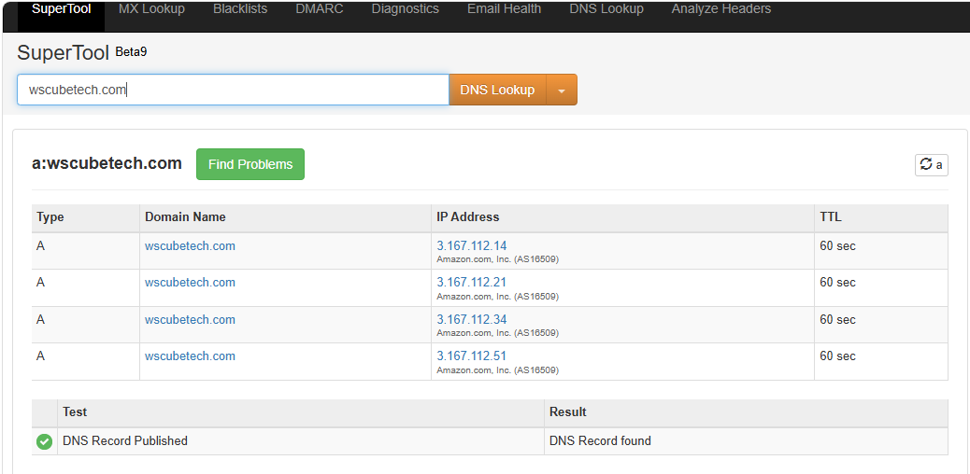

🔹 MX Record :
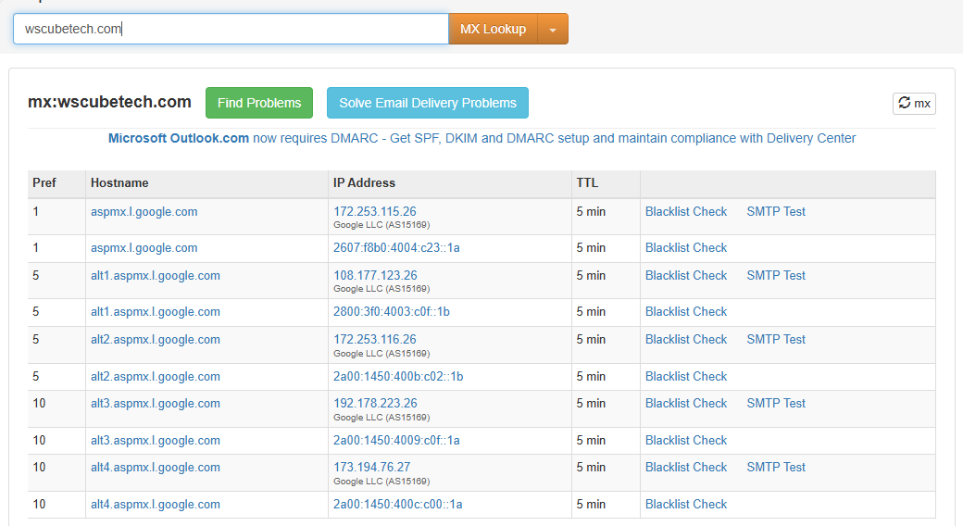

🔹 TXT Record :
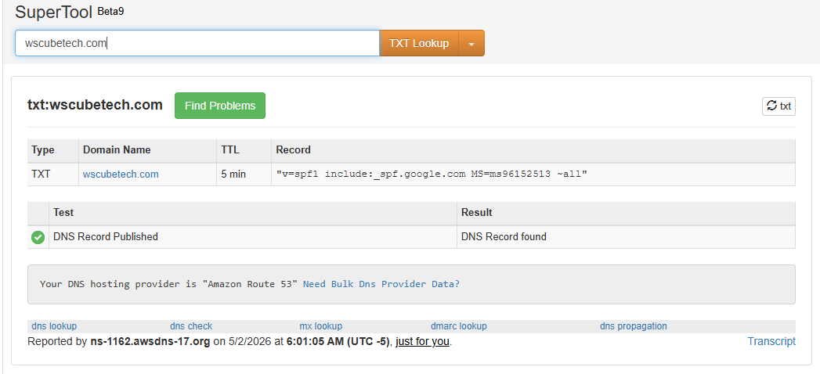

🔍 Google Dorking Results
Basic Dorks Used:
- site:wscubetech.com
- site:wscubetech.com filetype:pdf
- site:wscubetech.com filetype:doc
- site:wscubetech.com inurl:login
- site:wscubetech.com inurl:admin

🎯 Sensitive Data Discovery
🔐 Login Pages :
site:wscubetech.com inurl:login


⚙ Admin Pages
site:wscubetech.com inurl:admin



🧠 OSINT Data Collection :
Tool UsedCommand / Query Data Found Why It Matters

- Have I enter email no found brach data get
Been pawned

- Synapsint.com enter domain info about host websiteinfo

- Domain dossier enter domain ip’s of host server web-Reconn

📧 Emails Found
- Example: info@wscubetech
👉 Can be used for phishing attacks

🌍 Subdomains Found
- blog.wscubetech.com
- courses.wscubetech.com
👉 More entry points for attackers

⚙ Technologies Used
- Web Server (Apache/Nginx)
- CMS / Framework
- JavaScript Libraries
👉 Helps attacker target known vulnerabilities

🚨 6. Risk Analysis :

🔴 Risk 1: Exposed Documents
- Sensitive PDFs available publicly
👉 Impact: Data leakage

🔴 Risk 2: Public Admin/Login Pages
- Easily discoverable login URLs
👉 Impact: Brute force attacks

🔴 Risk 3: Email Exposure
- Emails publicly available
👉 Impact: Phishing & spam

🔴 Risk 4: Subdomain Exposure
- Multiple subdomains visible
👉 Impact: Weak subdomain = entry point
🔴 Risk 5: Technology Disclosure
- Tech stack identified
👉 Impact: Targeted attacks using known exploits

🧾 7. Conclusion

- The passive reconnaissance revealed that wscubetech.com exposes multiple pieces of sensitive information publicly.

- While no active attacks were performed, the gathered data could be leveraged by attackers to perform targeted attacks.

- Implementing the recommended security controls will significantly reduce risk.

