UNDERSTANDING NETWORK SCANNING

Name: Aditya Kashinath Bagade
Topic Name : Network Scanning
Course Name : Ethical Hacking
-By skillected cyber security course

🎯 Step 1: Find Target IP
Ip Address of kali linux :
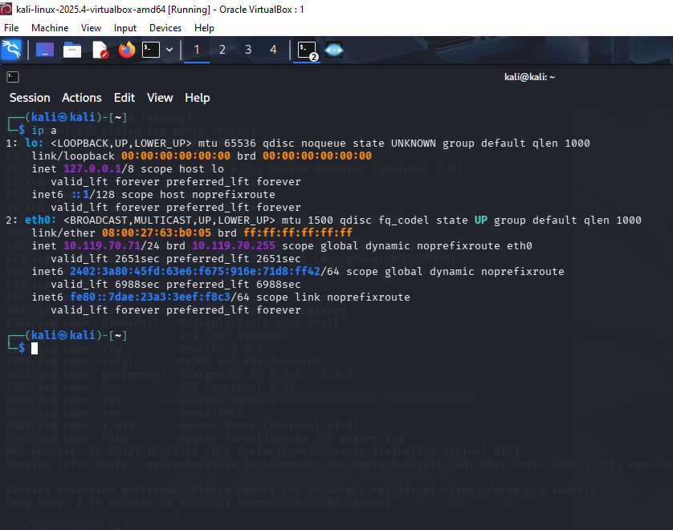
Ip address of Metasploit machine : 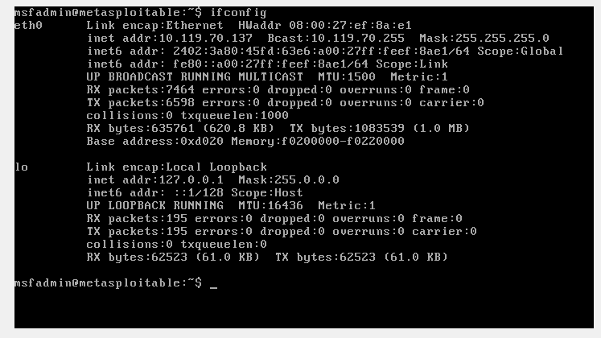

🎯 Step 2: Verify Host is Reachable
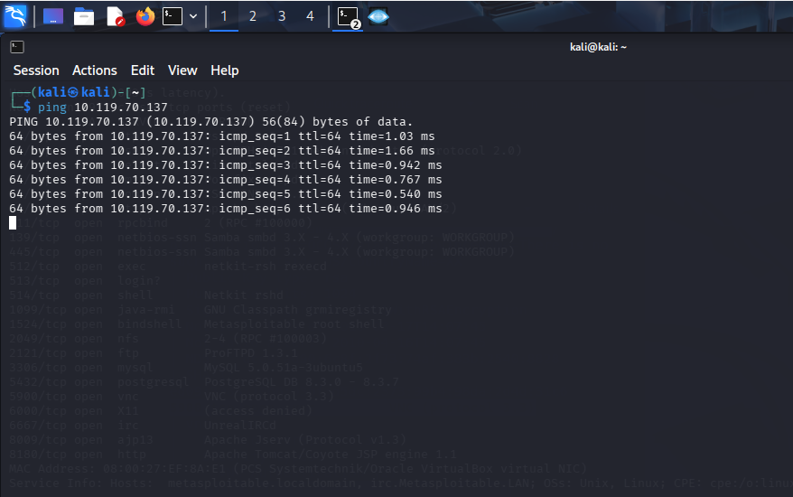

🎯 Step 3: Basic Nmap Scan
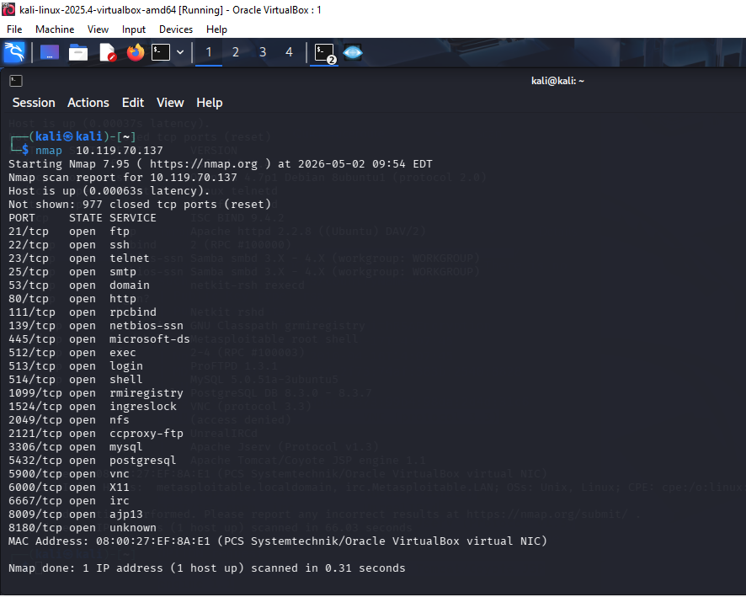

🎯 Step 4: Identify Open Ports & Services
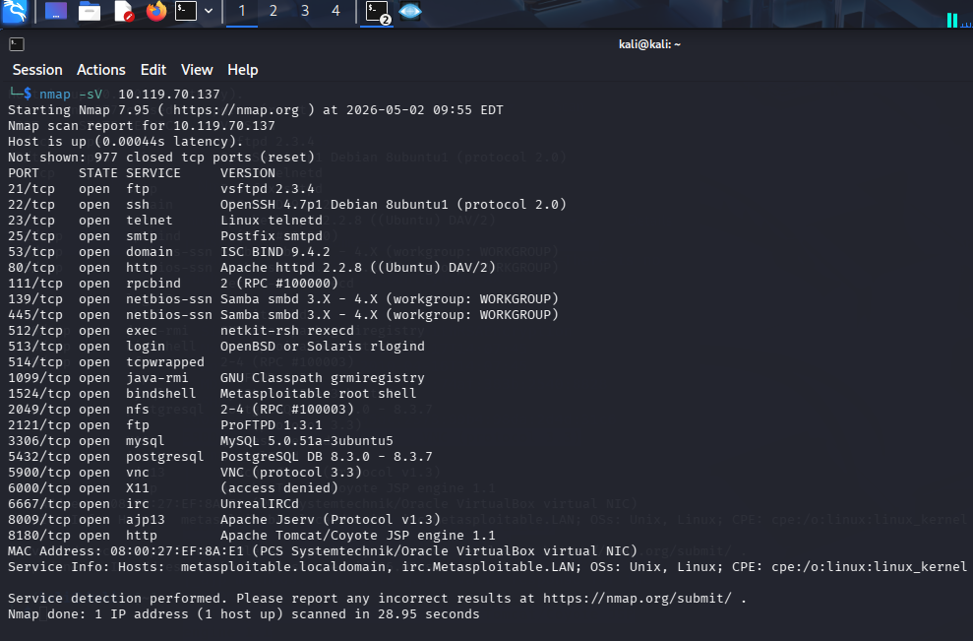

✅ Beginner Outcome :
- Target IP: 192.168.X.X
- Open Ports: 21, 22, 80, etc.
Services:
- FTP → vsftpd
- SSH → OpenSSH
- HTTP → Apache
✍️ Short Explanation :
Network scanning helps identify active systems, open ports, and running services. It is important because attackers use this information to find vulnerabilities. Security teams use scanning to detect and fix weaknesses before attackers exploit them.
🟡 Intermediate Practical – Commands & Logic

🎯 TCP SYN Scan (Stealth Scan) :
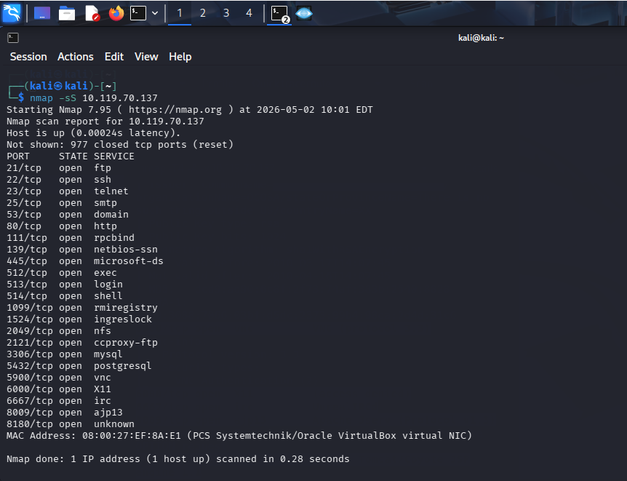
🎯 Service Version Detection:
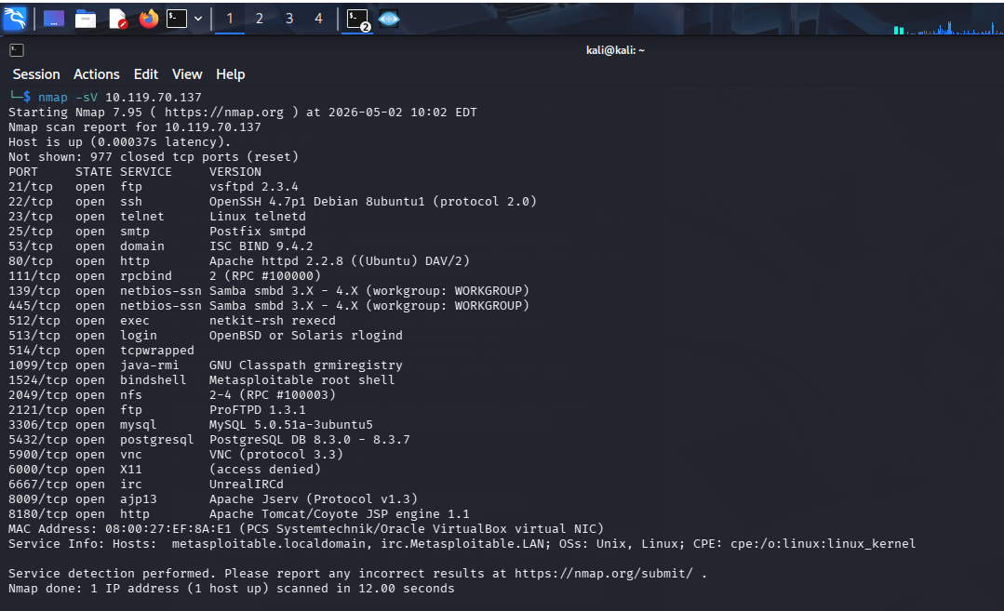
🎯 OS Detection :
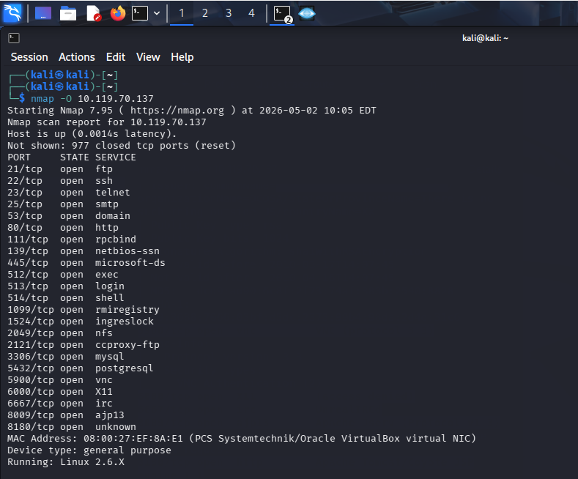

Port Service Risk
21 FTP Anonymous login vulnerability
23 Telnet Unencrypted login
80 HTTP Web vulnerabilities
3306 MySQL Weak credentials
139/445 SMB Exploitable services

🎯 Security Suggestions (Write This)
- Disable unused ports/services
- Use firewall (iptables / ufw)
- Replace Telnet with SSH
- Update outdated software
- Use strong passwords
- Restrict access using ACLs
🔴 Advanced Practical – Professional Report :
🧩 1. Host Discovery :
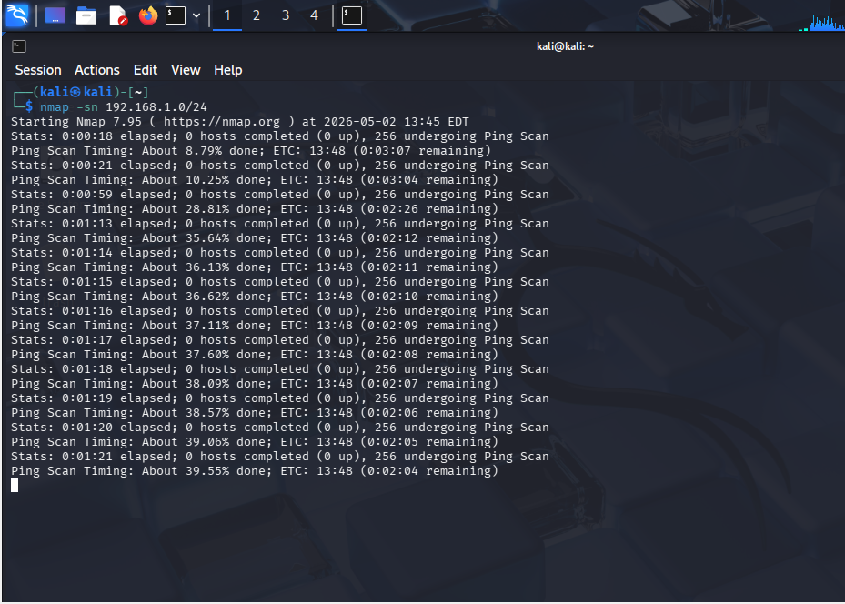
🧩 2. Full Port Scan :
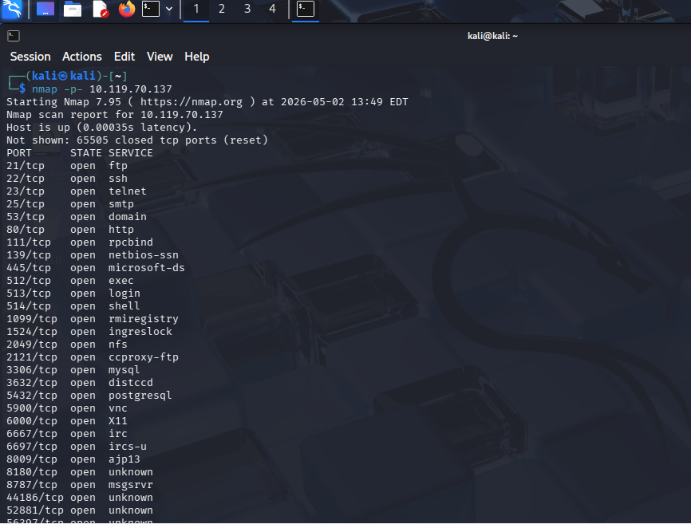
🧩 3. Service + Version Enumeration:
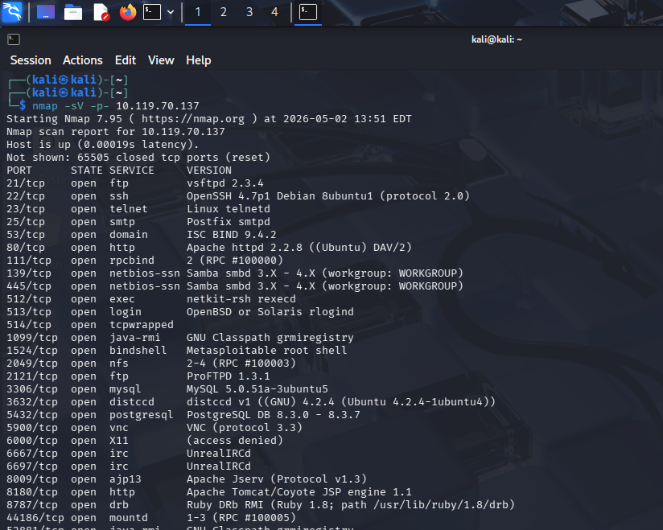
🧩 4. (Optional) Web Scan :
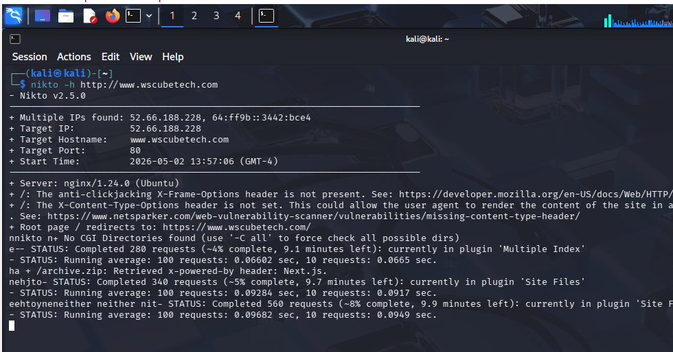
🧩 5. Risk Classification Table :
Port Service Version Risk Level reason
21 FTP vsftpd 2.3.4 🔴 High Known backdoor
23 Telnet - 🔴 High Plaintext login
80 HTTP Apache 2.2.8 🟡 Medium Outdated
22 SSH OpenSSH 🟢 Low Secure if configured

🧩 6. Recommendations :
- Disable FTP or secure it
- Remove Telnet completely
- Patch Apache server
- Use firewall rules
- Monitor logs

🧩 7. Executive Summary :

A network scan was performed on the Metasploitable system. Multiple open ports and outdated services were identified, including FTP and Telnet, which pose significant security risks. Immediate remediation is required to reduce attack surface and prevent exploitation.

