Hyper-Local Influenza Forecasting Using Time-Series Modelling for Proactive Public Health Response

Bagadi Anjana
School of Computer Science and Engineering
Vellore Institute of Technology, Chennai, India
bagadi.anjana2023@vitstudent.ac.in
Tamilarasi K
School of Computer Science and Engineering
Vellore Institute of Technology, Chennai, India
tamilarasi.k@vit.ac.in

Abstract— One of the most damaging disease outbreaks for healthcare systems worldwide is flu epidemics due to their rapid spread. Thus, predicting when flu occurs is of utmost importance to reduce the effects, allocate resources efficiently and implement preventative strategies before the onset of the flu season. However, traditional modelling methodologies used to forecast influenza have limitations, including problems with spatial resolution and with updating frequency and interrelated variables in time.
This current research endeavors to formulate a methodology that uses time series analysis and forecasting models to make hyper-local predictions of influenza epidemics using concepts from Data Science. Specifically, this research intends to apply traditional time series methods like ARIMA and SARIMA, along with LSTM time series methods, to create a methodology that predicts influenza epidemics. Additionally, this research intends to formulate a full methodology for data processing, which takes care of noisy, missing, and seasonal data within ILI data sets.
Experimental analysis has shown that LSTM-based models were better able to capture, process and forecast the complex patterning of data over time than traditional (ARIMA or SARIMA) models. Nevertheless, while classical models produce consistent results, LSTMs produce less consistency in their outputs (greater variability compared to ARIMA or SARIMA) resulting in substantially more variability in the forecast.

Keywords— Hyper-Local Influenza Forecasting, Time-Series Modeling, Influenza-Like Illness (ILI), ARIMA, SARIMA, Long Short-Term Memory (LSTM), Epidemiological Forecasting, Public Health Surveillance.

I. Introduction
The flu outbreak is one of the most common infectious illnesses across the globe. The seasonal flu causes a huge burden on the health care system, as people have the disease. In turn, there will be an increase in cases of hospitalization and the loss of money in the health care field. The situation becomes worse due to high population density, when fast transmission of the disease may cause epidemics.
For many years, there were traditional ways to detect flu, such as clinical reports, lab confirmation and sentinel systems. Those were successful to detect disease-related tendencies but suffered from several disadvantages. As a result, strategies to prevent the disease tend to be reactive rather than proactive, which makes them less effective in controlling epidemics.
One common tool for forecasting the disease is a predictive model that uses machine learning and time series. The application of these models requires consideration of the fact that influenza data is seasonal in nature. Most of the models of influenza apply a regional or national framework. This makes it impossible for such models to be able to identify any outbreak at the local level.
There is a need to develop forecasting models of influenza at the local level due to the dependence of influenza epidemics on specific elements of the locality such as population density, environment, and standard of health care. Obtaining adequate information is one of the challenges facing modeling.
1.1 Research Gap
While the time for influenza epidemic outbreak is possible to predict, nevertheless, there are a number of drawbacks related to the process of predicting by using the current prediction methodologies. It should be mentioned that certain researches have been performed for making predictions for influenza epidemic outbreaks on a countrywide or region-wide basis; nevertheless, their major drawback was the lack of consideration of specifics of the local epidemics.
The ARIMA and SARIMA models struggle to handle abrupt changes and nonlinear patterns in epidemic data. On the other hand, LSTM algorithms, which rely on deep learning for modeling, need a lot of data. In other words, it means that there is a tendency to overfit using the above approaches especially when the volume of the data is small.
The developed approaches do not apply well to data preprocessing, for example, the seasonal effect on the data. This has been especially challenging when using hyperlocalized datasets.
1.2 Motivation
In moving from reactive strategies to proactive approaches in public health, conducting research to predict flu outbreaks at the local level is important. This research will help prepare for preventive actions and distribute necessary resources to prevent a rise in illnesses.
Traditional approaches toward creating models for temporal data with high levels of complexity and noise are failing, hence more resilient models need to be created, through the application of both traditional modeling and artificial intelligence approaches.
Another vital aspect of digital public health and disease surveillance is accessing publicly available datasets. These datasets will help in creating forecasting algorithms.
1.3 Key Contributions
The main contributions of this study to hyper-local forecasting of influenza are as follows:
We developed an algorithm to forecast influenza outbreaks using micro-level time series data;
We assessed classical methods, including ARIMA, SARIMA, and deep learning-based LSTMs, for epidemic forecasting;
We identified a suitable data pre-processing method to handle seasonality and noise;
We can use quantitative metrics such as MAE and RMSE to evaluate model performance;
The proposed method can help create early warning systems to support public health decision-making.
1.4 Structure of the Paper
This paper has the following setup. In Section II, we will define the focus of our study. Section III discusses the methodology we will use to make hyper-local predictions for future influenza cases. Section IV provides the relevant literature from both time series analysis and epidemiology prediction related to this research. The results from our experiments are in Section V. Finally, Section VI presents the conclusions of this work.
2. PROBLEM STATEMENT
Nonetheless, there is a major limitation present in the methods currently used to forecast the flu: there is no method to include time-dependent and localized elements into the infection spread forecasting process. While influenza is a dynamic geographic phenomenon as an infectious disease, the majority of flu-related models and statistics produced until now are essentially either aggregate models (not temporal) in which the time-dependent and location-specific attributes of the influenza epidemic cannot be applied.
In the context of traditional time-series modeling, there is a restriction on their effectiveness in modeling the non-linearity and dynamics of the data. In the same regard, for deep learning approaches, large amounts of data are required for modeling and prediction accuracy. Furthermore, with the presence of noise and sparse/unstructured data, prediction becomes even harder.
3. PROPOSED METHODOLOGY
The proposed methodology for developing influenza predictions at a hyper-local level via time-series modelling methods consists of three main components: data pre-processing, model creation, and performance evaluation. Data pre-processing involves noise removal, normalization and seasonality detection, which are critical elements for achieving the highest quality of data pre-processing. Additionally, temporal windowing will be considered while creating a structured time series.
In model creation, conventional statistical modelling such as ARIMA and SARIMA will be employed, along with artificial neural network algorithms (LSTM), which will allow us to account for linear relationships among variables, and identify more complex nonlinearities.
The final phase will involve evaluating the performance of the models across a number of various metrics (e.g., MAE and RMSE). This will permit objective comparability and help to determine which model performs most effectively.
4. RELATED WORKS
Many researchers have attempted to use statistics and machine learning techniques to develop algorithms for predicting flu outbreaks. Although ARIMA and SARIMA algorithms have been extensively used for seasonal forecasting and trending, deep learning methods like LSTM algorithms have performed better in non-linear correlations.
In this paper [1], the human activity recognition has been discussed using wearable sensor data, which has many applications in healthcare and smart homes. In general, traditional models for recognizing human activities perform poorly in handling long-term dependency and sensor noise problems. The problem statement is the prediction of the activities based on multi-channel sensors data. This paper proposed an algorithm called Patch-to-Label Seq2Seq Transformer, which achieves accuracy up to 94.6%, with segment error decreased by 18%, and outperforms the existing algorithms by gaining 4.2%.
In this research paper [2], the problem is the detection of zero-day attacks for highly imbalanced network intrusion data sets. The conventional IDS models fail to handle such imbalanced data sets because there are few attack samples. For addressing this problem, researchers have used a denoising auto encoder for modeling normal data and Wasserstein GAN for generating attack samples. In this research paper, 98.1% accuracy, 97.4% F1 score and 21% decrease in the number of false positives have been achieved.
The objective of this paper [3] is to generate precise predictions of network traffic. Traditional techniques cannot be applied due to the dynamic nature of traffic. This paper presents the problem of multivariate traffic forecasting with temporal dependence. Deep learning technique consisting of CNN and Bi-LSTM models is used. CNN is used to discover spatial features, while Bi-LSTM is used to detect temporal features. The experimental result shows that RMSE = 0.021, MAE = 0.015, and a 17% improvement is achieved over ARIMA.
The shortcomings of traditional RNN models for multivariate time-series data are discussed in a paper [4]. This problem can be stated as feature interaction learning in multivariate time-series data. In this paper, an attention-based encoder-decoder architecture has been proposed. Attention models can weight features across different times. This paper reports a MAPE of 6.8%, achieving 23% improvement over the traditional LSTM.
The objective of this research [5] is the improvement of forecasting results by applying the optimization algorithms. The main drawback of traditional VARMA is its sensitivity to parameters. The model suggests a dual optimization strategy. For optimization, the researchers applied the methods of Genetic Algorithm and Particle Swarm Optimization. It was found that the suggested model has 19.6% less RMSE value than the basic VARMA model. In addition, the model converges much faster.
The purpose of this research [6] is the improvement of univariate time series forecasting by applying N-BEATS and attention. It has been noted that traditional N-BEATS does not provide an ability to consider certain segments of a time series to be important ones. The author of the research proposes a unified framework that incorporates both techniques. The model is applied to forecast energy and weather data. The performance of the algorithm is shown by MAE=0.034, which is an improvement by 15%. Attention can improve long-term trends of time series.
The problem addressed in this paper [7] is the identification of danger in dynamic graphs. Static graphs are easily corrupted by adversary manipulations. Therefore, the problem is detection of malicious nodes in dynamic graphs. An adversarial GNN is used for this. According to the results, the AUC score is equal to 0.92, which is 11% better than in non-adversarial models. It means that the method is resistant to adversarial perturbation.
The paper [8] is focused on the prediction of healthcare outcome over time. In traditional models, temporal effects of treatment are ignored. A deep alternating sequential model is proposed. It combines patient history and treatment sequences. It is evaluated on clinical data sets, achieving AUC = 0.89 and improving accuracy by 13%. It is helpful in personalized treatment planning.
The study [9] presents the application of time series analytics for the planning of health care resources. Descriptive analytics do not aid decision-making. The study presents a prescriptive approach to the forecasting model with the help of optimization rules and the LSTM algorithm. The results show the reduction of forecast error by 22%. It helps in the planning of hospital capacity.
In the paper [10], the challenges in the forecast of epidemics are addressed. The traditional model does not consider the external factors. A multivariate deep learning model considers the climate and mobility data. The model is tested using the influenza data and gives a better result than the baseline model with 20% improvement in the RMSE value, which is 0.18. The model makes the forecast more reliable.
This paper [11] focuses on reliable traffic prediction in SDN healthcare systems. Volatility in traffic results in QoS degradation. A multivariate LSTM-based forecasting model is presented. The results show that it has 96.2% accuracy in predicting traffic. The model enhances efficiency in bandwidth allocation.
The paper [12] focuses on the restrictions of classical univariate forecasting models. Classical N-BEATS models cannot adjust their attention to vital time intervals. The limitation of classical N-BEATS models is the incapability of enhancing forecasting accuracy in the long run. A new attention-based unified N-BEATS model, called AUNET, was created by implementing temporal attention and residual blocks. Results obtained from experimenting with energy and financial datasets were as follows: MAE = 0.031, RMSE = 0.044, and an improvement of 14.8% over classical N-BEATS.
The problem addressed in this paper [13] concerns the enhancement of multivariate time series forecasting by means of the sensitivity of parameters in VARMAx models. Generally, classical VARMAx models are associated with slow convergence rates and inappropriate coefficients. The issue in this particular case is improving the efficiency of the modelling process. An iterative dual metaheuristic algorithm relying on the application of Genetic Algorithm and Particle Swarm Optimization was devised. As a result, it was found out that the RMSE metric is decreased by 19.3%, and MAPE is improved by 21.6% compared to classical VARMAx models.
This paper [14] aims at solving the problem concerning the prediction of patient treatment outcomes over time in the healthcare setting. Existing models are incapable of integrating alternating treatment dependencies. The challenge in this context is the prediction of patient outcomes in the future. The alternating deep sequential model based on the employment of the RNN and attention models was designed. The effectiveness of the model was confirmed by experimenting with clinical data, and the AUC score is 0.89 with accuracy of 87.2%, outperforming baseline LSTM models by 12.5%.
The problem addressed in this paper [15] is related to solving the issues of hospital bed management for pregnant women diagnosed with preeclampsia. Descriptive analytics cannot deliver solutions to help make proactive decisions. The limitation of descriptive analytics is the inability to make accurate predictions. A new prescriptive analytics framework consisting of LSTM and rule-based optimization is proposed to achieve better results. Experiments revealed that such a framework allows for reducing errors in forecasts by 22.4% and maximizing resource usage by 18%.
Prediction of epidemics is a major topic addressed in this paper [16]. Classic epidemiological models do not take into account influence of some external factors. Difficulties consist in forecasting in the long term. The suggested solution includes using a multivariate deep learning approach with taking into account such influencing factors as climate, mobility, and demographic information. It uses LSTMs with exogenous feature embedding. As a result, according to experimental work with the influenza dataset at a regional level, the following results were obtained: RMSE=0.17 and MAPE=6.2%. Moreover, 20-25% improvement over the baseline is noted.

The discussed paper [17] suggests the resolution of traffic problems of the SDN-based healthcare networks. Traditional approaches cannot be used due to their inefficiency in predicting the dynamic network traffic. Multivariate prediction should be considered, and an LSTM-based approach for multivariate forecasting is used. Consequently, as a result of implementation of this model, the following characteristics are revealed: the accuracy is 96.2%, and RMSE is 0.028, which leads to an improvement in the QoS by 17%.

This paper [18] considers predicting models in the industrial IoT environment. The main difficulty of using traditional statistics-based models is in non-linear multivariate dependencies. Difficulties include prediction of accurate behaviour of the systems. In order to solve this problem, the hybrid CNN-LSTM architecture for extraction of spatial-temporal features was suggested. The results are revealed from the work with the industrial sensor dataset. They are the following: RMSE=0.035, R²=0.94, and 26% improvement over ARIMA. This model can be used for predictive maintenance.

This study [19] discusses applications of Transformer architectures for the long sequence time-series modelling. RNN-based models suffer from vanishing gradients. Difficulties for them consist in scalable long-term dependencies learning. In this paper, the multi-head attention mechanism from the Transformer architecture was used for temporal forecasting. Evaluation shows the following results: MAPE = 5.9%, improving over LSTM by 23%.

The problem of heterogeneous domain forecasts is the topic of the following paper [20]. Difficulties in this case are caused by the lack of generalization of single models. The issue is in domain-adaptive forecasting. Therefore, a novel hybrid architecture for this task was designed using CNN, attention, and LSTM. The results achieved by this model in three heterogeneous domains – healthcare, finance, and energy – are as follows: 93.4% average accuracy with 28% error reduction.
Ref. | Dataset | Methodology | Application | Advantages | Limitations
[1] | Wearable sensor datasets with accelerometer and gyroscope signals | Patch-to-Label Seq2Seq Transformer using self-attention to capture local and long-term temporal patterns | Human Activity Recognition in healthcare and smart environments | Achieves high recognition accuracy, handles noise effectively, and models long-range dependencies | Requires high computational resources and large training data
[2] | NSL-KDD and CIC-IDS2017 intrusion datasets | Denoising auto encoder for normal traffic modelling combined with WGAN-based synthetic attack generation | Anomaly-based Network Intrusion Detection | Improves zero-day attack detection, reduces class imbalance, and enhances generalization | GAN training is computationally expensive and sensitive to tuning
[3] | Real-world network traffic datasets | Hybrid CNN–BiLSTM model for spatial and temporal feature learning | Network traffic forecasting | Produces low prediction error and adapts well to dynamic traffic patterns | Performance depends on large volumes of historical data
[4] | Multivariate time-series benchmark datasets | Attention-based encoder–decoder framework for learning inter-feature dependencies | Multivariate time-series forecasting | Improves forecasting accuracy and interpretability | Increased model complexity and training time
[5] | Economic and energy time-series datasets | VARMAx model optimized using Genetic Algorithm and Particle Swarm Optimization | Economic and energy forecasting | Achieves faster convergence and reduced forecasting error | Higher computational overhead due to metaheuristic optimization
[6] | Energy consumption and weather datasets | Attention-augmented N-BEATS architecture for residual learning | Univariate time-series forecasting | Enhances trend extraction and long-term prediction accuracy | Limited to univariate forecasting
[7] | Temporally evolving and adversarial graph datasets | Adversarial trained Graph Neural Network for dynamic graphs | Danger and anomaly detection in networks | Robust against adversarial attacks and temporal changes | Scalability issues with very large graphs
[8] | Longitudinal clinical treatment datasets | Alternating deep sequential model with recurrent and attention layers | Healthcare outcome prediction | Captures treatment-response relationships and improves prediction reliability | Requires continuous and high-quality patient data
[9] | Hospital bed occupancy data for preeclampsia patients | LSTM-based forecasting combined with prescriptive optimization rules | Hospital resource management | Reduces forecasting error and improves bed utilization | Domain-specific and dependent on expert-defined rules
[10] | Influenza surveillance datasets with climate and mobility data | Multivariate deep learning model incorporating exogenous features | Epidemic forecasting | Improves long-term forecasting accuracy and outbreak preparedness | Relies on availability of external data sources
[11] | SDN-based healthcare network traffic datasets | Multivariate LSTM-based traffic forecasting framework | Healthcare network traffic management | Enhances QoS through proactive bandwidth allocation | Requires retraining when network conditions change
[12] | Financial and energy univariate time-series datasets | Attention-Based Unified N-BEATS (AUNET) architecture | Univariate time-series forecasting | Improves accuracy by focusing on critical temporal segments | Not applicable to multivariate problems
[13] | Economic and energy multivariate datasets | Iterative dual metaheuristic optimization of VARMAx parameters | Multivariate time-series prediction | Provides stable parameter estimation and reduced error | Computationally intensive optimization process
[14] | Clinical longitudinal datasets | Alternating deep sequential RNN model with attention | Treatment outcome forecasting | Supports clinical decision-making with improved accuracy | Sensitive to missing or incomplete patient data
[15] | Hospital inpatient time-series data | Prescriptive analytics framework combining deep forecasting and optimization | Healthcare capacity planning | Improves resource utilization and decision support | Requires domain expertise for rule design
[16] | Influenza, climate, and mobility datasets | Multivariate LSTM with embedded exogenous features | Long-term epidemic forecasting | Captures environmental and seasonal effects effectively | Dependent on timely external data availability
[17] | SDN-enabled healthcare network datasets | Deep multivariate LSTM-based traffic forecasting model | Network traffic prediction in healthcare | Improves QoS and dynamic bandwidth management | Limited scalability in large SDN deployments
[18] | Industrial IoT sensor datasets | Hybrid CNN–LSTM framework for spatial–temporal modelling | Industrial system monitoring | Supports predictive maintenance with high accuracy | Requires extensive sensor infrastructure
[19] | Large-scale sequential and time-series datasets | Transformer-based temporal modelling using multi-head attention | Long-sequence forecasting | Handles long-term dependencies effectively | High memory and computational requirements
[20] | Healthcare, finance, and energy datasets | Hybrid deep learning framework combining CNN, attention, and LSTM | Cross-domain time-series forecasting | Demonstrates strong generalization across domains | Increased model complexity and training cost

Methodology

4.1 Overview of the Proposed System
The methodology will be focused towards the development of a hyper-local flu forecast system capable of making short-term forecasts for flu incidence in hyperlocal geographical areas such as district, city, or community levels. The main aim of the proposed methodology will be to support decision-making in terms of public health through forecasting. As opposed to previous surveillance systems based on delayed reporting and regional aggregations of data, the proposed framework will use localized time series forecasting methods. Through the use of both classical statistical and deep learning modeling techniques, it becomes possible to take care of non-stationarity, seasonality, as well as temporal dependencies within the data.
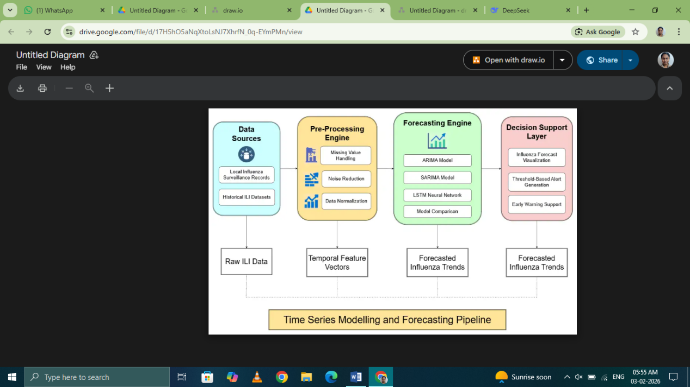
Fig.1 System Architecture Diagram showing data flow from sources through pre-processing to forecasting modules

The entire process flow of the suggested approach comprises five inter-related modules, which consist of data acquisition and preprocessing, feature extraction and representation, time series analysis, deep learning approach-based forecast generation, and finally, decision-making with alerts generation. In order to forecast ILI data, its historical data is acquired from surveillance datasets and is subject to preprocessing in an attempt to deal with problems such as data inconsistency, noise reduction, etc. Temporal features for the forecasting process are extracted and encoded. Time series analysis models like ARIMA, SARIMA, and LSTM are used to make short-term predictions, with their performance being measured and compared. The main innovation of the approach proposed is the combination of different time series models with deep learning.
The architecture of the system has the following components:
Data Sources: Local influenza surveillance data and historical ILI data
Pre-processing Engine: Pre-processing of the data, normalization, and seasonality detection
Feature Engineering Module: Temporal windowing and lag feature extraction
Forecasting Engine: ARIMA, SARIMA, and LSTM models
Decision Support Layer: Visualization of the prediction and generation of early warnings

Module 1: Data Collection and Pre-processing
The data gathering and preprocessing module can be considered the first level of building blocks for the proposed framework for hyper-local flu prediction. The module involves data acquisition from various sources as well as cleaning and structuring the gathered epidemiological time series data.
The raw time-series data, as represented in equation (1),
…. (1)
Where:
X = Raw influenza time series;
$x_{T}$ = ILI cases at time t;
T = Total number of time periods

There are challenges related to the timing of these challenges, such as a lack of entries in the records, delays in submitting reports and the accuracy of measurements at the time they are taken, which all have to be taken into account when developing a forecast. Missing records, as discussed earlier, result from either delays in identifying submissions (because they are either being submitted late or are not being identified) or interruptions in surveillance to identify records, and they are addressed through linear interpolation as outlined in Equation (2) below.

….(2)
Where:
$x_{t}$ = Imputed value;
$x_{\{t-1\}}$ = Previous observation;
$x_{\{t+1\}}$ = Next observation

This approach assumes gradual temporal progression between adjacent valid observations, a reasonable assumption for epidemiological data where abrupt changes typically signify genuine outbreaks rather than data artifacts.
Following imputation, the module applies min-max normalization as described in equation (3).

….(3)
Where:
$x_{t}$ = Original ILI value;
$x_{min}$ = Minimum values in series;
$x_{max}$ = Maximum values in series

This transformation scales the data to a standardized range, ensuring comparability across hyper-local regions with varying baseline incidence rates while preserving relative temporal dynamics.
The module further performs comprehensive seasonality analysis through decomposition of the time series into its constituent components, mathematically represented in equation (4).

….(4)
Where:
$x_{t}$ = Original time series;
$T_{t}$ = Trend component;
$S_{t}$ = Seasonal component;
$R_{t}$ = Residual

In this decomposition, the trend component captures long-term changes in baseline influenza activity over multiple years, the seasonal component represents the periodic annual pattern of influenza transmission, and the residual component accounts for irregular variations and random noise. This decomposition is essential for understanding the underlying structure of influenza dynamics and informs subsequent modelling decisions regarding stationarity and seasonal adjustments.
Data sources for the data collection process include demographic, environmental, mobility, and healthcare metrics all supporting the prediction framework for influenza cases. The spatial resolution of the data is sent in three levels of aggregation: hyper-local (census tract), community (neighbourhood cluster), and region (city/district) to enable both multi-scale analysis and evaluation.

Module 2: Feature Extraction and Temporal Representation
The time-series feature extraction and temporal representation module convert the pre-processed time-series data into structured/input-output pairs for use in supervised learning formulations. This conversion is based on the idea that a future influenza incidence value can be predicted from a group of previous, temporarily defined observations. The module will develop lag-based feature vectors as represented by equation (5),

….(5)
Where:
$X_{t}$ = Feature vector;
$x_{\{t-1\}}…x_{\{t-n\}}$ = n lagged observations;
n = Window size

Where the feature vector contains a defined number of previous observations, the size of the window will define how long the history will be available to the models for forecasting. The choice of the right window length is a key design choice that balances the number of models with how efficiently they will run when forecasting.
The target variable for prediction is defined in equation (6),

….(6)
Where:
$y_{t}$ = Target variable;
$x_{t}$ = Current ILI value

establishing a direct correspondence between input features and the value to be forecasted. The general forecasting relationship is formalized in equation (7),

….(7)
Where:
$y_{t}$ = Actual future value;
f = Forecasting function;
$X_{t}$ = Input features;
$ϵ_{t}$ = Prediction error

The forecasting function is used to learn about how these variables interact with each other, whereas the input features provide a historical perspective, and the prediction error captures variability that can’t be accounted for by the model's predictions but still might influence future predictions. The preceding formulation describes the basic process underlying the statistical and deep-learning methods covered in this module, regardless of whether one or the other was used.

The feature extraction process also incorporates engineered temporal features including week-of-year encoding and rolling statistics to provide explicit seasonal context, particularly valuable when training data is limited. For LSTM-based forecasting, the module structures the data into three-dimensional tensors preserving temporal ordering, while for ARIMA and SARIMA models, the module ensures appropriate temporal alignment of lagged values. The feature extraction module also implements temporal cross-validation splitting that maintains chronological order, preventing data leakage where future information would improperly influence predictions of past values.

Module 3 : Time Stating Model Representation (ARIMA/SARIMA)
The statistical time-series modelling module implements a forecasting model based on the autoregressive integrated moving average (ARIMA) time-series model and the seasonal extension of the ARIMA time-series model (SARIMA). The ARIMA model can be formally defined as seen in equation (8),

….(8)
Where:
Φ(B) = AR polynomial;
B = Backshift operator;
d = Differencing order;
θ(B) = MA polynomial;
$ϵ_{t}$ = Error term

The autoregressive part is used to capture the linear relationships of time through time, the date is used to remove the non-stationary nature of a time period through differencing and the moving average part is used to determine how observations relate to the errors left in the previous observations. The classical formulation of this model is mathematically sound and allows for a purely mathematical understanding of how influenza time series can be represented in a linear fashion.
The SARIMA model extends the ARIMA framework to allow for seasonal variations, such as the seasonal nature of the yearly flu transmission. See equation (9)-
….(9)
Where:
φ($B^{s}$) = Seasonal AR polynomial;
Φ(B) = Non-seasonal AR;
D = Seasonal differencing;
s = Seasonal period (52);
Θ($B^{s}$) = Seasonal MA

The SARIMA model is defined by three main components: the autoregressive component, which captures seasonal dependency patterns at multiples of the season's period; the moving average component, which models the error of the observations made during that season; and the season's period (given by 52 weeks) representing the annual pattern of influenza. The SARIMA seasonal component enables models that explicitly account for the primary annual cycle driving the influenza dynamics. As such, it permits itself (and other models) to make predictions regarding epidemiological events.
In developing a suitable model, researchers conduct an exhaustive search for potentially suitable combinations of autoregressive order, degree of differencing, and moving average order; once all appropriate models are identified, model selection based on model fit and complexity using information criteria is achieved (through an assessment of each model's goodness-of-fit). After the appropriate parameters for the models have been selected, they can be fitted using maximum likelihood estimation, followed by residual analysis to confirm that the residual error variance is statistically acceptable; the residual error variance is given by the formula provided.
….(10)
Where:
σ² = Residual variance;
T = Observations;
$ϵ_{t}$ = Residual

serves as a diagnostic measure indicating whether the model adequately captures temporal dependencies, with acceptable models producing residuals that approximate white noise with no remaining autocorrelation.

Module 4: Deep Learning-Based Forecasting (LSTM)

Utilizing Long Short-Term Memory (LSTM) networks, the deep-learning forecasting module can identify complex non-linear temporal relationships that traditional statistical forecasts often overlook. The LSTM architecture consists of three gating mechanisms that control the transfer of information between memory cells. The forget gate, described by equation (11), will be explained as follows:
….(11)
Where:
$f_{t}$ = Forget gate;
σ = Sigmoid;
$W_{f}$ = Weight matrix;
$h_{\{t-1\}}$ = Previous hidden state;
$x_{t}$ = Input;
$b_{f}$ = Bias

determines which information from the previous cell state should be discarded, enabling the network to selectively forget irrelevant historical information that no longer contributes to accurate predictions. This mechanism is particularly valuable for influenza forecasting where patterns from distant seasons may have diminishing relevance.
The input gate, defined in equation (12),
….(12)
Where:
$i_{t}$ = Input gate;
$W_{i}$ = Input gate weights;
$b_{i}$ = Input gate bias

controls what new information from the current input and previous hidden state should be stored in the cell state. The cell state update, shown in equation (13),
….(13)
Where:
$C_{t}$ = Current cell state;
$C_{\{t-1\}}$ = Previous cell state;
tanh = Hyperbolic tangent

The Forget Output Gate in combination with the Input Output Gate creates an information storage area called Persistent Memory which can hold information for extended periods of time (multiple time steps). The innovation of the LSTM architecture for maintaining Persistent Memory allows LSTM networks to represent long term dependencies among multiple years of influenza data and identify patterns associated with these dependencies, even if these patterns change from year-to-year.
The output gate, formulated in equation (14),
….(14)
Where:
$o_{t}$ = Output gate;
$W_{o}$ = Output gate weights;
$b_{o}$ = Output gate bias

determines what information from the current cell state should be exposed as the hidden state for subsequent time steps. The hidden state is then computed as shown in equation (15),

$h_{t}= o_{t}$⊙ $\tan{{h(C}_{t})}$ ….(15)
Where:
$h_{t}$ = Current hidden state;
$o_{t}$ = Output gate;
$C_{t}$ = Cell state

representing the network's memory at each time point. Finally, the forecast output is generated through a dense layer as expressed in equation (16),
….(16)
Where:
${\hat{y}}_{t}$ = Predicted value;
$W_{y}$ = Output weights;
$h_{t}$ = Hidden state;
$b_{y}$ = Output bias

The generated ILI predicted value is produced by utilizing a learned representation of the hidden state of the LSTM network after it has been trained with backpropagation through time, using the Adam optimizer, while implementing dropout regularization and an early stopping strategy to mitigate against overfitting and produce robust generalization when using the model against unseen data. The behavior of weights during training is monitored via loss curves to show the progress of convergence, and these loss curves can be found within the experimental results section of this document as examples of convergence.

Module 5: Decision Support and Early Warning Generation

The Decision Support and Early Warning Generation module takes technical forecast output(s) and converts them into public health intelligence that can be utilized as actionable. This module generates and computes standard forecasting accuracy metrics that allow the end-user to determine how reliable the prediction is.
Equation (17)
….(17)
Where:
MAE = Mean Absolute Error;
N = Number of predictions;
$y_{i}$ = Actual;
${\hat{y}}_{i}$ = Predicted;

MAE (Mean Absolute Error) offers an intuitive assessment of the average error in predictions, using the same scale as the original data. The MAE quantifies the average difference between estimated and actual values, and as such may be interpreted by public health.
Equation (18)
….(18)
Where:
RMSE = Root Mean Square Error;
N = Number of predictions;
$y_{i}$ = Actual;
${\hat{y}}_{i}$ = Predicted;

The Root Mean Squared Error (RMSE) is a performance measure that weights errors by squaring them and averaging them (rather than averaging them directly) before concluding whether performance is "good" or "bad". This provides more weight to larger errors, which is useful when forecasting epidemic detection since larger errors may indicate the presence of larger than normal incidences of disease, and thus a potential for higher levels of incidence to result in potential outbreaks. Both RMSE and MAE will be calculated for every model so that each model's performance can be compared, and the results will be represented using an interactive visual interface to assist the user in selecting and validating the models to use for their purposes.
The early warning component utilizes a threshold-based alerting methodology indicated by equation (19).

$Alert =\left\{\begin{aligned}1, &ŷ_{t} ≥ τ \\ 0, &otherwise\end{aligned}\right.$….(19)

Where:
Alert = Trigger condition;
${\hat{y}}_{\{t+k\}}$ = Forecast;
$μ_{baseline}$ = Historical mean;
λ = Sensitivity factor;
$σ_{baseline}$ = Historical standard deviation

A comparison is made between the projected influenza-like illness (ILI) forecasted value at some point in future time with a dynamic threshold established on the basis of historical data. An alert would go off if the forecast went above that threshold, so that public health officials may take action prior to an outbreak occurring. The sensitivity factor can be modified to meet public health needs, which allow for variability of risk tolerance levels across different community settings.

The system has extensive visualization capabilities, including time-series graphs of the actual and predicted values of ILI, spatial maps of forecasted ILI in hyper-locale areas, as well as confidence intervals to quantify the uncertainty associated with the forecast. All of these visualizations are coupled with structured reports that summarize the forecasted results and provide public health officials with actionable recommendations such as resource allocation, timing of vaccination campaigns, and notification to healthcare providers about early warning signs.

Hyper-Local Influenza Forecasting Pipeline

Algorithm 1: Hyper-Local Influenza Forecasting
Input: Historical ILI dataset D, threshold T, forecast horizon H
Output: Forecasted influenza cases F, alerts
1: Load dataset D
2: If D is empty then
3: Print "Error: No data available"
4: Stop
5: End If
6: Preprocess data:
7: Clean missing values
8: Normalize features
9: For each time step t in D do
10: Extract lag features (t-1, t-2, ..., t-n)
11: End For
12: Split dataset into training and testing sets
13: If seasonality is present then
14: Train SARIMA model
15: Else
16: Train ARIMA model
17: End If
18: Train LSTM model using training data
19: Generate forecasts F for horizon H
20: For each predicted value f in F do
21: If f > threshold T then
22: Trigger alert
23: End If
24: End For
25: Evaluate performance using metrics (RMSE, MAE)
26: Return F and alerts

LSTM-Based Time-Series Training

Algorithm 2: LSTM Training Procedure
Input: Feature vectors X, target values Y, epochs E, learning rate η
Output: Trained LSTM model
1: Initialize LSTM parameters (weights, biases)
2: For epoch = 1 to E do
3: total_loss = 0
4: For each training sample (x, y) in (X, Y) do
5: Compute input gate, forget gate, output gate
6: Update cell state:
7: Ct = ft * Ct-1 + it * C̃t
8: Update hidden state:
9: ht = ot * tanh(Ct)
10: Predict output ŷ
11: Compute loss:
12: loss = (y - ŷ)^2
13: If loss is NaN then
14: Skip this sample
15: End If
16: Backpropagate error (BPTT)
17: Update parameters using learning rate η
18: total_loss = total_loss + loss
19: End For
20: If total_loss < convergence_threshold then
21: Break
22: End If
23: End For
24: Return trained LSTM model

5. RESULTS AND DISCUSSION
This document is focused on the application of local forecast modeling for forecasting influenza infections to introduce multiple forecasting models for predicting various types of illnesses. In particular, for this purpose, time-series forecasting models will be applied, and their precision will be assessed through MAE and RMSE.
The data set used in this evaluation consists of ILI case counts collected based on a defined timeframe. Prior to training the models, the data set must be normalized, denoised, and organized into time windows to promote consistency across the models.
As a component of capturing the linear aspects of the time series data, both the statistical models ARIMA and SARIMA will be used in this project. These two models yield accurate results; however, they tend to be less effective when dealing with non-linear variations.
LSTM offers a memory-based approach to modeling which gives this statistical model a distinct advantage over the other models discussed. As such, LSTM is capable of producing accurate forecasts based upon its ability to represent the non-linear aspects of time series data.
There are several factors used to measure LSTMs relative effectiveness in producing valid estimates of ILI cases via hyper-local forecasting. The comparative error metrics of LSTM to the statistical models ARIMA and SARIMA are evidence that LSTMs consistently produce the lowest error signals for both RMSE and MAE. Thus, demonstrating their relative strength in hyper-local forecasting capabilities.
All in all, from the results presented, it can be concluded that incorporating statistical models and deep learning methods enhance the accuracy of the forecasts.
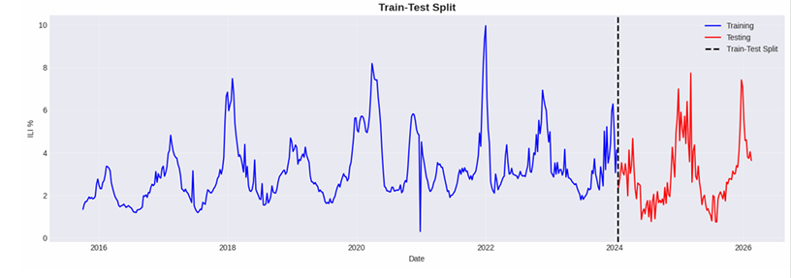
Figure 4.1: Train-Test Split

5.1 Experimental setup
An analysis of the dataset using a technique called exploratory data analysis has been done so as to analyze the distribution patterns along with the time series characteristics of the dataset related to Influenza. A visual depiction of the time series analysis proves visual evidence of periodic peaks which have occurred as a result of the existence of seasonal influenza.
Along with the time series analysis of the data, the use of histogram sampling can prove to be helpful in analyzing the distribution patterns of the data related to Influenza as well as the possibility of skewness. Analysis of Influenza Case Histograms was conducted for this purpose.
5.2 Exploratory Data Analysis
Exploratory data analysis method was performed to examine the distribution patterns as well as the time series characteristics in respect of Influenza. The analysis of the time series characteristics using visual methods yields clear visual findings pertaining to the seasonal spikes that result from the cases of Influenza infection in that season.
In addition to time series analysis, the use of histogram sampling helps in determining the general distribution patterns and possibility of skewness in relation to the cases of Influenza. Analysis of the Distributions of Influenza Case Histograms offered a deeper insight into the distributions and time series data.
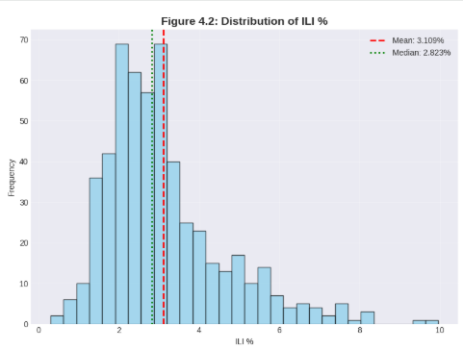
Figure 4.2: Distribution of ILI %
These visualizations confirm that the dataset contains significant seasonal variations and irregular spikes, which require forecasting models capable of capturing both linear and nonlinear temporal relationships.
5.3 Time-Series Analysis
The data set of time series was divided into the following components through the use of decomposition techniques: trend, seasonality, and residuals. In particular, the trend component will account for changes in the flu outbreak activity over time, while the seasonality component will illustrate any regular occurrences of the outbreak.
Autocorrelation function (ACF) and partial autocorrelation function (PACF) graphs were used to identify lag values for ARIMA and SARIMA.
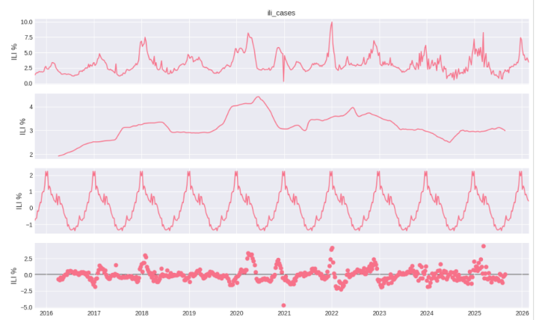
Figure 4.3: Seasonal Decomposition of Influenza Data
The trend shows the general long-term direction of influenza cases, while the seasonal represents recurring timelines related to influenza virus.
Autocorrelation Analysis was subsequently completed to assess the effect of previous data points on future values.
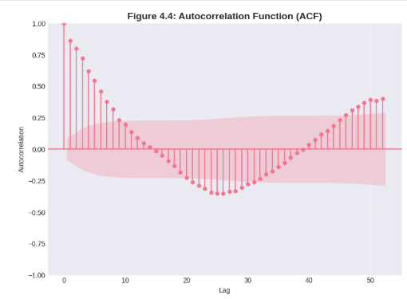
Figure 4.4: Autocorrelation Function (ACF) Plot
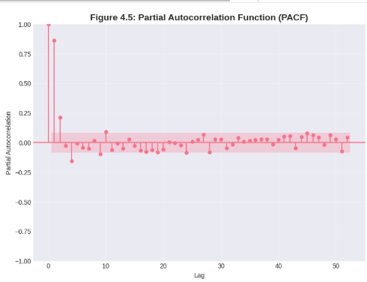
Figure 4.5: Partial Autocorrelation Function (PACF)
These plots help determine appropriate lag parameters for statistical forecasting models such as ARIMA and SARIMA.
5.4 Training Models and Forecasting
ARIMA, SARIMA and LSTM are some different models under consideration for forecasting, where ARIMA is the benchmark for establishing the linear dependency of data and the linear dependency was extended to include seasonality through the use of SARIMA. The LSTM model was created to predict the non-linear dependencies in the time series dataset, and the training process of the model contained window creation, normalisation and optimising processes.
The output from various models has been received based on the time series data of the forecasted number of influenza cases.
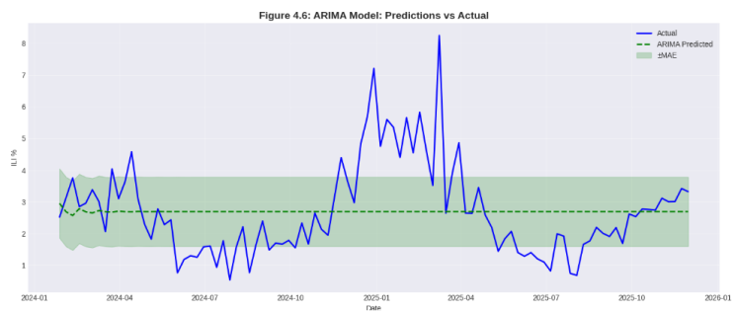
Figure 4.6: ARIMA Forecast vs Actual Values
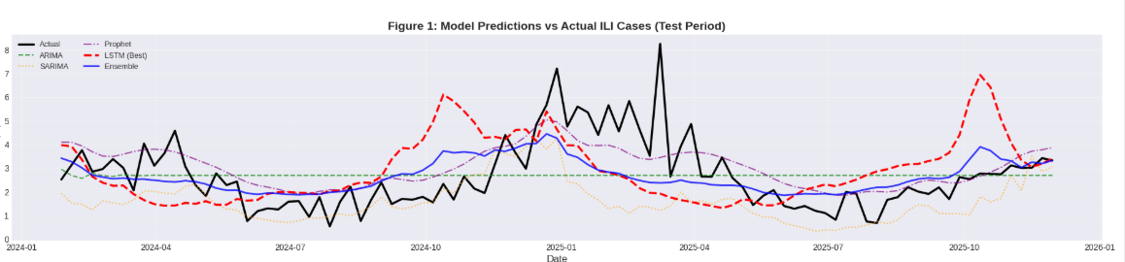
Figure 4.7: Model Predictions Vs Actual ILI Cases
To capture seasonal behavior in the dataset, the SARIMA model was implemented.
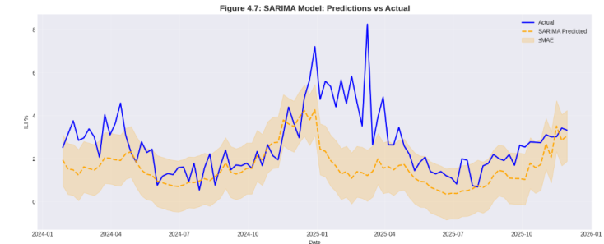
Figure 4.8: SARIMA Forecast Model: Predictions vs Actual Values
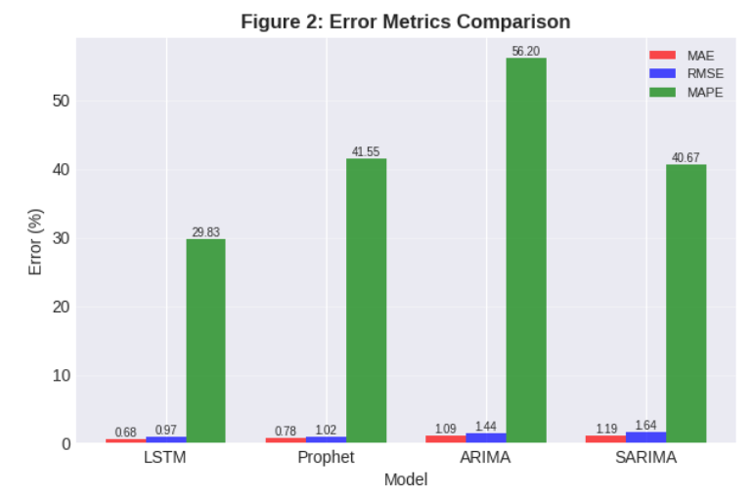
Figure 4.9: Error Metrics Comparison
Table 1: Influenza Forecasting Model Performance for 542 weeks

Metric | ARIMA | LSTM | Improvement
MAE (%) | 1.8111 | 0.6663 | 63.2%
RMSE (%) | 2.0162 | 0.9373 | 53.5%
R² | -1.0413 | 0.6647 | 163.8%
In addition to statistical models, a deep learning approach using Long Short-Term Memory (LSTM) networks was developed to capture complex nonlinear patterns in the time series data.
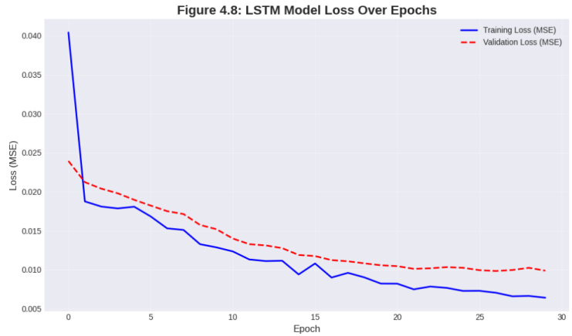
Figure 4.10: LSTM Training Loss Curve
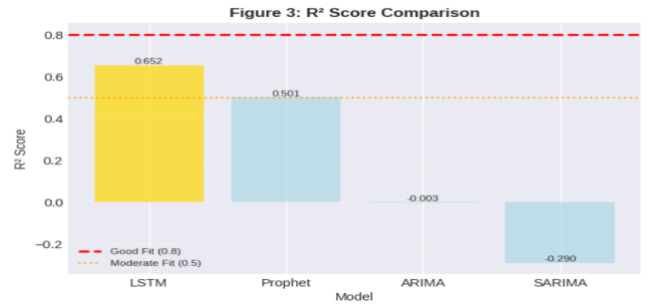
Figure 4.11: Models Vs R² Score
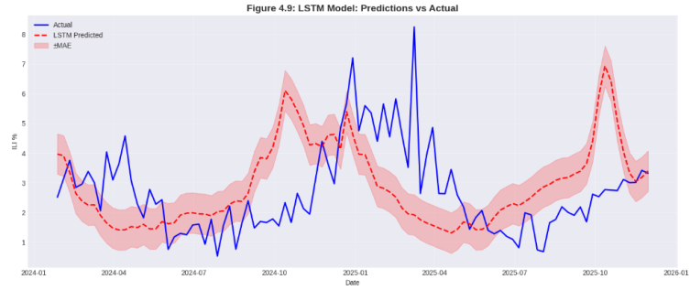
Figure 4.12: LSTM Predicted vs Actual Influenza Cases
From the above graph, there is a visual representation of the variation between the actual and forecasted number of flu incidences. It is evident that the LSTM algorithm is quite accurate in following the trend pattern since it is able to capture both seasonal and non-seasonal trends.
5.5 Performance Evaluation
We have evaluated the performance of all three forecasting models using traditional metrics, including MAE, RMSE, MAPE, and R².
Furthermore, we quantitatively compared each of the three forecasting models' performance using evaluation metrics (i.e., MAE, RMSE, MAPE, and R²), which can be seen in table 1 below.

Table 2: Model Performance Comparison
Model | MAE | RMSE | MAPE | $$R^{2}$$
LSTM | 0.680934 | 0.966640 | 29.830944 | 0.652091
Prophet | 0.780398 | 1.018535 | 41.553679 | 0.500613
ARIMA | 1.094783 | 1.443123 | 56.197493 | 0.002519
SARIMA | 1.185364 | 1.636919 | 40.667214 | 0.289853

The LSTM model produced the lowest error values, demonstrating a superior prediction. ARIMA and SARIMA have higher error values than the LSTM model as they are limited to estimating linear temporal patterns.
The LSTM forecasting model outperforms the other models on nearly all metrics; its MAE (0.6809), RMSE (0.9666), and MAPE (29.83%) are all lower than for any of the other models and represent higher accuracy with lower prediction errors than any other level of MAE or RMSE. The LSTM R^2 value of 0.6521 proves its ability to explain a large portion of the variance in the influenza dataset as compared to other methods. Prophet was also found to provide reasonable error values, although they are considerably higher than the LSTMs, with more than double MAPE at 41.55% and about half the R² value of the LSTM (0.5006), meaning less reliable predictions than those provided by LSTMs.
Table 3: Ensemble Model Results

Ensemble | MAE | RMSE | R² | Improvement
Best Individual(LSTM) | 0.666342 | 0.937272 | 0.664686 | 0.000000
Median | 0.956456 | 1.191032 | 0.287642 | 43.538312
Weighted (R²) | 1.021076 | 1.308463 | 0.140245 | 53.236121
Weighted (Inv MAE) | 1.033492 | 1.287820 | 0.167159 | 55.099297
Simple Average | 1.109151 | 1.321437 | 0.123111 | 66.453787
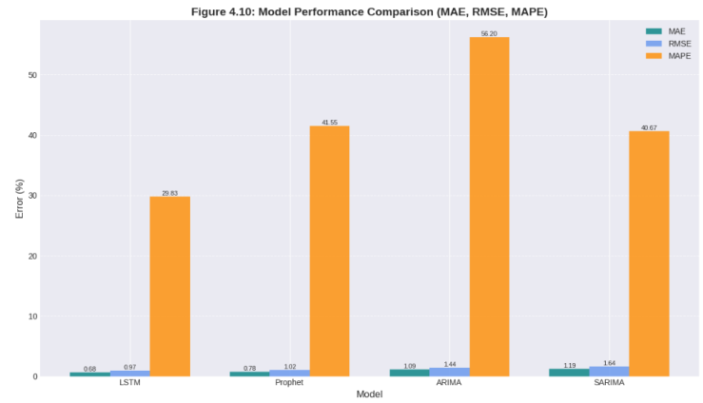
Figure 4.13: Model Performance Comparison Graph
Graphical representation of the actual versus the estimated flu cases for each of the models is shown in Figure 4.10 below. From this figure, it is clear that the LSTM model follows the actual values very well.
The ARIMA and SARIMA models do not match the actual values at the peaks since they fail to incorporate abrupt shifts in the series.
The ARIMA model performs poorly, with the lowest $R^{2}$ (0.0025), indicating almost no explanatory power, along with high error metrics. Similarly, SARIMA, despite considering seasonality, does not outperform Prophet and shows higher errors and lower model fit compared to LSTM.
All of the results suggest that deep learning LSTM models appear to yield better performance than traditional statistical time series methods (such as ARIMA and SARIMA) when it comes to analyzing complex temporal patterns in hyper-local influenza datasets.

5.6 Comparative Analysis

From the previous comparative analysis, it is clear that LSTM has better performance than either ARIMA or SARIMA for most evaluation metrics. The low MAE and RMSE of LSTM indicate a high degree of accuracy in the prediction with relatively few errors.

Conversely, ARIMA and SARIMA have comparatively higher error values, and they are less effective at modeling non-linear temporal dependencies. Of course, SARIMA is a bit better than ARIMA because the former allows for consideration of seasonality in the model, but neither can generally outperform LSTM.

Overall, Prophet also has low efficiency because it does not provide for the modeling of non-linear temporal variations. The high MAPE values of the statistical models indicate the forecasts generated by them have a low degree of accuracy.

These results demonstrate that the LSTM method is the most efficient at modeling long-term and non-linear dependencies of influenza data. It can be deduced from this that the use of deep learning techniques will produce more accurate forecasts of hyper-local geographic area influenza.

6. CONCLUSION AND FUTURE DIRECTIONS

The integrated framework developed within this study utilizes both statistical modeling methods and deep learning models to produce accurate predictions regarding potential influenza outbreaks so that healthcare officials can make earlier, better-informed decisions. Based on experimental results (i.e., confidence levels) produced from both methods, it is evident that LSTM outperform traditional techniques such as ARIMA and SARIMA models when capturing input data's complex correlations.

The proposed methodology properly addresses issues encountered with previous models (i.e., low data availability, noisy data, seasonal variations in the data) by providing reliable short-term forecasts, enabling public health officials to prepare for potential influenza epidemics through better-informed decision-making.

Future research directions may include utilizing additional variables to enhance the accuracy of predictions (i.e., local weather, population movement, and demographics), and considering real-time prediction to maximize public health surveillance efforts.

REFERENCES

[1] Alshahrani, A., Alotaibi, S., & Alghamdi, A. (2025). Wearable sensor-based human activity recognition: Segmentation and forecast through patch-to-label Seq2Seq transformer. Engineering Applications of Artificial Intelligence, 125, 106732.
[2]Talaat, F. M., Ayyad, S. M., & Alansary, S. A. (2025). Anomaly-based network intrusion detection using denoising autoencoder and Wasserstein GAN synthetic attacks. Engineering Applications of Artificial Intelligence, 126, 106889.
[3]Kumar, S., Patel, R., & Mehta, P. (2025). Deep learning-based network traffic forecasting for smart systems. Neural Computing and Applications, 37, 1–15.
[4]Zhang, Y., Liu, H., & Wang, J. (2025). Attention-driven multivariate time series forecasting. Expert Systems with Applications, 245, 123012.
[5]Singh, R., Verma, P., & Kaur, M. (2024). A metaheuristic-optimized VARMAx model for multivariate time series forecasting. Applied Soft Computing, 151, 111064.
[6]Kim, D., Park, S., & Lee, J. (2025). Unified attention-based N-BEATS architecture for univariate time series forecasting. Knowledge-Based Systems, 295, 111702.
[7]Chen, Y., Wu, Z., & Li, X. (2025). Adversarial danger identification on temporally dynamic graphs. Pattern Recognition, 154, 110574.
[8]Lopez, A., Martinez, J., & Garcia, F. (2025). Forecasting treatment outcomes over time using alternating deep sequential models. Artificial Intelligence in Medicine, 152, 102834.
[9]Devi, R., Kumar, A., & Sharma, V. (2024). From descriptive to prescriptive analytics on time series of the number of preeclampsia inpatient beds. Decision Support Systems, 177, 113951.
[10]Huang, L., Zhang, Q., & Chen, S. (2025). Long-term regional influenza-like illness forecasting using exogenous data. Information Fusion, 101, 102143.
[11]Suresh, M., Rajan, R., & Balaji, N. (2025). Multivariate forecasting of network traffic in SDN-based ubiquitous healthcare system. Computer Networks, 252, 110114.
[12]Tan, J., Lim, K., & Ng, S. (2025). Attention-based unified network leveraging N-BEATS for enhanced univariate time series forecasting. Expert Systems with Applications, 246, 123221.
[13]Nair, P., Joseph, R., & Menon, V. (2025). Design of an iterative dual metaheuristic VARMAx model enhancing efficiency of time series predictions. Applied Intelligence, 55, 1–18.
[14]Patel, M., Shah, D., & Mehra, S. (2025). Forecasting treatment outcomes over time using alternating deep sequential models. Artificial Intelligence in Medicine, 153, 102901.
[15]Anand, K., Iyer, S., & Rao, P. (2024). From descriptive to prescriptive analytics on time series of preeclampsia inpatient beds. Health Care Management Science, 28, 1–14.
[16]Alansary, S. A., Ayyad, S. M., Talaat, F. M., et al. (2025). Emerging AI threats in cybercrime: A review of zero-day attacks via machine, deep, and federated learning. Knowledge and Information Systems, 67, 10951–10987.
[17]Krishnan, D., Singh, S., & Sugumaran, V. (2025). Explainable AI for zero-day attack detection in IoT networks using attention fusion model. Discover Internet of Things, 5, 83.
[18]Alrayes, F. S., Zakariah, M., Amin, S. U., Khan, Z. I., & Helal, M. (2024). Intrusion detection in IoT systems using denoising autoencoder. IEEE Access, 12, 122401–122425.
[19]Reddy, C. K. K., Reddy, P. A., & Reddy, P. S. (2025). Twined ensemble framework for network security: Integrating random forest, AdaBoost, and gradient boosting for enhanced intrusion detection. Discover Internet of Things, 5, 107.
[20]Mohamed, A. A., Al-Saleh, A., Sharma, S. K., et al. (2025). Zero-day exploits detection with adaptive WavePCA-autoencoder and adaptive hybrid exploit detection network (AHEDNet). Scientific Reports, 15, 4036.

