|  |  |
| --- | --- |
| **Project Case** |  |
| COMP6681001  Web Programming |
| **Computer Science** | **O222-COMP6681-BD04-00** |
| ***Valid on*** *Odd Semester Year 2021/2022* | **Revision 00** |

1. Seluruh kelompok tidak diperkenankan untuk:

*The whole group is not allowed to:*

* + - Melihat sebagian atau seluruh proyek kelompok lain,

*Seeing a part or the whole project from another groups*

* + - Menyadur sebagian maupun seluruh proyek dari buku,

*Adapted a part or the whole project from the book*

* + - Mendownload sebagian maupun seluruh proyek dari internet,

*Downloading a part or the whole project from the internet,*

* + - Mengerjakan soal yang tidak sesuai dengan tema yang ada di soal proyek,

*Working with another theme which is not in accordance with the existing theme in the matter of the project,*

* + - Melakukan tindakan kecurangan lainnya,

*Committing other dishonest actions,*

* + - Secara sengaja maupun tidak sengaja melakukan segala tindakan kelalaian yang menyebabkan hasil karyanya berhasil dicontek oleh orang lain / kelompok lain.

*Accidentally or intentionally conduct any failure action that cause the results of the project was copied by someone else / other groups.*

1. Jika kelompok terbukti melakukan tindakan seperti yang dijelaskan butir 1 di atas, maka **nilai kelompok** yang melakukan kecurangan (menyontek maupun dicontek) akan di – **NOL** – kan.

*If the group is proved to the actions described in point 1 above, the score of the group which committed dishonest acts (cheating or being cheated) will be “Zero”*

1. Perhatikan jadwal pengumpulan proyek, segala jenis pengumpulan proyek di luar jadwal tidak dilayani.

*Pay attention to the submission schedule for the project, all kinds of submission outside the project schedule will not be accepted*

1. Bila Anda tidak membaca peraturan ini, maka Anda dianggap telah membaca dan menyetujuinya

*If you have missed to read these regulations, so you are considered to have read and agreed on it*

1. Persentase penilaiaan untuk matakuliah ini adalah sebagai berikut:

*Marking percentage for this subject is described as follows:*

|  |  |
| --- | --- |
| **Tugas Mandiri**  *Assignment* | **Proyek**  *Project* |
| 40% | 60% |

1. Software yang digunakan pada matakuliah ini adalah sebagai berikut:

*Software will be used in this subject are described as follows:*

|  |
| --- |
| **Software**  *Software* |
| • Visual Studio Code  • Three JS  • Chrome / Firefox / Microsoft Edge |

## Ekstensi file yang harus disertakan dalam pengumpulan tugas mandiri dan proyek untuk matakuliah ini adalah sebagai berikut:

*File extensions should be included in assignment and project collection for this subject are described as follows:*

|  |  |
| --- | --- |
| **Tugas Mandiri**  *Assignment* | **Proyek**  *Project* |
| HTML, CSS, JS, Image Files (JPG / PNG), GLB | HTML, CSS, JS, Image Files (JPG / PNG), GLB |

General Provisions:

* Use **MySQL** asdatabase and must using **Laravel Migration** features.
* **All file upload** feature such as image and document must be **stored to server storage**.
* Use PHP Framework **Laravel 8** to build the project.
* Use Laravel **MVC** concept (**Model, View, Controller**) to build the project.
* Use **Eloquent Query / Query Builder** to work with database.
* You are free to design your own database table **based on given requirements**.
* Print screen given below is only an example. You are free to create your own user interfaces.
* It is **prohibited** to install any kind of Laravel packages. You must use fresh installation of **Laravel 8**. Laravel UI package is allowed for authentication.
* Only **validation** in the **backend** (using Laravel) will be graded.

## Soal

*Case*

**Book Store**

**Book Store** is one of the most popular bookstores in Japan. This bookstore sells more than 100 types of book all over the world, and now the owner of Book Store wants to open a new branch in Indonesia. To handle all the transactions, the owner needs a website and some employees as the admin.

As a web developer, you are assigned to create the website using **Laravel 8 framework**. There are three roles in this website: **Admin**, **Member**, and **Guest** (**non**-**logged**-**in** **user**). Each page will show a **greeting message (**for the **logged-in user only)**, and the **current date and time**. You need to build this website based on the following criteria:

1. **Login Page**

Validate only **guest** can access this page. In this page, **guest** can login using **email** and **password** that are registered on the website **database**. If the user checks the “**Remember Me**” checkbox, the website will remember the user using **cookie** for **7 days**. After success login, redirect user to **Home Page**. The following table shows the existing fields on this page and the validation for each field:

|  |  |
| --- | --- |
| **Field** | **Information** |
| **Email** | Must be **filled** with **email** validation |
| **Password** | Must be **filled** |

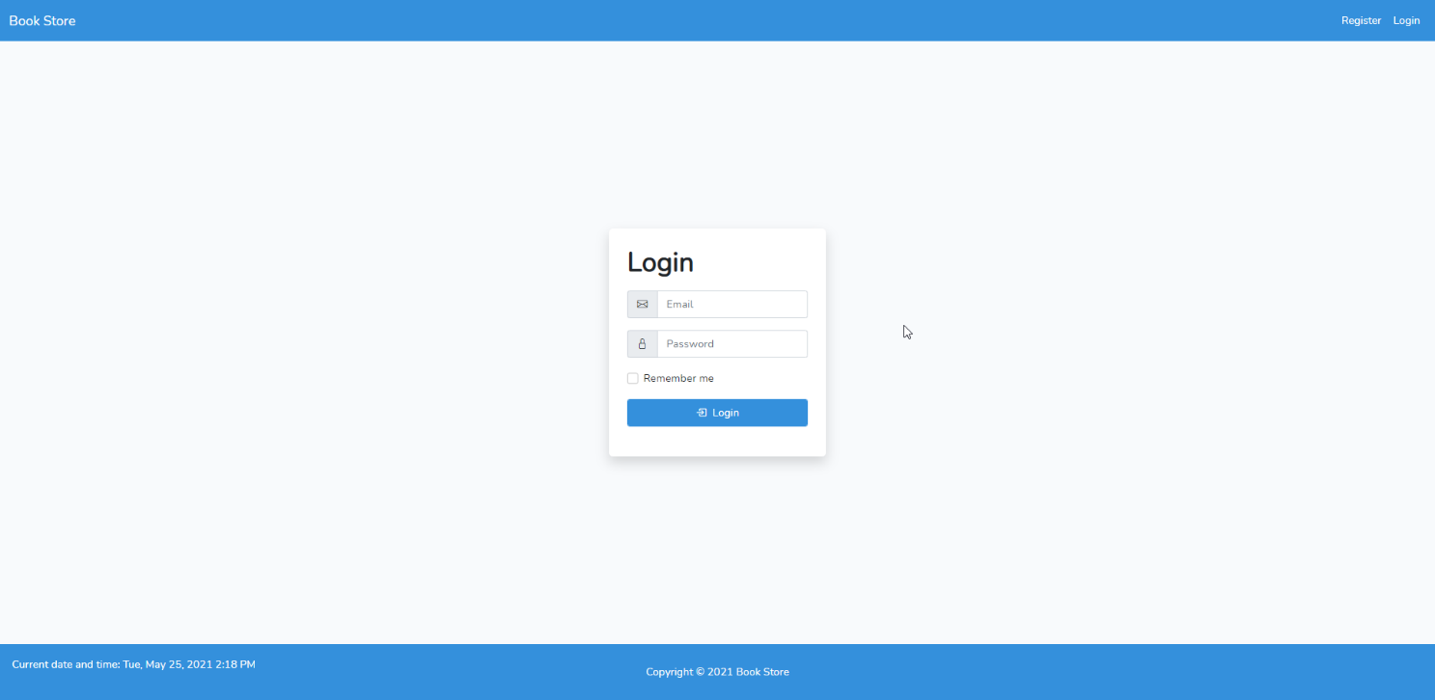

Figure 1. Login Page

1. **Register Page**

Validate only **guest** can access this page. In this page, **guest** can **register** an account to login to the website. Display an **error message** if user input incorrect personal data. After success register, redirect user to **Home Page**. The following table shows the existing fields on this page and the validation for each field:

|  |  |
| --- | --- |
| **Field** | **Information** |
| **Email** | Must be **filled** with **email** validation and **unique** |
| **Full Name** | Must be **filled** |
| **Password** | Must be **filled** with **minimum 8** characters length |
| **Confirm Password** | Must be **filled** and **same with password** |

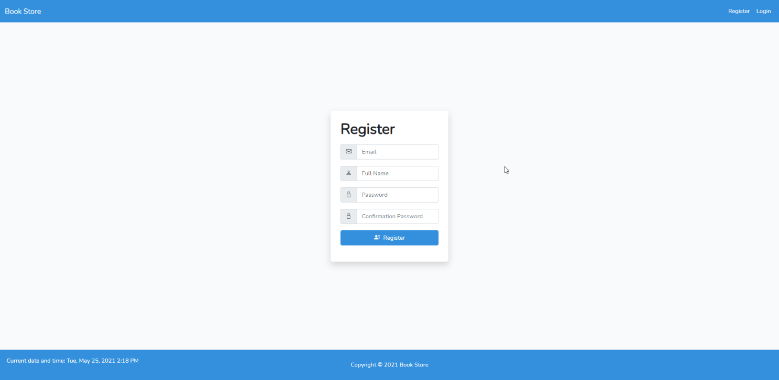

Figure 2. Register Page

1. **Home Page**

This page is accessible for **all** **users**. In this page, the user can **view all** the **books** that all sold at the website. The user can **search** the books by **Book**’**s** **Name** using the provided **input** and reset the view by press the ‘**Clear Filter**’ button. The shown books are **paginated** with **5 books** shown **each** **page**. The book’s information that shown are **Book**’**s** **Cover**, **Book’s Name**, **Book**’**s Author**, and **Book**’**s Price**. When the user clicks **View Detail** button, the user will be redirected to **Book Details** **page**. When the user click

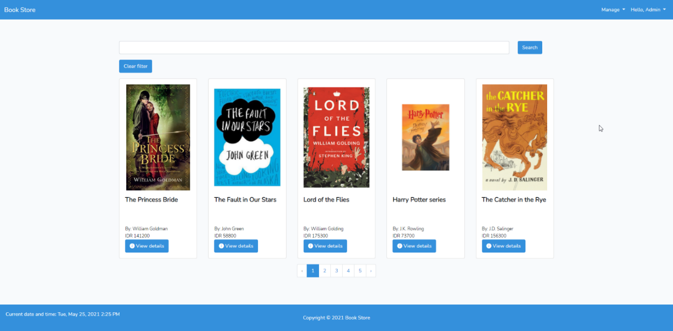

Figure 3. Home Page (Admin)

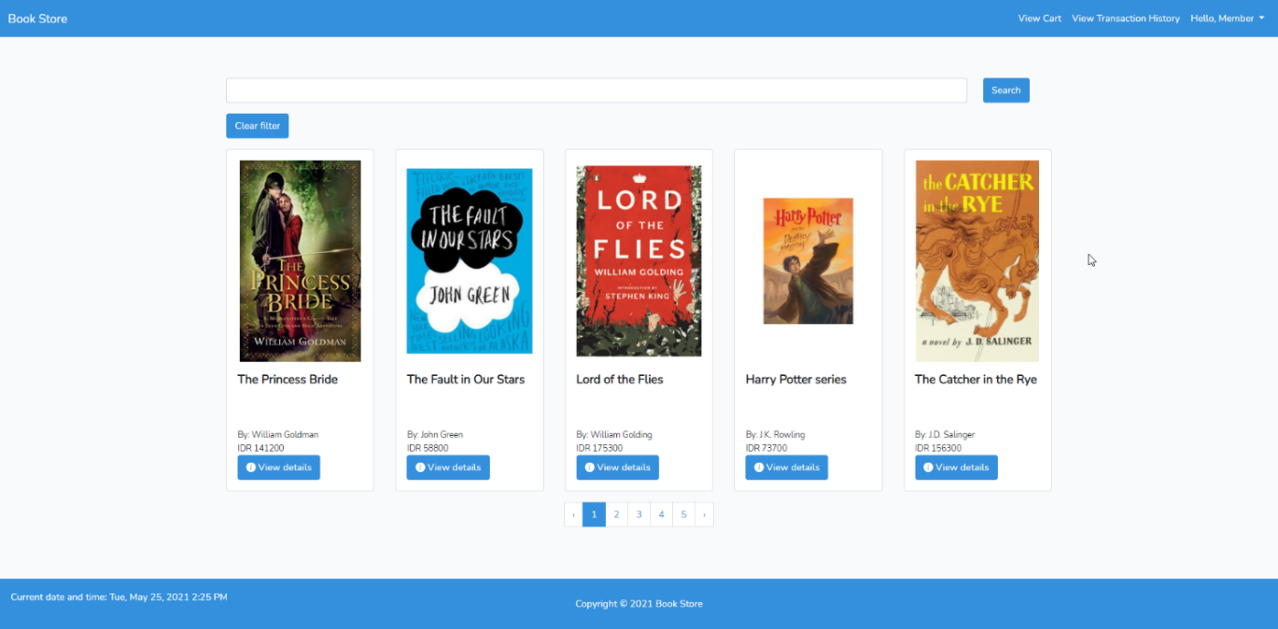

Figure 4. Home Page (Member)

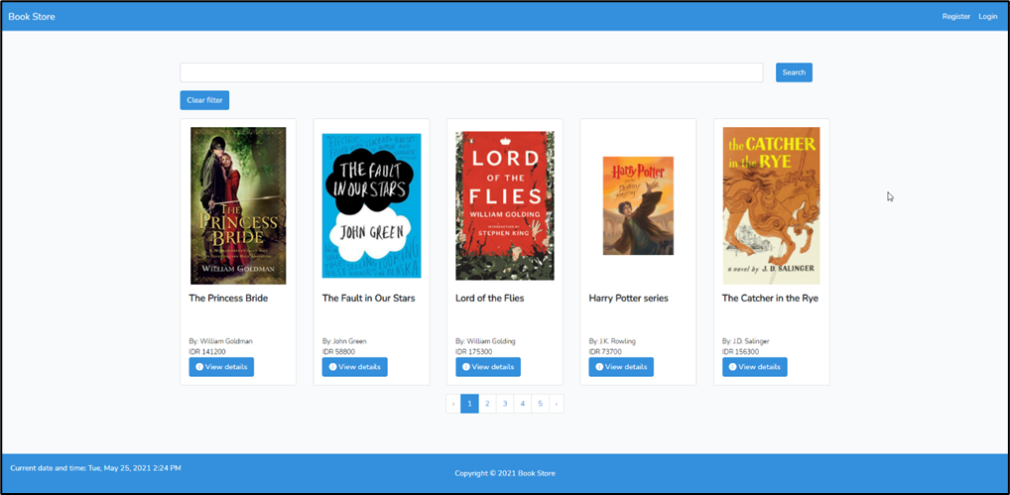

Figure 5. Home Page (Guest)

1. **Manage Books Page**

Validate only **admin** can access this page. In this page the **admin** can **manage** **all books** on the website. When the **admin** clicks **View Detail button**, the **admin** will be redirected to **Book Details page**. There is a **form** for inserting the book information. When **admin** clicks delete button, delete selected book from database. The following table shows the existing fields on this page and the validation for each field:

|  |  |
| --- | --- |
| **Field** | **Information** |
| **Name** | Must be **filled** |
| **Author** | Must be **filled** |
| **Synopsis** | Must be **filled** |
| **Genres** | Must be **chosen** and **exists** in the **database** |
| **Cover** | Must be **uploaded** and must be an **image** |
| **Price** | Must be **filled** and **integer** |

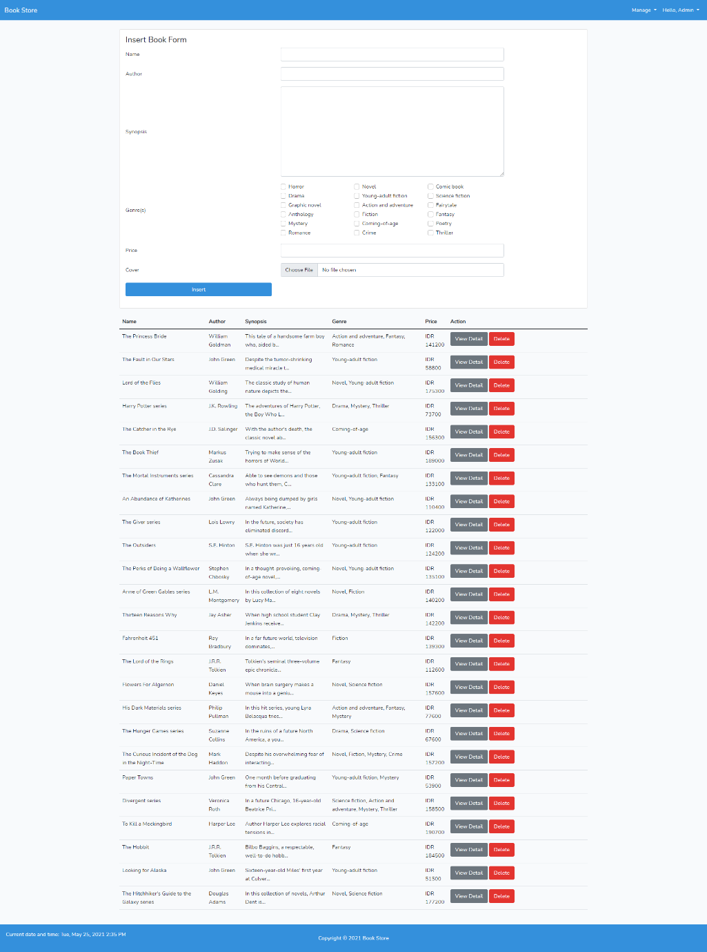

Figure 6. Manage Books Page

1. **Book Details Page**

This page is accessible for **all users**. In this page, **guest** can only view the **book details**. **admin** can **update** the book’s information. Make sure that **each field** is filled by the **book information**. The following table shows the existing fields on this page and the validation for each field:

|  |  |
| --- | --- |
| **Field** | **Information** |
| **Name** | Must be **filled** |
| **Author** | Must be **filled** |
| **Synopsis** | Must be **filled** |
| **Genres** | Must be **chosen** and **exists** in the **database** |
| **Cover** | **Sometimes** required and must be an **image** |
| **Price** | Must be **filled** and **integer** |

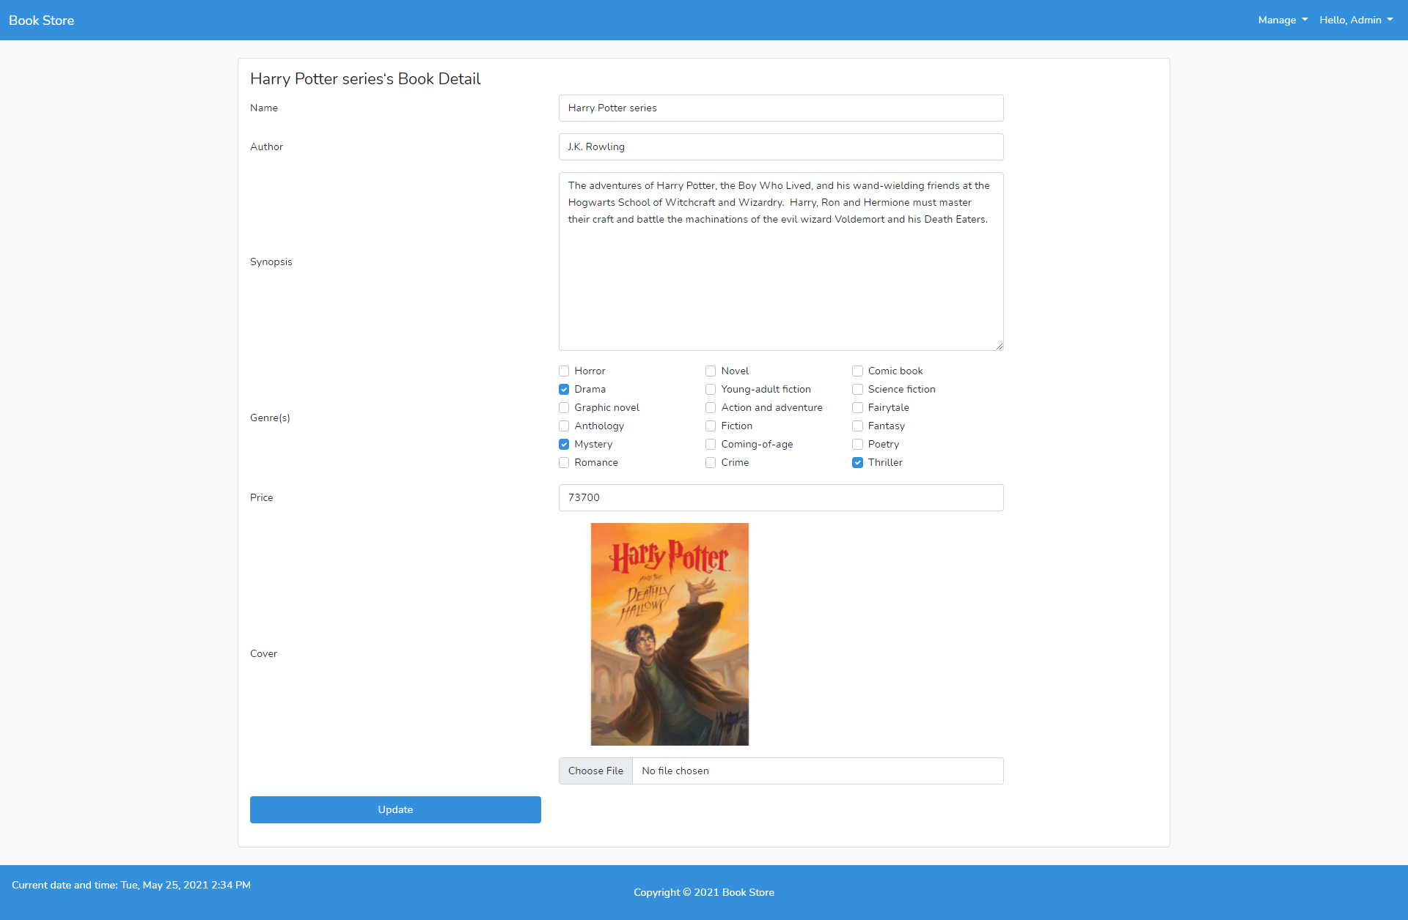

Figure 7. Book Details Page (Admin)

In this page, the **member** can add the book to the cart. The member must input the **quantity** of the book to be inserted to the cart. The **quantity** must be **integer** and **must be 1 or more**.

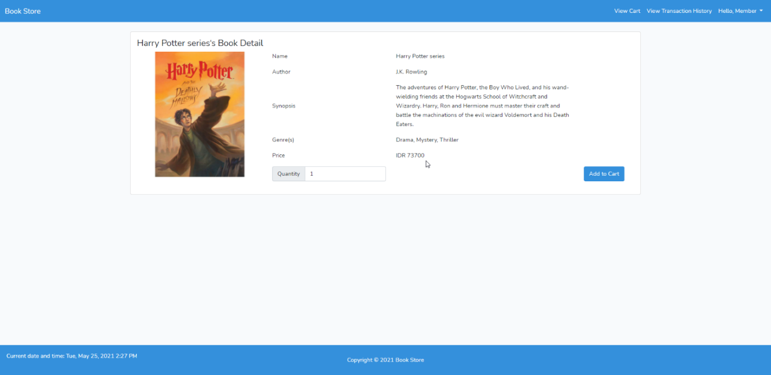

Figure 8. Book Details Page (Member)

Figure 9. Book Details Page (Guest)

1. **Manage Genre Page**

Validate only **admin** can access this page. In this page the **admin** can **manage** **all genres** on the website. The **admin** can view the details page by clicking the **View Details** button. There is a **form** for inserting the genre. When **admin** clicks delete button, delete selected genre from database. The following table shows the existing fields on this page and the validation for each field:

|  |  |
| --- | --- |
| **Field** | **Information** |
| **Name** | Must be **filled** and **unique** |

Figure 10. Manage Genre Page

1. **Genre Detail Page**

Validate only **admin** can access this page. In this page **admin** can **update** the genre. This page will **show all books** from the genre. Make sure that **each field** is filled by the **genre information**. The following table shows the existing fields on this page and the validation for each field:

|  |  |
| --- | --- |
| **Field** | **Information** |
| **Name** | Must be **filled** and **unique** |

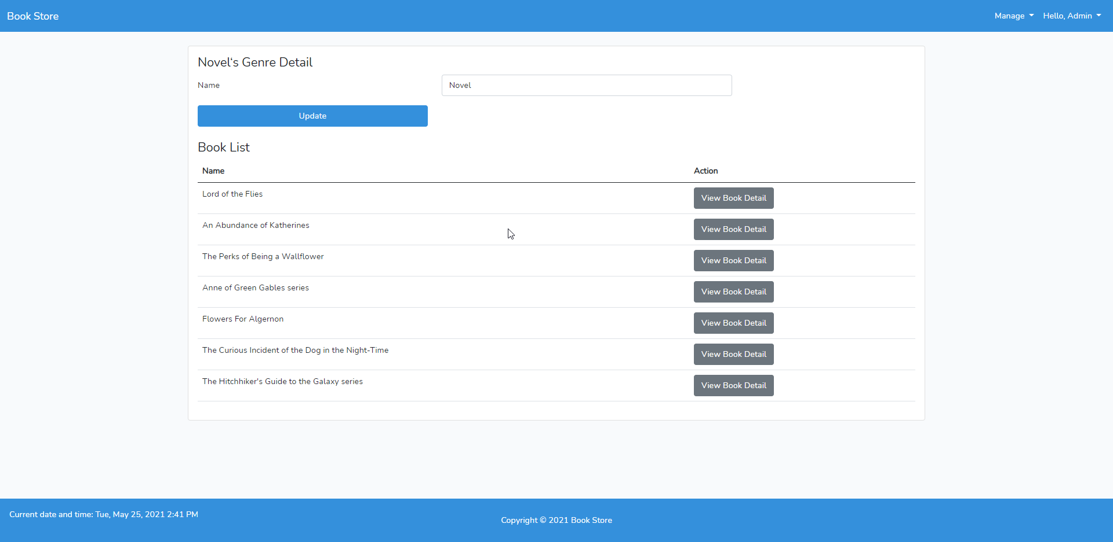

Figure 11. Genre Detail Page

1. **Manage User Page**

Validate only **admin** can access this page. In this page, **admin** can **view all the users** and **delete the non-admin users**. You need to show the **User’s Name**, **User’s Email**, and the **User’s Role**. When the **admin** clicks **View detail button**, the **admin** will be redirected to **User Detail Page**. When **admin** clicks delete button, delete selected user from database.

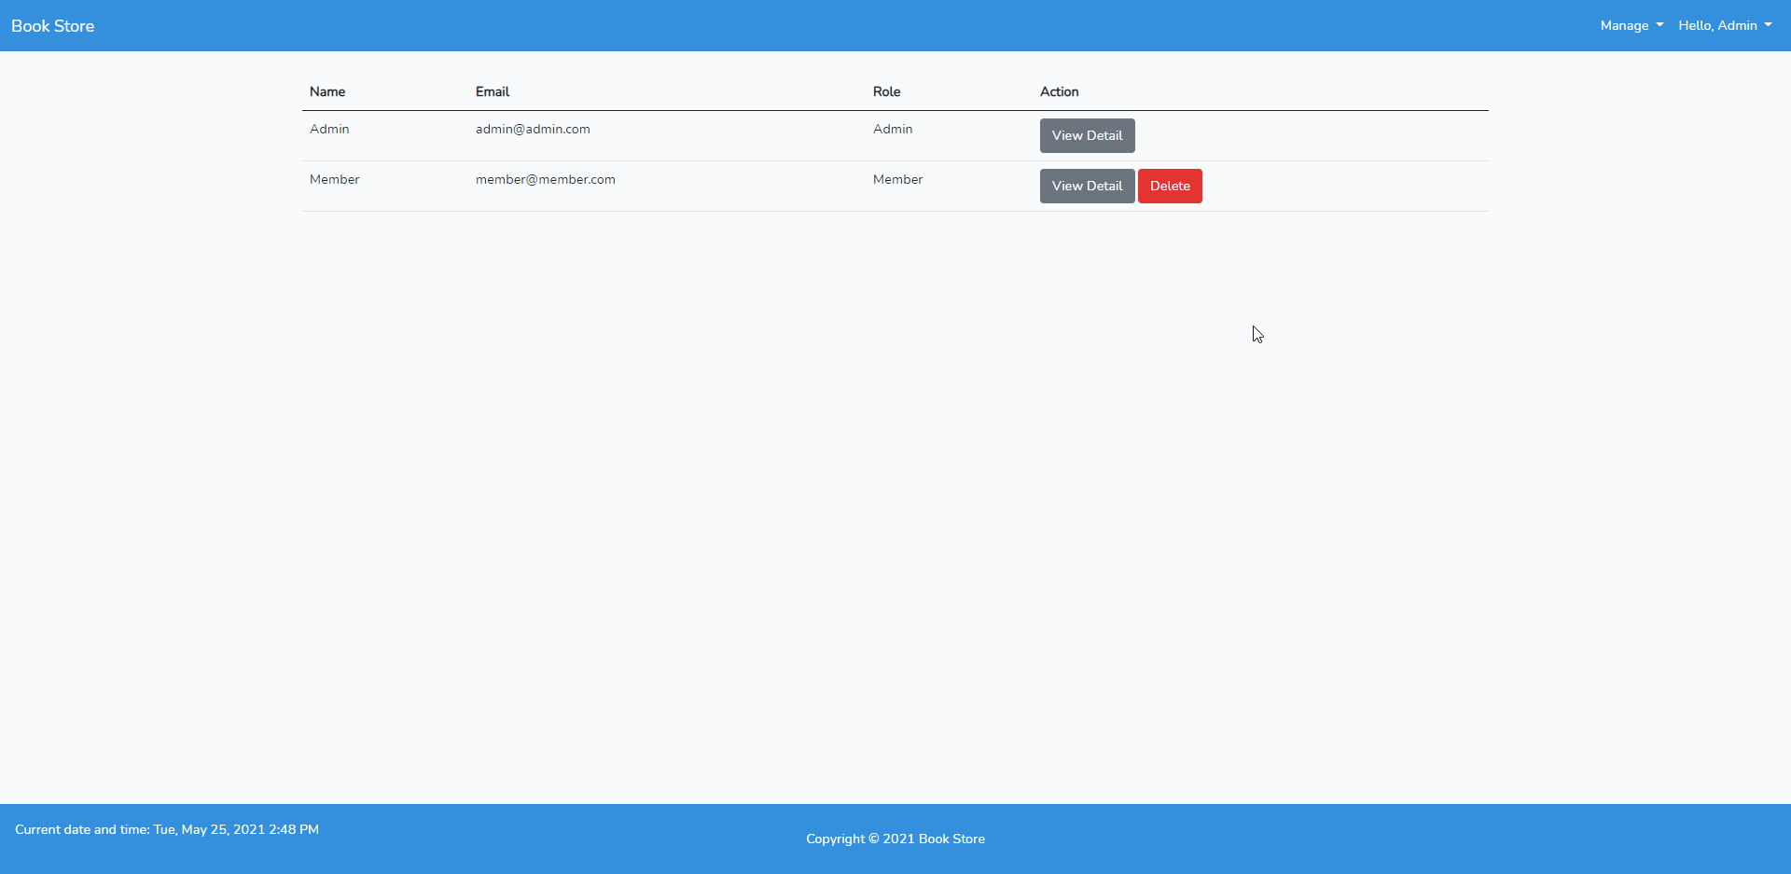

Figure 12. Manage User Page

1. **User Detail Page**

Validate only **admin** can access this page. In this page, admin **can view and update** all the information about the user **except password**. Make sure that **each field** is filled by the **user information**. The following table shows the existing fields on this page and the validation for each field:

|  |  |
| --- | --- |
| **Field** | **Information** |
| **Role** | Must be **filled** and must be either ‘**Admin**’ or ‘**Member**’ |
| **Name** | Must be **filled** |
| **Email** | Must be **filled** and **unique** with a valid **email format** |

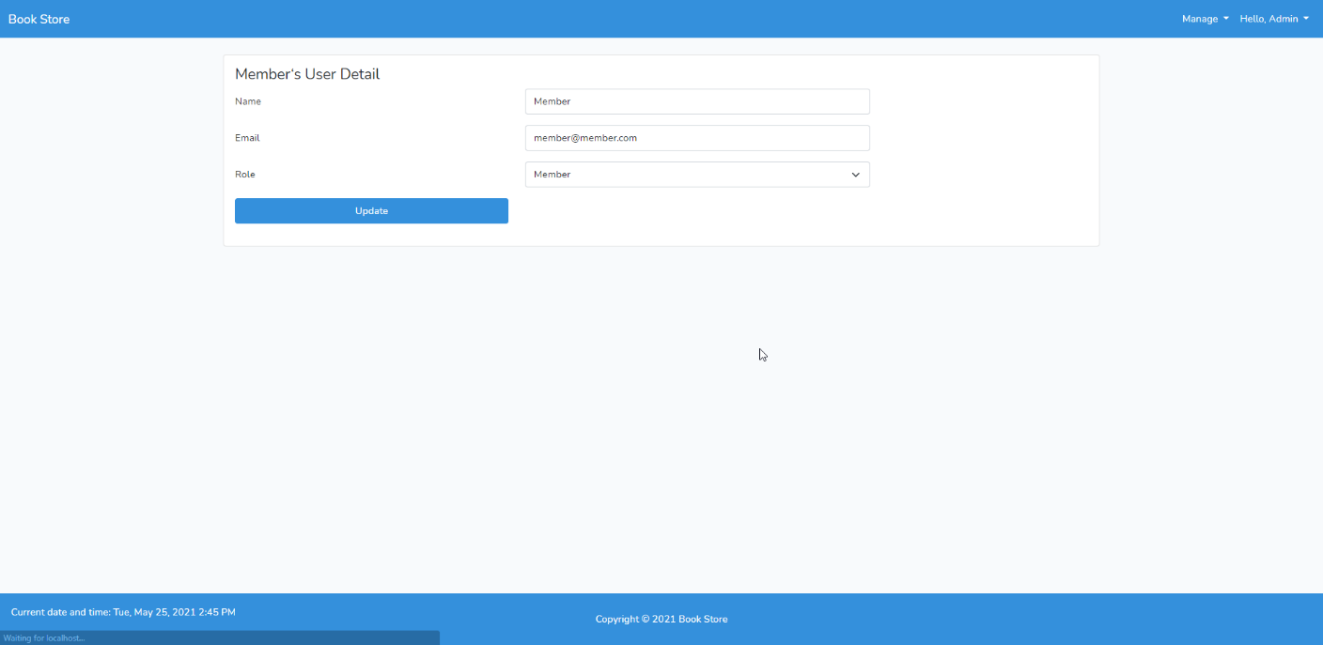

Figure 13. User Detail Page

1. **View Cart Page**

Validate only **member** can access this page. In this page, members **can view all the books** in their cart. You need to show the **Book’s Name**, **Book’s Author**, **Book’s Price**, and **Book’s Quantity**. Calculate and show **the sub total for each book** and the **grand total price**. When the **member** clicks the **View book detail**, then the **member** will be redirected to **Book Details Page**. When the **member** clicks the **Edit button**, then the **member** will be redirected to **Edit Cart Page**. When the **member** clicks the **Remove button**, then the website will remove the item from the **member**’**s** **cart**.You also need to provide a feature to **checkout** the cart. If the member wants to checkout, then **create a new transaction** that can be viewed in **transaction history page** later.

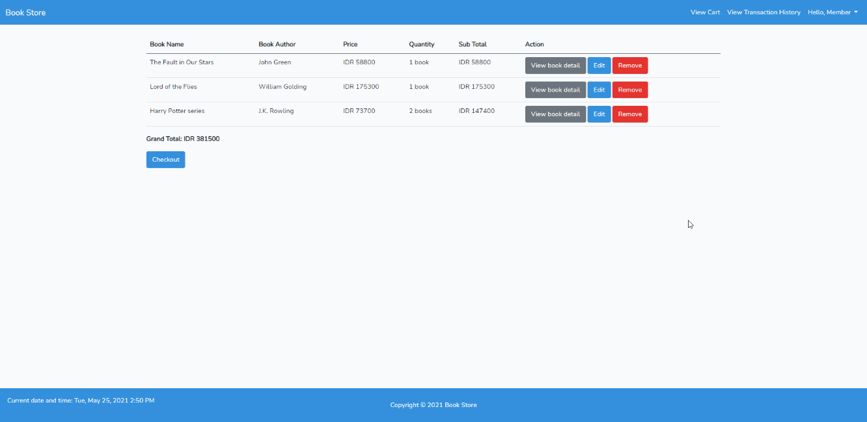

Figure . View Cart Page

1. **Edit Cart Page**

Validate only **member** can access this page. In this page, members can **view the current book** and **update the quantity**. You need to show the **Book’s Cover**, **Book’s Name**, **Book’s Author**, **Book’s Synopsis**, **Book’s Genre**, **Book’s Pric**e, and the **quantity**. The following table shows the existing fields on this page and the validation for each field:

|  |  |
| --- | --- |
| **Field** | **Information** |
| **Quantity** | Must be **filled** and must be **1 or more** |

Figure . Edit Cart Page

1. **View Transaction History Page**

Validate only **member** can access this page. In this page, members **can view all the transaction history** information which are **Transaction Id** and **Transaction Date**. When the **member** clicks the **View transaction detail**, then the **member** will be redirected to **Transaction History Detail Page**.

Figure . View Transaction History Page

1. **Transaction History Detail Page**

Validate only **member** can access this page. In this page, members **can view** **all the information** about the books they bought which are **Book’s Name**, **Book’s Author**, **Book’s Price**, **Quantity**, **Sub Total** for each book, and the **Grand Total Price**. When the **member** clicks **View book detail**, then the **member** will be redirected to **Book Detail Page**.

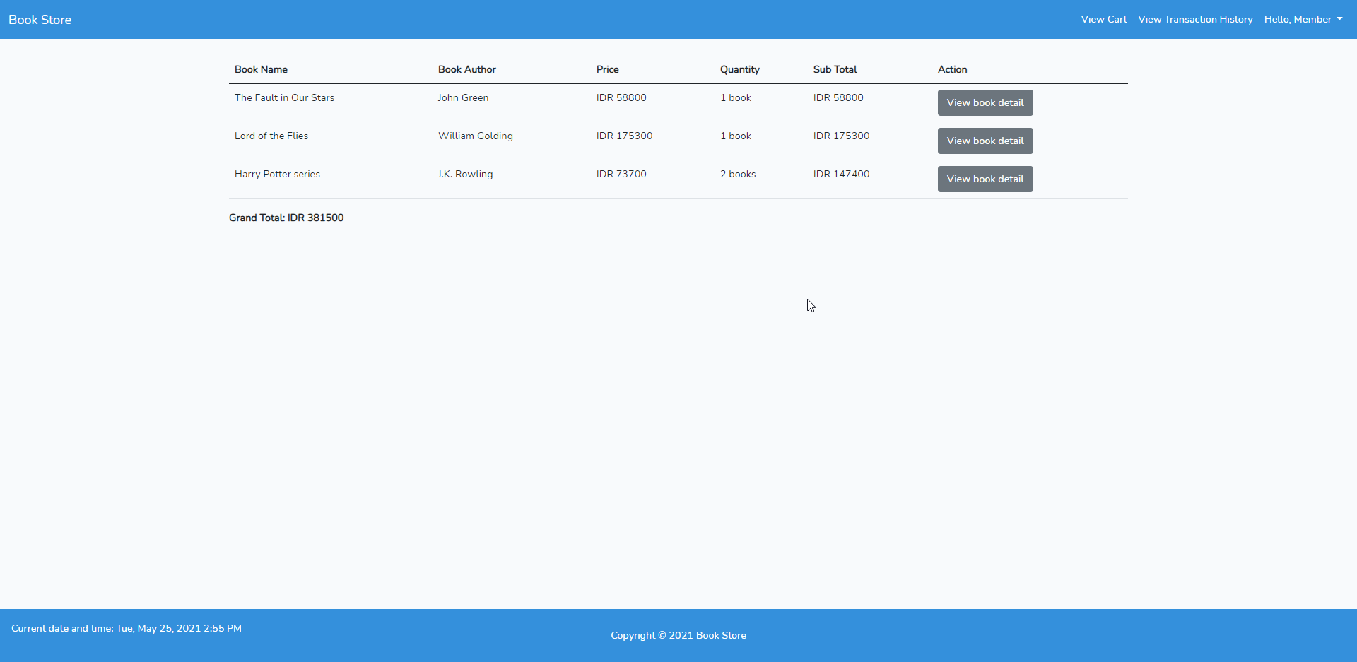

Figure . Transaction History Detail Page

1. **Profile Page**

Validate only **member** and **admin** can access this page. In this page, **user** can **update** their **name** and **password**. User **can view their email address** but **cannot update the email address**. When the **user** clicks **Change password**, then the **users** will be redirected to **Change Password Page**. The following table shows the existing fields on this page and the validation for each field:

|  |  |
| --- | --- |
| **Field** | **Information** |
| **Name** | Must be **filled** |

Figure . Profile Page

1. **Change Password Page**

Validate only **admin** and **member** can access this page. In this page, members need to **input their old password** as a verification and **input the new password twice**. The following table shows the existing fields on this page and the validation for each field:

|  |  |
| --- | --- |
| **Field** | **Information** |
| **Old Password** | Must be **filled** and must be **correct** |
| **New Password** | Must be **filled**, minimum **8 characters long**, and must be **different** from the **old password** |
| **New Confirmation Password** | Must be **filled** and must be **the same** with the **new password** |

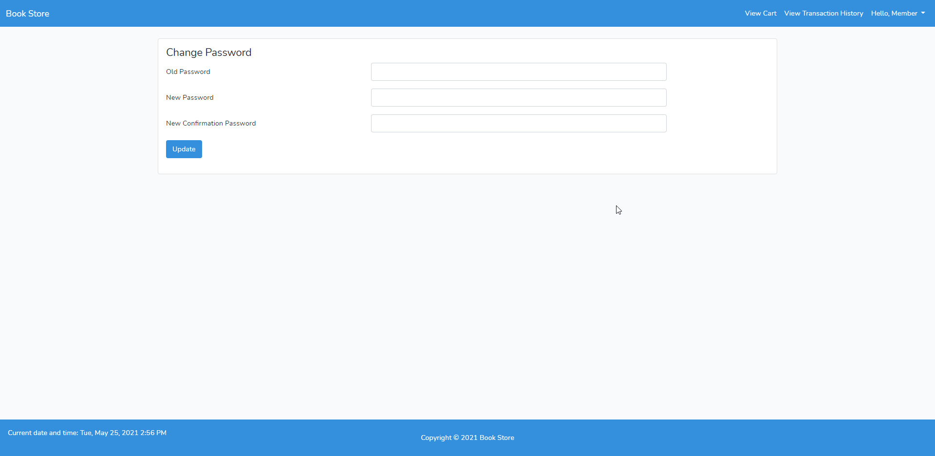

Figure . Change Password Page

Here are the rules that you must follow to create your project:

1. Use appropriate software for this subject based on **Sistem Praktikum** that can be downloaded from Binusmaya
2. Use the techniques taught during practicum.
3. Collect appropriate files for this subject based on **Sistem Praktikum** that can be downloaded from Binusmaya
4. Include the other files that can support your project, such as:
   * All files in your project
   * Other files (image, audio, video, etc.) used in your project
   * *.DOC file (documentation of your project) that contains all pages in your project, reference links of additional files (image, audio, video, etc.) used in your project, the description about how to use your application, etc

References:

<https://id.wikipedia.org/>