STHANAGNA

A
Project Report
Submitted in partial fulfilment of the Requirements for the award of the Degree of

BACHELOR OF ENGINEERING IN
INFORMATION TECHNOLOGY

By

S BAGAWAN REDDY 1602-21-737-012

B NIRDESH KUMAR 1602-21-737-038

A VENKAT SRI HARSHA 1602-21-737-063

Under the guidance of


Mrs.C. Sireesha Assistant Professor
Department of Information Technology Vasavi College of Engineering (Autonomous)

Accredited by NAAC with 'A++' Grade (Affiliated to Osmania University) Ibrahimbagh, Hyderabad-500 031

2024

Vasavi College of Engineering (Autonomous) Accredited by NAAC with 'A++' Grade (Affiliated to Osmania University) Hyderabad-500 031 Department of Information Technology


DECLARATION BY THE CANDIDATES

We, S Bagawan Reddy, B Nirdesh Kumar & A Venkat Sri Harsha, bearing hall ticket numbers, 1602-21-737-012, 1602-21-737-038 & 1602-21-737-063 respectively, hereby declare that the project report entitled STHANAGNA under the guidance of Mrs. C. Sireesha, Assistant Professor, Department of Information Technology, Vasavi College of Engineering, Hyderabad, is submitted in partial fulfilment of the requirement for the award of the degree of Bachelor of Engineering in Information Technology

This is a record of bonafide work carried out by me and the results embodied in this project report have not been submitted to any other university or institute for the award of any other degree or diploma.

S Bagawan Reddy
1602-21-737-012.

B Nirdesh Kumar
1602-21-737-038.

A Venkat Sri Harsha
1602-21-737-063

Vasavi College of Engineering (Autonomous)
Accredited by NAAC with 'A++' Grade (Affiliated to Osmania University) Hyderabad-500 031
Department of Information Technology



BONAFIDE CERTIFICATE

This is to certify that the project entitled Sthanagna being submitted by S Bagawan Reddy, B Nirdesh Kumar & A Venkat Sri Harsha bearing 1602-21-737-012, 1602-21-737-038 & 1602-21-737-063 in partial fulfilment of the requirements for the award of the degree of Bachelor of Engineering in Information Technology is a record of bonafide work carried out by him/her under my guidance.

Mrs.C.Sireesha | External Examiner | Dr. K. Ram Mohan Rao
Assistant Professor  Internal Guide |  | HOD IT

ACKNOWLEDGEMENT

The satisfaction that accompanies the successful completion of the project would not have been possible without the kind support and help of many individuals. We would like to extend our sincere thanks to all of them.
It is with immense pleasure that we would like to take the opportunity to express our humble gratitude to Mrs. C. Sireesha, Assistant Professor, Information Technology under whom we executed this project. Her constant guidance and willingness to share their vast knowledge made us understand this project and its manifestations in great depths and helped us to complete the assigned tasks.
We are very much thankful to Dr. K. Ram Mohan Rao, Professor and HOD, Information Technology, for his kind support and for providing necessary facilities to carry out the work.
We wish to convey our special thanks to Dr. S. V. Ramana, Principal of Vasavi College of Engineering for giving the required information in doing my project work. Not to forget, we thank all other faculty and non-teaching staff, and my friends who had directly or indirectly helped and supported me in completing my project in time.
We also express our sincere thanks to the Management for providing excellent facilities. Finally, we wish to convey our gratitude to our family who fostered all the facilities that we need.

ABSTRACT
Sthanagna is a comprehensive web application designed to revolutionize the way users interact with and discover various locations, including businesses, landmarks, and other points of interest. By leveraging the powerful Google Maps API, Sthanagna provides an intuitive and user-friendly platform that allows users to search for locations, view detailed information, and receive real-time insights. The application integrates seamlessly with Wikipedia to offer additional context and information, ensuring that users have access to a rich and informative database for their navigation and exploration needs.
At its core, Sthanagna addresses the inefficiencies and fragmented nature of existing location-based information systems. Traditionally, users have had to rely on multiple sources, such as review websites, online directories, and separate navigation apps, to gather the information they need. This often leads to a disjointed experience with inconsistent data. Sthanagna unifies these disparate sources into a single platform, providing comprehensive and accurate information about locations, including ratings, reviews, operational hours, and more. Additionally, the application utilizes geolocation services to offer personalized recommendations based on the user's current position, enhancing the relevance and usefulness of the information provided.
The development of Sthanagna involved creating a robust system architecture that integrates several key technologies. The backend is powered by Express.js, serving static files and handling API requests, while the frontend leverages HTML, CSS, and JavaScript to create an interactive user interface. By using Google Maps and Places APIs, the application dynamically fetches and displays location data, ensuring that users always have the latest information at their fingertips. The integration of voice search and real-time geolocation further enhances the user experience, making Sthanagna a versatile and indispensable tool for modern-day navigation and location discovery.

TABLE OF CONTENTS:

1. INTRODUCTION .................................................................................................................................. 1
1.1. OVERVIEW .........................................................................................................................… 1
1.2. PROBLEM STATEMENT...................................................................................................... 1
1.3. MOTIVATION OF THEME & TITLE ..............................................................................…. 1
2. LITERATURE SURVEY ...................................................................................................................... 2
3. EXISTING SYSTEM ............................................................................................................................ 4
4. PROPOSED SOLUTION ...................................................................................................................... 5
4.1. SYSTEM DESIGN .................................................................................................................. 5
4.1.1. ARCHITECTURE DIAGRAM ................................................................................. 5
4.1.2. USE-CASE DIAGRAM ............................................................................................. 6
4.1.2.1. USE-CASE DESCRIPTIONS .................................................................... 6
4.2. FUNCTIONAL MODULES .................................................................................................. 8
4.2.1. SCREENSHOTS & PSEUDOCODE ......................................................................... 8
5. EXPERIMENTAL SETUP ................................................................................................................... 17
5.1. SYSTEM SPECIFICATIONS ................................................................................................. 17
5.1.1. HARDWARE REQUIREMENTS............................................................................... 17
5.1.2. SOFTWARE REQUIREMENTS ............................................................................... 17
5.2. DATASETS ............................................................................................................................ 17
5.3. METHODOLOGY/ALGORITHM ........................................................................................ 17
6. RESULTS ............................................................................................................................................. 19
7. CONCLUSION & FUTURE SCOPE .................................................................................................. 21
8. REFERENCES ..................................................................................................................................... 22

1.INTRODUCTION

1.1. OVERVIEW

"Sthanagna" is a comprehensive web and mobile application designed to provide users with location-based information and services. Through its intuitive interface, users can effortlessly explore nearby points of interest, obtain detailed information about places, and access real-time data such as weather forecasts. By leveraging advanced technologies, including geolocation services and machine learning algorithms, Sthanagna aims to enhance user experiences and facilitate informed decision-making in various contexts. With features like personalized recommendations and interactive maps, Sthanagna offers a versatile platform for users to discover, explore, and engage with their surroundings like never before.

1.2. PROBLEM STATEMENT

Identification of a place and providing its information by means of machine learning and developing application.

1.3. MOTIVATION OF THEME & TITLE

The motivation behind the theme and title of "Sthanagna" stems from a desire to encapsulate the essence of location-based exploration and discovery. The word "Sthanagna," derived from Sanskrit, signifies "place explorer," embodying the core concept of the project: to empower users to navigate and uncover the richness of their surroundings. By choosing a title deeply rooted in exploration and discovery, the project aims to evoke a sense of curiosity and adventure, inspiring users to embark on journeys of exploration and discovery through the platform's immersive experiences and comprehensive location-based services.

2.LITERATURE SURVEY

Exploration of Location-Based Services (LBS)
Location-Based Services (LBS) have emerged as a crucial component of modern technology, facilitating personalized and context-aware experiences for users. With the proliferation of smartphones and the widespread availability of location data, LBS offer a diverse range of functionalities, from navigation and mapping to location-based advertising and social networking. Numerous studies have explored the potential applications of LBS across various domains, including tourism, urban planning, transportation, and emergency management. These services leverage location information to deliver relevant content and services based on the user's geographic location, enhancing user experiences and enabling innovative applications.

Integration of Web and Mobile Platforms
The integration of web and mobile platforms has become increasingly prevalent in the development of location-based applications. This approach offers several advantages, including broader accessibility, seamless user experiences across different devices, and enhanced functionality through the combination of web-based interfaces and native mobile features. By leveraging web technologies such as HTML5, CSS, and JavaScript, developers can create responsive and interactive web applications that adapt to different screen sizes and devices. Meanwhile, mobile applications provide additional capabilities such as access to device sensors, offline functionality, and push notifications, complementing the web-based experience.

User Engagement and Experience Design
User engagement and experience design play a critical role in the success of location-based applications. Research in this area emphasizes the importance of designing intuitive interfaces, providing personalized recommendations, and fostering user engagement through gamification, social interactions, and immersive experiences. Studies have shown that factors such as ease of use, relevance of content, and perceived utility significantly influence user satisfaction and retention. Effective engagement strategies, such as rewards, badges, and social sharing features, can incentivize users to explore and interact with the platform, driving adoption and fostering a sense of community among users.

Challenges and Opportunities in Location-Based Services
Despite the growing popularity of location-based applications, several challenges and opportunities exist in the development and deployment of these services. Privacy concerns related to location data collection and sharing remain a significant issue, requiring robust privacy policies, consent mechanisms, and data anonymization techniques to protect user privacy. Additionally, the accuracy and reliability of location data, particularly in urban environments and indoor spaces, pose challenges for location-based applications requiring precise positioning information. However, advancements in technologies such as Global Navigation Satellite Systems (GNSS), Wi-Fi positioning, and Bluetooth Low Energy (BLE) beacons offer opportunities to improve location accuracy and expand the scope of location-based services. Furthermore, the integration of emerging technologies such as Augmented Reality (AR), Artificial Intelligence (AI), and Internet of Things (IoT) presents new possibilities for enhancing user experiences and creating innovative applications in the field of location-based services.

3.EXISTING SYSTEM
In the current landscape, traditional location-based services (LBS) primarily rely on basic mapping and navigation functionalities provided by established platforms like Google Maps and Apple Maps. These services offer standard features such as route planning, real-time traffic updates, and points of interest (POI) identification. While highly reliable and widely used, these systems often lack personalization and fail to cater to the specific interests or preferences of individual users. Moreover, traditional LBS primarily focus on outdoor navigation and may struggle with accuracy and usability in indoor environments or areas with weak GPS signals. These limitations can affect user experience, especially in scenarios requiring precise location information and tailored recommendations.

4.PROPOSED SOLUTION

Sthanagna, aims to revolutionize location-based services by offering a highly personalized and comprehensive platform accessible via both web and mobile applications. Sthanagna integrates real-time location tracking, detailed place information, and personalized recommendations to enhance user experience. Leveraging Google Maps API and Wikipedia data, Sthanagna provides users with rich, contextual information about various locations, including ratings, opening hours, and historical data. Additionally, Sthanagna features voice search and user-generated content capabilities, allowing users to share their experiences and badges on social media, thereby fostering a more interactive and engaging platform. This holistic approach addresses the limitations of traditional LBS by delivering a unified, feature-rich experience tailored to individual user preferences and interests.

4.1 SYSTEM DESIGN
4.1.1 SYSTEM DESIGN

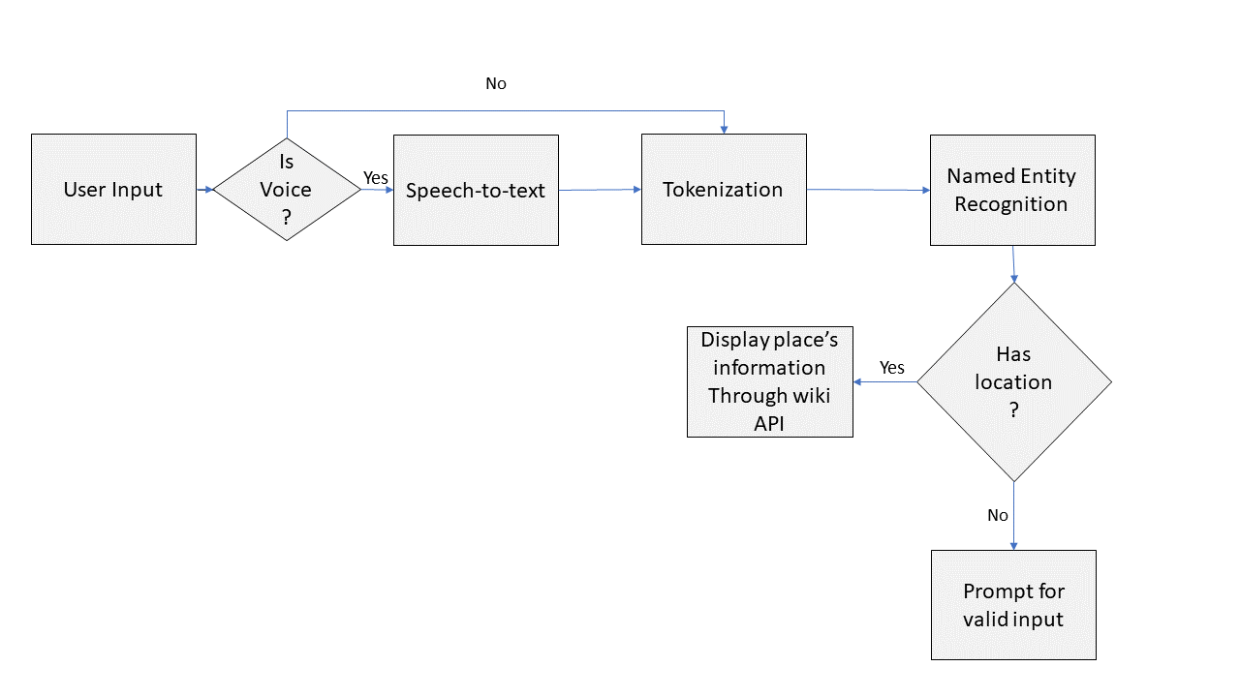

4.1.2 USE-CASE DIAGRAM
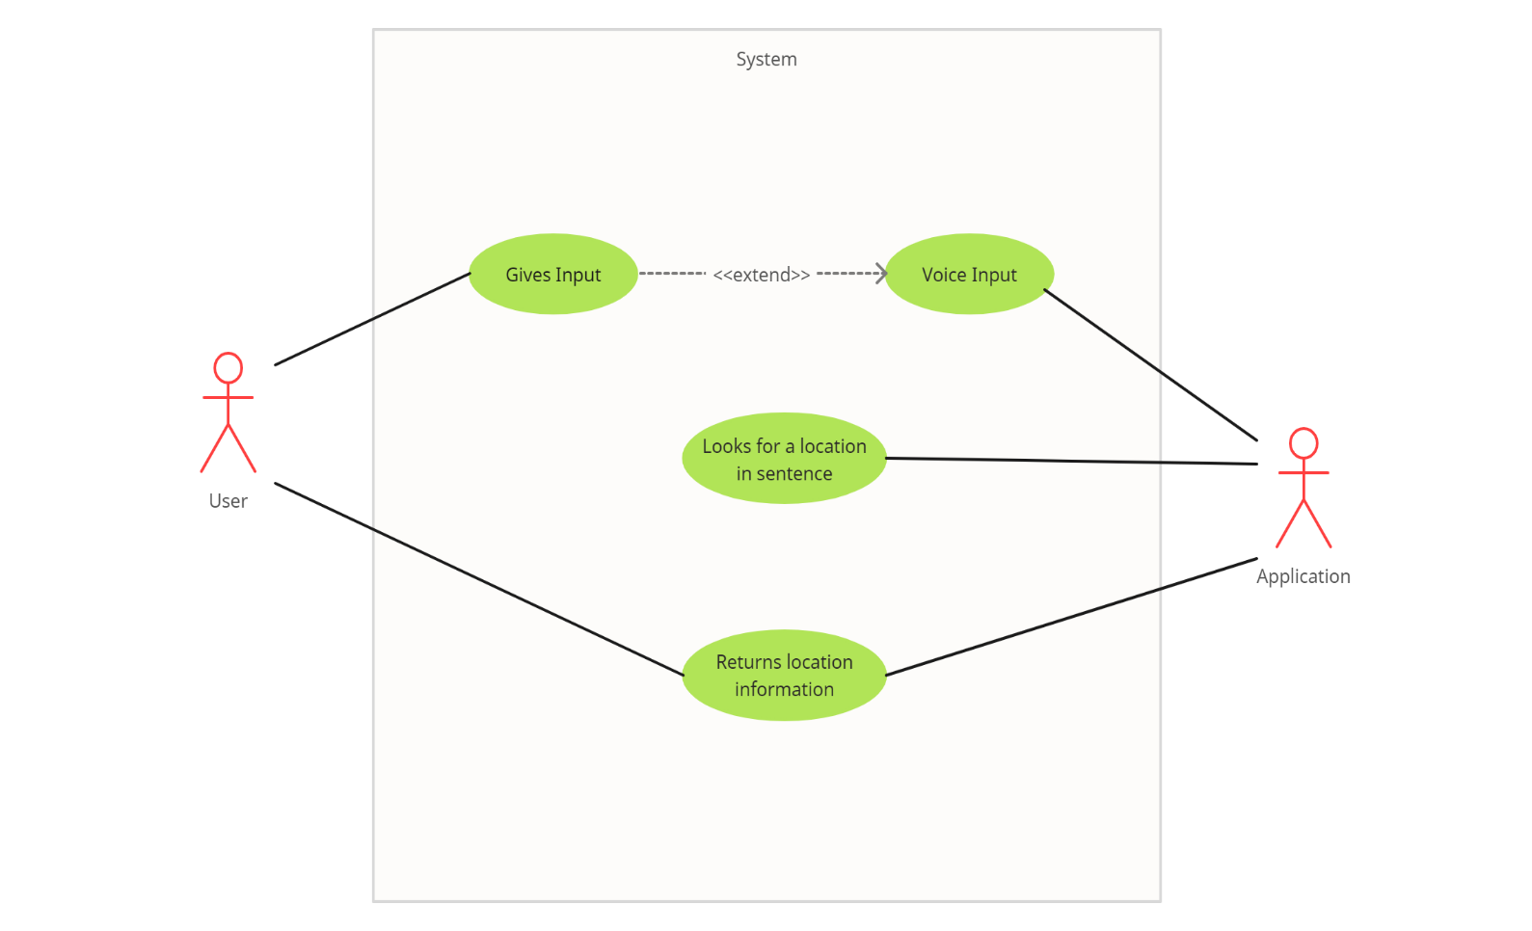

4.1.2.1 USE CASE DIAGRAM DESCRIPTION

Use Case ID: UC01
Name: Gives input
Actors: User
Description: Allows users to speak or enter a sentence manually about the place
Pre-conditions: User should have the application installed
Post-conditions: Information is displayed
Main Flow:

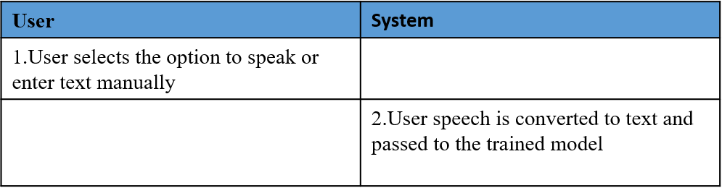

Use Case ID: UC02
Name: Find a location
Actors: Application
Description: The model trained in the application processes the input and searches if there is a location mentioned in the sentence
Pre-conditions: user should provide the application with input
Post-conditions: Information regarding the place, if found, is retrieved
Main Flow:

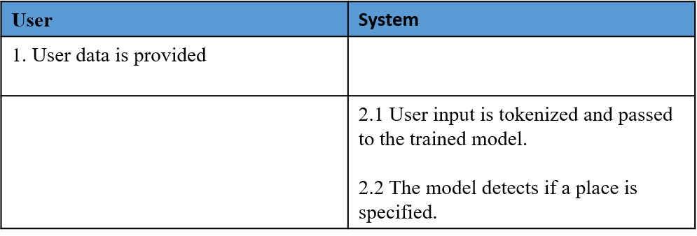

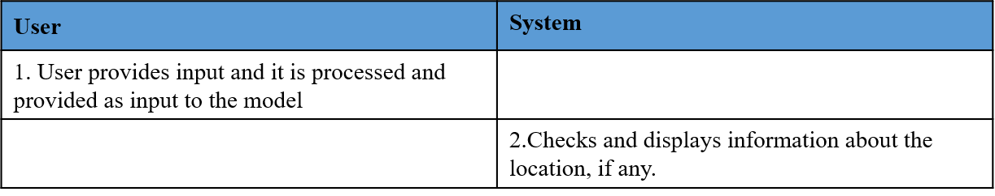
Use Case ID: UC03
Name: Returns location information
Description: Returns the information regarding the location found in the sentence
Pre-conditions: user input is passed through the model
Post-conditions: Error message is displayed
Main Flow: Information regarding the location is displayed

4.2 FUNCTIONAL MODULES
4.2.1 SCREENSHOTS

Flask Server:
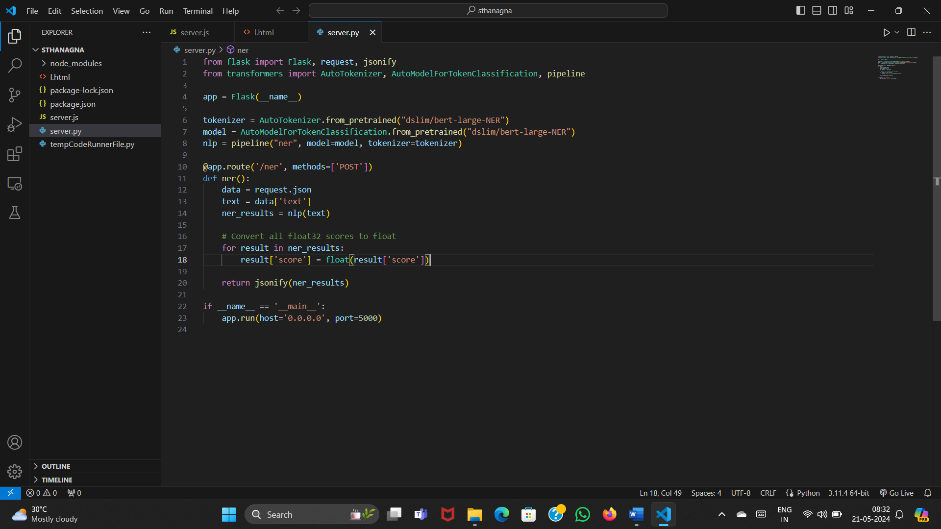

This code relates to the server-side module of the Sthanagna project's web application, handling backend functionalities and data processing.

Web application:
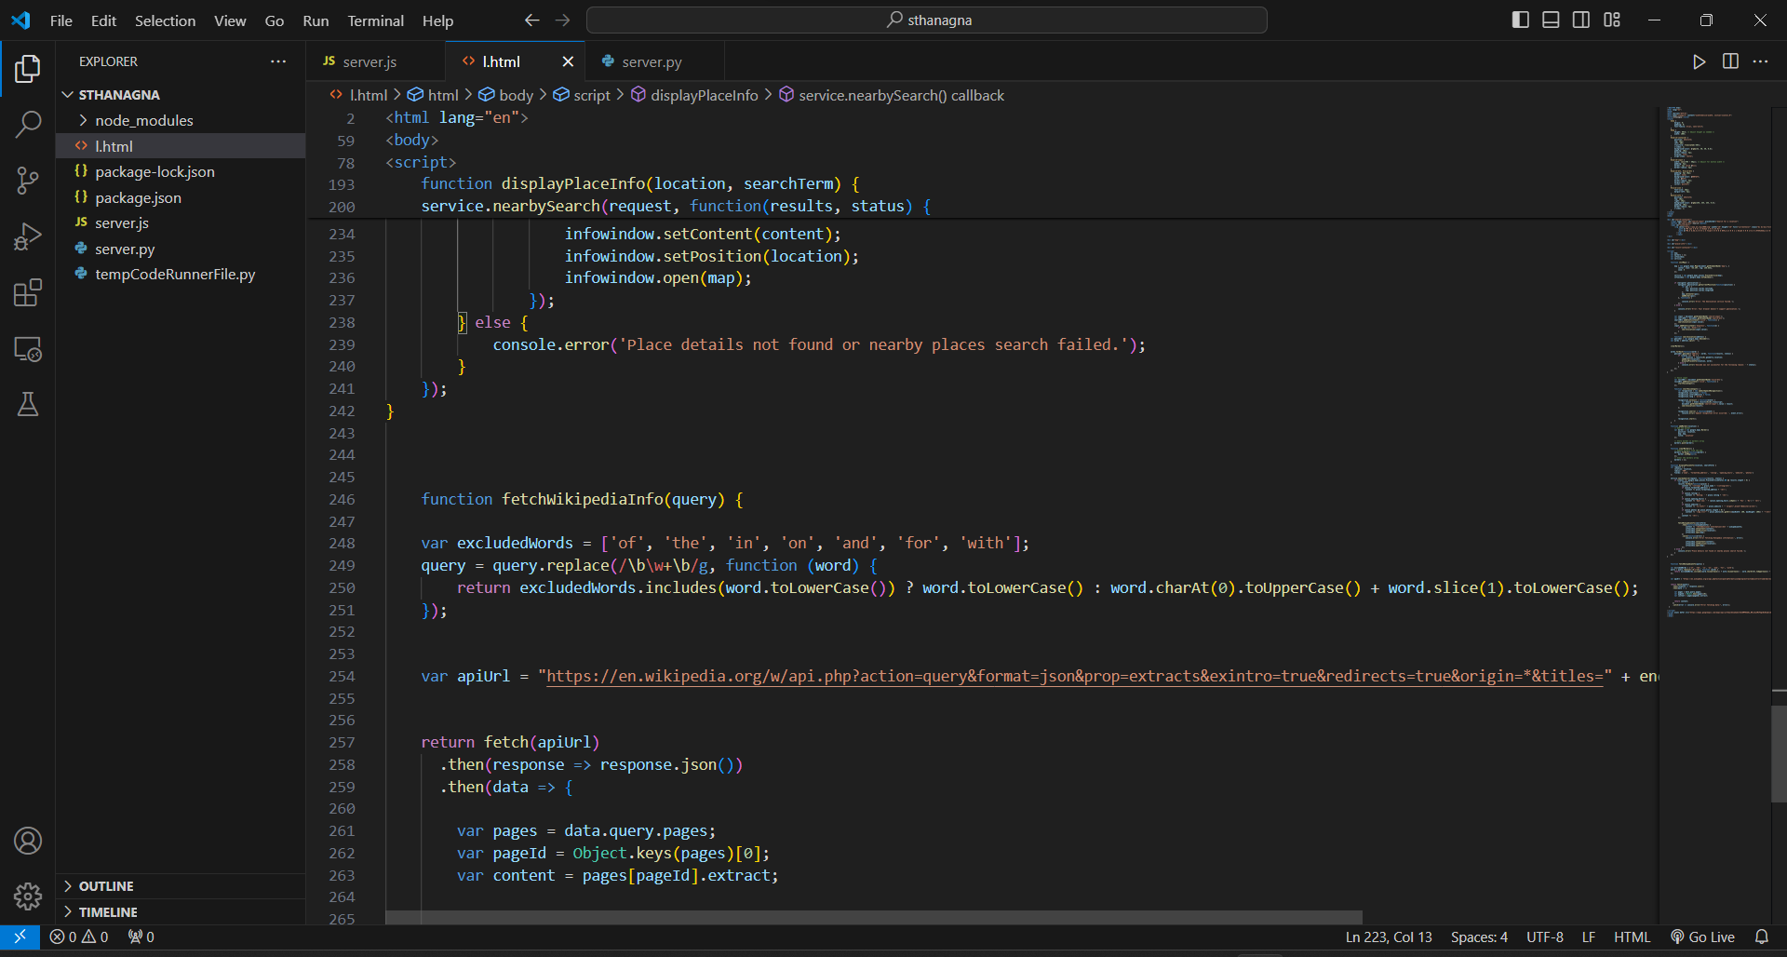
These lines of code are of the User Interface designed for the web application of Sthanagna. The code has the function that helps in error handling at runtime.
Mobile Application:

Main.dart:
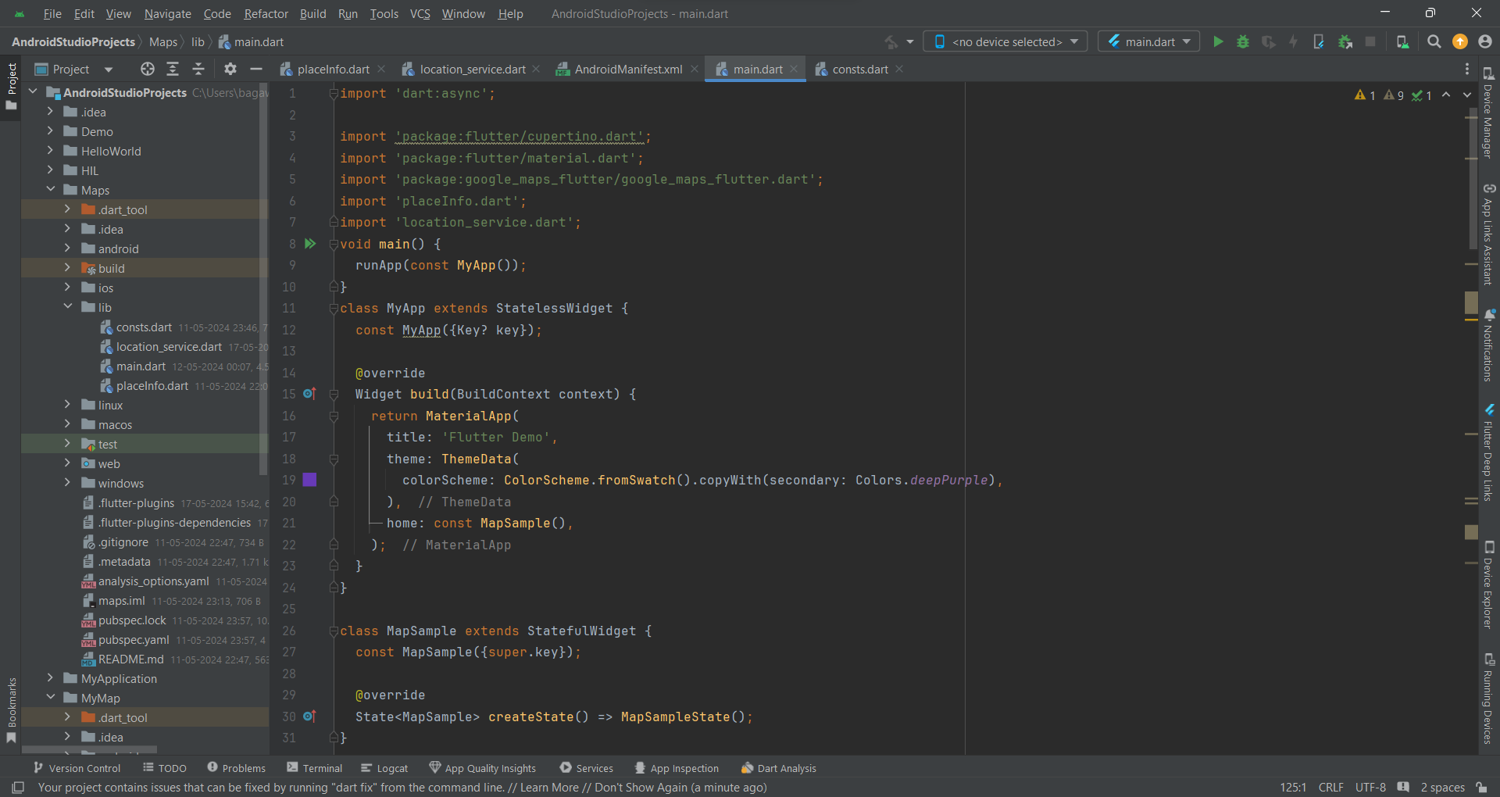
This is the code base for the mobile application designed for the Sthanagna project and holds the main user interface of the application.

Location_service.dart:

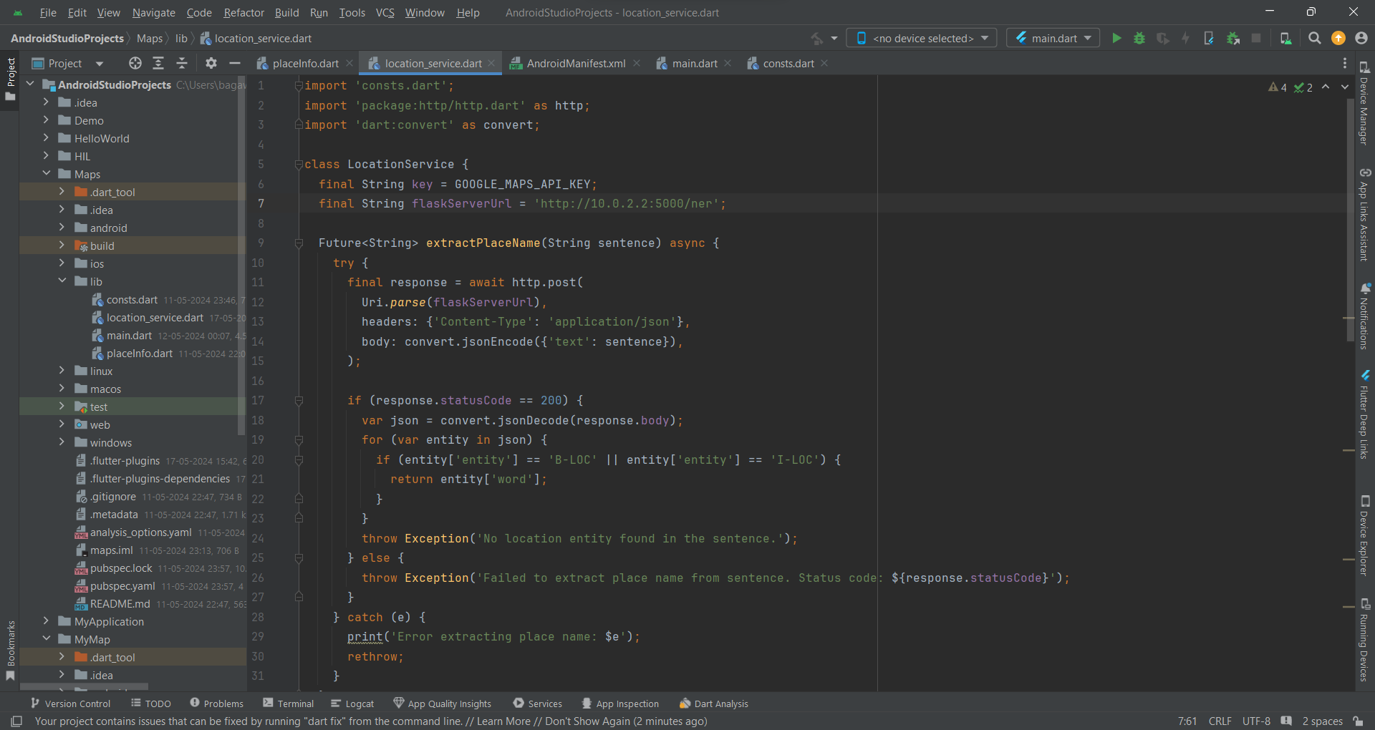
This functional module is responsible for the detection of place in the prompted natural sentence and retrieve output, if a location exists in the prompt.

4.2.2 PSEUDO CODE

Main.dart:

import 'dart:async';

import 'package:flutter/cupertino.dart';
import 'package:flutter/material.dart';
import 'package:google_maps_flutter/google_maps_flutter.dart';
import 'placeInfo.dart';
import 'location_service.dart';
void main() {
runApp(const MyApp());
}
class MyApp extends StatelessWidget {
const MyApp({Key? key});

@override
Widget build(BuildContext context) {
return MaterialApp(
title: 'Flutter Demo',
theme: ThemeData(
colorScheme: ColorScheme.fromSwatch().copyWith(secondary: Colors.deepPurple),
),
home: const MapSample(),
);
}
}

class MapSample extends StatefulWidget {
const MapSample({super.key});

@override
State<MapSample> createState() => MapSampleState();
}

class MapSampleState extends State<MapSample> {
final Completer<GoogleMapController> _controller = Completer<GoogleMapController>();
TextEditingController _searchController = TextEditingController();
Map<String, dynamic>? _placeInfo;
static const CameraPosition _kGooglePlex = CameraPosition(
target: LatLng(37.42796133580664, -122.085749655962),
zoom: 14.4746,
);
static final Marker _kGooglePlexMarker = Marker(
markerId: const MarkerId('_kGooglePlex'),
infoWindow: const InfoWindow(title: 'GooglePlex'),
icon: BitmapDescriptor.defaultMarker,
position: const LatLng(37.42796133580664, -122.085749655962),
);
static const CameraPosition _kLake = CameraPosition(
bearing: 192.8334901395799,
target: LatLng(37.43296265331129, -122.08832357078792),
tilt: 59.440717697143555,
zoom: 19.151926040649414);

@override
Widget build(BuildContext context) {
return Scaffold(
appBar: AppBar(title: const Text('Sthanagna')),
body: Stack(
children: <Widget>[
GoogleMap(
mapType: MapType.normal,
markers: {_kGooglePlexMarker},
initialCameraPosition: _kGooglePlex,
onMapCreated: (GoogleMapController controller) {
_controller.complete(controller);
},
),
Positioned(
top: 10.0,
left: 10.0,
right: 10.0,
child: Container(
padding: EdgeInsets.symmetric(horizontal: 10.0),
decoration: BoxDecoration(
color: Colors.white,
borderRadius: BorderRadius.circular(10.0),
boxShadow: [
BoxShadow(
color: Colors.grey.withOpacity(0.3),
spreadRadius: 2.0,
blurRadius: 5.0,
),
],
),

child: Row(
children: <Widget>[
Icon(Icons.search),
SizedBox(width: 10.0),
Expanded(
child: TextField(
controller: _searchController,
textCapitalization: TextCapitalization.words,
decoration: InputDecoration(
hintText: "Search location...",
border: InputBorder.none,
),
onChanged: (value) {},
),
),
IconButton(
icon: Icon(Icons.search),
onPressed: () async {
var place = await LocationService().getPlace(_searchController.text);
setState(() {
_placeInfo = place;
});
_goToThePlace(place);
},
),
],
),
),
),
if (_placeInfo != null) ...[
Positioned(
bottom: 10,
left: 10,
right: 10,
child: PlaceInfoWidget(placeInfo: _placeInfo!,onClose: () {},),
),
],
],
),
);
}

Future<void> _goToThePlace(Map<String, dynamic> place) async {
final double lat = place['geometry']['location']['lat'];
final double lng = place['geometry']['location']['lng'];
final GoogleMapController controller = await _controller.future;
await controller.animateCamera(
CameraUpdate.newCameraPosition(
CameraPosition(target: LatLng(lat, lng), zoom: 12),
),
);
}
}

Locationservice.dart:

import 'consts.dart';
import 'package:http/http.dart' as http;
import 'dart:convert' as convert;

class LocationService {
final String key = GOOGLE_MAPS_API_KEY;
final String flaskServerUrl = 'http://10.0.2.2:5000/ner';

Future<String> extractPlaceName(String sentence) async {
try {
final response = await http.post(
Uri.parse(flaskServerUrl),
headers: {'Content-Type': 'application/json'},
body: convert.jsonEncode({'text': sentence}),
);

if (response.statusCode == 200) {
var json = convert.jsonDecode(response.body);
for (var entity in json) {
if (entity['entity'] == 'B-LOC' || entity['entity'] == 'I-LOC') {
return entity['word'];
}
}
throw Exception('No location entity found in the sentence.');
} else {
throw Exception('Failed to extract place name from sentence. Status code: ${response.statusCode}');
}
} catch (e) {
print('Error extracting place name: $e');
rethrow;
}
}

Future<String> getPlaceId(String input) async {
try {
final String url = 'https://maps.googleapis.com/maps/api/place/findplacefromtext/json?input=$input&inputtype=textquery&key=$key';
var response = await http.get(Uri.parse(url));
if (response.statusCode == 200) {
var json = convert.jsonDecode(response.body);
var placeId = json['candidates'][0]['place_id'] as String;
return placeId;
} else {
throw Exception('Failed to get place ID. Status code: ${response.statusCode}');
}
} catch (e) {
print('Error getting place ID: $e');
rethrow;
}
}

Future<Map<String, dynamic>> getPlace(String sentence) async {
try {
final placeName = await extractPlaceName(sentence);
final placeId = await getPlaceId(placeName);
final String url = 'https://maps.googleapis.com/maps/api/place/details/json?place_id=$placeId&key=$key';
var response = await http.get(Uri.parse(url));
if (response.statusCode == 200) {

var json = convert.jsonDecode(response.body);
var results = json['result'] as Map<String, dynamic>;
print(results);
return results;
} else {
throw Exception('Failed to get place details. Status code: ${response.statusCode}');
}
} catch (e) {
print('Error getting place: $e');
rethrow;
}
}
}

placeinfo.dart:

import 'dart:convert' as convert;
import 'package:flutter/material.dart';
import 'package:http/http.dart' as http;

class PlaceInfoWidget extends StatefulWidget {
final Map<String, dynamic> placeInfo;
final VoidCallback onClose;

const PlaceInfoWidget({Key? key, required this.placeInfo, required this.onClose}) : super(key: key);

@override
_PlaceInfoWidgetState createState() => _PlaceInfoWidgetState();
}

class _PlaceInfoWidgetState extends State<PlaceInfoWidget> {
String? wikipediaSummary;
bool _isOpen = true;

@override
void initState() {
super.initState();
fetchWikipediaSummary(widget.placeInfo['name']);
}

Future<void> fetchWikipediaSummary(String placeName) async {
final String wikipediaUrl =
'https://en.wikipedia.org/api/rest_v1/page/summary/$placeName';
try {
final response = await http.get(Uri.parse(wikipediaUrl));
if (response.statusCode == 200) {
final json = convert.jsonDecode(response.body);
if (json.containsKey('extract')) {
setState(() {
wikipediaSummary = json['extract'];
});
}
}
} catch (e) {
print('Error fetching Wikipedia summary: $e');
}
}

@override
void didUpdateWidget(covariant PlaceInfoWidget oldWidget) {
super.didUpdateWidget(oldWidget);
if (oldWidget.placeInfo['name'] != widget.placeInfo['name']) {
fetchWikipediaSummary(widget.placeInfo['name']);
setState(() {
_isOpen = true; // Open the card when new placeInfo is provided
});
}
}

@override
Widget build(BuildContext context) {
return _isOpen
? Card(
elevation: 4,
child: Padding(
padding: const EdgeInsets.all(8.0),
child: Column(
mainAxisSize: MainAxisSize.min,
crossAxisAlignment: CrossAxisAlignment.start,
children: [
Row(
mainAxisAlignment: MainAxisAlignment.spaceBetween,
children: [
Text(
widget.placeInfo['name'],
style: const TextStyle(fontSize: 18, fontWeight: FontWeight.bold),
),
IconButton(
icon: Icon(Icons.close),
onPressed: () {
setState(() {
_isOpen = false; // Close the card
});
widget.onClose(); // Call the onClose callback
},
),
],
),
const SizedBox(height: 4),
Text(
widget.placeInfo['formatted_address'],
style: const TextStyle(fontSize: 16),
),
const SizedBox(height: 4),
if (wikipediaSummary != null) ...[
const Text(
'Wikipedia Summary:',
style: TextStyle(fontSize: 16, fontWeight: FontWeight.bold),
),
const SizedBox(height: 4),
Text(
wikipediaSummary!,
style: const TextStyle(fontSize: 16),
),
const SizedBox(height: 4),
],

],
),
),
)
: SizedBox.shrink(); // Hide the widget if _isOpen is false
}
}

5.EXPERIMENTAL SETUP

5.1 SYTEM SPECIFICATIONS
5.1.1 HARDWARE REQUIREMENTS
Development Machine:
Processor: Intel Core i5 or higher
RAM: 8 GB or higher
Storage: SSD with at least 256 GB of free space
Internet: High-speed internet connection for API access
Server (for hosting the web application):
Processor: Quad-core CPU
RAM: 16 GB
Storage: 500 GB SSD
Network: Reliable internet connection with a static IP address
Mobile Device (for testing the Android app):
Device: Android smartphone with Android 7.0 (Nougat) or higher
Storage: At least 2 GB of free space
Internet: Wi-Fi or mobile data for accessing the internet

5.1.2 SOFTWARE REQUIREMENTS
Operating System:
Windows 10 or higher, macOS, or Linux

Frontend:HTML, CSS, JavaScript, Flutter
Backend: Node.js (JavaScript)

5.2 DATASETS
- Named Entity Recognition Dataset (CoNNL-2003)
The task of CoNLL-2003 concerns language-independent named entity recognition. It will concentrate on four types of named entities: persons, locations, organizations and names of miscellaneous entities that do not belong to the previous three groups.
The CoNLL-2003 shared task data files contain four columns separated by a single space. Each word has been put on a separate line and there is an empty line after each sentence. The first item on each line is a word, the second a part-of-speech (POS) tag, the third a syntactic chunk tag and the fourth the named entity tag. The chunk tags and the named entity tags have the format I-TYPE which means that the word is inside a phrase of type TYPE. Only if two phrases of the same type immediately follow each other, the first word of the second phrase will have tag B-TYPE to show that it starts a new phrase. A word with tag O is not part of a phrase. Note the dataset uses IOB2 tagging scheme, whereas the original dataset uses IOB1

5.3 METHODOLOGY/ALGORITHM

Sthanagna works with the collaboration of well-define APIs and NER(Named Entity Recognition) model at its core. Sthanagna utilizes advanced NER models, which include pretrained model like BERT specific to the domain of location-based data. These models identify and classify entities such as place names, business names, landmarks, and other points of interest from the text data.Voice Search and Real-Time Geolocation enhance user interaction by allowing voice commands for searches and providing location-based recommendations based on the user’s current position. This ensures that the information provided is relevant and personalized.

6.RESULTS

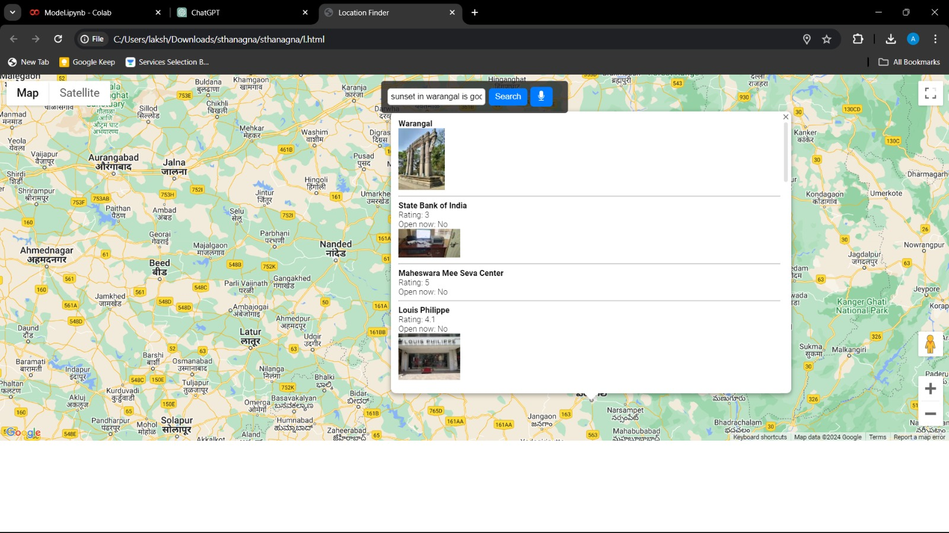
A natural sentence being prompted to the website.
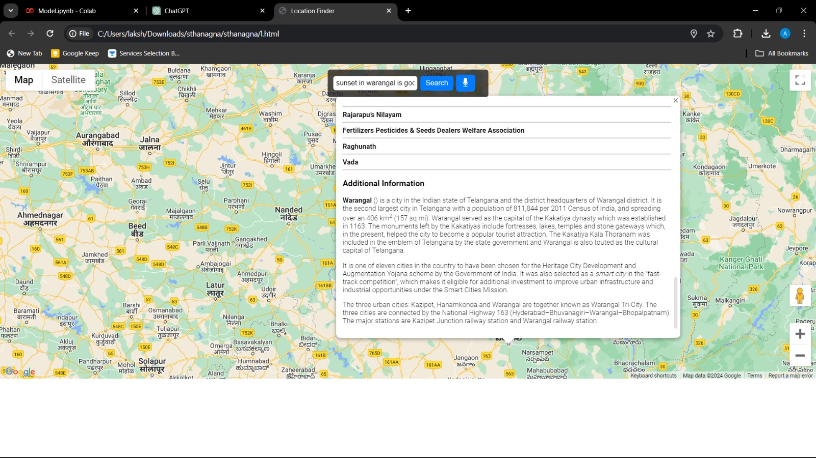
Information regarding a location, if it exists, being displayed on the website.

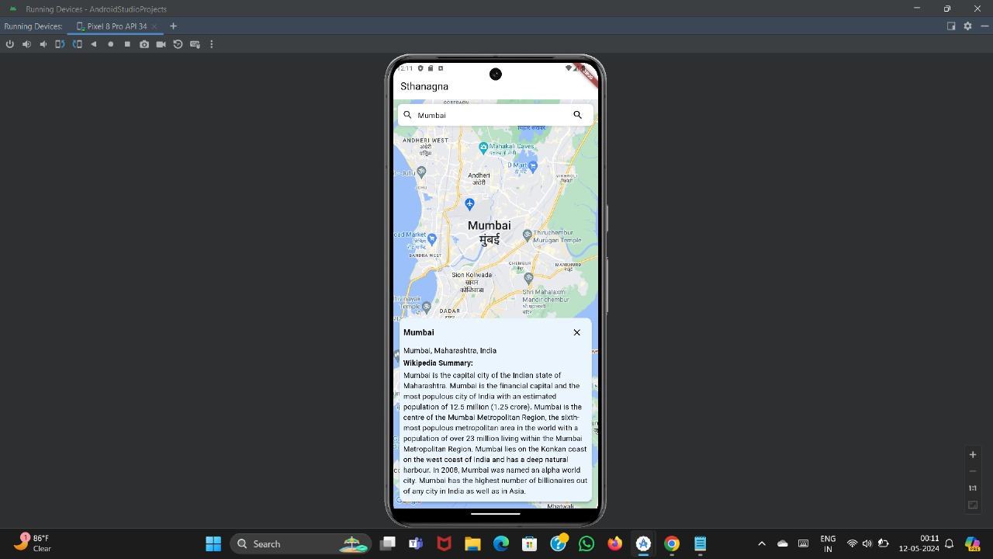

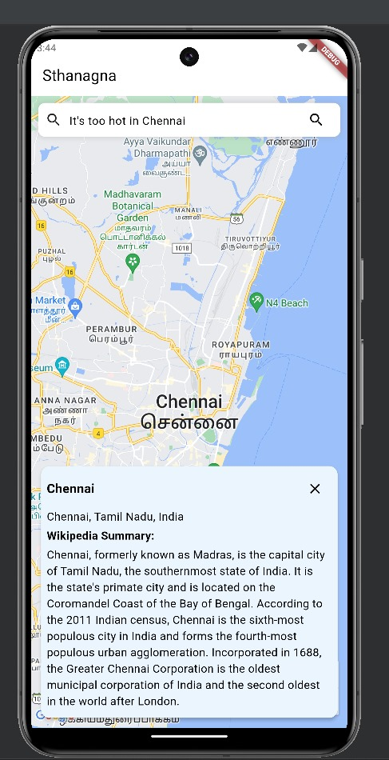

Output of a location’s information when the prompted sentence contains a location.

7.CONCLUSION & FUTURE SCOPE

The development of Sthanagna, a comprehensive location finder application, successfully integrates various technologies to enhance user experience in discovering and exploring places of interest. Sthanagna’s employs Google Maps for accurate and dynamic map services, leverages the Wikipedia API for enriching location data, and incorporates a voice input feature for ease of use. The application demonstrates significant advancements over traditional methods by automating feature extraction, capturing both spatial and temporal patterns, and providing detailed information about multiple locations simultaneously. Sthanagna's versatility, covering both web and mobile platforms, ensures accessibility and convenience for a wide range of users.

Looking ahead, Sthanagna has the potential to expand its capabilities by introducing social engagement features, such as location-based badges and achievements that users can share on social media. Continuous integration of emerging technologies, such as augmented reality (AR) for immersive location exploration and machine learning for predictive analytics, will further elevate Sthanagna's recommendations based on user preferences and history, making the application more intuitive and user-centric. Continuous integration of emerging technologies, such as augmented reality (AR) for immersive location exploration and machine learning for predictive analytics, will further elevate Sthanagna's utility and user satisfaction.

8.REFERENCES

- https://stackoverflow.com/
- https://docs.flutter.dev/
- https://www.w3schools.com/
- https://developers.google.com/docs/api/reference/

