Anti Malware Software Development
CourseScanner v2.2.0 · Anti-Malware Technologies Laboratory

1 Implementation tools and scope
CourseScanner v2.2.0 is a Windows laboratory prototype. It combines SQLite hash signatures, YARA content matching and static heuristics, explains verdicts, and supports quarantine, restoration and permanent deletion.

Technology choices
Tool | Role
Python and hashlib | Application logic and SHA-256 hashing
SQLite and sqlite3 | Local indexed signature lookup
yara-python | One demonstration rule and 13 Elastic Windows rules
Tkinter and ttk | High-DPI graphical interface in Chinese, English and Russian
threading and queue | Background scanning, cancellation and UI events
zipfile and PyInstaller | Quarantine packages and Windows x64 distribution

How the project evolved
v2.2.0 adds multi-source SQLite imports, 13 Elastic YARA rules, and two PE section checks. It retains the three-language UI and cumulative scan results. The public package includes ClamAV data; users can obtain and import MalwareBazaar data under the provider’s terms.
The scanner does not execute samples and does not provide dynamic analysis, sandboxing or real-time protection.

2 Architecture and detection algorithms
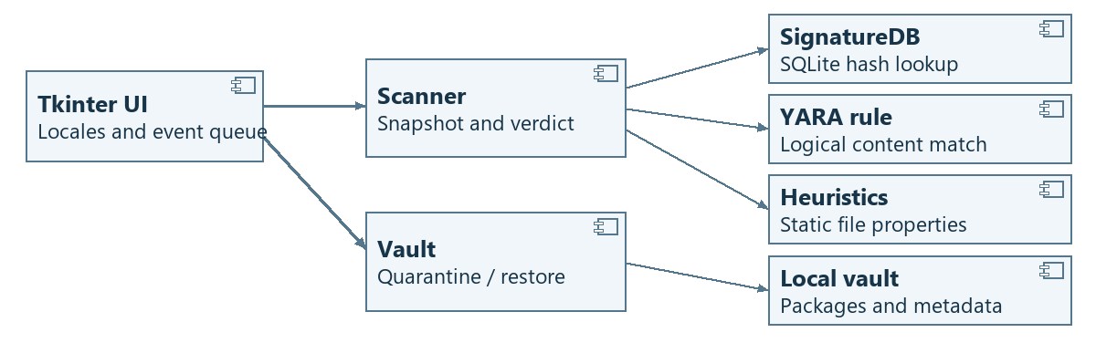
Figure 1. UML component diagram of the scan and quarantine paths.

Static detection pipeline
1. Read a snapshot of a regular file, limited to 32 MiB. A read failure, oversize file or YARA timeout is marked Not scanned. The scanner does not execute the file.
2. Compute SHA-256 and query indexed SQLite tables. The external table uses a hash-and-source key, preserving multiple sources. Scan the same bytes with the demo YARA rule and 13 Elastic rules covering BlackBasta, LockBit, AgentTesla, AsyncRAT and Remcos.
3. Check double extensions and disguised PE files. Inspect PE sections for writable-and-executable flags and high entropy in executable data. Legitimate packing can also trigger these signals.
4. Any hash or YARA match takes precedence. Otherwise, a heuristic match is Suspicious; no match is No threat detected, not a guarantee of safety.

3 Scanning and file disposition
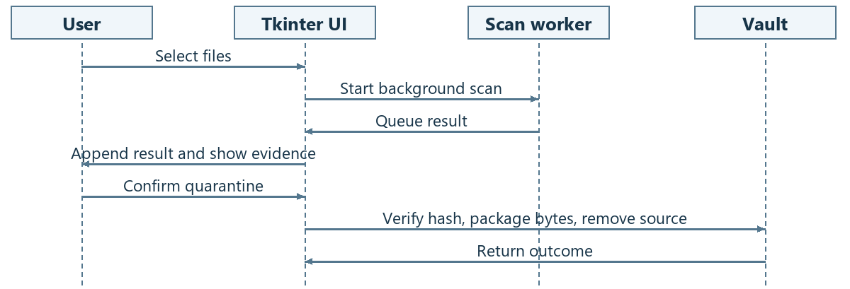
Figure 2. UML sequence diagram from manual scan to confirmed quarantine.

Scan lifecycle
The worker sends results through a queue. The UI appends them to the existing table. Stop allows the current file to finish, without starting the next file. Clear Results affects only the current session’s list; it does not change files or the quarantine vault.

Quarantine, restore and removal
Quarantine rechecks the file hash, writes a unique package containing the bytes and metadata, then rechecks and removes the original. Metadata records the original path, SHA-256 and evidence. Restore verifies the hash and creates the original path without overwriting an existing file. Permanent deletion requires confirmation and bypasses the Recycle Bin.
A quarantine package is not a sandbox. Rechecking and removing a file are not one atomic operation; the prototype is not intended to contain already-running malware.

4 Graphical interface and verification
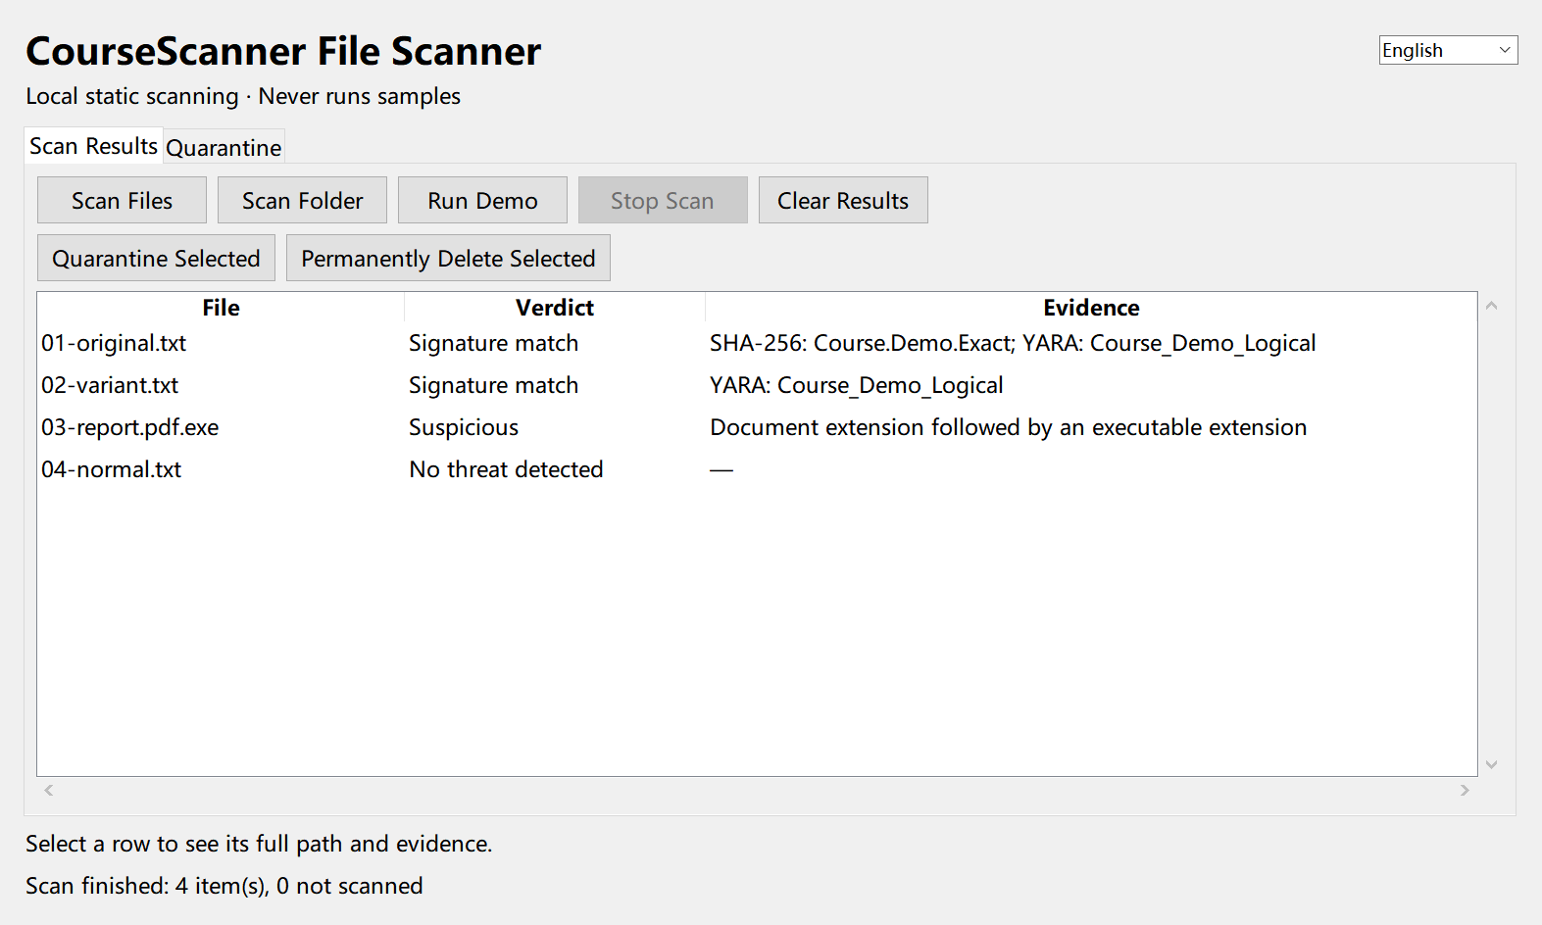
Figure 3. Actual v2.2.0 interface after a harmless demonstration scan.
Choose Scan Files, Scan Folder or Run Demo. The table shows the verdict and evidence. Right-click a row to open its containing folder without launching the file. The Quarantine tab provides restore and permanent delete controls. Switch the interface language from the top-right menu.
Harmless fixture | Observed result
01-original.txt | SHA-256 and YARA
02-variant.txt | YARA only
03-report.pdf.exe | Suspicious double extension
04-normal.txt | No threat detected
17 unit tests and desktop checks passed. The public package includes 117 ClamAV source records; the local build also contains 2,338 MalwareBazaar records. Rule loading was verified, but malware detection rates were not measured.
Download and extract the full Windows x64 ZIP from the GitHub Release. Double-click the EXE and keep the adjacent data folder. No Python or MySQL installation is required.

