Anti Malware Software Development
CourseScanner v2.3.1 · Anti-Malware Technologies Laboratory

1 Implementation tools and scope
CourseScanner v2.3.1 is a Windows laboratory prototype. It combines SQLite hash signatures, YARA content matching and static heuristics, explains verdicts, and supports quarantine, restoration and permanent deletion.

Technology choices
Tool | Role
Python and hashlib | Application logic and SHA-256 hashing
SQLite and sqlite3 | Local indexed signature lookup
yara-python | Runs 13 Elastic content rules and a separate demo rule
Tkinter and ttk | High-DPI graphical interface in Chinese, English and Russian
threading and queue | Background scanning, cancellation and UI events
zipfile and PyInstaller | Quarantine packages and Windows x64 distribution

How the project evolved
v2.3.0 focuses on traceable detection evidence. It keeps SQLite, YARA, static heuristics and three interface languages, while adding a self-contained safe demo and a read-only evidence viewer.
The scanner does not execute samples and does not provide dynamic analysis, sandboxing or real-time protection.

2 Version history
Numbered entries are GitHub version tags. The other entries are documented local iterations, not separately published releases.
Version or stage | Main change
v1.0.0 | Initial SQLite hash lookup, demo YARA, static heuristics, quarantine, restoration and removal.
v2.0.0 | Project-local data, high DPI, Chinese and English, stop, clear and open containing folder.
v2.1.0 | Cumulative scan results, Russian UI, shorter subtitle and drive-independent EXE.
MySQL prototype (local) | Validated multi-source import and lookup; added two PE section checks.
SQLite extension (local) | Kept offline deployment and verified ClamAV and MalwareBazaar imports.
v2.2.0 | Published multi-source SQLite, 13 Elastic rules and PE checks.
Rule classification (local) | Double extension became a YARA heuristic; demo, standard test and family matches were separated.
Imported-only scanner (local) | Ordinary scans stopped using classroom signatures; imported hashes and Elastic rules remained.
Demo iterations (local) | Separated SHA-256 and YARA demos; the user added external fixtures to demonstrate imported matches.
v2.3.0 | Added read-only evidence on double-click, an isolated fallback demo and an optional fixture pack.
v2.3.1 | Moved the double-extension check to Python and built the signature database and four demo fixtures into the EXE.

3 Architecture and detection algorithms
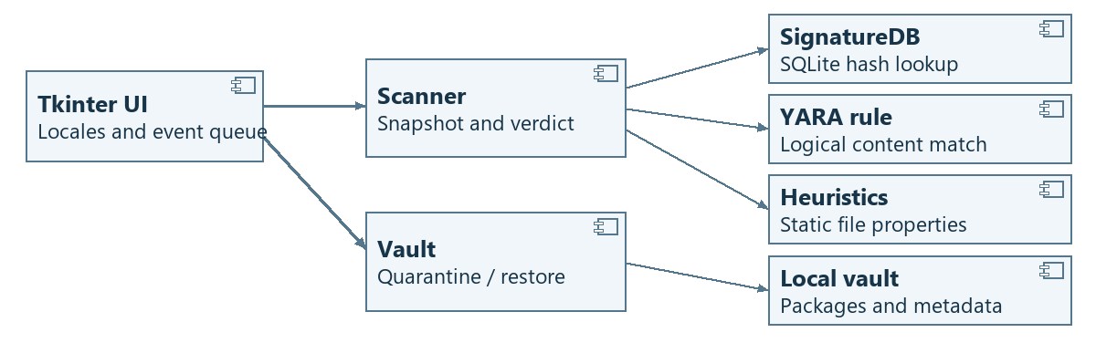
Figure 1. UML component diagram of the scan and quarantine paths.

Detection pipeline
The scanner reads a file snapshot without executing the file. The same bytes are used for hashing, YARA and heuristics; the limit is 32 MiB per file. Read failures, oversized files and YARA timeouts are reported as Not scanned.

Algorithm one SHA-256 whole-file signatures
Python computes the full-file digest with hashlib.sha256(data).hexdigest(). The SQLite signature_feeds table stores a 32-byte hash, its source and the signature name, not the sample itself. Lookup takes the hash alone. The composite key (hash, source) preserves records from multiple sources.
Example: the measured SHA-256 of 01-real-signature-eicar.com is:
275a021bbfb6489e54d471899f7db9d1663fc695ec2fe2a2c4538aabf651fd0f
A lookup in the SQLite database bundled in the release ZIP returned ClamAV as the source and Eicar-Test-Signature as the name. This database record supplies the evidence for the SHA-256 hit shown in Figure 3. EICAR is a harmless standard antivirus test file, not malware. Users decide whether to quarantine or delete a file.

Algorithm two YARA content signatures
Normal scans match the same bytes against 13 Elastic Windows content rules: one for BlackBasta, three for LockBit, five for AgentTesla, one for AsyncRAT and three for Remcos. The filename heuristic and isolated demo rule are not part of this count.
Example: the AgentTesla-related rule in Section 6 lists six string features, including ones associated with browser lists and screen logging. At least four distinct features must match. The harmless text meets that condition, so the program shows Signature match and keeps the rule name, source, file, line and text for inspection. A rule match does not prove an AgentTesla infection.

Algorithm three Static heuristics
Filename: Python checks the ending of the filename for a double extension without calling YARA. For example, 03-report.pdf.exe is Suspicious because .exe follows .pdf, even though the file contains plain text.
Filename versus contents: a document or image extension combined with MZ and a PE marker at the indicated header offset suggests disguise. For example, a file named report.pdf may contain both markers.
PE sections: the scanner checks whether a section is both writable and executable. For executable sections of at least 4 KiB, it computes byte entropy on the first 64 KiB or less and flags values of 7.6 or above. Entropy measures how evenly byte values are distributed; legitimate compression can also trigger the heuristic.

Combining the results
A hash or YARA content-rule hit takes precedence as Signature match. Otherwise, static heuristic findings are Suspicious. A completed scan with no hits is No threat detected.

4 Scanning and file disposition
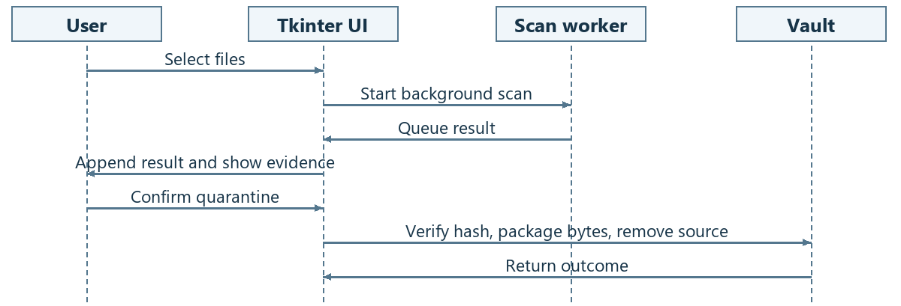
Figure 2. UML sequence diagram from manual scan to confirmed quarantine.

Scan lifecycle
The worker sends results through a queue. The UI appends them to the existing table. Stop allows the current file to finish, without starting the next file. Clear Results affects only the current session’s list; it does not change files or the quarantine vault.

Quarantine, restore and removal
Quarantine rechecks the file hash, writes a unique package containing the bytes and metadata, then rechecks and removes the original. Metadata records the original path, SHA-256 and evidence. Restore verifies the hash and creates the original path without overwriting an existing file. Permanent deletion requires confirmation and bypasses the Recycle Bin.
A quarantine package is not a sandbox. Rechecking and removing a file are not one atomic operation; the prototype is not intended to contain already-running malware.

5 Graphical interface and verification
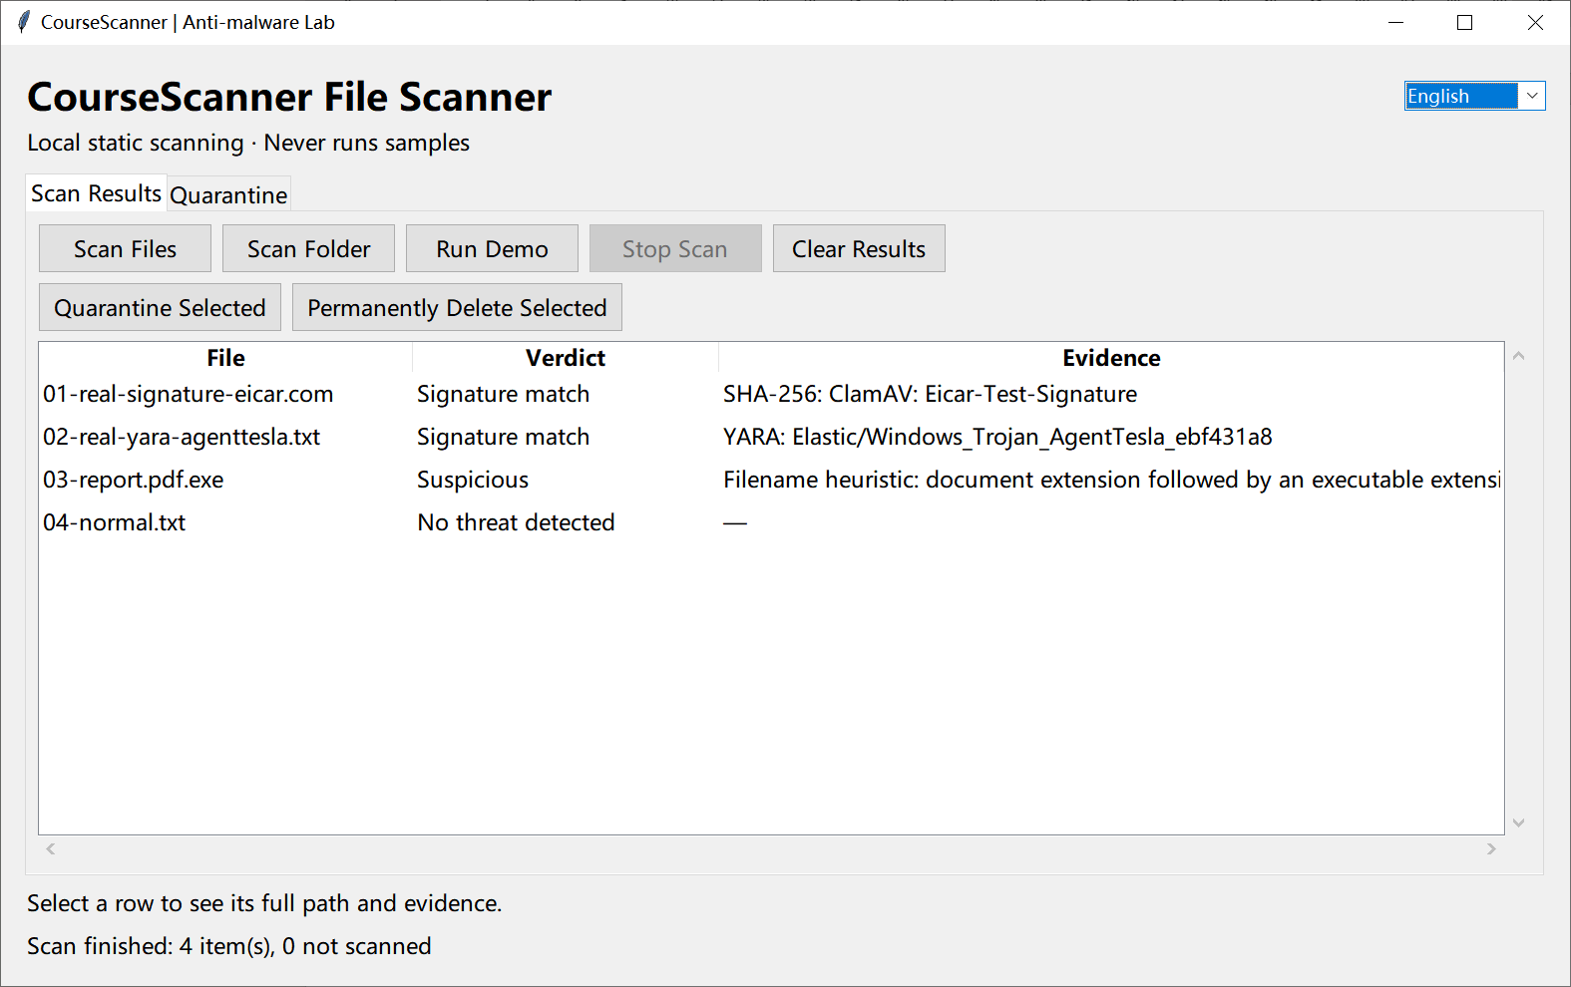
Figure 3. Safe demo results: four items scanned, none skipped.
The first two files matched a ClamAV SHA-256 signature and an Elastic YARA content rule, respectively. The third is Suspicious with Filename heuristic as its evidence. The fourth produced no hit.
Optional demo file | Observed verdict and evidence
01-real-signature-eicar.com | Signature match: SHA-256 / ClamAV / Eicar-Test-Signature
02-real-yara-agenttesla.txt | Signature match: Elastic AgentTesla-related YARA rule
03-report.pdf.exe | Suspicious: filename heuristic (.pdf followed by .exe)
04-normal.txt | No threat detected
The first two rows show independent detection paths: an exact whole-file hash lookup in SQLite and a content-rule match in YARA. EICAR is a standard test file, and the AgentTesla example is harmless text; these results do not measure malware detection rates.
To reproduce, download and open the v2.3.1 Windows EXE, then click Run Demo. The database and fixtures are built in; no extraction is needed. Double-click Evidence for read-only details.

6 Read-only evidence and verification
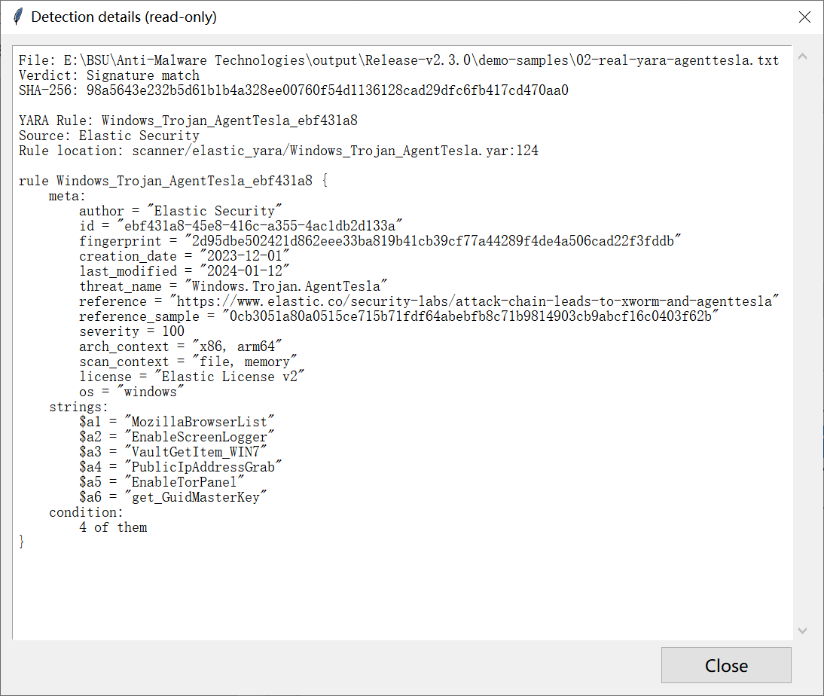
Figure 4. Read-only evidence for the AgentTesla-related YARA match shown in Figure 3.
The dialog identifies Elastic Security as the source and shows the rule name Windows_Trojan_AgentTesla_ebf431a8, its file and line (Windows_Trojan_AgentTesla.yar:124), and the rule text. The SHA-256 shown at the top is the scanned file’s digest, not a hash-signature match.
The rule requires at least four of its six strings. The harmless text meets that condition but is not evidence of an AgentTesla infection. The double-extension item appears only under Heuristic clues, with no YARA rule.

