Anti Malware Software Development
CourseScanner v2.3.0 · Anti-Malware Technologies Laboratory

1 Implementation tools and scope
CourseScanner v2.3.0 is a Windows laboratory prototype. It combines SQLite hash signatures, YARA content matching and static heuristics, explains verdicts, and supports quarantine, restoration and permanent deletion.

Technology choices
Tool | Role
Python and hashlib | Application logic and SHA-256 hashing
SQLite and sqlite3 | Local indexed signature lookup
yara-python | 13 Elastic Windows rules, a filename heuristic and an isolated demo rule
Tkinter and ttk | High-DPI graphical interface in Chinese, English and Russian
threading and queue | Background scanning, cancellation and UI events
zipfile and PyInstaller | Quarantine packages and Windows x64 distribution

How the project evolved
v2.3.0 focuses on traceable detection evidence. It keeps SQLite, YARA, static heuristics and three interface languages, while adding a self-contained safe demo and a read-only evidence viewer.
The scanner does not execute samples and does not provide dynamic analysis, sandboxing or real-time protection.

2 Version history
Numbered entries are GitHub version tags. The other entries are documented local iterations, not separately published releases.
Version or stage | Main change
v1.0.0 | Initial SQLite hash lookup, demo YARA, static heuristics, quarantine, restoration and removal.
v2.0.0 | Project-local data, high DPI, Chinese and English, stop, clear and open containing folder.
v2.1.0 | Cumulative scan results, Russian UI, shorter subtitle and drive-independent EXE.
MySQL prototype (local) | Validated multi-source import and lookup; added two PE section checks.
SQLite extension (local) | Kept offline deployment and verified ClamAV and MalwareBazaar imports.
v2.2.0 | Published multi-source SQLite, 13 Elastic rules and PE checks.
Rule classification (local) | Double extension became a YARA heuristic; demo, standard test and family matches were separated.
Imported-only scanner (local) | Ordinary scans stopped using classroom signatures; imported hashes and Elastic rules remained.
Demo iterations (local) | Separated SHA-256 and YARA demos; the user added external fixtures to demonstrate imported matches.
v2.3.0 | Read-only evidence on double-click, isolated fallback demo and a separate optional verified fixture pack.

3 Architecture and detection algorithms
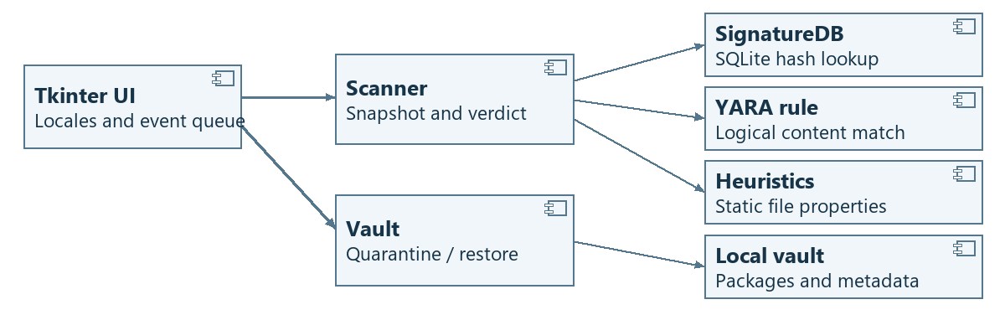
Figure 1. UML component diagram of the scan and quarantine paths.

Static detection pipeline
1. Read a snapshot of a regular file, limited to 32 MiB. A read failure, oversize file or YARA timeout is marked Not scanned. The scanner does not execute the file.
2. Compute SHA-256, query SQLite by hash and source, and keep the matched source and name. Run 13 Elastic content rules on the same bytes and retain the matched rule name, file, line and text.
3. Check double extensions and disguised PE files. Inspect PE sections for writable-and-executable flags and high entropy in executable data. Legitimate packing can also trigger these signals.
4. Any hash or YARA match takes precedence. Otherwise, a heuristic match is Suspicious; no match is No threat detected, not a guarantee of safety.

4 Scanning and file disposition
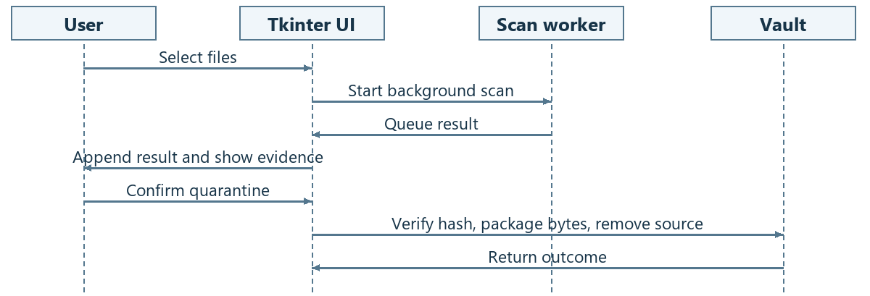
Figure 2. UML sequence diagram from manual scan to confirmed quarantine.

Scan lifecycle
The worker sends results through a queue. The UI appends them to the existing table. Stop allows the current file to finish, without starting the next file. Clear Results affects only the current session’s list; it does not change files or the quarantine vault.

Quarantine, restore and removal
Quarantine rechecks the file hash, writes a unique package containing the bytes and metadata, then rechecks and removes the original. Metadata records the original path, SHA-256 and evidence. Restore verifies the hash and creates the original path without overwriting an existing file. Permanent deletion requires confirmation and bypasses the Recycle Bin.
A quarantine package is not a sandbox. Rechecking and removing a file are not one atomic operation; the prototype is not intended to contain already-running malware.

5 Graphical interface and verification
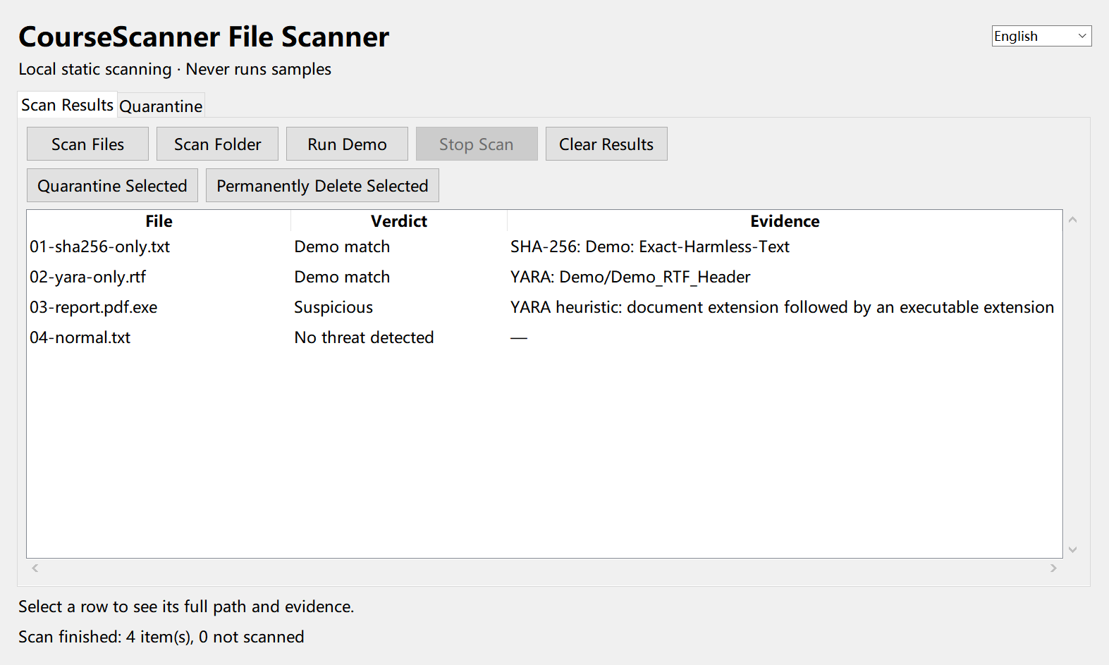
Figure 3. Actual v2.3.0 interface showing the hash, YARA and filename heuristic outcomes in the safe fallback demo.
Choose Scan Files, Scan Folder or Run Demo. The table shows the verdict and evidence. Right-click a row to open its containing folder without launching the file. The Quarantine tab provides restore and permanent delete controls. Switch the interface language from the top-right menu.
Harmless fixture | Observed result
01-sha256-only.txt | Demo SQLite SHA-256 only
02-yara-only.rtf | Demo RTF content rule only
03-report.pdf.exe | Suspicious double extension
04-normal.txt | No threat detected
The fallback demo uses a separate database and harmless text. Ordinary scans use imported hashes and Elastic rules. The optional pack includes EICAR and harmless text that triggers a real rule; it does not measure malware detection rates.
Extract the full Windows x64 ZIP and launch the EXE. Keep the adjacent data folder. No Python or MySQL installation is required.

6 Read-only evidence and verification
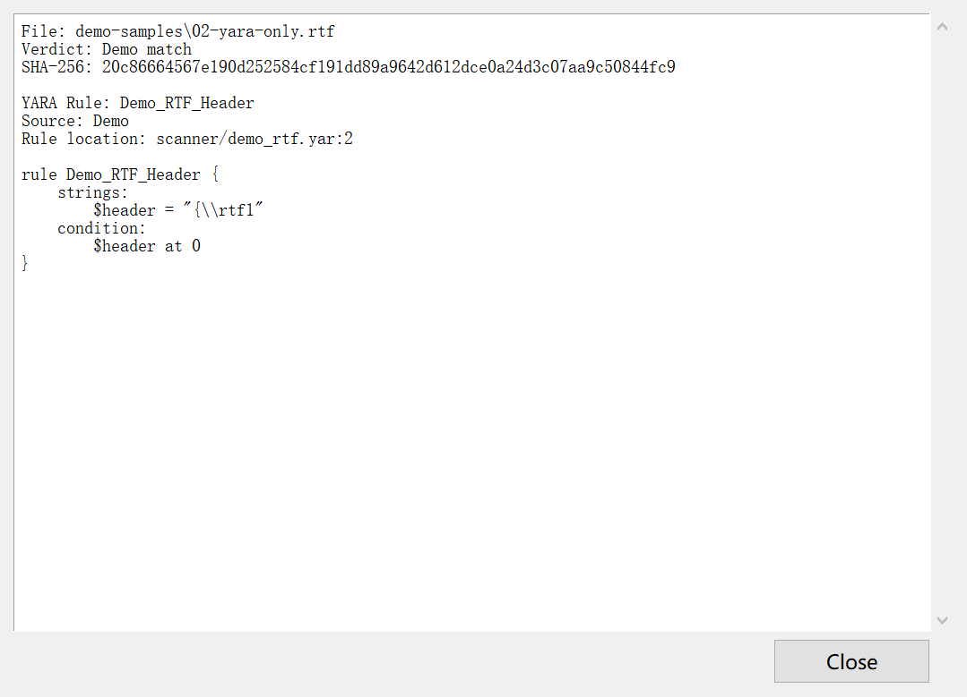
Figure 4. Read-only evidence opened from the Evidence column.
A SHA-256 match shows the digest and SQLite record. A YARA match shows the source, file, line and rule text. Heuristic reasons are listed separately. The viewer does not open or execute samples.
All 17 core tests passed. The public Windows package was checked for database integrity and startup, and the fallback demo verified separate SHA-256 and YARA matches. Only ClamAV records are bundled in the public database.

