Long Life Cardio – Max Pulse
Website content compiled from the saved copy of longlifecardio.com

Contents
1. Home
2. About Us
3. Max Pulse - Cardiovascular Screening Device Sales and Support
4. Max Pulse FDA Clearance
5. Max Pulse Test- Usage Guide
6. Max Pulse Test - Detailed Reports
7. Max Pulse Pricing
8. Max Pulse Value to Clinic
9. Max Pulse Device for GPs and Family Practices
10. More on the 1-7 Categories
11. Most Accurate Results
12. Patients Who Fail The Arterial Test
13. Arterial Health - Overview
14. HRV Overview
15. What Is Heart Rate Variability?
16. Diagnosing Atherosclerosis
17. CVD Mortality in the US - 2018 Update.
18. Cardiovascular Mortality Rates on the Rise due to Obesity Epidemic
19. Doctors Comment
20. Scientific Research
21. VasoScan
22. Video
23. Max Pulse Training Videos
24. Max Pulse Support
25. Max Pulse Troubleshooting
26. Software Support
27. Installing New Software
28. Software Setup Window
29. Max Pulse Testing Directory
30. Practice Directory
31. Order Form
32. Contact Us
33. Terms and Conditions
34. Disclaimer

Home

The Max Pulse
For Early Detection of Heart Disease

Screening for Patient Arterial Stiffness, and Circulation Issues.
“The future of cardiovascular research is to stop the disease before it starts,”
Dr. Steven Houser, President of the American Heart Association
The Max Pulse Screening Device

A Video Introduction to the Max Pulse
This 4 minute video will explain how to use the Max Pulse and the benefits it can offer to your medical practice.

Max Pulse Cardiovascular Testing
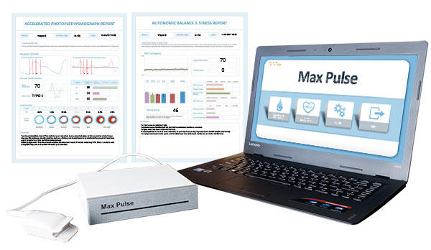
The Max Pulse will show you in just 1 minute if your patient is suffering from arterial wall stiffness and gives you an accurate estimate of the biological age of the arteries.
The simple finger clip is non-invasive and the test is very simple to administer. The information allows you to get your patient onto an appropriate program to address the problem before it develops into something more serious.
The Max Pulse can help Healthcare Practitioners reduce cardiovascular disease in their patient populations through early detection and prevention and assist to decrease the incidents and trauma associated with the cardiovascular system.
Cardiovascular disease is the number 1 killer for both men and women in the United States with an estimated economic cost of over $300 billion.
Find Out More Now

"One of the best medical tools I have ever used and it provides one of the most comprehensive cardiovascular screenings available." Dr. N

About Us
Long Life Cardio LLC is based in Wimberley, Texas and provides Max Pulse Sales and Support for all of the United States.

We are proud to be the Authorized Distributor for Medicore. This is a South Korean Based Medical Manufacturer. Medicore is ISO Certified with a Medical ISO Certificate 13485:2016.

We have been distributing arterial testing equipment since 2012. We pride ourselves on excellent customer service and the fact that we represent durable and high-quality equipment.

We distribute the Max Pulse Device.

Our Product

The Max Pulse
Sales: The Max Pulse comes with a 1-year factory warranty and is also available with an extended 5-year warranty.
Service: We service the Max Pulse devices as needed. Cost is dependent on the issue. In some very rare instances, the devices do have to be returned to the manufacturer for repair.
Parts: We supply finger probes and all connecting cables so if you need anything we can get it to you quickly.
Troubleshooting: We can troubleshoot your Max Pulse device.

OUR TEAM


WAYNE BAUMGARTEN owner
After working for the company that first distributed the Max Pulse in the USA, Wayne took over the distribution when the previous owner retired. Having worked with the Max Pulse and the earlier devices that were the forerunners to this device, Wayne has a deep knowledge of the equipment. Wayne also consults with our directors to ensure websites are kept up, oversees internet advertising, and that the best possible marketing strategies are used. With his long experience he is able to support owners who have more complex technical questions.


TRINA TEW managing director
The majority of Trina's career was spent in the medical field. Working in multiple practices she has had the opportunity to work with many different doctors here in Texas as well as in her home state of Virginia. Previous to working with Long Life Cardio, Trina was working in Seton Medical Center in Patient Care on the Ortho/Trauma floor. She is very compassionate and enjoys working with people to deliver great service and care. Trina has many years working with our medical testing devices. She has done seminars and presentations as well as training in the use and understanding of this testing.


SHARON MONNETT DISTRIBUTION MANAGER
Texas born and raised and with 36 years of Sales, Customer Service, and Business management -- with an emphasis on Customer Service -- Sharon takes care of customer service, stock and inventory, Shipping, and distribution of our medical devices. With her wide array of skills, Sharon is behind the scenes ensuring quality service to our customers as well as oversight and administrative support. Sharon is a jack of many trades, caring and professional, with great attention to detail.

Max Pulse - Cardiovascular Screening Device Sales and Support
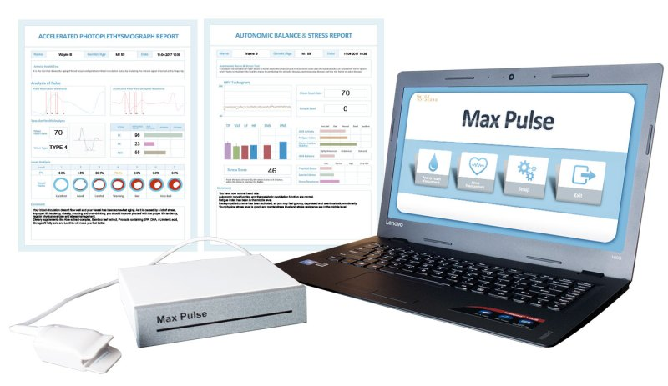

Detect Heart Disease & Arteriosclerosis in 1 Minute

Track Improvement of Arteries and Circulation

Detailed Report on Arterial Stiffness

Excellent Reimbursement Model
The Max Pulse is a great resource for any type of Healthcare Practitioner or health-related business or profession because it provides a simple and non-invasive means of determining the health of the cardiovascular system.
Max Pulse testing will give you a detailed analysis of arterial health, along with a separate report containing a detailed analysis of the autonomic nervous system and stress/fatigue levels.

Get Your Max Pulse Today!

Purchase with 5 Year Warranty
(Includes Max Pulse with Accessories, and Laptop with Software.
There are no other on-going fees or costs)
Click Here to Inquire

Video Introduction to the Max Pulse

Rapidly show your patient the state of their Cardiovascular health. Get an early indication of arterial hardening.

How It Works
The Max Pulse test is non-invasive and uses a photoelectric clip on the fingertip. By measuring the blood at the fingertip, the Max Pulse can graph the heartbeat as it moves through systolic and diastolic. When a person’s arteries are flexible, the pressure at the fingertip has specific deviations as the arteries flex. If the person’s arteries are very stiff, the graph becomes very tight and regular. The machine performs an analysis of the arterial pulse wave by using a very sophisticated algorithm to track variations in the graph that are not visible to the naked eye and then interprets those results against a large body of research. The result is an assessment of arterial hardening that is very accurate.
Arterial Health Score: The 1-7 scoring system gives a very accurate assessment of arterial hardening. The final report can also indicate instances where the patient has early congestive heart failure or heart weakening. This test allows you can detect arterial hardening or heart weakening long before the patient becomes symptomatic. This is crucial in diabetic patients and for patients with high blood pressure or elevated lipids.
Autonomic Balance Test: The machine also does a very accurate heart rate variability test and prints an autonomic nervous system analysis, showing if the person is overstressed and the sympathetic nervous system is dominant, or in some cases showing that the person is fatigued or the sympathetic is suppressed and the parasympathetic system is dominant. It also shows how well the patient is dealing with their stress levels and assigns a stress score.

Two Types of Testing:
The Max Pulse will show you in just 1 minute if the recipient is suffering from arterial wall stiffness and gives you an accurate estimate of the biological age of the arteries. The simple finger clip is non-invasive and the test is very simple to administer. The Arterial Stiffness Test shows the degree of plaque buildup in the arteries and resultant arterial hardening. The test will also indicate early-stage congestive heart failure if present.
The Stress Test uses heart rate variability to show the state of the autonomic nervous system. This shows clearly if someone is over-stressed or over-fatigued and also has an important bar graph that shows how well the person is withstanding his or her stress levels.
The information that you get from both reports allows you to get someone onto an appropriate program to address any issues before things develop into something more serious.

Comparative Testing (Before and After Treatment)
The Max Pulse is very sensitive and it can show changes quite quickly.
Long Term Treatment: For long-term, longer-lasting treatments you can see changes within 4-6 weeks of starting treatment.
Short Term Treatments: Some fast-acting treatments (such as some fast absorption nitrous oxide products) can show changes within 10 or 20 minutes.
Our machine tracks every heartbeat and scores it. Then the Max Pulse presents the results broken down by percentage of heartbeats. So after treatment even if the heart has just 5 or 10 heartbeats that struggle less or arteries flex a bit better, you will see it on the percentage scoring section.

Testimonials
“The Max Pulse device offers a simple, quick, and highly informative test for endothelial function as well as vessel integrity. This allows the clinician to identify patients at risk for cardiovascular disease allowing for appropriate counseling regarding lifestyle, diet, and supplemental changes as well as referral to a cardiologist if indicated. Also, patients appear more motivated to become proactive when discussing these test results.” – Dr Birken, MD FACOG Houston Texas

Read More Testimonials Here

Reimbursements and Increased Revenue
Monetizing this preventative care screening can significantly increase practice revenue. Doctors who have the Max Pulse have been billing insurance for this test successfully with great reimbursement rates. There are no hidden fees or costs associated with the Max Pulse and shipping is guaranteed within 3 days of payment.

Max Pulse Science
Photoplethysmography has been used for a long time. A simple pulse oximeter will measure the arterial pulse wave and the deviations between young healthy arteries and very advanced CVD is actually visible right there on the pulse ox. But that is not enough for clinical use. What makes the Max Pulse different is the more complex pulse wave analysis that our proprietary algorithm performs, reformatting the arterial pulse wave graph and pulling very detailed information. Multiple peer-reviewed studies have shown this technique to be effective when compared to more traditional and time-consuming methods of detecting cardiovascular disorders. Our machine takes the arterial pulse wave and interprets it using something called Accelerated Photoplethysmography (APG) which allows us to pull very precise information from the waveform. Our website has scientific studies (see link below). Contact us and we can email you a PDF that includes a summary of the important points in these studies.

What Comes With the Max Pulse
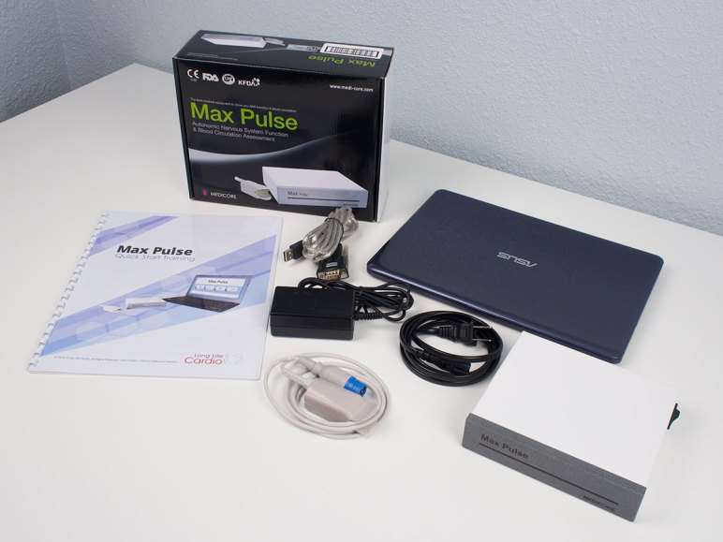The complete package ships with everything needed to perform the testing is included in the box. There are no extra costs associated with using the Max Pulse, everything you need is provided, including:
- The Max Pulse Device itself, (note: the Max Pulse must be connected to a computer to operate),
- 1 finger probe and all attendant power cords and connection cables,
- Computer Software Program (Windows 10 version, MacOs available on request),
- Training Manual that covers every aspect of the device and how to use it,
- Research documents on Pulse Wave technology and heart rate variability,
- Access to a series of Training Videos and excellent customer support,
- Financing if needed with low monthly payments.
Once the Max Pulse arrives with you, we have training videos that show you how to set up your device (which only takes a few minutes), how to perform the tests, and how to interpret the results. You can watch these anytime and use them to train personnel to administer the tests in your office. You can find these videos on this website under training videos or follow this link: https://longlifecardio.com/max-pulse-training-videos/

The Max Pulse Reports

The Max Pulse Arterial Stiffness Printable Report
(Pulse Wave Analysis)
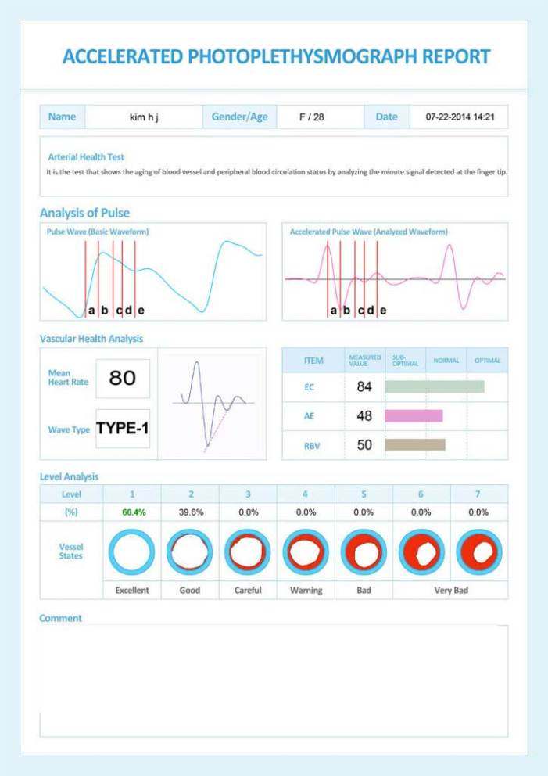
This is the results screen showing the final report for arterial stiffness. This example test report shows a type 1 graph, which is excellent arterial compliance (flexibility). When the machine arrives, it also comes with a manual and an interpretive guide so that you can easily interpret the results. The Max Pulse arterial stiffness report includes a very powerful feature. The report shows what percentage of heartbeats fell into each category. When the heart beats, it does so a little bit differently each and every time. So while the machine will give you an overall type from 1-7, it will also show you percentages next to each type. In this instance, notice that the patient had 60.4% of their heartbeats fall in type 1 and the rest were type 2. This shows a type 1 starting to degrade to a type 2. When you see lower scores these percentages become more and more important. For example, one person may score a type 2 result that is split between type 1 and type 2. That is good. Another person might score a type 2 result that is split between a type 2 and type 3. That is concerning and the patient should take that degradation seriously.

Max Pulse Heart Rate Variability Test Report
(Autonomic Balance and Stress Test)
The Autonomic Nervous System Test gives a deep look at the patient, telling the practitioner if the patient is over-stressed or over-fatigued.
The TO/VLF/LF/HF bar graphs are detailed and covered in the documentation.
The SNS/PNS bar graphs show immediately if the patient is over-stressed or over-fatigued.
The easy to interpret bar charts on the lower right-hand side show important metrics. The Fatigue Index shows if the patient is fatigued. Electro-Cardio Stability shows if there are irregular heartbeats present (which is also represented by the Ectopic Beats number above). ANS Balance is the immediate view of whether the person is balanced. Physical Stress and Mental Stress help to determine the source of your patient’s over-stress situation. Stress Resistance is a unique metric that shows how well your patient is dealing with the stress levels (or fatigue levels) that they are experiencing. This is a powerful metric that allows you to show your patient the state of their health reserves. Too often patients “feel fine” but are perilously close to the end of their reserves. Such a patient is hovering on the verge of a breakdown and needed help – help that you can provide and that the patient is likely to accept when they see how close to the edge they are.

Full Customer Support from People Not Computers
Long Life Cardio has been distributing arterial testing equipment since 2012 and we pride ourselves on excellent customer service and representing durable, high-quality equipment. We back up our Max Pulse sales with a comprehensive 1 year warranty or a 5 year extended warranty.
Our Tech Support is available during standard business hours for any troubleshooting needs. We handle servicing of the unit and in very rare cases, work with the manufacturer for repairs. We also supply finger probes and all connecting cables so if you need anything we can get it to you quickly.
The Team at Long Life Cardio made the acquisition of my Max Pulse device a great experience. Wayne went above and beyond to answer my questions. I highly recommend them.” – Dr. Horton, MD
Tech Support with Long Life Cardio is easily accessible and most professional. I highly recommend Max Pulse not only for all medical offices, but especially those clinicians who focus on preventive health.” – Randy A. Birken, MD

FDA Clearance
The Max Pulse is an FDA 501K Approved Class II Medical Device (See Clearance Information Here).

Get Your Max Pulse Today!

Purchase with 5 Year Warranty – As Low As $240 a Month!
(Includes Max Pulse with Accessories, and Laptop with Software.
There are no other on-going fees or costs)
To Inquire, Please fill out the form below

Contact Us:
We would love to hear from you! Please fill out this form and we will get in touch with you shortly.

Max Pulse FDA Clearance
The Max Pulse FDA 501(k) clearance was received in June of 2011, and the number is K110374.
It is listed as a “Photoelectric, Pneumatic or Hydraulic Plethysmograph” and is listed as a Class II Device.
The Max Pulse FDA Clearance indications for use are as follows:
“The device provides noninvasive measurement of pulse waveform and heart rate by photoelectric plethysmography. The anatomical site for taking the measurement is the left index finger. The device is intended for us with patient age 18 and older and with a weight of 100lbs or greater. The device is indicated for use in hospitals, health care clinics and physicians’ offices.”
The approval is from the division of Cardiovascular devices.
Contact Us To Learn More

Max Pulse Test- Usage Guide

Performing the Test
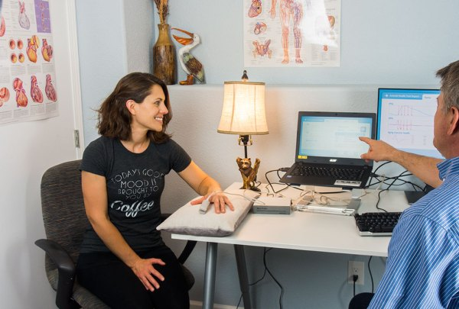The Max Pulse test is easy to perform and can be done in as little as one minute. Here are simple instructions that will help you to get accurate results. Click to see an overview of the Max Pulse.
- Do not perform the test until 2 hours after the patient has taken caffeine. Do not let the patient smoke before the test. For most accurate results, the test should be done on an empty stomach or mostly empty stomach (digestion can cause the body to tighten outer arteries and push blood to the internal organs).
- Have the test performed in a quiet room. Make sure there are no noises, vibrations or bright lighting that might disturb the patient during the short test.
- Have the patient relax for a few minutes before getting started. Anxiousness, tension, and stress affect the test. The test should be taken with the patient in a resting state since the pulse wave is affected by blood pressure, blood flow etc.
- The temperature of a room should be comfortable. If the clinic is kept cold or the climate is cold, then pay attention to make sure that the patient is warmed up before the test and does not have cold hands. Keep in mind that the device is using the volume of blood at the fingertip to track the heart and arteries. If the hands are cold, circulation to the fingertips can be too low for an accurate reading. (Disposable hand warmers can kept available in case of cold hands).
- Attach the finger clip lightly to the left index finger, making sure the clip is fully seated onto the finger. Make sure the finger clip is not being squeezed. There should be no pressure on the clip. For example a person who tucks their hands under their thighs will get an inaccurate readings. The hand should be approximately at heart level.
- Acrylic nails (false nails) can block the Max Pulse sensor in some cases, especially if they are long and wont allow the sensor to be seated deeply on the finger. In this instance retest the patient when this has been removed. Always ensure the finger clip is seated properly on the finger.
- The patient should not move or talk and should keep their eyes open during the test. The patient should breathe normally during the test. The patient should not meditate or try to influence the test.
Important: Invalid Tests
If you see any of these while the test is running, the test is invalid and the patient must be checked for A-C below and retested.
- A coarse or irregular heartbeat graph
- no heartbeat graph at all
- heart rate impossibly high or impossibly low
All these things indicate that the finger clip cannot read the patients finger. Most often these come from cold hands. Warm up the hands and any of these issues that are present will disappear.
IMPORTANT
INVALID AND INACCURATE TEST RESULTS
It is very important for both practitioners and those who are performing the test to be able to see when a Max Pulse test result is invalid.
There are three main reasons that results are invalid.
A. The most common cause of invalid test results is poor circulation in the patients hands, caused by cold hands or on rare occasions by Reynauds Disease (which is characterized by poor peripheral circulation). Because of this we recommend keep disposable hand warmers with the machine (available from most CVS, Walgrens etc) . The person doing the test should always feel the patient hands before starting the test to confirm they have a natural warmth.
B. The second most common cause is the patient doing something other than sitting quietly and waiting for the test to complete. If the patient moves, talks, closes their eyes, or alters their breathing or in any way makes an effort to influence the results, the test should be retaken.
C. Testing on a full or mostly full stomach. After eating, the body will constrict and relax main arteries to push blood into the digestive tract and balance it once there. This can alter the results and in fact results taken during the digestion period can be different one to the next, as the body adjusts for digestion.
Type 5 through 7 scores should be referred to a specialist (see documentation for what each of these score represents). Before referral it can be a good idea to retest a person taking care that one of the above factors was not missed by the person doing the test.
Recognizing A Completely Invalid Test: Tests can be inaccurate because of reasons A-C above. They can appear a bit worse or better than they really are. But in some cases the result can be completely invalid and meaningless. You will see these invalid tests immediately because they show the patient scoring in three or more categories and often none of the scores are over 50%. Any test where the patient scores significant percentages in three different categories is invalid.
- Arterial type score of less than 50% is showing as the dominant type. (Dominant arterial type is always more than 50% of the heart beats in accurate tests).
- 3 Way score. If the patient shows up with at least 5 percent of heart beats in 3 or more categories, the test is invalid. Check for cold hands and re-test being strict with no moving and no talking during the test. All three way scores are invalid.
Patients With Arrhythmia: Once you have checked A B and C above and are confident that the test is running properly, there is only one last factor that can be a problem – a patient with a severe Arrhythmia. Arrhythmia can often be cooled off by getting a patient to stop taking stimulants of any kind (including caffeine in any form). If you are getting strange results on the 1 minute arterial and have checked the that the test guidelines are being followed, we recommend you run the 3 minute Stress Test. Irregular heart beats are marked on the report as Ectopic Beats. You should not have more than 2 or 3. Normally it should be zero. More than 5 ectopic beats during the test period indicates the patient has an arrhythmia and this must be addressed first. The first step for that patient is cutting out stimulants and getting their heart beat calmed down and regular so they can be tested. If the person is not taking stimulants then the reason for the Arrhythmia should be discovered as quickly as possible.
If you have any concern about the accuracy of a test result please send us the test and we will assist.

Max Pulse Test - Detailed Reports

Max Pulse Test – Detailed Reports

The Arterial Stiffness Report

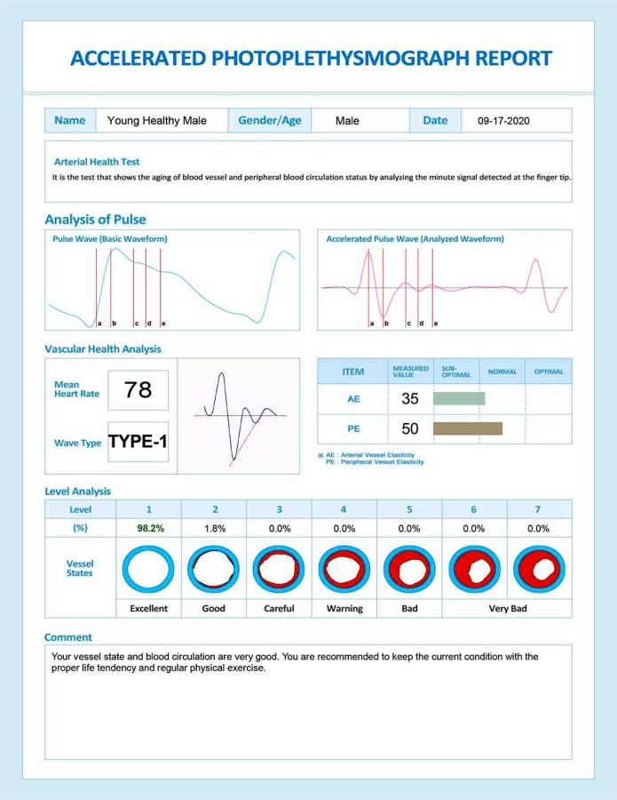The Max Pulse Test generates one report for arterial stiffness and another report showing patient stress levels. Max Pulse Test reports can be printed or saved to PDF.
The following report is generated by the Max Pulse to show arterial aging.

Analysis of Pulse Section
The first graph (left side of the report) shows the arterial pulse wave as the heart moves through systolic and diastolic. The amount of blood in the finger tip increases, then begins to decrease. There is a “bump” in the graph as the aortic valve closes and the diastolic completed.
The second graph (right side of the report) shows the same graph that has been mathematically accelerated. This graph is very sensitive and this is what the software analyzes to score the patients arterial hardness.

Vascular Health Analysis Section
Here the report shows Mean Heart Rate and then the most important metric – Wave type.
This “wave type” refers to the accelerated pulse wave mentioned above.
This accelerated pulse wave was found to fall into 7 distinct types which are numbered 1 to 7 with 1 being a healthy heart and 7 being a heart and vascular system in the poorest condition.
Then there are 3 metrics which have a bar graph to show if they are in range or not.
AE = Artery Elasticity: Represents the elasticity of the wall of the large arteries by the contraction power from the heart.
PE = Peripheral Elasticity: Represents the elasticity of the small arteries at the periphery of the body.
Level Analysis: This shows what percentage of the total heartbeats fell into which wave type. This gives a more in depth look. The report shown has almost all heartbeats as type 1 – a close to perfect score.

The Max Pulse Autonomic Balance and Stress Report

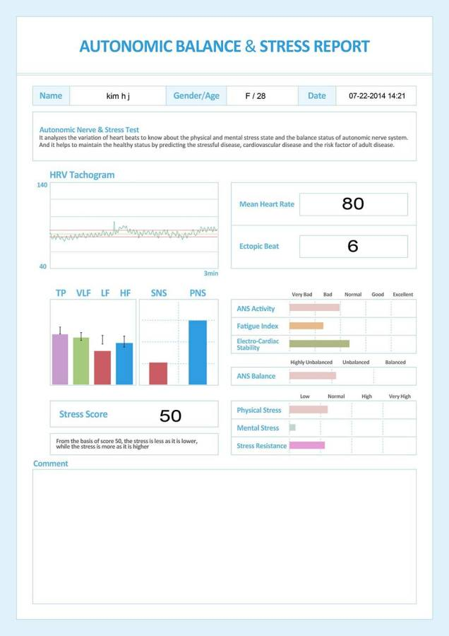
(The Max Pulse Test measures Heart Rate Variability and gives an analysis)
The HRV tachogram shows each heartbeat during the test period. To the right you will see mean heart rate and the number of ectopic beats.
TP LVF LF HF Section (Total Power / Very Low Frequency / Low Frequency / High Frequency)
These bar graphs reflect levels of Sympathetic and Parasympathetic activity and their balance.
Power in 4 frequency bands analyzed: Total Power / Very Low Frequency / Low Frequency / High Frequency
SNS PNS Bar Graphs
SNS/PNS Balance – SNS (sympathetic nervous system) & PNS (parasympathetic) Balance. SNS and PNS ratio is normal at around 6:4.
Higher SNS can show up as nervous, anxiety, agitation, excitement, increasing blood pressure, headache, etc.
The Frequency Bars – TP (total power), VLF (very low frequency), LF (low frequency) and HF (high frequency).
These bars show non-optimum when they are low.
Reduced TP: Decreased ANS function, decrease in bodies regulatory ability and a decrease in the ability to cope with environmental change.
Reduction of VLF: Decrease in the bodies ability to regulate body temperature and hormone levels.
Reduction of LF: Loss of energy, fatigue, too little sleep, tiredness and lethargy.
Reduction of HF: Chronic stress, aging, reduced electrical stability of the heart.
There is more, that is covered in the training.
But it is worth mentioning the Stress Resistance Score – the last bar graph. The Max Pulse has this unique aspect of HRV where it shows stress/fatigue, but it also scores how well the person is holding up under their stress- a kind of “stress gas tank”. This is great to show people the importance of caring for themselves. People can go charging along with terrible HRV scores for quite a while and feel fine. But when the Stress Resistance (“stress gas tank”) runs out, you get sudden collapses that can be serious and take a long time to recover from. This one score is very important and can avert poor patient outcomes by giving the early warning that the person can probably feel – but is ignoring.
Contact us for a more detailed explanation of the Heart Rate Variability report or if you have any questions about the Max Pulse Reports and how they work. There is a lot of information delivered by these reports that is not covered on this page.

Max Pulse Pricing

Bring this Life Saving Testing into Your Practice

Max Pulse with Accessories, Laptop and Software (5 Year Warranty) –

Financing As Low As $240 a Month*

Your Device Will Be Shipped Within 3 Business Days

For More Info Please Call:
(210) 610-2521

Your Max Pulse Comes With…
Shipping: Long Life Cardio ships all Max Pulse devices in the Continental US by 2-day FedEx, fully insured. We guarantee shipping within 3 days of your payment, but shipping is normally same day or next day.
Testing: Your device will be tested before shipment to ensure that everything is working correctly. Our quality control staff will ensure you receive a fully operational device.
Your Shipment will Contain:
- The Max Pulse Device with 5 year warranty
- Finger probe and all Connecting Cords.
- Modern 14″ laptop already set up and software loaded and tested
- Software USB for installation (PC and Mac versions Available)
- Training booklet (and access to training videos)
- The Max Pulse arrives ready to use. There are no hidden costs and no on-going fees.
- Tested through our Quality Control before shipping.
If the device arrives to you damaged or not in working order, you must contact us within 48 hours of delivery and report the issue. We will remote access the machine and debug it. If the machine cannot be debugged, we will send you a shipping label to return the device and we will ship a new device.
Training: We offer concise but very complete training videos. An easy-to-understand instructional booklet is also sent with the device.
Contact: For more information on Leasing, Sales and Service, please call 210-610-2521
Terms and Conditions: All Leases and Sales are subject to the terms and condition found at our Terms and Conditions Page
*All Leasing and Financing is offered through third party lenders and is dependent on their approval.

Max Pulse Value to Clinic
The Max Pulse device performs two functions.
Arterial Testing Function: The 1 minute arterial test will detect:
- Early stage arterial hardening, so early that the condition is reversible giving patients an early wake up call and a chance to act.
- Early/mid stage heart weakening, the beginning of congestive heart failure, often when the patient is unaware, but is showing symptoms such as edema but has disregarded them.
- Late stage arterial hardening, sufficiently advanced that it is not easily reversible and may even require surgical intervention (such as stenting). This can be life saving. Our equipment will detect advanced arterial hardening before BP and other markers are definite.
This is aimed at Primary care where it is impractical to do carotid dopplers or other advanced screenings on a high volume of patients. The machine offers incredible value to patients as they can be warned when their arterial health starts to decline or rescued when decline has already occurred.
Value to Medical Practice: There is a billing component to the machine. While our company does not recommend billing codes, the manufacturer has stated that 93922 might be appropriate and while reimbursement varies greatly state-to-state, we have had positive feedback from a number of doctors regarding this.
The secondary value is that the machine can show patients the value of various therapies being offered. For example you can test after the use of an innovative therapy and you will often see small bumps in the more sensitive markers that the report generates. You can validate your other treatments using the Max Pulse.
Heart Rate Variability Testing: The 3 minute test will show:
If the patient is stressed or fatigued
If the patient is reaching the end of their ability to withstand the stress or fatigue they are under (Stress Resistance).
If the stress or fatigue is mostly physical or mostly mental.
The HRV test is unique and very sensitive.
Peer Reviewed Scientific Studies
There are many studies of this technology all the way from PLOS one to the Journal of Hypertension. But this article covers the technology in great detail going step by step through each aspect of the technology. https://www.ncbi.nlm.nih.gov/pmc/articles/PMC3394104/. The articles gives many references for each steps of the development of this technology. To get the most applicable part of the article, scroll all the way down to C. Second Derivative Photoplethysmogram. Our equipment uses the Second Derivative (APG). There are a number of additional references that can be searched there. We have a lot of them on our website – https://longlifecardio.com/scientific-research/.
HRV has been extensively studied and connected to mortality in a number of studies. We have a number of studies that are appropiate – just contact us to ask for this information.

Max Pulse Device for GPs and Family Practices
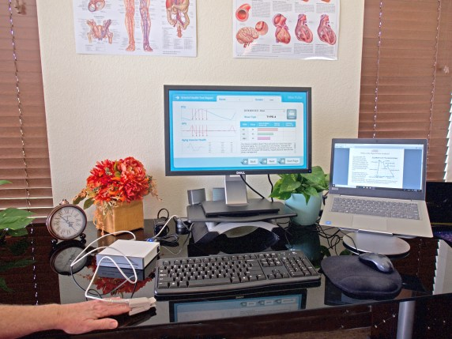
One of the biggest challenges that physicians face is treating and managing cardiovascular disease. More Americans die each year from CVD related problems than from any other disease. In many cases, patients are asymptomatic, or they aren’t aware of the severity of their disease until disaster strikes.
The World Health Organization has completed several studies on identifying and managing risk factors of cardiovascular disease, along with the obstacles that doctors encounter:
“The debilitating and often fatal complications of CVD are usually seen in middle-aged or elderly men and women. However, atherosclerosis, the main pathological process leading to coronary artery disease and peripheral artery disease beings early in life and progresses gradually through adolescence and early adulthood. It is usually asymptomatic for a long period.”
“…many people are unaware of their risk status; opportunistic and other forms of screening by healthcare providers are therefore a potentially useful means of detecting risk factors…”. Read more about this study and its findings at www.who.int/cardiovascular_diseases/guidelines/Full%20text.pdf.
General Practice Physicians frequently screen for cardiovascular disease by testing lipids, blood sugar, and regular blood pressure monitoring. However, the Max Pulse is an additional screening tool for cardiovascular disease that actually offers insight into the state of atherosclerosis in a patient.
The test is non-invasive, inexpensive, and takes approximately 3 minutes making it convenient for the doctor and the patient. Additionally, results print out instantly and can be reviewed with the patient right after it is completed.
This is a good tool to use in the course of regular check-ups regardless of age since it can help identify early signs of atherosclerosis. Additionally, it should be used with patients who have a known history and/or risk of CVD and can even help track progression from visit to visit. The Max Pulse should also be used in patients with diabetes as part of their regular testing program.

More on the 1-7 Categories
The 1-7 sequence does not seem to make sense because issues concerning arterial hardening are not in sequence. As the arteries get harder a patient moves through a scoring of 1-2-4-6. Types 3 and 5 are related to heart weakening.
But the numbers (or letters in the case of the Meridian DPA) are in sequence of severity.
The DPA is incredibly sensitive. And the 1-7 system is a severity numbering system.
1- Perfect
2 – Normal and natural loss of perfection when you are not in your teens or at peak fitness.
3. Arterial flexibility still OK, but a tiny, barely detectable loss of punch in the strength of the heartbeat.
4. Reversible, very early stage arterial hardening, probably not even showing up in blood pressure going over acceptable levels. But there is arterial degradation and is should be addressed now. Type 4 is not a condition or disagnosis and if you refer this person to a cardiologist they will come back clean. They are not will. They are just on their way to getting ill.
5- An actual condition shows up here- Congestive Heart Failure. The heart is not pumping as hard as it should and the patient likely has edema and shortness of breath. Very likely diagnosable but has been brushed off.
6- Serious arterial hardening – High risk of heart attack. Likely needs medication or in some case surgery. This is much more serious than 5.
7. Very serious, hardening and weakening, urgent, immediate intervention.
If you ignore what is wrong and just think about how serious the condition is, you will see that the 1-7 system makes sense. The numbers are arbitary. The designers could have swapped it around if they wanted to. But they created a numbering system that tells you immediately how much deterioration there is in the entire Cardiovascular system.
The original documentation uses the word dominant and gives
1-2-3-5 Dominantly Heart Weakening
1-2-4-6 Dominantly Arterial Hardening.
So they are not saying that at stage 5 there is no arterial hardening. They are saying that the big problem here is heart weakening. Same thing at Stage 6. They are not saying there is no heart weakening. They are saying that there is a huge problem with arterial hardening.
Type 3 often confuses people. But Type 3 is a passing score, with a tiny note. A Type 3 score can happen from a person not sleeping properly the night before. It is detecting a tiny weakening of the arterial pulse. It’s not all that clinically useful, especially in primary care where you are interested in sick or not sick and nothing in between. But if you are working with health, the Type 3 is worth digging a little bit on and seeing what comes out. Types 1-3 are all passing values. Type 1 is perfect, Type 2 is the slight tightening of arteries that comes from not being a teenager or at peak fitness. Type 3 is the tiny lack of punch from your heart that comes from not sleeping well, or having perhaps a slight illness – or in some cases a slight heart defect. Not very interesting in the world of illness. Only interesting if you are trying to bring people to peak health. In some of the most recent documentation, they ignore the special characteristics of type 3 completely. So we are talking tiny differences in the way the wave form is shaped.
Also keep in mind that the arterial wave has 5 components. Initial Pulse Wave, Reflected Pulse Wave, Dichtic notch or the bump when the valve closes, also central pressure and augmented pressure. So you take this very complex wave that has 5 factors moving around and then you convert it into acceleration values and get an even more complex wave. The things you see on the accelerated wave can’t be easily assigned to what is happening in the heart and arteries. The accelerated graph just shows how steep the change is moment to moment- swift increase, slow increase, swift decline, slower decline. The scientists who worked on the DPA divided it into 7 shapes. They matched the shapes to diagnoses after thousands of tests. Then they ordered them in terms of severity. That is why the 1-7 system works the way it does.

Most Accurate Results
When Using the Max Pulse In Research Studies: When doing trials that require perfectly repeatable tests, you have to be very careful to follow the test instructions exactly. Follow the wait period after coffee, the no smoking before the test, and the person must have an empty stomach and the hands must be warm.
The empty stomach is important. When a person eats, the body constricts the arteries at the periphery to push blood into the body core. Then the body will tighten and loosen arteries continuously to maintain the optimum core blood levels for digestion. Tests taken while digesting will fluctuate because of this. The length of time after eating is important but different foods digest at different speeds so its also important that the person reports that they have an empty stomach.
A. Back to Back Testing: If you are testing several times, one after another, you must follow the testing instructions precisely. That means you test the subject on an empty stomach, no caffeine or nicotine for at least 2 hours, with the patient having warm hands (use hand warmer) and the patient sitting comfortably and normally (no closing eyes, no special breathing, nothing except sitting comfortably). The clip must be on the left index finger with the hand approximately at heart level. So to get a very tight and accurate result you have to follow all the instructions here – https://longlifecardio.com/max-pulse/max-pulse-test-guide/. Any violations of the rules and the tests get sloppy and they move around a bit.
B. When tests move around: Tests move around a little bit when they are not done exactly per the instructions. To understand the movement you have to have a really clear understanding of the 2 types of scoring that are going on.
4 and 6 are arterial hardening. So a person who scores 60% Type 4 and 40% Type 6 is showing arterial hardening – some heartbeats reflecting severe, some heartbeats reflecting moderate. These percentages can shift around fluctuating between 4 and 6 if the person is digesting food, or agitated or any of the other things in the setup.
3 and 5 are heart weakening. So a persons score might move between a 3 and a 5 but its the same situation, just showing at different weakness. Type 3 is barely detectable heart weakening – Type 5 is noticable heart weakening. Again this can move around some if the test is not done per instructions.
C. Arrhythmia: Sometimes you can do a test perfectly and the test results are still not steady. The thing to check is to make sure the patient does not have an arrhythmia If a patient has an irregular heartbeat, you can get an invalid test. You can see this when you do the 3 minute HRV test – that test scores the number of ectopic (irregular) heartbeats. If you do a test and are careful to do everything right and the results are not fairly steady, then run the HRV and see how many ectopic beats there are. Those beats are going to throw everything off. People who drink a lot of coffee often have a lot of ectopic beats. Other stimulants, drugs, medications can do the same thing. You have to get the person off the stimulants before you can get a steady reading.
D.Quick Testing: Often medical practices are using the machine as a screening tool, trying to find severe problems. They should be testing on a mostly empty stomach, still no caffiene for 2 hours, no smoking directly before the test, warm hands etc but they don’t have to be so exacting. Tests will be less accurate. Once a person is detected with a severe problem – 5, 6 or 7. They should carefully re-test before referring the patient out.
Please let me know if that helps
Wayne

Patients Who Fail The Arterial Test
This is an example of some ideas that could be reviewed as potential recommendations for patients who fail the Max Pulse Arterial Test. This list should not be used for treatment of actual patients but patients should be given unique treatment programs as determined by qualified medical professionals. This list does not represent a complete statement of treatments possible or available. Practitioners must make their own treatment determinations. Long Life Cardio does not recommend any particular treatment program but offers this list as suggestions for a practitioner to examine. Where a patient or client fails the Max Pulse arterial test we recommend referral to a cardiologist.

Type 1-3 is a passing score.
Patient should be encouraged to continue or adopt healthy lifestyle choices that will preserve his or her current arterial score. Note that Type 3, while a passing grade, is a particular case and the training video should be studied for a deeper understanding of this score – https://longlifecardio.com/max-pulse-training-videos/

Type 4 Arterial Heath Score- Test Failed. First Stage of Arterial Hardening
- Stop Smoking
- Reduce Alcohol Consumption
- Start Daily Exercise (If the patient has a sedentary work situation have them also arrange to get up and move around every 30 min to 2 hours)
- Move to a Healthier Diet. The Mediterranean diet is a good choice. Reduce fast foods and sugars.
- Lose Weight.
- Recommend Nutritional Supplements as Determined by Practitioner. (Some studies suggest using supplements that include L-Arginine, Nitric Oxide or Red Beet Powder). Ensure the patient understands that nutritional supplements cannot replace steps 1-5 above.
- Check Blood Pressure and Lipids and recommend standard medical treatments for anything found.
Type 5 Arterial Health Score – Test Failed. First Stage of Congestive Heart Failure. Heart is Weakening.
- All the of the recommendations for Type 4 apply, but exercise must be gentle and supervised because Type 5 suggests a weakened heart.
- Any testing recommended by a medical doctor to search for factors that may be causing a weakened heartbeat (there are a wide range of factors that can cause a weakened heart, which a medical doctor will be familiar with).
- Refer to a cardiologist, requesting testing for congestive heart failure (weak heart beat, low pulse strength)

Type 6 Arterial Health Score- Test Failed. Severe Arterial Hardening. Immediate Action Recommended.
- All the same steps as Type 4, except that everything should be stricter except for exercise. Exercise should be very mild and closely supervised. Patient should be warned that exercise must be light and not to over-exert themselves. Type 6 or 7 should be considered to be at imminent risk of a cardio event.
- Refer to a cardiologist who should be asked to check for arteriosclerosis and blockages. Cardiologist referral is urgent.

Type 7 Arterial Score
This score is almost never seen because Type 7’s are normally too sick to visit primary care physicians. If you see a Type 7 score then Cardiologist referral is critically urgent.

Arterial Health - Overview

Arterial Health – Overview

VASCULAR DISEASE: IT STARTS IN THE WALL
Early Detection of Vascular Disease through Arterial Waveform Analysis
by Dr. Jay N. Cohn, M.D. Professor of Medicine University of Minnesota Medical School Cardiovascular Division Minneapolis, Minnesota
Dr. Cohn founded the Heart Failure Society of America and was its first president and also founded the Journal of Cardiac Failure.
- Director, Rasmussen Center for Cardiovascular Disease Prevention
- President, International Society of Cardiovascular Pharmacotherapy (2008-2010)
- Scientific Advisory Committee (1996-1998)
- Victor Chang Cardiac Research Institute, Sydney, Australia (1997)
- President, International Society of Hypertension (1996)

SUMMARY
Significant advances have occurred in the prevention and treatment of vascular disease. Yet vascular disease remains as the leading cause of death in the United States. Awareness of risk factors has encouraged healthier eating habits and more active lifestyles. Risk factors can include:
- smoking
- inactivity
- obesity
- diabetes
- high blood pressure
- high cholesterol
- genetics
Prevention efforts target the entire population or those with specific risk factors. The whole- population approach imposes lifestyle alterations on a large population. Yet, only some of whom are at risk would realize such changes. The so-called high-risk population may or may not ever develop vascular disease.
Hypertension is present in less than 40 percent of patients sustaining a heart attack. High cholesterol levels are present in less than 40 percent of patients as well. This approach is useful. But, it does not identify the actual presence of vascular disease in its early stages. Early identification with current techniques is rare due to cost and other factors.

The University of Minnesota developed an advanced technology, called Arterial Waveform Analysis. This holds the promise of detecting vascular disease at the earliest stages. Subtle changes in the arterial wall can provide early markers for vascular disease.

Arterial waveform analysis may also help physicians improve management of the pharmacological therapy. This can aid in efforts to better use healthcare resources. Also, early intervention and life style changes are especially useful.

UNDERSTANDING THE PROBLEM – WHO REALLY IS AT RISK?
Vascular disease accounts for one-half of all deaths in the United States each year. It is the primary cause of heart attacks and strokes. Vascular disease can manifest itself in many ways: hypertension, coronary artery disease, peripheral artery disease, atherosclerosis, aneurysm, stroke, kidney failure and retinopathy. According to the AMA, 58 million Americans have some form of cardiovascular disease. Vascular disease can manifest itself in many ways:
- hypertension
- cornonary heart disease
- periphreal artery disease
- atherosclerosis
- aneurysm
- kidney failure
- retinopathy

HYPERTENSION
Hypertension is the leading cause of cardiovascular disease. Coronary artery disease affects 13.9 million Americans and is the nation’s number one killer. Stroke is the number three killer.
According to a 1997 release by the National Heart, Lung and Blood Institute, 50 million adults in the US are diagnosed with hypertension. Hypertension is defined as blood pressure greater than 140/90. Almost 75% of those are not properly treated for the condition. Those who are not treated face significant increased risk for heart disease.
According to the Johns Hopkins White Papers on Hypertension (1998), 30 million Americans have “high- normal hypertension.” This is also referred to “borderline hypertension.” It’s defined as a blood pressure reading at or slightly above 130/85.
These individuals are twice as likely to develop hypertension. They have a greater risk of CDV events than people with lower blood pressure. High-normal blood pressure is common in the United States. The majority of CV events occur because high blood pressure happens in people who have the condition but aren’t treated for it.
Hypertension is of particular concern to older adults, as levels increase with age. It accounts for 15-20% of all deaths over fifty years of age in the United States. Women also appear to be at increased risk with 33% of deaths caused by heart disease. 17% are relatable to stroke. Half of the women affected by stroke exhibited no symptoms of cardiovascular disease.

HYPERTENSION – THE SILENT KILLER
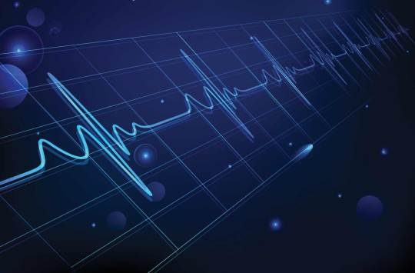Since hypertension can go undetected, it’s referred to as the “silent killer.” It usually produces no symptoms until after damage occurs to the heart, kidneys, or brain. This problem is more serious as the population grows older. Inviduals with high blood pressure have an increased death rate. This can be from stroke, heart attacks, or kidney disease.
The standard test for screening for vascular disease is use of an upper-arm blood pressure cuff device. While the cuff yields some information, the information it provides is very limited. It doesn’t note the presence of blood vessel disease. The blood pressure reading can be variable. It can be influenced by many factors, including physical activity, stress, etc.
When the aortic heart valve closes after ejecting its stroke volume, the decay of blood pressure before the next heartbeat describes a waveform which is dependent on the stiffness of the arterial system into which the blood is delivered.
The data from the blood pressure waveform can tell a lot about the likelihood of atherosclerosis. With this information, treatment may start for suspected CVD for patients with one or more risk factors. It is also possible that many of these patients do not have the disease. Some patients who develop atherosclerosis don’t exhibit high risk symptoms. Because of this, they may not receive treatment.
Augmenting current prevention efforts with positive identification of blood vessel disease has the potential to yield significant advances. Screening and diagnosing patients for CVD, the incidence and severity of heart attacks and strokes can reduce.

Get Your Max Pulse Today!

Purchase with 5 Year Warranty – As Low As $240 a Month!
(Includes Max Pulse® with Accessories, and Laptop with Software.
There are no other ongoing fees or costs)
Call: (210) 610-2521 or fill out the form below for More Info

VASCULAR DISEASE: IT STARTS IN THE WALL
Hypertension is a deadly disease that damages both large and small arteries. This leads to pathological changes in the tissues or organs supplied by these damaged arteries. It also accelerates the development of atherosclerosis in large blood vessels. The arteries supplying blood to the brain, heart, kidneys, and legs are also affected.

Plaques can cause minimal strokes (transient ischemic attacks) due to diminished blood flow (ischemia) to parts of the brain. Angina occurs from partly obstructed coronary arteries. Pain in the leg muscles when walking can be a result of poor blood supply to the legs (peripheral arterial disease). Blood clots, which occur at the sites of atherosclerotic narrowing. This can block a vessel and cause a stroke or heart attack.

The walls of all arteries (large and small) throughout the body are distensible. They expand and contract as blood pressure waves from the heart pass through the lumen. This is the passageway for blood within the arterial walls.

The distensibility enables the arterial system to act as an elastic reservoir that stores part of the energy of each cardiac contraction. This maintains blood pressure and flow during diastole to perfuse all tissues.

Changes in function and structure of the arterial wall precede the development of obstructive CAD. They are an early sign of the hypersensitive disease process. Vascular changes in elasticity can be induced by changes in:
- the smooth muscle
- the mass of the smooth muscle collagen
- elastin components of the wall
- infiltration of the wall with cellular or interstitial elements
- the change in tissue fluid in the wall

THE WALL
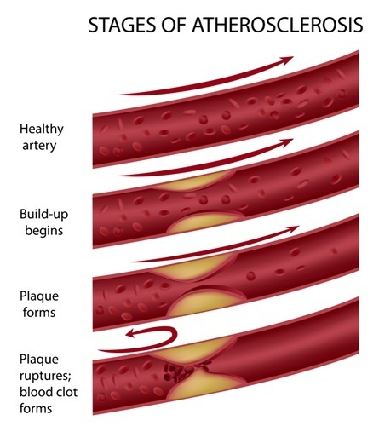The arterial wall is composed of three concentric zones termed the tunica intima, tunica media, and tunica adventitia. The tunica intima consists of the vascular endothelium. This is a thin layer of collagen and elastin fibers that anchor it to the internal elastin lamina. Recent research has explored the role the endothelium plays in the development of blood vessel disease. If the endothelium is thought of as an internal organ, it would be one of the largest organs of the body. Spread over a flat area, the endothelium cells lining the arteries of a single adult would cover the area of three football fields. Nitric oxide gas is released by the endothelium cells, and relaxation of the arterial walls is believed to be an important result.

The smallest arteries and arterioles are the sites of greatest hemodynamic resistance. They act in conjunction with the precapillary sphincters. Also, they form a variable resistance that controls the rate of blood flow perfusing all body tissue. An arterial system composed of elastic conduits and high-resistance terminals constitutes a hydraulic filter that converts the intermittent output from the heart into steady capillary flow.

THE ARTERIAL BLOOD PRESSURE WAVEFORM
The arterial blood pressure waveform is from the complex interaction of the left ventricle stroke volume, the physical properties of the arterial tree and the characteristics of the fluid (blood) in the system. Changes in arterial vascular compliance introduce changes in the arterial system. These reflect in the arterial blood pressure waveform. Changes are seen when examining the difference in the arterial pressure waveform of a patient before and after the administration of a pharmacological agent such as nitropurusside or nitroglycerin.

During systole, only the proximal part of the aorta becomes distended at first. This is because the inertia of blood hinders the passage of the total stroke volume to the periphery. The radial stretch of the ascending aorta brought about by left ventricle (LV) ejection initiates a blood pressure wave. This propagates down the aorta and its branches. This pressure wave moves at a finite velocity that is faster than the actual forward movement of the blood itself. The pressure pulse is simply a moving wave of pressure that involves very little forward movements of blood.

The distortion in the arterial waveform includes a delay in the time of the onset of the initial pressure rise. This dampens the high- frequency components of the pulse, and a narrowing and elevation of the systolic portions of the pressure wave.

In the initial portion of the diastolic pressure waveform, a feature referred to as the “dicrotic notch”becomes more prominent as the pulse passes peripherally. These morphologic changes tend to diminish with age as the arteries lose their elasticity. The damping of the high-frequency components of the arterial pulse are due to the viscoelastic properties of the arterial walls. The mechanisms involved in the peaking of the pressure wave are not fully understood.

ARTERIAL WAVEFORM ANALYSIS
Functional and structural changes in the arterial wall precede the development of obstructive CAD. They may be early markers for the hypertensive disease process. Vascular (or arterial) compliance has long been recognized as declining as part of the normal aging process. Also, as a declining at an accelerated rate in people with heart disease. The aorta and large arteries can be visualized by various x-ray and other techniques. Yet, there has been no means to test the flexibility or elasticity of the small arteries throughout the body. These can become altered in hypertension and with other vascular diseases.

Cardiovascular specialists spend considerable effort on evaluating heart function. including electrocardiograms (EKGs), echocardiograms and stress tests. But, they have been unable to assess the functional and structural abnormality of the arteries prior to the late phase of arterial obstruction (as determined by angiography).

THE WINDKESSEL MODEL
The arterial waveform analysis method utilizes a modified Windkessel model. This describes the pressure changes during the diastolic phase of the cardiac cycle in the circulatory system. This analysis method provides an assessment of the elasticity or flexibility of the large arteries. These expand to store blood ejected by the heart, and of the small and very small arteries (arterioles) which produce oscillations or reflections in response to the blood pressure waveform generated during each heartbeat.

Assessing the elasticity of the arterial system, clinical investigators have been able to identify a reduction in arterial elasticity in patients without evidence of traditional risk factors. This suggests the early presence of vascular disease. Research has demonstrated that individuals with heart failure, coronary artery disease, hypertension and diabetes exhibit a loss of arterial elasticity. These abnormal blood vessel changes often appear to precede overt signs of CVD and the occurrence of a heart attack or stroke by many years. Clinical investigators have also demonstrated an age- related loss of elasticity of both the large and small arteries. This suggests that premature stiffening of an individual’s arteries is a marker for the early onset of CVD.

Dozens of clinical research studies and pharmaceutical trials have been completed by utilizing this technology. More than 2,500 subjects have been reviewed. This has resulted in more than 30 scientific articles published in peer-reviewed medical journals.
Dr. Jay N. Cohn, M.D
(Contact Us to Obtain Copies of the Most Important Scientific Studies)

Get Your Max Pulse Today!

Purchase with 5 Year Warranty – As Low As $240 a Month!
(Includes Max Pulse® with Accessories, and Laptop with Software.
There are no other ongoing fees or costs)
Call: (210) 610-2521 or fill out the form below for More Info

Contact Us:
We would love to hear from you! Please fill out this form and we will get in touch with you shortly.

2 Responses
- Pingback: CASE STUDY: RMT AS AN INTERVENTION FOR CARDIOPULMONARY DECLINE | PNMedical Dev
- Pingback: CASE STUDY: RMT AS AN INTERVENTION FOR CARDIOPULMONARY DECLINE - PN Medical

HRV Overview
Heart Rate Variability (HRV) testing has emerged as a crucial component in both clinical and sports settings, providing insights into the autonomic nervous system’s regulation of cardiac function.

HRV Testing Uses:
1. Physical Health Monitoring: HRV serves as an indicator of overall cardiovascular health and autonomic balance. A higher HRV is generally associated with better health outcomes, while lower HRV can signify stress, fatigue, or potential health issues. This is the main use for the Max Pulse device stress test and is especially helpful in functional medicine settings where predictors of patient health are used to take action proactively, treating a patient before they have adrenal fatigue, a cardio event or other stress induced illness.
2. Stress and Resilience Evaluation: HRV testing or scoring gives understanding of an individual’s stress response mechanisms. Studies show a correlation between HRV and psychological and physical resilience, offering insights into the adaptability of individuals under stress. Stress Resistance is the last bar graph on the Max Pulse Stress Report but it is one of the most important, showing how close a patient is to overwhelming their reserves and thus opening the door to a health breakdown.
These two uses are currently most widely employed in athlete, sports and fitness. Individuals can see if they should be pushing their body harder or resting up based on their HRV scores, resulting in fewer injuries and an optimized training regimen that fits the person actual physical stage. There are other uses, such as a component in mental health analysis.

Important Scoring Methods:
Several methodologies exist to quantify HRV, the most notable of which include:
1. Time-Domain Methods: These methods analyze the amount of variation in intervals between successive heartbeats. Commonly used indices include the Standard Deviation of NN intervals (SDNN) and the Root Mean Square of Successive Differences (RMSSD).
2. Frequency-Domain Methods: These methods assess how the variability in heart rate changes depending on frequency. Key metrics derived from this analysis include Low-Frequency (LF) and High-Frequency (HF) power, which reflect sympathetic and parasympathetic activity, respectively.
The Max Pulse uses both of these methods to generate scores for its Stress Report.
3. Non-linear Methods: These methods capture complex patterns in HRV that may not be evident in linear analyses, such as Approximate Entropy (ApEn) and Poincaré analysis, which provide insights into the complexity of heart rhythm dynamics.

Important Research into HRV
Some of the most important scientific studies on heart rate variability (HRV) focus on its relationship to stress, mental health, cardiovascular health, and the impact of lifestyle factors like exercise and sleep, with key research highlighting HRV as a potential marker for autonomic nervous system function and its ability to predict health outcomes in various populations, particularly in relation to depression, diabetes, and cardiovascular disease.
- Stress and Mental Health:
Studies by researchers like Thayer and colleagues have significantly contributed to understanding HRV as a marker of stress, showing that lower HRV is associated with increased stress levels and potential implications for mental health conditions like depression and anxiety.
- Cardiovascular Health:
Research has demonstrated a link between decreased HRV and increased risk of cardiovascular events, especially in individuals with pre-existing heart conditions like heart failure or coronary artery disease.
- Exercise and Lifestyle Modifications:
Studies have shown that regular exercise, relaxation techniques like deep breathing, and mindfulness practices can positively impact HRV, suggesting their potential role in stress management and overall health.
- Sleep Quality:
Research is exploring the relationship between HRV and sleep quality, with lower HRV potentially indicating disrupted sleep patterns.
- Studies on HRV in depression:
Research has shown that individuals with depression often exhibit lower HRV, and changes in HRV may be associated with treatment response to antidepressant medications.
- Investigations into HRV in diabetes:
Studies have demonstrated that individuals with diabetes may have reduced HRV, which could be a marker of increased cardiovascular risk
Links To Important Studies on HRV
https://pmc.ncbi.nlm.nih.gov/articles/PMC8950456/
https://pmc.ncbi.nlm.nih.gov/articles/PMC5900369/
https://www.nature.com/articles/s41598-025-87729-7
https://www.nature.com/articles/s41598-024-57279-5
https://www.frontiersin.org/journals/public-health/articles/10.3389/fpubh.2017.00258/full
https://pmc.ncbi.nlm.nih.gov/articles/PMC9214473/
https://www.thelancet.com/journals/landig/article/PIIS2589-7500(20)30246-6/fulltext

What Is Heart Rate Variability?
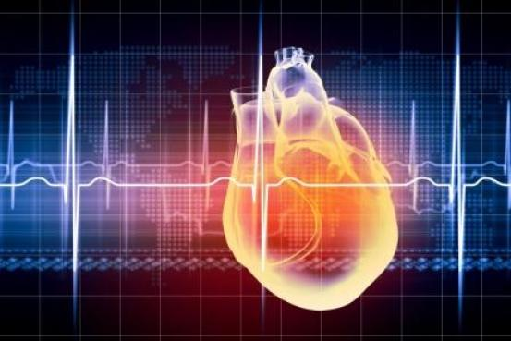
Heart rate variability (HRV) is a measurement of the interaction between the sympathetic (“fight or flight”) nervous system and the parasympathetic (“relaxation”) nervous system in the overall autonomic nervous system.
Basically your nervous system has two main divisions – the part that controls functions that are under conscious voluntary control such as skeletal muscles and sensory neurons of the skin. Then there’s the part that is automatic or involuntary, which is called the autonomic nervous system. Breathing, your beating heart, digestion of food and many other bodily functions are something you don’t have to think about, they just sort of happen on their own. That’s the autonomic nervous system (or ANS for short).
The ANS also breaks down into two major categories. One makes various body functions speed up (called sympathetic nervous system) and the other (called parasympathetic nervous system) slows things down and relaxes you. When you are resting and at ease, the parasympathetic side slows down your heart rate, breathing, digestion and other functions to conserve energy. But, if while you were resting, you heard gun shots or someone screaming, your sympathetic nervous system would suddenly kick in. Your heart would start beating and pumping blood must faster, you would become much more alert, the adrenal glands would kick in with hormones that give you an energy boost.
Heart Rate Variability is a measurement of the interaction between the sympathetic (“fight or flight”) nervous system and the parasympathetic (“relaxation”) nervous system in the overall autonomic nervous system. In other words, how well your heart rate can vary, or shift gears so-to-speak, between the sympathetic and parasympathetic says a lot about how healthy you are. Even more importantly, it can serve to predict more serious conditions and, if appropriate remedies are employed, can prevent more serious problems later.
Some examples of good Heart Rate Variability would be:
1) You are watching a funny movie on TV and you hear a loud bang. Prior to the bang you should have been quite relaxed. The bang should have immediately activated your sympathetic nervous system; the adrenals kick in, you are on your feet to investigate, heart rate is quite fast, etc. You then find out it was your cat in the kitchen knocked an empty pot off the counter. You go back to your movie and quickly relax.
2) You wake up at 2am to discover that your teenage son, who was supposed to be home by midnight, is not home yet. You call him on his cell phone and he doesn’t answer. Your sympathetic nervous system kicks in and you are now fully awake and pacing. You start calling hospitals. Your son walks in apologizing, saying he ran out of gas and his cell phone died. You give him his duly earned earful. You thank God that he’s safe and go back to bed. You are able to relax quickly and go back to sleep.
Now, if you had poor HRV you would still be worked up for quite some time, maybe even hours, after these two circumstances. Panic attacks and anxiety disorders are also disorders of heart rate variability in that sympathetic nervous system goes on overdrive.
Another example of poor HRV is the inability for the sympathetic nervous system to kick in. A loud bang in the kitchen might get a glance up and then back to the TV — in other words, the sympathetic nervous system doesn’t kick in at all when it should.
reflects the heart’s ability to adapt to changing circumstances by detecting and quickly responding to unpredictable stimuli or the lack of stimuli. HRV measures overall health and well-being and measures how efficiently the body adapts and adjusts to circumstances to be able to perform at maximum efficiency.
A wide range of other outcomes and conditions may also be associated with poor heart rate variability, including heart attack, stroke, congestive heart failure, diabetic neuropathy, depression and more.
The Max Pulse is an easy, non-invasive way to to test Heart Rate Variability. It only takes a few minutes.
I highly recommend getting anyone and everyone tested. Using the test results, one can make lifestyle changes or introduce simple supplements into their daily routine that can improve results. Over time patients may avoid debilitating or even life threatening situations by catching issues early and acting to address these when something can still be done about it.

Diagnosing Atherosclerosis
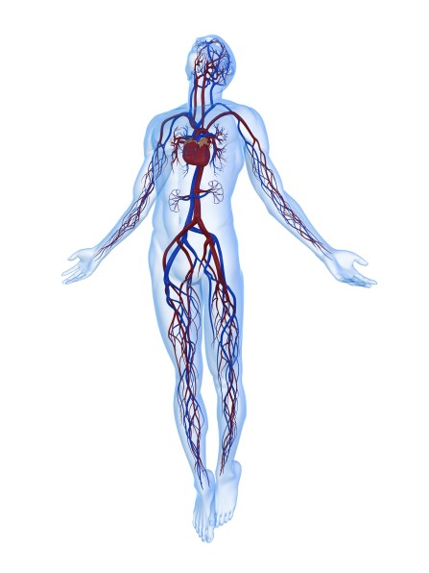Because atherosclerosis usually has no noticeable symptoms, it can be hard to detect in early stages. There are many diagnostic tests involved when trying to determine whether or not someone has signs of atherosclerosis, and to what extent. Oftentimes there are no symptoms or risk factors, so a family practitioner or internist might not be too concerned, especially if the patient is not elderly. However, cardiovascular disease is the leading cause of death in the United States and early detection is crucial. Nearly 50% of all cardiovascular events occur in patients who were asymptomatic before the event.
Blood pressure and blood may both be normal but someone can still be at risk and not be aware. The Max Pulse is a quick, non-invasive, and inexpensive way to get a better “snapshot” as to what might be going on in the arteries and can be included in a regular check-up. Additionally, it is an effective tool in diabetes management and for use on anyone else who is at increased risk of cardiovascular disease.
The Max Pulse measures blood at the fingertip, but it graphs the heart beat as it moves through both systolic and diastolic pressures. The more flexible the arteries are, the more deviations will show on the graph. If the graph is tight and more regular, it can be an indication that the arteries are stiff. This device also looks at circulation results for large and small arteries. If the test indicates that the larger arteries are constricting and appear to be hardened, then this is a red flag and further testing would be indicated.
Other testing can be done in the office to determine cardiovascular risk include:
- Ankle/Brachial Index – a non-invasive test which measures the difference in pulse rates taken in the ankles against pulse rates taken in the arm. If the pulse is slower in the ankle, this can be an indication that blood is not circulating in the legs like it should. This is most used to test for PAD.
- EKG (Electrocardiogram) – measures electrical activity, heart rate, rhythm, and strength and timing of the signals. This can show whether or not a person has had a prior heart attack and also show signs of heart disease or abnormalities with regards to the heart, but less so for atherosclerosis.
If more serious issues are detected, then the patient is usually referred to a cardiologist for additional testing such as:
- Stress test – The EKG is done while the patient is placed under physical stress to determine how the heart reacts under more rigorous conditions. Usually this is done while running on a treadmill, however if someone is unable to complete this task due to physical limitations, then medications can be given which will increase the heart rate. Images can be taken of the heart while the stress test is under way which can possibly show blockages. The patient is monitored during the test for shortness of breath and/or chest pain.
- EBCT, or Electron Beam Computed Tomography – this is a CAT scan done on the heart directly and shows the amount of calcium build-up which can be an indicator of plaque build-up. Hardening and narrowing of the large arteries may also show on this test.
- Carotid Artery Ultrasound – this provides a look via ultrasound to determine if any plaque build-up, atherosclerosis, exists in the carotid. This test is helpful in predicting risk for possible stroke or heart attack.
- Echocardiography – uses sound waves to create a moving picture of the heart. It shows both the size and shape of the heart which can indicate how it is functioning and can provide insight if any of the valves have any issues. Blood flow is also observed.
- Angiography – this is an invasive procedure that is usually done in the hospital. A thin catheter is put inside the leg and threaded up through the branching arteries to the heart. A dye is then injected which shows the arteries and whether or not any blockages exist. This test does carry some risk and is usually only used when is a person is confirmed to have existing atherosclerosis or, is exhibiting symptoms that a heart attack has happened or is occurring. This is frequently used when someone presents themselves in an emergent condition and allows the doctor to quickly diagnose life-threatening cardiovascular issues.
With cardiovascular death being the number one killer in America, it is important to monitor and detect risks so that prevention tactics can be implemented as soon as possible. The Max Pulse is a helpful tool for this kind of screening as it is easy to use, quick and noninvasive.

CVD Mortality in the US - 2018 Update.

CVD Mortality in the US – 2018 Update.
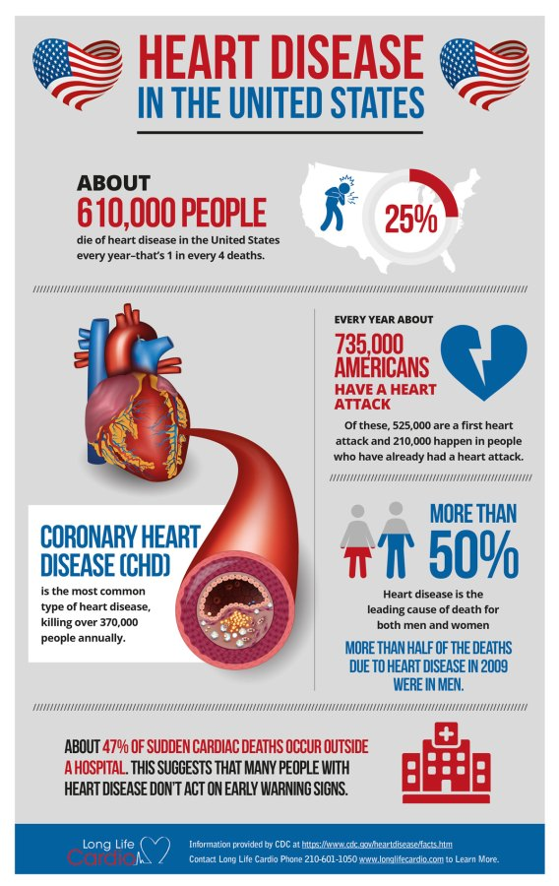
Heart Disease in the United States By The Numbers
Cardiovascular disease is still the No 1 cause of death in the US. In fact, Ischaemic Heart Disease (IHD) is the top killer in the world. Even in countries such as India, where diseases such as tuberculosis, pneumonia, and malaria were once the cause of most deaths.
CVD disease is generally considered to be controlled firstly by lifestyle factors such as smoking, exercise, healthy diet, and weight control. Then, physical factors such as cholesterol, blood pressure, and glucose control also enter the mix though these are most often seen as a result of lifestyle issues.
The mortality for males and females in the United States declined from 1979 to 2015 (Chart 12-19). In 2015, 2,712,630 resident deaths were registered in the United States, and 10 leading causes accounted for 74.2% of all registered deaths. The 10 leading causes of death were heart disease (No. 1), cancer (No. 2), chronic lower respiratory diseases (No. 3), unintentional injuries (No. 4), stroke (No. 5), Alzheimer disease (No. 6), DM (No. 7), influenza and pneumonia (No. 8), kidney disease (No. 9), and suicide (No. 10).
CHD (43.8%) is the leading cause of deaths attributable to CVD in the United States, followed by stroke (16.8%), high BP (9.4%), HF (9.0%), diseases of the arteries (3.1%), and other CVDs (17.9%).
This information is quoted from the American Heart Association Journal “Circulation” 2018 Update
CVD is still the biggest killer in the US and worldwide and is directly linked to lifestyle. The problem is that once the problem is bad enough to be diagnosed, the lifestyle problems are thoroughly ingrained. Breaking that chain is vital to cracking this problem. This means it has never been more important than now to have a quick and easy screening tool to catch CVD in its early stages. Such devices have the added benefit that they prompt patients to make lifestyle changes before such changes become too difficult. The longer a person keeps going being overweight and under-exercising the harder the path back to health is. For many people, the impetus to change comes too late and they simply cannot make the journey. Long Life Cardio is proud to be the supplier of two devices that provide this life-saving service. Learn more about the Max Pulse here.

Cardiovascular Mortality Rates on the Rise due to Obesity Epidemic

Cardiovascular Mortality Rates on the Rise Again Due to Obesity
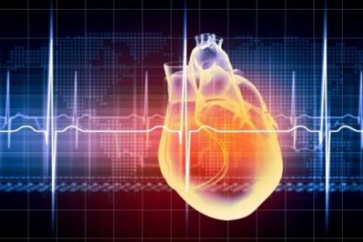Over the past 50 years, cardiovascular mortality rates have been decreasing each year by 2.4% for whites and 2.2% for blacks. Research indicates that these decreases are starting to plateau because of the obesity epidemic in the United States. While there have been consistent advances in treatment and diagnostics for heart disease, strokes, diabetes, and kidney diseases which have contributed to fewer deaths over the years, obesity among both children and adults is drastically increasing risk for these illnesses. According to the Centers for Disease Control, more than 93 million adults and 14 million children and teens are considered obese, and unfortunately, this number continues to climb.
What’s also alarming is that while cardiovascular disease-related deaths declined by 36% from 2000-2014 overall, the mortality rates began increasing for the first time between 2011 and 2014 and have now reached a plateau despite a drastic decrease of smokers in the general population. This is causing increases in mortality rates due to hypertension, diabetes, and kidney disease, all of which contribute to cardiovascular disease risk. The American Heart Association hoped to see at least a 20% continued decrease of CVD related deaths by 2020, however, it appears that goal will not be met.
Dr. Steven Nissen, esteemed chairman of the Cleveland Cardiovascular Clinic, researcher, and patient advocate, weighs in on this topic:
“We have to attack this problem before it gets to the point where people are really obese and in trouble. Because once people have developed severe obesity, reversing that is very difficult.” Early intervention is also key since chronic disease can be diagnosed, treated, and possibly reversed if it is caught in time.”
Continued education and programs regarding nutrition, exercise, and overall health and wellness is key for Americans to lose weight and become healthier. However, early intervention is also key since chronic disease can be diagnosed, treated, and possibly reversed if caught in time.

The Max Pulse Screening Device
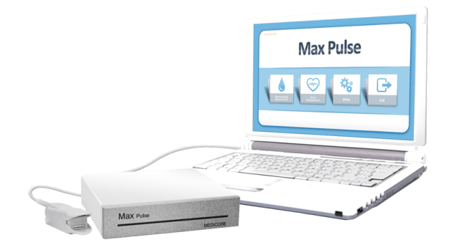The Max Pulse device is an excellent tool for helping family and general practice physicians and health and wellness providers to detect early signs of cardiovascular disease. It uses a complex analysis of the patient’s arterial pulse wave to determine arterial stiffness, circulation blockage, and stress levels in the body. It is non-invasive and only takes 3-minutes to complete the test which also makes it a convenient diagnostic tool for both patients and providers.
The Max Pulse shows accurate assessment of arterial hardening, and an indication of whether circulation is inhibited. There is a separate result for large arteries, small arteries, and capillaries. This information is very valuable to a practitioner. Larger arterial constriction and arterial hardening at the same time is of course, a huge cause of concern.
Additionally, this machine does a very accurate heart rate variability test and prints an autonomic nervous system analysis which shows if the patient is overstressed and whether or not the sympathetic nervous system is dominant, or in some cases showing that the person is inhibited or suppressed and the parasympathetic system is dominant.
For more detailed information about the Max Pulse, please visit us at our website and learn how the Max Pulse can help your patients. Our representatives will be happy to discuss our device with you. We can answer all of your questions and show you the incredible benefits this device can have for your practice.

Please Call Us at (210) 601-1050
Or Write to Us Here:


Doctors Comment
Video -Max Pulse Review from Dr Steven Bednarczyk DO

“The Max Pulse device offers a simple, quick, and highly informative test for endothelial function as well as vessel integrity. This allows the clinician to identify patients at risk for cardiovascular disease allowing for appropriate counseling regarding lifestyle, diet, and supplemental changes as well as referral to a cardiologist if indicated. Also, patients appear more motivated to become proactive when discussing these test results.
Wayne Baumgarten with Long Life Cardio is easily assessable and most professional.I highly recommend Max Pulse not only for all medical offices, but especially those clinicians who focus on preventive health.”
Randy A. Birken, MD
Dr. Randy Birken has practicing medicine for over 37 years and has served on the faculty at Baylor College of Medicine.
Author, The Bio-Identical Way: Patient Profiles in Hormone Optimization
Certified, Worldlink Medical Advanced Bio-Identical Hormones
Certified, Cenegenics Research and Educational Foundation in Age Management Medicine
Fellow of The American College of Surgeons
Fellow of The American College of Obstetrics and Gynecology
Medical Director of Birken Medical Aesthetics
The Max Pulse is a true game changer. It is an excellent screening tool for assessing the endothelial function of the vessel wall in addition to providing information on ANS balance. When a positive test for advanced arteriosclerosis is obtained, a carotid duplex with CIMT is performed in the clinic and a stress test is performed on the patient. This process led a few patients receiving cardiac catherization or carotid stenting due to the severity of their atherosclerosis. As a Doctor of Osteopathic medicine, I find the ANS report created by the Max Pulse to be of value as well. I use the device before and after manipulation to show the patients changes in their ANS balance. The Max Pulse is a great device for any office.
Steven J. Bednarczyk, DO
Medical Director of North Hills Health and Wellness
Certified, The Bale-Doneen Method
The Max Pulse has become such an integral part of our Cardiovascular Preventive Service line. We have discovered several irregularities already and have been able to help facilitate patient care in the best way possible. This has been an excellent investment, but more importantly, it is such a good feeling to be able to provide this testing for my patients and their families. We give Long Life Cardio and the Max Pulse system our highest recommendation.
Dr. Chris Shanklin, M.D.
Primary Care Physician Lubbock TX
I am an internist in Newburyport, MA seeing over 120 to 140 patients weekly. I cannot overstate the value of using the Max Pulse. Every patient over 50 is screened for cardiovascular prevention. The analysis print out is easy to understand based on measurable parameters of arterial elasticity, arterial contraction, and residual blood. The patients understand the relationship to arterial health and get the importance of follow-up testing to see if our treatments document substantial improvement. Secondly we use the heart rate variability testing to assess autonomic nervous system health. For example, we want to know if someone is stuck in sympathetic dominance. We want to know if the patient is highly stressed and has no residual reserve. We document improvements in stress, endurance, mental health, and digestion using the HRV analysis as well as by symptom management.
Our goal at our clinic is to prevent cardiovascular problems. Knowing that the arteries have excellent elasticity and contraction gives me reassurance that we are doing more than what is required by the standard of care. I cannot imagine working without the Max Pulse at our clinic.
Dr. Daniel A. Eyink MD is Board Certified in both Internal Medicine and Medical Acupuncture.
I am a Chiropractor in Santa Rosa CA and have been in practice for 30 years.With such a large percentage of people dying of cardiovascular problems..stroke/ heart attacks I am very happy to find a tool for early warning of a predilection for such events in my patients. After all what does their GP know about their cardiovascular health? Usually very little. I know that when I do go to my GP, my physical includes BP, heart rate (non variable), and pulse ox. Not a lot to go on to determine risk factors.
I now offer this test routinely to new patients. If the patient tests well they are obviously happy. If the Max Pulse detects signs of cardiovascular disease I have tools to help that patient reverse this trend. And, in the occasional case where the Max Pulse detected serious changes I convinced the patients to obtain a consult with a Cardiologist for further evaluation. For myself, I feel this allows me to add one more dimension to my care of my patients by offering reliable way to screen for problems developing the the patients’s CV system… one that they do not get from their PCP. I find this has engendered a good deal of good will in my patients, brought in many patients to my office, friends and relatives of patients who have gone through this screening and been referred in to the office just for the testing and often then staying with my office to manage their health. I have had patients refer their friends from as far as 2 1/2 hours away to come to get tested.
The Max Pulse is easy to use, has a graphic readout of results that is easy for the patient to understand and is impactful for the patients to have in their hands. Many of the patients who have detected problems have decided to let us help them improve their results and with the Max Pulse we can re-test them to verify that through the treatment they are indeed improving demonstrably. For any doctor who wishes to add a dimension of cardiovascular health testing and treatment to the services they offer I cannot recommend any better investment than this excellent diagnostic device for their practice. The testing does not take long and while I do it personally, it would be equally possible for staff to be trained.
Dr Kyle Yoder, DC Q.M.E. Chiropractor Santa Rosa CA
I have had the Max Pulse machine for 8 years but now with the new update I am so happy to now be able to offer this test routinely to all my patients. At my clinic I try to focus on preventive health and I am glad to have the Max Pulse to motivate my patients to become more proactive when discussing these test results. It is portable and easy for me to do events with because the Max Pulse is so easy to use. It has a graphic readout of results that is easy for the patients to understand and they can take a copy home with them right away.
Dr Lynn Chiassan DN, Doctor of Naturopathic Medicine in Moose Jaw Canada
The MaxPulse is an easy to use and easy to integrate program that is both easily understood by patients and easily interpreted by doctors. It’s just easy on everyone. People are becoming more acutely interested in their health and well being before they are diagnosed with a condition, especially since the coronavirus pandemic. The MaxPulse gives me the opportunity to provide a real time look at a patient’s current arterial and autonomic health, and allows us to start down the path to better health before entering a state of disease. Additionally, Wayne Baumgarten was incredibly helpful and attentive in getting me set up with the software, execution of the screening, and interpretation of the data. Thankful to have a support person that handled the situation so quickly and professionally.
Dr. Anthony Tortorella
Chiropractor
Sport Hill Chiropractic and Rehabilitation
Adjunct Professor, University of Bridgeport School of Chiropractic
About 5 years ago I mentioned to my husband that I was interested in getting a heart scanning device. There were two I was trying to decide between. One took about 15 mins. to perform, while the Max Pulse scan took only 3 mins. Needless to say in a busy practice I was looking for a lot of info in a short amount of time. I absolutely love my Max Pulse! I use it with every patient. My patients really pay attention to their results and I am able to discuss both lifestyle and nutrition support for them using the easy to explain results. Patients also love to see the progress they make during follow-up scans. Max Pulse is one of the best practice tools I’ve purchased. I have had no problems with the software or the Max Pulse hardware in the 5 plus years I have owned it. From HRV, to artifacts, to atrial elasticity, to the SNS & PNS activity, the patients are fully engaged in that conversation every time. It really supports compliance and follow through also. I love my Max Pulse, thank you Long Life Cardio for an excellent product.
Dr. Virginia Irby, D.C., DABCO, ACN
Functional Nutritionist and Chiropractor
California
“Atherosclerosis may be a basis of almost every health problem and this tells you where you stand.”
Davis Lamson, MS, ND
Tacoma, WA

Scientific Research
To understand the scientific foundation of the Max Pulse, please read this article-
https://www.ncbi.nlm.nih.gov/pmc/articles/PMC3394104/.
(The above article contains a section called 1. Pre-Processing PPG Signals. This is technical signal information and can be skipped. Most of the information is in Section 2).
To see a peer reviewed research study using an earlier version of the Max Pulse (called the Meridian DPA) please read this study 2015-Digital Photoplethysmography for
Assessment of Arterial Stiffness
Example of Full Study on the Technology – Assessment of Vasocative Agents and Vascular Aging by the Second Derivative of Photoplethysmogram Waveform. from the American Journal of Hypertension.

The Quotes and Articles Below Are A Small Representation of the Extensive Research Over Time into Photoplethysmography, Accelerated Photoplethysmography.
“Noninvasive pulse wave analysis is useful for evaluation of vascular load and vascular aging. It is usually measured at the palpable artery, including carotid, femoral and radial arteries. These pulse wave tracings provide more precise information concerning blood pressure changes than ?systolic and diastolic pressures only” Download This Study Here 1998-Assessment of Vasocative Agents
1998-Plethysmogram and Arterial Distensibily
“In conclusion, the present study has shown, in a cohort of untreated and treated hypertensive subjects, that aortic PWV was a better marker of the presence of AA [atherosclerotic alterations]… PWV seems to be useful for screening of arteriosclerotic independent of age.” Download This Study Here 1999-Assessment of Vascular Aging
2002- Pulse Wave Velocity and Second Derivative
2002-Arterial Stiffness and Pulse Contour
2002-Finger Volume Pulse Assessment
2005-Photoplethysmograph Utility of Second Derivative
“Ultimately, the low-cost and simplicity of this optical-based technology could offer significant benefits to healthcare (e.g. in primary care where non-invasive, accurate and simple-to-use diagnostic techniques are desirable). The further development of PPG together with its non-invasive nature can place this methodology among other tools used in the management of vascular disease.” Download this Study Here 2007- Optical Techniques in the Assessment of Peripheral Arterial Disease
“In this study, we demonstrate the clinical utility of a marker of arterial stiffness to stratify CVD risk in individuals using the digital pulse wave form analysis technique. This study demonstrates a close association between SI [stiffness index ] and CVD risk score estimation using the ESC HeartScore model. More importantly, the discriminatory properties of the SI in identifying higher risk groups were significantly better than those of conventional cardiovascular risk indices such as total cholesterol level and fasting blood sugar measurements.” – Download This Study Here- 2008-Measurement of Stiffness Index by Digital Volume
Pulse Analysis
2008-Measurment of Arterial Stiffness Index
“…our validation of the DPA against the gold standard method suggests that DPA is a valuable tool for estimation of vascular status. Since the DPA method is fast, relatively inexpensive and operator independent, it could implicate advantages in clinical practice and screening.” Download This Study Here 2015-Digital Photoplethysmography for
Assessment of Arterial Stiffness

Overview article
“Arterial waveform analysis has the potential to assist physicians in positively identifying individuals who exhibit the development of vascular disease and begin appropriate treatment – long before symptoms or clinical signs appear…” Download This Study Here- It Starts in the Wall- By Jay N Cohn, President, International Society of Hypertension

VasoScan
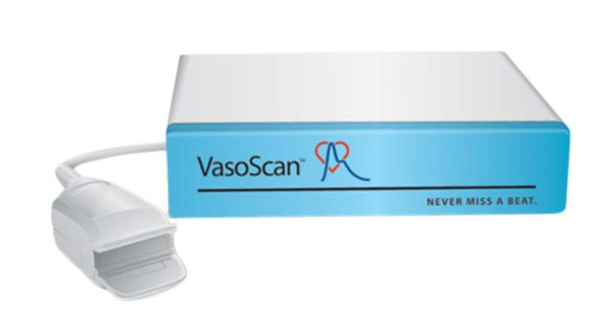The VasoScan device is a version of the Max Pulse. The VasoScan is licensed to use the exact same ground-breaking algorithms and hardware package as the Max Pulse and delivers the exact same arterial health score and ANS stress scoring as the Max Pulse device.
The difference between the Vasoscan and the Max Pulse is that the Max Pulse uses a more advanced version of the software, including features such as separate reports for the Arterial and ANS tests and the ability to perform a 1 minute arterial test (rather than the 3 minute minimum test time for the Vasoscan). You will see some changes in the software which are covered in the Reports Section below.

VasoScan Customer Support:
Long Life Cardio in Austin Texas can offer you support for your Vasoscan device. The finger probe and all connecting cords are available for shipping if you should need replacements. If you are having problems with your Vasoscan software, you can contact us about upgrading to the Max Pulse version of the software. The Vasoscan box will run the latest version of the Max Pulse software. Please be aware that there is a fee for the software. You can contact us here to get more information and support for your device- Contact Us

VasoScan Reports:
The Vascoscan runs a 3 minute test and presents the arterial test (accelerated photoplethysmograph) and the stress test (heart rate variability) in the same report. This was also the original way that the Max Pulse presented the information. The new software now breaks this into 2 separate reports – one for the arterial scoring and another report for the stress scores – which includes a more detailed stress scoring. If you upgrade to the latest version of the Max Pulse software you will get reports that look this this – Max Pulse Reports

VasoScan Training:
At this time in order to access training modules you will need to upgrade into the new software. We have a number of training videos that will be accessible to you at that time.

Buying A Vasoscan:
You can buy a Max Pulse device, which is the updated equivalent of the Vasoscan. Contact us for more information and to learn about our purchase and leasing options.

Video

Scientific References
Use of the pulse wave to evaluate arterial compliance (flexibility) is very well studied. This article originally published in Current Cardiology Reviews tracks the development of this technology all the way up to the use of the Accelerated Graph as used by the Max Pulse. It lists 85 supporting references.
https://www.ncbi.nlm.nih.gov/pmc/articles/PMC3394104/.

Max Pulse Training Videos

Protected: Max Pulse Training Videos

Max Pulse Support
Software Support Please Click Here
For Device Troubleshooting Click Here
Preparing Your Laptop for Remote Access by Support Staff:
- Make sure the Max Pulse is turned on and connected to the laptop or computer. (There will be a green light inside the power button if the Max Pulse has power)
- Make sure the computer is connected to the internet
- Go To Windows Settings > Power. Set the computer to “Never Sleep”.
- Please download this program.https://www.teamviewer.com/en-us/download/windows/ (If you are using the original laptop provided, this software will already be on the desktop.)
- Open the Teamviewer program and there will be a remote access ID and Password.
- Email us the Access ID and password for teamviewer.
- Do not close the computer or close teamviewer, we may access your computer after hours.
- One of our support staff will log in to your computer and perform a diagnostic test. One of your staff can be present while we do this and can also assist us to perform testing.

- (When we log off, we will not be able to access your machine again without you giving us a new password.)
Moving to a New Computer and Reinstalling the Software:
With software versions ending in 1.0.0.6.1.6 and also ending in 1.8 and 2.0 it is possible to load a newer version of the software without uninstalling or saving your patient database. You should always save the patient database before upgrading as a precaution.
For older software versions: When you install the Max Pulse in your PC, you will have the Max Pulse_General folder generated automatically. When you perform tests, all of data will be automatically saved in this folder.
To copy the patient information, you need to make a copy of the DATA folder and the PatientDB.accdb file. DATA folder has all of raw data in there and PatientDB.accdb is to read the raw data.
Therefore, you should copy both at the same time.
Then, uninstall the old version software completely, even empty folder and install a new software and it will create the folder automatically.
Then paste the files and folders you copies over the top of the new ones which are empty. This will paste your patient information into the new software.
Very important- if you are upgrading from very old software (for example 1.0.0.3 series software) to the latest version, it is possible your patient database will not transfer. If in doubt, copy and zip your entire Max Pulse folder before performing any software upgrades.
Contact Us To Inquire About Support Options

Max Pulse Troubleshooting
The Max Pulse is solid state electronics and after over 7 years selling this device, we have yet to have a defective machine. Normally the issues with the device are almost always:
A. The Max Pulse finger Probe
B. The power cord or the USB Cord
C. The Software or the computer that the software is installed on.
If you are having trouble with your device, check the following.
Step 1: Close the Software and Reopen: Make sure all the connections are tight and that the Max Pulse is switched on. If the Max Pulse has power, there will be a green light inside the on/off switch on the right side of the device. Then close the software and reopen it.
Explanation: The Max Pulse software needed to be opened after the Max Pulse is connected and turned on, otherwise the software fails to detect the device, even if its switched on later. The Max Pulse does not need to be powered down at night. However if the Max Pulse is switched off at any time, then the software must also be closed. When starting the machine, the Max Pulse must be switched on first. Then the software should be opened. This allows the software to detect the Max Pulse.
Software Opens but Does Not Register Patient: If the software starts up, but does not register the heart beat after starting the software and putting on the finger probe the issue can be – 1) Max Pulse does not have power, check for a green light inside the on/off switch. 2) Computer did not find the Max Pulse – Check that all cords are connected and then open and close the software after you are sure the Max Pulse has power
Is There A Green Light? There should be a green light on the power switch on the box. If this is not on, make sure the Max Pulse is plugged in, and also make sure the power cord is firmly connected. Check another power outlet to make sure there is power. If you cannot get the green light on, there may be an issue with your Max Pulse and you should contact us.
Is there Blue Light In The USB Cord? There should be a blue light on the USB cable where it goes into the Max Pulse. If this is not on, check that the cord is firmly plugged in to the Max Pulse and the computer. If you cannot get this light to turn on, you should get a new cord. If the machine is not under warranty you can order a generic “USB to RS232 Cord” click to see one from Amazon
Software: Is the software starting up correctly or is there an issue with the software? If you have an issue with the software, we recommend installing the latest version. Software issues almost never caused by a problem with the Max Pulse hardware. Be sure that your computer is running an up-to-date version of Windows 10 and that the computer itself has been checked for viruses and the hard drive is not overfull. Click Here To Learn More About Software Support
When uninstalling the software, be sure to copy the Max Pulse directory into your documents folder. This will preserve your patient database and allow you to reload the records at a later date. Never uninstall the software without doing this first.
Failure to Initialize Serial Port Error: Check that your Max Pulse is switched on (green light inside the power button). Then check that all connections are tight. Then, without turning off the Max Pulse, just open and close the software. See if this clears the error. If it does not, Windows Defender may be blocking the software. Go To Windows Defender, Go to Device Security, then Memory Integrity and switch this option off. This should clear the error. You will need to reboot after this. You may also need to go to the Device Manager, go to Ports (COM & LTP) and reinstall the driver for the US Serial Port. Also go to Universal Serial Bus Controllers, bottom the list >USB Serial Converter and also reinstall the driver.
This information only apply to the most recent version of the software.
Other Issues: What were the circumstances when the machine quit working. Did you move the software to another computer? Was there an electrical storm that could have damaged the circuit board in the device? Contact us with this information and we will assist you to troubleshoot your device.

Software Support

This website is operated by Long Life Cardio LLC, importer and distributor for the Max Pulse Arterial and Stress Testing Device.
The Manufacturer of the Max Pulse does not provide software updates or copies of the software. You must contact the distributor you purchased the machine from for software support. If you cannot reach your original distributor for any reason, see below for instructions. All support is subject to our terms and conditions.
Free Software Support For Our Clients
At this time, Long Life Cardio LLC does provide free software support for every machine we have ever sold, regardless of whether the warranty is still in effect or not (note that in the future there may be a fee for support once your warranty period is over).
If You Did Not Purchase Your Machine From Long Life Cardio
A. Troubleshooting for Your Existing Software: If you have the software, but require troubleshooting for installation or printing or some other issue, there is a flat fee of $475.00 per incident for Software troubleshooting. This fee covers the troubleshooting session of up to one hour. This is non-refundable and because of the complexity of network and printer setups, we do not guarantee to resolve your issue. Our technician is very experienced and will do his best to resolve your issue and if it cannot be resolved we will give you a recommendation that you can take to your local IT provider.
B. You Have Older Software and Would Like To Upgrade: If you have an older version of the software installed but would like a software upgrade to the latest version the total fee for the software is $375.00. We will send you the software to install and save for the future. You can also access our training videos.
C. You Have No Software and Want a Clean Install: If you do not have any copy of the software and require a clean install, we will need to verify your purchase through the manufacturer. If you have your original receipt or know who you purchased from this will help. If we can confirm your purchase then you will need to pay the normal upgrade fee of $375 for the latest software version and access to support. We do not guarantee that we can provide you with the software if you do not already have evidence that the software was previously installed.
How We Perform Software Troubleshooting and Installation
Our software support services are all performed by arranging a remote access of your computer, using Teamviewer which you can install for free on your computer for one-time use. Visit http://Teamviewer.com to download the software onto your computer. Once you have the software installed, you will see an ID and password. Text or Email that information to our technical support staff, they will log on to your computer and perform the service. Click Here For Exact Instructions: Setting Up Your Computer For Remote Access
Use Our Software Support
Please fill in the form below and we will contact you to arrange the service.
Purchase Latest Software Version
(You must fill out the service request form above, so that we have all of your information before we offer software)

Installing New Software
Please note, only the latest version of the software is available. The earlier version (which has a red/brown colored interface and prints all report information on a single page) is no longer available and is not distributed for security reasons.
The new software has blue highlights and generates 2 separate reports, one for Arterial and one for Stress. If your software has brown highlights and generates a single report, you can upgrade by purchasing the software we offer.
You can see what the new reports will look like here – https://longlifecardio.com/max-pulse/the-max-pulse-test-reports-detailed/
Important! Your prior patient database might not transfer if you are using older versions of the software. If your existing software is a very old version, the old patient records will not migrate. This often is the case when moving from the old brown single report version to the new blue 2 report version. If this is not a problem for you, simple take the new software and install it. If the old records can be migrated they will be.
If you want to try and preserve old records, we recommend the following steps:
Preserving your older test results.
- Print or otherwise export any reports you wish to have from your existing Max Pulse installation.
- We do not guarantee that you will be able to access your older test results once you upgrade. Some clients have had success by doing the following A. Find the MEDICORE folder on your hard drive. B. Zip this so that your old database is preserved. C. To access these old records you will need to use a different computer. You can unzip the Medicore file and you should be able to read the old records. D. If you have a copy of the old software, installing it on another computer and then copying the database files from the MEDICORE file into this installation will allow you to read your old records. But you must install the old version of the software on a different computer to the new software or they will conflict.
Installing the new software.
- Go to Windows Settings and uninstall your existing Max Pulse software. OPTIONAL: You may wish to leave your existing Max Pulse Software in place. In this case the new software install on top of the old software. Depending on what version you are upgrading from, this may result in all your records transferring. If you chose this method and there are any unexpected errors with names and records, that means there is a database mis-match. You will need to completely uninstall the software, and reinstall. That will give you a clean install of the new software with none of the old Max Pulse test results.
- Install the software from the download provided.

Software Setup Window
(This is for the 6.0 and above versions of the Software. Earlier versions not have the Excel and Print and Comport options)
Language: You may select a user interface language.
Test Time: You may select a longer test time for the Stress Test (5 Minutes). The longer test period will give a more accurate result. Note that the arterial test time cannot be changed and is always 1 minute.
Reference Type: The machine has two calibrations, one for Eastern populations and one for Western Populations.
User Name: You May Enter Your Practice Name
Telephone: You May Enter Your Phone Number
Printing Options: The Max Pulse will always print to whatever printer is setup as default in Windows. To set up a printer we recommend you go to Windows Settings, Devices and install the printer you want. Turn off the “Let Windows Manage My Printer” Option. Then set the default printer to whichever print you want. If you want to always save as PDF, then select Microsoft PDF as the default printer.
But in all versions of the software from 6.0 and later, the setup window will give you the option have the Max Pulse send a copy of the report to the printer for the patient and also save an image of the report onto your hard drive.
In these versions of the Software, if you go to the Set Up Menu, you will see at the bottom of the page two check boxes. One is called print and the other is called Image.
Print Check Box– Sends a printed report to the Windows default printer.
Image Check Box – Will save an image of the report onto the hard drive. The folder where the image is saved (with the name of the patient and the date) is on the C drive> MEDICORE>MAX PULSE_GENERAL> IMAGE. When using this it would be ideal to save a shortcut to that folder on the desktop.
Those same two options appear each time you print. You can check them or uncheck them depending on if you want to print, save an image, or both.
Printer: Select the default printer for printing reports.
Excel: Export Function to Export Test Information.
Not Shown: Turn Pre-Prepared Comments On of Off
When you are in the software set up window (which you access from the main menu) it is possible to turn the pre-prepared comments on or off using F8 or F9. Different computers access the F8 and F9 keys in different ways. You may need to hold down the function key and press the number 8. Or there may be an actual F8 key.
The printed reports can show a pre-printed comments section with generic comments. These can be turned on or off at the set up screen.
Press F8 to remove the comments. You will see this message:
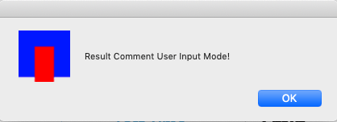
Press F9 to turn them on. You will see this message.
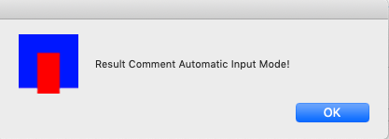

Max Pulse Testing Directory
You might have found our website looking for someone to give you the Max Pulse test. There is no directory for this, so we have decided to start one.
We will be adding more and more names and locations to this directory as time goes on.
Max Pulse Directory

Practice Directory

Alabama
Eriksen Chiropractic Laser Center
Dr. Kirk Eriksen
2500 Flowers Chapel Rd
Dothan, AL 36305

Alaska
The Alfa Doc
154 Fairbanks Drive,
Valdez, Alaska 99686

Arkansas
Lonnie Harrison MD, Cardiologist
5 Medical Park Dr Suite 201,
Benton, AR 72015
Back In Action
250 Southwest Dr,
Jonesboro, AR 72401
Bachert Wellness Clinic
803 NW 7TH St
Bentonville, AR 72712

Arizona
Lipogenex Anti-Aging Center
14300 N Northsight Blvd Suite 214,
Scottsdale, AZ 85260
Pristine Naturopathic Medicine, LLC
Dr. Noemi Quintanar
2469 N. Country Club Rd
Tucson, AZ 85716

California (Northern)
Previ Medical Group/Medical Institute of Healthy Aging
1776 Ygnacio Valley Road, Suite 204,
Walnut Creek, CA 94598
Bogard Health
508 Gibson Drive, Suite 290,
Roseville, CA 95678:
Dr. Virginia S. Irby DC ACN
2371 Iron Point Rd Suite 130
Folsom, CA, CA 95630

California (Southern)
Cynthia Thaik, MD
Cardiology, Holistic Cardiology
2211 Magnolia Blvd Suite 140A,
Burbank, CA 91506, United States
Primary & Multi-specialty Clinics of Anaheim
500 S Anaheim Hills road, Suite 230
Anaheim, Ca 92807
Santa Barbara Wellness For Life
Niko Hall, DC, CFMP
3888 State Street #203
Santa Barbara, CA 93105
Temecula Center Integrative Medicine
27450 Ynez Rd Ste 100
Temecula, CA 92591
Soheila Torabi, MD
3550 Q St. #301
Bakersfield, CA, 93301

Florida
Forever Young
907 S Ft Harrison Ave #101,
Clearwater, FL 33756
Queens Lifestyle Changes
16537 Spring Park Dr,
Clermont, FL 34711
Dr Carlos Vaca
8260 W Flagler Street, 2J
Miami, FL 33144
Dr. Herbert R. Slavin, M.D
7200 W. Commercial Boulevard, Suite #210
Lauderhill, FL 33319,
Doctors Studio
2595 NW Boca Raton Blvd, #200A
Boca Raton, FL 33431

Georgia
The Georgia Clinic
6330 Primrose Hill Court, Norcross, GA 30092-4544
(Over 20 Locations In Atlanta Offering Max Pulse Testing)
Personal Integrative Medicine, PLLC
CHARLES C. ADAMS, MD
4085 Cloud Springs Rd
Ringgold, GA 30736
Cole Dermatology & Aesthetic Center, P.C.
3525 Holcomb Bridge Road Suite 100
Peachtree Corners, GA 30092
David G. Lee, D.C., Ph.D., C.Ad.
4463 Towne Lake Pkwy Ste 200
Woodstock, GA 30189

Hawaii
Terry Shintani MD
600 Queen St C-2 Honolulu,
Hawaii 96813

Illinois
Heal n Cure Medical Wellness Center
2420 Ravine Way, Suite #400
Glenview, ILLINOIS 60025
Kimberly E. Wright, MD
The Wright Center for Women’s Health
1763 Freedom Drive, Suite 117
Naperville IL, 60563

Indiana
Dr Streeter
8127 Merrillville Road, Suite 3
Merrillville, IN 46410

Kansas
Warta Chiropractic
Hays, KS 67601
Rock Creek Wellness
5401 College Blvd
Suite 203
Leawood, KS 66211

Massachusetts
Dr. Dan’s Natural Healing Center
3 New Pasture Rd,
Newburyport, MA 01950

Michigan
Advanced Osteopath Health
3918 W St. Joseph Highway
Lansing, MI 48917-4214 US
Bio Energy Medical Center
James Neuenschwander, MD
4201 Varsity Drive Suite A
Ann Arbor, MI 48108

Missisippi
Reddix Medical Group
6501 Dogwood View Pkwy,
Jackson, MS 39213
Lexington Medical Clinic
22741 Hwy 12
Lexington, MS 39095

Missouri
Health+Plus – Naturopathic Medicine
106 SE 12th St, Oak Grove,
Kansas City, MO
Dr Kelly Miller
Health Restoration
800 W 47th Street, Suite 634
Kansas City, MO 64112

Nebraska
Neligh Chiropractic & Acupuncture
904 Riverside Blvd Ste E
Norfolk, Nebraska 68701

Nevada
Dr. John A. Thompson, DO
6316 S Rainbow Blvd #100
Las Vegas, NV 89118

New Mexico
Roswell Medical Clinic
111 W Hobbs st
Roswell, NM 88203

New Jersey
Advanced Chiropractic Healing Arts Center
33 Plymouth Street, Suite 102,
Montclair, NJ, 07042
CoreZone Chiropractic
Dr. James Corregano
200 West 57th Street, Suite 909
New York, NY 10019 US
Del Vecchio Metabolic & Aesthetic Institute
75 Lane Road Suite 408
Fairfield, NJ 07004

New York
Back To Health Chiropractic & Wellness
111 South Ridge Street #301
Rye Brook, NY 10573

North Carolina
Durham Health and Wellness, PLLC
5015 Southpark Dr #110,
Durham, NC 27713

Ohio
Optimal Health Institute Of Ohio
4030 Massillon Rd Suite C
Uniontown, Ohio 44685
Ageless Integrative Medicine
11841 Mason Montgomery Road, Unit 1B,
Cincinnati, OH 45249

Oklahoma
Optimal Health
9800 Broadway Extension, Suite 200
Oklahoma City, Oklahoma 73114

Oregon
Portland Clinic of Holistic Health
833 Southwest 11th Avenue Suite 525
Portland, OR 97205

South Carolina
Victory Center for Personalized Medicine
58 Parkway Commons Way
Greer, SC 29650
OptimalSelf MD
25 S Laurens St,
Greenville, SC 29601
Dr. Allan A. Rashford, MD
903 St Andrews Blvd Suite B,
Charleston, SC 29407
Dr Almog Gal, Unity Health
4612 Oleander Drive. Suite 101
Myrtle Beach, SC 29577

South Dakota
Caron Chiropractic
120 NW 2nd Street
Madison, SD 57042

Pennsylvania
Ann L Johnson
1135 Georgetown Road #120,
Christiana, PA 17509

Tennessee
Dr. Agustin Vitualla
Family Medicine Doctor in Camden, TN
Roth Wellness and Chiropractic
600 Old Hickory Blvd. | Suite 104
Nashville TN 37209
SJNMR
5003 Crossings Circle | Suite 200
Mount Juliet, TN 37122

Texas
Well Life Family Medicine
Eric Ehle, DO
7 Medical Drive
Amarillo, TX 79106
Texas Integrative Medicine & Cardiology
211 Bartlett Dr,
El Paso, TX 79912
Lubbock Primary Care
11007 Quaker Avenue
Lubbock, Texas 79424
Owen Health Group
5028 122nd St
Lubbock, TX 79424
Silsbee Family Medical Clinic
280 Highway 418 E,
Silsbee, TX 77656
Dallas Family Medical
16901 Dallas Parkway Suite 208
Addison, TX 75001
ReMed
7920 Belt Line Rd, #120
Dallas, TX 75254
Parker Wellness Centers
4709 W. Parker Road #440
Plano, TX 75093
M T Walsh, PA
6101 Chapel Hill Rd
Plano, TX 75093-8446
Chong Liu MD PA
7712 San Jacinto Place
Suite 100
Plano, TX 75024
Gladden Longevity
200 O’Connor Ridge Blvd
Suite 100
Irving, TX 75038
Houston Family Medical Clinic
11160 Fondren Rd,
Houston, TX 77096
Immortality Group
Dr. Balakrishnan
12112 Almeda Road, Suite A5
Houston, TX 77045
Anand Balasubramanian MD PA
17434 Red Oak Dr suite E,
Houston, TX 77090
Eni Health Care
9319 Pinecroft Drive Ste 120
Woodlands, TX 77380
Randy Birken MD
4185 Technology Forest Blvd,
The Woodlands, TX 77381\
Parul R Shah, D.O.
4806 Riverstone Blvd,
Missouri City, TX 77459,
Dr Luna, MD
219 Eastwood St,
Livingston, TX 77351
Cornerstone Primary Care
1717 US HWY 59 loop N Ste C
Livingston, Tx 77351
Seven Oaks Women’s Center San Antonio
7711 Louis Pasteur Dr #200,
San Antonio, TX 78229
Seven Oaks Women’s Center Bourne
134 Menger Springs # 1280,
Boerne, TX 78006
Oubre Medical
6836 Bee Caves Rd Building 2, Suite 101,
Austin, TX 78746
Carter Wellness Center, Dr Carter
580 Cibolo Valley Dr Suite 207
Cibolo, TX 78108
Wright, Douglas E MD
1001 Water St,
Kerrville, TX 78028

Oregon
Dr Daniel Hardt MD
1999 Willamette St,
Eugene, OR 97405
Quave Clinic
Brett Quave, MD
701 Golf View Dr,
Medford OR 97504

Utah
Bountiful Family Wellness
565 West 2600 South,
Bountiful UT 84010

Virginia
Virginia Functional Medicine
410 Pine St SE, Vienna,
VA 22180

Washington
Abrams Chiropractic Clinic
14326 Greenwood Ave North
SEATTLE, WA 98133
Dr. Ana Mihalcea
AM Medical
Yelm WA

Wisconsin
Center for Integrative Medicine
1538 Bellevue St Green Bay, WI 54311
Phone: 920-468-9442
Serenity Health Care
1708 Paramount Ct, Waukesha,
WI 53186, United States

Wyoming
Evanston Chiropractic Center
624 W Cheyenne Dr #3
Evanston, WY 82930
Dr Shepard
1206 West 4th St Suite 1
Gillette, Wy 82716

Canada
The Homeopathic Plus Centre Inc
853 Spinning Wheel Crescent,
Mississauga, ON L5W 1W4, Canada
Natural Therapies Clinic
1304 Highway # 8,
Stoney Creek, ON L8E 5K5, Canada
Vitality Health Center
726 Bloor St. West office # 205
Toronto, Ontario M6G 1L4
(416)532-6141
True Health Canada
#1-1890 Ambrosi Rd.
Kelowna, BC. V1Y 4R9
Northshore Naturopathic
Dr. Saeid Mushtagh, ND
120-889 Harbourside Drive,
North Vancouver, BC, V7P 3S1
Main Street Naturopathic Clinic
616 Main Street,
Moose Jaw, SK s6h3k4

Order Form
Thank you for your interest in the Max Pulse Device.
This is an order form, so that we can prepare an invoice for you. No payment is required at this time.
(Long Life Cardio does not collect sale tax for Georgia. If you are in Georgia, please pay Sales Tex on any items you purchase.)

Contact Us
Our representatives will be happy to discuss our device with you. We can answer all of your questions and show you the incredible benefits this device can have for your practice.

Please Call 210-610-2521 for more information.
Or fill out this form and we will contact you shortly.

Terms and Conditions
Informational Materials
The purpose of this website and any provided documentation both here on this website or provided with the devices shipped to the customer is to promote consumer understanding and knowledge of the way the Max Pulse operates. Information given is generic and not a substitute for professional medical advice, diagnosis or treatment.
The Max Pulse is an assessment tool only. Final diagnosis is the responsibility of a licensed practitioner. For usage and interpretation of medical results consult a physician or qualified healthcare professional. Seek the advice of a physician or qualified healthcare provider with any questions you may have about the correct usage of this device, interpretation of its results and correct billing practices.
Billing
The practitioner is responsible for the compliance of the CPT code and ICD-10 code according to the procedures of the AHA (American Hospital Association) Central Office.
The Max Pulse is a Class II medical device approved by the FDA.
Long Life Cardio does not recommend specific CPT or ICD codes. Any suggestions regarding CPT or ICD codes are anecdotal and the user is responsible to ascertain the correct codes and use them appropriately. Long Life Cardio shall not be liable for any damages or injury resulting from any suggested CPT codes or ICD-10 codes in case of practitioner’s audit.
Terms of the Sale
The Terms of Sale, Lease or Rental will be governed by and be construed in accordance with the laws of Texas. Long Life Cardio LLC reserves the right to refuse to sell, lease or rent machines to anyone with or without reason.
Pricing
Long Life Cardio seeks to provide current and accurate information on it prices and billing. However sometimes misprints or other errors occur. Accordingly, Long Life Cardio reserves the right to reject, correct. cancel or terminate any order for which the price was incorrectly displayed or where we otherwise displayed erroneous or inaccurate information.
Unless otherwise stated, prices quoted do not include applicable shipping charges or applicable federal and state taxes. Customer is responsible or all applicable shipping charges and for all applicable taxes associated with their order.
Shipping and Delivery Times
Any statement of delivery or shipping time is only an estimate of the time required to make shipment and Long Life Cardio will not assume liability, consequential or otherwise because of any delay or failure to deliver all or any part of any order tor any reason including active or passive negligence.
Damaged Max Pulse
If Customer receives a damaged Max Pulse it should refuse the product upon original delivery attempt. If damaged products are accepted from the carrier such damage should be noted on the carrier delivery record. Customer should save the product and the original box and packaging and notify Long Life Cardio immediately to arrange for a carrier inspection and a pick-up of damaged products. Customer should notify our customer service department of damaged products by phone at 1 210-601-1050 WITHIN 48 HOURS of receipt.
If a purchased product is damaged on delivery Long Life Cardio will replace the product.
Use of Purchased Products
It is the responsibility of the customer (and for greater certainty, it is not the responsibility of Long Life Cardio) to investigate, learn, abide by and ensure compliance with all local, state, federal, regulatory board, insurance company, medicare, medicaid or other applicable laws, regulations or other legal requirement related to the product purchased from Long Life Cardio. It is the responsibility of the customer to use correct ICD and CPT codes for all forms of billing and to ascertain themselves such correct usage.
Limitation of Liability
Long Life Cardio will only be liable to customer for direct damages suffered by the Customer in connection with the use of the purchased products up to a maximum amount equal to the total amount of the purchase price of such product.
Notwithstanding any other terms, the customer acknowledges that he or she uses this product at his or her own risk and agrees to indemnify and save Long Life Cardio harmless from all liabilities, losses, damages, expenses, suits and judgements arising from injury to, or death of, any persons or from damage to property resulting from the use operation, storage or transportation of the purchased product or products.
No Refunds
Long Life Cardio does not offer refunds or returns on purchased, rented or leased equipment. All sales are final. All leasing fees and rental fees are final. Rental fees are charged monthly and end on the month the equipment is returned. There is no pro-rated refund and the equipment must be undamaged and unmarked or the cost of repair or replacement will be billed. Rental requires at least 3 months. Leasing is final for the full 60 month term.
Privacy
Long Life Cardio respects Customer’s right to privacy and will take reasonable steps to secure and protect customers personal information.
Manufacturers Warranty
The Max Pulse is covered by a 12 month manufacturers warranty. Long Life Cardio will extend the warranty to 5 years on all devices that are purchased or leases and Long Life Cardio will warranty all devices that are rented for the duration of the rental. The warranty only covers the physical Max Pulse device. Any laptop, accessories and software are not covered by warranty.
Reverse Engineering
Purchaser will not reverse engineer, decompile, disassemble or otherwise attempt to derive the source code, techniques, processes, algorithms, know-how or other information from the binary code portions of the Max Pulse or Meridian DPA technology or permit or induce the foregoing. Purchaser will not reverse engineer, disassemble or otherwise attempt to derive the hardware, techniques, processes, know-how or other information from the hardware portion of the Max Pulse or Meridian DPA technology or permit or induce the foregoing.
Leases and Rentals
Any customer accepting a leased or rented Max Pulse authorizes LONG LIFE CARDIO to assess a late fee of 5% on any and all unpaid balances 30 days after Lessee’s receipt of invoice. If the balance is not paid after reasonable efforts to collect the unpaid balance and accrued late fees; and if an unpaid balance remains unpaid for sixty (60) days or more, Lessee authorizes LONG LIFE CARDIO to exercise its right to terminate the lease or rental, remove the Max Pulse from Lessee’s possession, and undertake legal action to recover the unpaid balance, late fees, attorney fees, court cost, and interest at the highest legal rate. If the Max Pulse cannot be recovered, customer agrees to pay LONG LIFE CARDIO the full retail price of the equipment and to undertake legal action to recover this payment including attorney fees, court costs, and any other costs associated with the rented or leased Max Pulse. Rentals and leases are only offered to established medical practices in the state of Texas and only at the discretion of Long Life Cardio. Requests for lease or rent may be declined without specific cause.
Completeness of Agreement
These Terms and Conditions, signed contracts and the customers invoice contain the entire agreement of the parties with respect to rental, lease or purchase of the Max Pulse device. These terms and conditions, signed contracts and the customer invoice supersede any prior agreements, understandings, or negotiations, whether written or oral.
Note: Terms and Conditions may be updated periodically without notice. (Rentals and in-house Leases are not longer offered by Long Life Cardio).

Disclaimer
WEBSITE DISCLAIMER
The information provided by Long Life Cardio LLC (“we,” “us,” or “our”) on longlifecardio.com (the “Site”) is for general informational purposes only. All information on the Site is provided in good faith, however we make no representation or warranty of any kind, express or implied, regarding the accuracy, adequacy, validity, reliability, availability, or completeness of any information on the Site. UNDER NO CIRCUMSTANCE SHALL WE HAVE ANY LIABILITY TO YOU FOR ANY LOSS OR DAMAGE OF ANY KIND INCURRED AS A RESULT OF THE USE OF THE SITE OR RELIANCE ON ANY INFORMATION PROVIDED ON THE SITE. YOUR USE OF THE SITE AND YOUR RELIANCE ON ANY INFORMATION ON THE SITE IS SOLELY AT YOUR OWN RISK.
PROFESSIONAL DISCLAIMER
This web site is provided for educational and informational purposes only and does not constitute providing medical advice or professional services. The information provided should not be used for diagnosing or treating a health problem or disease, and those seeking personal medical advice should consult with a licensed physician. Always seek the advice of your doctor or other qualified health provider regarding a medical condition. Never disregard professional medical advice or delay in seeking it because of something you have read on this website. If you think you may have a medical emergency, call 911 or go to the nearest emergency room immediately. No physician-patient relationship is created by this web site or its use. Neither Long Life Cardio LLC nor its employees, nor any contributor to this web site, makes any representations, express or implied, with respect to the information provided herein or to its use. The Site does not contain medical advice. The medical information is provided for general informational and educational purposes only and is not a substitute for professional advice. Accordingly, before taking any actions based upon such information, we encourage you to consult with the appropriate professionals. We do not provide any kind of medical/health advice. THE USE OR RELIANCE OF ANY INFORMATION CONTAINED ON THE SITE IS SOLELY AT YOUR OWN RISK.
TESTIMONIALS DISCLAIMER
The Site may contain testimonials by users of our products and/or services. These testimonials reflect the real-life experiences and opinions of such users. However, the experiences are personal to those particular users, and may not necessarily be representative of all users of our products and/or services. We do not claim, and you should not assume, that all users will have the same experiences. YOUR INDIVIDUAL RESULTS MAY VARY.
The testimonials on the Site are submitted in various forms such as text, audio and/or video, and are reviewed by us before being posted. They appear on the Site verbatim as given by the users, except for the correction of grammar or typing errors. Some testimonials may have been shortened for the sake of brevity where the full testimonial contained extraneous information not relevant to the general public.
The views and opinions contained in the testimonials belong solely to the individual user and do not reflect our views and opinions. We are not affiliated with users who provide testimonials, and users are not paid or otherwise compensated for their testimonials.

