PART1
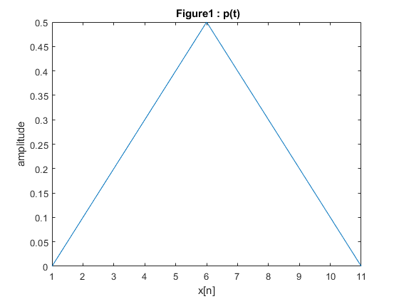
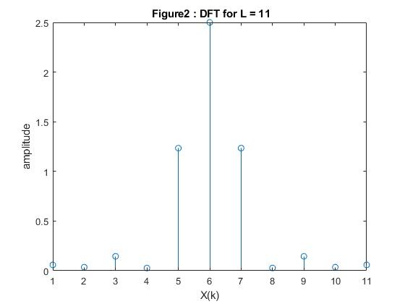
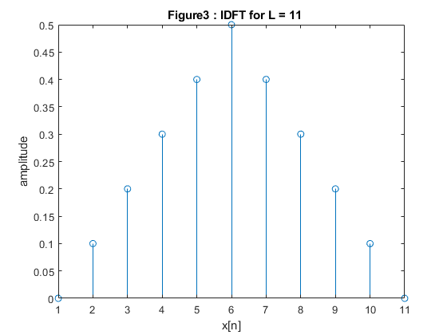
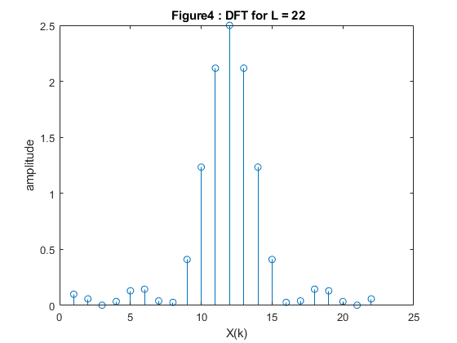
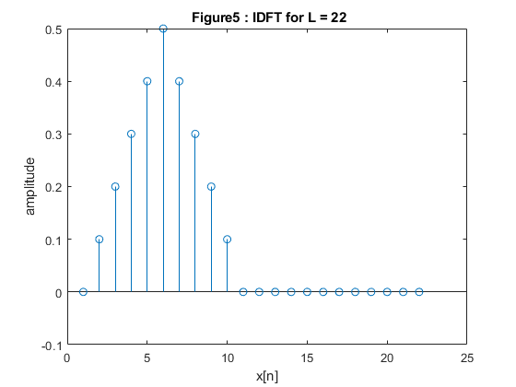
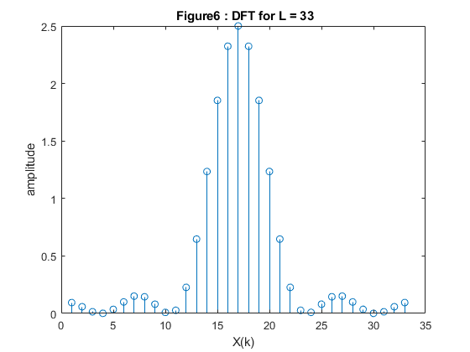
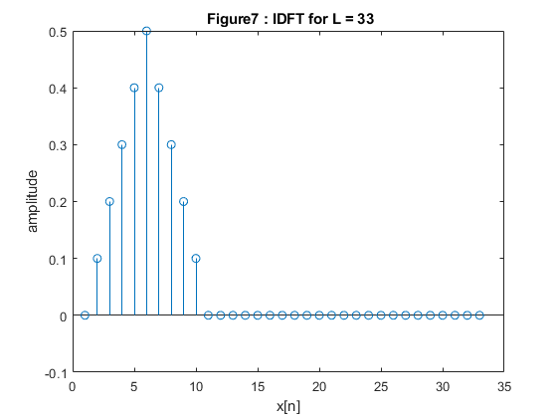
close all, clear all, clc;
tx = 0:1:10;
%Generating p(t)
for t = 0:1:10
t_ = t*(1/10);
if t <= 5
pt(t+1) = 1*t_;
else
pt(t+1) = 1*(1-t_);
end
end
figure(1);
plot(pt);
title(' Figure1 : p(t)');
xlabel('x[n]');
ylabel('amplitude');
DFT_11 = abs(fftshift(fft(pt,11)));
figure(2);
stem(DFT_11);
title(' Figure2 : DFT for L = 11');
xlabel('X(k)');
ylabel('amplitude');
figure(3);
IDFT_11 = ifft((fft(pt,11)),11);
stem(IDFT_11);
title(' Figure3 : IDFT for L = 11');
xlabel('x[n]');
ylabel('amplitude');
%L = 22
DFT_22 = abs(fftshift(fft(pt,22)));
figure(4);
stem(DFT_22);
title(' Figure4 : DFT for L = 22');
xlabel('X(k)');
ylabel('amplitude');
figure(5);
IDFT_22 = ifft((fft(pt,22)),22);
stem(IDFT_22);
title(' Figure5 : IDFT for L = 22');
xlabel('x[n]');
ylabel('amplitude');
%L = 33
DFT_33 = abs(fftshift(fft(pt,33)));
figure(6);
stem(DFT_33);
title(' Figure6 : DFT for L = 33');
xlabel('X(k)');
ylabel('amplitude');
figure(7);
IDFT_33 = ifft((fft(pt,33)),33);
stem(IDFT_33);
title(' Figure7 : IDFT for L = 33');
xlabel('x[n]');
ylabel('amplitude');

Orginal part of the pulse signal did not change as can be seen from Figure3,5,7. On the other hand as lenght increases, remanining indexes are zero padded. The signal that is recovered from the DFT using IDFT is same for all cases. For different DFT, as frequency of the sampling increase, one can see more samples for the DFT, where the amplitudes for same points are same as expected.

PART2
