close all, clear all, clc;
n = 0:1:63
x= sqrt(3/5).^n;
DFT_16 = abs(fftshift(fft(x(1:16),16)));
figure(1);
stem([-8:1:7],DFT_16);
title(' Figure1 : DFT X16(k)');
xlabel('X(k)');
ylabel('amplitude');
DFT_64 = abs(fftshift(fft(x(1:64),64)));
figure(2);
stem([-32:1:31],DFT_64);
title(' Figure2 : DFT X64(k)');
xlabel('X(k)');
ylabel('amplitude');
part16_fft=(fft(x(1:16),16));
part64_fft=(fft(x(1:64),64));
%Part4
part4_16 = part16_fft(3);
disp(part4_16)
part4_64 = part64_fft(9);
disp(part4_64);
n =
Columns 1 through 13
0 1 2 3 4 5 6 7 8 9 10 11 12
Columns 14 through 26
13 14 15 16 17 18 19 20 21 22 23 24 25
Columns 27 through 39
26 27 28 29 30 31 32 33 34 35 36 37 38
Columns 40 through 52
39 40 41 42 43 44 45 46 47 48 49 50 51
Columns 53 through 64
52 53 54 55 56 57 58 59 60 61 62 63
0.8813 - 1.0673i
0.8964 - 1.0856i
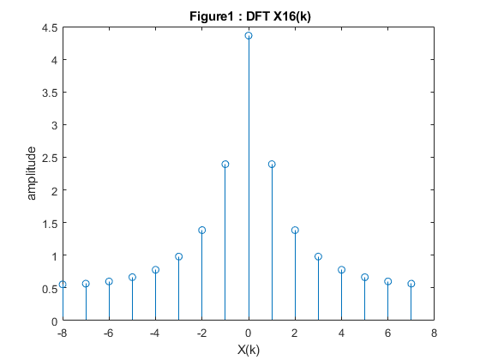
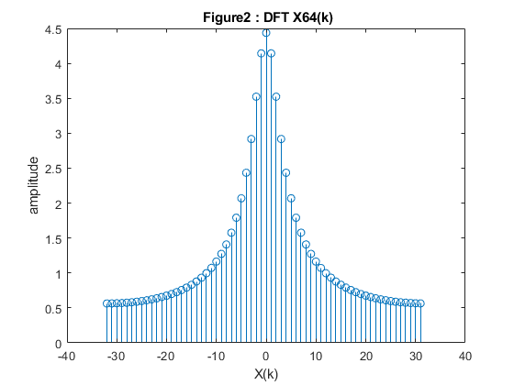
Published with MATLAB® R2020b

