close all, clear all, clc;
%Part5--------------------------------
N = 10000;
X = randi( [0 1], 1, N*4);
V = 1:1:4; % M = 2,4,8,16
for V = 4:1:4 % chosing the V that wanted to run
M = 2^V;
%Generating s(t)
for i = 1:1:N
decimal(i) = 0;
for j = 1:1:V
decimal(i) = decimal(i) + 2^(V-j)* X((i-1)*V+j);
st(i) = (2*decimal(i)-M+1);
end
end
count = zeros(1,10);
sigma = 1:1:10;
Ms = -(M-1):2:(M-1);
for j = 1:1:10
SNR(j) = 1/(2*sigma(j)); %Eb/No
nt = sqrt(sigma(j)) * randn(1, 1*N);
rt = st + nt;
for i = 1:1:N
for m = 2:1:M
if Ms(m)>= rt(i)
break;
end
end
if abs(Ms(m)-rt(i)) < abs(Ms(m-1)-rt(i))
r_ML(i) = Ms(m);
else
r_ML(i) = Ms(m-1);
end
% ML Decision rule
if (r_ML(i) == st(i))
count(j) = count(j) + 1;
end
end
end
SNR = [42.50 21.25 14.16 10.62 8.500 7.0833 6.0714 5.312 4.7222 4.2500]
error_rate = 1-(count./N);
SNR_db = 10*log10(SNR);
figure(3);
semilogy(SNR_db, error_rate);
xlabel('SNR(dB)');
ylabel('Error Rate');
title('Error rate for M = 16');
end
SNR =
Columns 1 through 7
42.5000 21.2500 14.1600 10.6200 8.5000 7.0833 6.0714
Columns 8 through 10
5.3120 4.7222 4.2500
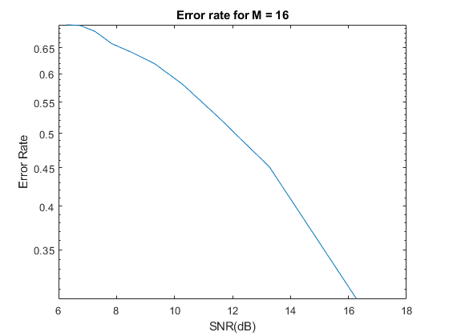
Published with MATLAB® R2020b

