close all, clear all, clc;
%Part1--------------------------------
N = 10000;
X = randi( [0 1], 1, N);
T = 20;
a = (12/T^3)^(1/2);
t = T/20:T/20:T;
%Generating p(t)
for t = 1:1:20
t_ = t*(T/20);
if t <= 10
pt(t) = a*t_;
else
pt(t) = a*(T-t_);
end
end
%power of pt = 1 unit
%disp(trapz([1/20:1/20:1],pt.^2))
figure(1);
subplot(1,2,1);
plot([20/20:20/20:20],pt);
title('p(t)');
subplot(1,2,2);
plot([20/20:20/20:20],-pt);
title('-p(t)');
%Generating s(t)
for i = 1:1:N
for j = 1:1:20
if X(i) == 1.0
st((i-1)*20 + j) = pt(j);
else
st((i-1)*20 + j) = -pt(j);
end
end
end
figure(2);
plot(st);
title('st');
%Generating nt
k = 1.38*(10^-23);
%N0 = k*300; %k = boltzman constant , 300 kelvin
%SNR = 1;
%N0 = 1/SNR;
count = zeros(1,10);
sigma = 1:1:10;
for j = 1:1:10
SNR(j) = 1/(2*sigma(j)); %Eb/No
nt = sqrt(sigma(j)) * randn(1, 20*N);
%nt = (N0/2)^1/2 * randn(1, 20*N);
%generating rt
rt = st + nt;
%figure(2);
%plot(rt);
%title('rt');
%Correlation type receiver
for i = 1:1:N
r(i) =trapz([20/20:20/20:20],rt( ((i-1)*20+1):((i-1)*20+20)).* pt);
% ML Decision rule
if r(i)<=0
r_ML(i) = 0;
else
r_ML(i) = 1;
end
if (r_ML(i) == X(i))
count(j) = count(j) + 1;
end
end
end
error_rate = 1-(count./N);
%sa = @(x) triangularPulse(0, 1/2, 1, x) .* sqrt(12);
%fplot(sa)
SNR_db = 10*log10(SNR);
figure(3);
semilogy(SNR_db, error_rate);
xlabel('SNR(dB)');
ylabel('Error Rate');
title('Error rate for different N0s');
%Part2--------------------------------
%Part3--------------------------------
pulse = sqrt(1/20)* ones(1,20);
count_p3 = zeros(1,10);
for j = 1:1:10
SNR_p3(j) = 1/(2*sigma(j)); %Eb/No
nt = sqrt(sigma(j)) * randn(1, 20*N);
%nt = (N0/2)^1/2 * randn(1, 20*N);
%generating rt
rt = st + nt;
%Correlation type receiver
for i = 1:1:N
r(i) =trapz([20/20:20/20:20],rt( ((i-1)*20+1):((i-1)*20+20)).* pulse);
% ML Decision rule
if r(i)<=0
r_ML(i) = 0;
else
r_ML(i) = 1;
end
if (r_ML(i) == X(i))
count_p3(j) = count_p3(j) + 1;
end
end
end
error_rate_p3 = 1-(count_p3./N);
SNR_db_p3 = 10*log10(SNR_p3.*0.8617);
figure(4);
semilogy(SNR_db_p3, error_rate_p3);
xlabel('SNR(dB)');
ylabel('Error Rate');
title('Error rate for different N0s with rectangular pulse in receiver');
%Part4--------------------------------
a = 1;
for deltaT = [5,8] % 5/20 = T/4 and 8/20 = 2T/5
count_p4 = zeros(1,10);
sigma = 1:1:10;
for j = 1:1:10
SNR_p4(j) = 1/(2*sigma(j)); %Eb/No
nt = sqrt(sigma(j)) * randn(1, 20*N);
%nt = (N0/2)^1/2 * randn(1, 20*N);
%generating rt
rt = st + nt;
%Correlation type receiver
for i = 1:1:N-1
r(i) =trapz([20/20:20/20:20],rt( ((i-1)*20+1+deltaT):((i-1)*20+20+deltaT)).* pt);
% ML Decision rule
if r(i)<=0
r_ML(i) = 0;
else
r_ML(i) = 1;
end
if (r_ML(i) == X(i))
count_p4(j) = count_p4(j) + 1;
end
end
end
error_rate_p4(a,:) = 1-(count_p4./N);
%sa = @(x) triangularPulse(0, 1/2, 1, x) .* sqrt(12);
%fplot(sa)
SNR_db_p4(a,:) = 10*log10(SNR_p4);
figure(5);
subplot(1,2,a);
semilogy(SNR_db_p4(a,:), error_rate_p4(a,:));
xlabel('SNR(dB)');
ylabel('Error Rate');
if a ==1
title('Error rate for different N0s for timing error T/4');
else
title('Error rate for different N0s for timing error 2T/5');
end
a = a+1
end
a =
2
a =
3
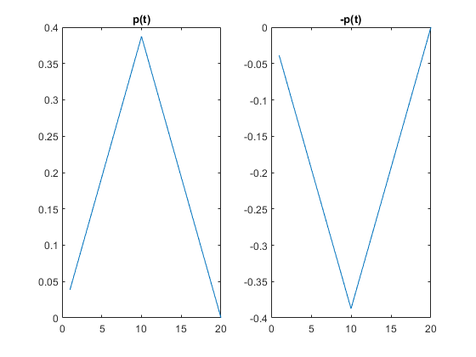
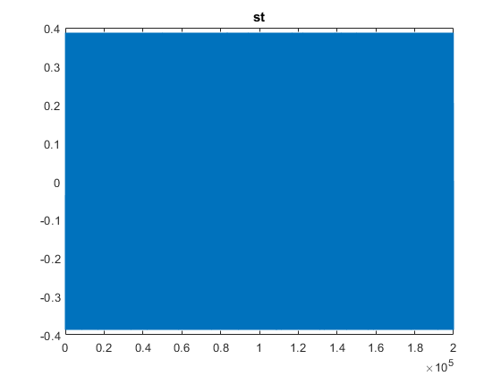
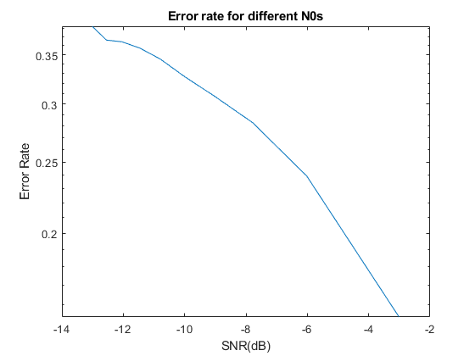
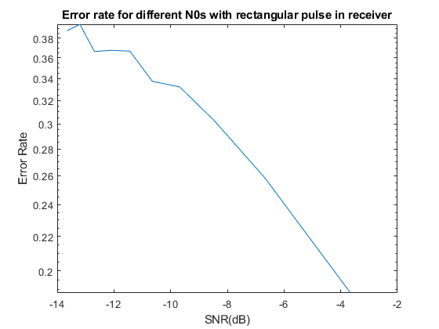
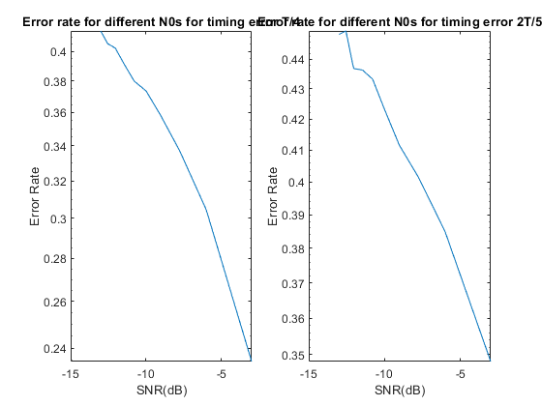
Published with MATLAB® R2020b

