SNAKE 3d
interactive graphics’ project

A.A. 2016-2017
Luca Borzacchiello 1602625

Table of Contents
1. Introduction 3
2. Technical aspects 4
2.1. The Snake 4
2.2. The Rabbit 5
2.3. The Parallelepiped and the Obstacles 6
2.4. The Environment 6
2.5. Camera, light and textures 7
2.6. Game loop 7
2.7. Code organization 7

1. Introduction
The software produced for this project is a 3D version of the famous game snake. In snake the player controls a snake which has to eat as many preys as possible. When the snake eats a prey, its body becomes longer and the player gains an amount of point which depends on the type of the prey. The player looses if the snake hits himself, hits an obstacle or steps over any of the edges of the environment.
Illustration 1: Game screenshot
In this particular version there are two types of preys: The Rabbit and The Parallelepiped whose technical aspects will be described in the following section of this report. The Parallelepiped just stands in the same location until the snake eats it. The player gains one point when the snake eats it. The Rabbit, on the other hand, moves randomly in the environment. If the snake eats the Rabbit, the player gains five points. Both preys are generated again in a random location of the environment as soon as the snake eats them.
This version of the game has one level and the speed of the snake is fixed but the code can be easily modified in order to change both the environment and the speed of the snake.
The player can interact with the game using the arrow keys (to move the snake) and with the key P in order to pause the game.

2. Technical aspects
The technologies which I used to develop the project are only HTML5, Javascript and WebGL [WebGLDoc]. The only external library which I used is the one by Ed. Angel from the textbook [Angel's book].
As support for 3D modeling, I’ve used the software Geogebra [Geogebra].

2.1. The Snake
The snake is the main element of the game and is controlled by the player. It is formed by three parts: the head, the body and the tail. When it eats a prey, a new body part is generated.
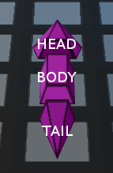Illustration 2: Snake
The behavior of the snake is simple: the player controls the head and the first body part moves according to its actual position and according to the head movement; all the other parts simply copies the last movement of the section which is ahead of them. Technically the snake is implemented with a linked list which is recursively scanned at each step of the animation.
The head of the snake can move only in three ways [drawing 1]:
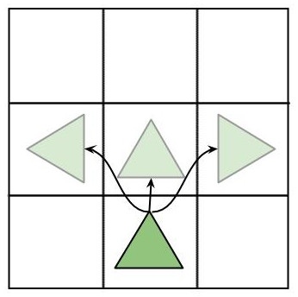Drawing 1:Head movements
- Forward movement: triggered by default if no arrow key is pressed by the player.
- Left rotation: triggered by the left arrow key, the head rotates counter-clockwise by 90 degrees and translate by one square forward and one square left.
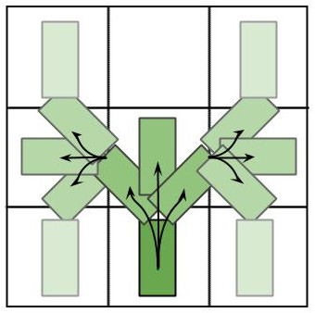Drawing 2:Body/tail movements
- Right rotation: as before but in the other direction.
The body and tail movements are a bit more complex, depending on their previous position and depending on the head movement, they can rotate by 45 or 90 degrees and they can translate forward by 1 square or less/more, depending on the situation [drawing 2].

2.2. The Rabbit
The Rabbit is one of the prey and is the object with the most complex hierarchical structure [drawing 3] in this project. It is formed by 11 parallelepipeds with one degree of freedom each.
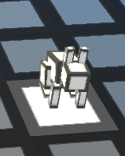Illustration 3: Rabbit
The Rabbit can jump forward or rotate by 90 degrees left/right.
It moves randomly in the environment according to Algorithm 1.
Algorithm 1: Rabbit movement
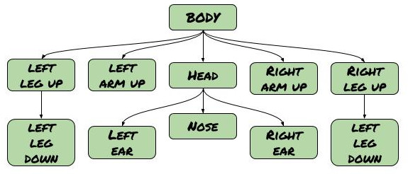Drawing 3: Rabbit hierarchical model
if last movement was rotation and it is possible to move forward then
move forward
else
with 50% of probability move forward
with 25% of probability rotate right
with 25% of probability rotate left
The rotation movement is very simple, the rabbit just rotate around itself by 90/-90 degrees.
The animation of the jump is quite more complex, it is broken down by three phases [illustration 4]:
- Charging phase: in this phase the rabbit pull forward its arms and flexes its lower legs.
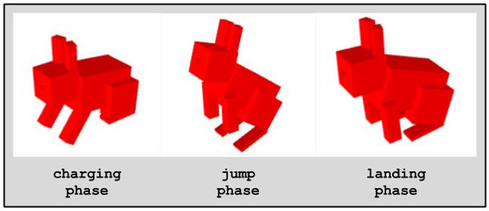Illustration 4: Rabbit jump
- Jump phase: in this phase the rabbit jumps, relaxing its arms and legs.
- Landing phase: in this phase the rabbit lands softly in a new square.

2.3. The Parallelepiped and the Obstacles
The Parallelepiped is the other prey which the snake can eat. It just stands in one square of the environment, rotating around itself waiting to be eaten by the snake.
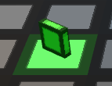Illustration 5: The Parallelepiped
The 3d model is simply a parallelepiped. As soon as the parallelepiped is eaten, a new one is generated randomly in any free square of the environment.
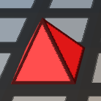Illustration 6: Obstacle
The Obstacles are just pyramids which stand in a square of the environment preventing the snake to pass through them. They cannot be destroyed and remains in the environment for the whole match.

2.4. The Environment
The environment is the grid which contains all the object of the game. The snake and the rabbit move in the environment and at the end of each animation, all the objects stand in one and only one square.
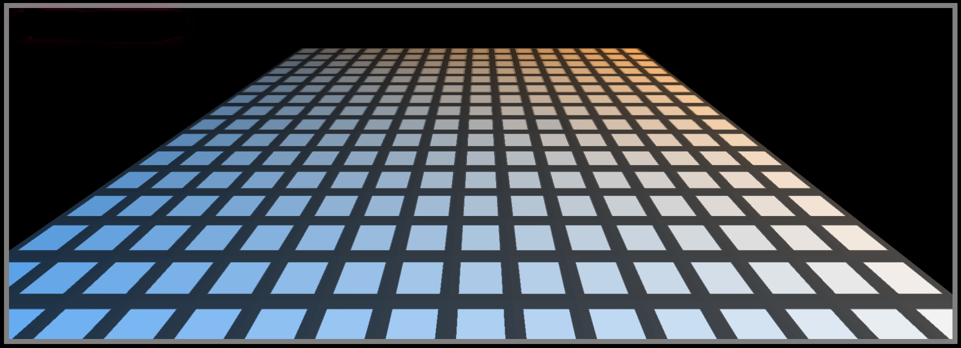Illustration 7: Environment
All the squares are rendered separately at the begin of each animation and the shading effect is achieved through textures and colors.
Programmatically, the environment is modeled through a matrix, each cell of the matrix contains an object which represents a square of the environment. The data that the object contains include: the color of the square, the type of object which is on the square (if any), the model-view matrix to be applied to the square at render time, etc.

2.5. Camera, light and textures
The camera is placed above the snake and remain fixed in the coordinate system of the snake head, so with respect of the environment it rotates and moves according to the snake.
There is only one light in the environment, a directional light which hits the squares with an angle of 45 degrees. The light is computed using Gouraud shading [Angel's book]. Other light effect (such as the shading of the squares) are achieved through texturing and coloring.
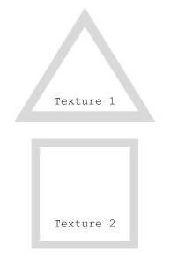Illustration 8: Textures
The only two textures used in this project are the ones in Illustration 8. The textures are applied to every faces of every object and are multiplied in the shader with a color. Each object is characterized by a specific color.
The textures are computed programmatically.

2.6. Game loop
The game loop is divided in two different parts. During the first part, the current animations are simply displayed for each object; during the second part it is checked whether or not a key was pressed, all animations of the new first part are decided for each object, it is checked if the snake has captured a prey etc.
The game loop is repeated until the player looses.

2.7. Code organization
The code is organized in 8 files:
- main.js which contains the init function, the render functions of all the objects of the environment and the main loop.
- rabbit.js which contains the code for the rabbit.
- snake.js which contains the code for the snake.
- list.js which contains an implementation of liked list used by snake.js.
- util.js which contains some util functions.
- contansts.js which contains all the constants used in the code.
- geometries.js which contains the points of all the geometries.
Bibliography
WebGLDoc: Khronos group, https://developer.mozilla.org/it/docs/Web/API/WebGL_API, 2011 - 2017,
Angel's book: Edward Angel, Dave Shreiner, Interactive Computer Graphics with WebGL,
Geogebra: Markus Hohenwarter, others, www.geogebra.org, 2001-2017,

