QPS ADMIN · BLAZOR SERVER · COOKIE AUTHENTICATION

QPS Sign-in Flow
How login, logout, forgot password and reset password work in the new auth module, which file does each job, and what you connect to your own database and mail server.

1. The core rule
An interactive page talks to the server over a WebSocket. A WebSocket message has no HTTP response, and only an HTTP response can set or clear a cookie. So every flow is split in two:
Interactive page (circuit) | HTTP endpoint
Shows the form, validates input, checks the password, handles lockout, shows messages. No page reloads. | Receives a normal form POST and writes or clears the auth cookie in its response. Then redirects.

Diagram colours: ━ blue = over the WebSocket (circuit) ━ green = real HTTP request ━ black = C# method call ┅ grey dashed = return value

2. Where HttpContext exists
HttpContext only exists while an HTTP request is being handled. An interactive page lives in three moments, and only two of them are HTTP requests.
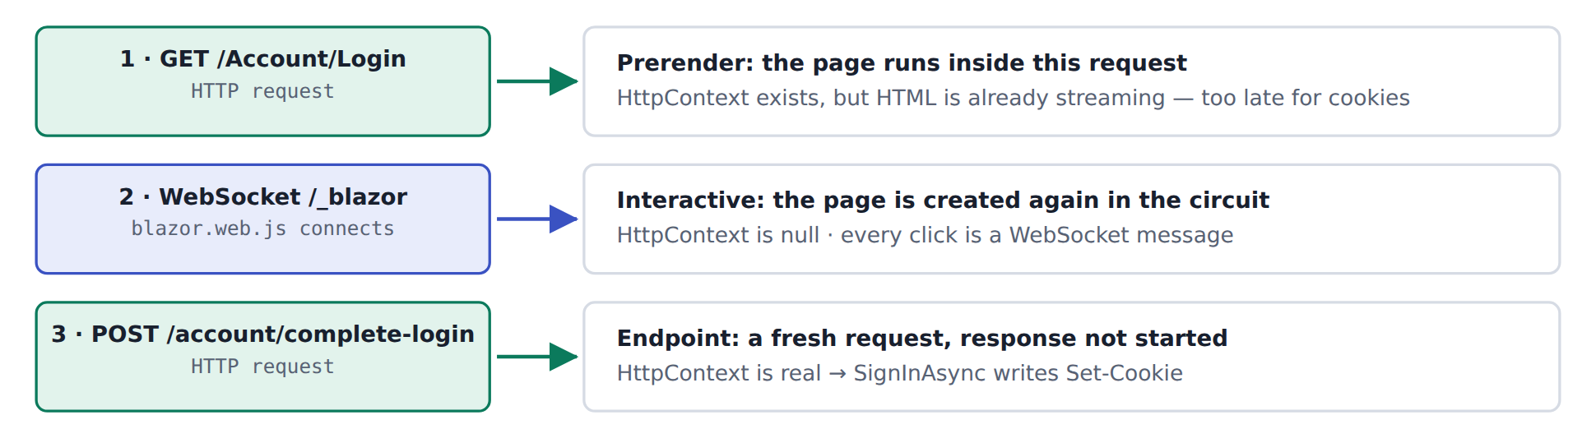
The login page never uses HttpContext. It reads the user from AuthenticationStateProvider, and step 3 does the cookie work.

3. Login
The password is checked over the circuit. The cookie is set by a separate HTTP POST that carries a one-time ticket, never the password.
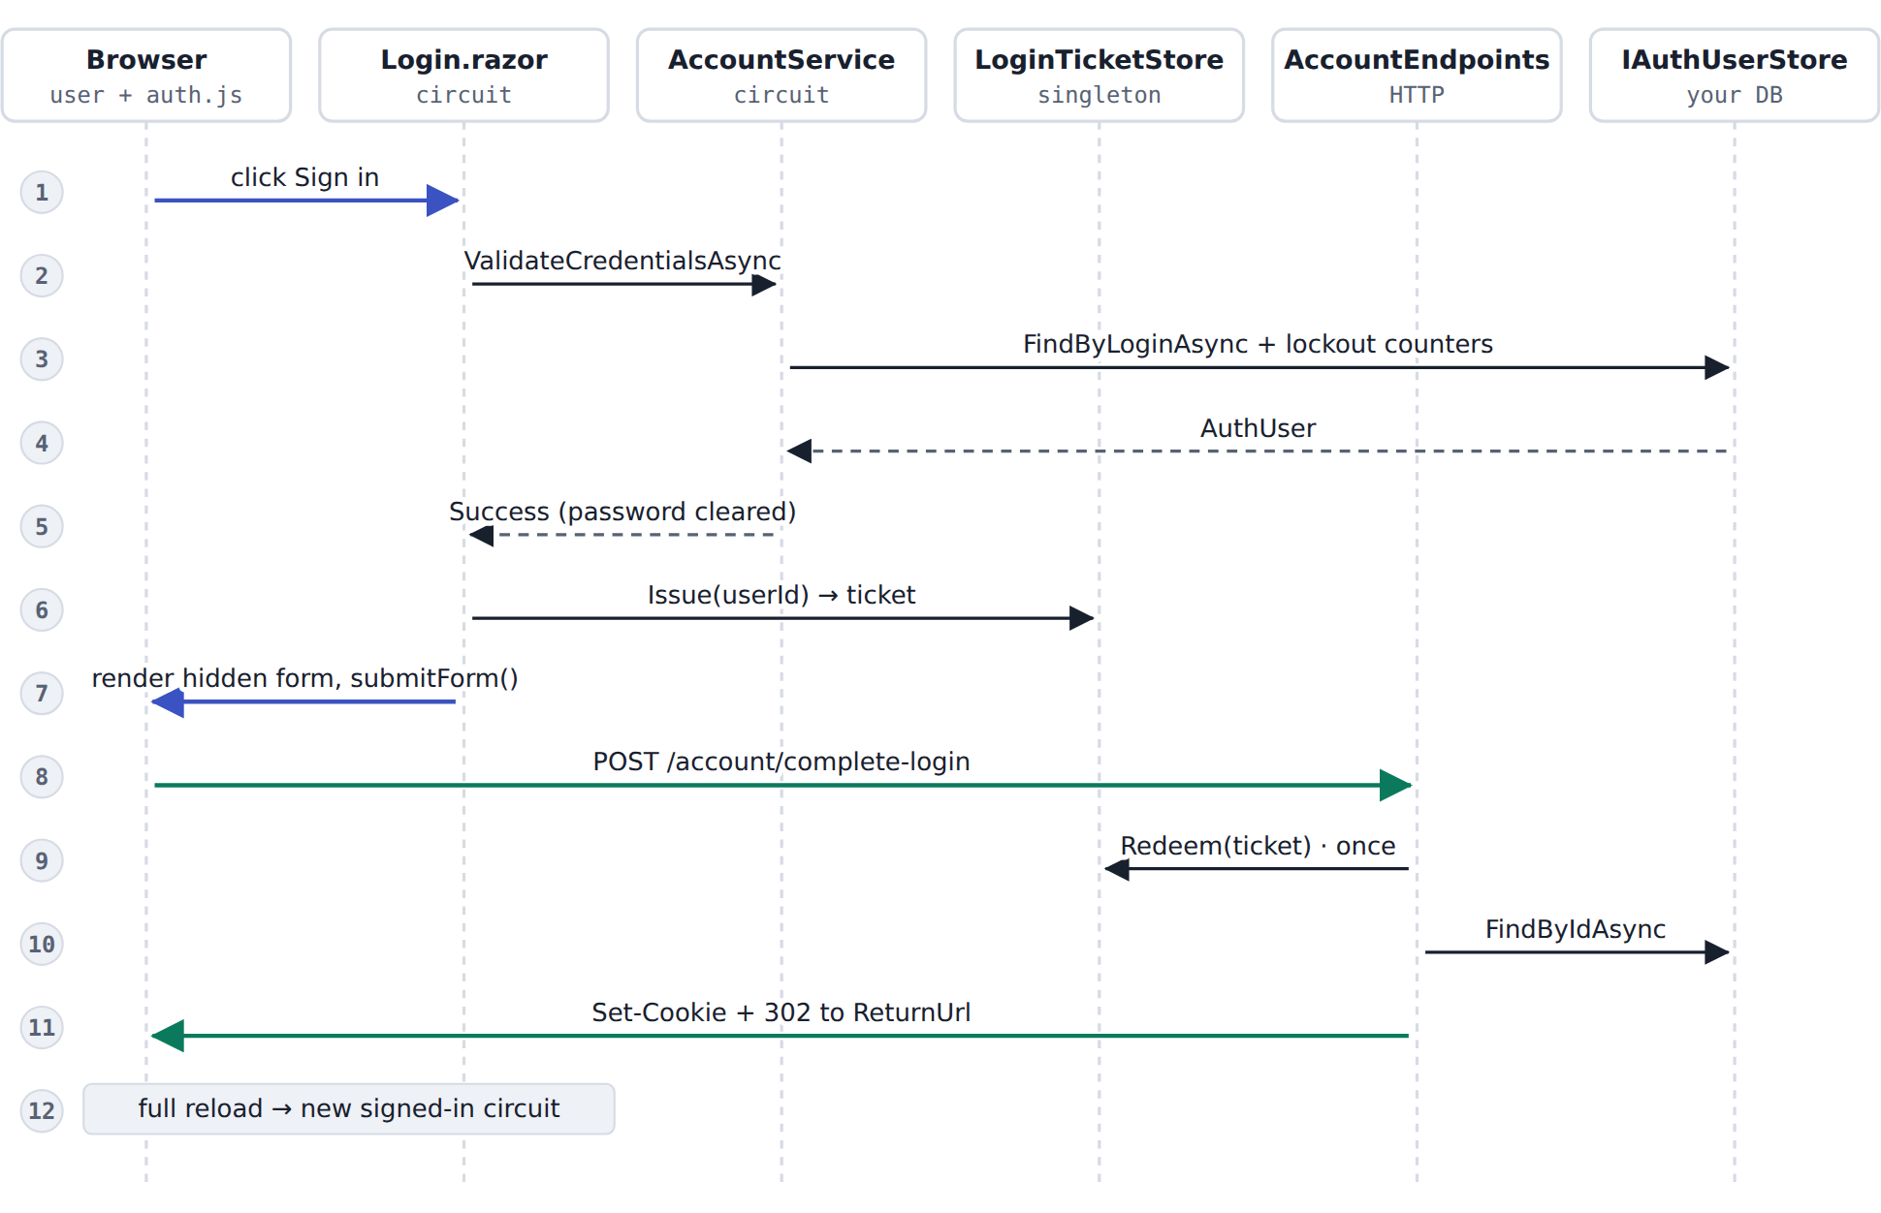
Steps 1–7 run over the WebSocket. Steps 8–11 are one HTTP request and its redirect. Step 12 is the fresh page load.
- The user fills in the MudBlazor form and clicks Sign in.
- Login.razor calls AccountService.ValidateCredentialsAsync.
- The service looks the user up. Unknown users are checked against a dummy hash so they take as long as a wrong password. A wrong password adds 1 to the failure count; at 5 the account locks for 15 minutes.
- The store returns the user.
- The service returns Success. If the stored hash is old, it is upgraded here. The page clears the password from memory.
- The page asks LoginTicketStore for a ticket: 64 random hex characters, valid 60 seconds, usable once.
- The page renders a hidden form (ticket, antiforgery token, ReturnUrl) and auth.js submits it.
- The browser sends a normal POST to /account/complete-login. The endpoint first validates the antiforgery token.
- It redeems the ticket. A second use of the same ticket fails.
- It reloads the user (still active?) and builds the claims.
- SignInAsync writes the __Host-App.Auth cookie, and the response redirects to the ReturnUrl, but only if that is a page on this site.
- The full page load starts a new circuit that is signed in.

4. Logout
Sign-out is always a POST with an antiforgery token. Opening a URL never signs anyone out, so a link on another site can't log your users out.
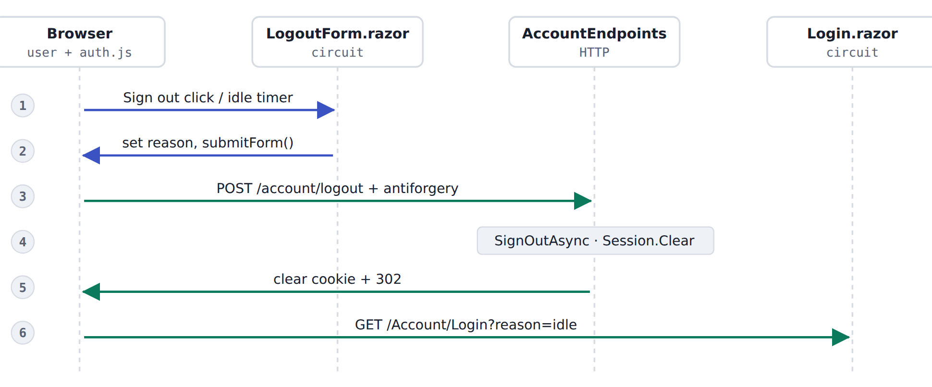
The same path is used by the Sign out menu, the /Account/Logout page and the idle-timeout monitor (reason idle).

5. Forgot and reset password
The raw token only exists in the e-mail. The database stores its SHA-256 hash, so a leaked table can't be used to reset passwords.
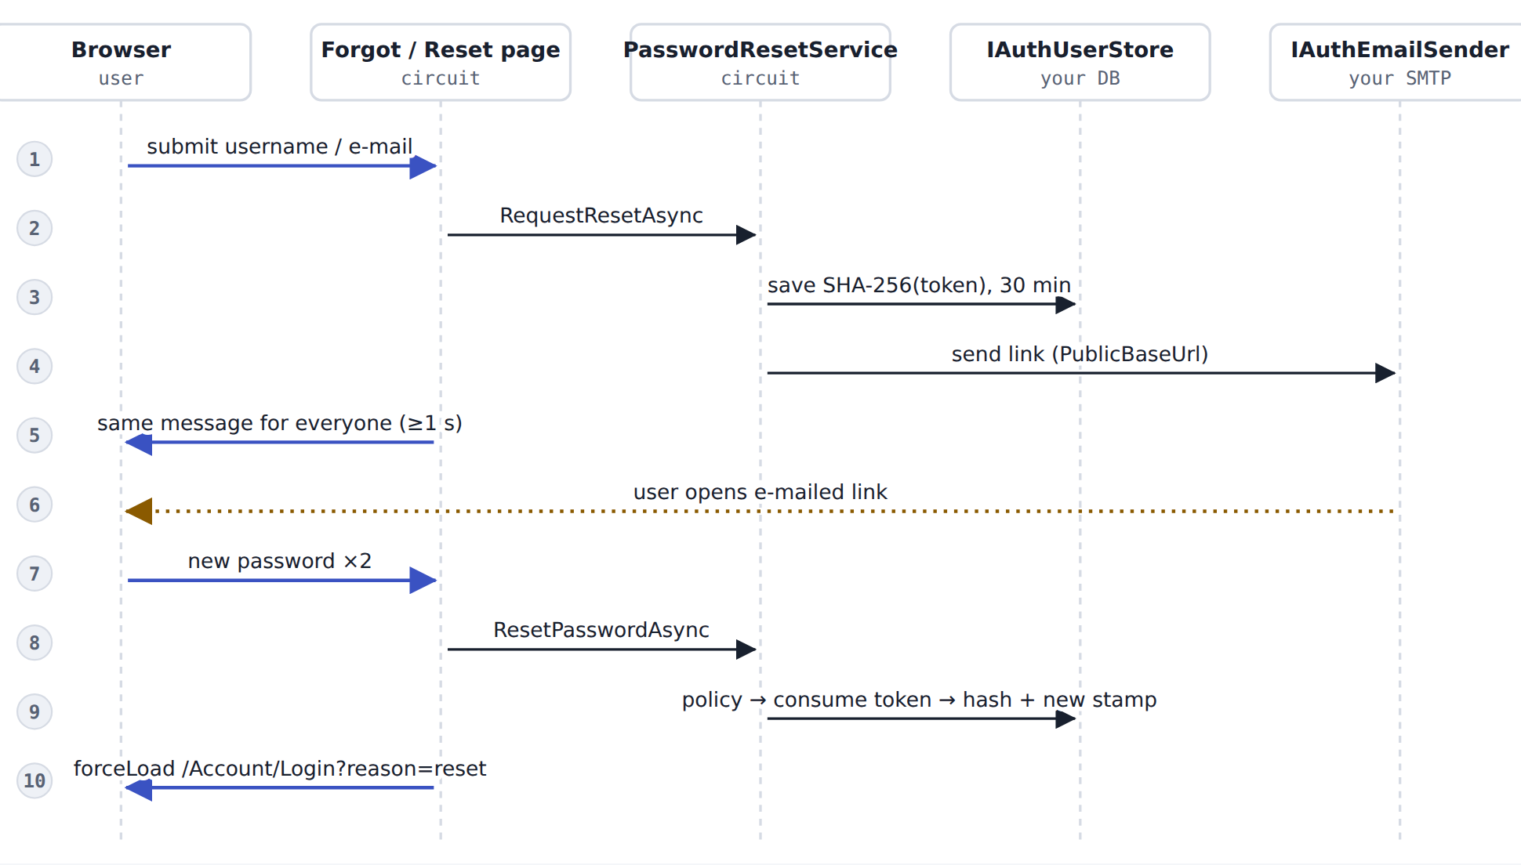
Step 5 shows the same message whether or not the account exists. Step 9 checks the password rules before using up the token, so a weak password doesn't waste the link.
- The user enters a username or e-mail on /Account/Forgot-Password.
- The page calls RequestResetAsync.
- If the account exists and is active, a random token is made and its hash is saved with a 30-minute expiry. Any older token for that user is replaced.
- The link is built from Auth:PublicBaseUrl, never from the request's Host header, and e-mailed.
- The page shows "If an account matches…" to everyone and takes at least 1 second, so it can't be used to find accounts.
- The user opens /Account/Reset-Password?token=… from the e-mail. The page checks the token on load.
- The user enters the new password twice.
- The page calls ResetPasswordAsync.
- Password rules are checked, the token is consumed (only one submit can win), the new hash is saved and the security stamp changes. That signs the user out on every other device. Any lockout is cleared.
- The page reloads to the login page with "Your password has been changed".

6. Session checks while the user works
Three limits apply to every session: 30 minutes idle (the cookie slides), 12 hours absolute after sign-in, and user still valid (active, password not changed). Two paths enforce them, because an open interactive page makes no HTTP requests.
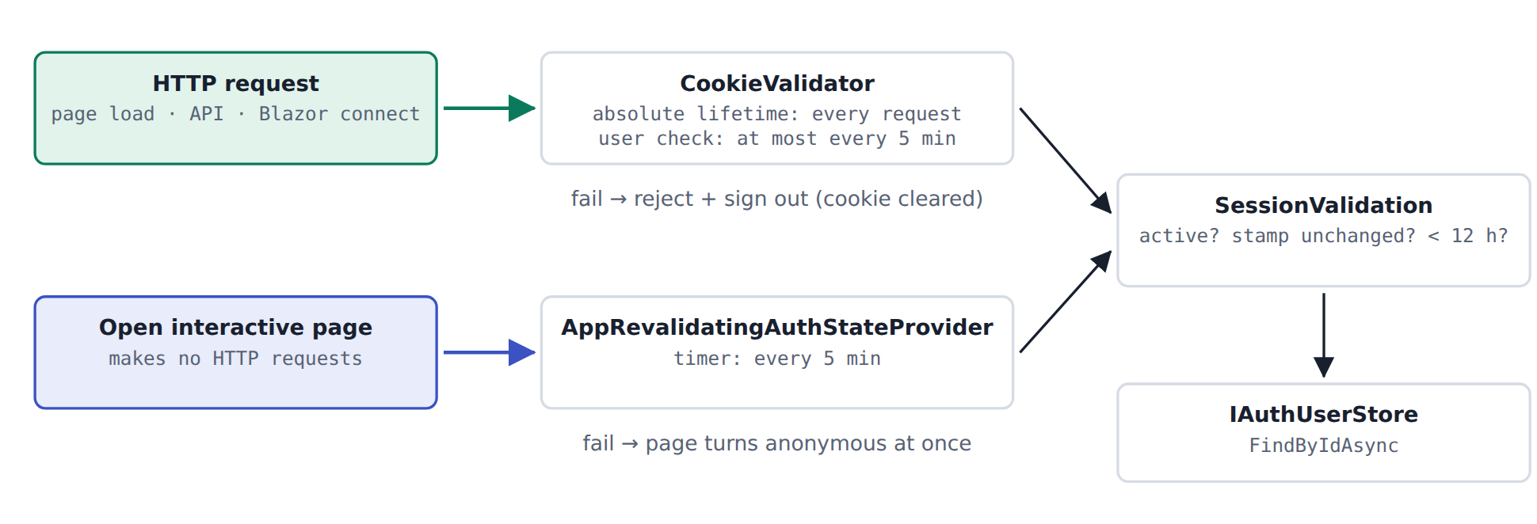
If an administrator disables a user or the password is reset, open pages lose access within 5 minutes and the cookie is cleared on the next HTTP request.

7. Which file does what
All paths are under Admin/. In the Runs column, blue runs over the WebSocket, green runs in a normal HTTP request, amber is browser JavaScript, and pink is what you implement or edit.

Pages the user sees
File | Runs | What it does | You change it?
Components/Pages/Account/Login.razor | Circuit | Sign-in form. Calls AccountService, gets a ticket from LoginTicketStore, renders the hidden form and asks auth.js to post it. Shows messages for idle, signed out, reset, expired. | No
Components/Pages/Account/Logout.razor | Circuit | "Sign out?" confirmation page. Opening it never signs out; the button submits LogoutForm. | No
Components/Pages/Account/ForgotPassword.razor | Circuit | Takes username or e-mail, calls RequestResetAsync, always shows the same message and waits at least 1 s. | No
Components/Pages/Account/ResetPassword.razor | Circuit | Opened from the e-mail. Checks the token on load, takes the new password twice, calls ResetPasswordAsync. | No
Components/Pages/Account/AccessDenied.razor | Static | Shown when a signed-in user lacks the role for a page (403). | No
Components/Layout/AuthLayout.razor | Layout | Centered card without the app menu, used by all account pages. | Optional: branding

Building blocks in your layout
File | Runs | What it does | You change it?
Components/Account/LogoutForm.razor | Circuit → HTTP | Hidden POST form with antiforgery token. SubmitAsync(reason) posts it to /account/logout. | No
Components/Layout/IdleTimeoutMonitor.razor | Circuit | Idle warning overlay. When time runs out it calls its LogoutForm with reason "idle". | No
wwwroot/js/auth.js | Browser | submitForm(id): posts a form as a real browser request, so the response can set or clear the cookie. | No

Services (run inside the circuit)
File | Runs | What it does | You change it?
Auth/AccountService.cs | Circuit | Checks the password: dummy hash for unknown users, lockout after 5 failures, disabled check, automatic hash upgrade. | No
Auth/LoginTicketStore.cs | Singleton | Issues and redeems one-time tickets (64 hex chars, 60 s, single use). In memory. | Redis if multi-server
Auth/PasswordResetService.cs | Circuit | Creates the reset token, stores its hash, sends the link; resets the password and rotates the security stamp. | No
Auth/PasswordPolicy.cs | Shared | Password rules: minimum length, common-password block-list, no username inside. | Optional: rules
Auth/AppRevalidatingAuthStateProvider.cs | Circuit | Re-checks the user of every open page every 5 minutes. | No

HTTP side (the only code that touches the cookie)
File | Runs | What it does | You change it?
Auth/AccountEndpoints.cs | HTTP | POST /account/complete-login (ticket → SignInAsync) and POST /account/logout (SignOutAsync). Both validate antiforgery. | No
Auth/CookieValidator.cs | HTTP | Runs on every request with the cookie: absolute lifetime, then a throttled user check. | No

Shared pieces and setup
File | Runs | What it does | You change it?
Auth/AuthServiceCollectionExtensions.cs | Startup | AddAppAuthentication(): registers the services and the cookie (name, HttpOnly, Secure, Lax, idle timeout, events). | No
Auth/AuthClaims.cs | Shared | Builds the claims (id, name, e-mail, roles, security stamp, sign-in time). Also holds SessionValidation. | No
Auth/UrlSafety.cs | Shared | Allows only local ReturnUrl values, so nobody can redirect users to another site. | No
Auth/AuthConstants.cs | Shared | Cookie name, page paths, endpoint paths, claim type names. | No
Auth/AuthSettings.cs | Config | The "Auth" section of appsettings.json: timeouts, lockout, token lifetime, PublicBaseUrl. | Set values
Auth/AuthUser.cs | Shared | The user record the module works with. Map it from your user table. | No

Connect to your system
File | Runs | What it does | You change it?
Auth/IAuthUserStore.cs | Interface | Every database call the module makes (find user, lockout, password hash, reset tokens). | Implement
Auth/InMemoryAuthUserStore.cs | Dev only | Stand-in store with user admin / ChangeMe!2026. Lost on restart. | Replace
Auth/IAuthEmailSender.cs | Interface + dev | Sends the reset e-mail. LoggingAuthEmailSender only writes the link to the log. | Implement
Program.cs · MainLayout.razor · appsettings.json | Your files | Wire-up, Sign out menu, Auth settings. See the checklist below. | Edit

8. What each protection stops
Attack | Protection | Where
Guessing passwords | Lock for 15 min after 5 failures; same error text for every failure | AccountService.cs
Finding valid usernames | Dummy hash check for unknown users; forgot page shows one message and takes ≥ 1 s | AccountService.cs, ForgotPassword.razor
Stolen password database | PBKDF2-SHA512 hashes (100,000 rounds); reset tokens stored only as SHA-256 | PasswordHasher<T>, PasswordResetService.cs
Cookie theft by script | HttpOnly, Secure, __Host- prefix, SameSite=Lax | AuthServiceCollectionExtensions.cs
Forged login or logout from another site | POST only, with antiforgery token; ticket usable once within 60 s | AccountEndpoints.cs, LoginTicketStore.cs
Redirect to a fake site after login | ReturnUrl must be a local path | UrlSafety.cs
Reset link pointing at an attacker's host | Links built from PublicBaseUrl, not the Host header | PasswordResetService.cs
Old sessions after a password change | Security stamp changes; both session checks compare it | CookieValidator.cs, AppRevalidatingAuthStateProvider.cs

9. Setup checklist
- Program.cs: add AddAppAuthentication(...), register your IAuthUserStore and IAuthEmailSender, and add app.MapAccountEndpoints(); before MapRazorComponents. Remove the old cookie and auth-state-provider registration.
- appsettings.json: add the "Auth" section with at least PublicBaseUrl.
- Database: add PasswordHash, SecurityStamp, FailedLoginCount, LockoutEndUtc to the user table and create PasswordResetTokens. SQL is in docs/AUTH.md.
- IAuthUserStore: implement it against your database. IAuthEmailSender: implement it with your SMTP service.
- MainLayout.razor: add <LogoutForm @ref="_logout" />, a Sign out menu item that calls _logout.SubmitAsync(), and <IdleTimeoutMonitor />.
- App.razor: keep <Routes @rendermode="InteractiveServer" /> with prerendering on. The antiforgery token comes from the prerendered page.
- Existing passwords: either ask everyone to reset, or verify the old hash format once in your store and re-save with the new hasher on the next login.

// Program.cs (order matters)
builder.Services.AddAppAuthentication(builder.Configuration, builder.Environment);
builder.Services.AddScoped<IAuthUserStore, SqlAuthUserStore>(); // yours
builder.Services.AddScoped<IAuthEmailSender, SmtpAuthEmailSender>(); // yours

app.UseStaticFiles();
app.UseAuthentication();
app.UseAuthorization();
app.UseAntiforgery();
app.MapAccountEndpoints();
app.MapRazorComponents<App>().AddInteractiveServerRenderMode();
Note: this code has not been compiled yet. SqlAuthUserStore and SmtpAuthEmailSender are example names for the classes you write.

