QPS ADMIN · BLAZOR WEB APP · INTERACTIVE SERVER

QPS Sign-in & Dashboard
Implementation steps and calling sequence of each file
This guide covers the new login, logout, forgot-password and reset-password pages, the CAPTCHA, the role-based home page, and the left menu. Section 1 is the order to put it into the project. Sections 3–9 show which file calls which, step by step, for every flow.
Item | Value
Branch | claude/magical-davinci-tgsk4x
Code folders | Admin/Auth, Admin/Navigation, Admin/Components/{Account, Dashboard, Layout, Pages}, Admin/wwwroot/{css, js, images}
Other docs | docs/AUTH.md (reference), docs/auth-flow.html (diagrams), docs/QPS-Sign-in-Flow.docx (earlier overview)
Dev logins | Employee: admin, admin5, qaadmin, qam, qa, ch, ach, merch, buyer, qc, view, asn, bft, cm · Vendor tab: vendor · password ChangeMe!2026 (from InMemoryAuthUserStore)

How it fits together
The pages are fully interactive. After the first load they talk to the server over a WebSocket (the Blazor circuit), not over HTTP. A WebSocket message has no HTTP response, and only an HTTP response can set or clear a cookie. So every sign-in and sign-out is split into two halves:
 | Circuit half (Blazor page) | HTTP half (AccountEndpoints)
Runs | Inside the WebSocket, in the Razor component | A normal POST, with a full page load
HttpContext | Not available (null, or left over from the first request) | Available: it is a real request
Does | CAPTCHA, check the password, lockout, show errors | Antiforgery check, write or remove the cookie, redirect
Joined by | A one-time ticket (LoginTicketStore, 60 s) and a hidden <form> that auth.js posts

Colours used in the tables and diagrams:
Browser JavaScript / page load Circuit Blazor over the WebSocket HTTP real request C# call service method Your code what you implement

1. Implementation steps
Do these in order. Each step says what to change and how to check it before moving on.

Step 1 — Copy the files
Folder | Contents
Admin/Auth/ | Services, endpoints, cookie setup, roles, policies, Captcha/
Admin/Navigation/AppMenu.cs | Left-menu rules (role IDs and modules)
Admin/Components/Pages/Account/ | Login, Logout, ForgotPassword, ResetPassword, AccessDenied pages
Admin/Components/Pages/ | Home.razor ("/"), NoPage.razor, ComingSoon.razor
Admin/Components/Account/ | CaptchaField, LoginSlider, LogoutForm, illustrations
Admin/Components/Layout/ | AuthLayout, DashboardLayout, AppNavMenu, NavNode, QpsTheme, IdleTimeoutMonitor
Admin/Components/Dashboard/ | HomeDashboards, DashboardCatalog, RoleDashboard and the tiles
Admin/wwwroot/ | css/auth.css, css/app-shell.css, js/auth.js, images/vmm-logo.png, images/login-slides/*.jpg

Check: the project builds. Fix any namespace errors now (see Step 3).

Step 2 — Packages and references
- MudBlazor (already used). The layout uses MudDrawer, MudNavMenu, MudMenu.
- VmmCaptcha — the company CAPTCHA library used by VmmCaptchaGenerator.cs. It draws with System.Drawing, which works on Windows only.
- Your project that contains IPasswordHasher / PasswordHasher.

Step 3 — Point the password hasher at your interface
Admin/Auth/AuthUsings.cs has one line. Change the namespace if yours is different:
global using AppPasswordHasher = Application.Interfaces.V1.User.IPasswordHasher;

Keep your existing registration in Program.cs: builder.Services.AddSingleton<IPasswordHasher, PasswordHasher>();. VendorPasswordVerifier calls VerifyPassword(password, hash) and PasswordResetService calls HashPassword(password), so existing passwords keep working.

Step 4 — appsettings.json
"Auth": {
"PublicBaseUrl": "https://qps.vishalmegamart.com",
"IdleTimeoutMinutes": 30,
"AbsoluteLifetimeHours": 12,
"RevalidationMinutes": 5,
"MaxFailedAttempts": 5,
"LockoutMinutes": 15,
"PasswordResetTokenMinutes": 30,
"MinPasswordLength": 10,
"LandingPages": { "ChangePassword": "/changepassword" }
}

Keep AppConfigurationSettings:MaxSessionTime equal to Auth:IdleTimeoutMinutes. IdleTimeoutMonitor uses MaxSessionTime; the cookie uses IdleTimeoutMinutes. If they differ, the page and the cookie expire at different times. PublicBaseUrl must be https outside Development, or the app will not start (ValidateOnStart).

Step 5 — Program.cs: services
Remove the old authentication setup, or two cookie handlers will compete:
- builder.Services.AddAuthentication(Cons.AuthScheme).AddCookie(...) — the whole block
- builder.Services.AddScoped<AuthenticationStateProvider, CustomRevalidatingAuthenticationStateProvider>();
- The second AddCascadingAuthenticationState() (the new code adds it)
- Old role policies you no longer use (PPSAccess, … can stay if pages still use them — AddAuthorization calls add up)
Add after AddRazorComponents():
using Admin.Auth;

builder.Services.AddAppAuthentication(builder.Configuration, builder.Environment);
builder.Services.AddScoped<IAuthUserStore, QpsAuthUserStore>(); // Step 9 (dev: InMemoryAuthUserStore as singleton)
builder.Services.AddScoped<IAuthEmailSender, QpsAuthEmailSender>(); // Step 10 (dev: LoggingAuthEmailSender)
builder.Services.AddScoped<IEmployeeAuthApi, QpsEmployeeAuthApi>(); // Step 9b (dev: DevEmployeeAuthApi)
builder.Services.AddSingleton<IPasswordHasher, PasswordHasher>(); // already there

Keep the fallback policy with anonymousPaths (/_framework, /_blazor, /service-worker.js). Pages mark themselves [AllowAnonymous]; the three /account/... endpoints call .AllowAnonymous().

Step 6 — Program.cs: pipeline
Order matters. MapAccountEndpoints() must be called, otherwise /account/complete-login returns 404 and sign-in never finishes (this was the "0 references" problem).
app.UseHttpsRedirection();
app.UseStaticFiles();
app.UseSession(); // only while old code still uses HttpContext.Session
app.UseAuthentication();
app.UseAuthorization();
app.UseAntiforgery();
app.MapControllers(); // api/session/keepalive for IdleTimeoutMonitor
app.MapAccountEndpoints(); // /account/complete-login, /account/sign-out, /account/antiforgery-token
app.MapRazorComponents<App>().AddInteractiveServerRenderMode();

CSP: keep img-src 'self' data: (the CAPTCHA image is a data: URL) and connect-src 'self' wss:.

Step 7 — App.razor and Routes.razor
App.razor needs <HeadOutlet /> in <head> — the layouts add their stylesheet with <HeadContent>. Load blazor.web.js normally.
<head>
...
<link rel="stylesheet" href="css/auth.css" /> @* optional: AuthLayout also adds it *@
<HeadOutlet @rendermode="InteractiveServer" />
</head>
<body>
<Routes @rendermode="InteractiveServer" />
<script src="_framework/blazor.web.js"></script>
</body>

In Routes.razor, use AuthorizeRouteView and send anonymous users to the login page with the page they wanted:
<Router AppAssembly="typeof(Program).Assembly">
<Found Context="routeData">
<AuthorizeRouteView RouteData="routeData" DefaultLayout="typeof(Layout.DashboardLayout)">
<NotAuthorized>
@* your redirect component: NavigateTo("/Account/Login?ReturnUrl=...", forceLoad: true) *@
</NotAuthorized>
</AuthorizeRouteView>
<FocusOnNavigate RouteData="routeData" Selector="h1" />
</Found>
</Router>

Step 8 — Remove the old pages on the same routes
- Any other page with @page "/" — two pages on one route stop the app with an AmbiguousMatchException.
- The old /Account/Login page (LoginOld) and old logout page / User-Logout endpoint.
- Old code that writes the CAPTCHA to HttpContext.Session — the new CAPTCHA does not use session.
Check now: run with InMemoryAuthUserStore. Sign in as qa / ChangeMe!2026 and you should land on "/" with the QA dashboard and menu. Before continuing, sign out, then test the Vendor tab with vendor.

Step 9 — Implement IAuthUserStore (your database)
This is the main piece of work. InMemoryAuthUserStore is only for development. Create QpsAuthUserStore : IAuthUserStore that reads your user tables. Every method is called by a specific file:
Method | Called by | Must do
FindByLoginAsync(login, type) | AccountService, PasswordResetService | Find by username or e-mail, only for that account type (Employee/Vendor). Return role IDs ("1006"…) in Roles and modules in Modules.
FindByIdAsync(id) | AccountEndpoints, SessionValidation | Same user by id. Called every 5 min per session — keep it fast.
RecordFailedLoginAsync(id) | AccountService | Atomically +1 and return the new count.
LockOutAsync(id, until) | AccountService | Set LockoutEndUtc.
ClearLockoutAsync(id) | AccountService | Reset count and lockout after a good password.
SetPasswordHashAsync(id, hash, rotate) | PasswordResetService | Save the hash; if rotate, new SecurityStamp (signs out other sessions).
SavePasswordResetTokenAsync | PasswordResetService | Store the SHA-256 hash of the token and its expiry.
FindUserIdByPasswordResetTokenAsync | PasswordResetService | Look up a valid (not expired) token hash.
ConsumePasswordResetTokenAsync | PasswordResetService | Delete and return the user id in one statement (single use).

Employees are not checked against a stored hash: their row in QPS gives roles, modules, status and lockout, and the password goes to the employee API (Step 9b). Vendors: FindByLoginAsync can use IVendorLookupService.

Register it as scoped (it uses a DbContext). AppRevalidatingAuthStateProvider already creates a fresh scope for each check.

Step 9b — Employee API (IEmployeeAuthApi)
Employees sign in with their company password, checked by the employee API (two parameters in, the user out). Only the password check differs from vendors:
Step | Vendor | Employee
1. Find user | QPS vendor row | QPS user row (roles, modules, active, lockout)
2. Locked out? | Refuse | Refuse — API not called
3. Check password | VendorPasswordVerifier → VerifyPassword | EmployeeApiVerifier → IEmployeeAuthApi.AuthenticateAsync
4. Wrong password | Count; lock after 5 | Same
5. Disabled in QPS? | Refuse | Refuse
6. Success | Ticket → cookie | Same

public sealed class QpsEmployeeAuthApi(/* your API client */) : IEmployeeAuthApi
{
public async Task<EmployeeApiUser?> AuthenticateAsync(string userName, string password, CancellationToken ct = default)
{
var response = await api.CallingAPI<EmployeeLoginRes, EmployeeLoginReq>(
AllApiNames.EmployeeLogin, new EmployeeLoginReq(userName, password));
if (response is null)
throw new HttpRequestException("Employee API returned nothing"); // → "temporarily unavailable"
if (response.responseCode != 0)
return null; // wrong user name / password
return new EmployeeApiUser(response.ApiData.EmpCode, response.ApiData.Name, response.ApiData.Email);
}
}

- Return null only for "wrong user name or password"; throw for errors, so an API outage doesn't lock people out.
- The returned employee code must equal the QPS user name, or the sign-in is rejected.
- Employee rows need no PasswordHash, but still need a SecurityStamp and the lockout columns.

Step 10 — Implement IAuthEmailSender
One method: SendPasswordResetAsync(user, resetLink, validFor). Send the link with your existing IEmailService / MailSender. LoggingAuthEmailSender only writes the link to the log, in Development.

Step 11 — Real dashboards and menu items
- Dashboard per role: build e.g. QaDashboard.razor and register it in HomeDashboards.Custom: [R.QA] = typeof(QaDashboard). Roles not listed keep their dummy dashboard from DashboardCatalog.
- Which dashboard wins for a user with several roles: the first match in QpsRoles.DashboardPriority.
- Menu: edit Navigation/AppMenu.cs. Add the dynamic GET_MENUS_LIST items there if you still need them. Hiding a link is not security: each page still needs [Authorize(Roles = ...)] or a policy.
- Other pages after sign-in use @layout DashboardLayout (or rely on DefaultLayout in Routes.razor).

Step 12 — Test checklist
- Opening / signed out → login page with ?ReturnUrl=%2F.
- Wrong CAPTCHA → error and a new image; the password is not checked.
- Wrong password 5 times → "Too many failed attempts"; wait 15 min or clear in DB.
- Employee tab shows the MyVishal link; Vendor tab shows "Forgot password?".
- Good login → "/" with the dashboard and menu for that role; logo moves when the drawer toggles.
- Sign out → login page "You have been signed out"; Back button does not show the dashboard.
- Leave the page idle past the limit → signed out with "period of inactivity".
- Vendor forgot password → e-mail link → new password → "Your password has been changed"; old sessions are signed out.
- Disable a user in the DB → their open page loses access within 5 minutes.
- Browser console: no CSP, MIME or antiforgery errors.

2. Which file does what, and who calls it

Startup and configuration
File | Called by | What it does / calls
Program.cs | .NET host | Calls AddAppAuthentication, MapAccountEndpoints, registers your store and sender.
Auth/AuthServiceCollectionExtensions.cs | Program.cs | Binds AuthSettings, registers all services below, configures the cookie (__Host-App.Auth, HttpOnly, sliding 30 min) and hooks CookieValidator.
Auth/AuthSettings.cs | Options | Values from the Auth section.
Auth/AuthConstants.cs | Everywhere | Paths, cookie name, claim names, auth.js URL.
Auth/AuthUsings.cs | Compiler | Alias AppPasswordHasher → your IPasswordHasher.
Auth/AppPolicies.cs | AddAppAuthentication | Employee and Vendor policies; IsType(user, type).
Auth/QpsRoles.cs | AppMenu, HomeDashboards, layout | Role ID constants, names, PrimaryRole, Describe.

Sign-in
File | Called by | What it does / calls
Pages/Account/Login.razor | Router (/Account/Login) | Tabs, form, calls CaptchaService, AccountService, LoginTicketStore, then auth.js.
Account/CaptchaField.razor | Login, ForgotPassword | Shows the image; CaptchaService.Create/Discard; exposes ChallengeId, RefreshAsync.
Auth/Captcha/CaptchaService.cs | CaptchaField, pages | Stores answers in memory (5 min, single use); Create, Validate, Discard.
Auth/Captcha/VmmCaptchaGenerator.cs | CaptchaService | Calls VmmCaptcha.Captcha().Generate(...) → text + PNG.
Auth/AccountService.cs | Login.razor | ValidateCredentialsAsync: store lookup, lockout, picks the ICredentialVerifier for the tab; failures take ≥ 1 s.
Auth/CredentialVerifiers.cs | AccountService | VendorPasswordVerifier (stored hash) and EmployeeApiVerifier (calls IEmployeeAuthApi, 15 s timeout).
Auth/IEmployeeAuthApi.cs | EmployeeApiVerifier | Your employee API client (user name + password → employee or null). DevEmployeeAuthApi for development.
Auth/LoginTicketStore.cs | Login.razor, AccountEndpoints | Issue (circuit) → Redeem (HTTP). 60 s, single use.
wwwroot/js/auth.js | Login, LogoutForm | submitForm: GET antiforgery token, then real form.submit().
Auth/AccountEndpoints.cs | Browser POST / GET | CompleteLoginAsync, LogoutAsync, GetAntiforgeryToken.
Auth/AuthClaims.cs | AccountEndpoints | CreatePrincipal: id, name, stamp, type, auth_time, roles, modules.
Auth/LandingPageResolver.cs | AccountEndpoints, Login | AfterSignIn: change-password page if required, else ReturnUrl or "/".
Auth/UrlSafety.cs | Endpoints, pages | LocalOrRoot: blocks open redirects (bad URL → "/").

Session checks
File | Called by | What it does / calls
Auth/CookieValidator.cs | Cookie handler, every HTTP request | Absolute 12 h limit; every 5 min SessionValidation.
Auth/AppRevalidatingAuthStateProvider.cs | Blazor, every 5 min per circuit | Same check for open pages (no HTTP requests).
SessionValidation (in AuthClaims.cs) | Both above | FindByIdAsync; active + same security stamp.
Layout/IdleTimeoutMonitor.razor | DashboardLayout | Warning at 60 s, keep-alive while active, LogoutForm.SubmitAsync("idle").

After sign-in: layout, menu, dashboard
File | Called by | What it does / calls
Pages/Home.razor | Router ("/") | HomeDashboards.For(user) → <DynamicComponent>.
Layout/DashboardLayout.razor | Home and other pages | App bar, user menu, drawer, footer, LogoutForm, IdleTimeoutMonitor.
Layout/AppNavMenu.razor + NavNode.razor | DashboardLayout | Draws AppMenu.For(user) as MudNavGroup/MudNavLink.
Navigation/AppMenu.cs | AppNavMenu | Menu rules from role IDs and modules; merges groups.
Dashboard/HomeDashboards.cs | Home.razor | Primary role → custom component or RoleDashboard + definition.
Dashboard/DashboardCatalog.cs | HomeDashboards | Dummy data for 16 dashboards.
Dashboard/RoleDashboard.razor | DynamicComponent | Draws header, KPI tiles, cards, tables.

Sign-out, forgot and reset
File | Called by | What it does / calls
Account/LogoutForm.razor | DashboardLayout, IdleTimeoutMonitor, Logout.razor | Hidden POST form to /account/sign-out.
Pages/Account/ForgotPassword.razor | Vendor link on login | CAPTCHA, PasswordResetService.RequestResetAsync.
Pages/Account/ResetPassword.razor | Link in e-mail | IsTokenValidAsync, ResetPasswordAsync.
Auth/PasswordResetService.cs | Forgot / Reset pages | Token (hashed), e-mail, PasswordPolicy, HashPassword, rotate stamp.
Auth/PasswordPolicy.cs | PasswordResetService | Length, varied characters, not a common password, no username or e-mail.
Auth/IAuthUserStore.cs / IAuthEmailSender.cs | Services above | Your database and e-mail code.

3. Calling sequence — application start
# | Runs in | File → method | What happens
1 | C# call | Program.cs → AddAppAuthentication() | Reads Auth section; validation runs at start (bad PublicBaseUrl stops the app).
2 | C# call | AuthServiceCollectionExtensions | Registers LoginTicketStore, VmmCaptchaGenerator, CaptchaService, LandingPageResolver, AppMenu (singletons) and AccountService, PasswordResetService (scoped).
3 | C# call | AuthServiceCollectionExtensions → AddCookie | Cookie options; OnValidatePrincipal = CookieValidator.ValidatePrincipalAsync.
4 | C# call | AppPolicies.Register | Adds Employee / Vendor policies.
5 | C# call | AddScoped<AuthenticationStateProvider, AppRevalidatingAuthStateProvider> | Used by every circuit.
6 | C# call | Program.cs → MapAccountEndpoints() | Maps 3 endpoints, all AllowAnonymous.

4. Calling sequence — opening the site signed out
# | Runs in | File → method | What happens
1 | Browser | Browser → GET / | No auth cookie.
2 | HTTP | Cookie handler | No cookie → anonymous user.
3 | HTTP | Fallback policy / [Authorize] on Home.razor | Fails → OnRedirectToLogin → 302 to /Account/Login?ReturnUrl=%2F (APIs under /api get 401 instead).
4 | HTTP | GET /_framework/blazor.web.js | Allowed by anonymousPaths, so the script loads with the right MIME type.
5 | Circuit | Login.razor → OnInitializedAsync | UrlSafety.LocalOrRoot(ReturnUrl); tab from ?type=vendor; message from ?reason=/?error=.
6 | Circuit | AuthLayout.razor | Brand panel, LoginSlider, footer with version.
7 | Circuit | CaptchaField → OnAfterRender(first) | CaptchaService.Create() → VmmCaptchaGenerator.Generate() → image shown as data: URL. Answer stays on the server.

If a signed-in user opens /Account/Login, OnInitializedAsync sends them straight to LandingPageResolver.AfterSignIn(...).

5. Calling sequence — Sign in
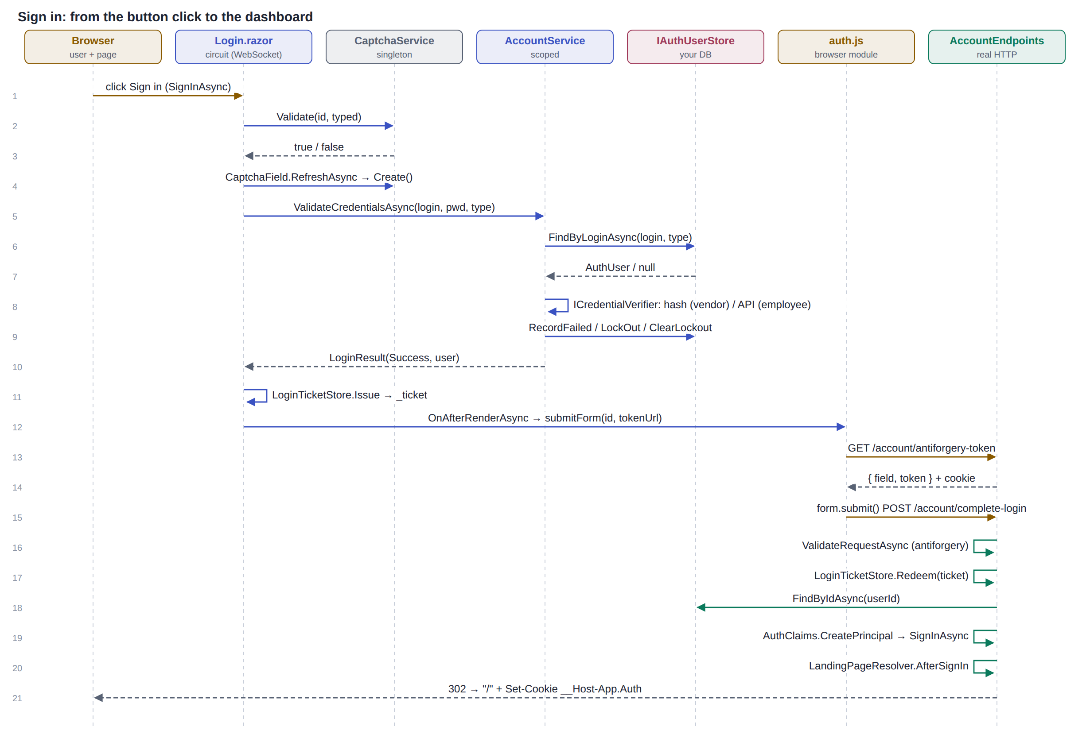
Steps 1–12 run over the WebSocket. Steps 13–21 are real HTTP, which is where the cookie is written.
# | Runs in | File → method | What happens
1 | Browser | User clicks Sign in | EditForm checks [Required] fields, then calls Login.SignInAsync().
2 | Circuit | Login.SignInAsync → CaptchaService.Validate(ChallengeId, typed) | Checked first. Case-insensitive, single use: the answer is removed either way.
3 | Circuit | CaptchaField.RefreshAsync() | New image every attempt. Wrong code → error, stop.
4 | Circuit | AccountService.ValidateCredentialsAsync(login, password, type) | Trim login.
5 | Your code | → IAuthUserStore.FindByLoginAsync(login, type) | Not found or wrong type → "Invalid username or password" (padded to ≥ 1 s). Employees not in QPS never reach the API.
6 | Circuit | Lockout check | LockoutEndUtc in the future → LockedOut.
7 | C# call | → ICredentialVerifier.VerifyAsync(user, password) | Vendor: IPasswordHasher.VerifyPassword. Employee: IEmployeeAuthApi.AuthenticateAsync(userName, password); API down → "temporarily unavailable", not counted.
8 | Your code | Wrong → RecordFailedLoginAsync; ≥ 5 → LockOutAsync(now + 15 min) | Same generic error.
9 | Circuit | Right but IsActive = false → Disabled | Only revealed after a correct password.
10 | Your code | Right → ClearLockoutAsync (if needed) → LoginResult(Success, user)
11 | Circuit | Login clears _model.Password; LoginTicketStore.Issue(user.Id, rememberMe) | 64-hex ticket, 60 s. Rendered into hidden form login-complete.
12 | Circuit | OnAfterRenderAsync → import auth.js → submitForm("login-complete", tokenUrl) | Runs after the ticket is in the DOM.
13 | Browser | auth.js → GET /account/antiforgery-token | Returns { field, token } and sets the antiforgery cookie.
14 | Browser | auth.js inserts token → form.submit() | Real POST to /account/complete-login (not Blazor enhanced navigation).
15 | HTTP | AccountEndpoints.CompleteLoginAsync → IsAntiforgeryValidAsync | Invalid → 400.
16 | HTTP | LoginTicketStore.Redeem(ticket) | Used once; expired → back to login ?error=expired.
17 | Your code | IAuthUserStore.FindByIdAsync(userId) | Must still be active.
18 | HTTP | AuthClaims.CreatePrincipal(user, now) → HttpContext.SignInAsync | Claims: id, name, email, display_name, sstamp, account_type, auth_time, roles, qps_module.
19 | HTTP | Session.Clear() (if session is on) | No pre-login session data carries over.
20 | HTTP | LandingPageResolver.AfterSignIn(principal, returnUrl) | /changepassword if must_change_password, else ReturnUrl or "/".
21 | HTTP | 302 + Set-Cookie: __Host-App.Auth | Browser loads the target page — section 6.

6. Calling sequence — Home page, menu and dashboard
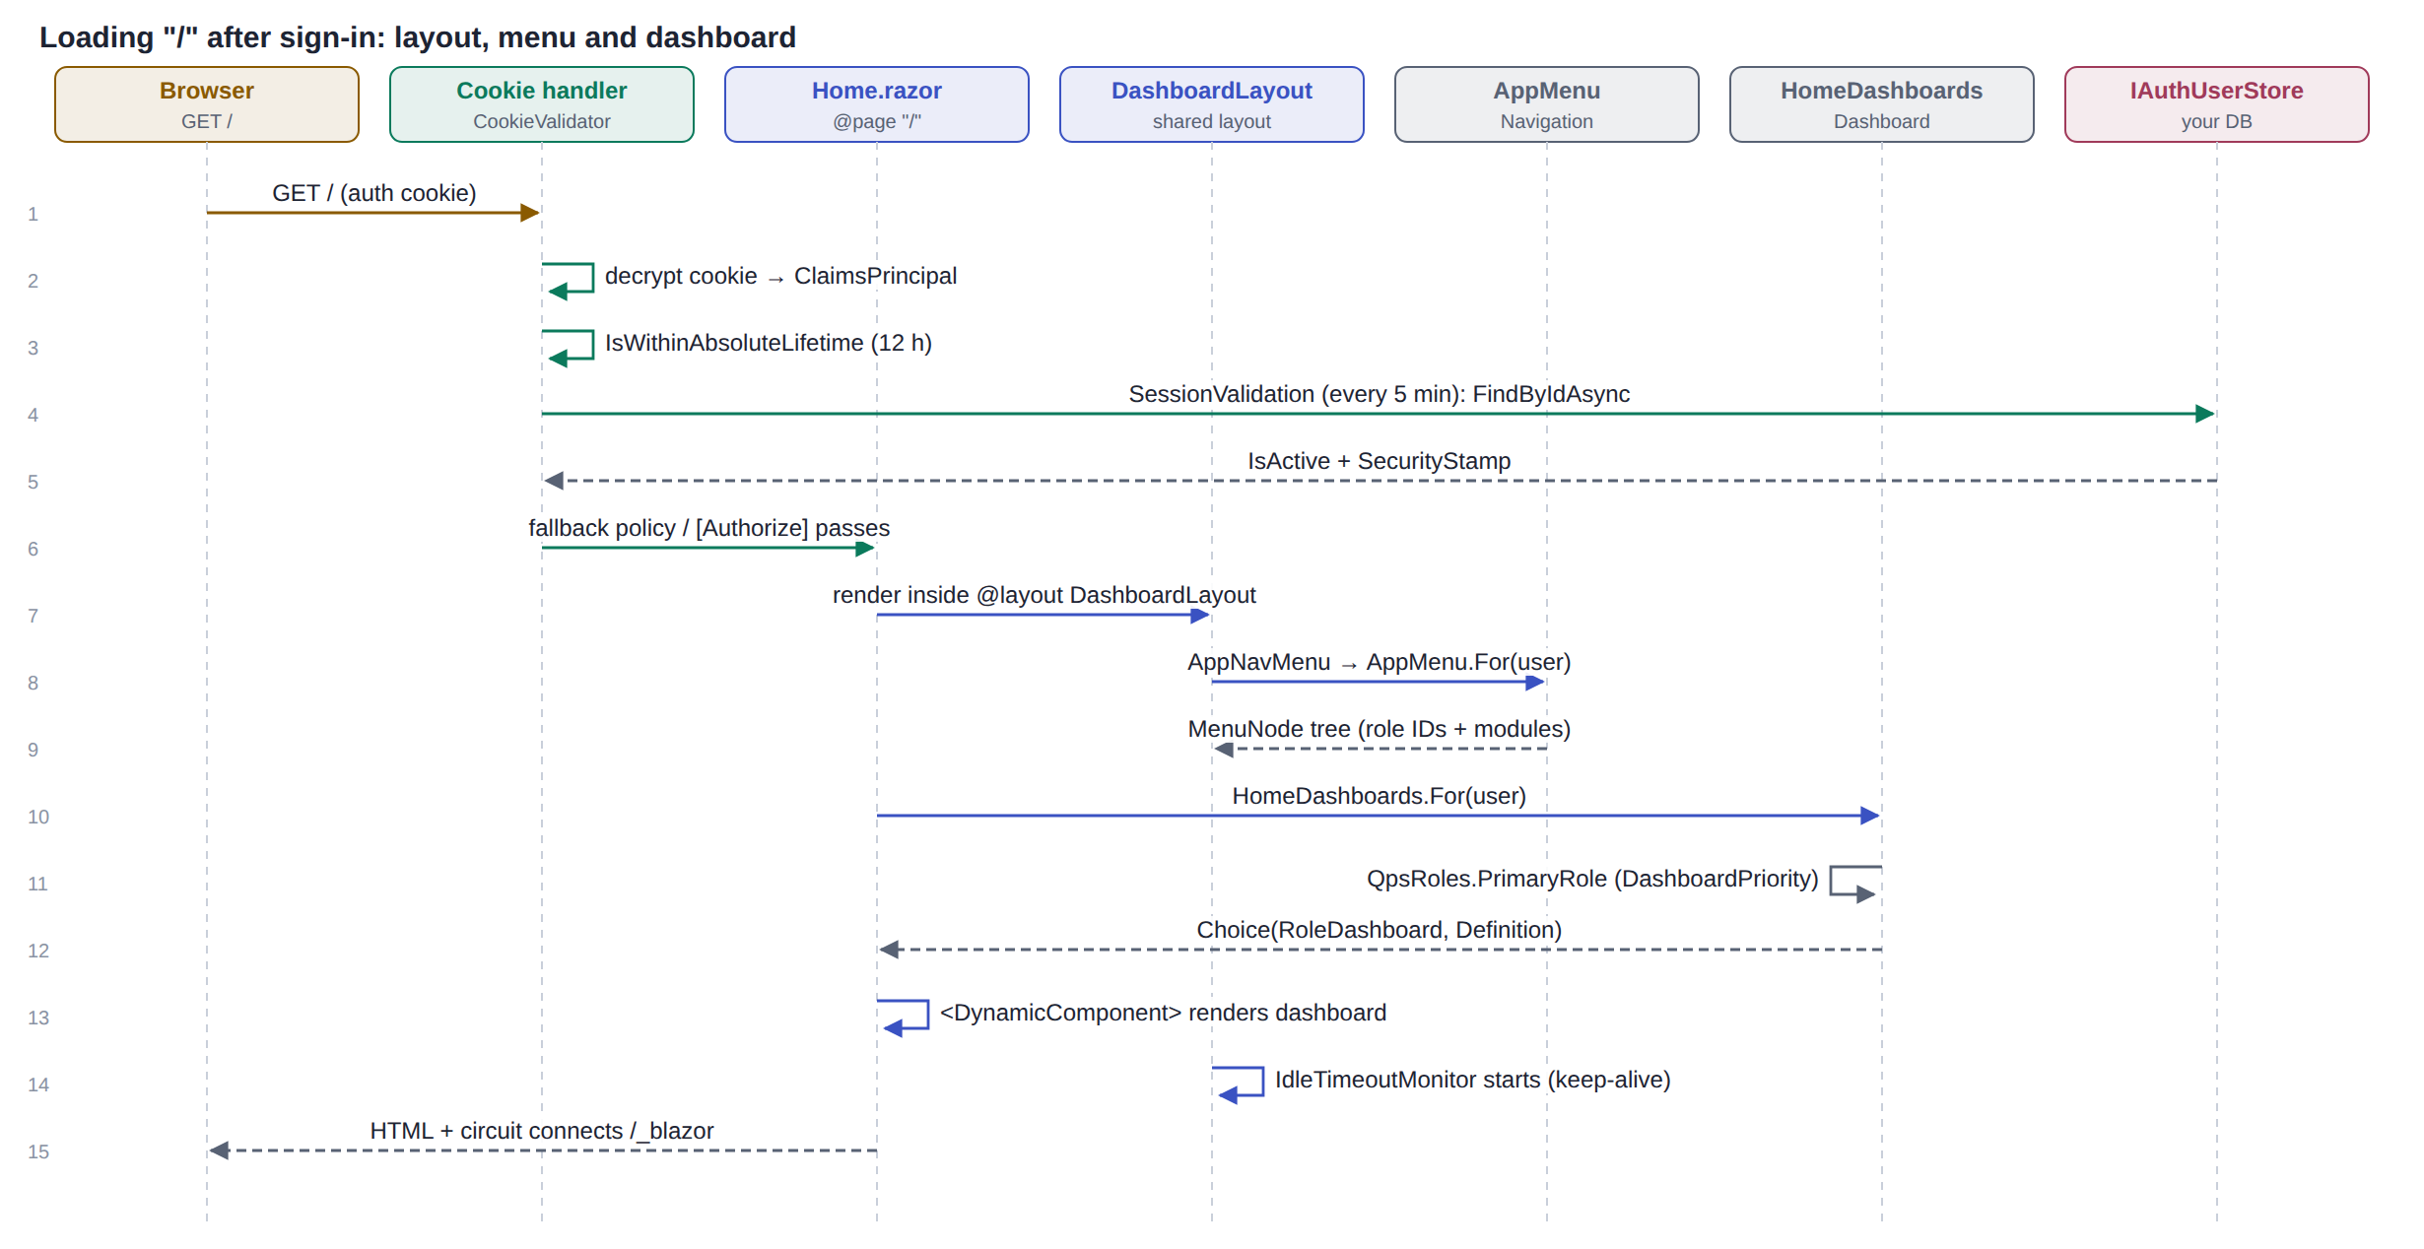
The same sequence runs for every page that uses DashboardLayout; only the Body changes.
# | Runs in | File → method | What happens
1 | HTTP | Cookie handler decrypts __Host-App.Auth | ClaimsPrincipal from the cookie; sliding expiry renews it.
2 | HTTP | CookieValidator.ValidatePrincipalAsync | Over 12 h since auth_time → sign out. Every 5 min → SessionValidation.IsValidAsync.
3 | Your code | → IAuthUserStore.FindByIdAsync | User inactive or stamp changed → cookie rejected → login.
4 | HTTP | Authorization | Home.razor has [Authorize] → passes.
5 | Circuit | Home.razor renders inside DashboardLayout | Layout gets the user from <AuthorizeView> / cascading state.
6 | Circuit | DashboardLayout → AppNavMenu → AppMenu.For(user) | Uses QpsRoles.Has(roleId) and HasModule to build MenuNode groups; NavNode draws them.
7 | Circuit | App bar user chip | DisplayName, initials, QpsRoles.Describe(user) (role names).
8 | Circuit | Home.OnParametersSetAsync → HomeDashboards.For(user) | QpsRoles.PrimaryRole = first of the user's roles in DashboardPriority; vendor → Vendor; none → NoRole.
9 | Circuit | Custom registered? → that component; else RoleDashboard + DashboardCatalog.X | <DynamicComponent Type=... Parameters=...>.
10 | Circuit | RoleDashboard → DashboardHeader, KpiTile, DashCard, StatusChip | Dummy data until real dashboards are added.
11 | Circuit | IdleTimeoutMonitor.OnAfterRenderAsync | Starts idle-timeout.js: activity reports and keep-alive api/session/keepalive.
12 | Circuit | Drawer toggle (☰) | _drawerOpen flips; logo shows in MudDrawerHeader when open, in the app bar when closed.

Dashboard priority (first match wins): 1 Administrator → 5 Admin → 1008 QA Admin → 1007 QAM → 1006 QA → 1010 Category Head → 1011 Associate Category Head → 1012 Merchandiser → 2 Buyer → 3 QC → 1014 ASN → 1013 BFT → 1009 CM → 4 View.

7. Calling sequence — while the page is open
An open interactive page sends WebSocket messages, not HTTP requests, so the cookie handler does not see them. Two timers keep the session honest:
# | Runs in | File → method | What happens
1 | Circuit | AppRevalidatingAuthStateProvider every 5 min | New DI scope → SessionValidation.IsValidAsync → FindByIdAsync.
2 | Circuit | Invalid → auth state becomes anonymous | <AuthorizeView> / [Authorize] content disappears at once.
3 | Browser | idle-timeout.js user activity | Reports to IdleTimeoutMonitor (throttled 15 s) and calls keep-alive so the cookie keeps sliding.
4 | Circuit | IdleTimeoutMonitor timer | 60 s before the limit → warning dialog; at the limit → section 8 with reason idle.

8. Calling sequence — Sign out and idle timeout
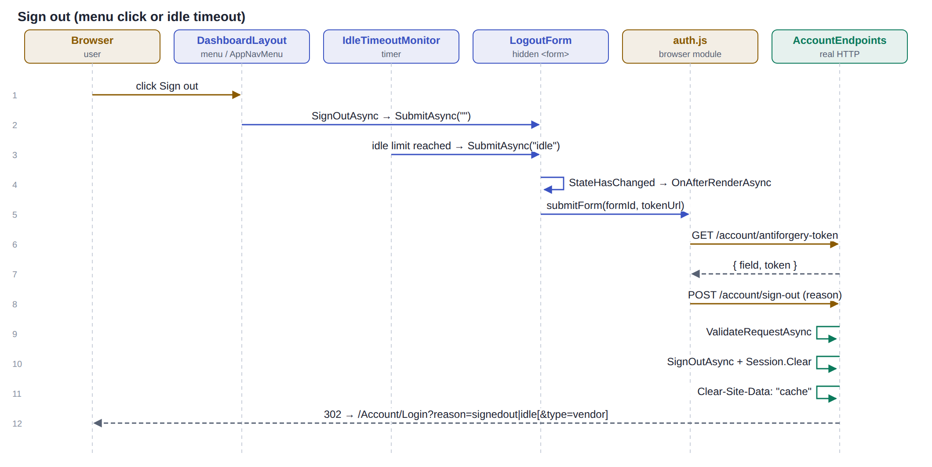
# | Runs in | File → method | What happens
1 | Browser | User clicks Sign out (user menu or menu item) | DashboardLayout.SignOutAsync().
2 | Circuit | → LogoutForm.SubmitAsync("") | Idle path: IdleTimeoutMonitor → SubmitAsync("idle") (retries every 5 s if the browser is unreachable).
3 | Circuit | LogoutForm.OnAfterRenderAsync → auth.js submitForm(formId, tokenUrl) | Form now carries the reason.
4 | Browser | GET /account/antiforgery-token → POST /account/sign-out | Real HTTP.
5 | HTTP | AccountEndpoints.LogoutAsync | Antiforgery check → SignOutAsync → Session.Clear → Clear-Site-Data: "cache".
6 | HTTP | 302 → /Account/Login?reason=signedout or idle (+ &type=vendor) | Login shows the matching message and opens the right tab.

/Account/Logout (Logout.razor) is a page that does the same thing via LogoutForm — use it for plain links. /account/sign-out is the endpoint. They have different paths on purpose (same path caused the AmbiguousMatchException).

9. Calling sequence — Vendor forgot and reset password
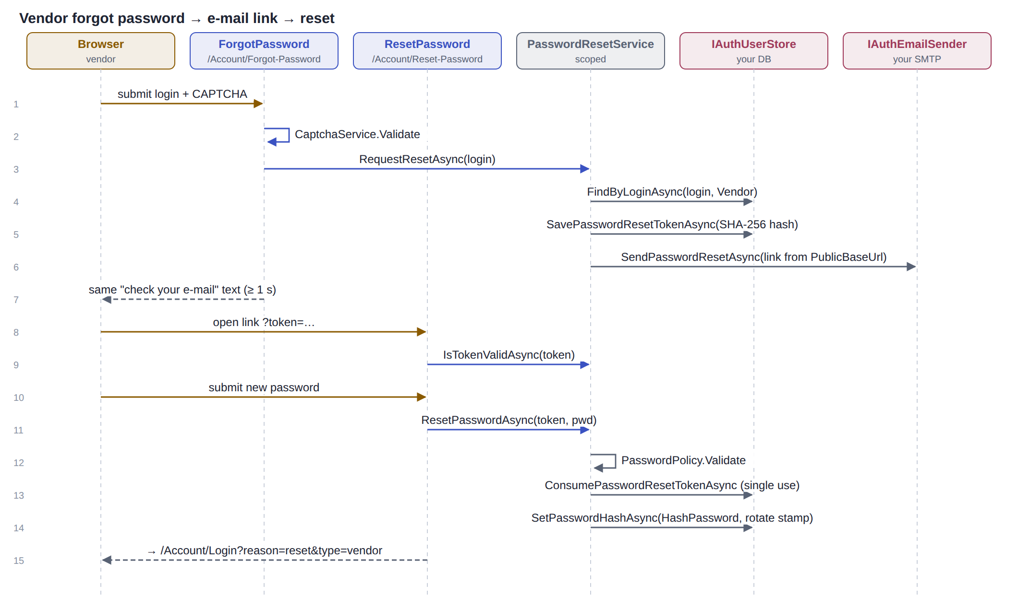

Forgot password (/Account/Forgot-Password)
# | Runs in | File → method | What happens
1 | Circuit | ForgotPassword.SubmitAsync → CaptchaService.Validate + RefreshAsync | Stops scripts sending mass e-mails.
2 | Circuit | → PasswordResetService.RequestResetAsync(login) | Padded to ≥ 1 s so "exists" and "does not exist" take the same time.
3 | Your code | → FindByLoginAsync(login, Vendor) | Not an active vendor → do nothing (no error shown).
4 | C# call | Random 32-byte token; SHA-256 hash | Only the hash is stored.
5 | Your code | → SavePasswordResetTokenAsync(hash, now + 30 min)
6 | Your code | → IAuthEmailSender.SendPasswordResetAsync(link) | Link = PublicBaseUrl + /Account/Reset-Password?token=… (never the Host header).
7 | Circuit | Page shows "check your e-mail" | Same message whether or not the account exists.

Reset password (/Account/Reset-Password?token=…)
# | Runs in | File → method | What happens
1 | Circuit | ResetPassword.OnInitializedAsync → IsTokenValidAsync(token) | Invalid, expired or used → "This reset link is invalid, has expired, or has already been used."
2 | Circuit | Submit → ResetPasswordAsync(token, newPassword)
3 | C# call | PasswordPolicy.Validate | Errors shown; token not used up.
4 | Your code | ConsumePasswordResetTokenAsync | Atomic single use.
5 | Your code | SetPasswordHashAsync(IPasswordHasher.HashPassword(pwd), rotate: true) | New security stamp → other sessions end within 5 min.
6 | Circuit | → /Account/Login?reason=reset&type=vendor | "Your password has been changed."

Employees do not use this flow. The Employee tab links to the MyVishal app for password changes.

10. Troubleshooting
Symptom | Cause and fix
blazor.web.js MIME type error / redirect to login | Fallback policy blocked /_framework. Keep it in anonymousPaths.
Sign-in spins, then 404 on /account/complete-login | app.MapAccountEndpoints() is missing in Program.cs.
AmbiguousMatchException | Two endpoints/pages on one route (e.g. two @page "/", or logout page and endpoint on the same path).
Antiforgery "token not found" on sign-in | Stale auth.js in the browser cache. AuthScriptUrl has ?v=; bump it after changing auth.js.
Back at login with "Sign-in took too long" | Ticket expired (60 s) or used twice, or the app restarted between steps.
CAPTCHA box says "Couldn't load the code" | VmmCaptcha / System.Drawing failed (e.g. not Windows). See the log; sign-in stays blocked safely.
Page styles missing | <HeadOutlet /> missing in App.razor, so <HeadContent> stylesheets are not added.
Heading gets a blue focus outline after login | FocusOnNavigate focuses the h1; CSS :focus{outline:none} rule is in auth.css/app-shell.css.
Signed out earlier/later than expected | MaxSessionTime ≠ Auth:IdleTimeoutMinutes, or the 12 h absolute limit.
User sees menu but page says access denied | Menu comes from AppMenu; page checks [Authorize]. Make both use the same role IDs.
Browser Link / service worker console messages | Visual Studio dev tools only; not from this code.

Note: this document describes the code on the branch. It has not been compiled here against your full solution. Namespaces in AuthUsings.cs and your own services may need small adjustments.

