( Victor )

— Docker —

→ Docker is a Containerization platform which packages your application and all its dependencies together in the form of Containers so as to ensure that your app works seamlessly in any environment be it Development or Test or Production.

→ Docker is a Software Developpment Platform (March 2013) : make it easy to develop and deploi apps with « packages virtual containerized environment »

→ Docker is designed to benefit Developpers and System Administrators :
- Developpers can write code without worrying about the testing/production environment
- System Administrators need not worry about infrastructure as Docker can easily scale up/scale down the number of systems.

→ Docker is developed primarily for Linux, where it uses the resource isolation features of the Linux kernel such as cgroups and kernel namespaces, and a union-capable file system such as OverlayFS and others to allow independent "containers" to run within a single Linux instance, avoiding the overhead of starting and maintaining virtual machines.
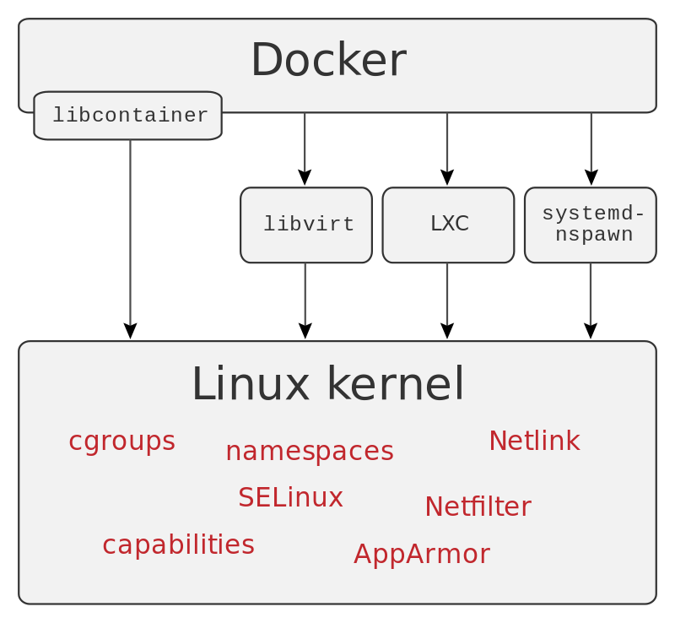
→ Docker can use different interfaces to access virtualization features of the Linux kernel :
The Linux kernel's support for namespaces mostly isolates an application's view of the operating environment, including process trees, network, user IDs and mounted file systems, while the kernel's cgroups provide resource limiting for memory and CPU. Since version 0.9, Docker includes the libcontainer library as its own way to directly use virtualization facilities provided by the Linux kernel, in addition to using abstracted virtualization interfaces via libvirt, LXC and systemd-nspawn.
Building on top of facilities provided by the Linux kernel (primarily cgroups and namespaces), a Docker container, unlike a virtual machine, does not require or include a separate operating system. Instead, it relies on the kernel's functionality and uses resource isolation for CPU and memory, and separate namespaces (cgroups) to isolate the application's view of the operating system. Docker accesses the Linux kernel's virtualization features either directly using the libcontainer library, which is available as of Docker 0.9, or indirectly via libvirt, LXC (Linux Containers) or systemd-nspawn.

