TRANSPORT AND TELECOMMUNICATION INSTITUTE



<<TSI : Vesjolijs Aleksejs>>

COURSE WORK
Object-Oriented Programming

Topic: «Desktop Application : Museum - Catalog of art»

Performed by:
Student: Gabriel Cellier
Group: 4101BDA
Student code: st62695

Riga
2022

TABLE OF CONTENTS

INTRODUCTION 2
TASK FOR LABORATORY WORK 3
ANALYSIS OF THE SUBJECT AREA 4
DESIGN 6
DEVELOPMENT 9
TESTING 13
CONCLUSIONS 16

INTRODUCTION

This report presents the development process of a custom desktop application, with theme number 9, for museums around the world. The objective of this project is to create a functional and user-friendly application tailored to specific requirements. Note that this app was initially developed with and for linux (Ubuntu more precisely), It should also work on Windows or MacOS but no test was done.
The report focuses on the main technical aspects of the application development and is structured into several sections that cover different stages of the process. A User guide to teach users how to launch and use the application is also in annexes. This sections include analysis of the subject area, design considerations, development details, testing procedures, conclusions, and annexes containing the source code. Everything like it should be.
In the analysis section, the specific requirements and factors influencing the application's development are examined. Then requirements are taken from the document of the same name on Moodle. This involves a thorough understanding of the target users, their needs, and the context in which the application will be use. Because the real point of this app is its user. This means that the goal is to make an app as user friendly as possible.
The design section addresses the user interface and overall aesthetics of the application.It is important to understand that the color theme and layout of the app is not built to be pretty, it is not pretty, it is built to be very clear. It explores the layout, color schemes and other visual elements to ensure an intuitive and visually appealing user experience (I hate light color so the app is black and red).
The development section delves into the technical aspects of the project, discussing the programming languages, database, and tools employed during the application's development. It also covers architectural decisions and data management strategies.Testing procedures are very central in the project creation. because without a test, nothing works. So I tested the database, the installation plan, the button, the search bar… To provide the user the best possible experiences
The conclusions section summarizes the main findings and insights gained from the project. It discusses limitations encountered during the development process and suggests possible avenues for future enhancements and improvements.
Finally, the annexs section contains the source code of the application, providing a valuable resource for further examination and review. The all code will be in the .zip directory provided with this report, in that way the user can easily access it.So, to be clear, this report aims to make you understand everything about the app, its interface, its color code, its functionality etc.

TASKS
1. Create an Intuitive User Interface:
- Creating an intuitive and easy-to-use application is one of the main goals.
- Also I use javaFX to create all the layout of the app.
2. Build a Strong Database:
- Design and implement a robust database to store and manage application data is
- another one.
- Define appropriate data structures and relationships to efficiently store and retrieve information.
- Implementing data validation and error handling mechanisms to maintain data integrity is a real obligation if you want to work with databases.
3. Implement Object-Oriented Programming (OOP) Concepts:
- Utilize object-oriented programming principles to design and implement four key classes in the application.
- Define classes and methods for each object..
- Use object in various way, like adding, deleting and editing information

4. Window Management:
- Develop a system to manage multiple windows of varying sizes within the application and allow the user to do multiple things at the same time.
- Allow users to open, close, minimize, and maximize windows as needed like in every other app.
5. File and Image Handling:
- Enable the application to read and generate files and images.
- Allow the user to create a report about a work of art and its museum.
6. User Guide and Help Page:
- Design a comprehensive user guide.
- The guide is here to replace a help button because a well written guide is WAY better than a little button.
7. Account System:
- Create a secure and reliable account system for users.
- Implement user registration, login, and authentication features again like everywhere.
8. The code is readable and well commented (Not everywhere but it should be ok).
9. Prepare a report.
10. Submit the work. (Obviously if you are reading this)

Analysis of the Subject Area

The aim of this project is to develop a comprehensive desktop application that feet to the specific needs of museum employees and art enthusiasts. The application will serve as a centralized platform for museum employees to register and manage various works of art and historical pieces within their collections. It will also provide an interactive interface for users to explore and access information about these artworks, as well as details about the museums that own them. I personally like to think of this app as the perfect fusion between google art and wikipedia (not that I aim for this level of quality).

Museums play a crucial role in preserving and showcasing cultural heritage, including works of art, historical artifacts, and significant pieces of history. So it is very important to convince people to continue coming into the museum.But museums usually have a problem,they have trouble when managing and organizing vast collections of artworks or historical pieces. It involves cataloging, tracking, and maintaining detailed records of each artwork, as well as providing a means for visitors and enthusiasts to engage with these masterpieces on a deeper level. And my app aims to help precisely on that last point.

To address this challenge, my application aims to provide an efficient solution for museum employees to manage their collections seamlessly. It offers features that enable easy registration and tracking of artworks, including their titles, artists, descriptions, dates of creation, dimensions, and images (Here the database enters in place). This comprehensive database will serve as a digital repository, allowing museum personnel to access and update information about their artworks easily, the app also allows them to provide information on their museum, like the localisation. By digitizing and centralizing these records, the application will streamline the management process, saving time and effort for museum employees, and let’s be honest, everyone wants to save time and effort.

Moreover, the application will empower art enthusiasts and visitors to engage with the artworks in an interactive and informative manner. Users have the ability to search and explore the collection based on artwork title and picture. This research functionality will provide a convenient way to discover specific artworks or explore themes and artistic styles that interest them. And if they are more interested in a style they will go to a museum. And the application will also offer detailed information about each artwork, including its historical context, significance and more. Note that for now no professional museum worker have used my app so all the information come from me and, like you may suspect I am not a professional painter or historian so information are a little bit poor, but the objective is higher (and higher than my level in impressionism is not a hard goal).Any way, users will be able to view images of the artworks and appreciate the masterpieces from the comfort of their own devices and their couch.

Furthermore, the application will establish connections between the artworks and their respective museums. Each artwork will be linked to the museum that owns it, providing users with valuable information about the museum's location, contact details (Email), and website. This feature will not only deepen the users' understanding of the artworks but also encourage them to explore and visit the museums in person. By promoting museum visits, the application will contribute to the preservation and appreciation of cultural heritage and support the sustainability of these important institutions so it will encourage museums to post more art, this will promote museums even more etc.

In conclusion, the development of this comprehensive desktop application for museum management and art exploration aims to provide a valuable tool for museum employees and art enthusiasts alike, everyone will be happy.I explain you one last time the idea : by streamlining the collection management process, offering interactive features, and facilitating connections between artworks and museums, the application will encourage people to go in museum and contribute to the preservation, appreciation, and accessibility of cultural heritage. It will empower museum personnel to efficiently manage their collections and enable users to engage with artworks on a digital platform, fostering a deeper understanding and appreciation for the rich tapestry of human creativity and history (What a plan).
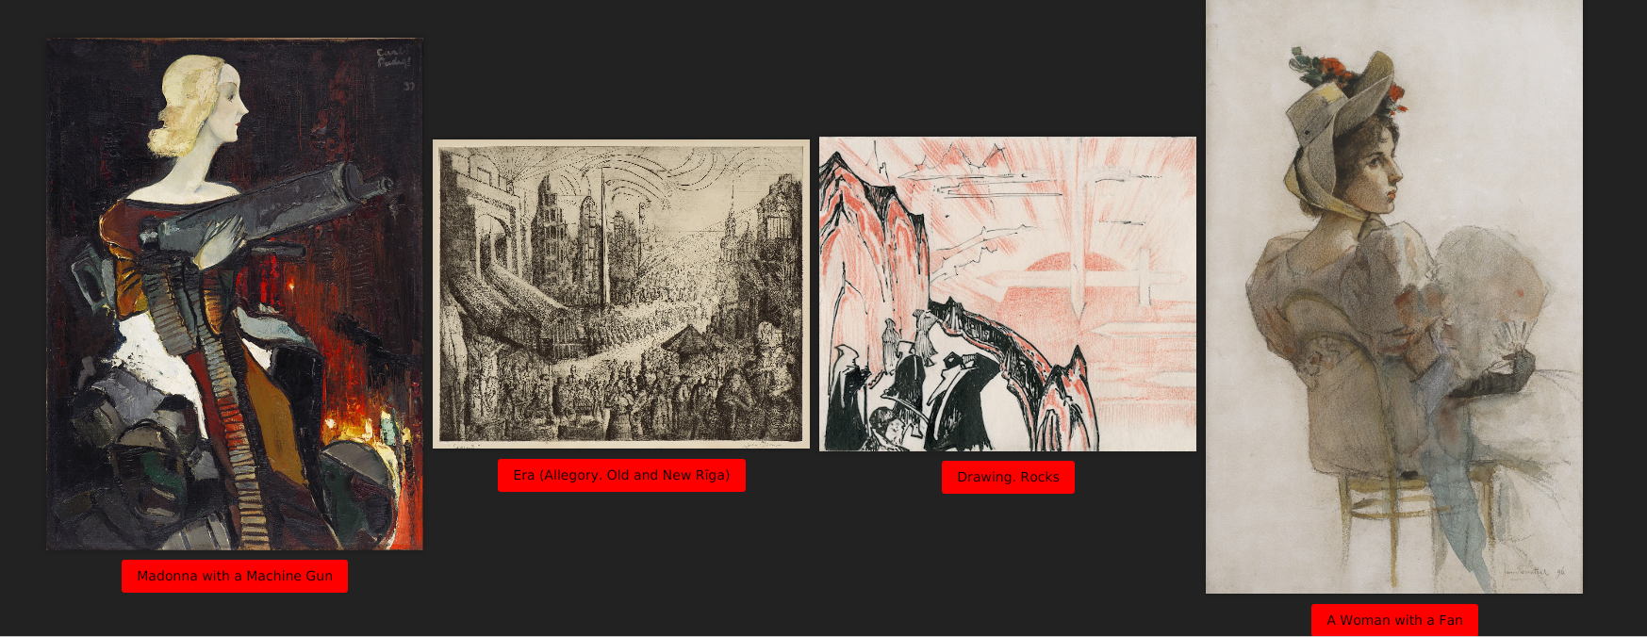Example of ArtWork

Design

The design of the custom desktop application for museums has been carefully crafted to create an engaging and user-friendly experience. The chosen color scheme, with a black background and red buttons, contributes to a visually striking interface that captures the attention of users.

The black background sets a sophisticated and elegant tone, providing a sleek backdrop for the application's content. It also helps to reduce visual distractions, allowing users to focus on the artworks and information presented on the screen. The use of a dark background enhances the visual impact of the artworks and creates a sense of depth within the application. And more particularly the dark is the most pleasant color to look at. White is stressful, black is perfect !

Complementing the black background, the red buttons serve as focal points and call-to-action elements. The vibrant red color adds a pop of excitement and energy to the interface, drawing users' attention to important features and functionalities. In other words, when the user sees these red buttons he first thinks “yuck” and then after 2 or 3 minutes he doesn't want to look away because the red is an attention grabber. Additionally, the contrast between the black background and red buttons ensures clear visibility and facilitates intuitive navigation.

The color scheme is carefully designed to create an anti-harmonious visual experience. The combination of black and red creates a powerful and balanced contrast that is visually appealing and striking.

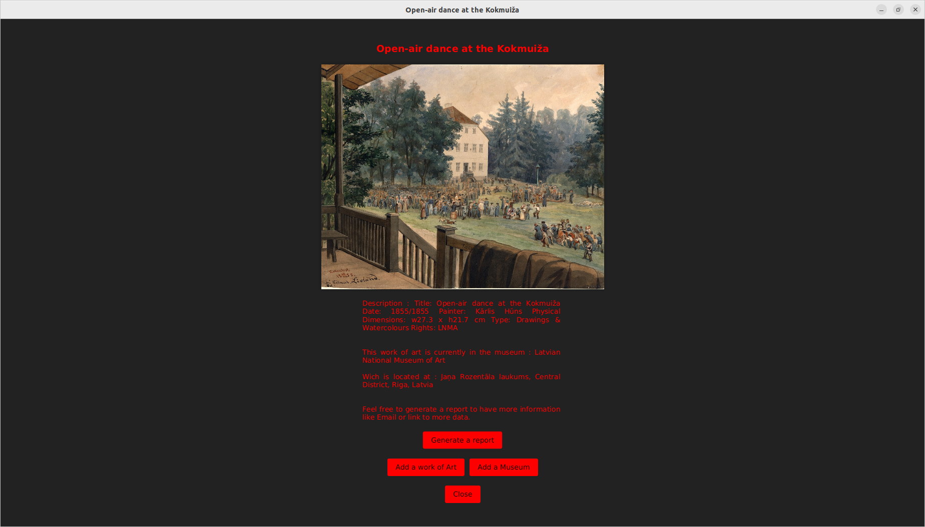The “yuck” interfaces.

Visual comfort is an essential consideration in the design of the application. The dark background not only adds a touch of elegance but also helps reduce eye strain, providing a comfortable viewing experience for users. And for people like me that live with headaches it’s the best gift. By using a dark interface, the application minimizes the intensity of light emitted from the screen, making it easier on the eyes, especially during extended periods of use.

The application is designed to prioritize visual elements, particularly images of artworks, by that I mean that the app contains the least text possible. Also by placing visuals at the forefront, the application allows users to quickly appreciate the beauty and details of the artworks without relying heavily on text. This approach creates a more immersive and engaging experience, as users can connect with the artworks on a visual level, fostering a deeper appreciation for the cultural and historical significance they represent.

In line with the objective of minimizing text, the application employs a concise and visually-driven approach to information presentation.I explain : instead of overwhelming users with lengthy descriptions, the emphasis is placed on clear and succinct information. Visual elements such as images, icons, and graphics are utilized to convey information effectively, enabling users to quickly grasp key details without the need for extensive reading. Then, if the user is very interested in the artwork he can download a report that will provide him a lot of information, but also link to other websites with more information and even museum contact to plan his next trip or ask a question to pro.

The application incorporates windows of various sizes to facilitate multitasking and seamless navigation. By including smaller windows, users can perform multiple tasks simultaneously, such as viewing artworks while accessing additional features or information. This multitasking capability enhances user productivity and allows for a more efficient workflow within the application.

Furthermore, the inclusion of scroll bars in the application enables users to navigate through content that exceeds the visible area of a window. This feature ensures that users can access all the necessary information without the need to switch between different screens or lose context. In addition the app contains a search bar that helps the user to not lose time if he precisely knows what he wants to see.

Overall, the design of the custom desktop application for museums prioritizes visual elements, utilizes a striking color scheme, provides visual comfort, minimizes reliance on text, incorporates multitasking windows, and includes scroll bars for seamless navigation. So yes maybe the app is not the prettiest app in the world but it’s an intention, every decision is the result of careful consideration.

Development

Here is the git : “git@github.com:bagleir/MuseumApp.git”, you can clone it but please don’t push anything.

The development of the application involved an extensive process of designing and implementing various classes and functionalities to create a robust and user-friendly platform for art enthusiasts and professionals. This section provides an in-depth overview of the development journey, the key classes involved, and the functionalities my app offers. Note that some information is already in the User guide, take them into consideration.

To ensure a personalized experience, the application offers two types of user accounts: User and Professional. Users are required to create an account by providing a unique username, a secure password, and a valid email address. Professional accounts grant additional privileges and access rights within the application. Professionals can add new artworks or museums to the database, expanding its collection and enriching the user experience. If a museum is not listed, professionals can contact an administrator to have it added (rixede@gmail.com). The 2 classes will be explained later but remember that they have the major role in the Account creation and login, here is one of their database (Note the primary and foreign key that are essentials).

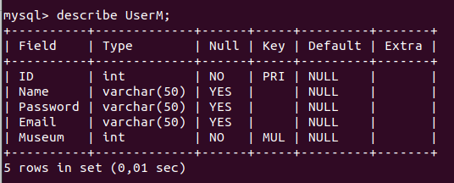
The table of the professional account.

Main Page:

The main page serves as the central hub of the application, providing users with a comprehensive overview of the available artworks. Designed with user convenience in mind, the main page features a powerful search bar that simplifies the research process. Users can enter patterns related to artwork titles, and the search bar intelligently filters the results (It really works as a filter), displaying artworks that match the search criteria. This feature enables users to quickly find specific artworks of interest, saving time and effort.

Detailed Page :

The detailed page offers a rich and immersive experience by providing users with in-depth information about a specific artwork. Each artwork has its own page and the user can access it by clicking on the title of an artwork of interest from the main page. In the detailed page user can explore the artwork's description, which provides a comprehensive overview of its historical context, artistic style, and cultural significance or they can just try to understand what is an Etching or who is Karligs Padegs, again I’m not a professional and that's the magic of it all - even the most inexperienced can see the appeal in such a collection of art.

Report Generation:

One of the application's standout features is the ability to generate detailed reports about artworks and their associated museums. Users can initiate the report generation process from the detailed page. By selecting the appropriate option, users trigger the generation of a report, which is then saved to the file directory. These reports serve as valuable resources, providing comprehensive information about the artwork, including museum information, contact and more (I let you discover). Report a text file so they can be easily copied or shared, additionally, the reports highlight the museum's role in preserving and showcasing the artwork, providing insights into the institution's mission, vision, and collections, and again, this encourages users to go to museums.

Art Class :

The `Art` class represents individual artwork within the application. It encapsulates various attributes that define the artwork's characteristics and associations. The class includes the following fields:

- `Identifier`: An integer value representing the unique identifier of the art. This identifier serves as a reference for identifying and distinguishing the artwork within the system.
- `Name`: A string indicating the name or title of the art.
- `Picture`: An instance of `BufferedImage` that stores the picture or image associated with the artwork. This field allows for visual representation and identification of the art by the user and is linked with the Picture file provided within the app.
- `Museum`: An instance of the `Museum` class representing the museum associated with the art. This association establishes a link between the artwork and the institution where it is housed or exhibited.
- `Description`: A string containing the description or narrative associated with the artwork. This field provides valuable insights into the art's historical context, thematic elements, and artistic techniques employed.
- `Link`: A string representing a reference or link related to the artwork. This field can be used to provide additional information or direct users to external sources for further exploration.

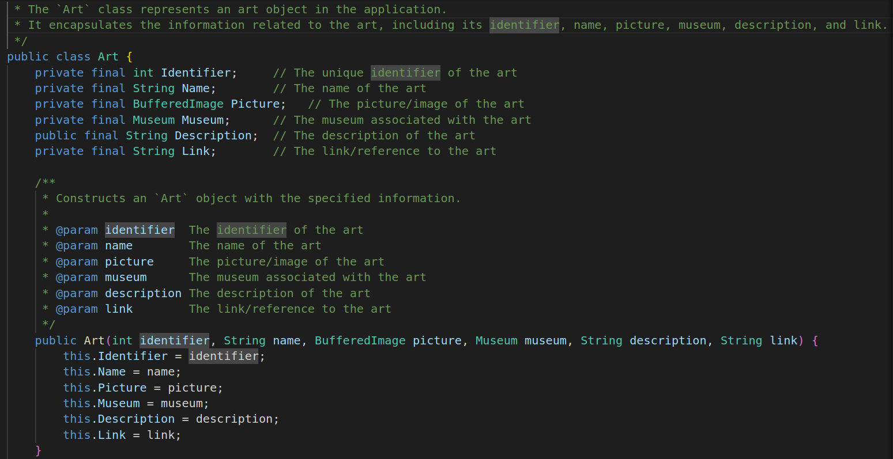
The Artwork classes

UserM Class :

The `UserM` class represents a user account with professional privileges within the application. It captures the relevant information of a professional user, allowing for personalized interactions and functionalities. The class includes the following fields:

- `Name`: A string indicating the name or username of the professional user.
- `ID`: An integer value serving as a unique identifier for the user.
- `Password`: A string representing the password associated with the user account.
- `Email`: A string containing the email address associated with the professional user.
- `Museum`: An instance of the `Museum` class representing the museum to which the professional user is associated. This association establishes a link between the user and their affiliated institution.

User Class :

The `User` class represents a user account within the application, without professional privileges. It’s almost the same as the UserM and they share a lot of data so I will skip this one to make you win some time.

Museum Class :

The `Museum` class represents a museum within the application. It encapsulates information related to a specific institution, enabling seamless organization and categorization of artworks. The class includes the following fields:

- `Code`: An integer value serving as a code or identifier for the museum.
- `Name`: A string indicating the name of the museum.
- `Location`: A string representing the address of the museum.
- `Description`: A string containing a description or overview of the museum, providing insights into its history, collections, and mission.
- `Email`: A string containing the email address associated with the museum.
- `Link`: A string representing a reference or link related to the museum. This link can direct users to the museum's official website or additional resources.

These classes play integral roles in organizing and managing the data within the application, facilitating seamless interactions between users, artworks, and museums.

In conclusion, the development process of this application involved the meticulous design and implementation of various classes and functionalities. User account management, the main page with its powerful search bar, the detailed page offering comprehensive artwork information, and the report generation feature collectively contribute to an immersive and informative user experience, to add to this come the account and register system and the beauty of the art exposed(no thanks to me, of course). The application's structured classes, such as Artwork and Museum, ensure efficient data management. Through these efforts, the application aims to create a dynamic platform that connects art enthusiasts, professionals, and institutions in a meaningful and engaging manner.

Testing
Here I will list some test I have done (for most of them multiple time), remember that this list does not include all the test I have done.

1. Account Creation and Login Test:
- Test Scenario: Verify that users can create an account and log in successfully.
- Test Steps:
1. Create a new account by providing a unique username, password, and valid email.
2. Verify that the account creation is successful and the user is redirected to the login page.
3. Log in using the newly created account credentials.
4. Ensure that the login process is successful and the user is redirected to the main page.

2. Artwork Access Test:
- Test Scenario: Verify that users can access and view artwork details.
- Test Steps:
1. Log in with a user account.
2. Navigate to the main page where all artworks are listed.
3. Click on an artwork to access its detailed page.
4. Verify that the artwork details, such as name, picture, description, and associated museum, are displayed correctly.

3. Search Functionality Test:
- Test Scenario: Validate the search functionality of the app.
- Test Steps:
1. Log in with a user account.
2. Enter a specific keyword or pattern in the search bar on the main page.
3. Verify that the search results display the artworks that match the search criteria
4. Ensure that irrelevant artworks are not displayed in the search results.

4. Report Generation Test:
- Test Scenario: Validate the generation of artwork reports.
- Test Steps:
1. Log in with a professional user account.
2. Access the detailed page of an artwork.
3. Generate a report for the artwork.
4. Verify that the report is successfully generated and saved to the specified file directory.
5. Open the generated report and validate that it contains accurate information about the artwork and its associated museum.

5. Artwork and Museum Addition Test:
- Test Scenario: Test the functionality to add new artwork and museum entries.
- Test Steps:
1. Log in with a professional user account.
2. Navigate to the appropriate section for adding artwork or museum.
3. Fill in the required information, such as name, description, picture, and associated details.
4. Submit the entry and verify that it is successfully added to the database.
5. Retrieve the added artwork or museum from the database and ensure that the information matches the entered data.

These test scenarios cover some essential aspects of the app's functionality, including account management, artwork access, search capability, report generation, and data addition. Performing these tests will help ensure that the app functions as intended and meets the required specifications.

Conclusion

To conclude, The development of this app was very long, but the initial goals have been reached, some features like the chat or the web part have been canceled during the early development but the corpse, the intention, the soul of the application has been conserved. This desktop application aims to make the lives of people who work in museums easy and to encourage people to go into the museum. To do so, the app allows users to see a lot of artwork or history pieces and provide some key information about it to make users curious. This also helps museum’s worker to keep track of all their pieces. The app offers a varied catalog of work of art that concentrates information about each of them. The database has been successfully used, and the different buttons and features work well and are easy to use A lot could have been done for the accessibility for example but the main corps is already here. All the app is built with javafx and mysql, everything depends on some key class and table. Most of the code has not been mentioned here, obviously, but I invite you to go and check my code. There are a lot of comments explaining my function and class, it should be easy to read. Furthermore, this report doesn't have any annexes because I think that my project is the annexe, feel free to go see my code, go read the User Guide to launch and use the app, go watch my presentation or the pictures I use.. In other word :

Have fun with my app !

