Michelle Bagnall

Screenshot for source code for project.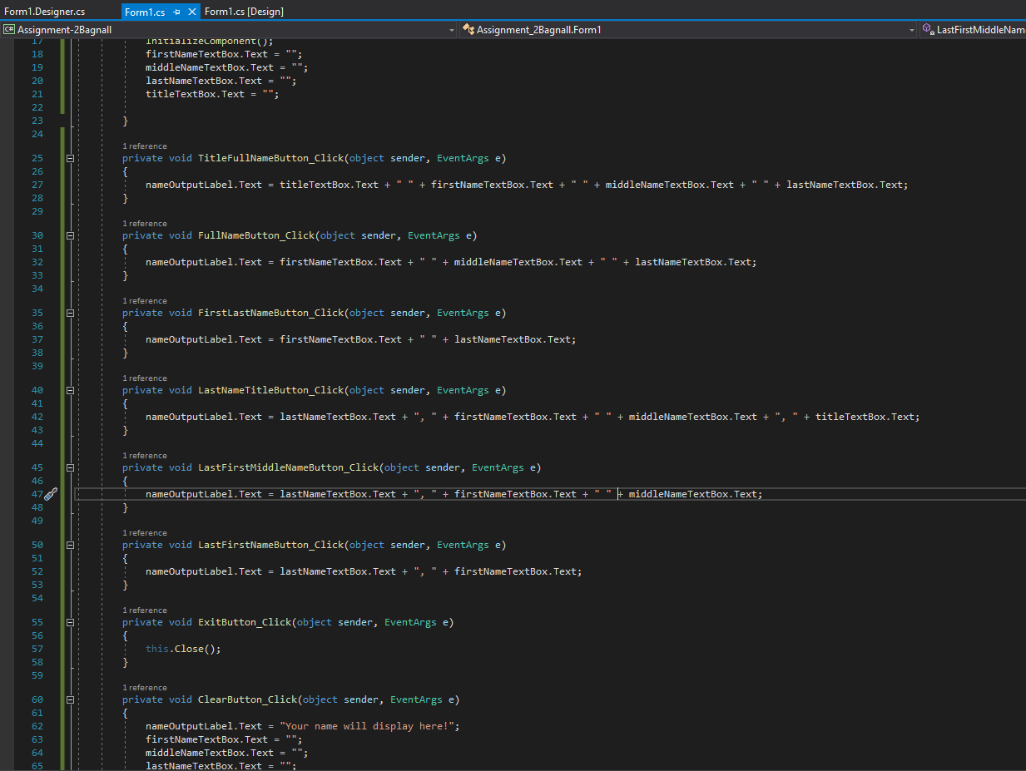

Screenshot for application output.

