Michelle Bagnall

CITA 210

Assignment 3 Part 2 Screenshots

Each screenshot shows the output for each test to determine if the application is calculating properly.

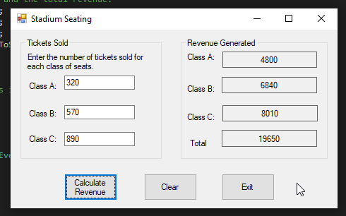

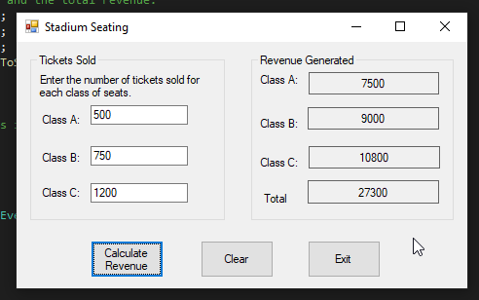

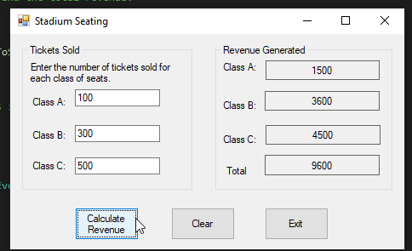

This screenshot shows the source code for the seat revenue application.