Colby Bailey

GitHub: bagoferasers

Game Development

CS 4423-001 Spring 2023

Blood Moon

# Summary

Blood moon is an Android mobile 2D RPG platformer that takes place in a small town in Oregon surrounded by mountains, forest, waterfalls, rivers, caves, and small-town drama of course! You will play as a park ranger who gets thrown into a world of the supernatural as he becomes the focal point of a murder mystery. You will battle nature, beasts, and even other people as you solve clues and find loot to help you along the way. So, will you conquer death or fall to the rage of the blood moon?

# Gameplay

You will encounter combat, terrain traversal, and character progression. You will navigate the game by gaining quests and spanning the environment and scenes to complete them. Completing quests will open new ones and increase experience. Sleeping will help gain back health. Death will require a restart of the quest, not the game. Combat will be completed by maneuvering around the different enemies with run and jump, while implementing an attack option as well. You will be allowed to interact with NPCs for dialogue, animals, doors to go to new scenes, some of the environment, and other various objects in the environment that could help you along the way. The main menu will have buttons to play new game, continue gameplay, options to adjust things such as audio, and quit game. The in-game user interface will have touch buttons that you can use to walk/run to the right and left, jump, interact with objects, attack, and pause the game. The pause menu will have options to continue, view active quests, options to adjust things such as audio, and quit to main menu.

# Art and Visuals

Blood moon will be a pixel art creation that implements a scaled down 1920x1080 environment to a pixel perfect camera environment of 320x180 pixels. Pixel art is the only kind of art I can even try to do, and luckily, is the style I really enjoy experiencing as well as creating. I want the world to be a mixture of the raw and sharp aspect of pixel art mixed with the right amount of depth that unity can deliver to ensure an immersive environment and experience. My goal is to have all of the game be my own, including all the art! References as well as inspiration for Blood Moon include Stardew Valley and Mercury Abbey; both can be found on steam.

## Stardew Valley

This game has a lot of the gameplay experience as well as the art style that I really enjoy. I do not want a top-down game for this, but the other aspects of Stardew Valley are an inspiration. I love the different mushrooms and plants. I love the caves. I love the dialogue.

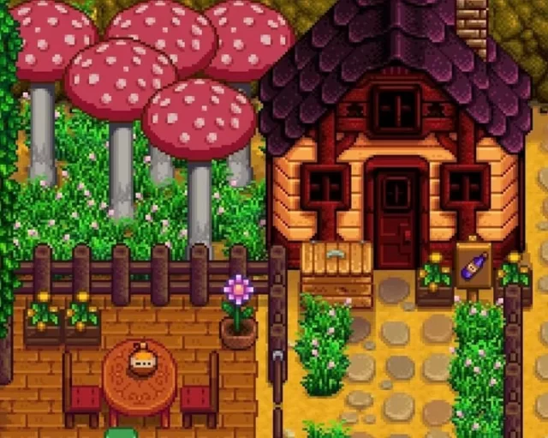

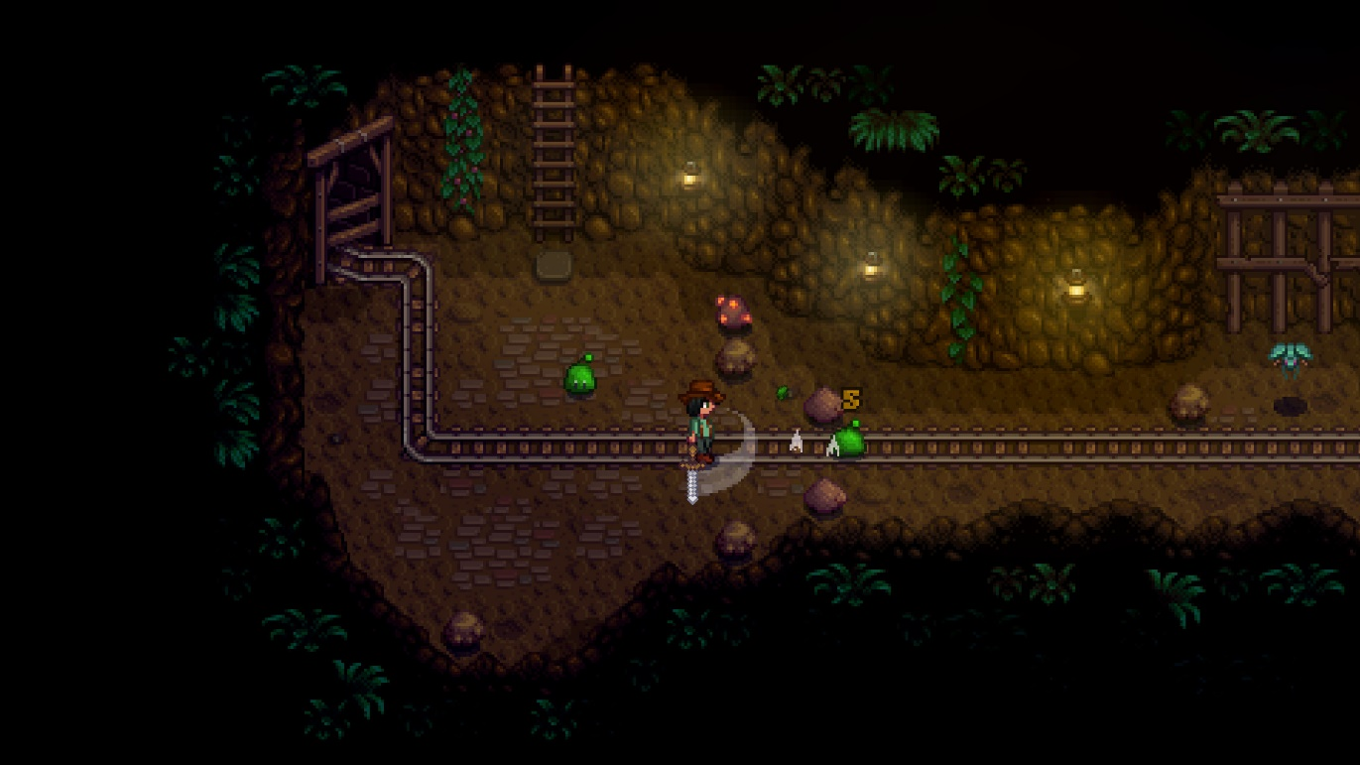

## Mercury Abby

This game contains the art as well as the gameplay aspects that I want in Blood Moon. I like how depth is added to the scenes that don’t make it feel like a normal platformer. The gameplay is extremely immersive and if I can capture a small, tiny little pixel out of this I’ll be happy.

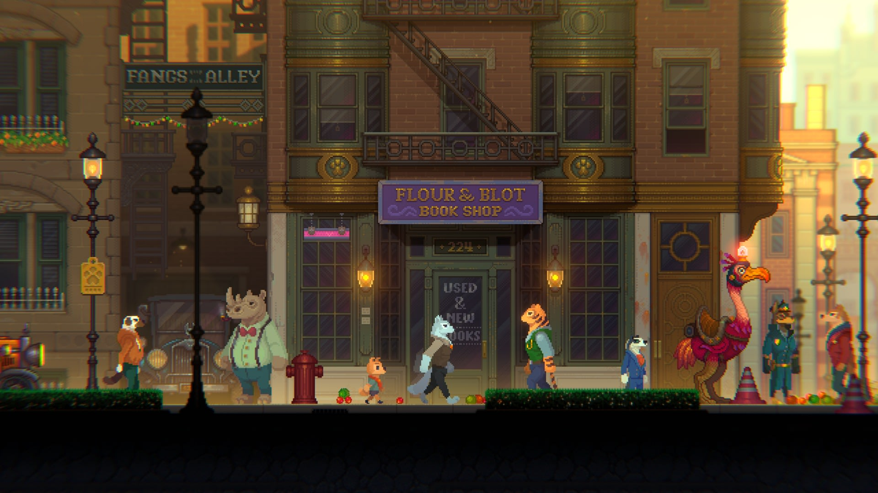

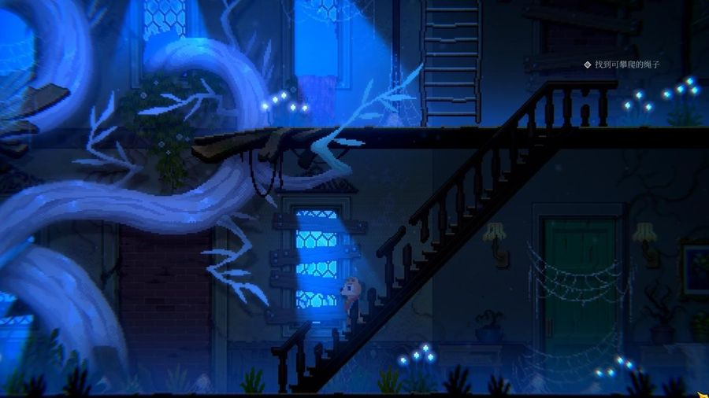

## Current Design

Right now, I have a much-less-pretty version of what I’m inspired by. I’m no artist, but that doesn’t mean I haven’t had a blast making what I have so far. I intend to apply this style of art to the rest of the game as well as implement a lot of the unity features that allow for cool effects. So far everything except the tilemap, buttons, and character sprite are my own. I fully intend to replace these with my own art after I have got the basic components of the project completed.

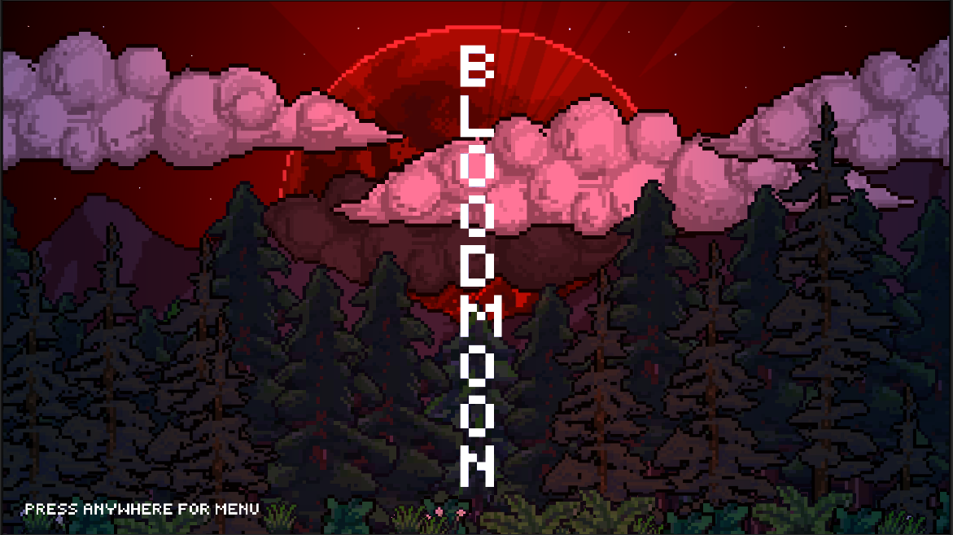

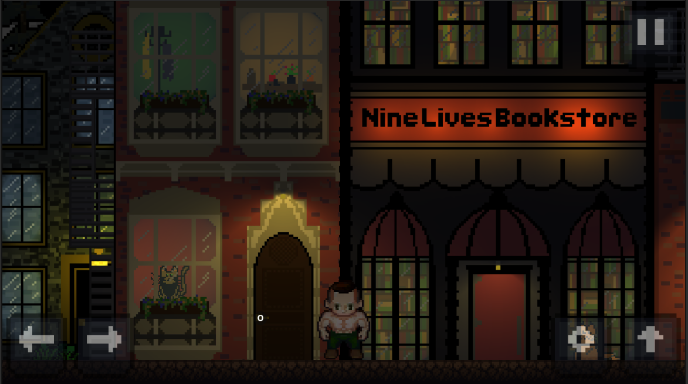

# Development Plan

For the developmental plan for the next six weeks, I hope to be able to achieve the main functionality of the game. If I can complete this, I can spend the last four weeks of class creating more quests and other fun things. I have had a hard time toning down my ideas to fit into a manageable project for the allotted time, but here is my best attempt:

## Week One (20FEB23 – 26FEB23) - Town Creation

My goal for week one is to make all the major scenes in the town. These are not going to be complete, but the functionality and majority of the layout I want to be able to have completed. I will create an Inside Apartment Scene with basic layout and design. This should include a separate scene with the main character’s apartment. I’ll also create the inside bookstore and inside the bar scenes.

## Week Two (27FEB23 – 05MAR23) – Outside Town Creation

My goal for week two will be to create some scenes outside of the main town. I want these to include a ranger station as well as some nature scenes where the player will complete other quests.

## Week Three (06MAR23 – 12MAR23) – Main Character

My goal for this week three will be completing the main character’s sprite sheet animations as well as outfits. I have the basic mechanics figured out, but I still need to make my own personal sprite sheet as well as implement jump and attack animations. I also want to implement the character sprite sheets into actual animations that work with the character movement and behavior. I also hope to complete the attack button as well as perfecting the rest of the character movement and interaction with the world.

## Week Four (13MAR23 – 19MAR23) – NPC and Quest Creation

My goal for week four is to create the NPC sprite sheets as well as the functionality of quest creation and management through menu options. I hope to have the idea of the different quests I want to implement in place so that I can move forward with the development of them in the last four weeks of class.

## Week Five (20MAR23 – 26MAR23) – Enemies

My goal for week five is to create some enemies and obstacles for the main character to have to overcome during quests.

## Week Six (27MAR23 – 02APR23) – Quests Implemented

My goal for week six will be the implementation of the different quests. My goal by this point is to have at least two completed for demo.