COMPLETION AND CODE-QUALITY REVIEW
MYORL Client Requirements Completion Audit
Deployed evidence, editorial parity, code risks, and an acceptance-ready remediation backlog
Audit date | 26 July 2026
Canonical input | MYORL.docx — 18 pages, 26 screenshots, 25 stable audit requirements
Deployment | Railway production — nextjs-frontend-production-afcd.up.railway.app
Code baseline | Committed main at a42c83c; local uncommitted work excluded from completion claims
Source integrity | SHA-256 fingerprint: 1a99ae00…de51009 (full value in the repository matrix)

Executive conclusion
The remediation is substantial, but the client list is not complete. Only R14 and R22 met their requirement-specific deployed acceptance gates. Most remaining items have code treatment but still fail production visual, configuration, editorial, or clarification gates. A single completion percentage would conceal those distinctions and is intentionally not reported.
- P0: production form delivery is unconfigured; the map loads but resolves to a world view without the clinic marker; two date-sensitive frontend tests fail.
- P1: narrow-width clipping affects multiple Russian and Greek surfaces even where document-level overflow reports false; editorial/media parity remains incomplete.
- The codebase has strong architecture documentation and broad frontend/backend tests, but CI coverage, migration safety, oversized modules, and production verification are material risks.

How the audit was performed
- Treated the supplied Word document as the canonical client source; rebuilt the older repository matrix because it described a different/older requirement set.
- Mapped broken source numbering to stable IDs R01–R25 while preserving each original source label.
- Inspected committed main separately from the existing dirty local worktree; no uncommitted user work is credited as shipped.
- Checked the Railway production deployment at 1440 px, 390 px, and a 320 px stress width; compared selected editorial pages with the legacy myorl.gr baseline.
- Reviewed automated tests, CI configuration, Strapi lifecycle/migration code, frontend structure, delivery configuration, search, and map behavior.

Status distribution
Status | Count
Verified complete | 2
Implemented awaiting browser/CMS verification | 2
Partial | 17
Open | 3
Needs client clarification | 1

Immediate remediation priorities
Priority | Area | Finding / gate
P0 | Form delivery | Configure Resend key, sender, recipient, domain/sender verification, then perform a consented production delivery test.
P0 | Map | Use coordinates/reliable query so the in-page map centers on the clinic with a visible marker; retain a secondary external Maps link.
P0 | Test reliability | Replace fixed June 2026 appointment dates with relative/frozen dates and restore a green frontend suite.
P1 | Responsive UI | Fix clipping at 390/320 px across home, video, header, office, biography, and section-index layouts.
P1 | Editorial parity | Reconcile legacy media, author notices, video placements, Russian video labels, and clinic galleries in CMS.
P1 | Data safety | Fix partial-update validation and make section migration atomic/idempotent before another content run.
P2–P3 | Quality and maintainability | Run backend/E2E/full Python checks in CI, address accessibility warnings, then split oversized UI/search modules and remove stale migration residue.

Requirement-by-requirement verification

R01 — Repair video/content-card layout so titles and descriptions do not collide with images.
Source label: 1 • Status: Partial
Evidence. The video directory is restored, but /ru/video remains dense and visibly clipped at 390/320 px. Several tags are malformed or untranslated.
Close when. Rework responsive card geometry and clean Russian categories/tags; verify at all three target widths.

R02 — Restore the Russian video library.
Source label: 2 • Status: Partial
Evidence. The route and entries exist in production. The directory still has inconsistent media and editorial labels that are not client-ready.
Close when. Finish Russian content parity and verify the complete published entry set.

R03 — Stop broken word wrapping/splitting on the Russian homepage and slider.
Source label: 3 • Status: Partial
Evidence. Desktop is improved. At 390/320 px, text and controls are clipped while document overflow is suppressed; automatic hyphenation remains on some surfaces.
Close when. Remove hidden clipping and add bilingual long-string and zoom regression checks.

R04 — Show the clinic location marker on the map.
Source label: 4 • Status: Partial
Evidence. Clicking the facade loads an iframe, but production resolves to a world view with no visible clinic marker.
Close when. Use coordinates or a reliable location query and verify the exact marker visually.

R05 — Remove unfinished EL homepage “Menu” copy and the unexplained blank pill/button.
Source label: 5 • Status: Open
Evidence. Production /el still shows the literal H1 “Menu” and a blank dark CTA; /ru shows the equivalent “Меню” and blank CTA.
Close when. Correct CMS home content and suppress empty CTA/link surfaces.

R06 — Complete /el/iaso-paidwn: address, uncropped logo/media, and clinic photographs.
Source label: 6 • Status: Partial
Evidence. The route and address content exist. The logo is severely cropped/oversized at 390 px, and complete gallery parity was not demonstrated.
Close when. Correct object fit and validate the clinic photo set against the legacy page.

R07 — Make appointment/contact form delivery work.
Source label: 7 • Status: Open
Evidence. Form UI and server handling exist, but production has no RESEND_API_KEY, CONTACT_TO_EMAIL, or CONTACT_FROM_EMAIL configured.
Close when. Configure sender/recipient/secrets and perform a consented end-to-end delivery test.

R08 — Remove photos where the legacy page had none.
Source label: 8 • Status: Open
Evidence. The Russian privacy page still renders an unrelated otoplasty image. The Greek clinic index also needs per-asset semantic parity review.
Close when. Remove unrelated legal-page media and approve each clinic-index asset against legacy.

R09 — Restore the missing phrase/byline on /el/kreatakia-egxeirisi.
Source label: 9 • Status: Partial
Evidence. The medical body is largely present, but the legacy author line and top medical-advice notice are missing.
Close when. Restore or explicitly approve replacement copy; confirm the client-highlighted wording.

R10 — Improve speed/performance.
Source label: 10 • Status: Implemented awaiting browser/CMS verification
Evidence. ISR, image handling, dynamic imports, and web-vitals instrumentation exist. No p75 field dataset was available; the PageSpeed API was rate-limited during the audit.
Close when. Collect field evidence and require p75 LCP ≤2.5 s, INP ≤200 ms, CLS ≤0.1 before closure.

R11 — Correct the cropped image on /el/iatreio.
Source label: 11 • Status: Implemented awaiting browser/CMS verification
Evidence. Controlled media/gallery rendering exists, but the exact client-highlighted image was not conclusively matched at every target width.
Close when. Recheck the source screenshot at 1440, 390, and 320 px.

R12 — Repair header/navigation layout and dropdown behavior.
Source label: 12 • Status: Partial
Evidence. Desktop mega-navigation is populated and usable. At narrow widths the header/appointment control is clipped and overflow is masked.
Close when. Finish responsive header QA, including long Greek/Russian labels.

R13 — Improve search overlay suggestions/results presentation.
Source label: 13 • Status: Partial
Evidence. Grouped results and filters work, but a cold production query took roughly ten seconds and excerpts expose escaped <em> markup.
Close when. Fix highlight rendering and validate cold/warm search latency.

R14 — Make the query “уздечка языка” return relevant content.
Source label: 14 • Status: Verified complete
Evidence. Production returned “Короткая уздечка языка у ребенка” as result 1 of 4, with no unrelated result above it.
Close when. Keep as a regression query; lower-ranked broad results can be tuned separately.

R15 — Restore a legacy-like messenger/floating contact affordance.
Source label: 15 • Status: Partial
Evidence. A mobile dock exposes phone and email, but no WhatsApp, Viber, or other actual messenger is integrated.
Close when. Ask the client whether they mean the legacy contact dock or named messenger services.

R16 — Restore information missing on mobile.
Source label: 16 • Status: Partial
Evidence. Mobile content exists, but the requirement is not specific and 390/320 screenshots show substantial right-side clipping.
Close when. Get the exact missing field/section list and verify each item explicitly.

R17 — Restore missing photographs on /ru/iatreio.
Source label: 17 • Status: Partial
Evidence. Office media and gallery assets render, but the narrow view clips content and twelve gallery controls lack accessible labels.
Close when. Confirm the Alexandras/Koukaki photo sets and fix gallery accessibility/layout.

R18 — Resolve the clinic/gallery issue shown without explanatory text.
Source label: 18 (screenshot only) • Status: Needs client clarification
Evidence. The screenshot does not identify the route, wrong asset, expected order, crop, or behavior.
Close when. Ask the client to name the route and expected image set/behavior.

R19 — Remove forced hyphenation/broken words across the interface.
Source label: repeated 3 • Status: Partial
Evidence. Desktop overflow is reduced, but narrow screenshots still crop text and controls; automatic hyphenation remains in some styles.
Close when. Eliminate hidden clipping and add 200% zoom plus bilingual stress tests.

R20 — Make biography content readable and locale-correct.
Source label: repeated 17 • Status: Partial
Evidence. Both routes exist and dense content is structured. The Russian page still uses a dominant cropped/blurred hero and needs locale parity review.
Close when. Reduce media dominance and obtain editorial sign-off for EL/RU content.

R21 — Use a dark RU homepage map facade, then load the clinic map in place.
Source label: repeated 18 • Status: Partial
Evidence. The facade and in-place transition work. The loaded map shows the world rather than the clinic location.
Close when. Fix marker centering and present a nearby secondary external Maps link.

R22 — Expand menu choices/discoverability.
Source label: 19 • Status: Verified complete
Evidence. Production desktop navigation exposes the major sections; the expanded directory shows eight themes with nested topic counts and links.
Close when. Retain mobile discoverability in regression QA.

R23 — Remove the unexpected element and restore missing legacy content on /el/afairesi-amygdalwn.
Source label: 20 • Status: Partial
Evidence. The article and sources exist, but the legacy author/medical notice and multiple video positions are absent; top tags are not a direct legacy equivalent.
Close when. Restore missing content or obtain explicit editorial approval for the new structure.

R24 — Repair the chaotic /ru/iatreio page.
Source label: 21 • Status: Partial
Evidence. A dedicated office layout, doctor block, media, and galleries exist. Narrow layouts clip content and gallery controls remain unlabeled.
Close when. Complete responsive and accessibility remediation, then re-run visual acceptance.

R25 — Repair the chaotic /ru/pathiseis page.
Source label: 22 • Status: Partial
Evidence. A structured section index exists. At 390/320 px filters and article text are visibly cut off.
Close when. Repair narrow layout and verify filter/card behavior at all target widths.

Selected production evidence
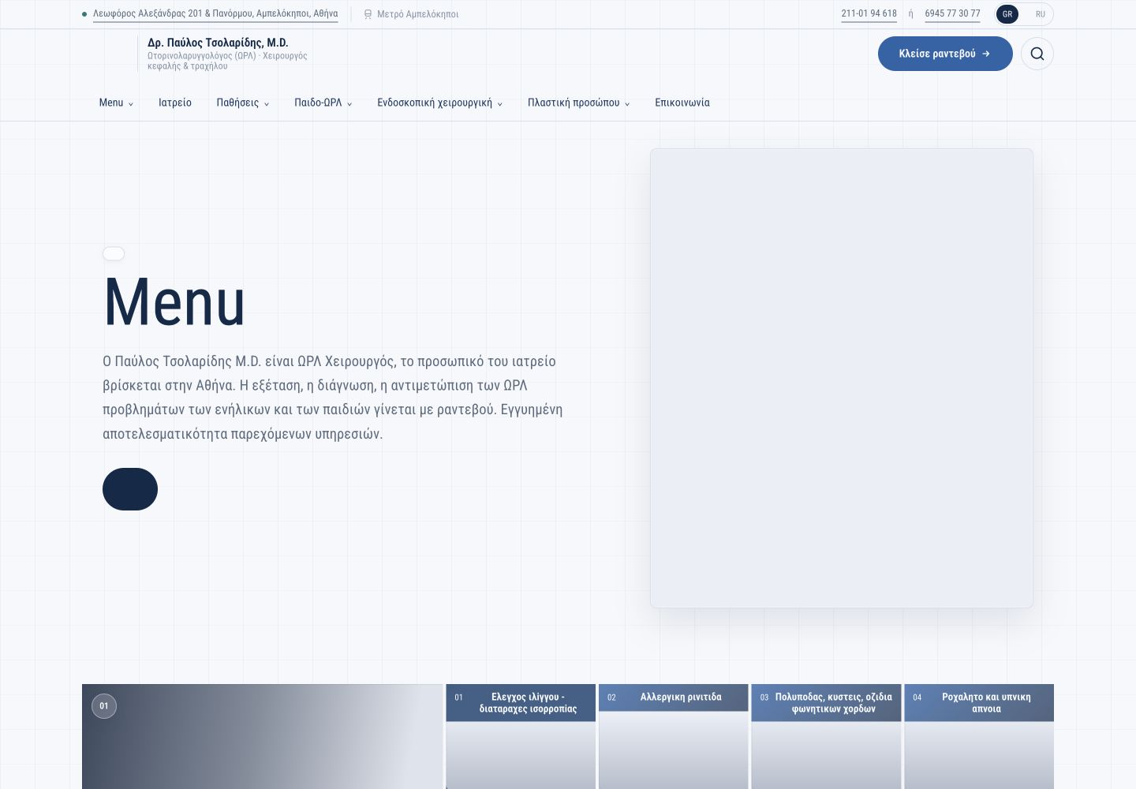
Figure 1. Greek production home: literal “Menu” and a blank CTA remain visible.
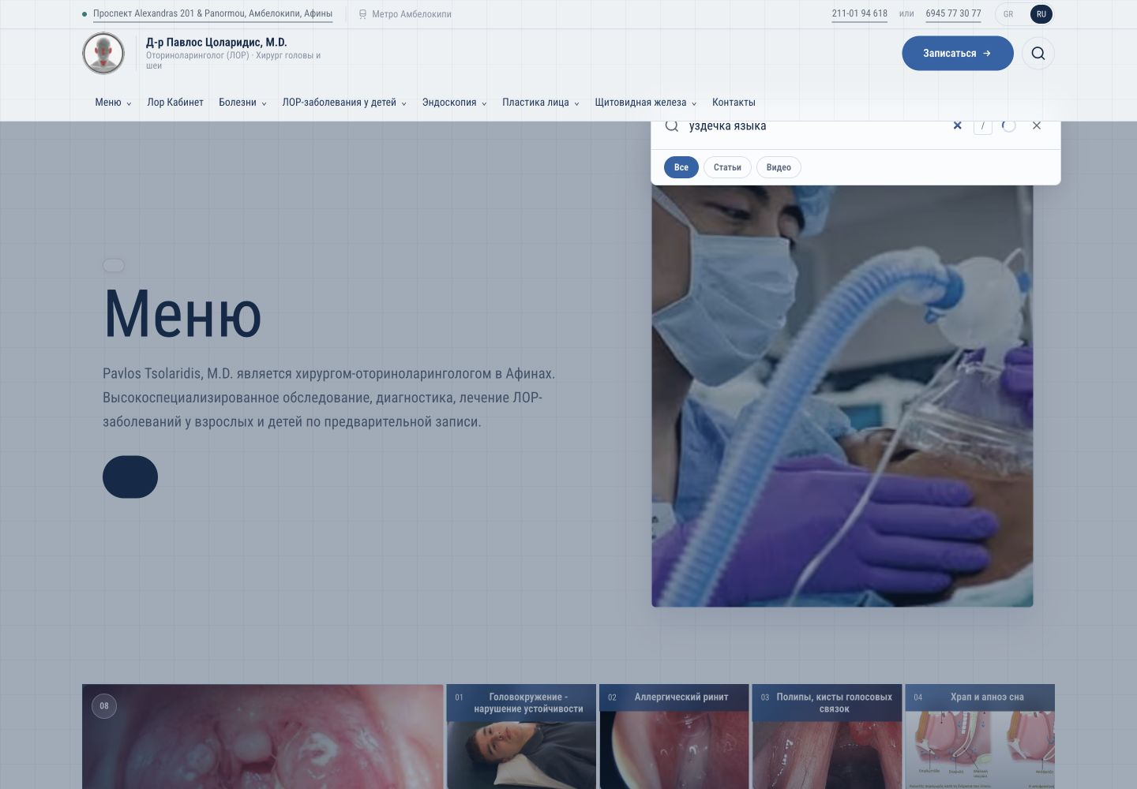
Figure 2. Russian search query before results populated; cold response remained visually empty for several seconds.
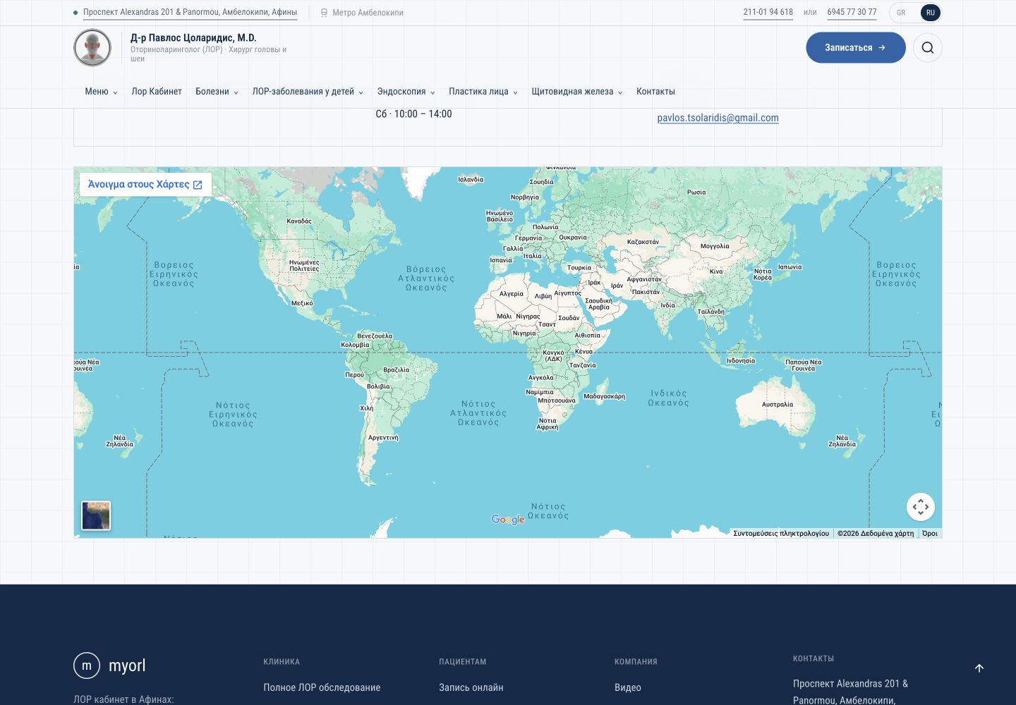
Figure 3. The loaded map resolves to a world view instead of the clinic marker.

Codebase review
Overall assessment. The system is not a hopeless codebase: the architecture vocabulary, ADR coverage, frontend test breadth, Strapi contracts, and search design are stronger than average. The mess is concentrated in migration residue, large UI/search modules, weak CI enforcement, and gaps between component-level confidence and deployed content verification.

High-severity findings
- Partial-update validation bypass — A page update that omits home type/variant can bypass the home-section policy because validation only sees the incoming patch. Merge the stored entity with the patch before validation and add partial-update tests. Evidence: backend/src/api/page/content-types/page/home-section-policy.ts:24–26 and lifecycles.ts:24–43.
- Unsafe legacy section migration — Each dedicated field can rebuild from stale pageSections; later writes may overwrite earlier migrated data. Per-page errors are swallowed and the completion marker can still be written. Make the migration transactional/idempotent and fail closed. Evidence: backend/src/bootstrap/migrate-sections.ts:28–117.
- CI confidence gap — Backend tests are not part of CI, browser E2E is disabled, and only six selected Python files run despite a much larger suite. The green pipeline therefore overstates release confidence. Evidence: .github/workflows/ci.yml:52–126.
- Clock-brittle frontend tests — Two tests hard-code June 2026 and now fail while 1360 pass. Freeze the clock or generate future dates relative to the test date. Evidence: frontend/src/components/page-layouts/layouts.test.tsx:2571–2623.

Medium-severity findings
- The Python suite has no single declared test environment: collection fails when respx is absent, an archived live-network test is collected, and the local system Python does not match the documented Python 3.11+ contract.
- The Strapi editor configuration duplicates hideFromMenu/externalUrl and omits disclaimerOverride from the configured layout, increasing editorial error risk.
- URL-mapping revalidation sends a secret in the query string; query strings are more likely to be logged. The receiver also cannot fully refresh a build-time mapping table, leaving ADR-012 behavior incomplete.
- The contact endpoint has a honeypot but no equivalent bounded rate limiter; the existing rate limiter is process-local, unbounded, and trusts the first forwarded IP value.
- Search query logs promise a 90-day TTL, but no deletion job or repository-managed schedule was found.

Maintainability hotspots
- SearchOverlay (~667 lines), search reindex (~659), ContactForm (~593), PageBody (~571), and SectionIndexGrid (~559) combine too many responsibilities.
- Frontend lint finishes with 16 warnings; backend TypeScript strictness is disabled; there are no coverage thresholds.
- Split modules by state/data/rendering boundaries, keep CMS contracts at adapters, and add tests around deep policy/migration modules before refactoring UI shells.

Verification record
- Frontend: 1360/1362 tests passed; two current-date failures in appointment layout tests.
- Backend: 47/47 tests passed when run directly.
- Typecheck: passed. Lint: completed with 16 warnings.
- Python: selected homepage-backfill tests 4/4 passed; full collection is blocked by environment/dependency/test-discovery issues.
- Production: browser checks at 1440, 390, and 320 px; map and search interactions executed without submitting forms or changing external state.
- Delivery config: required production email variables absent; values were never printed or exposed.

Questions that block honest closure
- R15: does “messenger” mean the legacy floating phone/contact dock, or specific WhatsApp/Viber links? If specific, provide the approved numbers/accounts.
- R16: which exact information is missing on mobile, and on which routes?
- R18: which route and image/gallery behavior does the screenshot-only note refer to?
- R09: confirm the exact phrase/byline expected if it is not the legacy author line and medical-advice notice.
- R23: confirm which element should be removed and whether the legacy author notice and each historical video position must be restored.
- R07: identify the approved recipient mailbox and authorize a real production delivery test after email configuration.

