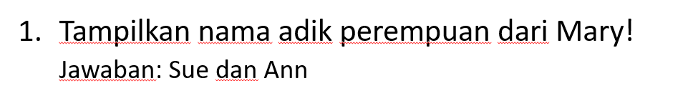

MATCH (aa:ns0__person)-[:ns0__hasYoungerSister]-(sister) WHERE aa.ns0__hasFirstName="Mary" RETURN sister.ns0__hasFirstName

Hasil :

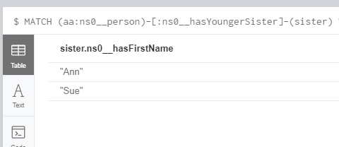

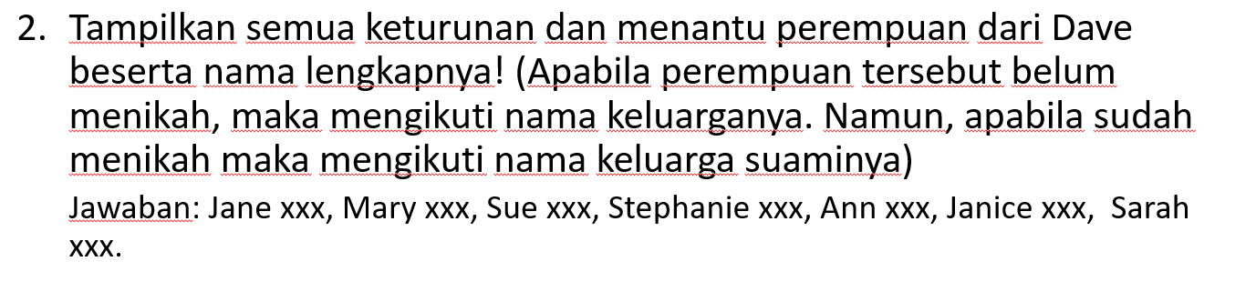

MATCH(n:ns0__person {ns0__hasFirstName: "Dave"})-[:ns0__hasSon]->(bob)-[:ns0__hasSpouse]->(w) RETURN DISTINCT w.ns0__hasMariageName AS mar

UNION

MATCH(n:ns0__person {ns0__hasFirstName: "Dave"})-[:ns0__hasSon]->(bob)-[:ns0__hasChild]->(childs) WHERE NOT EXISTS(childs.ns0__hasMariageName) AND (childs:ns0__woman) RETURN childs.ns0__hasFamilyName AS mar

UNION

MATCH(n:ns0__person {ns0__hasFirstName: "Dave"})-[:ns0__hasSon]->(bob)-[:ns0__hasChild]->(childs) WHERE EXISTS(childs.ns0__hasMariageName) AND (childs:ns0__woman) RETURN childs.ns0__hasMariageName AS mar

UNION

MATCH(n:ns0__person {ns0__hasFirstName: "Dave"})-[:ns0__hasSon]->(bob)-[:ns0__hasChild]->(childs)-[:ns0__hasSpouse]->(spouse) WHERE (spouse:ns0__woman) RETURN spouse.ns0__hasMariageName AS mar

UNION

MATCH(n:ns0__person {ns0__hasFirstName: "Dave"})-[:ns0__hasSon]->(bob)-[:ns0__hasChild]->(childs)-[:ns0__hasSpouse]->(spouse)-[:ns0__hasChild]->(grandchild) WHERE NOT EXISTS(grandchild.ns0__hasMariageName) AND (grandchild:ns0__woman) RETURN grandchild.ns0__hasFamilyName AS mar

Hasil :

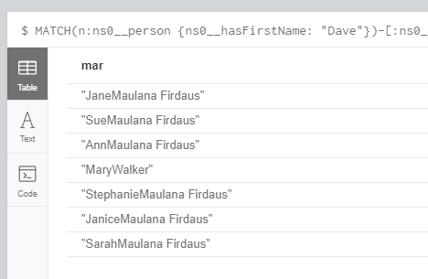

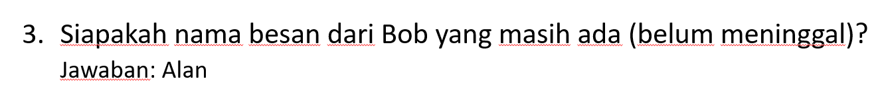

MATCH(bob:ns0__person {ns0__hasFirstName: "Bob"})-[x:ns0__hasChild]->(aa)<-[:ns0__hasSpouse]->(pasangan)-[:ns0__hasParent]->(menantu) WHERE NOT EXISTS(menantu.ns0__hasDOD) RETURN DISTINCT menantu.ns0__hasFirstName AS FIRST_NAME

Hasil :

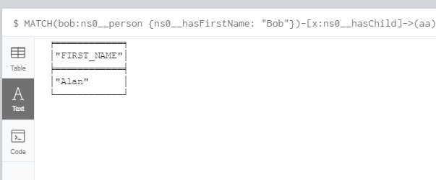

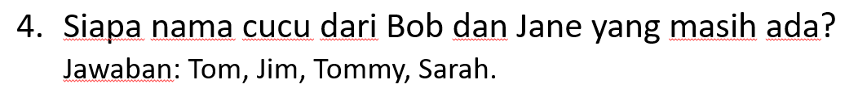Hasil :

MATCH(aa:ns0__person {ns0__hasFirstName : "Bob"})-[x:ns0__hasChild]->(anak)-[y:ns0__hasChild]->(cucu) WHERE NOT EXISTS(cucu.ns0__hasDOD) RETURN DISTINCT cucu.ns0__hasFirstName

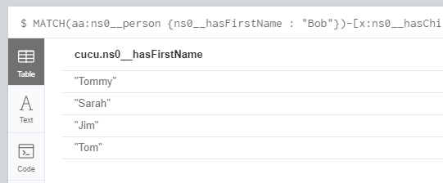

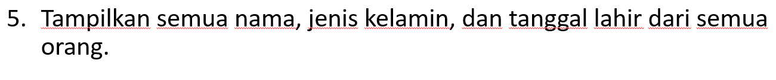

MATCH(n:ns0__person) Return n.ns0__hasFirstName AS FamilyName, n.ns0__hasSex as Sex, n.ns0__hasBOD as BirthDate

Hasil :

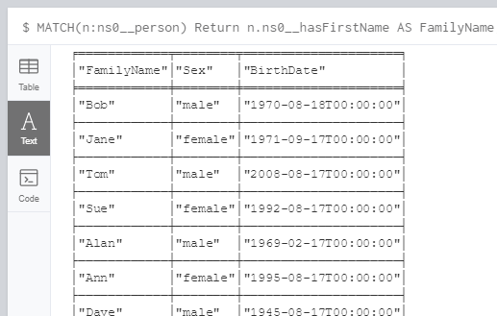

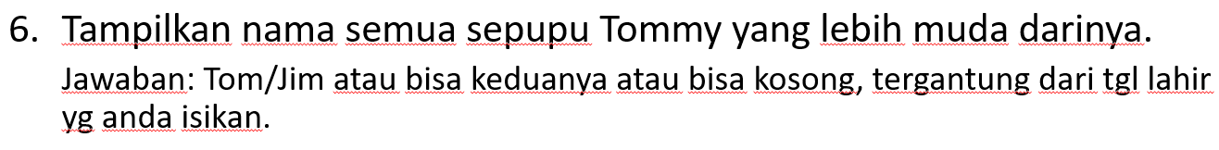

MATCH(n:ns0__person {ns0__hasFirstName: "Tommy"})-[x:ns0__hasParent]->(parent)-[:ns0__hasSiblings]->(siblings)-[:ns0__hasChild]->(childs) WHERE (childs.ns0__hasBOD < n.ns0__hasBOD) RETURN childs.ns0__hasFirstName AS result

Hasil :

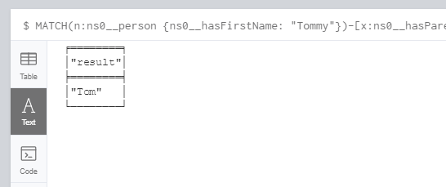

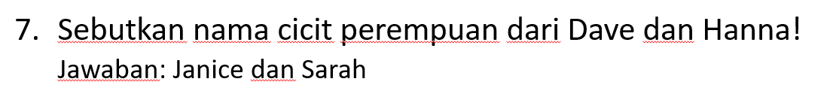

MATCH(p:ns0__person)-[:ns0__hasChild]->(anak)-[:ns0__hasChild]->(cucu)-[:ns0__hasDaughter]->(cicitp) RETURN DISTINCT cicitp.ns0__hasFirstName

Hasil :

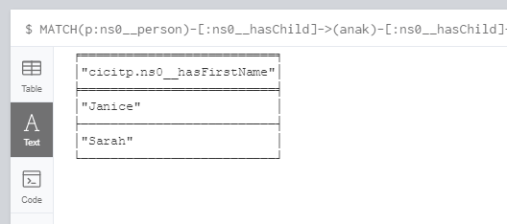

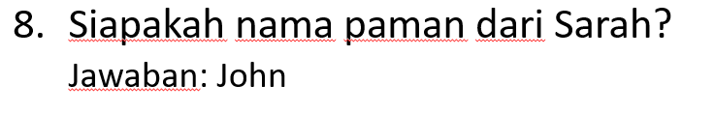

MATCH(s:ns0__person {ns0__hasFirstName: "Sarah"})-[:ns0__hasUncle]->(uncle) return uncle.ns0__hasFirstName

Hasil :

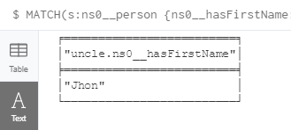



MATCH(n:ns0__person {ns0__hasFirstName: "Dave"})-[:ns0__hasChild]->(child)-[:ns0__hasChild]->(cicit)-[:ns0__hasSpouse]->(s) RETURN s.ns0__hasFirstName as NAME

UNION

MATCH(n:ns0__person {ns0__hasFirstName: "Dave"})-[:ns0__hasChild]->(child)-[:ns0__hasSpouse]->(s) return s.ns0__hasFirstName as NAME

Hasil :

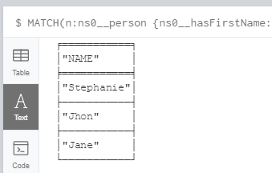

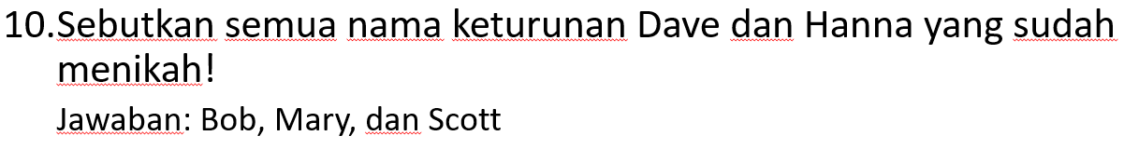

Hasil :

MATCH(n:ns0__person {ns0__hasFirstName: "Dave"})-[:ns0__hasChild]->(x)-[:ns0__hasSpouse]->(y) RETURN x.ns0__hasFirstName as keturunan

UNION

MATCH(n:ns0__person {ns0__hasFirstName: "Dave"})-[:ns0__hasChild]->(x)-[:ns0__hasChild]->(y)-[:ns0__hasSpouse]->(u) RETURN y.ns0__hasFirstName as keturunan

