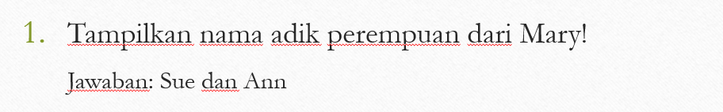

Jawab :

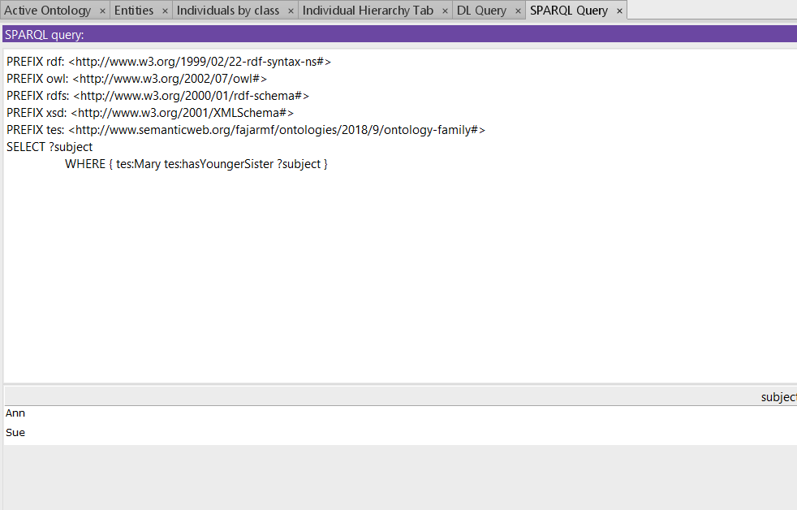

Query :

SELECT ?object

WHERE { tes:Mary tes:hasYoungerSister ?object }

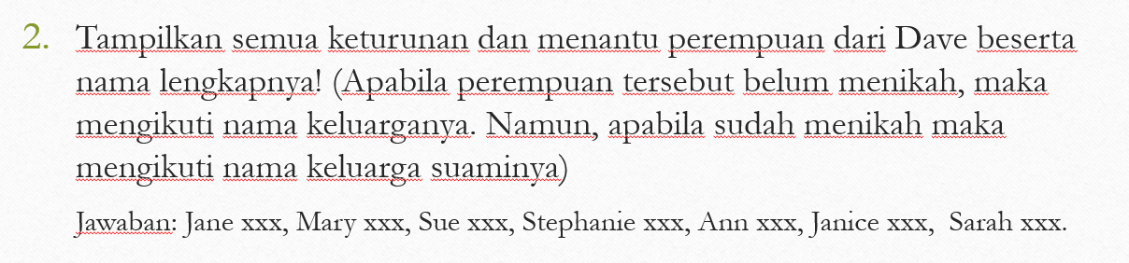

Jawab :

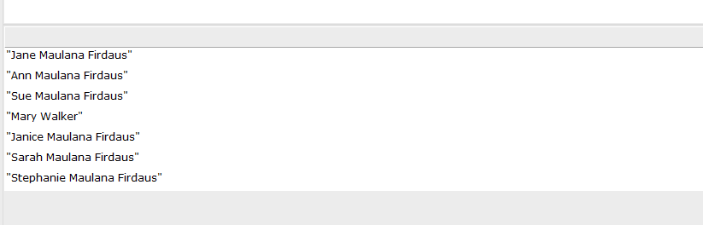

Query :

SELECT (str(?Family) as ?TesDescent)

WHERE {

{tes:Dave tes:hasSon ?son . ?son tes:hasSpouse ?wife . ?wife tes:hasMariageName ?Family }

UNION

{tes:Dave tes:hasSon ?son . ?son tes:hasDaughter ?granddaughter. FILTER NOT EXISTS {?granddaughter tes:hasSpouse ?x} . ?granddaughter tes:hasFamilyName ?Family }

UNION

{tes:Dave tes:hasSon ?son . ?son tes:hasDaughter ?granddaughter. FILTER EXISTS {?granddaughter tes:hasSpouse ?x} . ?granddaughter tes:hasMariageName ?Family }

UNION

{tes:Dave tes:hasSon ?son . ?son tes:hasSon ?grandson. FILTER EXISTS {?grandson tes:hasSpouse ?x} . ?grandson tes:hasDaughter ?grandgrandDaughter . FILTER NOT EXISTS {?grandgrandDaughter tes:hasSpouse ?x} . ?grandgrandDaughter tes:hasFamilyName ?Family}

UNION

{tes:Dave tes:hasSon ?son . ?son tes:hasSon ?grandson. FILTER EXISTS {?grandson tes:hasSpouse ?x} . ?x tes:hasMariageName ?Family .}}

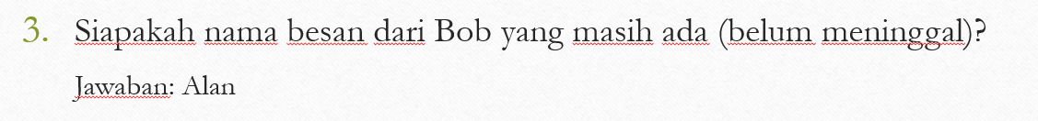

Jawab :

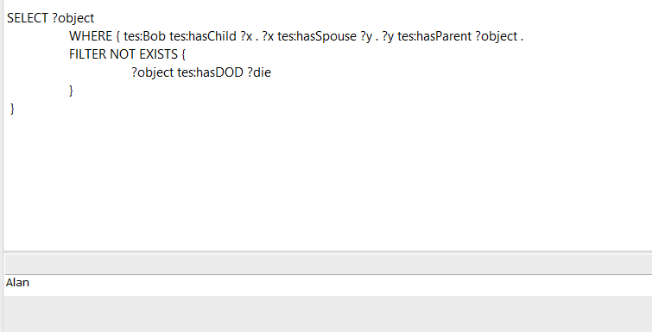

Query :

SELECT ?object

WHERE { tes:Bob tes:hasChild ?x . ?x tes:hasSpouse ?y . ?y tes:hasParent ?object .

FILTER NOT EXISTS {

?object tes:hasDOD ?die

}

}

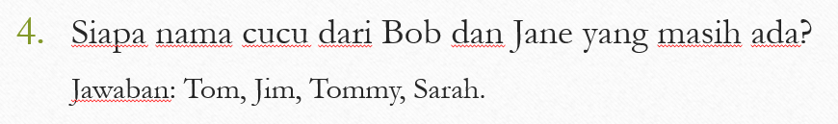

Jawab :

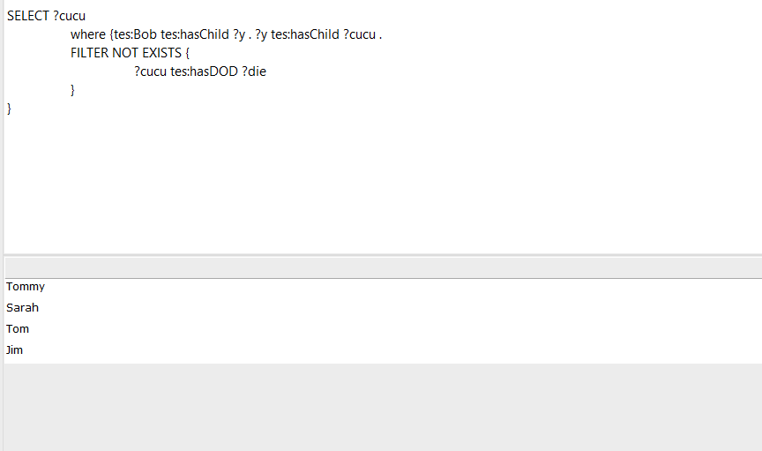

Query :

SELECT ?cucu

where {tes:Bob tes:hasChild ?y . ?y tes:hasChild ?cucu .

FILTER NOT EXISTS {

?cucu tes:hasDOD ?die

}

}



Jawab :

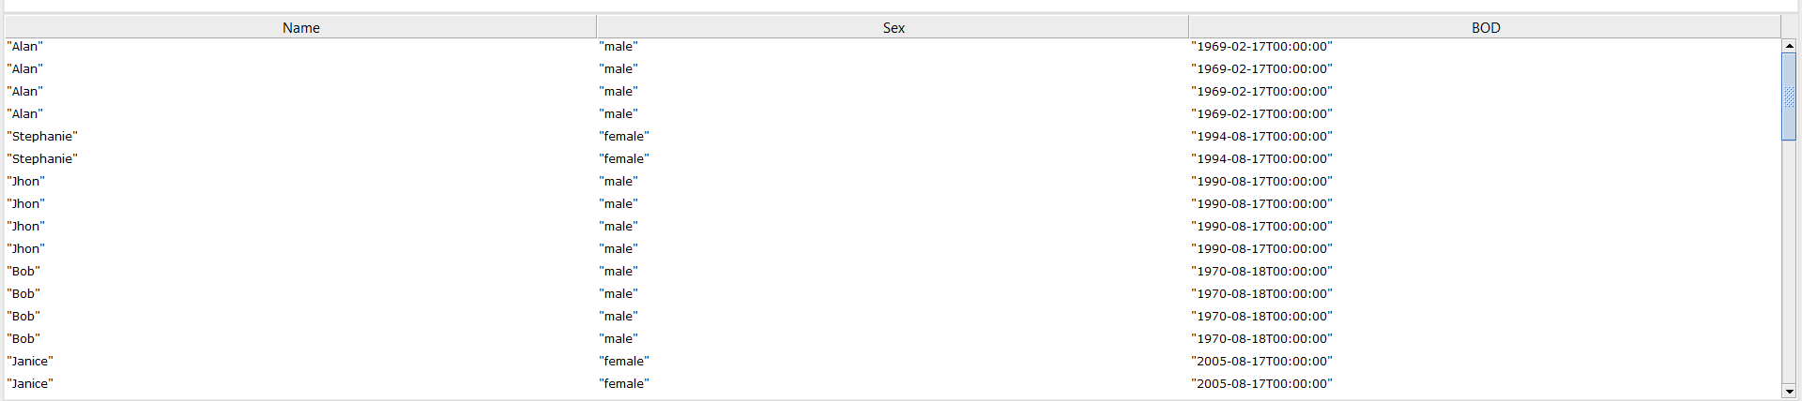

Query :

SELECT (str(?name) as ?Name) (str(?sex) as ?Sex) (str(?bod) as ?BOD )

where{

?person tes:hasFirstName ?name . ?person tes:hasSex ?sex . ?person tes:hasBOD ?bod

}

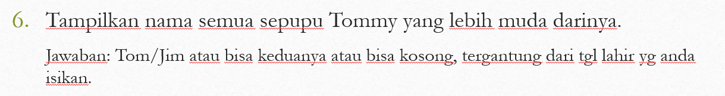

Jawab :

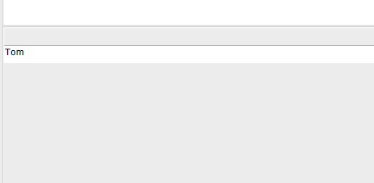

Query :

SELECT ?subject

where{

tes:Tommy tes:hasParent ?x . ?x tes:hasSiblings ?y .

?y tes:hasChild ?subject .

?subject tes:hasBOD ?born . tes:Tommy tes:hasBOD ?bornself

FILTER(?born < ?bornself)

}

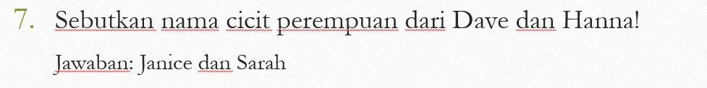

Jawab :

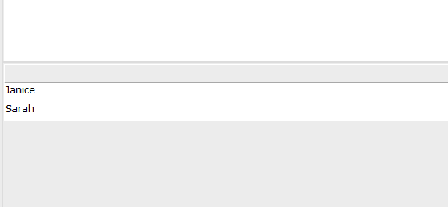

Query :

SELECT ?subject

where{

tes:Dave tes:hasChild ?x . ?x tes:hasChild ?z . ?z tes:hasDaughter ?subject

}

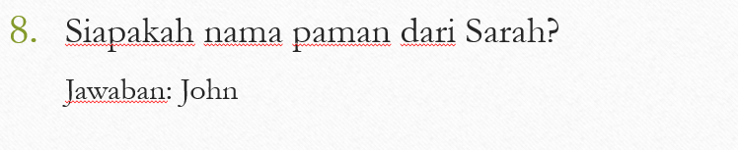

Jawab :

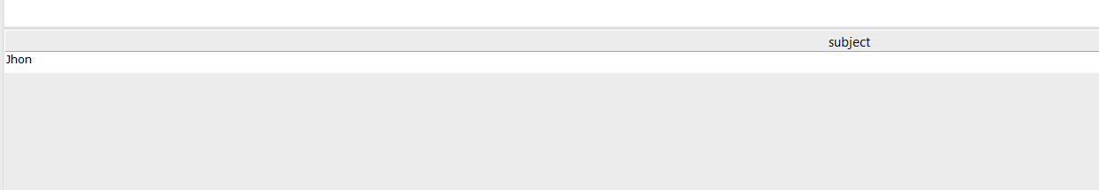

Query :

SELECT ?subject

where{

tes:Sarah tes:hasUncle ?subject

} 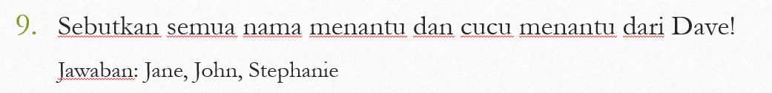

Jawab :

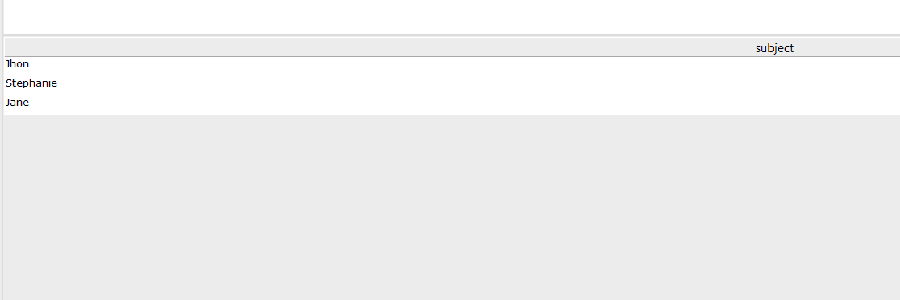

Query :

SELECT ?subject

where{

{

tes:Dave tes:hasChild ?x . ?x tes:hasChild ?y . ?y tes:hasSpouse ?subject .

}

UNION

{

tes:Dave tes:hasChild ?x . ?x tes:hasSpouse ?subject .

}

}

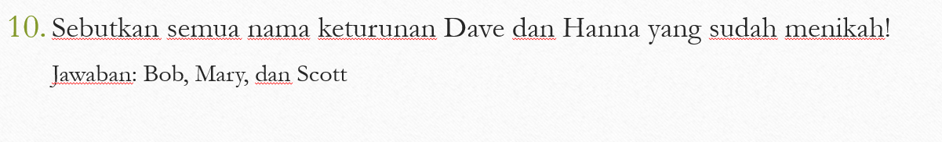

Jawab :

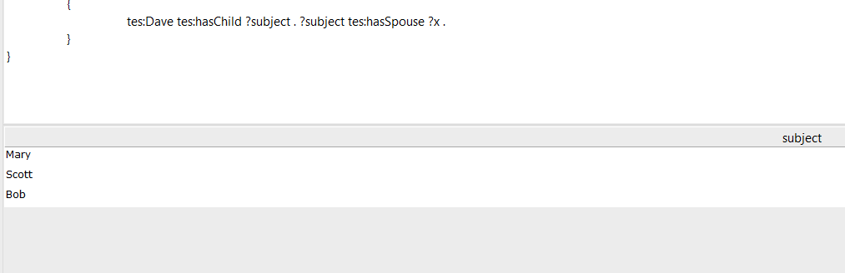

Query :

SELECT ?subject

where{

{

tes:Dave tes:hasChild ?x . ?x tes:hasChild ?subject . ?subject tes:hasSpouse ?y .

}

UNION

{

tes:Dave tes:hasChild ?subject . ?subject tes:hasSpouse ?x .

}

}