# NAMA : IDA BAGUS KRESNAYANA EKA

**NIM : 2001020002**

**KLS : TI_A**

# Desain Form

## Form1 Properties

|  |  |  |  |
| --- | --- | --- | --- |
| **No** | **Object** | **Property** | **Value** |
| 1 | Form1 | Name | Data Buku |
| 2 | Label1 | Text | Kode Buku |
| 3 | Button1 | Name Text | BtnSimpan  Simpan |
| Dst | Dst | Dst | Dst |

## Form1 Design

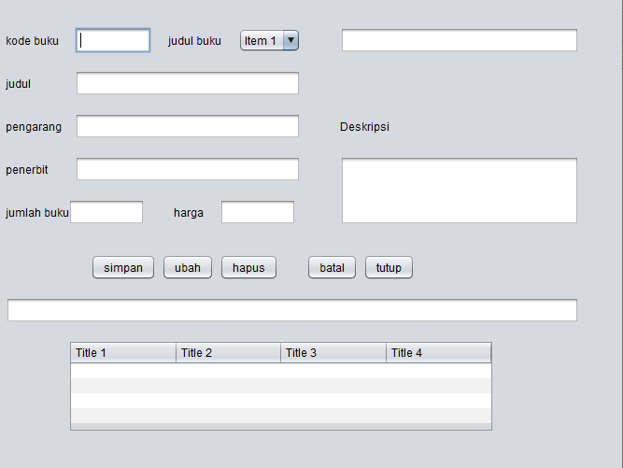

# Listing Program

1. Code untuk tombol simpan

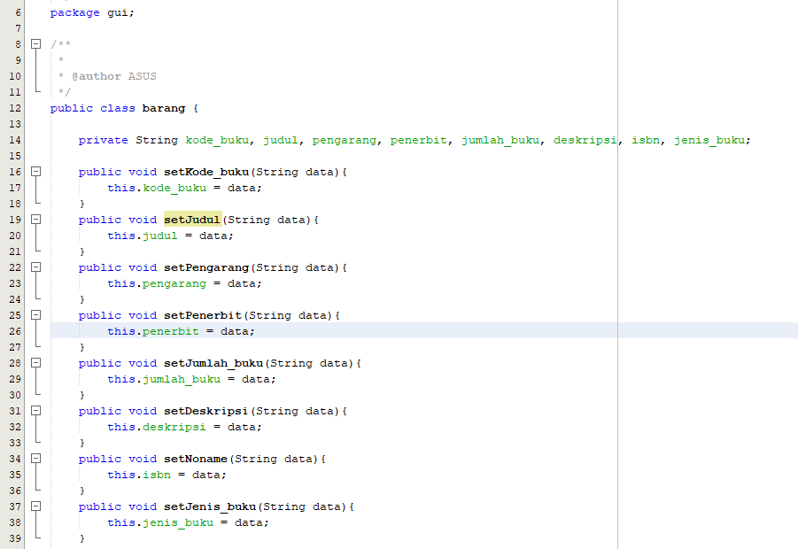

1. Code untuk koneki ke database

