RESCUE-NET
DISASTER MANAGEMENT SYSTEM BLUEPRINT
Decision-centric • Traceable • Multi-organization • Offline-capable • Human-governed AI
TUJUAN UTAMA
Mengubah laporan bencana yang terfragmentasi menjadi keputusan operasional yang dapat dipercaya, dapat ditelusuri, dan dapat dieksekusi—tanpa menghapus laporan asli, tanpa double counting, dan tanpa menggantungkan keputusan kritis pada AI.

Operational Truth  Raw Report dipisahkan dari hasil verifikasi, konsolidasi, correction, dan War Room. | End-to-End Response  Reporting → verification → logistics → medical → shelter → search/found → recovery. | Multi-Organization  Organisasi, Posko, relawan, verifier, donor, pemerintah, dan command center dalam scope terkontrol.
Offline & Resilient  PWA/local queue, retry, conflict handling, dan operasi regional tetap dirancang untuk konektivitas tidak stabil. | AI with Human Authority  AI membantu normalisasi, ringkasan, prioritas, dan pattern detection; keputusan kritis tetap manusia. | Evolutionary Architecture  Modular, API-first, migration-safe; transisi FastAPI/PostgreSQL → Frappe dilakukan bertahap dengan UAT.
KEMAMPUAN INTI
Capability Area | Ringkasan
Capture & Trust | Laporan masyarakat, evidence, GPS, verifikasi, conflict/duplicate review
Command & Coordination | War Room, Posko, organization scope, corrections, alerts, operational queues
Logistics & Distribution | Need, stock observation, aid offer, transport/distribution flow, configurable normalization
Humanitarian Operations | Medical, shelter, volunteer, kitchen, resources, Search & Found, WhatsApp Posko
Programs & Recovery | Donor program backend, program khusus, recovery/reconstruction tracking
Decision Intelligence | Privacy-safe AI context, BYOK, recommendation support, future OCR/forecast/simulation architecture

KELEBIHAN STRATEGIS
- Menjaga provenance: sumber, waktu, lokasi, evidence, dan histori keputusan tetap dapat ditelusuri.
- Mencegah agregasi salah: overlap menggunakan MAX sebagai default; SUM hanya untuk scope penerima/area yang benar-benar berbeda.
- Memisahkan data publik, internal, restricted, confidential, dan secrets dengan prinsip minimum necessary.
- Mendukung scale-up bertahap dari Posko/kabupaten hingga federasi nasional tanpa menghapus local provenance.
Blueprint ini menggabungkan baseline arsitektur Rescue-Net, implementasi aktif, dan arah target Frappe. Status implementasi dijelaskan terpisah dari target desain agar tidak terjadi overclaim.

Daftar Isi & Cara Membaca
Halaman 2 dan seterusnya berisi detail arsitektur bisnis, data, aplikasi, teknis, keamanan, operasi, dan roadmap.
Bagian | Isi
1 | Visi, Objective, dan Operating Model
2 | Actors & Disaster Lifecycle
3 | Capability Map
4 | Operational Truth & Consolidation
5 | Enterprise / C4 Architecture
6 | Domain & Service Boundaries
7 | Data Architecture & Core Entities
8 | Logistics, Distribution & Normalization
9 | Humanitarian Operations Modules
10 | AI Decision Support Architecture
11 | API, Integration & Offline Sync
12 | Security, Privacy & Authorization
13 | Technical Programming Blueprint
14 | Deployment, DevOps, Backup & DR
15 | Frappe Migration Architecture
16 | Current Implementation Snapshot
17 | National Scaling Architecture
18 | Quality Gates, KPIs & Roadmap
A | Source Basis & Glossary

Status legend
Label | Arti
Implemented / UAT | Sudah dibangun di shadow/pilot dan memiliki UAT fungsional yang tercatat.
Backend UAT | Backend semantics lulus; UI final dapat masih ditunda atau menunggu mockup.
Compatibility bridge | UI existing diarahkan ke endpoint Frappe tanpa redesign besar.
Target / Blueprint | Arah arsitektur yang direncanakan; tidak otomatis berarti sudah production-cutover.

1. Visi, Objective, dan Operating Model
Rescue-Net adalah platform koordinasi manajemen bencana yang berorientasi pada keputusan. Nilai utamanya bukan jumlah menu, melainkan kemampuan mengubah input lapangan yang tidak seragam menjadi operational picture yang dapat dipercaya, ditelusuri, dan ditindaklanjuti.

1.1 Objectives
- Menghasilkan operational truth tanpa menghapus raw report dan evidence asli.
- Menghubungkan masyarakat, organisasi, Posko, verifier, operator, donor, relawan, tenaga medis, shelter, dan command center dalam satu model koordinasi.
- Mengurangi double counting, silent overwrite, dan keputusan distribusi berdasarkan data yang tidak terverifikasi.
- Mempertahankan operasi penting saat konektivitas terganggu melalui pola offline queue dan reconciliation.
- Menggunakan AI untuk mempercepat analisis dan normalisasi tanpa menggantikan human authority.
- Menyediakan jalur scale-up dari operasi lokal menuju multi-region dan national coordination layer.

1.2 Operating principles
Prinsip | Implikasi Sistem
Decision-centric | Fitur dinilai dari dampaknya pada keputusan, bukan sekadar jumlah form/dashboard.
Immutable raw input | Original payload/text/unit/evidence tidak ditimpa oleh normalisasi atau koreksi.
Human authority | Rule engine/AI menghasilkan candidate atau recommendation; keputusan kritis disetujui manusia.
Traceability | Merge, split, correction, approval, distribution, dan review memiliki jejak.
Offline-first | Fungsi lapangan kritis tidak diasumsikan selalu online.
API-first | Web, PWA, admin, dan mitra menggunakan kontrak business rule yang konsisten.
Modular evolution | Modular monolith/service modules sebelum memecah microservices.
Security by design | Scope akses, PII, evidence, secrets, audit, dan retention dibangun sejak awal.
No destructive migration | Perubahan schema/backends dilakukan additive, reversible, dan diuji.

2. Actors & Disaster Lifecycle
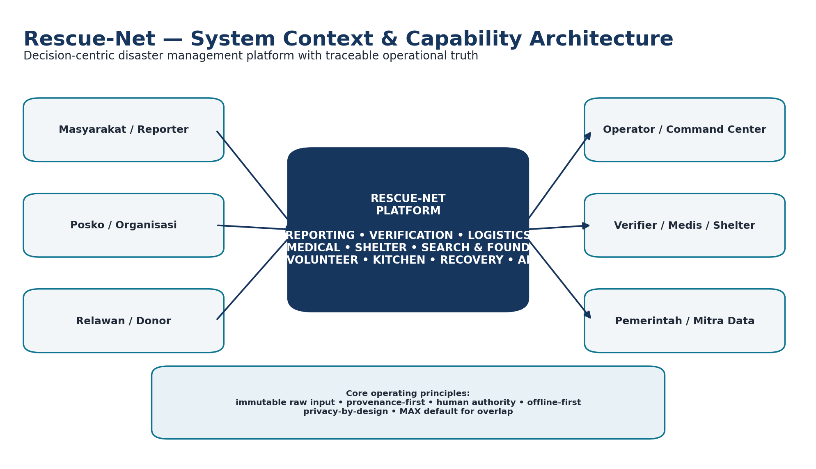
System context: actors, operational platform, and core design principles.

2.1 Actors
Actor | Peran Utama | Scope
Masyarakat / Reporter | Laporan kondisi, kebutuhan, evidence, lokasi | Public / self-service
Organisasi / Kelompok | Kontribusi, resource, keanggotaan, Posko | Organization-scoped
Posko Operator | Kebutuhan, stok, distribusi, shelter/medis, evidence | Posko-scoped
Trusted Verifier | Verifikasi identity/location/organization/need/evidence | Authorized verification scope
Command Center | Operational correction, prioritization, cross-Posko coordination | Event / region / command scope
Relawan | Skill, availability, assignment | Assignment-scoped
Donor / Resource Owner | Aid offers, resources, program contribution | Offer/program scope
Medical / Shelter Team | Case/capacity/need reporting sesuai privacy policy | Restricted operational scope
Government / Partner | Standards, coordination, controlled data exchange | Region / governance scope

2.2 Disaster lifecycle coverage
Fase | Rescue-Net Capability | Catatan
Preparedness / Readiness | Organization, Posko, resource profile, contact directory, role & policy, baseline normalization | Early-warning modelling bukan fokus implementasi inti saat ini.
Impact & Reporting | Community reporting, evidence, GPS/manual location, incident context | Raw report disimpan sebagai source, bukan truth final.
Verification & Consolidation | Layered verification, duplicate/overlap candidate, consolidation, command correction | Human review menjadi authority.
Response Operations | Logistics, stock, aid, distribution, medical, shelter, volunteers, kitchen, Search & Found | Fokus operasional utama.
Recovery | Program khusus, donor/recovery project tracking, progress and spending semantics | Memisahkan response stock/flow dari recovery project accounting.
Learning & Scaling | Audit, provenance, KPIs, AI evaluation, national roll-up roadmap | Target jangka menengah/panjang.

3. Capability Map
Capability | Design / Scope
Community Reporting | Input publik; reporter identity; GPS/manual location; evidence; event linkage.
Organization & Posko | Kelompok/organisasi, membership, Posko, assignment, public participation policy.
Verification & Privacy | Layered verification; access scope; evidence handling; freshness; public masking.
War Room / Consolidation | Open needs, alerts, conflicts, operational read model, drill-down, corrections.
Logistics Need | Raw need text, quantity modes, urgency, category/group/item normalization.
Stock Observation | Snapshot stock state; bukan accounting ledger; observed/source timestamps.
Aid Offer & Distribution | Offer → reserve/dispatch/arrival/receipt; destination/source Posko; evidence.
Transport / Resource | Vehicle/tools/resource profile/capacity; tidak dicampur dengan stock.
Medical | Case coordination, restricted evidence, evacuation workflow terpisah dari stock distribution.
Shelter | Occupancy snapshots, needs, registered households dibedakan.
Volunteer | Skill, availability, assignment, anti-double-booking principle.
Search & Found | Missing/found reports, privacy-safe dashboard, restricted identity evidence.
Kitchen | Meal production/consumption events; stock observation tetap snapshot.
Donor & Special Program | Program accounting semantics; special program budget-spent berbeda dari donor current_amount.
Recovery | Project updates, progress non-regression, spent amount accumulation, soft lifecycle.
AI Decision Support | BYOK, privacy-safe context, summary/recommendation; AI never overwrites raw.
Normalization Registry | Admin-configurable logistics category/group/item rules with fallback classifier.
Offline / Sync | Queue, retry, conflict, reconciliation; Sync Console/Log berada di P2 roadmap/current next cluster.

4. Operational Truth & Consolidation
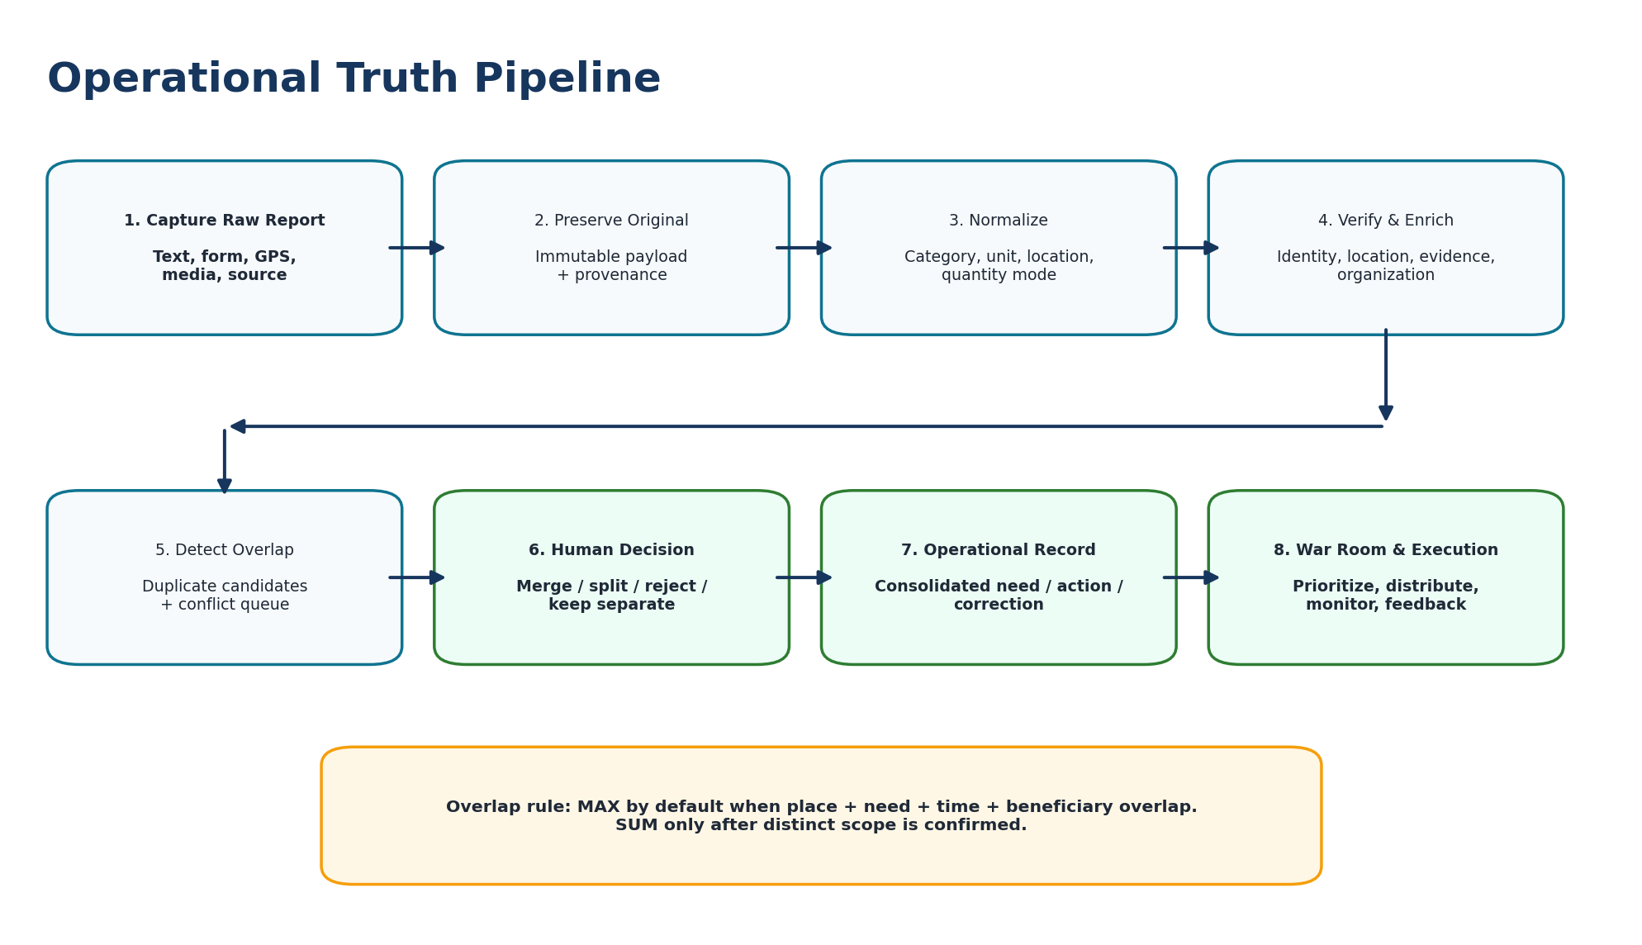
Operational Truth is derived and reviewable; it never silently replaces raw sources.

4.1 Why Raw Report ≠ Operational Truth
Laporan lapangan dapat overlap, berbeda satuan, berasal dari periode yang berbeda, atau memiliki cakupan penerima yang sama. Karena itu sistem memisahkan sumber mentah, hasil normalisasi, verification signals, consolidation group, command correction, dan read model War Room.

4.2 Quantity model
Mode | Makna | Contoh
exact | Angka cukup pasti | 120 botol
estimated | Perkiraan tunggal | sekitar 200 orang
range | Rentang | 50–80 paket
unknown | Belum dapat dikuantifikasi | butuh air bersih segera

4.3 Overlap rule
Untuk lokasi + kebutuhan + waktu + beneficiary yang sama, default konsolidasi adalah MAX, bukan SUM. SUM hanya dilakukan setelah scope penerima/area yang berbeda dikonfirmasi. Aturan ini melindungi War Room dari double counting dan over-allocation.

4.4 Freshness & evidence
- Observed time, source-updated time, server modified time, dan freshness policy tidak dianggap sebagai hal yang sama.
- Verification report tidak otomatis memverifikasi seluruh downstream need; status tiap domain tetap terpisah.
- Command correction bersifat traceable dan tidak menghapus source report.
- Evidence memiliki metadata, checksum/integrity, visibility class, dan retention policy.

5. Enterprise / C4 Architecture

5.1 Logical layers
Layer | Components | Rule
Experience | Public Web, PWA, War Room, Admin/Frappe Desk | Frontend tidak menghitung Operational Truth sendiri.
API / Application | Use-case orchestration, auth, workflows, transactions | Thin transport handlers; clear transaction boundary.
Domain | Policies, state transitions, normalization, MAX/SUM, verification distinction | Domain rules tidak disebar ke UI/infrastructure.
Infrastructure | DB, storage, messaging, GIS, external AI adapters | Infrastructure tidak menentukan keputusan domain.
Data / Analytics | Read models, rollups, alerts, scenario/summary | Dapat dibangun ulang dari source + audit trail.

5.2 Near-term architecture choice
Blueprint mempertahankan modular monolith/service modules sebagai tahap aman. Pemisahan microservice hanya dilakukan jika ada alasan operasional yang nyata—misalnya kebutuhan scaling independen, isolation, compliance boundary, atau failure domain yang jelas.

5.3 Read / write separation
Writes menyimpan source, evidence, verification, state change, distribution event, dan command action. War Room menggunakan read model/summary yang dioptimalkan agar query analitik tidak mengganggu capture lapangan.

6. Domain & Service Boundaries
Domain | Owns | Must Not Own
Disaster Event | Lifecycle kejadian, area, active status | Validitas individual report
Reporting | Raw report, source, time, location claim | Operational truth final
Evidence | Media, metadata, checksum, chain of custody | Consolidation decision
Verification | Identity/location/org/need/evidence review | Universal “verified everything” badge
Consolidation | Duplicate/overlap, merge/split, provenance | Authentication
Command | Manual correction, assignment, decision record | Mutation of raw report
Resources | Stock/resource/vehicle/volunteer capability | Truth decision for reports
Distribution | Plan, dispatch, transport, arrival, receipt | Deletion of source need
Medical | Case coordination, medical risk, evacuation | General logistics stock ledger
Shelter | Capacity, occupancy snapshot, shelter needs | Identity exposure on public view
Search & Found | Missing/found/match coordination | Public PII disclosure
Recovery | Recovery projects, progress, spending | Response stock semantics
Offline Sync | Queue, retry, conflict, reconciliation | Silent last-write-wins
AI | Derived recommendation/candidate/context | Final operational authority

7. Data Architecture & Core Entities

7.1 Conceptual data model
Entity / DocType Concept | Key Relationships / Purpose
Disaster Event | Parent context for incident, reporting, Posko, operations, recovery.
Organization | Government/NGO/community/company/verifier identity; parent/child where required.
Posko | Operational node linked to event + organization/personal scope.
Community Report / Raw Report | Original report text/payload, source, device, time, location, reporter context.
Operational Evidence | Media/document/GPS references, metadata, checksum, visibility, verification status.
Verification Request / Action | Layered verification state and audit trail.
Logistic Need | Raw need + quantity mode + canonical category/group/item + urgency/status.
Stock Observation | Observed snapshot: quantity, state, timestamp, Posko; not mutable stock truth.
Aid Offer | Donor/resource contribution pipeline with target Posko.
Distribution Flow | Movement source→destination; dispatch/arrival/receipt semantics.
Medical / Shelter / Search-Found | Domain-specific operational entities with privacy policy.
Volunteer / Resource Profile | Capability and assignment, separate from inventory stock.
Donor/Special/Recovery Program | Program/recovery financial and progress semantics.
AI User Setting / AI Result | BYOK secret handling + derived decision-support outputs.
Normalization Rule | Admin-configured mapping from aliases to canonical logistics taxonomy.
Sync Log / Queue | P2 reconciliation/audit target for offline/mobile synchronization.

7.2 Data classes
Class | Examples | Control
Public | Safe disaster summary, aggregate need | No unnecessary personal data
Internal | Verification queue, conflict queue, resource status | Operator/organization access
Restricted | Detailed Posko, stock, assignment, medical/shelter operational detail | Event/region/org/Posko scope
Confidential | Reporter/victim identity, verifier contact | Masking, retention, audited access
Highly confidential | Credential, token, API key | Never Git/log; backend secret storage

8. Logistics, Distribution & Normalization

8.1 Operational states are separate
Rescue-Net membedakan offered, reserved, dispatched, arrived, received, available stock, distributed, dan consumed. Status ini tidak boleh disederhanakan menjadi satu angka stok karena akan menyebabkan overcommit atau kehilangan provenance.
Object | Meaning | Example Guardrail
Need | Apa yang dibutuhkan Posko/operasi | Tidak harus exact quantity; narrative/estimated/range valid.
Stock Observation | Snapshot yang terlihat pada waktu tertentu | Bukan accounting ledger permanen.
Aid Offer | Barang/resource yang ditawarkan | Offer ≠ reserved ≠ delivered.
Distribution Flow | Pergerakan dari source ke destination | Capture ETA, dispatch, arrival, receipt.
Kitchen Consumption | Event konsumsi/produksi | Tidak otomatis mengubah historical stock observation.
Medical Evacuation | Movement pasien/case | Terpisah dari aid distribution.

8.2 Configurable logistics normalization
Normalization registry memungkinkan admin Frappe mengatur Category → Group → Item berdasarkan alias lapangan. Rule aktif diprioritaskan; jika tidak cocok, classifier built-in tetap menjadi fallback. Raw item text tetap disimpan.
Baseline Category | Representative Group / Item | Examples of aliases
Pangan & Air | Air Minum / Air Minum Kemasan | air mineral, aqua, air botol
Pangan & Air | Air Bersih / Air Bersih | air bersih, air mandi, air sanitasi
Pangan & Air | Bahan Pangan / Beras | beras, beras medium/premium
Medis & Kesehatan | Obat & Perbekalan / Paracetamol | paracetamol, parasetamol
Medis & Kesehatan | APD & Perlindungan / Masker | masker medis, surgical mask, N95
Sanitasi & Hygiene | Hygiene / Hygiene Kit | sabun, pembalut, sikat gigi
Shelter & Hunian | Perlengkapan Pengungsian | tenda, selimut, matras, terpal
Energi & Bahan Bakar | Bahan Bakar / BBM | bensin, solar, pertalite
Energi & Bahan Bakar | Peralatan Energi / Genset | genset, generator listrik

Baseline 11 normalization rules telah di-seed secara idempotent; perubahan admin tidak di-overwrite oleh installer default.

9. Humanitarian Operations Modules
Module | Operational Model | Important Separation / Privacy
Medical | Case/capacity/risk/evidence; evacuation workflow | Patient code/private evidence; public output minimized.
Shelter | Occupancy snapshot, need, capacity, facility context | Occupancy snapshot ≠ registered households.
Volunteer | Skill, availability, assignment | Anti-double-booking; assignment has actor/time.
Search & Found | Missing/found reports, matches, coordination | Dashboard avoids person name; identity is restricted.
Resource Tools | Tools/vehicle/capability availability | Capacity ≠ stock ≠ transport cargo.
Kitchen | Meal production and explicit consumption events | Stock observation remains a separate snapshot.
WhatsApp Posko | Operational contact/coordination surface | Imported content keeps source/provenance.
Donor Program | Program contributions and updates | Legacy semantics: amount_spent increments current_amount.
Program Khusus | Special program using donor tables/contracts | budget_spent increments; current_amount not automatically changed.
Recovery | Project progress + spending + updates | Progress non-regression; no forced auto-status from spend.

10. AI Decision Support Architecture

10.1 Role of AI
AI mempercepat pemrosesan informasi, konsistensi, normalisasi, ringkasan, dan pencarian pola. AI tidak menyatakan operational truth secara final, tidak menghapus evidence, dan tidak menetapkan jumlah distribusi tanpa human approval.
Capability | Input | Output / Guardrail
Classification & Normalization | Need/report text | Canonical candidates + confidence; raw preserved.
Duplicate / Overlap | Location/time/category/text/evidence/source signals | Candidate score + reasons; never auto-merge final.
Summarization | Privacy-safe operational context | Situation summary / priorities / caveats.
OCR / Document Intelligence | Photos/docs | Extraction candidate + bbox/confidence; file original retained.
Forecast / Simulation | Historical + operational context | Range/assumptions; recommendation only.
Vision | Photo/video | Object/damage signals; not final assessment.
Copilot / Situation Analyst | Authorized event/Posko context | Operational Q&A with minimum-necessary data.

10.2 BYOK & privacy
- API key tidak boleh masuk JavaScript, Git, browser response, atau plaintext log.
- Browser hanya menerima status/masked key; secret disimpan melalui backend secret mechanism.
- AI context mengikuti scope user/Posko/organization dan tidak membuka identity medis/Search & Found yang tidak diperlukan.
- Workflow inti tetap berfungsi ketika provider AI tidak tersedia.
- Provider call tidak digunakan sebagai gate untuk report, verification, logistics, atau emergency operations.

10.3 Target AI gateway
Arsitektur jangka panjang memisahkan AI gateway dari domain Rescue-Net sehingga backend memanggil capability (classify, summarize, OCR, similarity, forecast) bukan vendor tertentu. Setiap AI result idealnya menyimpan input references, model/version, policy context, latency, confidence, review status, dan reviewer.

11. API, Integration & Offline Sync

11.1 API contract principles
Standard | Blueprint
Versioning | Gunakan contract/version yang konsisten; kompatibilitas dijaga selama migration.
Errors | Machine-readable code + message + details + request_id.
Pagination | Cursor untuk stream besar; page sederhana untuk admin.
Idempotency | Wajib untuk report/sync/distribution writes yang retry-prone.
Time | ISO 8601; server authoritative; UI menampilkan timezone lokal.
Identifiers | Business identifiers stabil/UUID-style.
Authorization | Role + event + region + organization/Posko scope.
Audit | Critical writes menyimpan actor/reason bila relevan.

11.2 Integration surfaces
- Master wilayah/boundary dan geocoding.
- Weather/geological observation jika disetujui.
- Messaging/notification dan WhatsApp operational bridge.
- Government/NGO controlled data exchange.
- Map tiles/GIS layers.
- AI providers melalui backend adapters, bukan direct browser calls.

11.3 Offline / PWA protocol
Concern | Rule
Local queue | UUID, status, retry_count, last_error, created_at, server mapping.
Evidence | Media tidak hilang ketika sync gagal; upload/retry terkontrol.
Conflict | Critical fields tidak diselesaikan dengan silent last-write-wins.
Reconnect | Batch + jitter + backpressure; retry idempotent.
Device identity | Dipisahkan dari user identity; device dapat memiliki lifecycle sendiri.
Sync audit | Target P2: Sync Log/Console untuk reconciliation dan visibility.

12. Security, Privacy & Authorization

12.1 Security model
Control Area | Blueprint
Authentication | Native Frappe session / controlled compatibility bridge; no implicit trust from legacy session alone.
Authorization | Least privilege; scope event/region/org/Posko/role. Command and System Manager global scopes are explicit.
Public registration | Operator request does not automatically grant operator authority.
Secrets | No credentials in repo/log/JS/browser response; rotate exposed secrets before production.
Medical / Search & Found | PII minimized; restricted detail; public views safe/aggregate.
Evidence | Owner + access scope + checksum + retention + audit.
Exports | Sensitive export must be auditable.
AI | External provider only receives minimum-necessary authorized context.
Migration | Source remains production until explicit cutover; no destructive schema/container actions by default.

12.2 Privacy hierarchy
Organization policy can constrain Posko behavior; public publication uses safe aggregate/masking; AI must follow the same effective permissions. Precise GPS for vulnerable individuals and unnecessary identity fields are not public data.

13. Technical Programming Blueprint

13.1 Technology stack: current and target
Layer | Current / Legacy | Target / New Platform
Frontend | HTML, CSS, JavaScript; existing web pages | Frappe Desk/Portal + compatibility with existing UI during migration
Mobile / Offline | PWA / service worker / local queue patterns | PWA retained; Sync Log/Console integrated with Frappe operational records
Backend | Python FastAPI | Python Frappe app (whitelisted APIs + DocType controllers + policies)
Data | PostgreSQL rescuenet_db | Frappe site database (MariaDB in current shadow environment)
Domain storage | Legacy relational tables | RN * DocTypes, Version/Audit, derived read models
AI | Backend provider calls / BYOK | Frappe api_ai + future vendor-neutral AI gateway
Deployment | Docker + nginx + Tailscale Funnel | Shadow/pilot Frappe container alongside legacy until cutover
Versioning | Git repository | Same repo, exact-path commits; module-by-module migration history

13.2 Frappe application structure
rescue_net/
├── api_*.py # application/API surfaces
├── access_policy.py # actor + organization/Posko scope
├── intelligence/ # normalization / decision-support logic
│ └── normalization_registry.py
├── migration/ # source→shadow import/validation
├── rescue_net/doctype/rn_*/ # native operational DocTypes
├── setup/ # idempotent defaults/install hooks
└── www/ # Frappe web/portal surfaces

13.3 Coding standards
- HTTP router/whitelisted method menangani transport; business rule dipisahkan ke service/policy/controller.
- Gunakan nama domain yang jelas; hindari singkatan ambigu dan silent exception.
- Critical business change memiliki transaction boundary, audit, dan idempotency sesuai kebutuhan.
- Jangan melakukan long network call di dalam database transaction.
- Schema migration additive terlebih dahulu; destructive DROP/rename memerlukan compatibility plan dan restore test.
- Frontend tidak menghitung operational truth dan tidak membawa secret provider.
- Every critical change: inspect → backup → smallest reversible change → local/direct test → proxy/public test → monitor → handover.
- Git staging selalu exact paths; hindari sweeping unrelated worktree changes.

13.4 Representative modules
Area | Representative Implementation
Logistics | api_logistics.py + RN Logistic Need / Stock Observation / Aid Offer / Distribution Flow
Access | access_policy.py + organization memberships + Posko assignments
AI | api_ai.py + RN AI User Setting + privacy-safe context
Normalization | intelligence/normalization.py + normalization_registry.py + RN Normalization Rule
Migration | import_*_from_rescuenet_pg.py + validation/status tools
Community reporting | api_reports.py + RN Community Report + admin-area handling

14. Deployment, DevOps, Backup & Disaster Recovery
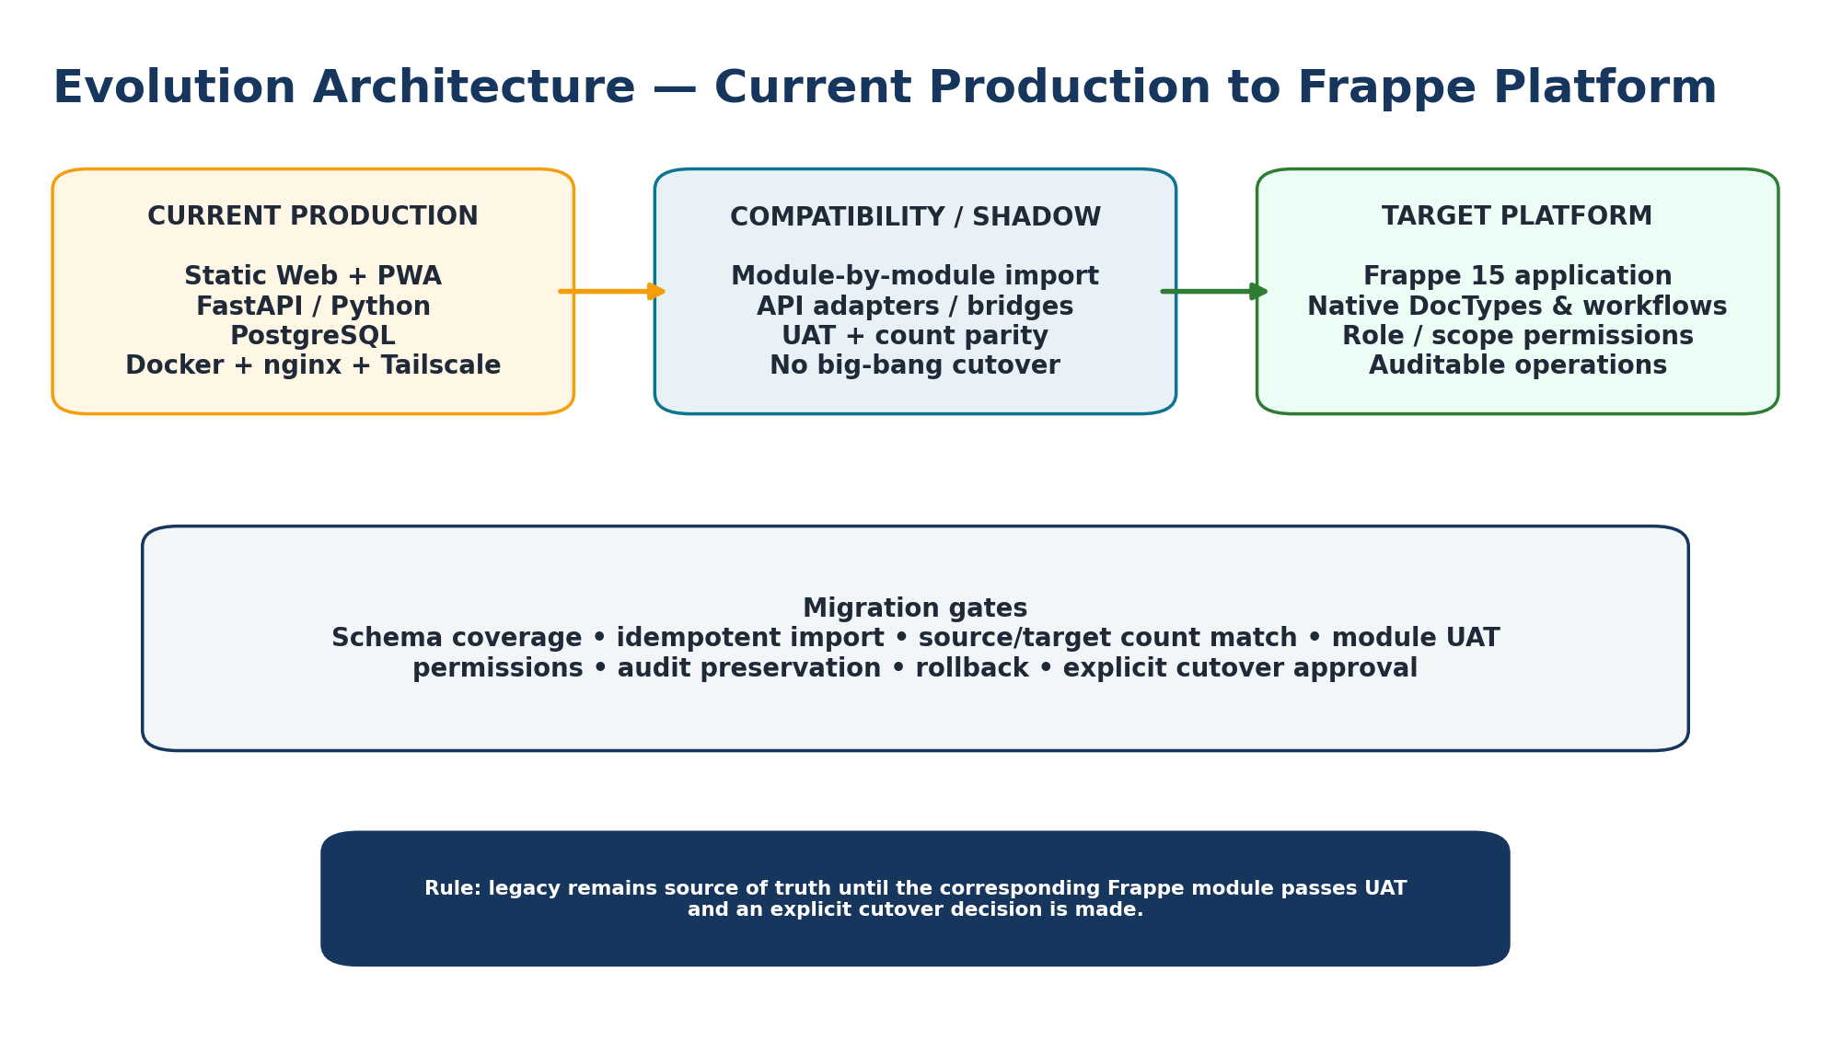
Evolution architecture: current production, compatibility/shadow, and Frappe target.

14.1 Current production baseline
Component | Current Baseline
Web/static repo | /volume1/web/rescue-net
Legacy backend runtime | /volume1/docker/rescue-net-api
PWA runtime | /volume1/web/rescue-net-app
API container / port | rescue-net-api / 8092
Database | postgres-main / rescuenet_db
Docker network | rescue-net-net
Reverse proxy | nginx
Public access | Tailscale Funnel / ts.net host
Frappe shadow/pilot | osiun.localhost, backend on 8095, app rescue_net

14.2 Operations guardrails
- Do not recreate PostgreSQL container or delete volumes without tested restore.
- Capture container image, command, mounts, network, environment, restart policy, and port mappings before recreation.
- If public access fails while direct/local health is normal, audit nginx/Tailscale before changing application code.
- Backup before migration; preflight on staging/copy; rollback path must be concrete.
- Runtime secret backups stay outside Git; do not commit .env, inspect dumps, tokens, or evidence.

14.3 Observability / health path
1. Test backend directly.
2. Test reverse-proxy path locally.
3. Test public URL.
4. Inspect application logs only after routing layer is isolated.
5. Verify database connectivity and functional data endpoint—not just process health.

15. Frappe Migration Architecture

15.1 Migration strategy
Rescue-Net menggunakan migration-by-module, bukan big-bang. FastAPI/PostgreSQL tetap source of truth sampai module terkait lulus UAT dan cutover eksplisit disetujui. Existing UI dapat memakai compatibility bridge selama native Frappe UX belum final.
Gate | Definition
DocType coverage | Target fields mencakup source table/API semantics.
Idempotent import | Importer dapat dijalankan ulang tanpa duplicate or destructive mutation.
Count parity | Source/target counts atau reconciled deltas dapat dijelaskan.
Semantic UAT | Create/read/update/state transitions mengikuti legacy/domain rule.
Permissions | Admin/command/Posko/verifier/public/donor scopes diuji.
Audit preservation | History/provenance dipertahankan atau intentionally transformed.
Compatibility | Existing UI/API consumer tidak diputus sebelum replacement siap.
Rollback | Production route dan source remain recoverable.
Explicit cutover | Tidak ada reroute hanya karena shadow terlihat sehat.

15.2 Current platform versions in shadow/pilot
Component | Observed Version / State
Frappe | 15.113.4
ERPNext | 15.115.0
rescue_net app | 0.0.1
Mode | Shadow / pilot; no production cutover
Public UAT | Dedicated Frappe public endpoint on the same host environment

16. Current Implementation Snapshot
Snapshot based on implementation/UAT activity through 24 August 2026. “Implemented” does not imply production cutover.
Module | Status | Notes
Community Reporting + Posko | Implemented / UAT | Native reporting, Posko handling, GPS/admin-area flow.
Verification / Privacy / Freshness | Implemented / UAT | Foundation for scoped access and privacy-safe operational views.
Logistics / Stock / Distribution | Implemented / UAT | Need, stock observation, aid offer, distribution and transport semantics.
WhatsApp Posko | Implemented | Operational integration path available.
Medical | Implemented / UAT | Privacy-first case workflow.
Shelter | Implemented / UAT | Occupancy/need separation.
Volunteer | Implemented / UAT | Assignment / availability workflow.
Search & Found | Implemented / UAT | Restricted identity and safe dashboard principle.
Resource Tools | Implemented / UAT | Resource/capability separate from stock/transport.
Kitchen | Implemented / UAT | Production/consumption semantics.
Donor Program | Backend UAT | Generated UI rejected/removed; redesign deferred to mockup-native Frappe UX.
Program Khusus | Backend UAT | Special budget semantics validated.
Recovery | Backend UAT | Progress non-regression, spend accumulation, soft lifecycle.
AI BYOK + Context | Backend UAT + bridge | Privacy-safe context and masked-key handling validated; no real provider call required for UAT.
Logistics Normalization | Implemented / UAT | Admin-configurable rules + fallback classifier; 11 idempotent baseline rules.
Sync Console / Sync Log | Next P2 cluster | Planned next after normalization/AI integration stabilization.

Recent milestone: configurable logistics normalization defaults committed locally as 033a2d4. Local Git history may be ahead of origin; push is intentionally separate from implementation work.

17. National Scaling Architecture
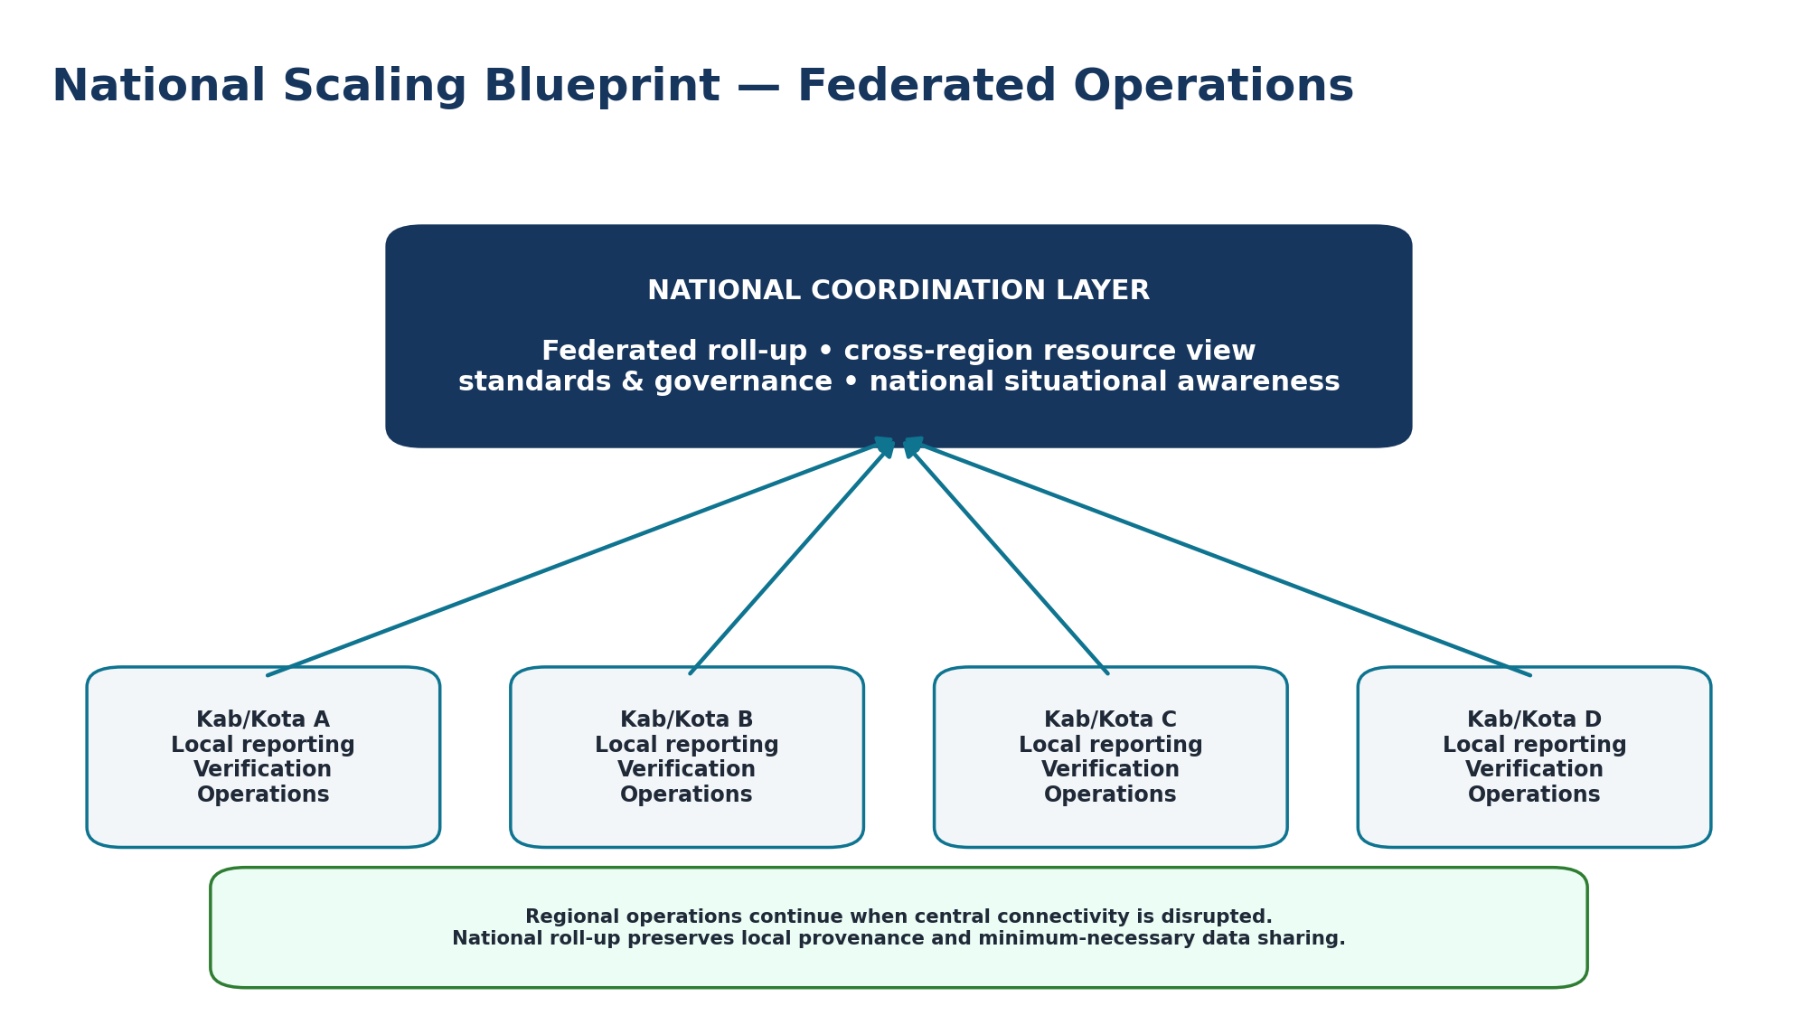
Federated national model: local operations remain autonomous enough to continue during central connectivity disruption.

17.1 Scaling principles
- Regional operations continue when central connectivity is disrupted.
- National layer performs federated roll-up and cross-region coordination without deleting local provenance.
- Data sharing follows minimum-necessary principle and clear authority boundaries.
- Rollout progresses through lab → tabletop → single district → multi-district → provincial → inter-provincial → national integration.

17.2 Operating model
Level | Role
National | Standards, national roll-up, cross-region resource coordination, governance.
Provincial | Regional coordination, escalation, stewardship.
District / City | Operational command, data quality, local authority.
Village / Posko | Field capture, verification, distribution evidence, local response.
Organization | Resources, verifier contribution, operational support.

18. Quality Gates, KPIs & Roadmap

18.1 Recommended operational KPIs
KPI | Purpose
Report → first review time | Mengukur kecepatan triage tanpa mengorbankan quality.
Duplicate/overlap candidate rate | Mengukur data noise dan kebutuhan consolidation review.
Open need aging | Menemukan kebutuhan yang belum ditangani terlalu lama.
Stock freshness / coverage | Menilai apakah snapshot cukup baru untuk keputusan.
Offer → receipt cycle time | Mengukur efisiensi bantuan sampai penerimaan.
Shelter occupancy vs capacity | Mengidentifikasi capacity gap.
Medical critical case backlog | Prioritas koordinasi kasus.
Search-found match resolution time | Mengukur efektivitas koordinasi.
Volunteer utilization / conflicts | Mencegah double-booking dan unused skills.
Offline sync backlog / failure rate | Mengukur resilience lapangan.
AI override / rejection rate | Governance dan model quality; bukan target untuk “memaksimalkan AI”.

18.2 Product priority order
1. Stability before scale
2. Data quality before analytics
3. Consolidation before distribution optimization
4. Offline reliability before native expansion
5. Traceability before automation
6. Pilot before national rollout
7. Capability before menu

18.3 Near-term roadmap
Priority | Workstream
P0 / Stabilize | Freeze validated modules, regression coverage, secrets rotation, access policies, backup/restore rehearsals.
P2 / Sync | Native Sync Log / Sync Console, reconciliation visibility, device/offline conflict handling.
UX | Build new Frappe-native UI from actual approved mockups; preserve existing UI until replacement passes UAT.
AI Governance | Close context parity gaps, add provenance/evaluation, optional OCR/similarity shadow-first.
Pilot | Tabletop and single-area operational exercise with explicit success/failure criteria.
Scaling | Federated regional nodes, HA, external data exchange, formal security/privacy assurance.

Appendix A. Source Basis & Glossary

A.1 Primary internal source basis
Reference | How it informs this blueprint
Volume 2 — Enterprise & System Architecture | Principles, C4/context, logical layers, domain boundaries, operational truth pipeline, deployment baseline.
Volume 3 — Data & Integration Architecture | Immutable/provenance data principles, conceptual model, data classification, API/offline/integration foundations.
Volume 5 — Engineering, Operations & Security | Coding standards, backend/frontend/PWA patterns, database rules, security/operations quality gates.
Volume 8 — API Reference & Integration Guide | API contracts, correction semantics, organization/Posko integration surfaces.
Volume 9 — AI Architecture & Intelligence Engine | Human-in-loop AI, provenance, OCR/similarity/summary/forecast architecture, privacy guardrails.
Volume 12 — Deployment, Infrastructure & Production Operations | Synology/Docker/nginx/Tailscale baseline, backup/rollback/troubleshooting guardrails.
Volume 13 — Product Roadmap & National Scaling | Priority order, rollout gates, federated national scaling and governance.
Current implementation/UAT records | Frappe shadow migration, module statuses, AI bridge, logistics normalization milestone through 24 Aug 2026.

A.2 Glossary
Term | Definition
Raw Report | Original field/user/source report preserved without destructive overwrite.
Operational Truth | Versioned operational record derived from evidence, verification, consolidation, and authority.
Posko | Operational node for local response and data scope.
Kelompok / Organization | Operational membership/resource boundary; internal data model uses organization.
Evidence | Media/document/location/witness artefact linked to a report/action with integrity metadata.
Consolidation | Process to detect overlap/duplicate and form operational records while preserving provenance.
Command Correction | Traceable human adjustment to an operational result; not mutation of raw source.
BYOK | Bring Your Own Key for an AI provider; secret remains backend-only.
Shadow / Pilot | Frappe environment used for migration/UAT without production cutover.
Compatibility Bridge | Temporary adapter allowing existing UI/API consumers to use new Frappe endpoints.
Freshness | Age/validity assessment based on observed/source timestamps and policy, not merely database modified time.

Document note
This blueprint is an architecture and implementation reference. It distinguishes confirmed implementation status from target design. National certification, formal government adoption, external security certification, and production cutover are not implied by this document.

