**PUNE INSTITUTE OF COMPUTER TECHNOLOGY, PUNE**

**ACADEMIC YEAR 2024-25**

**DEPARTMENT OF COMPUTER ENGINEERING**

**CNSL ASSIGNMENT NO 2**

**NAME : MISBAH IQBAL BAGWAN ROLL NO : 31455**

**BATCH : M4 CLASS: TE-IV**

**PROBLEM STATEMENT:** Setup a WAN which contains wired as well as wireless LAN by using a

packet tracer tool. Demonstrate transfer of a packet from LAN 1 (wired LAN) to LAN2 (Wireless LAN).

**REQUIREMENT :** **Cisco Packet Tracer Version Number 8.2.2**

**COURSE OBJECTIVES:**

1.To understand the fundamental concept of networking standards, protocols, and technologies

**COURSE OUTCOMES:**

1.Summarise fundamental concept of Computer Network, Architecture, protocols and technologies

**Theory:**

**DIFFERENCE BETWEEN GUIDED TRANSMISSION MEDIA AND UNGUIDED TRANSMISSION MEDIA**

|  |  |  |
| --- | --- | --- |
| **Feature** | **Guided Medium** | **Unguided Medium** |
| **Medium** | Coaxial cable ,shielded twisted pair cables -UTP and STP ,Fibre optic cables | Infrared,radiowave,  microwave,air,vaccum |
| **Data Transmission Rates** | |  | | --- | | higher |  |  | | --- | |  | | lower |
| **Installation** | Complex and costly | easier |
| **Applications** | **In LANS,TV,Internet ,telephony** | **WLANS ,mobile communication, satellite communication** |

**WIRELESS TOPOLOGIES**

**A)ADHOC**

An ad hoc wireless network is a decentralized type of wireless network where devices communicate directly with each other without relying on N/W devices like routers or access points.

This topology is also known as a peer-to-peer network.

device communicate directly without any intermediate devices

**B)INFRASTRUCTURE**

An infrastructure wireless network relies on access points (APs) and routers to manage communication between devices.

This topology is more structured compared to an ad hoc network.

The client stations do not communicate directly other client stations.

Rather, they communicate with the AP, and the AP forwards the frames to the destination station

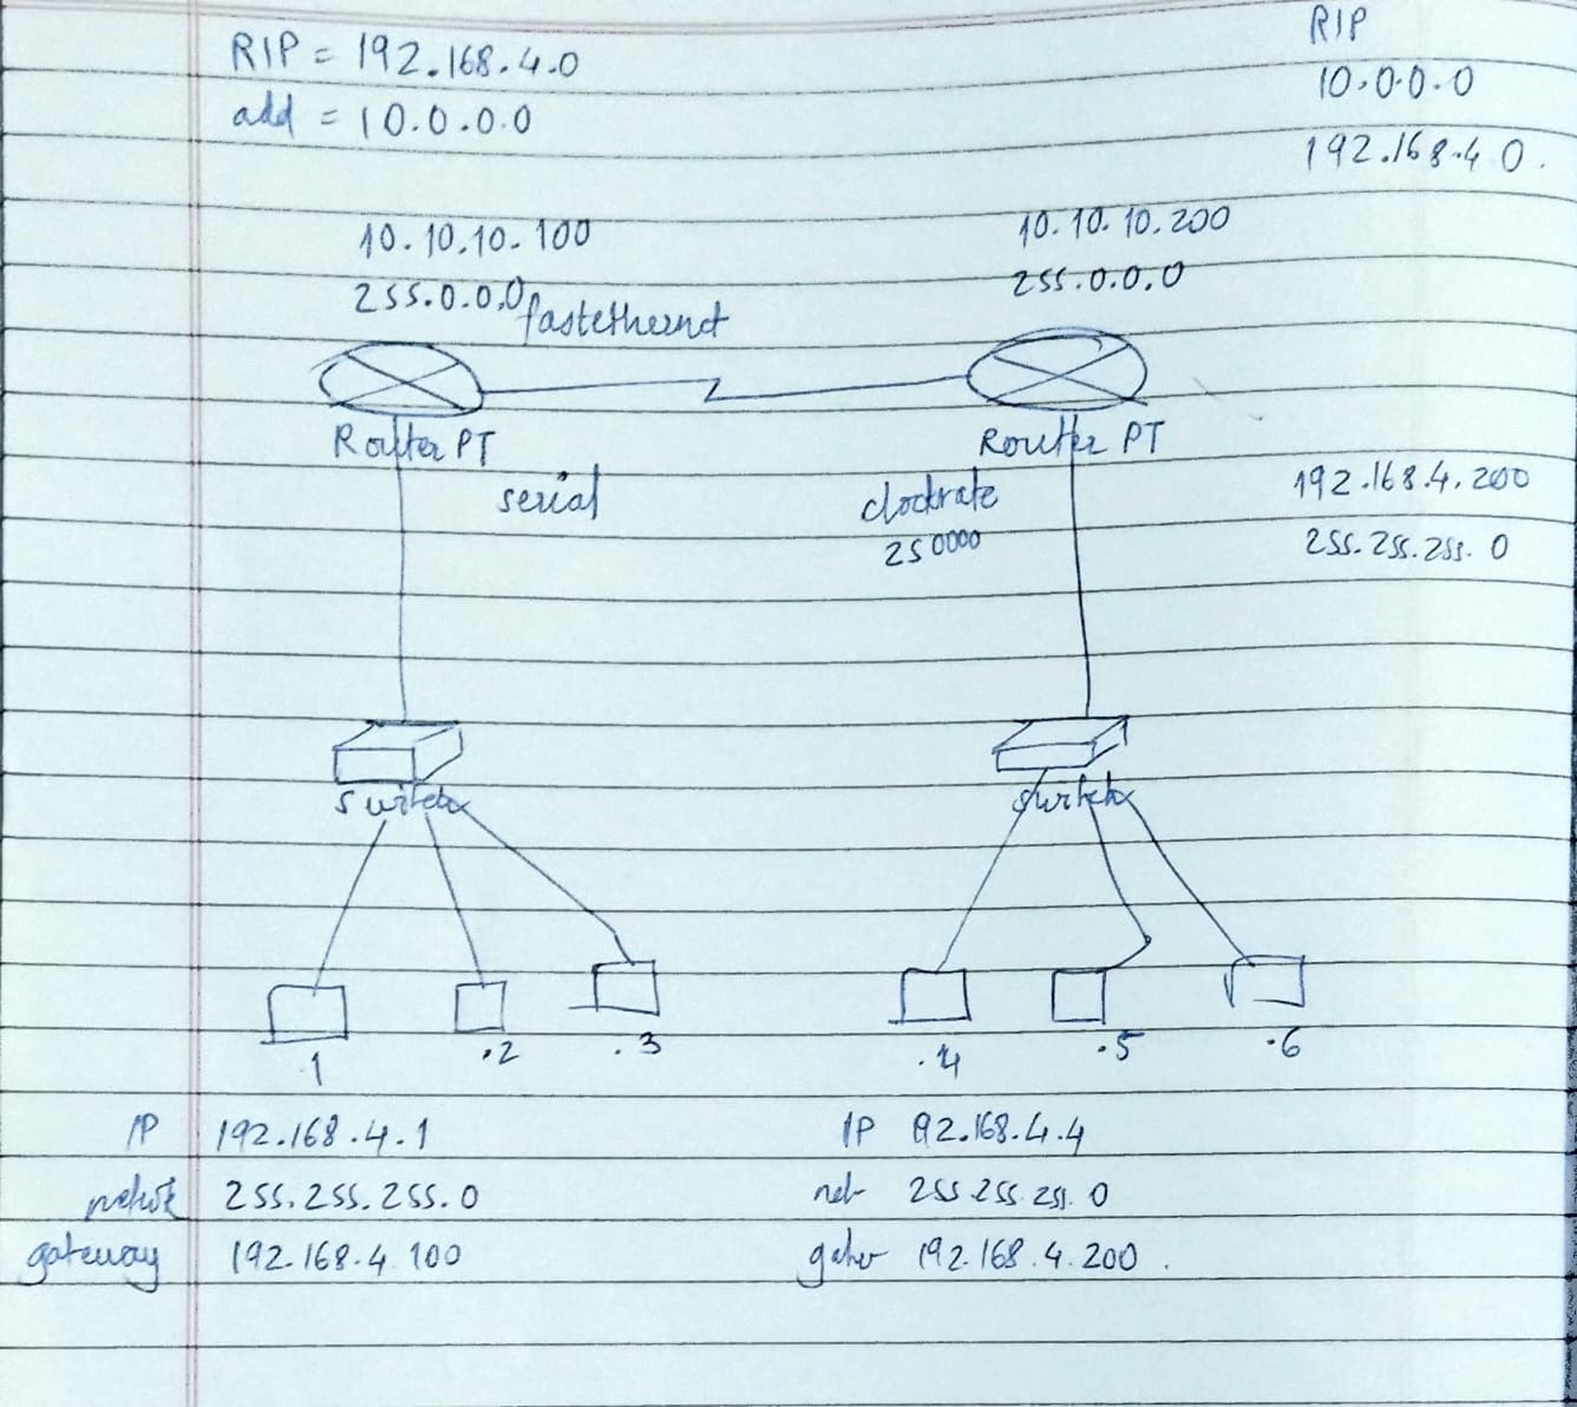

fastethernet

serial

**IEEE 802.11a, b, g, n Comparison Table :**

|  |  |  |  |  |
| --- | --- | --- | --- | --- |
| Standard | Release Year | Frequency band | Max Data transfer rate | Range |
| 802.11a | 1999 | 5 GHz | 54 Mbps | Shorter |
| 802.11b | 1999 | 2.4 GHz | 11 Mbps | Longer |
| 802.11g | 2003 | 2.4 GHz | 54 Mbps | Longer |
| 802.11n | 2009 | 2.4 GHz & 5 GHz | 600 Mbps (theoretical), 150-200 Mbps (practical) | Longer |

**Wired and Wireless LAN Network :**

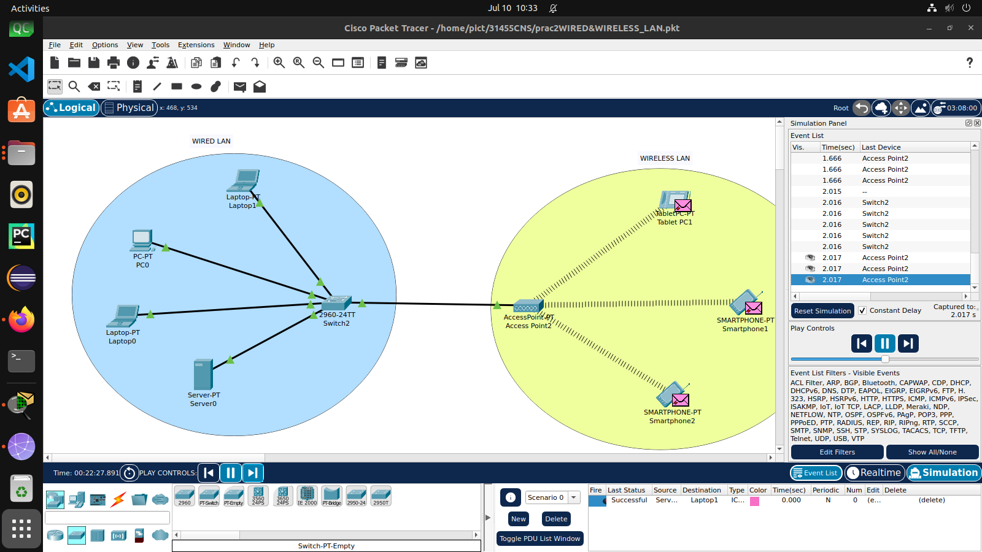

**WAN Network: Combining Wired and Wireless LAN *:***

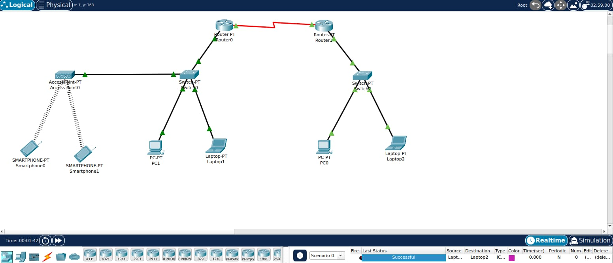

**TROUBLESHOOTING:**

While configuring Router , port was not on .

After turning on the ports I was able to send the packets

**CONCLUSION:**

In this practical assignment, I was able to set up a WAN combining a wired LAN and a wireless LAN using Cisco Packet Tracer v8.2.2.I demonstrated packet transfer between the two networks,