**Name : Misbah Bagwan**

**Roll no: 31455**

**Problem Statement:**

**1. Implement a web page index.htm for any client website (e.g., a restaurant website project) using following: a. HTML syntax: heading tags, basic tags and attributes, frames, tables, images, lists, links for text and images, forms etc. b. Use of Internal CSS, Inline CSS, External CSS**

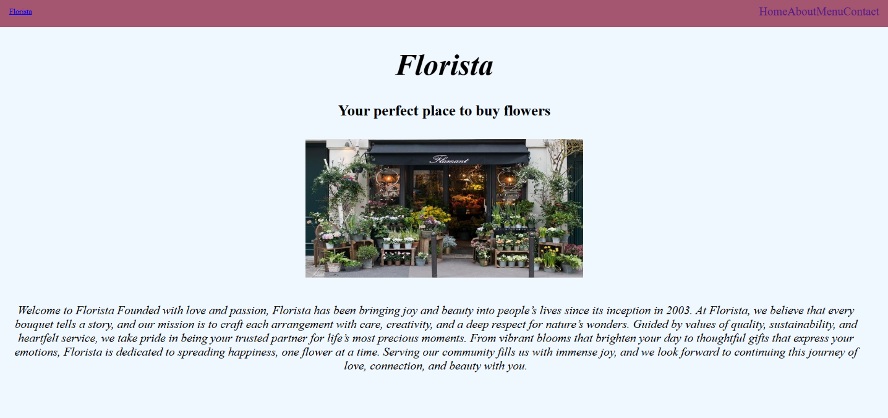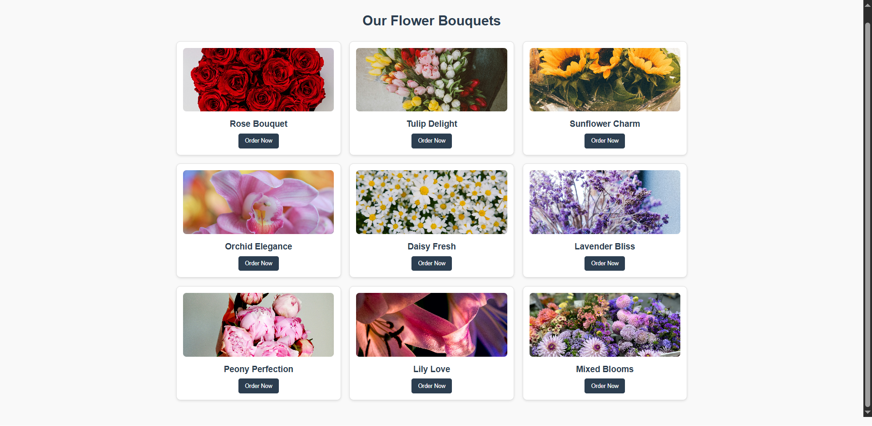

**home.html**

<!DOCTYPE html>

<html lang="en">

<head>

    <link rel="stylesheet" href="style.css">

    <meta charset="UTF-8">

    <meta name="viewport" content="width=device-width, initial-scale=1.0">

    <title>FLORISTA</title>

</head>

<body>

    <div class="navbar">

        <a href="#" class="logo">Florista</a>

        <ul>

            <li><a href="home.html">Home</a></li>

            <li><a href="about.html">About</a></li>

            <li><a href="menu.html">Menu</a></li>

            <li><a href="contact.html">Contact</a></li>

        </ul>

    </div>

    <h1 id="h1_1"><i>Florista</i></h1>

    <h4 id="h4_1">Your perfect place to buy flowers </h4>

    <img src="images/img3.jpeg" id="img1" width="600px" height="300px">

    <div id="para_div">

        <p id="intro_para">

            Welcome to Florista

            Founded with love and passion, Florista has been bringing joy and beauty into people’s lives since its inception in

            2003. At Florista, we believe that every bouquet tells a story, and our mission is to craft each

            arrangement with care, creativity, and a deep respect for nature’s wonders. Guided by values of quality, sustainability,

            and heartfelt service, we take pride in being your trusted partner for life’s most precious moments. From vibrant blooms

            that brighten your day to thoughtful gifts that express your emotions, Florista is dedicated to spreading happiness, one

            flower at a time. Serving our community fills us with immense joy, and we look forward to continuing this journey of

            love, connection, and beauty with you.

        </p>

    </div>

</body>

</html>

**menu.html**

<!DOCTYPE html>

<html lang="en">

<head>

  <meta charset="UTF-8">

  <meta name="viewport" content="width=device-width, initial-scale=1.0">

  <title>Florista - Menu</title>

  <style>

    body {

      margin: 0;

      font-family: Arial, sans-serif;

      background-color: #f9f9f9;

    }

    .menu-container {

      max-width: 1200px;

      margin: 20px auto;

      padding: 20px;

    }

    .menu-title {

      text-align: center;

      font-size: 32px;

      color: #2c3e50;

      margin-bottom: 30px;

    }

    .flower-grid {

      display: grid;

      grid-template-columns: repeat(3, 1fr);

      gap: 20px;

    }

    .flower-card {

      background-color: #ffffff;

      border: 1px solid #e0e0e0;

      border-radius: 10px;

      padding: 15px;

      box-shadow: 0 2px 5px rgba(0, 0, 0, 0.1);

      text-align: center;

      transition: transform 0.3s ease, box-shadow 0.3s ease;

    }

    .flower-card:hover {

      transform: translateY(-5px);

      box-shadow: 0 4px 10px rgba(0, 0, 0, 0.2);

    }

    .flower-card img {

      max-width: 100%;

      border-radius: 8px;

      height: 150px;

      object-fit: cover;

    }

    .flower-card h3 {

      font-size: 20px;

      color: #2c3e50;

      margin: 15px 0 10px;

    }

    .flower-card button {

      padding: 10px 15px;

      background-color: #2c3e50;

      color: #ffffff;

      border: none;

      border-radius: 5px;

      cursor: pointer;

      transition: background-color 0.3s ease;

    }

    .flower-card button:hover {

      background-color: #f1c40f;

    }

  </style>

</head>

<body>

  <div class="menu-container">

    <h1 class="menu-title">Our Flower Bouquets</h1>

    <div class="flower-grid">

      <div class="flower-card">

        <img src="images\rose1.jpg" alt="Rose Bouquet" width="400px" height="200px">

        <h3>Rose Bouquet</h3>

        <button>Order Now</button>

    </div>

      <div class="flower-card">

        <img src="images\tulips.jpg" alt="Tulip Delight" width="400px" height="200px">

        <h3>Tulip Delight</h3>

        <button>Order Now</button>

      </div>

      <div class="flower-card">

        <img src="images\sun1.jpg" alt="Sunflower Charm" width="400px" height="200px">

        <h3>Sunflower Charm</h3>

        <button>Order Now</button>

      </div>

      <div class="flower-card">

        <img src="images\orc2.jpg" alt="Orchid Elegance" width="400px" height="200px">

        <h3>Orchid Elegance</h3>

        <button>Order Now</button>

      </div>

      <div class="flower-card">

        <img src="images\da1.jpg" alt="Daisy Fresh" width="400px" height="200px">

        <h3>Daisy Fresh</h3>

        <button>Order Now</button>

      </div>

      <div class="flower-card">

        <img src="images\lav1.jpg" alt="Lavender Bliss" width="400px" height="400px">

        <h3>Lavender Bliss</h3>

        <button>Order Now</button>

      </div>

      <div class="flower-card">

        <img src="images\pe2.jpg" alt="Peony Perfection" width="400px" height="200px">

        <h3>Peony Perfection</h3>

        <button>Order Now</button>

      </div>

      <div class="flower-card">

        <img src="images\lily1.jpg" alt="Lily Love" width="400px" height="200px">

        <h3>Lily Love</h3>

        <button>Order Now</button>

      </div>

      <div class="flower-card">

        <img src="images\mi1.jpg" alt="Mixed Blooms" width="400px" height="200px">

        <h3>Mixed Blooms</h3>

        <button>Order Now</button>

      </div>

    </div>

  </div>

</body>

</html>

**about.html**

<!DOCTYPE html>

<html lang="en">

<head>

  <meta charset="UTF-8">

  <meta name="viewport" content="width=device-width, initial-scale=1.0">

  <title>Florista - About Us</title>

  <style>

    body {

      margin: 0;

      font-family: 'Arial', sans-serif;

      background-color: #f9f9f9;

      color: #2c3e50;

    }

    .about-container {

      max-width: 900px;

      margin: 50px auto;

      padding: 20px;

      background-color: #ffffff;

      border-radius: 10px;

      box-shadow: 0 2px 10px rgba(0, 0, 0, 0.1);

    }

    .about-title {

      text-align: center;

      font-size: 36px;

      margin-bottom: 20px;

      color: #2c3e50;

    }

    .about-section {

      margin-bottom: 30px;

    }

    .about-section h2 {

      font-size: 24px;

      margin-bottom: 10px;

      color: #f39c12;

    }

    .about-section p {

      font-size: 16px;

      line-height: 1.8;

      margin-bottom: 10px;

    }

    .about-footer {

      text-align: center;

      font-size: 16px;

      color: #7f8c8d;

    }

  </style>

</head>

<body>

  <div class="about-container">

    <h1 class="about-title">About Florista</h1>

    <div class="about-section">

      <h2>Our Story</h2>

      <p>Founded in 2010, Florista began with a simple dream: to bring joy to people’s lives through the beauty of

        flowers. What started as a small, family-run flower shop has blossomed into a beloved brand known for its

        high-quality blooms and impeccable service.</p>

      <p>Over the years, we’ve worked tirelessly to create a place where everyone can find the perfect floral

        arrangement for any occasion, whether it’s a wedding, a birthday, or just to brighten someone’s day.</p>

    </div>

    <div class="about-section">

      <h2>Our Values</h2>

      <p>At Florista, we believe in spreading happiness, one flower at a time. Our core values include:</p>

      <ul>

        <li><strong>Excellence:</strong> We strive to deliver the freshest flowers and exceptional customer service

          every time.</li>

        <li><strong>Creativity:</strong> Our floral arrangements are designed with love and creativity to suit any style

          or event.</li>

        <li><strong>Community:</strong> We’re proud to support local growers and give back to our community through

          various initiatives.</li>

      </ul>

    </div>

    <div class="about-section">

      <h2>Why Choose Us?</h2>

      <p>With over a decade of experience, Florista has become a trusted name for flower lovers everywhere. Our

        customers choose us because:</p>

      <ul>

        <li>We source only the freshest and most vibrant flowers.</li>

        <li>Our team of expert florists ensures every bouquet is handcrafted to perfection.</li>

        <li>We offer reliable delivery services to bring smiles to your loved ones’ faces.</li>

      </ul>

    </div>

    <div class="about-section">

      <h2>A Note from Us</h2>

      <p>We are truly honored to be part of your special moments. Your trust and support inspire us to keep growing and

        delivering joy to your doorstep. Thank you for making Florista a part of your life.</p>

    </div>

    <div class="about-footer">

      <p>&copy; 2025 Florista. All rights reserved.</p>

    </div>

  </div>

</body>

</html>

**contact.html**

<!DOCTYPE html>

<html lang="en">

<head>

  <meta charset="UTF-8">

  <meta name="viewport" content="width=device-width, initial-scale=1.0">

  <title>Florista - Contact Us</title>

  <style>

    body {

      margin: 0;

      font-family: Arial, sans-serif;

      background-color: palevioletred;

    }

    .contact-container {

      max-width: 800px;

      margin: 50px auto;

      padding: 20px;

      background-color: #ffffff;

      border-radius: 10px;

      box-shadow: 0 2px 10px rgba(0, 0, 0, 0.1);

    }

    .contact-title {

      text-align: center;

      font-size: 32px;

      margin-bottom: 20px;

    }

    .contact-form {

      display: flex;

      flex-direction: column;

      gap: 15px;

    }

    .contact-form label {

      font-weight: bold;

    }

    .contact-form input,

    .contact-form textarea,

    .contact-form button {

      font-size: 16px;

      padding: 10px;

      border: 1px solid #e0e0e0;

      border-radius: 5px;

      outline: none;

    }

    .contact-form textarea {

      resize: vertical;

    }

    .contact-form input:focus,

    .contact-form textarea:focus {

      border-color: #2c3e50;

    }

    .contact-form button {

      background-color: #2c3e50;

      color: white;

      cursor: pointer;

      transition: background-color 0.3s ease;

    }

    .contact-form button:hover {

      background-color: #f1c40f;

    }

    .contact-details {

      margin-top: 30px;

      text-align: center;

      font-size: 16px;

      line-height: 1.8;

    }

    .contact-details a {

      color: #2c3e50;

      text-decoration: none;

      font-weight: bold;

    }

    .contact-details a:hover {

      text-decoration: underline;

    }

  </style>

</head>

<body>

  <div class="contact-container">

    <h1 class="contact-title">Contact Us</h1>

    <form class="contact-form" action="submit_form.php" method="POST">

      <label for="name">Your Name:</label>

      <input type="text" id="name" name="name" placeholder="Enter your name" required>

      <label for="email">Your Email:</label>

      <input type="email" id="email" name="email" placeholder="Enter your email" required>

      <label for="message">Your Message:</label>

      <textarea id="message" name="message" rows="5" placeholder="Write your message here..." required></textarea>

      <button type="submit">Send Message</button>

    </form>

    <div class="contact-details">

      <p>You can also reach us at:</p>

      <p>Email: <a href="mailto:info@florista.com">info@florista.com</a></p>

      <p>Phone: <a href="tel:+1234567890">+1 234-567-890</a></p>

      <p>Address: Flora Complex ,Gulabnagar, Pune : 43 </p>

    </div>

  </div>

</body>

</html>