**Name : Misbah Bagwan**

**Roll no: 31455**

**Problem Statement: Design a login page with entries for name, mobile number email id**

**and login button. Use struts**

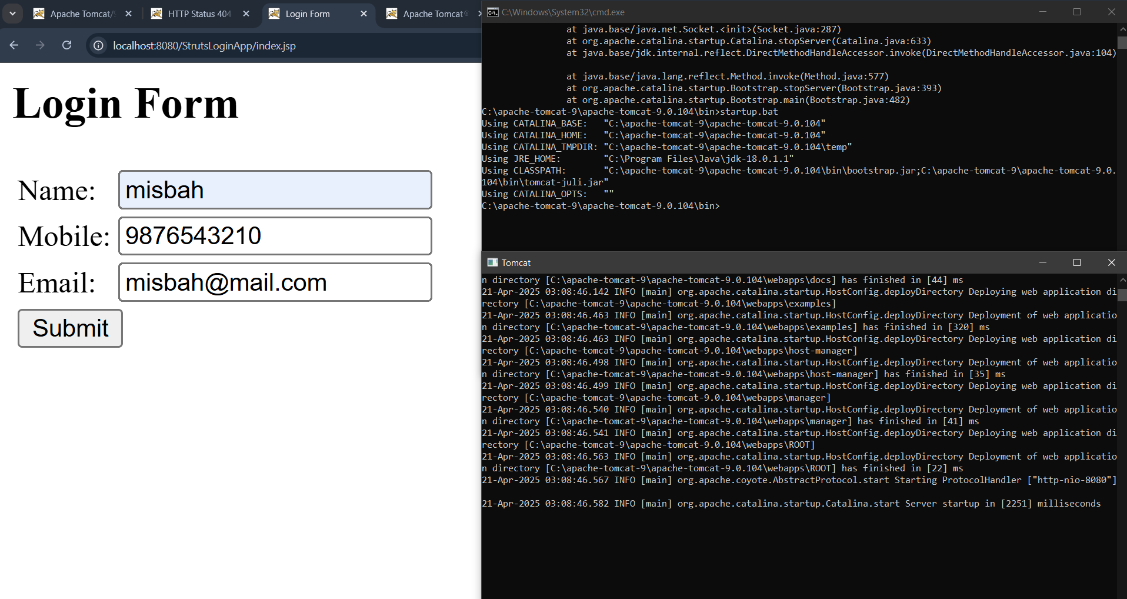

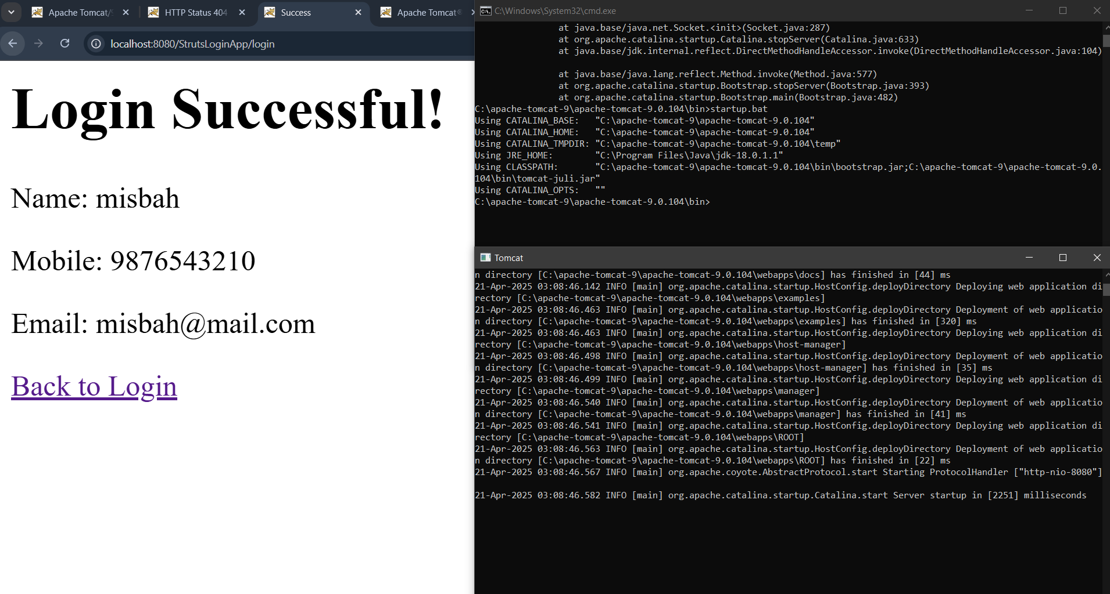

**LoginAction.java**

package com.login;

import com.opensymphony.xwork2.ActionSupport;

public class LoginAction extends ActionSupport {

private String name;

private String mobile;

private String email;

public String execute() {

return SUCCESS;

}

@Override

public void validate() {

if (name == null || name.trim().isEmpty()) {

addFieldError("name", "Name is required");

}

if (mobile == null || !mobile.matches("\\d{10}")) {

addFieldError("mobile", "Invalid mobile (10 digits only)");

}

if (email == null || !email.matches(".+@.+\\..+")) {

addFieldError("email", "Invalid email");

}

}

// Getters and setters

public String getName() {

return name;

}

public void setName(String name) {

this.name = name;

}

public String getMobile() {

return mobile;

}

public void setMobile(String mobile) {

this.mobile = mobile;

}

public String getEmail() {

return email;

}

public void setEmail(String email) {

this.email = email;

}

}

**index.jsp (Login Form):**

<%@ taglib prefix="s" uri="/struts-tags" %>

  <html>

  <head>

    <title>Login Form</title>

    <style>

      .errorMessage {

        color: red;

      }

    </style>

  </head>

  <body>

    <h2>Login Form</h2>

    <s:form action="login">

      <s:textfield name="name" label="Name" />

      <s:textfield name="mobile" label="Mobile" />

      <s:textfield name="email" label="Email" />

      <s:submit value="Submit" />

    </s:form>

    <s:fielderror />

  </body>

  </html>

**Success.jsp:**

<%@ taglib prefix="s" uri="/struts-tags" %>

  <html>

  <head>

    <title>Success</title>

  </head>

  <body>

    <h1>Login Successful!</h1>

    <p>Name:

      <s:property value="name" />

    </p>

    <p>Mobile:

      <s:property value="mobile" />

    </p>

    <p>Email:

      <s:property value="email" />

    </p>

    <a href="index.jsp">Back to Login</a>

  </body>

  </html>

**Web.xml:**

<?xml version="1.0"?>

<web-app xmlns="http://java.sun.com/xml/ns/javaee"

         xmlns:xsi="http://www.w3.org/2001/XMLSchema-instance"

         xsi:schemaLocation="http://java.sun.com/xml/ns/javaee http://java.sun.com/xml/ns/javaee/web-app_3_0.xsd"

         version="3.0">

    <context-param>

        <param-name>struts.devMode</param-name>

        <param-value>true</param-value>

    </context-param>

    <filter>

        <filter-name>struts2</filter-name>

        <filter-class>org.apache.struts2.dispatcher.filter.StrutsPrepareAndExecuteFilter</filter-class>

    </filter>

    <filter-mapping>

        <filter-name>struts2</filter-name>

        <url-pattern>/*</url-pattern>

    </filter-mapping>

</web-app>

**Struts.xml**

<!DOCTYPE *struts* PUBLIC

    "-//Apache Software Foundation//DTD Struts Configuration 2.5//EN"

    "http://struts.apache.org/dtds/struts-2.5.dtd">

<struts>

    <package name="default" extends="struts-default" namespace="/">

        <action name="login" class="com.login.LoginAction">

            <result name="success">/success.jsp</result>

            <result name="input">/index.jsp</result>

        </action>

    </package>

</struts>