**Name : Misbah Bagwan**

**Roll no: 31455**

**Problem Statement:** **Design the XML document to store the information of the employees of any business organization and demonstrate the use of: a) DTD b) XML Schema And display the content in (e.g., tabular format) by using CSS/XSL.**

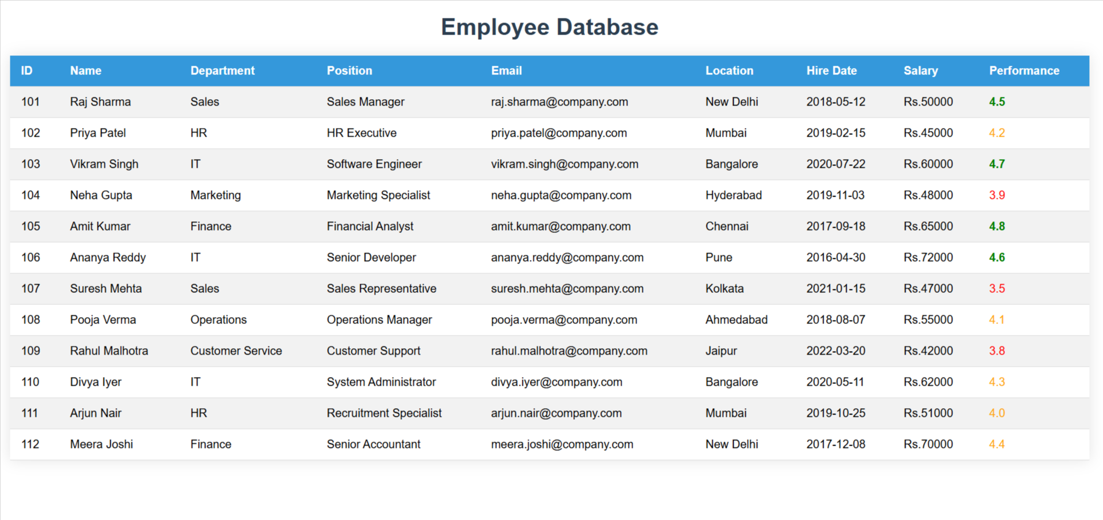

**employee.xsd**

<?xml version="1.0" encoding="UTF-8"?>

<xs:schema xmlns:xs="http://www.w3.org/2001/XMLSchema">

    <xs:element name="employees">

        <xs:complexType>

            <xs:sequence>

                <xs:element name="employee" maxOccurs="unbounded">

                    <xs:complexType>

                        <xs:sequence>

                            <xs:element name="id" type="xs:int"/>

                            <xs:element name="name" type="xs:string"/>

                            <xs:element name="department" type="xs:string"/>

                            <xs:element name="salary" type="xs:decimal"/>

                            <xs:element name="position" type="xs:string"/>

                        </xs:sequence>

                    </xs:complexType>

                </xs:element>

            </xs:sequence>

        </xs:complexType>

    </xs:element>

</xs:schema>

**employee.dtd**

<!ELEMENT employees (employee+)>

<!ELEMENT employee (id, name, department, salary, position)>

<!ELEMENT id (#PCDATA)>

<!ELEMENT name (#PCDATA)>

<!ELEMENT department (#PCDATA)>

<!ELEMENT salary (#PCDATA)>

<!ELEMENT position (#PCDATA)>

**index.html**

<!DOCTYPE html>

<html lang="en">

<head>

  <meta charset="UTF-8">

  <meta name="viewport" content="width=device-width, initial-scale=1.0">

  <title> Employee Database</title>

  <style>

    body {

      font-family: Arial, sans-serif;

      margin: 20px;

    }

    h1 {

      text-align: center;

      color: #2c3e50;

    }

    table {

      width: 100%;

      margin: 20px auto;

      border-collapse: collapse;

      box-shadow: 0 0 20px rgba(0, 0, 0, 0.1);

    }

    th,

    td {

      padding: 12px 15px;

      text-align: left;

      border-bottom: 1px solid #ddd;

    }

    th {

      background-color: #3498db;

      color: white;

      position: sticky;

      top: 0;

    }

    tr:nth-child(even) {

      background-color: #f2f2f2;

    }

    tr:hover {

      background-color: #e2e2e2;

    }

    .rating-high {

      color: green;

      font-weight: bold;

    }

    .rating-medium {

      color: orange;

    }

    .rating-low {

      color: red;

    }

  </style>

</head>

<body>

  <h1> Employee Database</h1>

  <div id="employeeTable"></div>

  <script>

    const xmlString = `<?xml version="1.0" encoding="UTF-8"?>

    <!DOCTYPE employees SYSTEM "employee.dtd">

    <employees>

        <employee>

            <id>101</id>

            <name>Raj Sharma</name>

            <department>Sales</department>

            <salary>50000</salary>

            <position>Sales Manager</position>

            <email>raj.sharma@company.com</email>

            <hireDate>2018-05-12</hireDate>

            <performanceRating>4.5</performanceRating>

            <location>New Delhi</location>

        </employee>

        <employee>

            <id>102</id>

            <name>Priya Patel</name>

            <department>HR</department>

            <salary>45000</salary>

            <position>HR Executive</position>

            <email>priya.patel@company.com</email>

            <hireDate>2019-02-15</hireDate>

            <performanceRating>4.2</performanceRating>

            <location>Mumbai</location>

        </employee>

        <employee>

            <id>103</id>

            <name>Vikram Singh</name>

            <department>IT</department>

            <salary>60000</salary>

            <position>Software Engineer</position>

            <email>vikram.singh@company.com</email>

            <hireDate>2020-07-22</hireDate>

            <performanceRating>4.7</performanceRating>

            <location>Bangalore</location>

        </employee>

        <employee>

            <id>104</id>

            <name>Neha Gupta</name>

            <department>Marketing</department>

            <salary>48000</salary>

            <position>Marketing Specialist</position>

            <email>neha.gupta@company.com</email>

            <hireDate>2019-11-03</hireDate>

            <performanceRating>3.9</performanceRating>

            <location>Hyderabad</location>

        </employee>

        <employee>

            <id>105</id>

            <name>Amit Kumar</name>

            <department>Finance</department>

            <salary>65000</salary>

            <position>Financial Analyst</position>

            <email>amit.kumar@company.com</email>

            <hireDate>2017-09-18</hireDate>

            <performanceRating>4.8</performanceRating>

            <location>Chennai</location>

        </employee>

        <employee>

            <id>106</id>

            <name>Ananya Reddy</name>

            <department>IT</department>

            <salary>72000</salary>

            <position>Senior Developer</position>

            <email>ananya.reddy@company.com</email>

            <hireDate>2016-04-30</hireDate>

            <performanceRating>4.6</performanceRating>

            <location>Pune</location>

        </employee>

        <employee>

            <id>107</id>

            <name>Suresh Mehta</name>

            <department>Sales</department>

            <salary>47000</salary>

            <position>Sales Representative</position>

            <email>suresh.mehta@company.com</email>

            <hireDate>2021-01-15</hireDate>

            <performanceRating>3.5</performanceRating>

            <location>Kolkata</location>

        </employee>

        <employee>

            <id>108</id>

            <name>Pooja Verma</name>

            <department>Operations</department>

            <salary>55000</salary>

            <position>Operations Manager</position>

            <email>pooja.verma@company.com</email>

            <hireDate>2018-08-07</hireDate>

            <performanceRating>4.1</performanceRating>

            <location>Ahmedabad</location>

        </employee>

        <employee>

            <id>109</id>

            <name>Rahul Malhotra</name>

            <department>Customer Service</department>

            <salary>42000</salary>

            <position>Customer Support</position>

            <email>rahul.malhotra@company.com</email>

            <hireDate>2022-03-20</hireDate>

            <performanceRating>3.8</performanceRating>

            <location>Jaipur</location>

        </employee>

        <employee>

            <id>110</id>

            <name>Divya Iyer</name>

            <department>IT</department>

            <salary>62000</salary>

            <position>System Administrator</position>

            <email>divya.iyer@company.com</email>

            <hireDate>2020-05-11</hireDate>

            <performanceRating>4.3</performanceRating>

            <location>Bangalore</location>

        </employee>

        <employee>

            <id>111</id>

            <name>Arjun Nair</name>

            <department>HR</department>

            <salary>51000</salary>

            <position>Recruitment Specialist</position>

            <email>arjun.nair@company.com</email>

            <hireDate>2019-10-25</hireDate>

            <performanceRating>4.0</performanceRating>

            <location>Mumbai</location>

        </employee>

        <employee>

            <id>112</id>

            <name>Meera Joshi</name>

            <department>Finance</department>

            <salary>70000</salary>

            <position>Senior Accountant</position>

            <email>meera.joshi@company.com</email>

            <hireDate>2017-12-08</hireDate>

            <performanceRating>4.4</performanceRating>

            <location>New Delhi</location>

        </employee>

    </employees>`;

    const xslString = `<?xml version="1.0" encoding="UTF-8"?>

    <xsl:stylesheet version="1.0" xmlns:xsl="http://www.w3.org/1999/XSL/Transform">

        <xsl:output method="html" indent="yes"/>

        <xsl:template match="/employees">

            <table>

                <tr>

                    <th>ID</th>

                    <th>Name</th>

                    <th>Department</th>

                    <th>Position</th>

                    <th>Email</th>

                    <th>Location</th>

                    <th>Hire Date</th>

                    <th>Salary</th>

                    <th>Performance</th>

                </tr>

                <xsl:for-each select="employee">

                    <tr>

                        <td><xsl:value-of select="id"/></td>

                        <td><xsl:value-of select="name"/></td>

                        <td><xsl:value-of select="department"/></td>

                        <td><xsl:value-of select="position"/></td>

                        <td><xsl:value-of select="email"/></td>

                        <td><xsl:value-of select="location"/></td>

                        <td><xsl:value-of select="hireDate"/></td>

                        <td>Rs.<xsl:value-of select="salary"/></td>

                        <td>

                            <xsl:choose>

                                <xsl:when test="performanceRating >= 4.5">

                                    <span class="rating-high"><xsl:value-of select="performanceRating"/></span>

                                </xsl:when>

                                <xsl:when test="performanceRating >= 4.0">

                                    <span class="rating-medium"><xsl:value-of select="performanceRating"/></span>

                                </xsl:when>

                                <xsl:otherwise>

                                    <span class="rating-low"><xsl:value-of select="performanceRating"/></span>

                                </xsl:otherwise>

                            </xsl:choose>

                        </td>

                    </tr>

                </xsl:for-each>

            </table>

        </xsl:template>

    </xsl:stylesheet>`;

    const parser = new DOMParser();

    const xmlDoc = parser.parseFromString(xmlString, "application/xml");

    const xslDoc = parser.parseFromString(xslString, "application/xml");

    const xsltProcessor = new XSLTProcessor();

    xsltProcessor.importStylesheet(xslDoc);

    const resultDocument = xsltProcessor.transformToFragment(xmlDoc, document);

    document.getElementById("employeeTable").appendChild(resultDocument);

  </script>

</body>

</html>