SIMATS ENGINEERING (SAVEETHA SCHOOL OF ENGINEERING)
Department of Computer Science and Engineering
CO1_AT2 — DATA INTERPRETATION EXERCISE
Course Code: | DSA0606 | Course Title: | Data Handling and Visualization
CO Assessed: | CO1 – Apply (BL3) | Assessment: | Assessment Tool 2 – Data Interpretation
Weightage: | 20% of CIA | Total Marks: | 20 (2 Questions × 20 Marks)
CO1 Statement: | Understand the fundamental concepts, principles, and techniques of data visualization. (BL2)
Student Name: | Bagya Vennkatesh | Reg. No.: | 1923242643
Section / Batch: | 2023 | Date: | 01-08-2026

Problem 10 (10 Marks)
Scenario: A market share pie chart shows four companies with shares of 45%, 30%, 15%, and 10%.
a) What coordinate system underlies a pie chart, and what two variables (r, θ) define each slice's boundary?
- Coordinate System: Polar Coordinate System
- Variables:
  - r (radius): Distance from the center to the edge of the circle.
  - θ (theta): Central angle that determines the size of each slice.

b) Calculate the angle (in degrees) of the slice representing the 30% market share.
Formula:
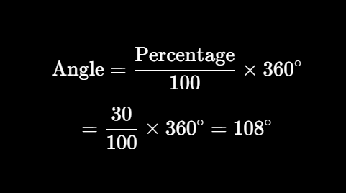
Answer: 108°

c) What is a key limitation of polar coordinates (pie charts) when more than 5–6 categories are shown?
Answer:
When a pie chart has more than 5–6 categories, the slices become too small and crowded, making it difficult to compare sizes and read labels accurately. A bar chart is generally more effective in such cases.
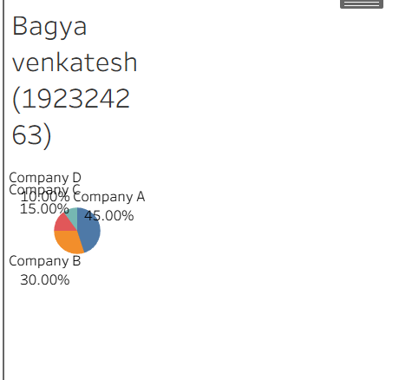

Problem 20 (10 Marks)
Scenario: A temperature anomaly map (showing how much warmer or cooler each region is compared to a historical average) uses a diverging red-blue color scale.
a) What does the color white (or the midpoint color) represent on this map?
Answer:
The white (or midpoint) color represents zero temperature anomaly, meaning the region's temperature is equal to the historical average (no warming or cooling).

b) If a region is shown in deep red, what can you conclude about that region's temperature relative to the historical average?
Answer:
A deep red region indicates a large positive temperature anomaly, meaning the region is much warmer than the historical average.

c) Why would a sequential (single-hue) color scale be a poor choice for this particular dataset?
Answer:
A sequential (single-hue) color scale is unsuitable because it only shows increasing values and cannot clearly distinguish between temperatures that are above and below the historical average. A diverging red-blue color scale is better since it highlights both warming (red) and cooling (blue) around the central value (zero anomaly).
