SIMATS ENGINEERING (SAVEETHA SCHOOL OF ENGINEERING)
Department of Computer Science and Engineering
CO1_AT2 — DATA INTERPRETATION EXERCISE
Course Code: | DSA0606 | Course Title: | Data Handling and Visualization
CO Assessed: | CO1 – Precision (BL2) | Assessment: | Assessment Tool 3 –Visualization Design
Weightage: | 40% of CIA | Total Marks: | 20 (2 Questions × 20 Marks)
CO1 Statement: | Understand the fundamental concepts, principles, and techniques of data visualization.(BL2)
Student Name: | Bagya Vennkatesh | Reg. No.: | 1923242643
Section / Batch: | 2023 | Date: | 01-08-2026

Problem 10 (10 Marks)
Scenario: A meteorologist wants to show wind direction (0°–360°) and wind speed (numeric) recorded every hour for one day.
a) Design a chart that uses polar coordinates to represent both wind direction and speed simultaneously. Describe the mapping.
Answer:
Use a Polar Scatter Plot (Wind Rose).
- θ (Theta) → Wind Direction (0°–360°)
- r (Radius) → Wind Speed (km/h)
Each point represents one hourly wind observation.

b) Why would Cartesian coordinates be a poor natural fit for the "direction" variable?
Answer:
Wind direction is circular (0° and 360° represent the same direction). Cartesian coordinates treat these values as being far apart, making directional relationships difficult to interpret. Polar coordinates naturally represent angles.

c) What additional aesthetic could you add to represent time of day?
Answer:
Use Color to represent the time of day (for example, a gradient from light colors for early morning to darker colors for evening). You can also use different point sizes or shapes, but color is the most common choice.

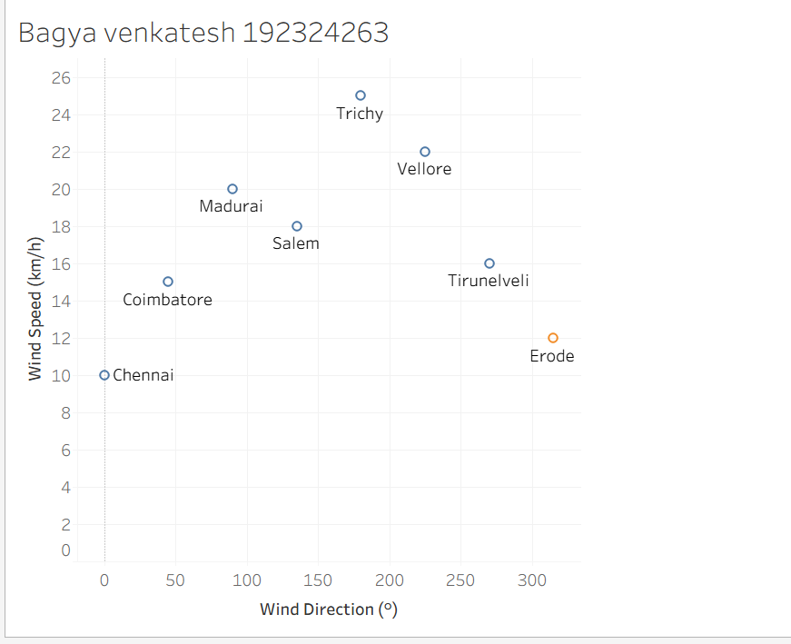
Problem 20 (10 Marks)
Scenario: An environmental agency wants to show carbon emissions change relative to a baseline year
(some regions improved, others worsened) across 20 countries.
a) Design a color scheme appropriate for this data. Justify the type of color scale.
Answer:
Use a diverging Red–Blue color scale:
- Blue → Decrease in carbon emissions (improvement)
- White → No change from the baseline
- Red → Increase in carbon emissions (worsening)
A diverging scale is appropriate because the data contains both negative and positive changes relative to a baseline.

b) What color would you assign to a country with no change from the baseline?
Answer:
White should represent no change (0%) because it is the midpoint of the diverging color scale, clearly separating improvements from worsening emissions.

c) Explain why a sequential color scale would misrepresent this dataset.
Answer:
A sequential color scale only represents values from low to high and cannot distinguish decreases (negative values) from increases (positive values). A diverging color scale correctly highlights changes on both sides of the baseline.

