SIMATS ENGINEERING (SAVEETHA SCHOOL OF ENGINEERING)
Department of Computer Science and Engineering
CO3_AT3 — VISUALIZATION CRITIQUE & REDESIGN

Course Code: | DSA06 | Course Title: | Data Handling and Visualization
CO Assessed: | CO3 – Evaluation (BL5) | Assessment: | Assessment Tool 3 – Critique & Redesign
Weightage: | 20% of CIA | Total Marks: | 25 (5 Questions × 5 Marks)
CO3 Statement: | Evaluate flawed or misleading data visualizations, critique their specific shortcomings, and justify an improved redesign.(BL5)
Student Name: | Bagya Venkatesh | Reg. No.: | 192324263
Section / Batch: | 2023 | Date: | 18.08.2026

Code of Conduct
I __________________________ (Name / Reg No) certify that this submission is my original work and that I have adhered to the guidelines specified for this assessment. I understand that any violation of academic integrity rules will result in disciplinary action.

Signature of the Student: _________________________

Instructions
- This test contains 5 questions, each carrying 5 marks. Total: 25 Marks.
- No negative marking. Unanswered questions carry zero marks.
- No calculators or electronic devices permitted.
- Duration: 90 minutes.
- Each answer must go beyond simply naming a flaw: explain WHY it is misleading and what a reader could wrongly conclude from it.
- Your redesign must be a specific, justified chart proposal — not just “use a different chart.”
- Diagrams may be hand-drawn or clearly described in words if drawing tools are unavailable.

Annexure A – VISUALIZATION CRITIQUE & REDESIGN

Rubrics for Calculation ASSESSMENT RUBRIC
AT3 — Visualization Critique & Redesign
CO3 · BT5: Evaluate ·
This rubric is used to assess student responses to the CO3-AT3 Visualization Critique & Redesign problems, in which students are given a flawed or misleading chart, must critique its specific shortcomings, and propose a justified redesign.

Criteria | Weightage | Level 4 – Exemplary | Level 3 – Proficient | Level 2 – Developing | Level 1 – Beginning
Understanding of Concepts | 25% | Demonstrates thorough understanding of the specific visualization principle being violated (e.g., proportional ink, axis scaling, color perception, overplotting) in the given flawed chart. | Good understanding of the relevant principle, with only minor gaps in identifying exactly what is violated. | Basic understanding, but with some misconceptions about which principle applies to the flaw shown. | Poor understanding of core principles; misidentifies the nature of the flaw entirely.
Explanation | 25% | Clearly explains why the flaw is misleading, including what a reader could wrongly conclude as a result — not just that something is 'wrong.' | Explains the flaw with adequate reasoning, covering most of why it misleads a reader. | Identifies the flaw but explanation is generic or only loosely tied to its misleading effect. | Little or no explanation of why the flaw is misleading; the critique is a bare assertion.
Application | 20% | Proposes a specific, well-justified redesign that directly resolves the identified flaw, correctly applying appropriate chart-selection and design principles. | Proposes a workable redesign that resolves the flaw, with only minor gaps in justification. | Proposes a redesign, but it only partially resolves the flaw or lacks sufficient justification. | Fails to propose a workable redesign, or the redesign does not address the identified flaw.
Organization | 15% | The response is clearly structured, addressing both the critique and the redesign in a logical sequence with coherent overall flow. | The response is organized and addresses both parts, with only minor issues in flow or clarity. | Basic structure; both parts are addressed but the response lacks clarity or a logical sequence. | Poorly organized; the response is incoherent, and one or both parts are left unaddressed.
Accuracy | 10% | Both the critique and the redesign are completely accurate and well-suited to the specific chart and data described. | Mostly accurate, with only minor omissions or a small error in the critique or redesign. | Partially correct; the critique or redesign contains notable inaccuracies or mismatches to the scenario. | Largely incorrect or inappropriate, with major gaps in both the critique and the redesign.

Scoring Guide
For each criterion, award a performance level (1–4) based on the descriptors above. Multiply the level achieved (as a percentage of 4, i.e., Level 4 = 100%, Level 3 = 75%, Level 2 = 50%, Level 1 = 25%) by the criterion's weightage, then sum across all five criteria to obtain the total score out of 100%.

Faculty In-charge | Course Coordinator | Head of Department
Signature: _______________ | Signature: _______________ | Signature: _______________
Date: ___________________ | Date: ___________________ | Date: ___________________

Problem 5 (5 Marks)
Scenario: A pie chart uses red, orange, and yellow for three nearly-equal-sized categories, making the
slices hard to visually tell apart at a glance.
a) Critique this color choice.
b) Redesign: propose a better color scheme and explain your reasoning.
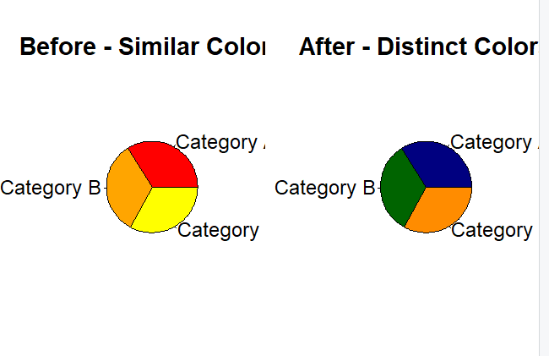
Problem 7 (5 Marks)
Scenario: A city report states “Region A's efficiency improved by 15%” without stating the original
baseline value or total scale.
a) Critique why percentage-only reporting like this can be misleading.
b) Redesign: what additional information or chart element would you add to fix this?
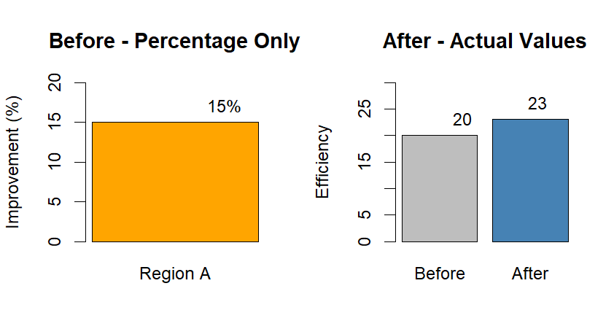
Problem 14 (5 Marks)
Scenario: A histogram of exam scores uses only 2 very wide bins, making the distribution's shape almost
impossible to interpret.
a) Critique the bin-width choice.
b) Redesign: explain how you would choose a better bin width or alternative technique.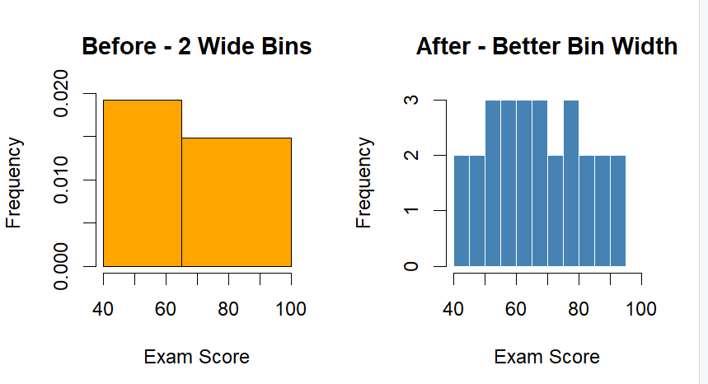
Problem 16 (5 Marks)
Scenario: A dashboard uses a dual-axis line chart to compare company sales (nearly flat) with an
unrelated metric (rising sharply), with mismatched, arbitrary axis scales making the two appear
correlated.
a) Critique why this dual-axis design is misleading.
b) Redesign: propose an alternative that avoids the false impression of correlation.
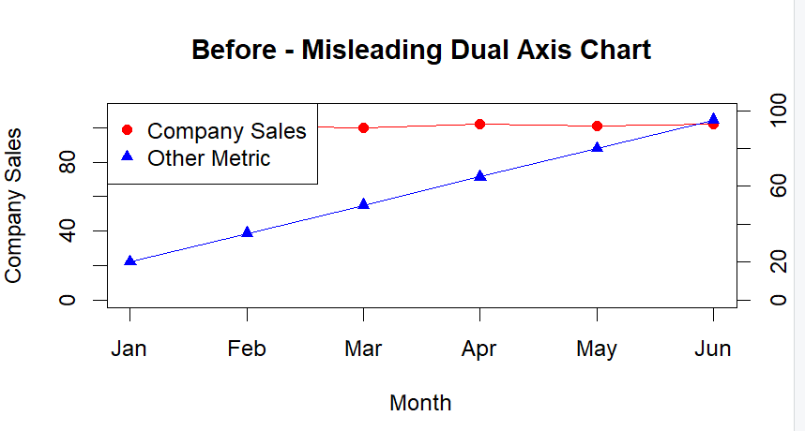

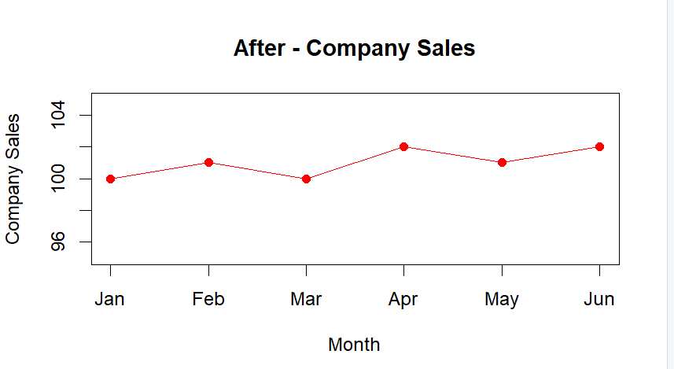

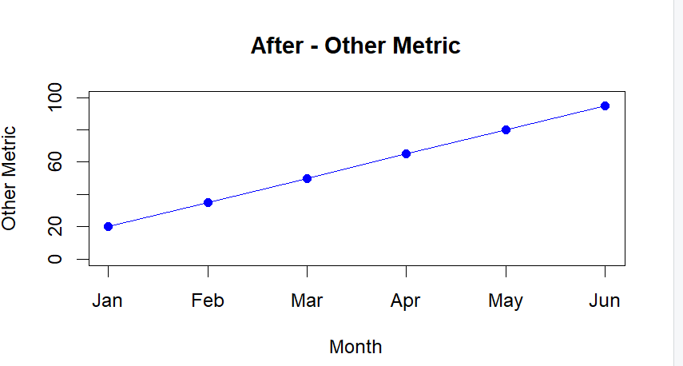

Problem 23 (5 Marks)
Scenario: A choropleth-style heatmap of sales by region uses a rainbow color scale (not perceptually
ordered) to represent a continuous variable.
a) Critique this color scale choice and why it makes the map hard to read.
b) Redesign: propose an appropriate color scale and explain why it is better suited to this data. 