SIMATS ENGINEERING (SAVEETHA SCHOOL OF ENGINEERING)
Department of Computer Science and Engineering
CO2_AT3 — CASE STUDY
Course Code: | DSA0606 | Course Title: | Data Handling and Visualization
CO Assessed: | CO2 – Evaluation (BL5) | Assessment: | Assessment Tool 3 – Case Study
Weightage: | 20% of CIA | Total Marks: | 20 (2 Questions × 10 Marks)
CO1 Statement: | Analyze real-world data scenarios and evaluate/justify the most appropriate chart types, coordinate systems, color scales, and dashboard designs to represent them .(BL5)
Student Name: | Bagya Venkatesh | Reg. No.: | 1923242643
Section / Batch: | 2023 | Date: | 04-08-2026

Q 10
CASE STUDY: CITY BUDGET ANALYSIS AND PUBLIC SERVICE VISUALIZATION
Introduction
Data visualization has become an essential component of modern public administration because governments generate large amounts of financial and public service data every year. City councils and municipal corporations rely on data to understand how public money is allocated, how effectively services are delivered, and how citizens perceive the quality of those services. However, raw numerical data alone cannot provide meaningful insights. Data visualization transforms complex datasets into charts, graphs, and dashboards that allow decision-makers to quickly understand patterns, trends, comparisons, and relationships.
A well-designed visualization enables city administrators to compare district-wise spending, evaluate changes in annual budgets, monitor citizen satisfaction, and identify areas that require improvement. Appropriate chart selection is important because different types of data require different visualization techniques. Numerical data is best represented using bar or line charts, while categorical and ordinal data require charts that preserve their logical order. Similarly, color plays an important role in highlighting increases, decreases, and neutral values within the data.
This case study focuses on selecting suitable visualization techniques for district spending, service satisfaction, and year-over-year budget changes. It also proposes a dashboard that combines multiple visualizations to support evidence-based decision-making for city council members.

(a) What axis scale is appropriate for the district spending data, and why?
The most suitable axis scale for district spending data is a linear axis scale. A linear scale represents equal numerical intervals using equal distances on the graph, making it appropriate for comparing financial data such as annual expenditure or budget allocation across different districts.
District spending is measured using continuous numerical values such as millions of dollars or lakhs of rupees. Since the values generally increase in a regular manner and do not span several orders of magnitude, a linear scale provides a clear and accurate representation of the differences between districts. Every unit increase on the axis corresponds to an equal increase in spending, allowing viewers to interpret the chart without confusion.
A bar chart with a linear axis enables users to compare district budgets instantly. Larger bars immediately indicate higher spending, while smaller bars represent lower expenditure. This visual comparison allows administrators to identify funding imbalances and evaluate whether resources are distributed fairly among districts.
Advantages of a Linear Scale
- Provides accurate comparison of financial values.
- Maintains equal spacing for equal numerical differences.
- Easy for policymakers and citizens to understand.
- Prevents distortion of budget differences.
- Suitable for government financial reports and dashboards.
Thus, a linear axis ensures clarity, accuracy, and fairness in representing district spending data.

(b) Which chart correctly represents the ordinal service-satisfaction categories while preserving their order?
Service satisfaction data is ordinal data, meaning that the categories have a natural sequence but the intervals between categories are not necessarily equal. The categories generally follow the order:
- Very Poor
- Poor
- Neutral
- Good
- Excellent
The most appropriate visualization for this type of data is an ordered bar chart.
An ordered bar chart preserves the logical arrangement of satisfaction levels while clearly displaying the number of responses in each category. Unlike alphabetical ordering, which would disrupt the natural progression, ordinal ordering enables viewers to understand the overall quality of public services more effectively.
Each bar represents one satisfaction category, and the height of the bar corresponds to the number of citizens who selected that category. By observing the chart, decision-makers can quickly determine whether citizens are generally satisfied or dissatisfied with municipal services.
The ordered bar chart also helps identify service gaps. For example, if the "Poor" and "Very Poor" categories contain a large number of responses, the city council may investigate those departments and implement corrective measures. Conversely, if "Good" and "Excellent" dominate the chart, the city can continue its existing service strategies.
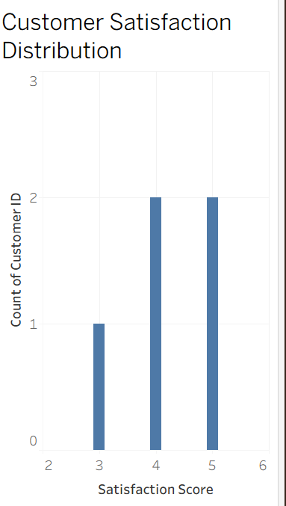
Advantages of an Ordered Bar Chart
- Preserves the natural order of satisfaction categories.
- Simple and easy to interpret.
- Clearly compares frequencies across categories.
- Supports decision-making based on citizen feedback.
- Suitable for surveys and opinion-based datasets.
Because service satisfaction represents ordered categories rather than numerical measurements, the ordered bar chart is the most effective visualization technique.

(c) Propose a chart and color scale for the year-over-year spending change data (increases vs. decreases).
Year-over-year spending changes contain both positive values (budget increases) and negative values (budget decreases). Therefore, the most appropriate visualization is a bar chart combined with a diverging color scale.
The bar chart effectively displays the magnitude of change for each year, while the diverging color scale visually separates increases from decreases. The central reference point is zero, which represents no change in spending.
A commonly used color scheme is:
- Green – Increase in spending
- Red – Decrease in spending
- White or Gray – No significant change
This color combination allows users to interpret the data immediately without reading the numerical values. Positive bars extending upward indicate increased investment, while negative bars extending downward represent budget reductions.
The diverging color scale is particularly useful because spending changes are relative to a baseline rather than absolute values. The colors help viewers distinguish favorable and unfavorable financial trends at a glance.
Such visualizations are valuable during annual budget meetings because they allow city officials to identify years of rapid investment growth or financial constraints. They also help evaluate whether budget increases have resulted in improved public services.
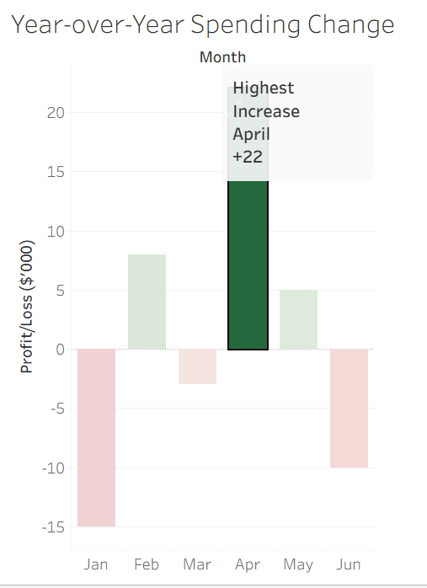
Advantages of a Diverging Color Scale
- Clearly distinguishes positive and negative values.
- Highlights years with major spending increases or decreases.
- Improves readability.
- Makes trend analysis faster.
- Enhances financial decision-making.
Thus, the combination of a bar chart and a diverging color scale provides both numerical precision and visual clarity.

(d) Design a combined dashboard using two of the above views, with a narrative takeaway a city council member could act on.
A dashboard combines multiple visualizations into a single interactive interface, enabling decision-makers to analyze different aspects of the data simultaneously.
For this case study, an effective dashboard should combine:
- District Spending Bar Chart
- Service Satisfaction Ordered Bar Chart
The district spending chart displays the amount of money allocated to each district, allowing administrators to compare financial investments across the city. The service satisfaction chart shows how citizens evaluate public services, helping officials understand whether spending has translated into better outcomes.
Displaying these charts together enables city council members to compare financial investment with citizen satisfaction. For example, if a district receives a large budget but still records low satisfaction levels, the problem may lie in inefficient implementation rather than insufficient funding. Similarly, districts with lower spending but high satisfaction may indicate efficient resource utilization.
The dashboard should include clear titles, axis labels, legends, data labels, and annotations highlighting important observations such as the district with the highest spending or the most common satisfaction level.
Interactive filters can also be included to allow users to analyze specific districts, departments, or years. Such dashboards support transparent governance by presenting financial and citizen feedback data together in one place.
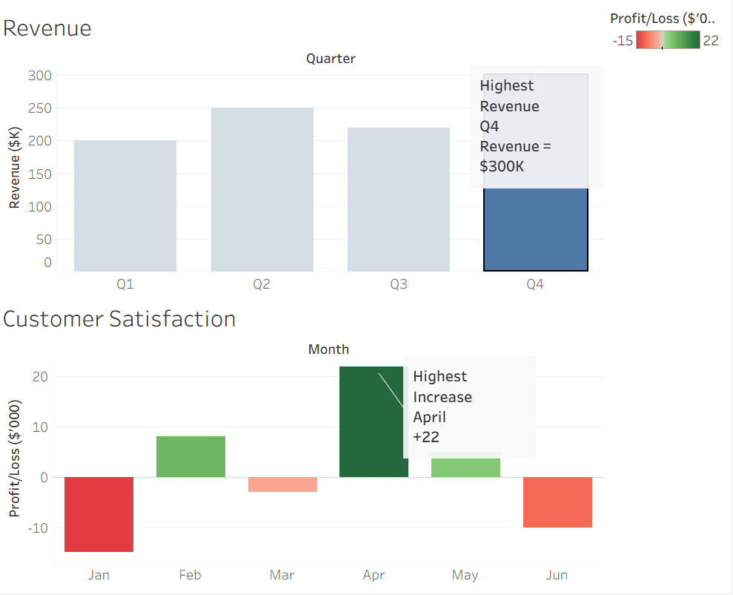
Benefits of the Dashboard
- Combines financial and survey information.
- Enables quick comparison between spending and citizen satisfaction.
- Supports evidence-based policy decisions.
- Helps identify inefficient budget allocation.
- Improves communication between administrators and stakeholders.
- Provides an interactive and user-friendly decision support system.
Narrative Takeaway
The dashboard indicates that while some districts receive significantly higher financial allocations, citizen satisfaction does not always increase proportionally. This suggests that efficient utilization of resources is as important as the amount of funding provided. City council members should investigate districts where spending is high but satisfaction remains low, improve service delivery mechanisms, and allocate future budgets based on both financial requirements and citizen feedback. Such an approach will improve transparency, optimize resource utilization, and enhance the overall quality of public services.

Conclusion
Data visualization plays a significant role in public sector planning and decision-making. Selecting the correct visualization technique ensures that complex financial and survey data can be interpreted quickly and accurately. A linear axis scale provides a fair representation of district spending, while an ordered bar chart preserves the logical sequence of service satisfaction categories. A bar chart combined with a diverging color scale effectively highlights annual budget increases and decreases, making financial trends easier to understand. Finally, integrating district spending and citizen satisfaction into a single dashboard allows policymakers to evaluate whether financial investments are producing meaningful improvements in public services. Such dashboards support informed decision-making, efficient budget allocation, and better governance. By using appropriate visualization techniques, city councils can improve transparency, strengthen public trust, and make data-driven decisions that contribute to sustainable urban development.

Q 5 :
CASE STUDY – ENVIRONMENTAL DATA VISUALIZATION
Introduction
Environmental monitoring plays a vital role in understanding climate change, air quality, and carbon emissions. Governments and environmental agencies collect large amounts of data to monitor temperature changes, Air Quality Index (AQI), and greenhouse gas emissions. However, raw data is difficult to interpret. Data visualization transforms this information into charts, maps, and dashboards that help decision-makers identify trends, compare regions, and take appropriate actions.
(a) What type of color scale is required for the temperature anomaly map, and why?
Answer
The most appropriate color scale for a temperature anomaly map is a Diverging Color Scale.
A diverging color scale is designed for datasets that have a meaningful midpoint. In temperature anomaly data, the midpoint is 0°C, which represents no change from the historical average.
The color mapping is as follows:
- Dark Blue → Much cooler than average
- Light Blue → Slightly cooler than average
- White → No temperature change (0°C anomaly)
- Light Red → Slightly warmer than average
- Dark Red → Much warmer than average
The white color acts as a neutral midpoint, making it easy to distinguish between regions that have become warmer and those that have become cooler.
Why Diverging Colors?
A sequential color scale only represents increasing values. Temperature anomalies contain both positive and negative values. Therefore, a diverging color scale clearly separates warming and cooling regions while emphasizing the baseline.

Tableau Visualization
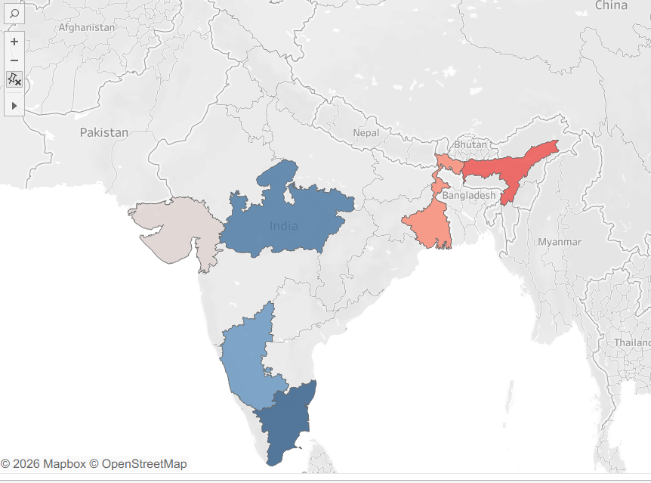
Advantages
- Easy comparison of positive and negative anomalies.
- Clearly highlights climate changes.
- Provides immediate visual interpretation.
- Suitable for scientific and environmental reports.

(b) Propose a chart for the 5-year AQI trend, and explain how you would handle large seasonal swings in the data.
Answer
The most suitable chart for representing AQI over five years is a Line Chart.
A line chart effectively displays continuous data over time and allows users to observe long-term trends in air quality.
The x-axis represents Time (Years or Months).
The y-axis represents Air Quality Index (AQI).
Each point on the graph corresponds to the AQI recorded during a specific period.
Why a Line Chart?
A line chart:
- Shows increasing or decreasing AQI trends.
- Identifies pollution spikes.
- Makes long-term comparisons easier.
- Clearly displays seasonal fluctuations.
Handling Seasonal Swings
AQI often changes because of seasonal effects such as:
- Winter pollution
- Summer dust
- Monsoon rainfall
- Agricultural burning
If raw monthly data is plotted, the graph may become highly irregular.
To reduce this problem:
1. Moving Average
A 12-month moving average smooths short-term fluctuations and reveals the long-term trend.
2. Monthly Average
Instead of plotting daily AQI values, calculate monthly averages.
This removes unnecessary noise while preserving important seasonal patterns.
Tableau Implementation
- Import AQI dataset.
- Drag Date to Columns.
- Drag AQI to Rows.
- Choose Line Chart.
- Add Moving Average using Analytics pane.

Advantages
- Clearly shows trends.
- Easy to understand.
- Helps identify improvements or deteriorations in air quality.
- Supports long-term environmental planning.

(c) Design a choropleth-style map or grid for the temperature anomaly data, combined with an annotation on the most extreme region.
Answer
A Choropleth Map (Filled Map) is the best visualization.
A choropleth map colors each country, state, or district based on its temperature anomaly.
Color Scheme
Blue → Cooler than average
White → No change
Red → Warmer than average
Dark Red → Highest temperature increase
Each geographical area is filled according to its anomaly value.
Annotation
The region with the highest anomaly should be highlighted.
Example:
Rajasthan
+4.8°C above historical average
Highest temperature anomaly recorded.
The annotation immediately attracts attention and helps users identify the most affected location.
Tableau Visualization :
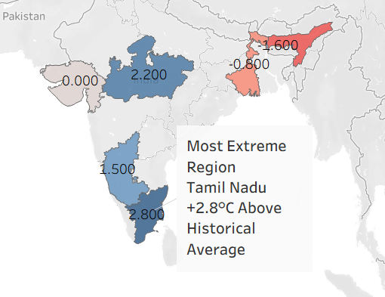
Benefits
- Geographic visualization.
- Easy regional comparison.
- Identifies hotspots.
- Supports environmental decision making.

(d) Justify your choice of chart for carbon emissions by sector, and explain why a treemap might be preferred over a pie chart for this particular breakdown.
Answer
The most appropriate visualization is a Treemap.
A treemap displays each sector as a rectangle whose area is proportional to its carbon emissions.
Example sectors include:
- Transportation
- Electricity
- Industry
- Agriculture
- Residential
- Commercial
Larger rectangles represent sectors producing higher emissions.
Different colors distinguish each category.
Why Treemap?
Treemaps efficiently display many categories in a compact space.
They allow users to compare areas more accurately than pie slices.
Labels fit naturally inside rectangles.
Large and small contributors are immediately visible.
Why not Pie Chart?
Although pie charts show proportions, they become difficult to read when several categories are present.
Problems include:
- Similar-sized slices are difficult to compare.
- Small slices become hard to see.
- Labels overlap.
- Limited space.
- Not suitable for detailed environmental datasets.
Treemaps solve all these issues by using rectangular areas instead of angles.
Tableau Visualization:
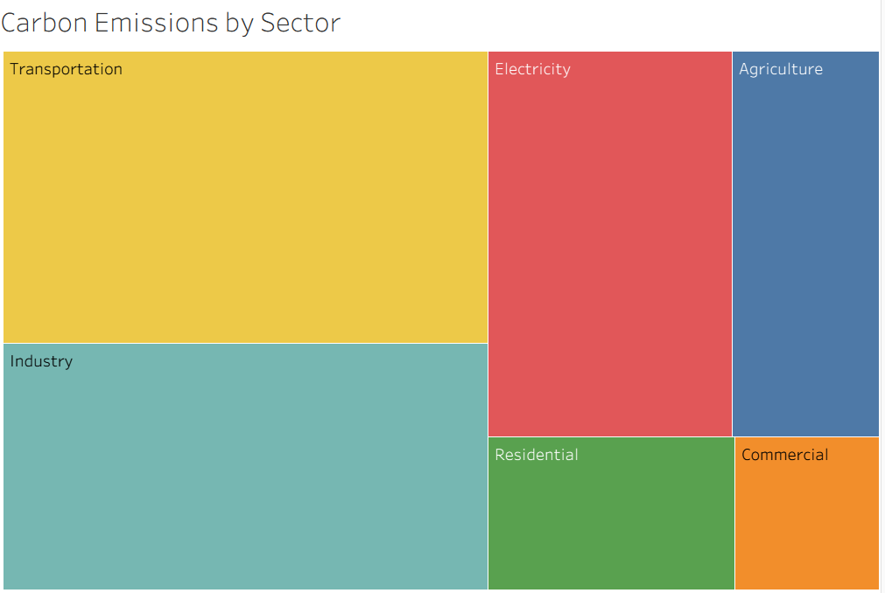
Advantages
- Better comparison of multiple sectors.
- Space-efficient.
- Easier to interpret.
- Professional dashboard appearance.

Overall Dashboard Design
The environmental dashboard should contain:
Dashboard 1
Temperature Anomaly Filled Map
Blue–White–Red Diverging Colors
Annotation on the hottest region

Dashboard 2
Five-Year AQI Line Chart
Monthly Moving Average
Trend Analysis

Dashboard 3
Carbon Emission Treemap
Sector Comparison
Area proportional to emissions

Dashboard Features
- Clear titles
- Legends
- Data labels
- Tooltips
- Consistent color scheme
- Interactive filters for Year and Region

Conclusion
Environmental data visualization enables governments and researchers to understand climate conditions, monitor pollution levels, and evaluate carbon emissions effectively. A diverging color scale is ideal for temperature anomaly maps because it highlights both positive and negative deviations from the baseline. A line chart is the most suitable visualization for analyzing AQI trends over time, especially when combined with moving averages to reduce seasonal fluctuations. A choropleth map effectively displays regional temperature variations while emphasizing the most affected areas through annotations. Finally, a treemap offers a clearer and more efficient representation of carbon emissions by sector than a pie chart, particularly when multiple categories are involved. Together, these visualizations provide meaningful insights that support environmental planning, policy-making, and sustainable development.

