SIMATS ENGINEERING (SAVEETHA SCHOOL OF ENGINEERING)
Department of Computer Science and Engineering
CO3_AT1 — EXPERIMENT
Course Code: | DSA06 | Course Title: | Data Handling andVisualization
CO Assessed: | CO3 – Construction (BL3) | Assessment: | Assessment Tool 1 — Experiment
Weightage: | 20% of CIA | Total Marks: | 25 (5 Questions × 5 Marks)
CO3 Statement: | Apply appropriate experimental charting techniques — pie charts, bean plots, violin plots, box plots, and stacked bar charts — to construct accurate visualizations from given data. (BL3)
Student Name: Bagya Venkatesh |  | Reg. No.: 192324263
Section / Batch: 2023 |  | Date:18.08.26

Code of Conduct
I ______________________________ (Name / Reg No) certify that this submission is my original work and that I have adhered to the guidelines specified for this assessment. I understand that any violation of academic integrity rules will result in disciplinary action.
Signature of the Student: ______________________________

Instructions
- This test contains 5 questions, each carrying 5 marks. Total: 25 Marks.
- No negative marking. Unanswered questions carry zero marks.
- No calculators or electronic devices permitted.
- Duration: 75 minutes.
- Graph paper or a ruler is recommended for accurate, to-scale drawing.
- Show all calculations (e.g., pie chart angles, five-number summary, IQR) as part of your answer.
- Every chart must include a title, correctly labeled axes (where applicable), and a legend where relevant.

Problem 5 (5 Marks)
Data: A company's revenue by product line: Electronics = ₹50,000, Clothing = ₹30,000, Books = ₹20,000.
Task: Construct a pie chart showing each product line's percentage share of total revenue.
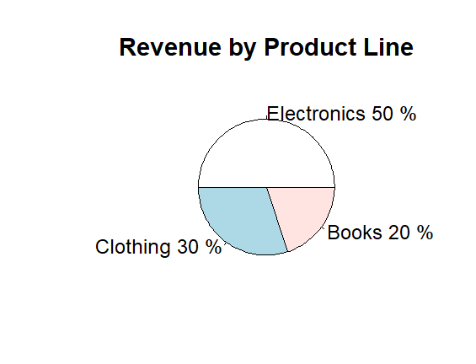
Problem 7 (5 Marks)
Data: Two groups' test scores — Group A: 50, 55, 58, 60, 60, 62, 65. Group B: 30, 40, 50, 60, 70, 80, 90.
Task: Construct bean plots for both groups and compare how their spread differs, even though both have a similar average.
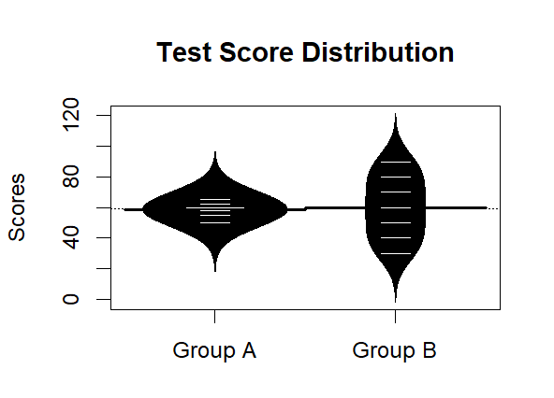

\

Problem 14 (5 Marks)
Data: Weights (in kg) of 10 packages: 2, 3, 3, 4, 4, 4, 5, 6, 7, 10.
Task: Construct a violin plot and describe whether the resulting shape looks symmetric skewed.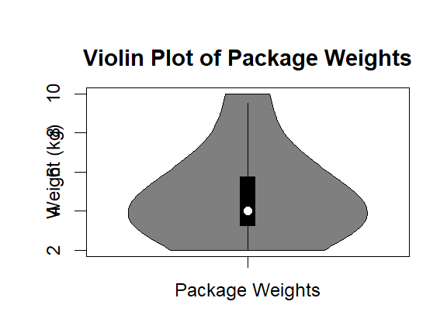
Problem 16 (5 Marks)
Data: Marks of 11 students: 40, 45, 50, 52, 55, 58, 60, 62, 65, 70, 90.
Task: Calculate the five-number summary (minimum, Q1, median, Q3, maximum) and construct a box
plot.

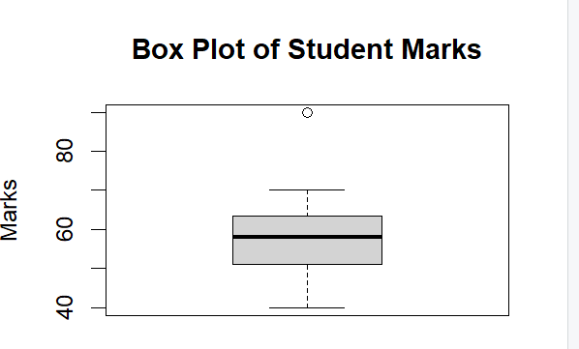

Problem 23 (5 Marks)
Data: Company headcount by department and year: 2022 — Engineering = 40, Sales = 25, Support = 15.
2023 — Engineering = 55, Sales = 30, Support = 20.
Task: Construct a stacked bar chart showing total headcount and departmental composition for both
years.

