SIMATS ENGINEERING (SAVEETHA SCHOOL OF ENGINEERING)
Department of Computer Science and Engineering
CO1_AT2 — DATA INTERPRETATION EXERCISE
Course Code: | DSA0606 | Course Title: | Data Handling and Visualization
CO Assessed: | CO2 – Construction (BL3) | Assessment: | Assessment Tool 1 – Chart  Construction
Weightage: | 20% of CIA | Total Marks: | 25 (5 Questions × 5 Marks)
CO1 Statement: | Apply appropriate chart construction techniques — correct chart type, axes, scales, and calculations  — to accurately represent given data.(BL3)
Student Name: | Bagya Vennkatesh | Reg. No.: | 1923242643
Section / Batch: | 2023 | Date: | 01-08-2026

Problem 1 — Bar Chart — Basic Construction (5 Marks)
Data: Monthly sales (units): Jan = 120, Feb = 150, Mar = 90, Apr = 200, May = 175.
Task: Construct a bar chart to represent monthly sales. Label both axes, include a chart title, and keep
the months in chronological order.
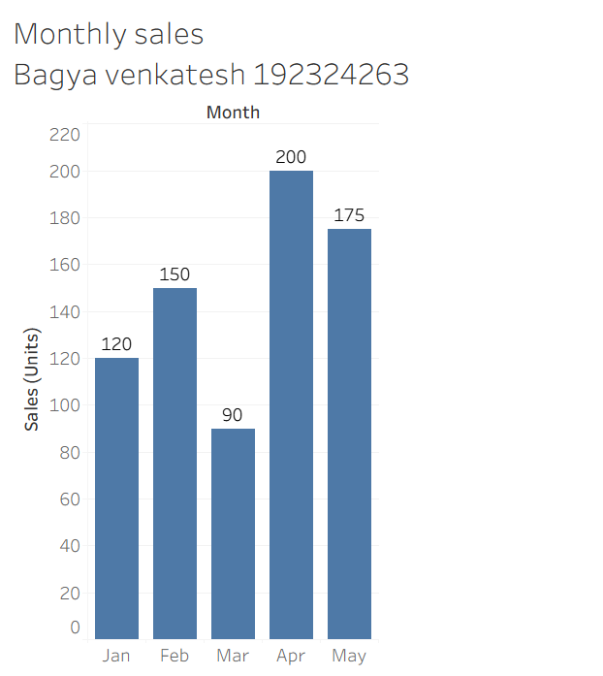

Problem 22 — Diverging Color Scale — Profit/Loss (5 Marks)
Data: Monthly profit/loss ($'000): Jan=−15, Feb=+8, Mar=−3, Apr=+22, May=+5, Jun=−10.
Task: Construct a bar chart using a diverging color scale (e.g., one color for loss, another for profit) to
represent this data, clearly marking the zero baseline.
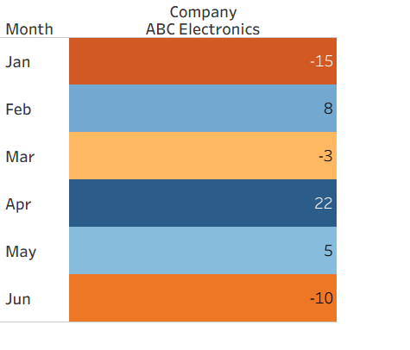

Problem 23 — Treemap — Proportional Area (5 Marks)
Data: Revenue by product category: Electronics=$400K, Clothing=$250K, Books=$150K, Toys=$100K,
Home=$100K.
Task: Construct a treemap where each rectangle's area is proportional to that category's share of total
revenue. Show your calculation of each category's percentage share.
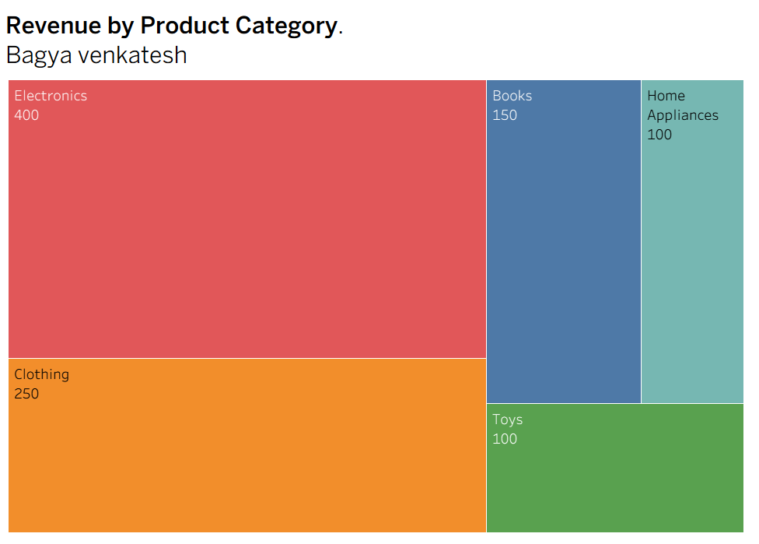
Problem 24 — Combination Chart — Bar + Line (5 Marks)
Data: Monthly sales (units) and average price ($): Jan=(100,20), Feb=(120,22), Mar=(90,25),
Apr=(150,21), May=(130,23), Jun=(160,24).
Task: Construct a chart combining a bar chart (units sold) with a line chart (average price) across the six
months. Explain why you would avoid using a dual y-axis and how you would represent both variables
clearly instead.
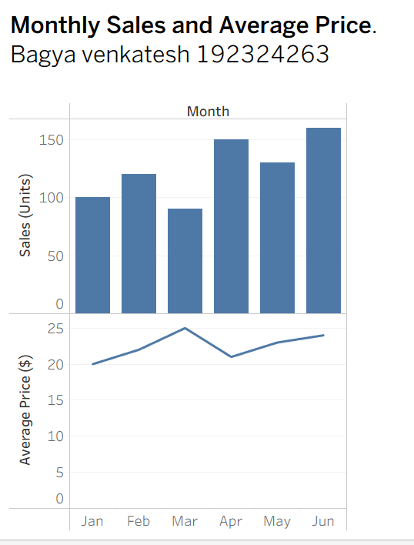

Problem 25 — Small Multiples Construction (5 Marks)
Data: Weekly sales (units) for 4 regions over 4 weeks: Region A: 40, 55, 50, 65 Region B: 30, 35, 45, 40
Region C: 60, 58, 70, 75 Region D: 20, 25, 22, 30
Task: Construct a set of four small-multiple line charts, one per region (rather than one overlaid chart),
and briefly justify this design choice over a single combined chart.
