

E-Vehicle Charging Management System for a
Smart University Campus

Bagya Venkatesh(192324263) :
https://github.com/bagya1275/Java-programming/tree/main/assignment
Subiksha U (192424135):
https://github.com/subixu/JAVA---CSA0905-/tree/main/ASSIGNMENT%20DOC
Hema Priya T(192524467):
192524467-JAVA/ASSIGNMENT at main · 192524467simats-wq/192524467-JAVA

PROBLEM STATEMENT
Develop a GUI-based Java application using AWT/Swing and JDBC to manage an E-Vehicle Charging Facility on a university campus. The system should manage users, electric vehicles, charging stations, charging points, reservations, charging sessions, energy consumption, and payments.
It should provide charging-point availability, slot reservation, check-in/check-out, charging cost calculation, payment management, and reports. The application should use MySQL with JDBC for database operations and include input validation, conflict checking, exception handling, and proper database relationships to ensure efficient and reliable charging management.

OBJECTIVE
To develop a Java Swing-based system that efficiently manages EV charging, reservations, billing, payments, and reports on a university campus, while presenting the operational information through a clear dashboard and visualization interface.

PSEUDO CODE:
BEGIN
DISPLAY "EV VEHICLE CHARGING MANAGEMENT SYSTEM"

1. APPLICATION STARTUP
LOAD / INITIALIZE application data
CREATE the Java Swing user interface
CONFIGURE window, sidebar, top bar and main body
DISPLAY Dashboard

2. DASHBOARD
CALCULATE total charging points
CALCULATE available points
CALCULATE occupied points
CALCULATE total energy delivered
DISPLAY KPI cards
DISPLAY live point-status cards
DISPLAY quick actions

3. USER / VEHICLE MANAGEMENT
IF user selects Users or Vehicles THEN
DISPLAY existing records
ALLOW registration of a new user or vehicle
VALIDATE required input
IF input is valid THEN
CREATE the corresponding record
REFRESH the page
ELSE
DISPLAY validation warning
END IF
END IF

4. CHARGING STATION MANAGEMENT
IF user selects Charging Stations THEN
DISPLAY station name
DISPLAY campus location
DISPLAY charging point
DISPLAY connector type
DISPLAY current status
ALLOW status change
IF user adds a station THEN
INPUT station name and campus location
INPUT charging point type
VALIDATE required fields
CREATE station and point record
REFRESH Stations page
END IF
END IF

5. CHARGING POINT MANAGEMENT
FOR each charging station
FOR each charging point
DISPLAY point ID
DISPLAY connector type
DISPLAY status
IF point is available THEN
DISPLAY "AVAILABLE"
ELSE IF point is occupied THEN
DISPLAY "OCCUPIED"
ELSE IF point is reserved THEN
DISPLAY "RESERVED"
ELSE
DISPLAY "MAINTENANCE"
END IF
END FOR
END FOR

6. RESERVATION
IF no vehicles exist THEN
DISPLAY "Register a vehicle first"
STOP
END IF

FIND usable charging points
IF no usable point exists THEN
DISPLAY "No usable charging points available"
STOP
END IF

SELECT vehicle
SELECT charging point
INPUT reservation slot
IF user confirms THEN
CREATE Reservation record
ADD reservation to reservation list
CHANGE selected point status to "RESERVED"
SAVE application state
REFRESH Reservations page
END IF

7. START / RECORD CHARGING SESSION
IF no vehicles exist THEN
DISPLAY "Register a vehicle first"
STOP
END IF

BUILD list of usable charging points
SELECT vehicle and charging point
INPUT energyConsumed
INPUT charging duration

IF energyConsumed <= 0 OR duration <= 0 THEN
DISPLAY validation warning
STOP
END IF

selectedPoint.status ← "AVAILABLE"
cost ← energyConsumed × 8.50

CREATE Session(
vehicle,
point,
energyConsumed,
duration,
cost,
"Completed"
)

ADD Session to session list

CREATE Payment(
session,
cost,
"Paid"
)

ADD Payment to payment list
SAVE application state
REFRESH Charging Sessions page

8. COST CALCULATION
INPUT energyConsumed
SET chargingRate ← 8.50
totalCost ← energyConsumed × chargingRate
DISPLAY totalCost

9. PAYMENT
IF a charging session is completed THEN
RETRIEVE session amount
CREATE payment record
SET payment status ← "Paid"
DISPLAY payment information
END IF

10. ANALYTICS AND REPORTS
sessions ← number of recorded sessions
energy ← SUM(session.kWh)
revenue ← SUM(session.cost)

COUNT charging points by status:
Available
Occupied
Reserved
Maintenance

CALCULATE utilization
DISPLAY session count
DISPLAY total energy
DISPLAY total revenue
DISPLAY utilization
DRAW point-distribution chart
DISPLAY management insights

11. VALIDATION
FOR every user input
CHECK required fields
CHECK numeric values
CHECK vehicle / registration values
CHECK reservation selection
IF invalid THEN
DISPLAY appropriate warning
ASK user to enter again
END IF
END FOR

12. EXCEPTION / ERROR HANDLING
TRY application operations
PERFORM requested operation
CATCH invalid input
DISPLAY validation warning
CATCH unavailable charging point
DISPLAY availability message
CATCH unexpected exception
DISPLAY error message
END TRY

13. NAVIGATION
IF user selects another page THEN
CLEAR current body
LOAD requested page
REFRESH interface
END IF

14. EXIT
IF user closes application THEN
SAVE supported local state
CLOSE application
END IF
END

CLASS DIAGRAM

USECASE DIAGRAM
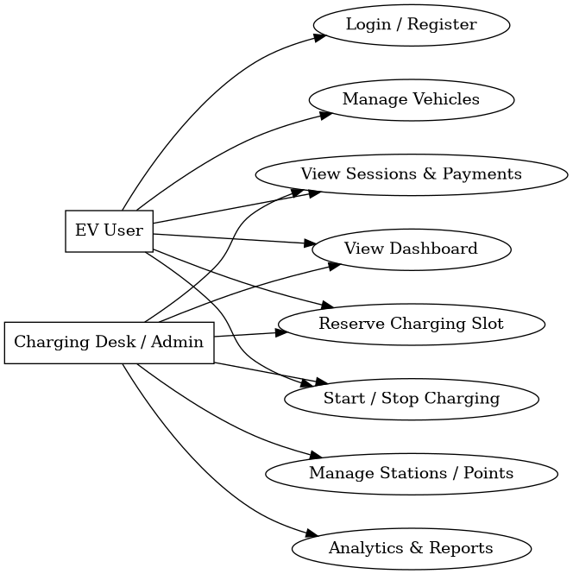

ACTIVITY DIAGRAM
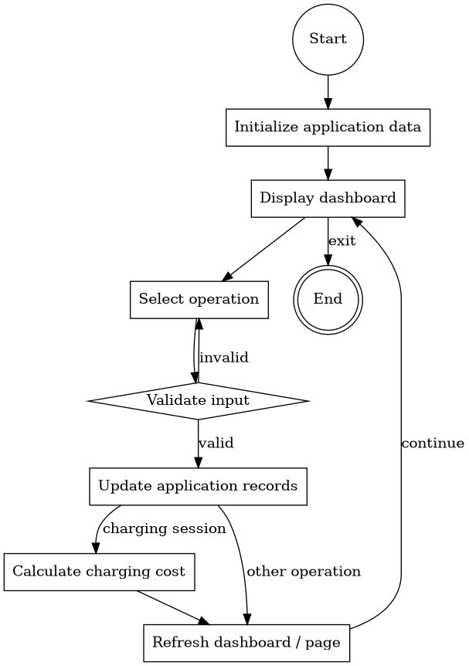

DATA MODEL
Entity | Important Attributes | Relationship / Use
User | id, name, email | Owns one or more registered vehicles
Vehicle | id, userId, registration, model | Belongs to a user; participates in reservations and sessions
Station | id, name, location, points | Contains charging points
Point | id, status, type | Represents an individual charging point
Reservation | id, vehicleId, pointId, slot, status | Connects a vehicle to a charging point and slot
Session | id, vehicleId, pointId, kWh, hours, cost, status | Records charging activity and calculated cost
Payment | id, sessionId, amount, status | Represents payment generated from a completed session

IMPLEMENTATION CODE:

MAIN.JAVA
import javax.swing.*;
import javax.swing.border.EmptyBorder;
import javax.swing.table.DefaultTableModel;
import java.awt.*;
import java.io.*;
import java.util.*;

public class Main {

static final double TARIFF = 8.50;

static class User {
int id;
String name;
String email;

User(int id, String name, String email) {
this.id = id;
this.name = name;
this.email = email;
}
}

static class Vehicle {
int id;
int userId;
String reg;
String model;

Vehicle(int id, int userId, String reg, String model) {
this.id = id;
this.userId = userId;
this.reg = reg;
this.model = model;
}
}

static class Point {
int id;
String status;
String type;

Point(int id, String status, String type) {
this.id = id;
this.status = status;
this.type = type;
}
}

static class Station {
int id;
String name;
String location;
List<Point> points = new ArrayList<>();

Station(int id, String name, String location) {
this.id = id;
this.name = name;
this.location = location;
}
}

static class Reservation {
int id;
int vehicleId;
int pointId;
String slot;
String status;

Reservation(int id, int vehicleId, int pointId,
String slot, String status) {
this.id = id;
this.vehicleId = vehicleId;
this.pointId = pointId;
this.slot = slot;
this.status = status;
}
}

static class Session {
int id;
int vehicleId;
int pointId;
double kwh;
double hours;
double cost;
String status;

Session(int id, int vehicleId, int pointId,
double kwh, double hours, String status) {
this.id = id;
this.vehicleId = vehicleId;
this.pointId = pointId;
this.kwh = kwh;
this.hours = hours;
this.cost = kwh * TARIFF;
this.status = status;
}
}

static class Payment {
int id;
int sessionId;
double amount;
String status;

Payment(int id, int sessionId, double amount,
String status) {
this.id = id;
this.sessionId = sessionId;
this.amount = amount;
this.status = status;
}
}

public static void main(String[] args) {
load();
SwingUtilities.invokeLater(Main::build);
}

static void build() {
try {
UIManager.setLookAndFeel(
UIManager.getCrossPlatformLookAndFeelClassName()
);
} catch (Exception ignored) {
}

frame = new JFrame(
"EV ChargeHub | Smart Campus Charging"
);

frame.setDefaultCloseOperation(
JFrame.EXIT_ON_CLOSE
);
frame.setSize(1250, 790);
frame.setMinimumSize(
new Dimension(1050, 680)
);
frame.setLocationRelativeTo(null);

JPanel root = new JPanel(
new BorderLayout()
);
root.setBackground(BG);

root.add(
sidebar(),
BorderLayout.WEST
);

JPanel main = new JPanel(
new BorderLayout()
);
main.setBackground(BG);

main.add(
topbar(),
BorderLayout.NORTH
);

body = new JPanel(
new BorderLayout()
);
body.setBackground(BG);
body.setBorder(
new EmptyBorder(
20, 26, 26, 26
)
);

main.add(
body,
BorderLayout.CENTER
);

root.add(
main,
BorderLayout.CENTER
);

frame.setContentPane(root);
frame.setVisible(true);

show("Dashboard");
}

static void dashboard() {
int totalPoints = 0;
int available = 0;
int occupied = 0;
double energy = getEnergy();

for (Station s : stations) {
for (Point p : s.points) {
totalPoints++;

if (p.status.equals("AVAILABLE"))
available++;

if (p.status.equals("OCCUPIED"))
occupied++;
}
}

cards.add(
card(
"Available",
String.valueOf(available),
available + " ready to charge",
GREEN
)
);

cards.add(
card(
"Active / Occupied",
String.valueOf(occupied),
"Currently in use",
ORANGE
)
);

cards.add(
card(
"Energy Delivered",
String.format("%.1f kWh", energy),
"Recorded sessions",
PURPLE
)
);
}

static void changeStatus(int pointId) {
Point p = findPoint(pointId);

if (p == null)
return;

String[] statuses = {
"AVAILABLE",
"OCCUPIED",
"RESERVED",
"MAINTENANCE"
};

String selected =
(String) JOptionPane.showInputDialog(
frame,
"Select new status:",
"Change Point Status",
JOptionPane.PLAIN_MESSAGE,
null,
statuses,
p.status
);

if (selected == null)
return;

p.status = selected;
save();
}

static void addStation() {
JTextField name = new JTextField();
JTextField location = new JTextField();

JComboBox<String> type =
new JComboBox<>(
new String[]{
"AC Type-2",
"DC Fast",
"CCS2"
}
);

JPanel form = new JPanel(
new GridLayout(0, 2, 8, 8)
);

form.add(new JLabel("Station Name"));
form.add(name);
form.add(new JLabel("Campus Location"));
form.add(location);
form.add(new JLabel("Connector Type"));
form.add(type);

int result =
JOptionPane.showConfirmDialog(
frame,
form,
"Add Charging Station",
JOptionPane.OK_CANCEL_OPTION
);

if (result != JOptionPane.OK_OPTION)
return;

if (name.getText().trim().isEmpty()
|| location.getText().trim().isEmpty()) {

JOptionPane.showMessageDialog(
frame,
"Please enter all required details."
);
return;
}

Station station = new Station(
nextStationId(),
name.getText().trim(),
location.getText().trim()
);

station.points.add(
new Point(
nextPointId(),
"AVAILABLE",
type.getSelectedItem().toString()
)
);

stations.add(station);
save();
show("Stations");
}

OUTPUT / RESULTS
The following screenshots document the working Java Swing interface. The pages use the same dashboard and navigation design supplied in the student's project and show the principal operational screens used during demonstration.
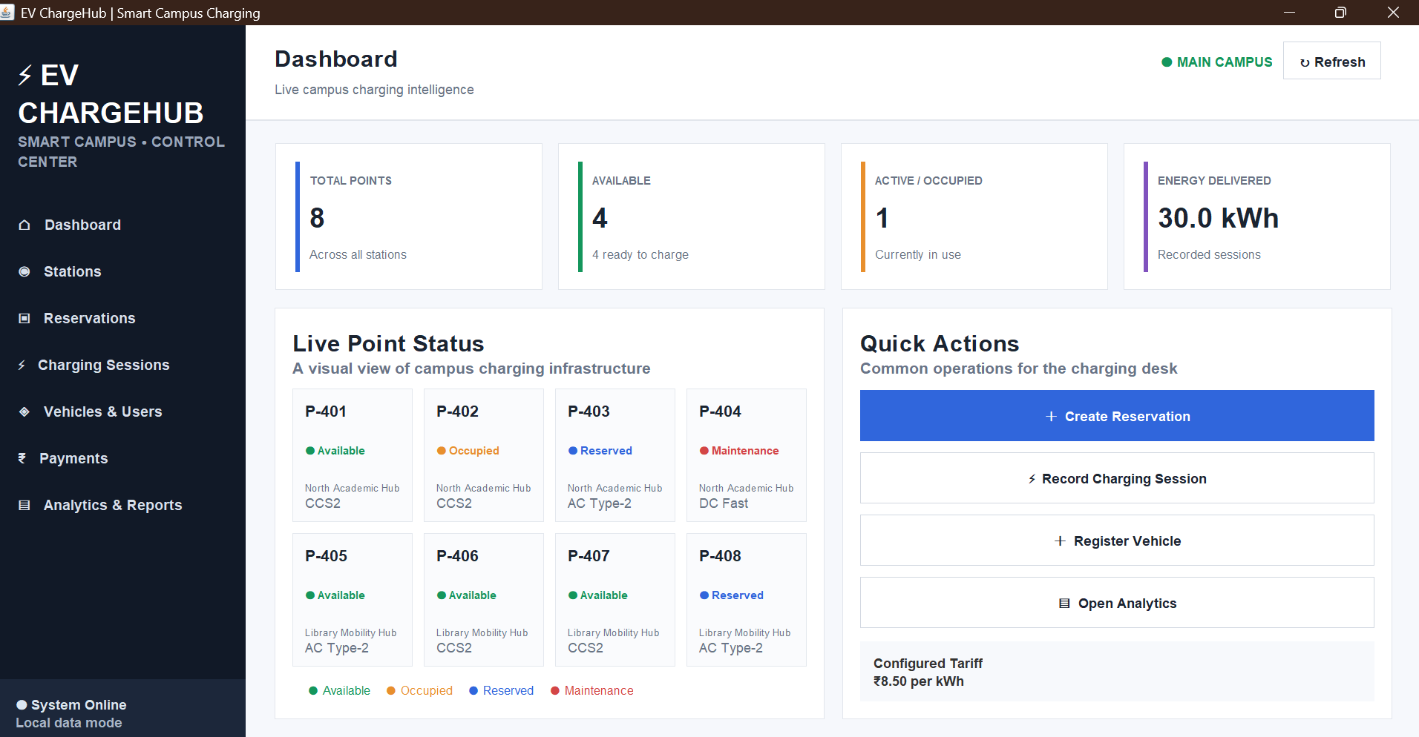
Figure 1. Dashboard – KPI cards, live point status and quick actions.

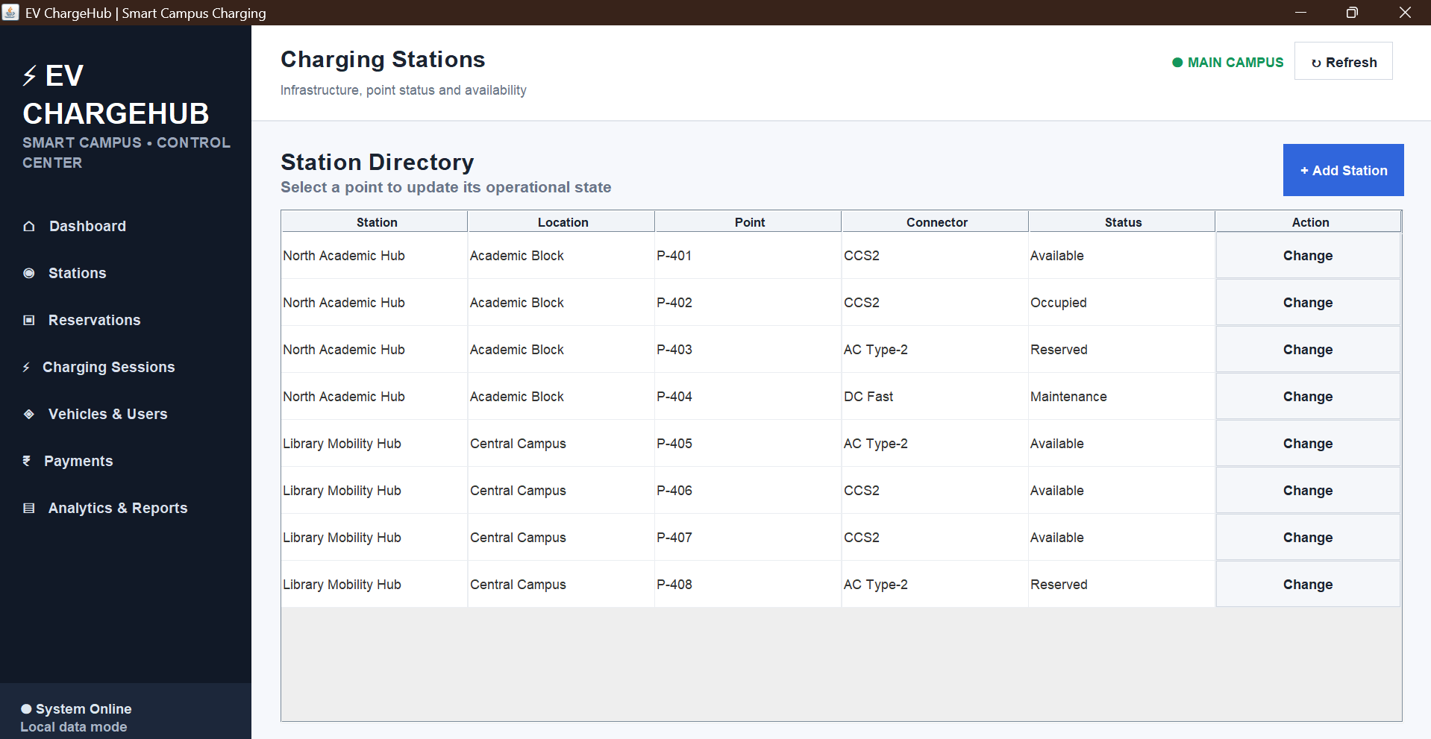
Figure 2. Charging Stations – station directory with point and status information.

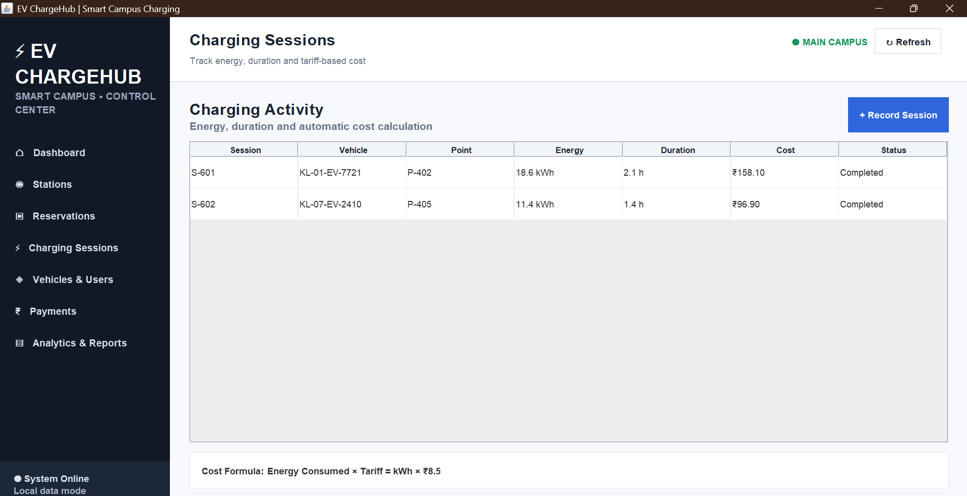
Figure 3. Charging Sessions – charging activity with energy, duration and calculated cost.

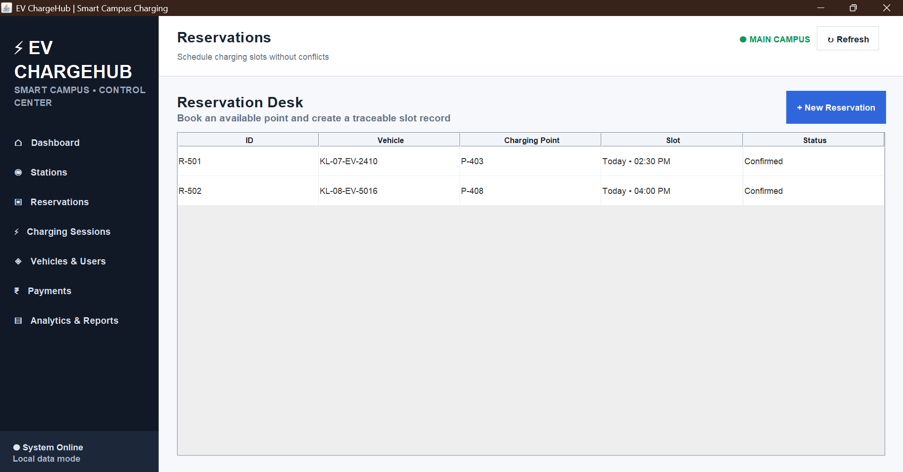
Figure 4. Reservations – reservation desk with vehicle, point, slot and status.

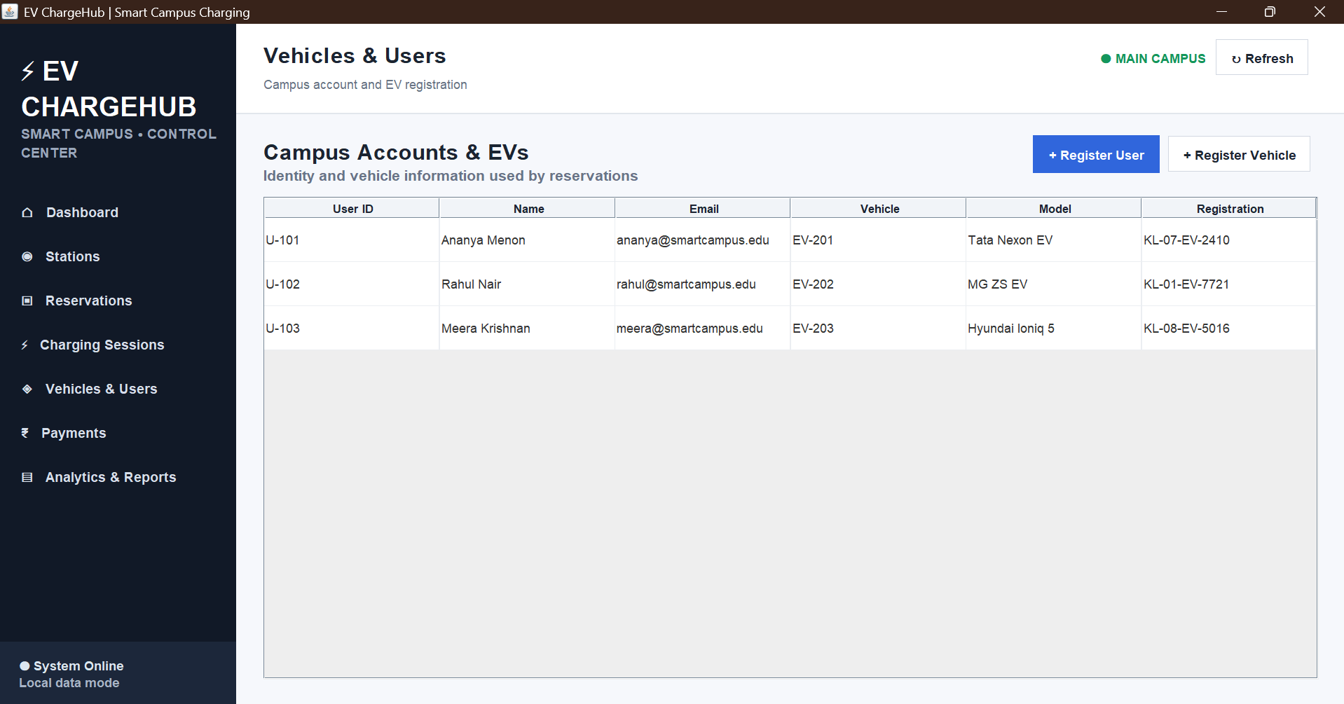
Figure 5. Vehicles & Users – user and registered EV information.

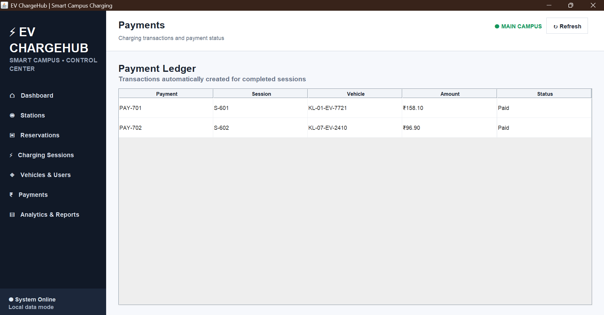
Figure 6. Payments – payment ledger associated with completed charging sessions.

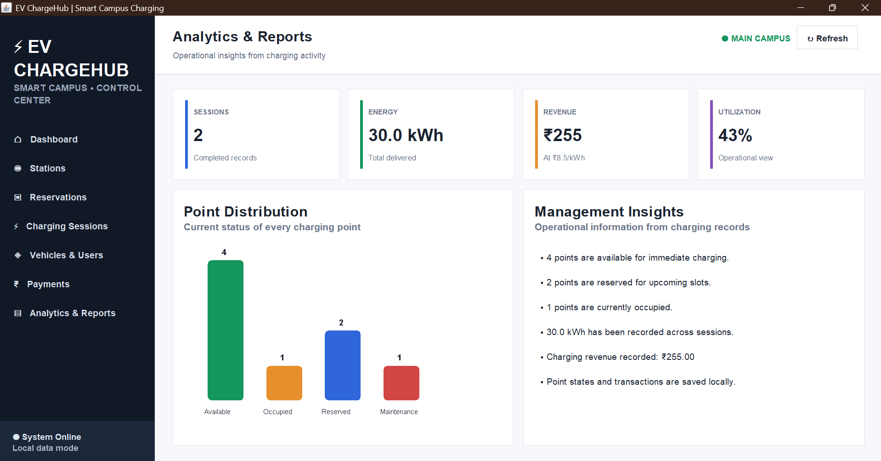
Figure 7. Analytics & Reports – KPI summary, point distribution and management insights.

TESTING AND VALIDATION
Testing was performed at the GUI and workflow level using the supplied application. The checks focus on navigation, data-entry validation, state changes, charging-cost calculation and visual output.
Test ID | Test Case | Expected Result | Observed Result
T01 | Launch application | Dashboard opens successfully | Dashboard displayed with KPI cards and live point status
T02 | Open Stations | Station directory is displayed | Station records and Change actions displayed
T03 | Change point status | Selected point status is updated | Status can be changed and page refreshed
T04 | Create reservation | Reservation is added for selected vehicle/point/slot | Reservation workflow is available
T05 | Record session | Session and payment are created | Session and payment entries appear
T06 | Invalid session values | Validation warning is shown | Numeric validation warning is implemented
T07 | Register user/vehicle | New record is added | Registration dialogs are available
T08 | Open Payments | Payment ledger is displayed | Payment records and amounts displayed
T09 | Open Analytics | KPIs and chart reflect current records | Point distribution and management insights displayed
T10 | Refresh/navigation | Current page is rebuilt | Navigation and refresh workflow operate through the GUI

COST CALCULATION
The Session constructor calculates cost as kWh × tariff. With the configured tariff of ₹8.50 per kWh, the sample sessions of 18.6 kWh and 11.4 kWh correspond to ₹158.10 and ₹96.90 respectively. The total sample energy is 30.0 kWh and the corresponding total charging revenue is ₹255.00.

INDIVIDUAL CONTRIBUTION
My primary contribution to the project was focused on the visualization, dashboard design, and presentation of the charging-management information. I worked on designing the graphical interface so that the data could be displayed in a clear, organized, and user-friendly manner.
I worked on the main dashboard, where important charging information is represented through KPI cards such as total charging points, available points, active or occupied points, and total energy delivered. The dashboard was designed to provide an immediate overview of the charging infrastructure without requiring the user to go through individual records.
I also worked on the Live Point Status section, where the condition of individual charging points is displayed using different status indicators such as Available, Occupied, Reserved, and Maintenance. This makes it easier for an operator to identify the current condition of charging points and quickly understand which points are ready for use.
Another important part of my contribution was the Analytics and Reports section. I worked on presenting important information such as charging sessions, energy consumption, revenue, and utilization in a visual format. The point-distribution chart was designed to represent the number of charging points according to their current status. This helps convert the collected data into information that can be easily interpreted for monitoring and decision-making.
I also contributed to the overall navigation and visual consistency of the application. I worked with the dashboard layout, page headings, cards, tables, buttons, spacing, and navigation structure to maintain a consistent appearance throughout the application. The interface allows users to move between the Dashboard, Charging Stations, Reservations, Charging Sessions, Vehicles & Users, Payments, and Analytics & Reports sections.
Testing and debugging were also part of my contribution. I checked the dashboard values, charging-point statuses, energy totals, revenue information, and analytical chart to ensure that the displayed information corresponded correctly with the application data. I also checked the different screens and interactions to ensure that the interface remained consistent during navigation and data updates.
Through this work, I gained practical experience in Java Swing GUI development, event handling, layout management, data visualization, dashboard design, testing, debugging, and presenting application data in a simple and understandable manner. My contribution helped improve the overall usability and visual representation of the EV charging management system.

CONCLUSION
EV ChargeHub demonstrates a practical desktop interface for managing a Smart Campus EV charging environment. The application brings together charging infrastructure, reservations, charging sessions, users and vehicles, payments and analytics in one navigable control center. The dashboard and reports views demonstrate how operational records can be transformed into useful visual information.
The supplied implementation demonstrates the intended GUI workflows, charging-point status management, session cost calculation and visualization features. The project provides a foundation for further integration with persistent database services and a separated backend architecture.

FUTURE ENHANCEMENTS
- Integrate a persistent database for all users, vehicles, stations, reservations, sessions and payments.
- Introduce a dedicated backend/service layer for database operations.
- Add role-based authentication for charging-desk operators and administrators.
- Implement stronger date/time-based reservation conflict validation.
- Add richer daily and monthly energy and utilization analytics.
- Provide exportable reports and improved administrative monitoring.

SOURCE AND SUBMISSION NOTES
The report has been reformatted to follow the supplied reference document's presentation style: centered project title, simple academic headings, Times New Roman body text, page-separated pseudocode, diagram pages, implementation-code pages, output screenshots, testing, and individual contribution. The project content and screenshots were retained from the student's supplied Word report rather than replacing the project with unrelated material.

