Department of Computer Science and Engineering
Assignment Questions
Course Code & Name : CSA0905 - Programming in Java
Assignment Title: | E-Vehicle Charging Management System for a Smart University Campus
Course Outcome(s) – CO: | CO4: Design GUI-based user interfaces using AWT, Swing, and Applets by implementing event handling, layout managers, AWT controls, and menus.  CO5: Construct database-driven web applications by implementing JDBC connectivity to perform SQL operations such as insert, update, and delete using different statement types.
Bloom’s Taxonomy Level | L3 – Apply; L4 – Analyse
SDG Mapping (SDG 1-17) | SDG 7 – Affordable and Clean Energy;  SDG 9 – Industry, Innovation and Infrastructure;  SDG 11 – Sustainable Cities and Communities
Problem Statement : Design, implement, and evaluate a GUI-based Java application using AWT/Swing and JDBC to manage an E-Vehicle Charging Facility for a large University campus, where multiple charging points are distributed across campus locations and manual coordination can lead to charging-point conflicts, waiting time, inefficient utilization, and difficulty in maintaining accurate charging records. The prototype shall automate the charging workflow — registering electric vehicles and users, maintaining charging stations and charging points, checking point availability, reserving charging slots, recording vehicle check-in and check-out, creating and updating charging sessions, recording charging duration and energy consumed, computing charging cost using configured tariff rates, maintaining charging and payment records, and generating station-utilization, energy-consumption, and usage reports. The core entities (users, vehicles, charging stations, charging points, reservations, charging sessions, energy usage, and payments) shall be maintained through appropriate relational database tables with suitable primary and foreign key relationships to ensure data integrity and consistency. The graphical user interface shall use appropriate AWT/Swing controls, layout managers, menus, tables, and event-handling mechanisms to support data entry, navigation, reservation, charging operations, searching, filtering, validation, and report generation. Charging-point status such as available, occupied, reserved, and maintenance shall be displayed appropriately through the GUI. JDBC shall be used to establish connectivity with a MySQL database and perform SQL operations such as insert, select, update, and delete using suitable statement types including Statement, PreparedStatement, and CallableStatement. Robustness shall be ensured through input validation and exception handling for invalid data, duplicate records, unavailable charging points, conflicting reservations, database connectivity failures, and SQL exceptions. The completed prototype shall demonstrate the integration of GUI design, event-driven programming, layout management, AWT/Swing controls, JDBC connectivity, relational database design, SQL operations, validation, exception handling, charging-cost computation, and management reporting to address an industry-specific smart-campus electric-vehicle charging requirement.
Assessment Rubrics

Criteria (CO Mapping) | Max Marks | Excellent | Good | Satisfactory | Needs Improvement
GUI Design: AWT/Swing Controls & Layout Managers  (CO4) | 15 | Uses appropriate AWT/Swing controls and layout managers effectively; GUI is well organized and user-friendly. | Most controls and layouts are appropriate with minor design issues. | Basic GUI is implemented but has some design or layout limitations. | GUI is incomplete, poorly organized, or lacks appropriate controls/layout.
Event Handling, Controls & Menus  (CO4) | 15 | All required events, controls, menus, and user interactions are implemented correctly and integrated with system functions. | Most event-handling and menu operations work correctly with minor issues. | Basic event handling is present but some operations are incomplete. | Event handling or menu functionality is largely missing or non-functional.
JDBC Connectivity & Database Design  (CO5) | 15 | JDBC connectivity is reliable; database tables and relationships are appropriate, with correct handling of database resources. | Connectivity and database design are mostly correct with minor issues. | Connectivity works but database design or resource handling has gaps. | JDBC connectivity or database design is missing or incorrect.
SQL Operations & Statement Types  (CO5) | 20 | INSERT, SELECT, UPDATE, and DELETE operations work correctly; Statement, PreparedStatement, and CallableStatement are appropriately demonstrated. | Most SQL operations and statement types work correctly with minor issues. | Some SQL operations or statement types are implemented but incomplete. | Major SQL operations or required statement types are missing or non-functional.
E-Vehicle Charging Management & Calculations  (CO4/CO5) | 20 | Vehicle registration, station/point management, reservation, charging sessions, energy recording, tariff-based cost calculation, and status tracking work correctly end-to-end. | Most charging functions work correctly with minor logical issues. | Core charging functions work but some operations or calculations are incomplete. | Major charging functions are missing, incorrect, or non-functional.
Validation, Exception Handling & Report Generation  (CO4/CO5) | 10 | Comprehensive validation and exception handling are implemented; station, energy, and usage reports are accurate and meaningful. | Validation, exception handling, and reports are mostly correct with minor gaps. | Basic validation/exception handling/reporting is present but incomplete. | Little or no validation or exception handling; reports are missing or unreliable.
Reflection: Design Decisions, SDG Relevance & Learning Outcomes | 5 | Thoughtful justification of design choices, clear connection to SDG 7/9/11 relevance, and specific challenges and learning outcomes. | General justification of design choices and sustainability relevance with minor gaps. | Reflection is present but generic; limited justification or learning evidence. | No genuine reflection submitted, or content is generic with no clear design/SDG connection.
Deliverables
To receive full credit, each submission must include the following deliverables:
- Pseudo code
- Implementation & Results
- Github Upload

Abstract
EV ChargeHub is a Smart Campus charging-management application designed to organize electric-vehicle charging infrastructure and present operational information through a single desktop interface. The system provides views for charging stations, reservations, charging sessions, vehicles and users, payments, and analytics. The dashboard converts operational data into summary indicators such as total charging points, available points, occupied points, and energy delivered. It also presents a live point-status view and quick actions for common charging-desk operations.
The implementation supplied for this report is a Java Swing desktop prototype. It uses structured in-memory objects for users, vehicles, stations, charging points, reservations, sessions, and payments, with a local properties file used to store application-state metadata. The application calculates session cost using a configured tariff of ₹8.50 per kWh and updates the dashboard and analytical views from the current records.
The report documents the problem, objectives, system design, pseudocode, implementation approach, output screenshots, testing observations, and the individual contribution related to visualization and dashboard work.

Keywords
Electric Vehicle Charging • Smart Campus • Java Swing • Dashboard • Visualization • Reservations • Charging Sessions • Analytics

Table of Contents
1. Introduction
2. Problem Statement
3. Objectives
4. System Requirements
5. System Overview and Architecture
6. Functional Modules
7. Data Model
8. Pseudocode
9. Implementation
10. Output and Screenshots
11. Testing and Validation
12. Individual Contribution
13. Conclusion
14. Future Enhancements
15. Source and Submission Notes

1. Introduction
Electric vehicles require dependable charging infrastructure, but operating several charging points on a campus can become difficult when station status, reservations, charging activity, user information and payment records are maintained separately. A charging-management system provides a common interface through which an operator can observe infrastructure and perform routine operations.
EV ChargeHub addresses this requirement through a desktop control-center interface. The application opens with a dashboard and provides navigation to the main operational modules. The design emphasizes visual clarity: KPI cards summarize the current state, point cards display individual charger status, tables organize records, and the analytics page presents a visual distribution of charging-point states.

2. Problem Statement
Design and implement a campus-oriented EV charging management application that can represent charging stations and points, register users and vehicles, create charging reservations, record charging sessions, calculate charging costs, maintain payment records, and visualize operational information through a dashboard and reports interface.

3. Objectives
- Provide a centralized interface for monitoring campus charging infrastructure.
- Display the status of individual charging points as Available, Occupied, Reserved, or Maintenance.
- Allow charging-desk operations such as adding stations, creating reservations, and recording charging sessions.
- Maintain relationships between users, vehicles, charging points, reservations, sessions, and payments.
- Automatically calculate session cost from energy consumed and the configured tariff.
- Present operational summaries and visual analytics for quick decision-making.
- Provide a clear and navigable desktop GUI suitable for demonstration and day-to-day charging-desk workflows.

4. System Requirements
Category | Requirement
Language | Java
GUI Technology | Java Swing
Runtime | Java Development Kit (JDK)
Data Handling | Java collections and local properties-file state metadata
Primary Tariff | ₹8.50 per kWh
Main Interface | Dashboard with sidebar navigation and top status bar
Core Records | Users, vehicles, stations, points, reservations, sessions, payments
Visualization | KPI cards, point-status cards, analytical bar chart, management insights
Development Environment | Compatible with standard Java/VS Code workflow
Note: The supplied working prototype runs in local data mode. The source code does not currently implement a live MySQL/JDBC connection or JDBC Statement/PreparedStatement/CallableStatement operations. Therefore, this report describes the implementation as it exists in the supplied code rather than claiming database features that are not present.

5. System Overview and Architecture
The application follows a presentation-and-logic structure inside a single Java Swing program. The GUI layer creates pages and controls, while the application logic manipulates domain objects stored in Java lists. Navigation is centralized through the show(page) method, which clears the current body and loads the requested view. The main data groups are represented by User, Vehicle, Station, Point, Reservation, Session and Payment classes.
Layer / Area | Responsibility | Examples
Presentation | Builds the desktop interface and navigation | Sidebar, top bar, cards, tables, dialogs
Application Logic | Handles user actions and state changes | Create reservation, record session, change point status
Domain Model | Represents project entities | User, Vehicle, Station, Point, Reservation, Session, Payment
Persistence Support | Creates local state metadata | data/evhub.properties
Analytics | Aggregates current records for visualization | Point distribution, energy, revenue, utilization

5.1 High-Level Workflow
- Application starts and initializes the sample data.
- The Swing interface is constructed and the Dashboard page is displayed.
- The operator uses the sidebar to move between operational modules.
- Actions performed in a page update the corresponding Java objects.
- Charging sessions calculate cost using energy consumed × tariff.
- The dashboard and analytics views recompute summaries from the current data.
- Local state metadata is written when supported operations call the save routine.

6. Functional Modules

6.1 Dashboard
Displays total charging points, available points, active/occupied points and total energy delivered. It also provides a live point-status grid, quick actions and tariff information.

6.2 Charging Stations
Lists station name, campus location, point identifier, connector type and current status. A point can be selected for a status change, and a new station can be added.

6.3 Reservations
Provides a reservation desk for selecting a vehicle, a usable charging point, and a charging slot. Reservation records are shown in a table.

6.4 Charging Sessions
Records vehicle, charging point, energy consumed and duration. The system calculates cost automatically and creates a corresponding payment record.

6.5 Vehicles & Users
Maintains campus user information and links registered vehicles to their owners. The page supports user and vehicle registration.

6.6 Payments
Displays payment identifiers, associated sessions, vehicle information, amounts and payment status. Completed charging sessions generate payment entries.

6.7 Analytics & Reports
Summarizes completed sessions, total energy, revenue and utilization, and visualizes the distribution of charging-point states.

7. Data Model
Entity | Important Attributes | Relationship / Use
User | id, name, email | Owns one or more registered vehicles
Vehicle | id, userId, registration, model | Belongs to a user; participates in reservations and sessions
Station | id, name, location, points | Contains charging points
Point | id, status, type | Represents an individual charging point
Reservation | id, vehicleId, pointId, slot, status | Connects a vehicle to a charging point and slot
Session | id, vehicleId, pointId, kWh, hours, cost, status | Records charging activity and calculated cost
Payment | id, sessionId, amount, status | Represents payment generated from a completed session

7.1 Relationships
The object relationships mirror the operational flow: a User is associated with a Vehicle; a Station contains multiple Points; a Vehicle can participate in Reservations and Sessions; a Session refers to a Point and produces a Payment. These relationships are also reflected in the tables shown by the GUI.

8. Pseudocode

8.1 Application Startup
BEGIN
Load / initialize application data
Create the Swing user interface
Configure window size, theme, sidebar and main body
Display Dashboard
END

8.2 Dashboard Generation
BEGIN
totalPoints ← 0
available ← 0
occupied ← 0
FOR each station
FOR each charging point in station
totalPoints ← totalPoints + 1
IF point.status = "Available"
available ← available + 1
END IF
IF point.status = "Occupied"
occupied ← occupied + 1
END IF
END FOR
END FOR
energy ← SUM(session.kWh for all sessions)
Display totalPoints
Display available
Display occupied
Display energy
Display live point-status cards
Display quick actions
END

8.3 Create Reservation
BEGIN
IF no vehicles exist
Show "Register a vehicle first"
STOP
END IF
Find points whose status is Available or Reserved
IF no usable point exists
Show "No usable charging points available"
STOP
END IF
Select vehicle
Select charging point
Enter slot
IF user confirms
Create Reservation record
Add reservation to reservation list
Change selected point status to Reserved
Save state
Refresh Reservations page
END IF
END

8.4 Record Charging Session
BEGIN
IF no vehicle exists
Show "Register a vehicle first"
STOP
END IF
Build list of usable points
Select vehicle and charging point
Enter energyConsumed and duration
IF values are invalid
Show validation warning
STOP
END IF
selectedPoint.status ← Available
cost ← energyConsumed × 8.50
Create Session(vehicle, point, energyConsumed, duration, Completed)
Add Session to session list
Create Payment(session, cost, Paid)
Add Payment to payment list
Save state
Refresh Charging Sessions page
END

8.5 Analytics Calculation
BEGIN
sessions ← number of recorded sessions
energy ← SUM(session.kWh)
revenue ← SUM(session.cost)
Count points by status:
Available
Occupied
Reserved
Maintenance
Calculate utilization from the operational point counts
Display KPI cards
Draw bar chart using the four status counts
Display management insights
END

9. Implementation
The supplied implementation is a Java Swing application. The source begins by importing Swing, table, AWT, file-system, time and collection APIs. It defines application colors, the tariff and a local storage path, followed by the domain classes and GUI methods.

9.1 Domain Classes
}
static class Vehicle {
int id;
int userId;
String reg;
String model;
Vehicle(int id, int userId, String reg, String model) {
this.id = id;
this.userId = userId;
this.reg = reg;
this.model = model;
}
}
static class Point {
int id;
String status;
String type;
Point(int id, String status, String type) {
this.id = id;
this.status = status;
this.type = type;
}
}
static class Station {
int id;
String name;
String location;
List<Point> points = new ArrayList<>();
Station(int id, String name, String location) {
this.id = id;
this.name = name;
this.location = location;
}
}
static class Reservation {
int id;
int vehicleId;
int pointId;
String slot;
String status;
Reservation(int id, int vehicleId, int pointId, String slot, String status) {
this.id = id;
this.vehicleId = vehicleId;
this.pointId = pointId;
this.slot = slot;
this.status = status;
}
}
static class Session {
int id;
int vehicleId;
int pointId;
double kwh;
double hours;
double cost;
String status;
Session(int id, int vehicleId, int pointId, double kwh, double hours, String status) {
this.id = id;
this.vehicleId = vehicleId;
this.pointId = pointId;
this.kwh = kwh;
this.hours = hours;
this.cost = kwh * TARIFF;
this.status = status;
}
}
static class Payment {
int id;
int sessionId;
double amount;
String status;
Payment(int id, int sessionId, double amount, String status) {
this.id = id;
this.sessionId = sessionId;
this.amount = amount;
this.status = status;
}
}
public static void main(String[] args) {
load();
SwingUtilities.invokeLater(Main::build);
}
static void build() {
try {
UIManager.setLookAndFeel(
UIManager.getCrossPlatformLookAndFeelClassName()

9.2 Application Initialization
} catch (Exception ignored) {
}
frame = new JFrame(
"EV ChargeHub | Smart Campus Charging"
);
frame.setDefaultCloseOperation(
JFrame.EXIT_ON_CLOSE
);
frame.setSize(1250, 790);
frame.setMinimumSize(
new Dimension(1050, 680)
);
frame.setLocationRelativeTo(null);
JPanel root = new JPanel(
new BorderLayout()
);
root.setBackground(BG);
root.add(
sidebar(),
BorderLayout.WEST
);
JPanel main = new JPanel(
new BorderLayout()
);
main.setBackground(BG);
main.add(
topbar(),
BorderLayout.NORTH
);
body = new JPanel(
new BorderLayout()
);
body.setBackground(BG);
body.setBorder(
new EmptyBorder(
20,
26,
26,
26
)
);
main.add(
body,
BorderLayout.CENTER
);
root.add(
main,
BorderLayout.CENTER
);
frame.setContentPane(root);
frame.setVisible(true);
show("Dashboard");
}
static JPanel sidebar() {
JPanel p = new JPanel(
new BorderLayout()
);
p.setPreferredSize(
new Dimension(225, 790)

9.3 Dashboard KPI Computation
"Across all stations",
BLUE
)
);
cards.add(
card(
"Available",
String.valueOf(available),
available + " ready to charge",
GREEN
)
);
cards.add(
card(
"Active / Occupied",
String.valueOf(occupied),
"Currently in use",
ORANGE
)
);
cards.add(
card(
"Energy Delivered",
String.format(
"%.1f kWh",
energy
),
"Recorded sessions",
PURPLE
)
);
root.add(
cards,
BorderLayout.NORTH
);
JPanel middle = new JPanel(
new GridLayout(
1,
2,
16,
0
)
);
middle.setOpaque(false);
middle.add(
pointPanel()
);
middle.add(
quickPanel()
);
root.add(
middle,
BorderLayout.CENTER
);
body.add(root);
}
static JPanel pointPanel() {
JPanel p = panel();

9.4 Station Status Interaction
}
JTable t = table(m);
t.getColumnModel()
.getColumn(5)
.setCellRenderer(
new ButtonRenderer()
);
t.getColumnModel()
.getColumn(5)
.setCellEditor(
new ButtonEditor(
new JCheckBox(),
row -> {
int point =
Integer.parseInt(
t.getValueAt(
row,
2
)
.toString()
.replace(
"P-",
""
)
);
changeStatus(point);
show("Stations");
}
)
);
root.add(
new JScrollPane(t),
BorderLayout.CENTER
);
body.add(root);
}
static void addStation() {
JTextField name =
new JTextField();
JTextField location =
new JTextField();
JComboBox<String> type =
new JComboBox<>(
new String[]{
"AC Type-2",
"DC Fast",
"CCS2"
}
);
JPanel f = form();
f.add(
new JLabel(
"Station Name"
)
);
f.add(name);
f.add(
new JLabel(
"Campus Location"
)
);
f.add(location);

9.5 Cost Calculation
Session(int id, int vehicleId, int pointId, double kwh, double hours, String status) {
this.id = id;
this.vehicleId = vehicleId;
this.pointId = pointId;
this.kwh = kwh;
this.hours = hours;
this.cost = kwh * TARIFF;
this.status = status;
}

9.6 Analytics Chart
root.add(
middle,
BorderLayout.CENTER
);
body.add(root);
}
static JPanel reportChart(
int available,
int occupied,
int reserved,
int maintenance) {
JPanel p = panel();
p.setLayout(
new BorderLayout()
);
p.add(
heading(
"Point Distribution",
"Current status of every charging point"
),
BorderLayout.NORTH
);
JPanel chart = new JPanel() {
protected void paintComponent(
Graphics g) {
super.paintComponent(g);
int[] values = {
available,
occupied,
reserved,
maintenance
};
String[] names = {
"Available",
"Occupied",
"Reserved",
"Maintenance"
};
Color[] colors = {
GREEN,
ORANGE,
BLUE,
RED
};
int max = 1;
for (int value : values) {
max = Math.max(max, value);
}
int x = 35;
for (int i = 0;
i < values.length;
i++) {
int height =
(int)
(
(getHeight() - 90)
*
(
values[i]
/
(double) max
The code excerpts above are taken from the supplied Main.java source. The complete working source should be maintained in the project repository together with the files required to compile and run the application.

10. Output and Screenshots
The following screenshots document the working GUI supplied with the report. They show the dashboard and the main operational modules used during demonstration.

Figure 1. Dashboard
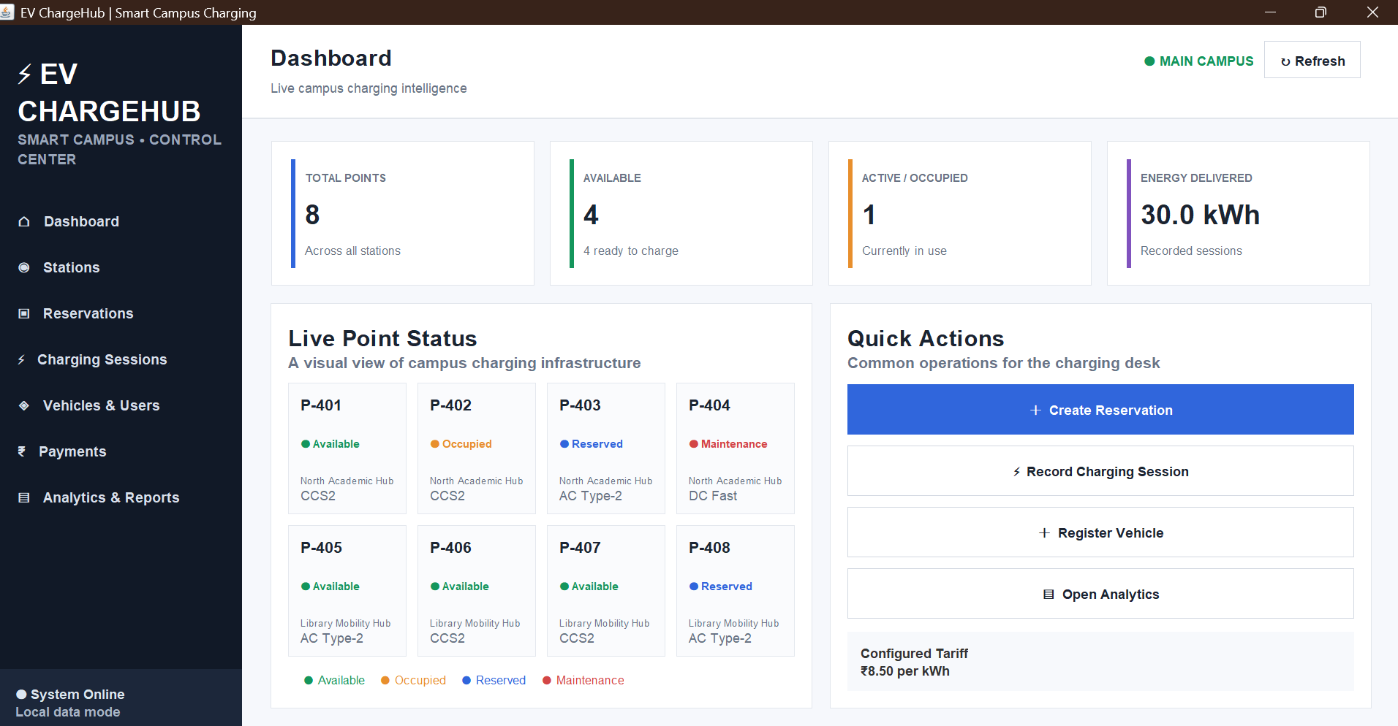
Main dashboard showing KPI cards, live charging-point status, quick actions and configured tariff.

Figure 2. Charging Stations
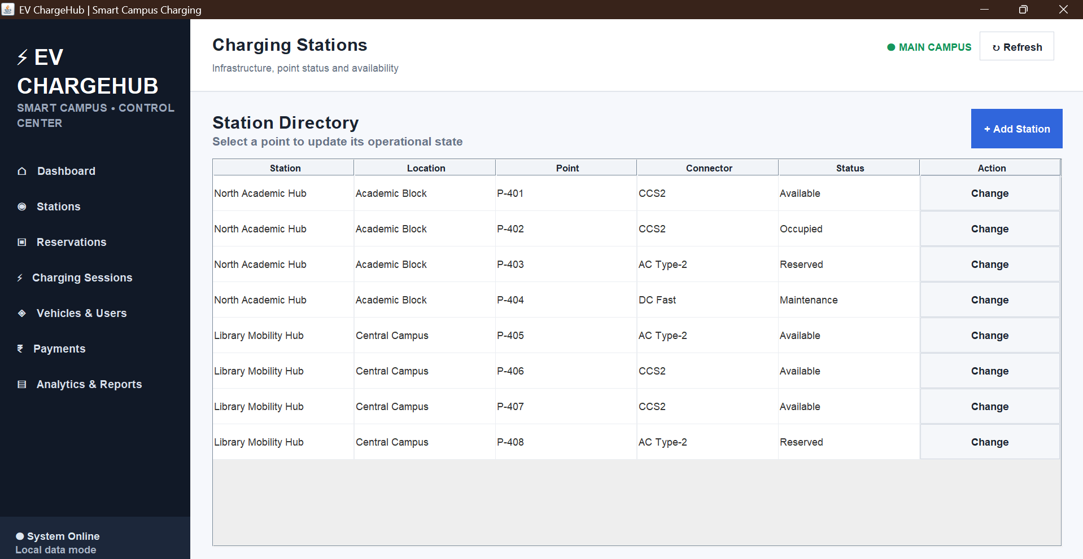
Station directory showing station, location, point, connector and operational status.

Figure 3. Charging Sessions
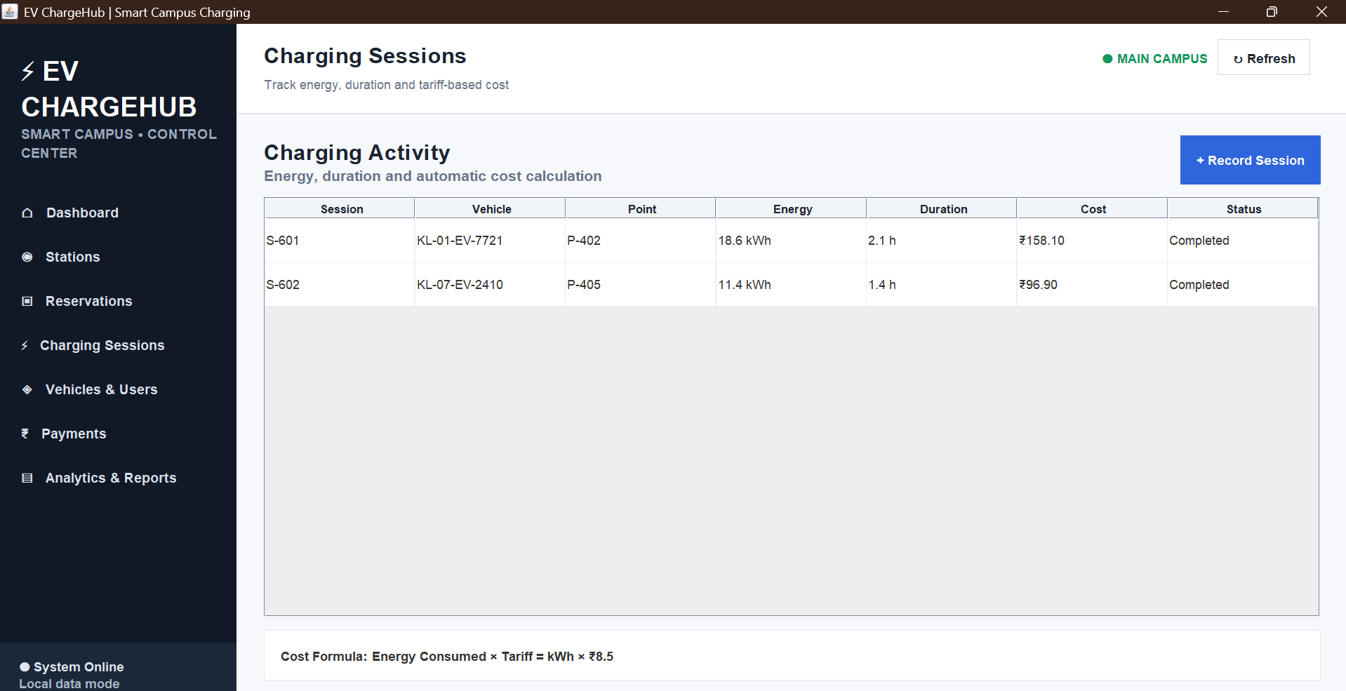
Charging activity table showing energy, duration, automatic cost and completion status.

Figure 4. Reservations
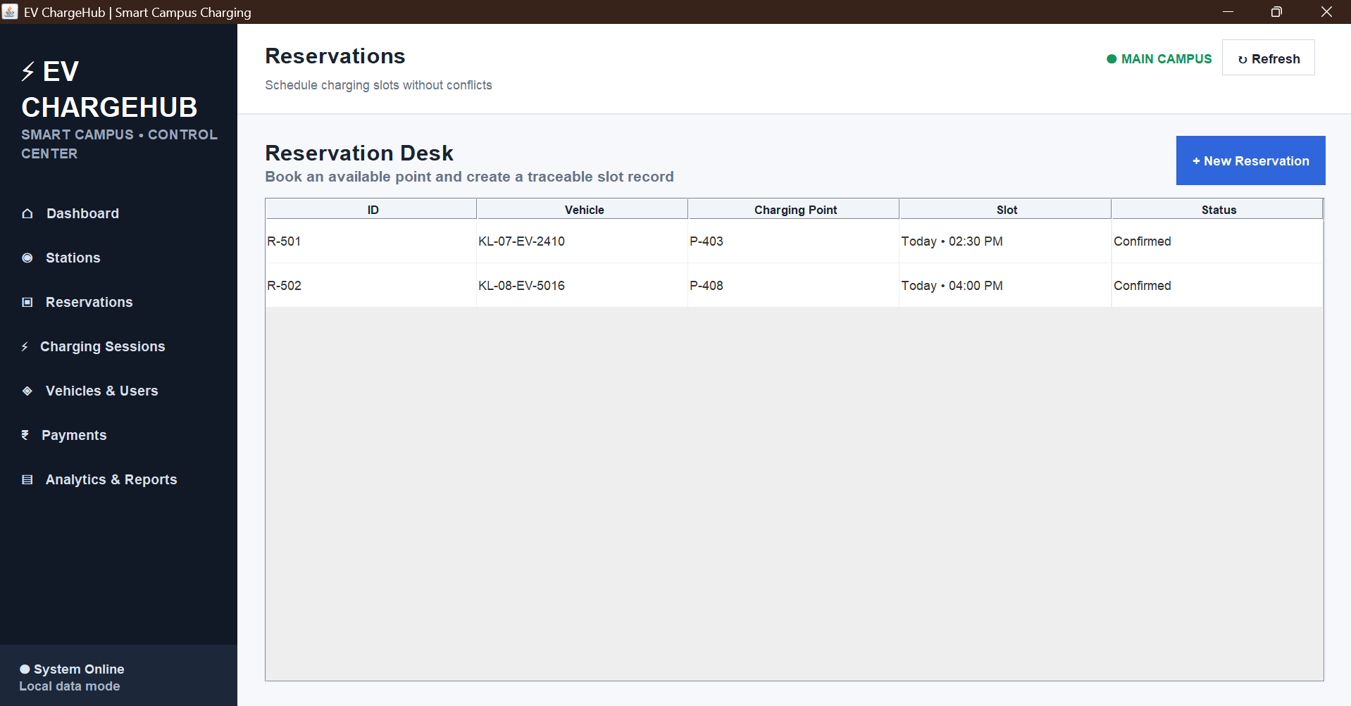
Reservation desk showing vehicle, charging point, slot and reservation status.

Figure 5. Vehicles & Users
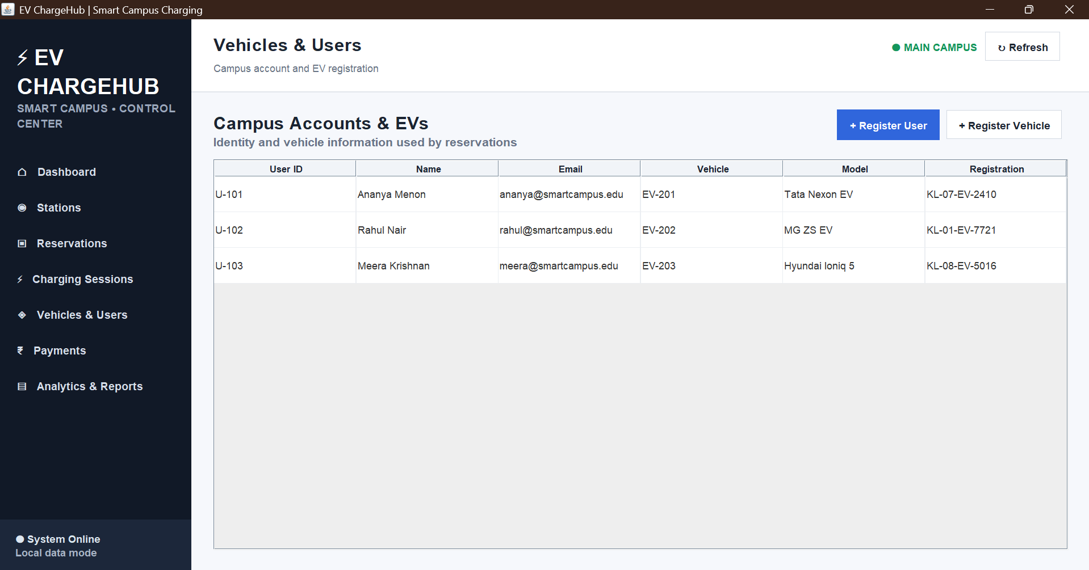
Campus accounts and EV registration view linking users with their vehicles.

Figure 6. Payments
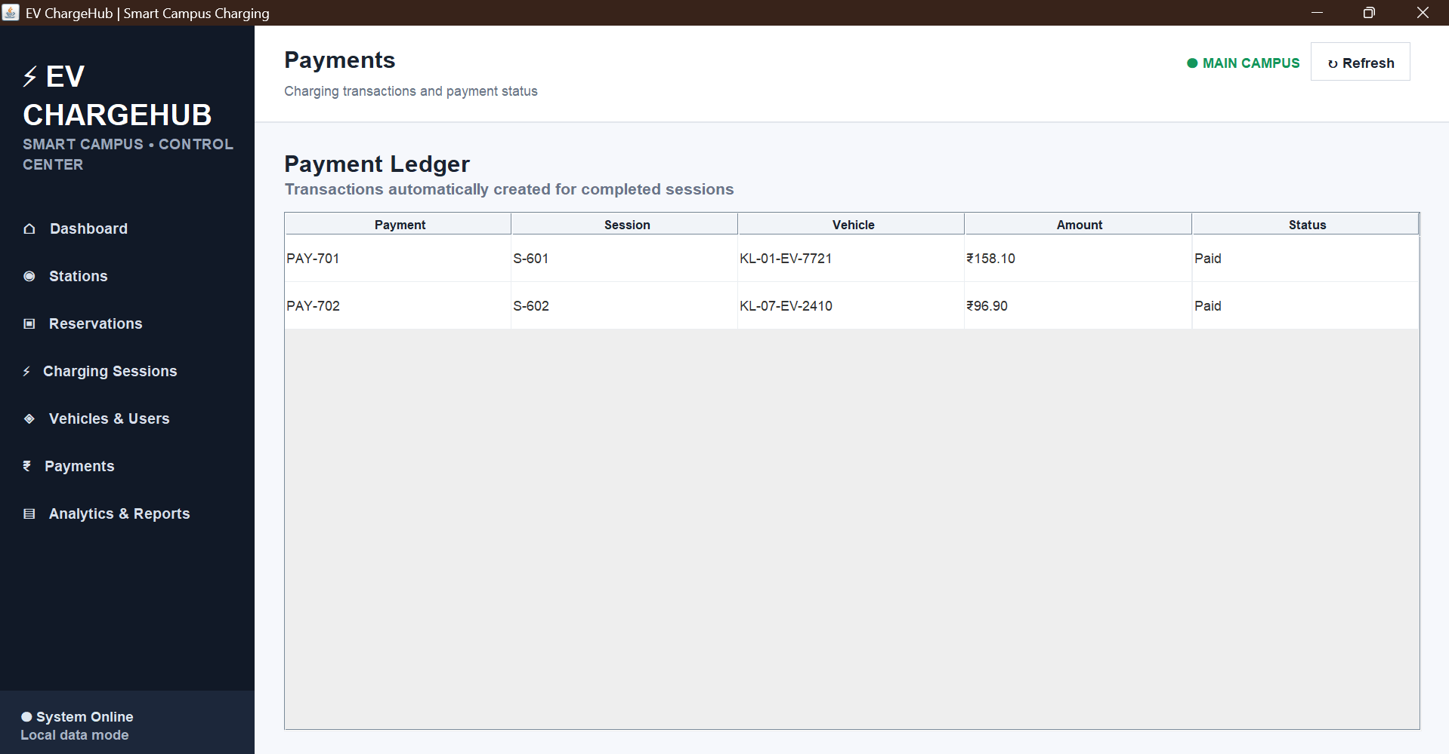
Payment ledger showing payments automatically associated with completed charging sessions.

Figure 7. Analytics & Reports
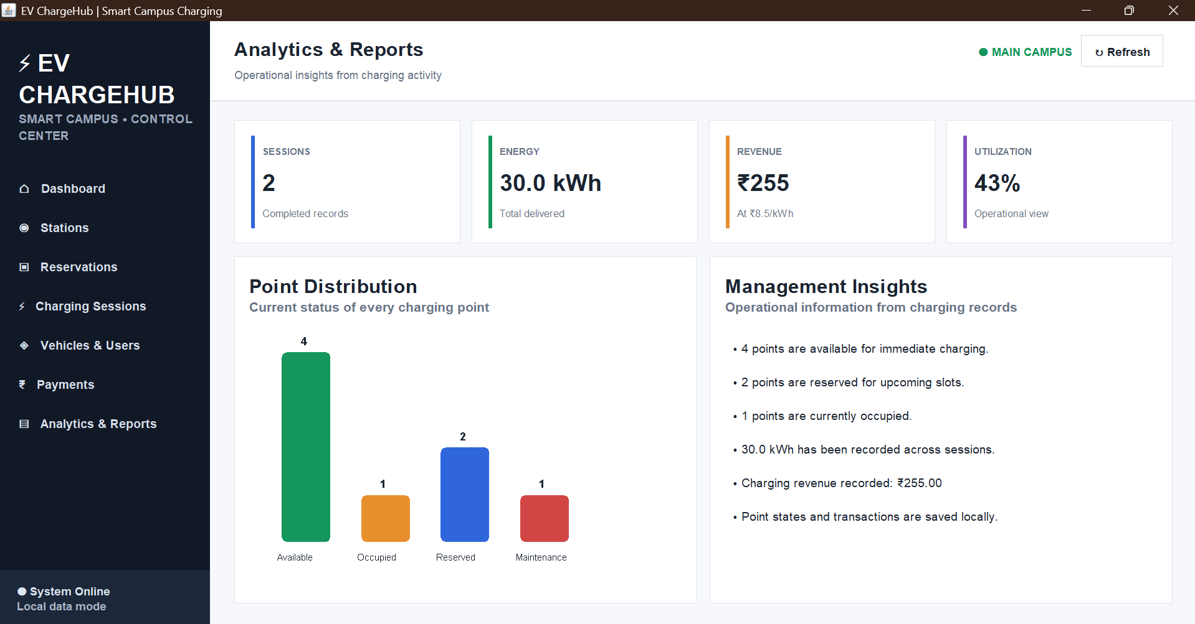
Analytical dashboard showing session count, energy, revenue, utilization, point distribution and management insights.

11. Testing and Validation
Testing was performed at the GUI/workflow level using the supplied working application. The checks below focus on navigation, data-entry validation, state changes, calculations and visual output.
Test ID | Test Case | Expected Result | Observed Result
T01 | Launch application | Dashboard opens successfully | Dashboard displayed with KPI cards and live point status
T02 | Open Stations | Station directory is displayed | Station records and Change actions displayed
T03 | Change point status | Selected point status is updated | Status can be changed and page refreshed
T04 | Create reservation | Reservation is added for selected vehicle/point/slot | Reservation workflow is available
T05 | Record session | Session and payment are created | Session and payment entries appear
T06 | Invalid session values | Validation warning is shown | Numeric validation warning is implemented
T07 | Register user/vehicle | New record is added | Registration dialogs are available
T08 | Open Payments | Payment ledger is displayed | Payment records and amounts displayed
T09 | Open Analytics | KPIs and chart reflect current records | Point distribution and management insights displayed
T10 | Refresh/navigation | Current page is rebuilt | Navigation and refresh workflow operate through the GUI

11.1 Validation of Cost Formula
The session constructor calculates cost as kWh × tariff. With the configured tariff of ₹8.50 per kWh, the displayed sample sessions of 18.6 kWh and 11.4 kWh correspond to ₹158.10 and ₹96.90 respectively. The total sample energy shown on the dashboard and analytics view is 30.0 kWh, and the corresponding total charging revenue is ₹255.00.

11.2 Error Handling
- The reservation and session workflows check whether vehicles are registered before continuing.
- Charging-session numeric input is validated and a warning is shown for invalid or non-positive values.
- The application prevents recording a session when no usable charging point is available.
- The GUI refreshes the relevant page after state-changing operations.

12. Individual Contribution
The individual contribution to the project focused mainly on visualization and dashboard development. The work involved transforming charging-management data into a clear visual interface that could be understood quickly during both demonstration and normal operational use.
A major part of the contribution was the design of the main dashboard. The dashboard was organized around key performance indicators so that the charging desk could immediately see the total number of charging points, currently available points, occupied points and energy delivered. The KPI-card approach was selected to reduce the effort required to interpret raw records and to provide an at-a-glance operational summary.
The live charging-point section was another important part of the visualization work. Individual point cards were used to distinguish Available, Occupied, Reserved and Maintenance states. This made the status of the campus charging infrastructure easier to understand than a plain list alone. The interface also included a status legend and quick-action controls so that the dashboard connected visualization with operational tasks.
The contribution also included the Analytics & Reports view. The analytics page summarizes charging sessions, energy, revenue and utilization and provides a point-distribution chart. The chart is generated from the current charging-point status counts, allowing the visualization to change when the underlying operational state changes. Management insights were presented as concise statements so that the dashboard could support decision-making rather than only display raw values.
During implementation, attention was given to navigation and consistency across the interface. The sidebar provides access to Dashboard, Stations, Reservations, Charging Sessions, Vehicles & Users, Payments and Analytics & Reports. Consistent headings, tables, cards, spacing and action buttons were used across these pages to make the application feel like one integrated control center.
Testing and debugging were also part of the contribution. The visualization was checked against the application data to ensure that the KPI values, charging-point states, energy totals, revenue values and chart categories were consistent. The final screenshots document the resulting dashboard and module interfaces.
Overall, the contribution strengthened the presentation layer of the project by connecting the underlying charging records with understandable visual summaries, interactive navigation and an operational dashboard.

13. Conclusion
EV ChargeHub demonstrates a practical desktop interface for managing a Smart Campus EV charging environment. The application brings together charging infrastructure, reservations, charging sessions, users and vehicles, payments and analytics in one navigable control center. The dashboard and reports views demonstrate how raw operational records can be transformed into useful visual information.
The supplied implementation successfully demonstrates the intended GUI workflows, status management, session cost calculation and visualization features in local data mode. The project can serve as a foundation for a more complete deployment with a persistent relational database and a separated backend service.

14. Future Enhancements
- Integrate MySQL or another relational database for persistent storage of all entities.
- Introduce a dedicated backend/DAO/service layer and connect the Swing frontend to it.
- Implement JDBC operations using appropriate Statement, PreparedStatement and CallableStatement usage where required by the project architecture.
- Add authentication and role-based access for charging-desk operators and administrators.
- Add date/time-based reservation conflict validation and cancellation workflows.
- Add richer analytics such as daily/monthly energy trends, station utilization over time and revenue trends.
- Connect the application to real charger telemetry for live point updates.
- Add export of reports to CSV/PDF and automated backup of operational data.

15. Source and Submission Notes
The report is based on the supplied Java source and the supplied output screenshots. The source file contains the Swing GUI, domain objects, navigation, dashboard calculations, operational workflows, local-state saving support and analytics chart. The project files should be uploaded to GitHub as required by the assignment.
For the final submission, the team should ensure that the GitHub repository contains the complete working files needed to compile and run the application, and that the single submitted document contains the pseudocode, implementation evidence, output screenshots and individual contribution write-up. No student name or register number is included in this report.

Appendix A – Implementation File Map
Area | Representative Methods / Classes
Data model | User, Vehicle, Point, Station, Reservation, Session, Payment
Startup | main(), build()
Navigation | sidebar(), navButton(), show()
Dashboard | dashboard(), pointPanel(), quickPanel(), card()
Stations | stationsPage(), addStation(), changeStatus()
Reservations | reservationsPage(), newReservation()
Sessions | sessionsPage(), newSession()
Users / Vehicles | usersPage(), addUser(), addVehicle()
Payments | paymentsPage()
Analytics | reportsPage(), reportChart()
Local state | save(), load(), seed()
This appendix is a navigation map of the supplied source rather than a duplicate of the full 3,000+ line source file. The complete source should remain in the GitHub project repository and working project folder.

