EXPERIMENT 1:

Write a R program to print the square of numbers.

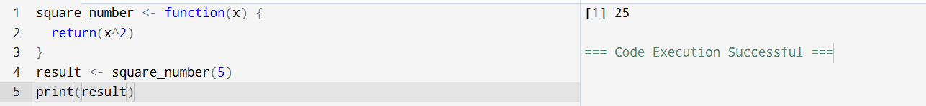

EXPERIMENT 2:

Write a R program to print the elements of array using user defined function.

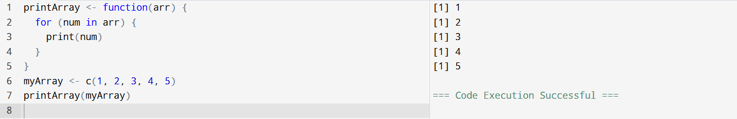

EXPERIMENT 3:

Write a R program to access the elements from the number array in different ways.

EXPERIMENT 4:

Write a R program to create matrix and display.

