BUILDING MODULE DATA DICTIONARYBuildings Module Table of Contents

*(To navigate to a specific section of the Data Dictionary (DD) press the CTRL key and click on the section you wish to go to.)*

1 Introduction 1-3

2 Change Log 2-1

3 BUILDINGS -- DETAILS Tab 3-1

4 BUILDINGS -- ADDRESS Tab 4-24

5 BUILDINGS – OPERATION/ENERGY Tab 5-27

6 BUILDINGS -- ACQUISITION Tab 6-31

7 BUILDINGS -- ACCESSIBILITY Tab 7-35

8 FLOOR/ROOMS/USAGE/OCCUPANCY Tab 8-37

9 EQUIPMENT Tab 9-38

10 SEISMIC Tab 10-47

11 SURVEY Tab 11-55

12 WORK ITEMS Tab 12-58

13 COMPONENTS BUTTON 13-67

14 FMP BUTTON 14-110

# Introduction

The purpose of this document is to provide definitions for the data fields in the Buildings module of the Infra application. Due to the size of this document, it is recommended you use it in the electronic format rather than print it.

To better delineate the different areas discussed in the Data Dictionary (DD), a color scheme is used to denote areas of commonality. The first row of each field definition has a color for that tab/button or area being discussed. The effectiveness of this color system will be assessed for future data dictionary releases.

Infra v6.3 has been modified to include many data fields from USDA’s real property system CPAIS (Corporate Property Automated Information System). Infra data is replicated up into CPAIS to provide official Forest Service inventory data for USDA’s external reporting. Many of the Infra fields the Forest Service uses to manage its buildings are not available in CPAIS; therefore the CPAIS fields have been added in v6.3 to ensure Forest Service staff have use of all the fields unavailable in CPAIS (the alternative was to adopt CPAIS in place of Infra and lose the use of all the Infra fields that are unavailable in CPAIS).

Fields that have been added are noted in this document.

Additional information concerning the Buildings module, and information on the work the Building User Board is pursuing, is available at:

<http://fsweb.r6.fs.fed.us/eng/facilities/user_board/Buildings_User_Board.htm>

Due to the many changes buildings module v6.3 there are many list of value (LOV) corrections and changes that need to be made. You will find that the LOVs in this document will not always completely match what v6.3 contains on the screen. These minor discrepancies are regretted; but we are moving toward a better system and this transition period should be brief.

# Change Log

This Data Dictionary is dynamic and will constantly be updated to reflect changes in business rules, new data structures, and screen changes.

Please refer to the chart below for Building DD version, chapter and changes that have been made (since this is the first release of the building DD, there are not, of course, any change entries).

|  |  |  |
| --- | --- | --- |
| **Version** | **Chapter** | **Description** |
|  |  |  |
|  |  |  |
|  |  |  |
|  |  |  |
|  |  |  |
|  |  |  |

# BUILDINGS -- DETAILS Tab

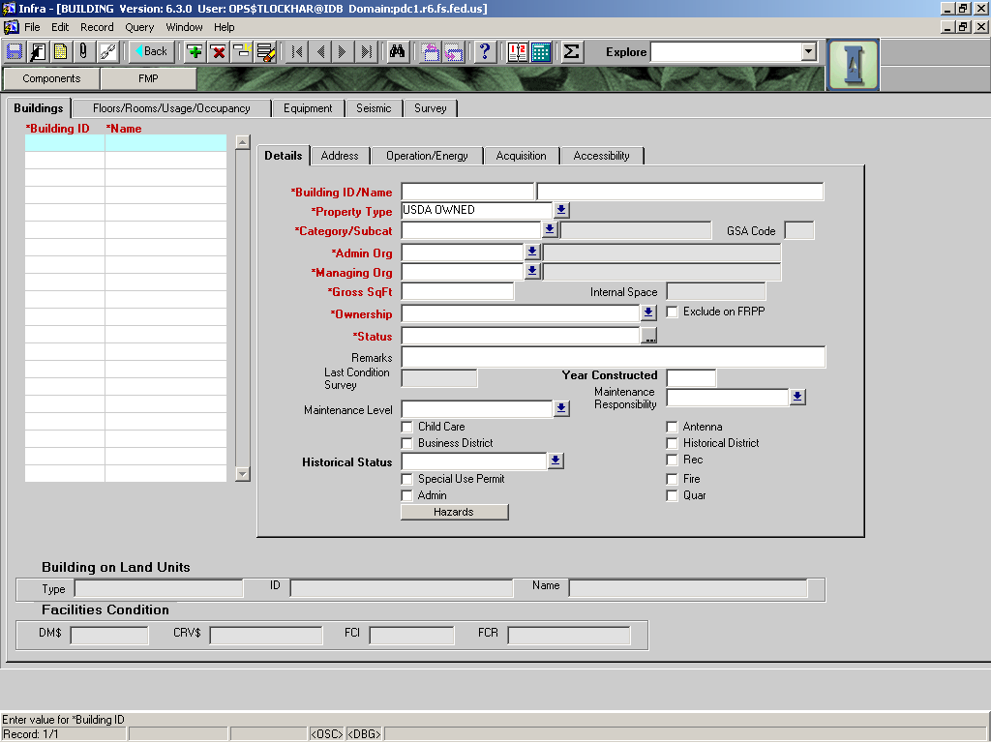

|  |  |  |  |  |  |  |  |
| --- | --- | --- | --- | --- | --- | --- | --- |
|  |  | | | | | **Used in Tables:** | |
| **Name:** | **Building ID** | | | | | II_BASICS | |
|  |  | | | | | II_EVENTS | |
| **Definition:** | The official identifier for the building. | | | | | | |
|  |  | | | | | | |
| **Reference:** | FSH 6509.11K, section 56.05  FSH 7309.11, section 05 | | | | | **Screen:** | Main |
|  |  | | | | |  |  |
| **Format:** |  | | | | | **Unit of Measure:** |  |
|  |  | | | | |  |  |
| **Data Type:** | varchar2 | **Size:** | UP TO 5 |  |  | **Mandatory:** | **YES** |
|  |  | | | | | **Requirement** | **YES** |
| **Look Up:** |  | | | | | | |
|  |  | | | | | | |
| **Business Rules:** | 1. For all structures that meet the following definition: “A building is defined as ‘a structure to support, shelter, or enclose persons, animals or property of any kind’. Reference FSH 09.11k, section 56.05 and FSH 7309.11, section 05. A trailer pad is not a building.” Please see Notes for further details on what constitutes a building for Real Property. 2. This should be the same identifier that is used on the ground. 3. There is no required or standardized numbering system for buildings. 4. Assign a unique number for each building. When replacing a building with a new structure, assign a new number. | | | | | | |
|  |  | | | | | | |
| **Notes:** | Sample scenarios will be added in the future. | | | | | | |
|  |  | | | | | | |

|  |  |  |  |  |  |  |  |
| --- | --- | --- | --- | --- | --- | --- | --- |
|  |  | | | | | **Used in Tables:** | |
| **Name:** | **NAME** | | | | | II_FEATURES | |
|  |  | | | | |  | |
| **Definition:** | The name of the building. | | | | | | |
|  |  | | | | | | |
| **Reference:** |  | | | | | **Screen:** | Main |
|  |  | | | | |  |  |
| **Format:** |  | | | | | **Unit of Measure:** |  |
|  |  | | | | |  |  |
| **Data Type:** | varchar2 | **Size:** | 30 |  |  | **Mandatory:** | **YES** |
|  |  | | | | | **Requirement** | **YES** |
| **Look Up:** |  | | | | | | |
|  |  | | | | | | |
| **Business Rules:** | 1. Name should be descriptive to type and location. 2. Name should be unique to each building on a forest. | | | | | | |
|  |  | | | | | | |
| **Notes:** | Example: The Bighorn N.F. and Bitterroot N.F. could both have a building named “Greybull Warehouse” but the Bighorn N.F. could not have two buildings both named “Greybull Warehouse”. | | | | | | |
|  |  | | | | | | |

|  |  |  |  |  |  |  |  |  |  |
| --- | --- | --- | --- | --- | --- | --- | --- | --- | --- |
|  |  | | | | | | **Used in Tables:** | | |
| **Name:** | **PROPERTY TYPE** | | | | | |  | | |
|  |  | | | | | |  | | |
| **Definition:** |  | | | | | | | | |
|  |  | | | | | | | | |
| **Reference:** |  | | | | | | **Screen:** | | Building |
|  |  | | | | | |  | |  |
| **Format:** | LOV | | | | | | **Unit of Measure:** | |  |
|  |  | | | | | |  | |  |
| **Data Type:** | varchar2 | **Size:** |  | |  |  | **Mandatory:** | | **YES** |
|  |  | | | | | | **Requirement** | | **YES** |
| **Look Up:** |  | | | | | | | | |
|  |  | | | | | | | | |
| **Business Rules:** | 1. | | | | | | | | |
|  |  | | | | | | | | |
| **Notes:** | Defaults to “USDA OWNED” | | | | | | | | |
|  |  | | | | | | | | |
| **Valid Codes** | | | | | | | | | |
| **Code** | | | | **Description** | | | |  | |
| GSA Assigned | | | | *GSA Assigned Property* | | | |  | |
| OTHER | | | | *Property not USDA Owned, USDA Leased, GSA Assigned or Trust* | | | |  | |
| TRUST | | | | *Trust, Real Property whose title is held in trust by the United States for the benefit of an individual person or group of people (e.g. an Indian tribe).* | | | |  | |
| USDA LEASED | | | | *USDA Leased Property* | | | |  | |
| USDA OWNED | | | | *USDA Owned Property* | | | |  | |

|  |  |  |  |  |  |  |  |  |  |
| --- | --- | --- | --- | --- | --- | --- | --- | --- | --- |
|  |  | | | | | | **Used in Tables:** | | |
| **Name:** | **CATEGORY** | | | | | |  | | |
|  |  | | | | | |  | | |
| **Definition:** | The principal use for the building. This field is automatically populated when the subcategory is selected. | | | | | | | | |
|  |  | | | | | | | | |
| **Reference:** |  | | | | | | **Screen:** | | Building |
|  |  | | | | | |  | |  |
| **Format:** | LOV | | | | | | **Unit of Measure:** | |  |
|  |  | | | | | |  | |  |
| **Data Type:** | varchar2 | **Size:** |  | |  |  | **Mandatory:** | | **YES** |
|  |  | | | | | | **Requirement** | | **YES** |
| **Look Up:** |  | | | | | | | | |
|  |  | | | | | | | | |
| **Business Rules:** | 1. To be determined by the Real Property Manager. | | | | | | | | |
|  |  | | | | | | | | |
| **Notes:** | System generated | | | | | | | | |
|  |  | | | | | | | | |
| **Valid Codes** | | | | | | | | | |
| **Code** | | | | **Description** | | | | **GSA Usage Code** | |
| ALL OTHER | | | |  | | | | 80 | |
| COMMUNICATION SYSTEMS | | | |  | | | | 72 | |
| HOSPITAL | | | | ***A building providing medical care.*** | | | | 21 | |
| HOUSING | | | | ***A building that is used for lodging.*** | | | | 30 | |
| INDUSTRIAL | | | |  | | | | 50 | |
| INTERIM USE | | | |  | | | | 90 | |
| NAVIGATION AND TRAFFIC AIDS | | | |  | | | | 73 | |
| OFFICE | | | | ***A building used for office space.*** | | | | 10 | |
| OTHER INSTITUTIONAL USES | | | |  | | | | 29 | |
| RESEARCH | | | | ***A building used to do research (not all of these buildings are owned by Research).*** | | | | 70 | |
| SCHOOL | | | | ***A building used to teach students.*** | | | | 23 | |
| SERVICE | | | | ***A building used to perform day-to-day FS operations.*** | | | | 60 | |
| STORAGE | | | | ***A building that protects assets from the elements.*** | | | | 40 | |
| TRUST | | | |  | | | | 99 | |
| UTILITY | | | | ***A building protecting electrical, mechanical or chemical utility system components.*** | | | | 80 | |

Wednesday, August 07, 2013 6:11 AM

In FY 2012, several new FRPP data elements prompted extensive review of offices and warehouses in NRM in an effort to reduce the data entry workload that would have been required for those predominant use types (category).  As a result, it was decided to restrict the minimum square footage for these categories.

Steve Austin

Asset Management Branch Chief

US Forest Service, Acquisition Management

**These changes are included in the table below.**

|  |  |  |  |  |  |  |  |  |  |
| --- | --- | --- | --- | --- | --- | --- | --- | --- | --- |
|  |  | | | | | | **Used in Tables:** | | |
| **Name:** | **SUBCATEGORY** | | | | | | II_BUILDINGS | | |
|  |  | | | | | |  | | |
| **Definition:** | ***Defines the type of building based upon its primary use.*** | | | | | | | | |
|  |  | | | | | | | | |
| **Reference:** |  | | | | | | **Screen:** | | Main |
|  |  | | | | | |  | |  |
| **Format:** | LOV | | | | | | **Unit of Measure:** | |  |
|  |  | | | | | |  | |  |
| **Data Type:** | varchar2 | **Size:** |  | |  |  | **Mandatory:** | | **YES** |
|  |  | | | | | | **Requirement** | | **YES** |
| **Look Up:** |  | | | | | | | | |
|  |  | | | | | | | | |
| **Business Rules:** | 1. Select value that most closely reflects the actual use of the building. 2. Only use those sub-categories shown in **BOLD**. It is expected that the remaining sub-categories will go away in a future version. | | | | | | | | |
|  |  | | | | | | | | |
| **Notes:** |  | | | | | | | | |
|  |  | | | | | | | | |
| **Valid Codes** | | | | | | | | | |
| **Sub-Category** | | | | **Description** | | | | **Category** | |
| ACCESS CONTROL | | | | ***Do not use.*** | | | | ALL OTHER | |
| ADMINISTRATIVE OFFICES AND LABORATORY | | | | ***Do not use.*** | | | | ALL OTHER | |
| **ALL OTHER** | | | | ***Includes buildings with predominate use as office space, under 750 gross square feet.*** | | | | **ALL OTHER** | |
| ANIMAL FACILITY, ALL OTHER | | | | ***Do not use.*** | | | | ALL OTHER | |
| BARN | | | | ***Do not use.*** | | | | ALL OTHER | |
| CHANGING FACILITY | | | | ***Do not use.*** | | | | ALL OTHER | |
| FILLING STATION | | | | ***Do not use.*** | | | | ALL OTHER | |
| FIRE STATION, RELATED BUILDINGS | | | | ***Do not use.*** | | | | ALL OTHER | |
| GARAGE, ALL OTHER | | | | ***Do not use.*** | | | | ALL OTHER | |
| HANGAR | | | | ***Do not use.*** | | | | ALL OTHER | |
| LABORATORY (INCLUDING OFFICE) | | | | ***Do not use.*** | | | | ALL OTHER | |
| LABORATORY WASTE COLLECTION | | | | ***Do not use.*** | | | | ALL OTHER | |
| LIBRARY, ALL OTHER | | | | ***Do not use.*** | | | | ALL OTHER | |
| MULTIPURPOSE | | | | ***Do not use.*** | | | | ALL OTHER | |
| OFFICE, ALL OTHER | | | | ***Do not use.*** | | | | ALL OTHER | |
| PAVILLION, ALL OTHER | | | | ***Do not use.*** | | | | ALL OTHER | |
| REST ROOM (SEPARATE BUILDING) | | | | ***Do not use.*** | | | | ALL OTHER | |
| SCALE HOUSE | | | | ***Do not use.*** | | | | ALL OTHER | |
| SCREEN HOUSE | | | | ***Do not use.*** | | | | ALL OTHER | |
| SHOP, ALL OTHER | | | | ***Do not use.*** | | | | ALL OTHER | |
| STORAGE BUILDING, STORAGE SHED | | | | ***Do not use.*** | | | | ALL OTHER | |
| TRAILER | | | | ***Do not use.*** | | | | ALL OTHER | |
| UTILITY BUILDING | | | | ***Do not use.*** | | | | ALL OTHER | |
| VISITORS CENTER | | | | ***Do not use.*** | | | | ALL OTHER | |
| WASTE FACILITY | | | | ***Do not use.*** | | | | ALL OTHER | |
| WATER SYSTEM BUILDING | | | | ***Do not use.*** | | | | ALL OTHER | |
| WEATHER STATION BUILDING | | | | ***Do not use.*** | | | | ALL OTHER | |
| **COMMUNICATION SYSTEMS** | | | | ***Building dedicated to communication system equipment.*** | | | | **COMMUNICATIONS SYSTEM** | |
| **HOSPITAL** | | | | ***Any medical facility for humans (not animals)(i.e. infirmary, clinics, hospitals).*** | | | | **HOSPITAL** | |
| BARN, HOUSING | | | | ***Do not use.*** | | | | HOUSING | |
| BUNK HOUSE | | | | ***Do not use.*** | | | | HOUSING | |
| **CABIN** | | | | ***A building that contains three or fewer rooms used as a single housekeeping unit with the cooking, living, and sleeping facilities.*** | | | | **HOUSING** | |
| **CREW** | | | |  | | | | **HOUSING** | |
| **HOTEL/MOTEL** | | | | ***Multiple units with transient users.*** | | | | **HOUSING** | |
| HOUSING, RESIDENCE, BUNKHOUSE | | | | ***A building for 4 or more residents. It may have common toilet and bathroom facilities and provides cooking and dining facilities.*** | | | | HOUSING | |
| **QUARTERS-COOK HOUSE** | | | | ***List under Mess Hall.*** | | | | **HOUSING** | |
| **QUARTERS-CREW** | | | | ***A building for 4 to 19 occupants. It may have common toilet and bathroom facilities but does not provide cooking and dining facilities.*** | | | | **HOUSING** | |
| **RESIDENCE** | | | | ***A building with four or more rooms used for a single-family dwelling.*** | | | | **HOUSING** | |
| TRAILER, HOUSING | | | | ***Do not use.*** | | | | HOUSING | |
| **ACCESS CONTROL, INDUSTRIAL** | | | |  | | | | **INDUSTRIAL** | |
| **INDUSTRIAL** | | | |  | | | | **INDUSTRIAL** | |
| ELECTRIC | | | | ***Do not use.*** | | | | INTERIM USE | |
| **NAVIGATION AND TRAFFIC AIDS** | | | |  | | | | **NAVIGATION AND TRAFFIC AIDS** | |
| ADMINISTRATIVE AND LABORATORY, OFFICE | | | | ***Do not use.*** | | | | OFFICE | |
| GREENHOUSE, OFFICE | | | | ***Do not use.*** | | | | OFFICE | |
| LABORATORY, OFFICE | | | | ***Do not use.*** | | | | OFFICE | |
| **OFFICE** | | | | ***Buildings with predominate use as office space, 750 gross square feet or more.*** | | | | **OFFICE** | |
| TRAILER, OFFICE | | | | ***Do not use.*** | | | | OFFICE | |
| **ANIMAL FACILITY** | | | |  | | | | **OTHER INSTITUATIONAL USES** | |
| CHAPEL OR OTHER WORSHIP-RELATED BUILDING | | | | ***Do not use.*** | | | | OTHER INSTITUATIONAL USES | |
| LIBRARY | | | | ***Do not use.*** | | | | OTHER INSTITUATIONAL USES | |
| **OTHER INSTITUTIONAL USES** | | | |  | | | | **OTHER INSTITUATIONAL USES** | |
| ANIMAL FACILITY, RESEARCH | | | | ***Do not use.*** | | | | RESEARCH | |
| ANIMAL QUARANTINE | | | | ***Do not use.*** | | | | RESEARCH | |
| BARN RESEARCH | | | | ***Do not use.*** | | | | RESEARCH | |
| CHEMICAL STORAGE BUILDING | | | | ***Do not use.*** | | | | RESEARCH | |
| ENGINEERING FACILITY, RESEARCH | | | | ***Do not use.*** | | | | RESEARCH | |
| FEED MILL | | | | ***Do not use.*** | | | | RESEARCH | |
| **GREENHOUSE** | | | | ***A building used to grow plants or trees.*** | | | | **RESEARCH** | |
| **HEADHOUSE** | | | | ***A building, usually adjoining a greenhouse, for preparation of said organic matter.*** | | | | **RESEARCH** | |
| INCINERATOR BUILDING | | | | ***Do not use.*** | | | | RESEARCH | |
| INSECT FACILITY | | | | ***Do not use.*** | | | | RESEARCH | |
| **LABORATORY** | | | | ***A building used for performing scientific experiments.*** | | | | **RESEARCH** | |
| LABORATORY WASTE COLLECTION BUILDING | | | | ***Do not use.*** | | | | RESEARCH | |
| LIBRARY, RESEARCH | | | | ***Do not use.*** | | | | RESEARCH | |
| OFFICE, RESEARCH | | | | ***Do not use.*** | | | | RESEARCH | |
| PLANT QUARANTINE, RESEARCH | | | | ***Do not use.*** | | | | RESEARCH | |
| PUMPHOUSE | | | | ***Do not use.*** | | | | RESEARCH | |
| RADIOLOGICAL MATERIALS BUILDING | | | | ***Do not use.*** | | | | RESEARCH | |
| **RESEARCH OFFICE/LABORATORY** | | | | ***A building which has both office and research lab space.*** | | | | **RESEARCH** | |
| SCALE HOUSE, RESEARCH | | | | ***Do not use.*** | | | | RESEARCH | |
| SCREEN HOUSE, RESEARCH | | | | ***Do not use.*** | | | | RESEARCH | |
| SHED, RESEARCH | | | | ***Do not use.*** | | | | RESEARCH | |
| SHOP, RESEARCH | | | | ***Do not use.*** | | | | RESEARCH | |
| STORAGE BUILDING, STORAGE SHED, RESEARCH | | | | ***Do not use.*** | | | | RESEARCH | |
| TRAILER, RESEARCH | | | | ***Do not use.*** | | | | RESEARCH | |
| UTILITY BUILDING, RESEARCH | | | | ***Do not use.*** | | | | RESEARCH | |
| WASTEWATER | | | | ***Do not use.*** | | | | RESEARCH | |
| WATER SYSTEM BUILDING, RESEARCH | | | | ***Do not use.*** | | | | RESEARCH | |
| WEATHER STATION BUILDING, RESEARCH | | | | ***Do not use.*** | | | | RESEARCH | |
| **EDUCATIONAL** | | | | ***A building used as a school or training facility to teach academics rather than technical skills.*** | | | | **SCHOOL** | |
| **PLANT QUARANTINE** | | | |  | | | | **SCHOOL** | |
| **SCHOOL** | | | | ***A building used for teaching both academic and technical skills.*** | | | | **SCHOOL** | |
| **VOCATIONAL** | | | | ***A building used as a school or teaching facility to teach technical skills rather than academics.*** | | | | **SCHOOL** | |
| **AMPHITHEATER** | | | | ***A covered outdoor theater providing seating for the conveyance of information or entertainment*** | | | | **SERVICE** | |
| ANIMAL FACILITY, SERVICE | | | | ***Do not use.*** | | | | SERVICE | |
| **AVIATION** | | | | ***A building used to service planes and related equipment.*** | | | | **SERVICE** | |
| BARN, SERVICE | | | | ***A building for housing animals or related items.*** | | | | SERVICE | |
| **BATHHOUSE** | | | | ***A building used for bathing or showering.*** | | | | **SERVICE** | |
| BUS STATION | | | | ***Do not use.*** | | | | SERVICE | |
| CAFETERIA | | | | ***Do not use.*** | | | | SERVICE | |
| CHANGING FACILITY, SERVICE | | | | ***Do not use.*** | | | | SERVICE | |
| **DAYCARE** | | | | ***A building for the care of children of FS employees.*** | | | | **SERVICE** | |
| **DISPENSARY, SERVICE** | | | | ***A building used to give out needed tools or medicine.*** | | | | **SERVICE** | |
| ENGINEERING FACILITY, SERVICE | | | | ***Do not use.*** | | | | SERVICE | |
| **ENTRANCE STATION** | | | | ***A building used as a first point of contact at campgrounds or other public facility. Mobile units or non-building stations shall be tracked in the recreation module.*** | | | | **SERVICE** | |
| FEED MILL, SERVICE | | | | ***Do not use.*** | | | | SERVICE | |
| FILLING STATION | | | | ***Do not use.*** | | | | SERVICE | |
| **FISH CLEANING** | | | | ***A building used to prepare fish for human consumption. Unroofed stations shall be entered in the recreation module.*** | | | | **SERVICE** | |
| GARAGE, SERVICE | | | | ***Do not use.*** | | | | SERVICE | |
| INCINERATORY BUILDING, SERVICE | | | | ***Do not use.*** | | | | SERVICE | |
| LABORATORY (INCLUDING OFFICE) SERVICE | | | | ***Do not use.*** | | | | SERVICE | |
| **LAUNDRY** | | | | ***A building used for cleaning of clothes or linen.*** | | | | **SERVICE** | |
| **MARINA** | | | | ***A building used to store or service boats and related equipment.*** | | | | **SERVICE** | |
| **MESS HALL** | | | | ***A building used to prepare food and feed large numbers of people.*** | | | | **SERVICE** | |
| OFFICE, SERVICE | | | | ***Do not use.*** | | | | SERVICE | |
| **OTHER TOWERS** | | | | ***Any other tower structure not used as a lookout.*** | | | | **SERVICE** | |
| **PAVILION** | | | | ***A covered picnic area with cooking apparatus.*** | | | | **SERVICE** | |
| PUMPHOUSE, SERVICE | | | | ***Do not use.*** | | | | SERVICE | |
| SCALE HOUSE, SERVICE | | | | ***Do not use.*** | | | | SERVICE | |
| SHED, SERVICE | | | | ***Do not use.*** | | | | SERVICE | |
| **SHELTER** | | | | ***A building used to help protect people or animals from the elements.*** | | | | **SERVICE** | |
| **SHOP** | | | | ***A building used to build or repair assets and equipment.*** | | | | **SERVICE** | |
| STORAGE BUILDING, STORAGE SHED, SERVICE | | | | ***Do not use.*** | | | | SERVICE | |
| **STORE/RESTAURANT** | | | | ***A building used to sell food or wares.*** | | | | **SERVICE** | |
| **TOILET-FLUSH** | | | | ***A toilet that is connected to a sewage piping system that transports waste to a central storage area or treatment facility.*** | | | | **SERVICE** | |
| **TOILET-OTHER** | | | | ***All other types of toilets.*** | | | | **SERVICE** | |
| **TOILET-PIT** | | | | ***Toilets that consist of an earthen pit. Generally illegal in most states.*** | | | | **SERVICE** | |
| **TOILET-VAULT** | | | | ***A toilet that stores the waste in a self contained vault.*** | | | | **SERVICE** | |
| UTILITY BUILDING, SERVICE | | | | ***Do not use.*** | | | | SERVICE | |
| **VISITOR INFORMATION SERVICE (VIS)** | | | | ***A building used as a point of contact for the public for recreation information.*** | | | | **SERVICE** | |
| WASTE FACILITY, SERVICE | | | | ***Do not use.*** | | | | SERVICE | |
| WASTE TRATMENT BUILDING | | | | ***Do not use.*** | | | | SERVICE | |
| WASTEWATER, SERVICE | | | | ***Do not use.*** | | | | SERVICE | |
| **WATCHTOWER (LOOKOUT)** | | | | ***A building intended for use as a lookout – may be elevated or at ground level..*** | | | | **SERVICE** | |
| ANIMAL FACILITY, STORAGE | | | | ***Do not use.*** | | | | STORAGE | |
| **BARN/STABLE** | | | | ***A building for housing animals and related items.*** | | | | **STORAGE** | |
| **CHEMICAL** | | | | ***A building used to store chemicals.*** | | | | **STORAGE** | |
| **COOLERS** | | | | ***A building used to store seedlings.*** | | | | **STORAGE** | |
| **EQUIPMENT** | | | | ***A building used to store equipment and tools.*** | | | | **STORAGE** | |
| **EXPLOSIVE** | | | | ***A building used to store explosive materials.*** | | | | **STORAGE** | |
| FEED MILL, STORAGE | | | | ***Do not use.*** | | | | STORAGE | |
| **FERTILIZER** | | | | ***A building used to store fertilizer (keep away from gas/oil building).*** | | | | **STORAGE** | |
| **FIRE CACHE** | | | | ***A building used to store fire suppression tools.*** | | | | **STORAGE** | |
| **FLAMMABLE** | | | | ***A building used to store flammable materials.*** | | | | **STORAGE** | |
| **GARAGE** | | | | ***A building used to store vehicles.*** | | | | **STORAGE** | |
| **GAS/OIL** | | | | ***A building used to store and dispense gasoline.*** | | | | **STORAGE** | |
| GREENHOUSE, STORAGE | | | | ***Do not use.*** | | | | STORAGE | |
| HANGAR, STORAGE | | | | ***Do not use.*** | | | | STORAGE | |
| OFFICE, STORAGE | | | | ***Do not use.*** | | | | STORAGE | |
| **OTHER** | | | | ***Use of this value is discouraged.*** | | | | **STORAGE** | |
| **PESTICIDE** | | | | ***A building used to store pesticides.*** | | | | **STORAGE** | |
| REST ROOM (SEPARATE BUILDING) STORAGE | | | | ***Do not use.*** | | | | STORAGE | |
| **RETARDANT** | | | | ***A building used to store fire retardant.*** | | | | **STORAGE** | |
| **SHED** | | | | ***A small building(less than 400 square feet) used for general storage (see warehouse)*** | | | | **STORAGE** | |
| SHOP, STORAGE | | | | ***Do not use.*** | | | | STORAGE | |
| **STORAGE BUILDING, STORAGE SHED, STORAGE** | | | | ***General storage buildings less than 5,000 gross square feet*** | | | | **STORAGE** | |
| **TOOL** | | | | ***A building used to store only tools*** | | | | **STORAGE** | |
| TRAILER, STORAGE | | | | ***Do not use.*** | | | | STORAGE | |
| **TREE PROCESS** | | | | ***A building used the prepare trees for planting or storage in a cooler.*** | | | | **STORAGE** | |
| UTILITY BUILDING, STORAGE | | | | ***Do not use.*** | | | | STORAGE | |
| **WAREHOUSE** | | | | ***A large building (greater than 5,000 gross square feet) used for general storage.*** | | | | **STORAGE** | |
| WASTE FACILITY, STORAGE | | | | ***Do not use.*** | | | | STORAGE | |
| **TRUST BUILDINGS** | | | | ***Buildings owned by others held in trust by the United States*** | | | | **TRUST BUILDING** | |
| **ELECTRIC** | | | | ***A building used to house electrical equipment.*** | | | | **UTILITY** | |
| **PUMPHOUSE** | | | | ***Building used to house a water pump or well (well house).*** | | | | **UTILITY** | |
| **SEWAGE** | | | | ***A building used to house a wastewater treatment facility.*** | | | | **UTILITY** | |
| **TELECOM** | | | | ***A building used to house telecom equipment.*** | | | | **UTILITY** | |
| **TREATMENT** | | | | ***Use of this field is discouraged. Use either Utility-water or Utility-Sewage for water and wastewater treatment, respectively. PHASE OUT.*** | | | | **UTILITY** | |
| **UTILITY** | | | | ***A building used to house general utility equipment.*** | | | | **UTILITY** | |
| **WATER** | | | | ***A building used to house water treatment equipment.*** | | | | **UTILITY** | |

|  |  |  |  |  |  |  |  |
| --- | --- | --- | --- | --- | --- | --- | --- |
|  |  | | | | | **Used in Tables:** | |
| **Name:** | **ADMIN_ORG** | | | | |  | |
|  |  | | | | |  | |
| **Definition:** | Unit having jurisdiction | | | | | | |
|  |  | | | | | | |
| **Reference:** |  | | | | | **Screen:** | Details |
|  |  | | | | |  |  |
| **Format:** | RRFFDD where RR is region/station, FF is Forest, DD is district (where applicable) | | | | | **Unit of Measure:** |  |
|  |  | | | | |  |  |
| **Data Type:** | varchar2 | **Size:** |  |  |  | **Mandatory:** | **YES** |
|  |  | | | | | **Requirement** | **YES** |
| **Look Up:** | LOV | | | | | | |
|  |  | | | | | | |
| **Business Rules:** | 1. The code shall be for the unit on which the building is located geographically. This may not be the same as the unit managing the building. | | | | | | |
|  |  | | | | | | |
| **Notes:** |  | | | | | | |

|  |  |  |  |  |  |  |  |
| --- | --- | --- | --- | --- | --- | --- | --- |
|  |  | | | | | **Used in Tables:** | |
| **Name:** | **GSA CODE** | | | | |  | |
|  |  | | | | |  | |
| **Definition:** | This field is only used by CPAIS. DO NOT ENTER. | | | | | | |
|  |  | | | | | | |
| **Reference:** |  | | | | | **Screen:** | Details |
|  |  | | | | |  |  |
| **Format:** | Automatically filled in. | | | | | **Unit of Measure:** |  |
|  |  | | | | |  |  |
| **Data Type:** | varchar2 | **Size:** |  |  |  | **Mandatory:** | **No** |
|  |  | | | | | **Requirement** | **No** |
| **Look Up:** |  | | | | | | |
|  |  | | | | | | |
| **Business Rules:** | 1. | | | | | | |
|  |  | | | | | | |
| **Notes:** |  | | | | | | |

|  |  |  |  |  |  |  |  |
| --- | --- | --- | --- | --- | --- | --- | --- |
|  |  | | | | | **Used in Tables:** | |
| **Name:** | **MANAGING_ORG** | | | | |  | |
|  |  | | | | |  | |
| **Definition:** | The Unit that actually manages the building. | | | | | | |
|  |  | | | | | | |
| **Reference:** |  | | | | | **Screen:** | Details |
|  |  | | | | |  |  |
| **Format:** | RRFFDD where RR is region/station, FF is Forest, DD is district (where applicable) | | | | | **Unit of Measure:** |  |
|  |  | | | | |  |  |
| **Data Type:** | varchar2 | **Size:** |  |  |  | **Mandatory:** | **YES** |
|  |  | | | | | **Requirement** | **YES** |
| **Look Up:** | LOV | | | | | | |
|  |  | | | | | | |
| **Business Rules:** | 1. The unit that has responsibility for managing the building. This may not be the same as the admin_org. | | | | | | |
|  |  | | | | | | |
| **Notes:** |  | | | | | | |

|  |  |  |  |  |  |  |  |
| --- | --- | --- | --- | --- | --- | --- | --- |
|  |  | | | | | **Used in Tables:** | |
| **Name:** | **GROSS SQFT** | | | | |  | |
|  |  | | | | |  | |
| **Definition:** | The total area of the building in square feet. | | | | | | |
|  |  | | | | | | |
| **Reference:** | 10 CFR Ch. II (1-1-01 Ed.) Definition of Gross Area | | | | | **Screen:** | Details |
|  |  | | | | |  |  |
| **Format:** | Number | | | | | **Unit of Measure:** | Square feet |
|  |  | | | | |  |  |
| **Data Type:** | numeric | **Size:** | 30 |  |  | **Mandatory:** | **YES** |
|  |  | | | | | **Requirement** | **YES** |
| **Look Up:** |  | | | | | | |
|  |  | | | | | | |
| **Business Rules:** | 1. **Gross square feet is the area computed by measuring from the normal outside face of exterior walls, disregarding architectural setbacks or projections, cornices, pilasters, and buttresses, and including all stories or areas which have floor surfaces and a clear standing headroom of 6.5 feet or more.** 2. **Gross area of a floor shall include any areas in excavated portions of basement, roofed porches, loading platforms, shipping platforms, attics with clear headroom, garages, penthouses, lobbies, corridors, and mechanical equipment floors.** 3. **Gross area does not include open courts, light wells, upper portions of rooms, lobbies, and other areas which rise above the story being measured, drives or ramps that extend beyond principal exterior walls, or unroofed areas such as cooling towers, and unenclosed portions of ground level or intermediate stories and unroofed porches and entries.** | | | | | | |
|  |  | | | | | | |
| **Notes:** | Previously known as **GROSS AREA.** The only place for gross area of building to be entered is in this field now. Gross floor areas are no longer entered to automatically update this field. User is responsible for putting the entire gross area of the building in now. | | | | | | |
|  |  | | | | | | |

|  |  |  |  |  |  |  |  |
| --- | --- | --- | --- | --- | --- | --- | --- |
|  |  | | | | | **Used in Tables:** | |
| **Name:** | **INTERNAL AREA** | | | | |  | |
|  |  | | | | |  | |
| **Definition:** | The definition and direction for calculating internal area will be provided by CPAIS managers at a later date. | | | | | | |
|  |  | | | | | | |
| **Reference:** |  | | | | | **Screen:** | Details |
|  |  | | | | |  |  |
| **Format:** | Automatically entered | | | | | **Unit of Measure:** | Square feet |
|  |  | | | | |  |  |
| **Data Type:** | numeric | **Size:** | 30 |  |  | **Mandatory:** | **No** |
|  |  | | | | | **Requirement** | **No** |
| **Look Up:** |  | | | | | | |
|  |  | | | | | | |
| **Business Rules:** |  | | | | | | |
|  |  | | | | | | |
| **Notes:** | USE OF THIS FIELD IS DISCOURAGED UNTIL DIRECTION IS GIVEN ON FIGURING THIS SQUARE FOOTAGE. | | | | | | |
|  |  | | | | | | |

|  |  |  |  |  |  |  |  |  |  |
| --- | --- | --- | --- | --- | --- | --- | --- | --- | --- |
|  |  | | | | | | **Used in Tables:** | | |
| **Name:** | **OWNERSHIP** | | | | | | II_FEATURES | | |
|  |  | | | | | |  | | |
| **Definition:** | The owner of the building. | | | | | | | | |
|  |  | | | | | | | | |
| **Reference:** |  | | | | | | **Screen:** | Details | |
|  |  | | | | | |  |  | |
| **Format:** |  | | | | | | **Unit of Measure:** |  | |
|  |  | | | | | |  |  | |
| **Data Type:** | varchar2 | **Size:** |  | |  |  | **Mandatory:** | **YES** | |
|  |  | | | | | | **Requirement** | **YES** | |
| **Look Up:** | LOV | | | | | | | | |
|  |  | | | | | | | | |
| **Business Rules:** | 1. If a building is owned by the Forest Service and leased to others, the coding will be designated as Forest Service ownership. | | | | | | | | |
|  |  | | | | | | | | |
| **Notes:** |  | | | | | | | | |
|  |  | | | | | | | | |
| **Valid Codes** | | | | | | | | | |
| **Code** | | | | **Description** | | | | |  |
| COUNTY, PARISH, BOROUGH | | | | ***Buildings on FS land and owned by County, Parish or Borough.*** | | | | |  |
| FOREST RESEARCH | | | | ***Buildings owned by Forest Service Research.*** | | | | |  |
| INTERNATIONAL FORESTRY | | | | ***Buildings owned by Forest Service International Forestry.*** | | | | |  |
| JOB CORPS | | | | ***A FS building on FS land USED by Department of Labor Job Corps.*** | | | | |  |
| LEASED ASSETS | | | | ***Buildings Leased by other than FS agencies.*** | | | | |  |
| LEASED ASSETS (FS) | | | | ***Buildings Leased by the FS.*** | | | | |  |
| ***MUNICIPAL GOVERNMENT*** | | | | ***Buildings on FS land and owned by Municipal Government (town/city).*** | | | | |  |
| NATIONAL FOREST (FS) | | | | ***Buildings on FS land and owned by FS.*** | | | | |  |
| OTHER FEDERAL | | | | ***Buildings on FS land and owned by another Federal agency.*** | | | | |  |
| OTHER LOCAL | | | | ***Buildings on FS land and owned by local Governments other than municipal, county, parish, or borough..*** | | | | |  |
| PRIVATE PRO- | | | | ***Buildings on FS land and owned by a non-Government entity (private).*** | | | | |  |
| PRIVATE OTHER | | | | ***Use of this field is discouraged*** | | | | |  |
| QUASI PROFIT | | | | ***Use of this field is discouraged*** | | | | |  |
| QUASI-PUBLIC | | | | ***Use of this field is discouraged*** | | | | |  |
| RENTAL/OCCUPANCY PROPERTY | | | | ***Buildings on FS land and not owned by the FS used for rentals*** | | | | |  |
| RESEARCH | | | | ***Buildings on FS land owned by the FS Research.*** | | | | |  |
| STATE | | | | ***Buildings on FS land and owned by State Government.*** | | | | |  |
| STATE & PRIVATE FORESTRY | | | | ***Buildings on FS land and owned by FS State & Private Forestry.*** | | | | |  |
| USER NFS LAND | | | | ***Use of this field is discouraged*** | | | | |  |
| WORKING CAPITAL FUND | | | | *Buildings on FS land owned by FS and subject to WCF (Fleet, etc.)* | | | | |  |

|  |  |  |  |  |  |  |  |
| --- | --- | --- | --- | --- | --- | --- | --- |
|  |  | | | | | **Used in Tables:** | |
| **Name:** | **EXCLUDE ON FRPP** | | | | |  | |
|  |  | | | | |  | |
| **Definition:** | Only Real Property Officers should populate this field. | | | | | | |
|  |  | | | | | | |
| **Reference:** |  | | | | | **Screen:** | Details |
|  |  | | | | |  |  |
| **Format:** | Checkbox | | | | | **Unit of Measure:** |  |
|  |  | | | | |  |  |
| **Data Type:** | Checkbox | **Size:** |  |  |  | **Mandatory:** | **No** |
|  |  | | | | | **Requirement** | **No** |
| **Look Up:** |  | | | | | | |
|  |  | | | | | | |
| **Business Rules:** |  | | | | | | |
|  |  | | | | | | |
| **Notes:** |  | | | | | | |

The Department changed the old Dev Status field to STATUS in V6.3. All previously populated entries were moved automatically to the new codes (all field definitions in green below relate to STATUS).

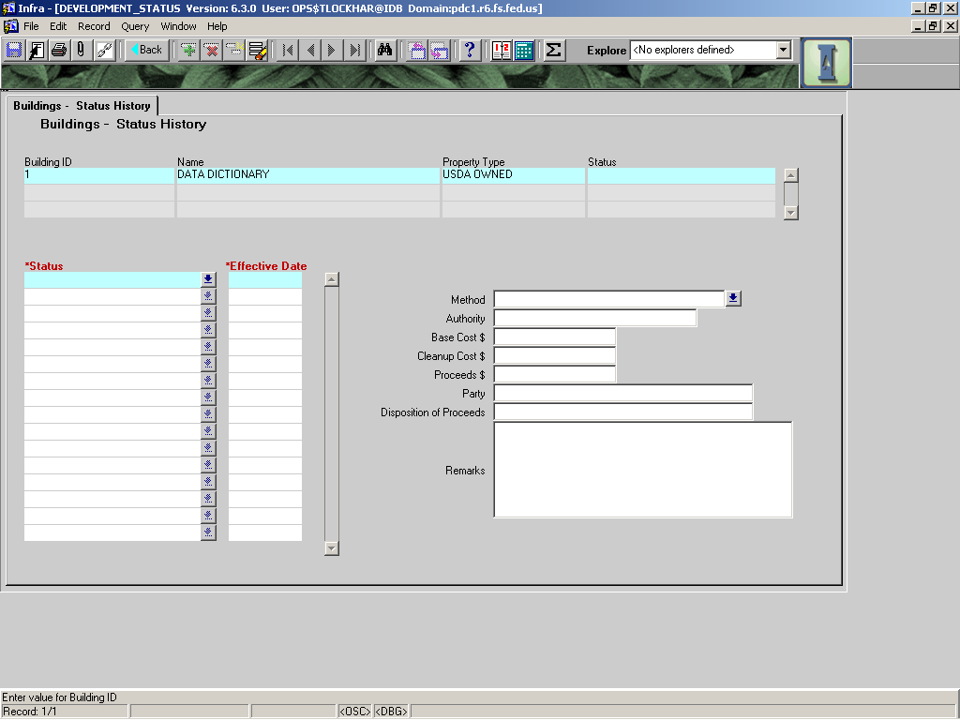

|  |  |  |  |  |  |  |  |  |  |
| --- | --- | --- | --- | --- | --- | --- | --- | --- | --- |
|  |  | | | | | | **Used in Tables:** | | |
| **Name:** | **STATUS** | | | | | | II_FEATURES | | |
|  |  | | | | | |  | | |
| **Definition:** | The status of the building. | | | | | | | | |
|  |  | | | | | | | | |
| **Reference:** |  | | | | | | **Screen:** | | Details |
|  |  | | | | | |  | |  |
| **Format:** | Auto populated from STATUS screen (push button to right of field) | | | | | | **Unit of Measure:** | |  |
|  |  | | | | | |  | |  |
| **Data Type:** | varchar2 | **Size:** |  | |  |  | **Mandatory:** | | **YES** |
|  |  | | | | | | **Requirement** | | **YES** |
| **Look Up:** |  | | | | | | | | |
|  |  | | | | | | | | |
| **Business Rules:** | Pushing the button to the right of this field takes the user to another area named “Buildings – Status History.” This tab will allow the user to record a history of the status of the building over time. This currently does not work except for an initial line. For other field definitions in this area see below. | | | | | | | | |
|  |  | | | | | | | | |
| **Notes:** | Previously known as **DEVELOPMENT STATUS** | | | | | | | | |
|  |  | | | | | | | | |
| **Valid Codes** | | | | | | | | | |
| **Code** | | | | **Description** | | | |  | |
| DISPOSED | | | | ***A building that has been sold and removed from its original location to one owned by the new owner (with or without the land). Inlcudes buildings previously identified as “OBLITERATED”.*** | | | |  | |
| EXISTING - ABANDONED | | | | ***An excessed building that has been evacuated.*** | | | |  | |
| EXISTING - EXCESS | | | | ***An existing building that is no longer needed by the FS, and is identified in the Forest Master Plan as such.*** | | | |  | |
| EXISTING - OPERATIONAL | | | | ***A building that exists and is being used.*** | | | |  | |
| PLANNED | | | | ***A building that is to be built in the near future.*** | | | |  | |
| UNDER CONSTRUCTION | | | | ***A building that is currently being built.*** | | | |  | |
| UNKNOWN | | | | ***Do not use this option.*** | | | |  | |

|  |  |  |  |  |  |  |  |  |  |
| --- | --- | --- | --- | --- | --- | --- | --- | --- | --- |
|  |  | | | | | | **Used in Tables:** | | |
| **Name:** | **METHOD** | | | | | |  | | |
|  |  | | | | | |  | | |
| **Definition:** | Method used to changes the status. I.E If building status is DISPOSED, the method is the description of how that building was disposed such as donates, sold, or demolished. See below for nested methods. | | | | | | | | |
|  |  | | | | | | | | |
| **Reference:** |  | | | | | | **Screen:** | | Buildings-Status History |
|  |  | | | | | |  | |  |
| **Format:** | LOV | | | | | | **Unit of Measure:** | |  |
|  |  | | | | | |  | |  |
| **Data Type:** | varchar2 | **Size:** |  | |  |  | **Mandatory:** | | **NO** |
|  |  | | | | | | **Requirement** | | **NO** |
| **Look Up:** |  | | | | | | | | |
|  |  | | | | | | | | |
| **Business Rules:** |  | | | | | | | | |
|  |  | | | | | | | | |
| **Notes:** |  | | | | | | | | |
|  |  | | | | | | | | |
| **Valid Codes** | | | | | | | | | |
| **Code** | | | | **Description** | | | | **STATUS** | |
| DEMOLISHED | | | | Building destroyed in place. | | | | DISPOSED | |
| DONATED | | | | Building given to another non-FS entity. | | | | DISPOSED | |
| EXCHANGED | | | | Building went to a non-Forest Service entity as part of a land exchange package. | | | | DISPOSED | |
| SOLD | | | | Building was Sold to a non-Government entity. | | | | DISPOSED | |
| TRANSFERRED | | | | Building’s ownership was transferred to a non-Forest Service entity. | | | | DISPOSED | |
| DONATION | | | |  | | | | EXISTING-ALL  PLANNED | |
| EXCHANGED | | | |  | | | | EXISTING-ALL  PLANNED | |
| MAJOR IMPROVEMENT | | | |  | | | | EXISTING-ALL  PLANNED  UNDER - CONSTRUCTION | |
| ORIGINAL CONSTRUCTION | | | |  | | | | EXISTING-ALL  PLANNED  UNDER  - CONSTRUCTION | |
| TRANSFERRED | | | |  | | | | EXISTING-ALL  PLANNED | |
| UNKNOWN | | | |  | | | | UNKNOWN | |
|  | | | |  | | | |  | |
|  | | | |  | | | |  | |

|  |  |  |  |  |  |  |  |
| --- | --- | --- | --- | --- | --- | --- | --- |
|  |  | | | | | **Used in Tables:** | |
| **Name:** | **AUTHORITY** | | | | |  | |
|  |  | | | | |  | |
| **Definition:** | Legal authority under which status change was made. | | | | | | |
|  |  | | | | | | |
| **Reference:** |  | | | | | **Screen:** | Status History |
|  |  | | | | |  |  |
| **Format:** |  | | | | | **Unit of Measure:** |  |
|  |  | | | | |  |  |
| **Data Type:** | varchar | **Size:** |  |  |  | **Mandatory:** | **No** |
|  |  | | | | | **Requirement** | **No** |
| **Look Up:** |  | | | | | | |
|  |  | | | | | | |
| **Business Rules:** |  | | | | | | |
|  |  | | | | | | |
| **Notes:** |  | | | | | | |
|  |  | | | | | | |

|  |  |  |  |  |  |  |  |
| --- | --- | --- | --- | --- | --- | --- | --- |
|  |  | | | | | **Used in Tables:** | |
| **Name:** | **BASE COST $** | | | | |  | |
|  |  | | | | |  | |
| **Definition:** | Base cost for the status change. Does not include clean-up costs associated with status change. | | | | | | |
|  |  | | | | | | |
| **Reference:** |  | | | | | **Screen:** | Status History |
|  |  | | | | |  |  |
| **Format:** |  | | | | | **Unit of Measure:** |  |
|  |  | | | | |  |  |
| **Data Type:** | numeric | **Size:** |  |  |  | **Mandatory:** | **No** |
|  |  | | | | | **Requirement** | **No** |
| **Look Up:** |  | | | | | | |
|  |  | | | | | | |
| **Business Rules:** | Do not include costs not directly associated with status change such as site clean-up from demolition or hazardous material mitigation, etc. | | | | | | |
|  |  | | | | | | |
| **Notes:** |  | | | | | | |
|  |  | | | | | | |

|  |  |  |  |  |  |  |  |
| --- | --- | --- | --- | --- | --- | --- | --- |
|  |  | | | | | **Used in Tables:** | |
| **Name:** | **CLEANUP COST $** | | | | |  | |
|  |  | | | | |  | |
| **Definition:** | Costs associated with cleaning up not directly tied to the base cost for the status change. | | | | | | |
|  |  | | | | | | |
| **Reference:** |  | | | | | **Screen:** | Status History |
|  |  | | | | |  |  |
| **Format:** |  | | | | | **Unit of Measure:** |  |
|  |  | | | | |  |  |
| **Data Type:** |  | **Size:** |  |  |  | **Mandatory:** | **No** |
|  |  | | | | | **Requirement** | **No** |
| **Look Up:** |  | | | | | | |
|  |  | | | | | | |
| **Business Rules:** | These costs may include hazardous material mitigation or general site-clean up. | | | | | | |
|  |  | | | | | | |
| **Notes:** |  | | | | | | |
|  |  | | | | | | |

|  |  |  |  |  |  |  |  |
| --- | --- | --- | --- | --- | --- | --- | --- |
|  |  | | | | | **Used in Tables:** | |
| **Name:** | **PROCEEDS** | | | | |  | |
|  |  | | | | |  | |
| **Definition:** | The dollar amount received as part of the disposal of the building. | | | | | | |
|  |  | | | | | | |
| **Reference:** |  | | | | | **Screen:** | Status |
|  |  | | | | |  |  |
| **Format:** | In dollars | | | | | **Unit of Measure:** |  |
|  |  | | | | |  |  |
| **Data Type:** |  | **Size:** |  |  |  | **Mandatory:** | **No** |
|  |  | | | | | **Requirement** | **No** |
| **Look Up:** |  | | | | | | |
|  |  | | | | | | |
| **Business Rules:** | Applies to only disposed or transferred buildings. | | | | | | |
|  |  | | | | | | |
| **Notes:** |  | | | | | | |
|  |  | | | | | | |

|  |  |  |  |  |  |  |  |
| --- | --- | --- | --- | --- | --- | --- | --- |
| **7** |  | | | | | **Used in Tables:** | |
| **Name:** | **PARTY** | | | | |  | |
|  |  | | | | |  | |
| **Definition:** | The party to which or from whom the building has been transferred, received, donated, etc. | | | | | | |
|  |  | | | | | | |
| **Reference:** |  | | | | | **Screen:** | Status |
|  |  | | | | |  |  |
| **Format:** |  | | | | | **Unit of Measure:** |  |
|  |  | | | | |  |  |
| **Data Type:** | varchar | **Size:** |  |  |  | **Mandatory:** | **No** |
|  |  | | | | | **Requirement** | **No** |
| **Look Up:** |  | | | | | | |
|  |  | | | | | | |
| **Business Rules:** |  | | | | | | |
|  |  | | | | | | |
| **Notes:** |  | | | | | | |
|  |  | | | | | | |

|  |  |  |  |  |  |  |  |
| --- | --- | --- | --- | --- | --- | --- | --- |
|  |  | | | | | **Used in Tables:** | |
| **Name:** | **DISPOSITION OF PROCEEDS** | | | | |  | |
|  |  | | | | |  | |
| **Definition:** | How the proceeds are distributed (i.e. in the case of a building sold through surplus, the proceeds go to the National Treasury.) | | | | | | |
|  |  | | | | | | |
| **Reference:** |  | | | | | **Screen:** | Status |
|  |  | | | | |  |  |
| **Format:** |  | | | | | **Unit of Measure:** |  |
|  |  | | | | |  |  |
| **Data Type:** |  | **Size:** |  |  |  | **Mandatory:** | **No** |
|  |  | | | | | **Requirement** | **No** |
| **Look Up:** |  | | | | | | |
|  |  | | | | | | |
| **Business Rules:** |  | | | | | | |
|  |  | | | | | | |
| **Notes:** |  | | | | | | |
|  |  | | | | | | |

|  |  |  |  |  |  |  |  |
| --- | --- | --- | --- | --- | --- | --- | --- |
|  |  | | | | | **Used in Tables:** | |
| **Name:** | **REMARKS** | | | | |  | |
|  |  | | | | |  | |
| **Definition:** | Any notes regarding the change in status or that status highlighted. | | | | | | |
|  |  | | | | | | |
| **Reference:** |  | | | | | **Screen:** | Status |
|  |  | | | | |  |  |
| **Format:** |  | | | | | **Unit of Measure:** |  |
|  |  | | | | |  |  |
| **Data Type:** | varchar | **Size:** |  |  |  | **Mandatory:** | **No** |
|  |  | | | | | **Requirement** | **No** |
| **Look Up:** |  | | | | | | |
|  |  | | | | | | |
| **Business Rules:** |  | | | | | | |
|  |  | | | | | | |
| **Notes:** |  | | | | | | |
|  |  | | | | | | |

|  |  |  |  |  |  |  |  |
| --- | --- | --- | --- | --- | --- | --- | --- |
|  |  | | | | | **Used in Tables:** | |
| **Name:** | **REMARKS** | | | | |  | |
|  |  | | | | |  | |
| **Definition:** | **Notes related to the building in general – also contains in (parentheses) the development status as it was entered pre-version 6.3.** | | | | | | |
|  |  | | | | | | |
| **Reference:** |  | | | | | **Screen:** | Details |
|  |  | | | | |  |  |
| **Format:** |  | | | | | **Unit of Measure:** | YYYY |
|  |  | | | | |  |  |
| **Data Type:** | varchar2 | **Size:** |  |  |  | **Mandatory:** | **NO** |
|  |  | | | | | **Requirement** | **NO** |
| **Look Up:** |  | | | | | | |
|  |  | | | | | | |
| **Business Rules:** |  | | | | | | |
|  |  | | | | | | |
| **Notes:** | The whole field is not shown. To see the text, one must click at end of shown text and scroll through. | | | | | | |
|  |  | | | | | | |

|  |  |  |  |  |  |  |  |
| --- | --- | --- | --- | --- | --- | --- | --- |
|  |  | | | | | **Used in Tables:** | |
| **Name:** | **LAST CONDITION SURVEY** | | | | |  | |
|  |  | | | | |  | |
| **Definition:** | **Date the building last had a condition survey completed.** | | | | | | |
|  |  | | | | | | |
| **Reference:** |  | | | | | **Screen:** | Details |
|  |  | | | | |  |  |
| **Format:** | Auto-populated from Survey Screen | | | | | **Unit of Measure:** |  |
|  |  | | | | |  |  |
| **Data Type:** | varchar2 | **Size:** |  |  |  | **Mandatory:** | **NO** |
|  |  | | | | | **Requirement** | **NO** |
| **Look Up:** |  | | | | | | |
|  |  | | | | | | |
| **Business Rules:** |  | | | | | | |
|  |  | | | | | | |
| **Notes:** |  | | | | | | |

|  |  |  |  |  |  |  |  |
| --- | --- | --- | --- | --- | --- | --- | --- |
|  |  | | | | | **Used in Tables:** | |
| **Name:** | **YEAR CONSTRUCTED** | | | | |  | |
|  |  | | | | |  | |
| **Definition:** | **Date the building was actually built.** | | | | | | |
|  |  | | | | | | |
| **Reference:** |  | | | | | **Screen:** | Details |
|  |  | | | | |  |  |
| **Format:** | YYYY | | | | | **Unit of Measure:** | YYYY |
|  |  | | | | |  |  |
| **Data Type:** | varchar2 | **Size:** |  |  |  | **Mandatory:** | **NO** |
|  |  | | | | | **Requirement** | **YES** |
| **Look Up:** |  | | | | | | |
|  |  | | | | | | |
| **Business Rules:** | **1. If Federal Government procured building construction, the year would be that of final acceptance of project.**   1. **If building was acquired by other means, input the year documented that building was built.** 2. **In such case that no documented date is available, input best estimated year.** | | | | | | |
|  |  | | | | | | |
| **Notes:** |  | | | | | | |

|  |  |  |  |  |  |  |  |  |  |
| --- | --- | --- | --- | --- | --- | --- | --- | --- | --- |
|  |  | | | | | | **Used in Tables:** | | |
| **Name:** | **MAINT. LEVEL** | | | | | |  | | |
|  |  | | | | | |  | | |
| **Definition:** | The maintenance level assigned to the building. | | | | | | | | |
|  |  | | | | | | | | |
| **Reference:** | FSH 7309.11 Sec 42.2 (see below for table) | | | | | | **Screen:** | | Main |
|  |  | | | | | |  | |  |
| **Format:** | LOV | | | | | | **Unit of Measure:** | |  |
|  |  | | | | | |  | |  |
| **Data Type:** | varchar2 | **Size:** |  | |  |  | **Mandatory:** | | No |
|  |  | | | | | | **Requirement** | | Yes |
| **Look Up:** |  | | | | | | | | |
| **Business Rules:** | 1. See 42.2 - Exhibit 01 below. | | | | | | | | |
|  |  | | | | | | | | |
| **Notes:** |  | | | | | | | | |
| **Valid Codes** | | | | | | | | | |
| **Code** | | | | **Description** | | | |  | |
| 1-Abate major H&S hazards | | | | Abate major health and safety hazards. | | | |  | |
| 2-MAINTAIN UNTIL RETIREMENT | | | | Maintain only to extend life until retirement, 0-5 years. | | | |  | |
| 3-KEEP OPERATIONAL | | | | Keep all systems and components operational | | | |  | |
| 4-MAINTAIN CRITICAL | | | | Repair critical service within 24 hrs, noncritical within 5 days. | | | |  | |
| 5-HIGHEST QUALITY | | | | Utilize highest quality materials/work, custodial staff. | | | |  | |

**42.2 - Exhibit 01**

**MAINTENANCE LEVELS**

|  |  |  |  |
| --- | --- | --- | --- |
| **Level** | **Type of Facility** | **Standard of Care** | **Operational Considerations** |
| 1 | - All types, no longer needed, no human occupancy.   * Awaiting retirement (demolition, surplus replacement). | - Maintain only to abate major health and safety hazards. | - Remove exposed personnel.  - Abate major health or safety hazards.  - Do not use or abandon. |
| 2 | - All types (sheds, storage bldgs.), with infrequent human use.  - Must use 3-5 years due to need. | - Maintain only to extend life until retirement, ideally no longer than 5 years.  - Prevent blighted appearance. | - Normal safety inspections; abate major health and safety hazards. |
| 3 | - Minor offices, (nonpublic) shop, warehouses. Seasonal quarters; general nonpublic areas. (Offices/work spaces occupied frequently or continuously due to need, but should be replaced. Support structures--infrequent, or no human use.) Interruptions in 24 hours; noncritical in 2 weeks. | - All systems and components operational.  - Maintain to extend life 10-15 years or anticipated retirement date.  - Repair of critical servi  - Appearance neat and pleasing, good quality. | - Normal safety inspections; abate all hazards. |
| 4 | - Major offices and high employee use area with less than 50 visitors per day, and operations centers, crew quarters, employee quarters. | - Same as level 3 except critical service repaired in 24 hours; noncritical in 5 days. Maintain to extend life 20+ years. | - Normal safety inspections; abate all hazards. |
| 5 | - Major offices and suburban offices, visitor centers, major laboratories similar to level 4 except greater than 50 visitors/day. | - Same as level 4 but highest quality materials and workmanship.  - Continual maintenance custodial staffing. | - Normal safety inspections; abate all hazards. |
| * Subscript H may be used to designate Historic Structure. Maintenance objectives would be as required in section 41.1 | | | |

|  |  |  |  |  |  |  |  |  |
| --- | --- | --- | --- | --- | --- | --- | --- | --- |
|  |  | | | | | | **Used in Tables:** | |
| **Name:** | **HISTORICAL STATUS** | | | | | |  | |
|  |  | | | | | |  | |
| **Definition:** | What is this building’s historical status? | | | | | | | |
|  |  | | | | | | | |
| **Reference:** |  | | | | | | **Screen:** | Main |
|  |  | | | | | |  |  |
| **Format:** | LOV | | | | | | **Unit of Measure:** |  |
|  |  | | | | | |  |  |
| **Data Type:** | varchar2 | **Size:** |  | |  |  | **Mandatory:** | **YES** |
|  |  | | | | | | **Requirement** | **YES** |
| **Look Up:** |  | | | | | | | |
|  |  | | | | | | | |
| **Business Rules:** | 1. Document what has been done to evaluate each building. | | | | | | | |
|  |  | | | | | | | |
| **Notes:** |  | | | | | | | |
|  |  | | | | | | | |
| **Valid Codes** | | | | | | | | |
| **Code** | | | | **Description** | | | | |
| ARCHAEOLOGICAL VALUES PRESENT | | | | Archaeological values present. | | | | |
| AT LEAST 1 PROP | | | | At least 1 property meets national registration criterion | | | | |
| DOES NOT MEET | | | | Does not meet age or other eligibility criteria | | | | |
| EVAL’D/NOT ELIG | | | | Evaluated – Found not eligible for national register | | | | |
| EVALUATED/MEETS | | | | Evaluated – Meets National Register criteria | | | | |
| IN/PENDING | | | | Included in National Register or on a pending list | | | | |
| MEETS AGE/FRTHR | | | | Meets age criterion – Needs further evaluation | | | | |
| NOT EVALUATED | | | | Not Evaluated. | | | | |

V6.3 added nine “check boxes” to better identify a building’s use or special attributes. Check all the applicable boxes in this area that apply to the building (field definitions below in cyan are the nine boxes).

|  |  |  |  |  |  |  |  |
| --- | --- | --- | --- | --- | --- | --- | --- |
|  |  | | | | | **Used in Tables:** | |
| **Name:** | **CHILD CARE** | | | | |  | |
|  |  | | | | |  | |
| **Definition:** | This field has been added from CPAIS and will be defined at a later date. It is best to not use them until definition is provided by CPAIS. | | | | | | |
|  |  | | | | | | |
| **Reference:** |  | | | | | **Screen:** | Details |
|  |  | | | | |  |  |
| **Format:** | Checkbox | | | | | **Unit of Measure:** |  |
|  |  | | | | |  |  |
| **Data Type:** | Checkbox | **Size:** |  |  |  | **Mandatory:** | **No** |
|  |  | | | | | **Requirement** | **No** |
| **Look Up:** |  | | | | | | |
|  |  | | | | | | |
| **Business Rules:** | Check if building contains child care facility, regardless of whether child care occupies the whole facility or only a portion. | | | | | | |
|  |  | | | | | | |
| **Notes:** |  | | | | | | |
|  |  | | | | | | |

|  |  |  |  |  |  |  |  |
| --- | --- | --- | --- | --- | --- | --- | --- |
|  |  | | | | | **Used in Tables:** | |
| **Name:** | **ANTENNA** | | | | |  | |
|  |  | | | | |  | |
| **Definition:** | This field has been added from CPAIS and will be defined at a later date. It is best to not use them until definition is provided by CPAIS. | | | | | | |
|  |  | | | | | | |
| **Reference:** |  | | | | | **Screen:** | Details |
|  |  | | | | |  |  |
| **Format:** | Checkbox | | | | | **Unit of Measure:** |  |
|  |  | | | | |  |  |
| **Data Type:** | Checkbox | **Size:** |  |  |  | **Mandatory:** | **No** |
|  |  | | | | | **Requirement** | **No** |
| **Look Up:** |  | | | | | | |
|  |  | | | | | | |
| **Business Rules:** | Check if applicable to this building. | | | | | | |
|  |  | | | | | | |
| **Notes:** |  | | | | | | |
|  |  | | | | | | |

|  |  |  |  |  |  |  |  |
| --- | --- | --- | --- | --- | --- | --- | --- |
|  |  | | | | | **Used in Tables:** | |
| **Name:** | **BUSINESS DISTRICT** | | | | |  | |
|  |  | | | | |  | |
| **Definition:** | This field has been added from CPAIS and will be defined at a later date. It is best to not use them until definition is provided by CPAIS. | | | | | | |
|  |  | | | | | | |
| **Reference:** |  | | | | | **Screen:** | Details |
|  |  | | | | |  |  |
| **Format:** | Checkbox | | | | | **Unit of Measure:** |  |
|  |  | | | | |  |  |
| **Data Type:** | Checkbox | **Size:** |  |  |  | **Mandatory:** | **No** |
|  |  | | | | | **Requirement** | **No** |
| **Look Up:** |  | | | | | | |
|  |  | | | | | | |
| **Business Rules:** | Check if applicable to this building. | | | | | | |
|  |  | | | | | | |
| **Notes:** |  | | | | | | |
|  |  | | | | | | |

|  |  |  |  |  |  |  |  |
| --- | --- | --- | --- | --- | --- | --- | --- |
|  |  | | | | | **Used in Tables:** | |
| **Name:** | **HISTORICAL DISTRICT** | | | | |  | |
|  |  | | | | |  | |
| **Definition:** | This field has been added from CPAIS and will be defined at a later date. It is best to not use them until definition is provided by CPAIS. | | | | | | |
|  |  | | | | | | |
| **Reference:** |  | | | | | **Screen:** | Details |
|  |  | | | | |  |  |
| **Format:** | Checkbox | | | | | **Unit of Measure:** |  |
|  |  | | | | |  |  |
| **Data Type:** | Checkbox | **Size:** |  |  |  | **Mandatory:** | **No** |
|  |  | | | | | **Requirement** | **No** |
| **Look Up:** |  | | | | | | |
|  |  | | | | | | |
| **Business Rules:** | Check if applicable to this building. | | | | | | |
|  |  | | | | | | |
| **Notes:** |  | | | | | | |

|  |  |  |  |  |  |  |  |
| --- | --- | --- | --- | --- | --- | --- | --- |
|  |  | | | | | **Used in Tables:** | |
| **Name:** | **REC** | | | | |  | |
|  |  | | | | |  | |
| **Definition:** | Buildings that are primarily used by the public in recreation/interpretation activities. These buildings will generally not support day-to-day operation of Forest Service administrative operations. | | | | | | |
|  |  | | | | | | |
| **Reference:** |  | | | | | **Screen:** | Details |
|  |  | | | | |  |  |
| **Format:** | Checkbox | | | | | **Unit of Measure:** |  |
|  |  | | | | |  |  |
| **Data Type:** | Checkbox | **Size:** |  |  |  | **Mandatory:** | **No** |
|  |  | | | | | **Requirement** | **No** |
| **Look Up:** |  | | | | | | |
|  |  | | | | | | |
| **Business Rules:** | Check if applicable to this building regardless of whether the building is linked to a recreation or administrative site or a GFA. | | | | | | |
|  |  | | | | | | |
| **Notes:** |  | | | | | | |

|  |  |  |  |  |  |  |  |
| --- | --- | --- | --- | --- | --- | --- | --- |
|  |  | | | | | **Used in Tables:** | |
| **Name:** | **SPECIAL USE PERMIT** | | | | |  | |
|  |  | | | | |  | |
| **Definition:** | Check if this building has any special use permits tied to it. | | | | | | |
|  |  | | | | | | |
| **Reference:** |  | | | | | **Screen:** | Details |
|  |  | | | | |  |  |
| **Format:** | Checkbox | | | | | **Unit of Measure:** |  |
|  |  | | | | |  |  |
| **Data Type:** | Checkbox | **Size:** |  |  |  | **Mandatory:** | **No** |
|  |  | | | | | **Requirement** | **No** |
| **Look Up:** |  | | | | | | |
|  |  | | | | | | |
| **Business Rules:** | Check if applicable to this building. | | | | | | |
|  |  | | | | | | |
| **Notes:** |  | | | | | | |

|  |  |  |  |  |  |  |  |
| --- | --- | --- | --- | --- | --- | --- | --- |
|  |  | | | | | **Used in Tables:** | |
| **Name:** | **FIRE** | | | | |  | |
|  |  | | | | |  | |
| **Definition:** | Buildings that primarily support the fire program, such as engine buildings, fire caches, etc. | | | | | | |
|  |  | | | | | | |
| **Reference:** |  | | | | | **Screen:** | Details |
|  |  | | | | |  |  |
| **Format:** | Checkbox | | | | | **Unit of Measure:** |  |
|  |  | | | | |  |  |
| **Data Type:** | Checkbox | **Size:** |  |  |  | **Mandatory:** | **No** |
|  |  | | | | | **Requirement** | **No** |
| **Look Up:** |  | | | | | | |
|  |  | | | | | | |
| **Business Rules:** | Check if applicable to this building. | | | | | | |
|  |  | | | | | | |
| **Notes:** |  | | | | | | |
|  |  | | | | | | |

|  |  |  |  |  |  |  |  |
| --- | --- | --- | --- | --- | --- | --- | --- |
|  |  | | | | | **Used in Tables:** | |
| **Name:** | **ADMIN** | | | | |  | |
|  |  | | | | |  | |
| **Definition:** | Building has QMQM collections made to pay for its maintenance. These collections are documented in the QMIS system used by the quarters program. | | | | | | |
|  |  | | | | | | |
| **Reference:** |  | | | | | **Screen:** | Details |
|  |  | | | | |  |  |
| **Format:** | Checkbox | | | | | **Unit of Measure:** |  |
|  |  | | | | |  |  |
| **Data Type:** | Checkbox | **Size:** |  |  |  | **Mandatory:** | **No** |
|  |  | | | | | **Requirement** | **No** |
| **Look Up:** |  | | | | | | |
|  |  | | | | | | |
| **Business Rules:** | Check only if this building is not a fire building regardless of whether it is linked to a recreation or administrative site or GFA. | | | | | | |
|  |  | | | | | | |
| **Notes:** |  | | | | | | |

|  |  |  |  |  |  |  |  |
| --- | --- | --- | --- | --- | --- | --- | --- |
|  |  | | | | | **Used in Tables:** | |
| **Name:** | **QUAR** | | | | |  | |
|  |  | | | | |  | |
| **Definition:** | Check if this building is in the quarters program. | | | | | | |
|  |  | | | | | | |
| **Reference:** |  | | | | | **Screen:** | Details |
|  |  | | | | |  |  |
| **Format:** | Checkbox | | | | | **Unit of Measure:** |  |
|  |  | | | | |  |  |
| **Data Type:** | Checkbox | **Size:** |  |  |  | **Mandatory:** | **No** |
|  |  | | | | | **Requirement** | **No** |
| **Look Up:** |  | | | | | | |
|  |  | | | | | | |
| **Business Rules:** | Check if applicable to this building. | | | | | | |
|  |  | | | | | | |
| **Notes:** |  | | | | | | |

The Hazards section was added in v6.3. It provides a place to document known hazards related to the building (lead paint, asbestos, etc.) (field definitions in orange are related to HAZARDS).

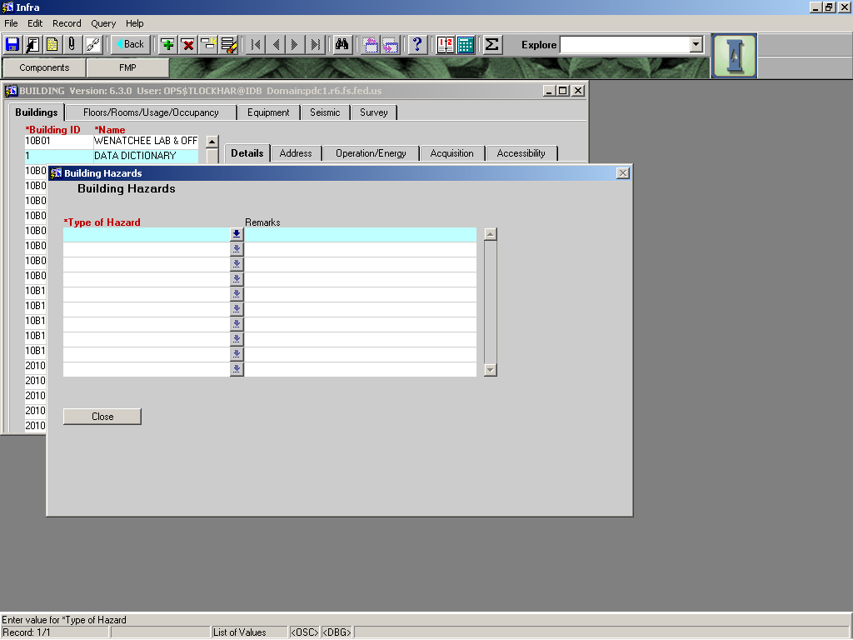

|  |  |  |  |  |  |  |  |
| --- | --- | --- | --- | --- | --- | --- | --- |
|  |  | | | | | **Used in Tables:** | |
| **Name:** | **HAZARDS** | | | | |  | |
|  |  | | | | |  | |
| **Definition:** | Button to go to the Hazards Screen, | | | | | | |
|  |  | | | | | | |
| **Reference:** |  | | | | | **Screen:** | Details |
|  |  | | | | |  |  |
| **Format:** | Button | | | | | **Unit of Measure:** |  |
|  |  | | | | |  |  |
| **Data Type:** |  | **Size:** |  |  |  | **Mandatory:** | **No** |
|  |  | | | | | **Requirement** | **No** |
| **Look Up:** |  | | | | | | |
|  |  | | | | | | |
| **Business Rules:** |  | | | | | | |
|  |  | | | | | | |
| **Notes:** |  | | | | | | |

|  |  |  |  |  |  |  |  |  |  |
| --- | --- | --- | --- | --- | --- | --- | --- | --- | --- |
|  |  | | | | | | **Used in Tables:** | | |
| **Name:** | **TYPE OF HAZARD** | | | | | |  | | |
|  |  | | | | | |  | | |
| **Definition:** | Type of hazard found associated with the building.. | | | | | | | | |
|  |  | | | | | | | | |
| **Reference:** |  | | | | | | **Screen:** | | Buildings-HAZARD |
|  |  | | | | | |  | |  |
| **Format:** | LOV | | | | | | **Unit of Measure:** | |  |
|  |  | | | | | |  | |  |
| **Data Type:** | varchar2 | **Size:** |  | |  |  | **Mandatory:** | | **NO** |
|  |  | | | | | | **Requirement** | | **NO** |
| **Look Up:** |  | | | | | | | | |
|  |  | | | | | | | | |
| **Business Rules:** |  | | | | | | | | |
|  |  | | | | | | | | |
| **Notes:** |  | | | | | | | | |
|  |  | | | | | | | | |
| **Valid Codes** | | | | | | | | | |
| **Code** | | | | **Description** | | | |  | |
| ASBESTOS MATRIX | | | | Asbestos matrix in place | | | |  | |
| ASBESTOS, FRIABLE | | | | Friable asbestos | | | |  | |
| ASBESTOS, NON-FRIABLE | | | | Non-friable asbestos | | | |  | |
| BIOCONTAINMENT1 | | | | Biocontainment Level 1 | | | |  | |
| BIOCONTAINMENT2 | | | | Biocontainment Level 2 | | | |  | |
| BIOCONTAINMENT3 | | | | Biocontainment Level 3 | | | |  | |
| BIOCONTAINMENT4 | | | | Biocontainment Level 4 | | | |  | |
| BIOLOGICAL | | | | Hazardous Biological Agent Present | | | |  | |
| CHEMICAL | | | | Chemical Hazard, Petroleum Products | | | |  | |
| CHEMICAL OTHER | | | | Chemical Other includes hazardous waste | | | |  | |
| CHEMICAL PESTICIDES/HERBICIDES | | | | Chemical hazard, pesticides/herbicides | | | |  | |
| DESIGN | | | | Design hazards (needs railings, etc.) | | | |  | |
| ELECTRICAL | | | | Subject to electrical hazards | | | |  | |
| ENVIRONMENTAL | | | | Subject to environmental hazards | | | |  | |
| EXPOLSION | | | | Presence of explosion hazard | | | |  | |
| FIRE SAFETY | | | | Fire (emergency) exits inadequate | | | |  | |
| FLAMABLE | | | | Flammable hazards | | | |  | |
| FLOOD PLAIN | | | | Located in 100 year flood plain | | | |  | |
| FUEL LEAK | | | | Fuel Leak from under/oabove ground fuel container | | | |  | |
| INDUSTRIAL | | | | Presence of industrial hazard | | | |  | |
| LEAD OR LEAD PAINT HAZARD PRESENT | | | | Lead or lead paint hazard present | | | |  | |
| LOCATION | | | | Located in high risk area | | | |  | |
| MECHANICAL | | | | Mechanical hazard present | | | |  | |
| NO HAZARD APPARENT | | | | No Hazard Apparent | | | |  | |
| NO HAZARD DETERMINED | | | | No hazard determined | | | |  | |
| NOISE | | | | Noise related hazard | | | |  | |
| NUCLEAR | | | | Nuclear Material Present | | | |  | |
| PCB | | | | Presence of PCB’s | | | |  | |
| RADIOLOGICAL HAZARD | | | | Radiological hazard | | | |  | |
| RADON>200PCI/1 | | | | Radon tested > than 200 pCi/1 | | | |  | |
| RADON>20<200 | | | | Radon tested > 20 but < than 200 | | | |  | |
| RADON<4PCI/1 | | | | Radon tested <4pCi/1 | | | |  | |
| RADON>4<20 | | | | Radon tested > 4 and < than 20 pCi | | | |  | |
| STRUCTURAL | | | | Structural Hazard Present | | | |  | |
| USTS | | | | Underground Storage Tanks, petroleum | | | |  | |
| VENTILATION | | | | Ventilation, air born hazards | | | |  | |
| WETLANDS | | | | Located in Wetlands | | | |  | |

|  |  |  |  |  |  |  |  |
| --- | --- | --- | --- | --- | --- | --- | --- |
|  |  | | | | | **Used in Tables:** | |
| **Name:** | **REMARKS** | | | | |  | |
|  |  | | | | |  | |
| **Definition:** | Any notes regarding the hazard identified. May enter dates of assessment, etc. | | | | | | |
|  |  | | | | | | |
| **Reference:** |  | | | | | **Screen:** | HAZARD |
|  |  | | | | |  |  |
| **Format:** |  | | | | | **Unit of Measure:** |  |
|  |  | | | | |  |  |
| **Data Type:** | varchar | **Size:** |  |  |  | **Mandatory:** | **No** |
|  |  | | | | | **Requirement** | **No** |
| **Look Up:** |  | | | | | | |
|  |  | | | | | | |
| **Business Rules:** |  | | | | | | |
|  |  | | | | | | |
| **Notes:** |  | | | | | | |

# BUILDINGS -- ADDRESS Tab

The Department added a new tab called ADDRESS in v6.3. It provides a location for data on the location of the building (tan headers relate to the ADDRESS tab).

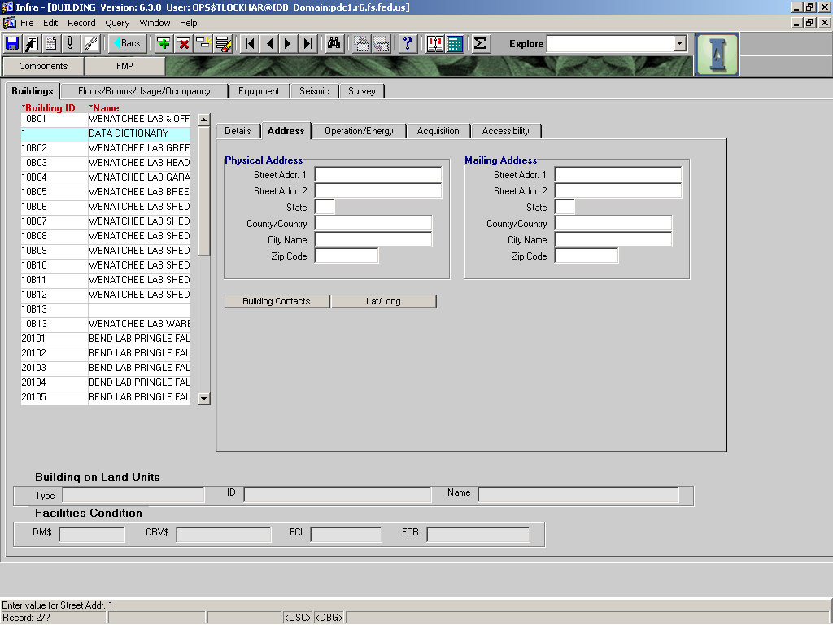

|  |  |  |  |  |  |  |  |  |
| --- | --- | --- | --- | --- | --- | --- | --- | --- |
|  |  | | | | | **Used in Tables:** | | |
| **Name:** | **PHYSICAL ADDRESS** | | | | |  | | |
|  |  | | | | |  | | |
| **Definition:** | The physical address of the building. This may or may not be the mailing address. | | | | | | | |
|  |  | | | | | | | |
| **Reference:** |  | | | | | **Screen:** | | ADDRESS |
|  |  | | | | |  |  | |
| **Format:** |  | | | | | **Unit of Measure:** |  | |
|  |  | | | | |  |  | |
| **Data Type:** | varchar | **Size:** |  |  |  | **Mandatory:** | **No** | |
|  |  | | | | | **Requirement** | **No** | |
| **Look Up:** |  | | | | | | | |
|  |  | | | | | | | |
| **Business Rules:** |  | | | | | | | |
|  |  | | | | | | | |
| **Notes:** |  | | | | | | | |

|  |  |  |  |  |  |  |  |
| --- | --- | --- | --- | --- | --- | --- | --- |
|  |  | | | | | **Used in Tables:** | |
| **Name:** | **MAILING ADDRESS** | | | | |  | |
|  |  | | | | |  | |
| **Definition:** | The mailing address for the building. | | | | | | |
|  |  | | | | | | |
| **Reference:** |  | | | | | **Screen:** | Address |
|  |  | | | | |  |  |
| **Format:** |  | | | | | **Unit of Measure:** |  |
|  |  | | | | |  |  |
| **Data Type:** | varchar | **Size:** |  |  |  | **Mandatory:** | **No** |
|  |  | | | | | **Requirement** | **No** |
| **Look Up:** |  | | | | | | |
|  |  | | | | | | |
| **Business Rules:** |  | | | | | | |
|  |  | | | | | | |
| **Notes:** |  | | | | | | |

The BUILDING CONTACT button provides a location to enter data on the building maintenance companies that may exist (data definitions related to BUILDING CONTACTS are in yellow).

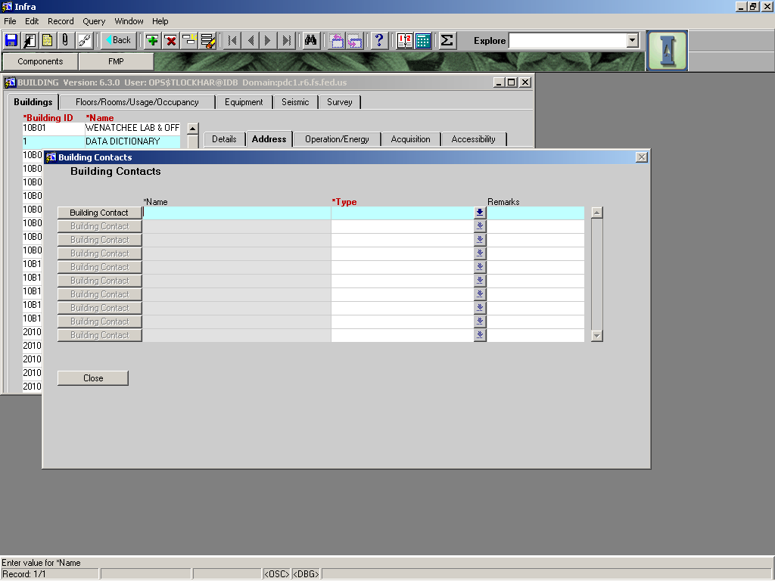

|  |  |  |  |  |  |  |  |
| --- | --- | --- | --- | --- | --- | --- | --- |
|  |  | | | | | **Used in Tables:** | |
| **Name:** | **BUILDING CONTACTS** | | | | |  | |
|  |  | | | | |  | |
| **Definition:** | Push button to get to the building contact screen. For more information see below. | | | | | | |
|  |  | | | | | | |
| **Reference:** |  | | | | | **Screen:** | Address |
|  |  | | | | |  |  |
| **Format:** | BUTTON | | | | | **Unit of Measure:** |  |
|  |  | | | | |  |  |
| **Data Type:** |  | **Size:** |  |  |  | **Mandatory:** | **No** |
|  |  | | | | | **Requirement** | **No** |
| **Look Up:** |  | | | | | | |
|  |  | | | | | | |
| **Business Rules:** |  | | | | | | |
|  |  | | | | | | |
| **Notes:** |  | | | | | | |

Select the gray Building Contact button on the left of field line to enter a new contact. Complete the form with all pertinent information on the vendor. There are three sections, make sure you populate the RED field(s) if you plan on populating any information a specific section (RED fields are mandatory, and you will not be able to save the data in a given section without populating them).

|  |  |  |  |  |  |  |  |
| --- | --- | --- | --- | --- | --- | --- | --- |
|  |  | | | | | **Used in Tables:** | |
| **Name:** | **LAT/LONG** | | | | |  | |
|  |  | | | | |  | |
| **Definition:** | Press this button to get to the spatial data related to this building. | | | | | | |
|  |  | | | | | | |
| **Reference:** |  | | | | | **Screen:** | ADDRESS |
|  |  | | | | |  |  |
| **Format:** |  | | | | | **Unit of Measure:** |  |
|  |  | | | | |  |  |
| **Data Type:** | varchar | **Size:** |  |  |  | **Mandatory:** | **No** |
|  |  | | | | | **Requirement** | **No** |
| **Look Up:** |  | | | | | | |
|  |  | | | | | | |
| **Business Rules:** |  | | | | | | |
|  |  | | | | | | |
| **Notes:** |  | | | | | | |
|  |  | | | | | | |

# BUILDINGS – OPERATION/ENERGY Tab

V6.3 gives us a new area to populate operation and energy data.

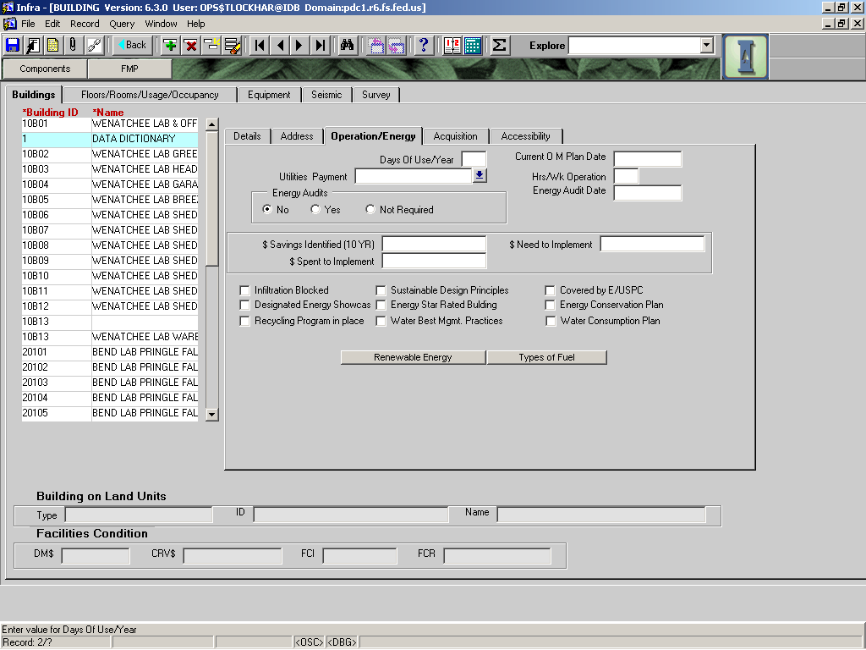

|  |  |  |  |  |  |  |  |
| --- | --- | --- | --- | --- | --- | --- | --- |
|  |  | | | | | **Used in Tables:** | |
| **Name:** | **DAYS OF USE/YEAR** | | | | |  | |
|  |  | | | | |  | |
| **Definition:** | **The number of days this building is being used annually.** | | | | | | |
|  |  | | | | | | |
| **Reference:** |  | | | | | **Screen:** | Main |
|  |  | | | | |  |  |
| **Format:** | MM/DD/YYYY | | | | | **Unit of Measure:** |  |
|  |  | | | | |  |  |
| **Data Type:** | varchar2 | **Size:** |  |  |  | **Mandatory:** | NO |
|  |  | | | | | **Requirement** | NO |
| **Look Up:** |  | | | | | | |
|  |  | | | | | | |
| **Business Rules:** |  | | | | | | |
|  |  | | | | | | |
| **Notes:** |  | | | | | | |

|  |  |  |  |  |  |  |  |
| --- | --- | --- | --- | --- | --- | --- | --- |
|  |  | | | | | **Used in Tables:** | |
| **Name:** | **CURRENT O/M PLAN DATE** | | | | |  | |
|  |  | | | | |  | |
| **Definition:** | **The date the latest operations and maintenance plan was updated.** | | | | | | |
|  |  | | | | | | |
| **Reference:** |  | | | | | **Screen:** | Main |
|  |  | | | | |  |  |
| **Format:** | MM/DD/YYYY | | | | | **Unit of Measure:** |  |
|  |  | | | | |  |  |
| **Data Type:** | varchar2 | **Size:** |  |  |  | **Mandatory:** | NO |
|  |  | | | | | **Requirement** | NO |
| **Look Up:** |  | | | | | | |
|  |  | | | | | | |
| **Business Rules:** |  | | | | | | |
|  |  | | | | | | |
| **Notes:** |  | | | | | | |

|  |  |  |  |  |  |  |  |  |  |
| --- | --- | --- | --- | --- | --- | --- | --- | --- | --- |
|  |  | | | | | | **Used in Tables:** | | |
| **Name:** | **UTILITIES PAYMENT** | | | | | |  | | |
|  |  | | | | | |  | | |
| **Definition:** | The method of payment used to pay utility bills. | | | | | | | | |
|  |  | | | | | | | | |
| **Reference:** |  | | | | | | **Screen:** | | Main |
|  |  | | | | | |  | |  |
| **Format:** |  | | | | | | **Unit of Measure:** | |  |
|  |  | | | | | |  | |  |
| **Data Type:** | varchar2 | **Size:** |  | |  |  | **Mandatory:** | | NO |
|  |  | | | | | | **Requirement** | | NO |
| **Look Up:** | LOV | | | | | | | | |
|  |  | | | | | | | | |
| **Business Rules:** |  | | | | | | | | |
|  |  | | | | | | | | |
| **Notes:** |  | | | | | | | | |
|  |  | | | | | | | | |
| **Valid Codes** | | | | | | | | | |
| **Code** | | | | **Description** | | | |  | |
| GOVERNMENT PURCHASE CARD | | | |  | | | |  | |
| UTVN | | | | Utility Vendor | | | |  | |
| PURCHASE ORDER | | | |  | | | |  | |
| OTHER | | | |  | | | |  | |

|  |  |  |  |  |  |  |  |
| --- | --- | --- | --- | --- | --- | --- | --- |
|  |  | | | | | **Used in Tables:** | |
| **Name:** | **HRS/WK OPERATION** | | | | |  | |
|  |  | | | | |  | |
| **Definition:** | **The number of hours this building is being operated each week.** | | | | | | |
|  |  | | | | | | |
| **Reference:** |  | | | | | **Screen:** | Main |
|  |  | | | | |  |  |
| **Format:** | MM/DD/YYYY | | | | | **Unit of Measure:** |  |
|  |  | | | | |  |  |
| **Data Type:** | varchar2 | **Size:** |  |  |  | **Mandatory:** | NO |
|  |  | | | | | **Requirement** | NO |
| **Look Up:** |  | | | | | | |
|  |  | | | | | | |
| **Business Rules:** |  | | | | | | |
|  |  | | | | | | |
| **Notes:** |  | | | | | | |

|  |  |  |  |  |  |  |  |  |  |
| --- | --- | --- | --- | --- | --- | --- | --- | --- | --- |
|  |  | | | | | | **Used in Tables:** | | |
| **Name:** | **ENERGY AUDIT** | | | | | |  | | |
|  |  | | | | | |  | | |
| **Definition:** | **Has an energy audit been done on this building?** | | | | | | | | |
|  |  | | | | | | | | |
| **Reference:** |  | | | | | | **Screen:** | | Main |
|  |  | | | | | |  | |  |
| **Format:** | MM/DD/YYYY | | | | | | **Unit of Measure:** | |  |
|  |  | | | | | |  | |  |
| **Data Type:** | varchar2 | **Size:** |  | |  |  | **Mandatory:** | | NO |
|  |  | | | | | | **Requirement** | | NO |
| **Look Up:** |  | | | | | | | | |
|  |  | | | | | | | | |
| **Business Rules:** | 1. Only select yes if there has been an audit performed. Further guidance will be forthcoming. | | | | | | | | |
|  |  | | | | | | | | |
| **Notes:** |  | | | | | | | | |
|  |  | | | | | | | | |
| **Valid Codes** | | | | | | | | | |
| **Code** | | | | **Description** | | | |  | |
| YES | | | |  | | | |  | |
| NON | | | |  | | | |  | |
| NOT REQUIRED | | | |  | | | |  | |

|  |  |  |  |  |  |  |  |
| --- | --- | --- | --- | --- | --- | --- | --- |
|  |  | | | | | **Used in Tables:** | |
| **Name:** | **ENERGY AUDIT DATE** | | | | |  | |
|  |  | | | | |  | |
| **Definition:** | **The date the latest energy audit was completed.** | | | | | | |
|  |  | | | | | | |
| **Reference:** |  | | | | | **Screen:** | Main |
|  |  | | | | |  |  |
| **Format:** | MM/DD/YYYY | | | | | **Unit of Measure:** |  |
|  |  | | | | |  |  |
| **Data Type:** | varchar2 | **Size:** |  |  |  | **Mandatory:** | NO |
|  |  | | | | | **Requirement** | NO |
| **Look Up:** |  | | | | | | |
|  |  | | | | | | |
| **Business Rules:** |  | | | | | | |
|  |  | | | | | | |
| **Notes:** |  | | | | | | |

|  |  |  |  |  |  |  |  |
| --- | --- | --- | --- | --- | --- | --- | --- |
|  |  | | | | | **Used in Tables:** | |
| **Name:** | **$ SAVINGS IDENTIFIED (10 YR)** | | | | |  | |
|  |  | | | | |  | |
| **Definition:** | **The savings that would be realized if the energy audit’s recommendations were completed. This is the savings for a ten year period.** | | | | | | |
|  |  | | | | | | |
| **Reference:** |  | | | | | **Screen:** | Main |
|  |  | | | | |  |  |
| **Format:** | MM/DD/YYYY | | | | | **Unit of Measure:** |  |
|  |  | | | | |  |  |
| **Data Type:** | varchar2 | **Size:** |  |  |  | **Mandatory:** | NO |
|  |  | | | | | **Requirement** | NO |
| **Look Up:** |  | | | | | | |
|  |  | | | | | | |

|  |  |  |  |  |  |  |  |
| --- | --- | --- | --- | --- | --- | --- | --- |
|  |  | | | | | **Used in Tables:** | |
| **Name:** | **$ NEEDED TO IMPLIMENT** | | | | |  | |
|  |  | | | | |  | |
| **Definition:** | **The dollars needed to implement the findings of the energy audit.** | | | | | | |
|  |  | | | | | | |
| **Reference:** |  | | | | | **Screen:** | Main |
|  |  | | | | |  |  |
| **Format:** | MM/DD/YYYY | | | | | **Unit of Measure:** |  |
|  |  | | | | |  |  |
| **Data Type:** | varchar2 | **Size:** |  |  |  | **Mandatory:** | NO |
|  |  | | | | | **Requirement** | NO |
| **Look Up:** |  | | | | | | |
|  |  | | | | | | |

|  |  |  |  |  |  |  |  |
| --- | --- | --- | --- | --- | --- | --- | --- |
|  |  | | | | | **Used in Tables:** | |
| **Name:** | **$ SPENT TO IMPLIMENT** | | | | |  | |
|  |  | | | | |  | |
| **Definition:** | **The dollars spent to date to implement the findings of the energy audit** | | | | | | |
|  |  | | | | | | |
| **Reference:** |  | | | | | **Screen:** | Main |
|  |  | | | | |  |  |
| **Format:** | MM/DD/YYYY | | | | | **Unit of Measure:** |  |
|  |  | | | | |  |  |
| **Data Type:** | varchar2 | **Size:** |  |  |  | **Mandatory:** | NO |
|  |  | | | | | **Requirement** | NO |
| **Look Up:** |  | | | | | | |
|  |  | | | | | | |

There are nine “check boxes” to better identify a building’s operation planning and energy program. Check the boxes that apply to each building.

|  |  |  |  |  |  |  |  |
| --- | --- | --- | --- | --- | --- | --- | --- |
|  |  | | | | | **Used in Tables:** | |
| **Name:** | **RENEWABLE ENERGY** | | | | |  | |
|  |  | | | | |  | |
| **Definition:** | **Populate this form if the building uses a renewable energy source. List all types used** | | | | | | |
|  |  | | | | | | |
| **Reference:** |  | | | | | **Screen:** | Main |
|  |  | | | | |  |  |
| **Format:** | MM/DD/YYYY | | | | | **Unit of Measure:** |  |
|  |  | | | | |  |  |
| **Data Type:** | varchar2 | **Size:** |  |  |  | **Mandatory:** | NO |
|  |  | | | | | **Requirement** | NO |
| **Look Up:** |  | | | | | | |
|  |  | | | | | | |

|  |  |  |  |  |  |  |  |
| --- | --- | --- | --- | --- | --- | --- | --- |
|  |  | | | | | **Used in Tables:** | |
| **Name:** | **TYPES OF FUEL** | | | | |  | |
|  |  | | | | |  | |
| **Definition:** | **Populate this form with all types of fuel used in the operation of this building.** | | | | | | |
|  |  | | | | | | |
| **Reference:** |  | | | | | **Screen:** | Main |
|  |  | | | | |  |  |
| **Format:** | MM/DD/YYYY | | | | | **Unit of Measure:** |  |
|  |  | | | | |  |  |
| **Data Type:** | varchar2 | **Size:** |  |  |  | **Mandatory:** | NO |
|  |  | | | | | **Requirement** | NO |
| **Look Up:** |  | | | | | | |
|  |  | | | | | | |

# BUILDINGS -- ACQUISITION Tab

At this time the User Board knows little about requirements for this tab. Please proceed with caution as guidance is forthcoming that may conflict with any perceived understanding of intent.

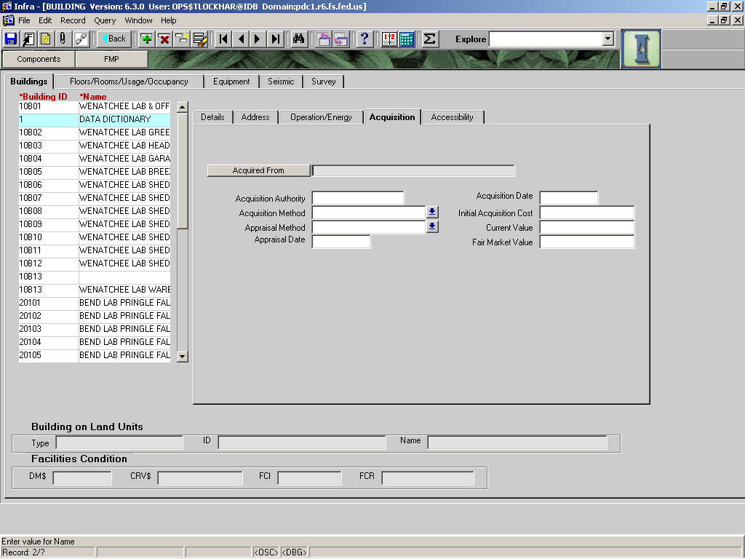

|  |  |  |  |  |  |  |  |
| --- | --- | --- | --- | --- | --- | --- | --- |
|  |  | | | | | **Used in Tables:** | |
| **Name:** | **ACQUIRED FROM** | | | | |  | |
|  |  | | | | |  | |
| **Definition:** | Selecting the gray box brings you to the CONTACTS form. | | | | | | |
|  |  | | | | | | |
| **Reference:** |  | | | | | **Screen:** | Main |
|  |  | | | | |  |  |
| **Format:** |  | | | | | **Unit of Measure:** |  |
|  |  | | | | |  |  |
| **Data Type:** | varchar2 | **Size:** |  |  |  | **Mandatory:** | NO |
|  |  | | | | | **Requirement** | NO |
| **Look Up:** | LOV | | | | | | |
|  |  | | | | | | |
| **Business Rules:** |  | | | | | | |
|  |  | | | | | | |
| **Notes:** |  | | | | | | |
|  |  | | | | | | |

|  |  |  |  |  |  |  |  |
| --- | --- | --- | --- | --- | --- | --- | --- |
|  |  | | | | | **Used in Tables:** | |
| **Name:** | **ACQUISITION AUTHORITY** | | | | |  | |
|  |  | | | | |  | |
| **Definition:** |  | | | | | | |
|  |  | | | | | | |
| **Reference:** |  | | | | | **Screen:** | Main |
|  |  | | | | |  |  |
| **Format:** |  | | | | | **Unit of Measure:** |  |
|  |  | | | | |  |  |
| **Data Type:** | varchar2 | **Size:** |  |  |  | **Mandatory:** | NO |
|  |  | | | | | **Requirement** | NO |
| **Look Up:** | LOV | | | | | | |
|  |  | | | | | | |
| **Business Rules:** |  | | | | | | |
|  |  | | | | | | |
| **Notes:** |  | | | | | | |
|  |  | | | | | | |

|  |  |  |  |  |  |  |  |
| --- | --- | --- | --- | --- | --- | --- | --- |
|  |  | | | | | **Used in Tables:** | |
| **Name:** | **ACQUISITION DATE** | | | | |  | |
|  |  | | | | |  | |
| **Definition:** |  | | | | | | |
|  |  | | | | | | |
| **Reference:** |  | | | | | **Screen:** | Main |
|  |  | | | | |  |  |
| **Format:** |  | | | | | **Unit of Measure:** |  |
|  |  | | | | |  |  |
| **Data Type:** | varchar2 | **Size:** |  |  |  | **Mandatory:** | NO |
|  |  | | | | | **Requirement** | NO |
| **Look Up:** | LOV | | | | | | |
|  |  | | | | | | |
| **Business Rules:** |  | | | | | | |
|  |  | | | | | | |
| **Notes:** |  | | | | | | |
|  |  | | | | | | |

|  |  |  |  |  |  |  |  |  |  |
| --- | --- | --- | --- | --- | --- | --- | --- | --- | --- |
|  |  | | | | | | **Used in Tables:** | | |
| **Name:** | **ACQUISITION METHOD** | | | | | |  | | |
|  |  | | | | | |  | | |
| **Definition:** | The method by which the building was acquired. | | | | | | | | |
|  |  | | | | | | | | |
| **Reference:** |  | | | | | | **Screen:** | | Main |
|  |  | | | | | |  | |  |
| **Format:** |  | | | | | | **Unit of Measure:** | |  |
|  |  | | | | | |  | |  |
| **Data Type:** | varchar2 | **Size:** |  | |  |  | **Mandatory:** | | NO |
|  |  | | | | | | **Requirement** | | NO |
| **Look Up:** | LOV | | | | | | | | |
|  |  | | | | | | | | |
| **Business Rules:** | 1. | | | | | | | | |
|  |  | | | | | | | | |
| **Notes:** |  | | | | | | | | |
|  |  | | | | | | | | |
| **Valid Codes** | | | | | | | | | |
| **Code** | | | | **Description** | | | |  | |
| CONSTRUCTED | | | | Building was constructed by Forest Service | | | |  | |
| EXCHANGED | | | | Building came in land exchange | | | |  | |
| LEASED HOLD | | | | ????? | | | |  | |
| PURCHASED | | | | Building was purchased whole by Forest Service | | | |  | |

|  |  |  |  |  |  |  |  |
| --- | --- | --- | --- | --- | --- | --- | --- |
|  |  | | | | | **Used in Tables:** | |
| **Name:** | **INITIAL ACQUISITION COST** | | | | |  | |
|  |  | | | | |  | |
| **Definition:** |  | | | | | | |
|  |  | | | | | | |
| **Reference:** |  | | | | | **Screen:** | Main |
|  |  | | | | |  |  |
| **Format:** |  | | | | | **Unit of Measure:** |  |
|  |  | | | | |  |  |
| **Data Type:** | varchar2 | **Size:** |  |  |  | **Mandatory:** | NO |
|  |  | | | | | **Requirement** | NO |
| **Look Up:** | LOV | | | | | | |
|  |  | | | | | | |
| **Business Rules:** |  | | | | | | |
|  |  | | | | | | |
| **Notes:** |  | | | | | | |

|  |  |  |  |  |  |  |  |  |  |
| --- | --- | --- | --- | --- | --- | --- | --- | --- | --- |
|  |  | | | | | | **Used in Tables:** | | |
| **Name:** | **APPRAISAL METHOD** | | | | | |  | | |
|  |  | | | | | |  | | |
| **Definition:** | Who did the appraisal? | | | | | | | | |
|  |  | | | | | | | | |
| **Reference:** |  | | | | | | **Screen:** | | Main |
|  |  | | | | | |  | |  |
| **Format:** |  | | | | | | **Unit of Measure:** | |  |
|  |  | | | | | |  | |  |
| **Data Type:** | varchar2 | **Size:** |  | |  |  | **Mandatory:** | | NO |
|  |  | | | | | | **Requirement** | | NO |
| **Look Up:** | LOV | | | | | | | | |
|  |  | | | | | | | | |
| **Business Rules:** |  | | | | | | | | |
|  |  | | | | | | | | |
| **Notes:** |  | | | | | | | | |
|  |  | | | | | | | | |
| **Valid Codes** | | | | | | | | | |
| **Code** | | | | **Description** | | | |  | |
| FED EMPLOYEE | | | | APPRAISED BY FED EMPLOYEE | | | |  | |
| PRO CONTRACT | | | | APPRAISED BY PROFESSIONAL CONTRACT APPRAISER | | | |  | |
| EMPLOYEE COMMIT | | | | APPRAISED BY EMPLOYEE COMMITTEE | | | |  | |
| GENERAL ESTIMTE | | | | APPRAISAL IS GENERAL ESTIMATE OF MARKET VALUE | | | |  | |
| OTHER METHOD | | | | OTHER APPRAISAL METHOD USED | | | |  | |

|  |  |  |  |  |  |  |  |
| --- | --- | --- | --- | --- | --- | --- | --- |
|  |  | | | | | **Used in Tables:** | |
| **Name:** | **CURRENT VALUE** | | | | |  | |
|  |  | | | | |  | |
| **Definition:** |  | | | | | | |
|  |  | | | | | | |
| **Reference:** |  | | | | | **Screen:** | Main |
|  |  | | | | |  |  |
| **Format:** |  | | | | | **Unit of Measure:** |  |
|  |  | | | | |  |  |
| **Data Type:** | varchar2 | **Size:** |  |  |  | **Mandatory:** | NO |
|  |  | | | | | **Requirement** | No |
| **Look Up:** |  | | | | | | |
|  |  | | | | | | |
| **Business Rules:** |  | | | | | | |
|  |  | | | | | | |
| **Notes:** |  | | | | | | |

|  |  |  |  |  |  |  |  |
| --- | --- | --- | --- | --- | --- | --- | --- |
|  |  | | | | | **Used in Tables:** | |
| **Name:** | **APPRAISAL DATE** | | | | |  | |
|  |  | | | | |  | |
| **Definition:** |  | | | | | | |
|  |  | | | | | | |
| **Reference:** |  | | | | | **Screen:** | Main |
|  |  | | | | |  |  |
| **Format:** |  | | | | | **Unit of Measure:** |  |
|  |  | | | | |  |  |
| **Data Type:** | varchar2 | **Size:** |  |  |  | **Mandatory:** | NO |
|  |  | | | | | **Requirement** | NO |
| **Look Up:** |  | | | | | | |
|  |  | | | | | | |
| **Business Rules:** |  | | | | | | |
|  |  | | | | | | |
| **Notes:** |  | | | | | | |
|  |  | | | | | | |

|  |  |  |  |  |  |  |  |
| --- | --- | --- | --- | --- | --- | --- | --- |
|  |  | | | | | **Used in Tables:** | |
| **Name:** | **FAIR MARKET VALUE** | | | | |  | |
|  |  | | | | |  | |
| **Definition:** |  | | | | | | |
|  |  | | | | | | |
| **Reference:** |  | | | | | **Screen:** | Main |
|  |  | | | | |  |  |
| **Format:** |  | | | | | **Unit of Measure:** |  |
|  |  | | | | |  |  |
| **Data Type:** | varchar2 | **Size:** |  |  |  | **Mandatory:** | NO |
|  |  | | | | | **Requirement** | NO |
| **Look Up:** |  | | | | | | |
|  |  | | | | | | |
| **Business Rules:** |  | | | | | | |
|  |  | | | | | | |
| **Notes:** |  | | | | | | |
|  |  | | | | | | |

# BUILDINGS -- ACCESSIBILITY Tab

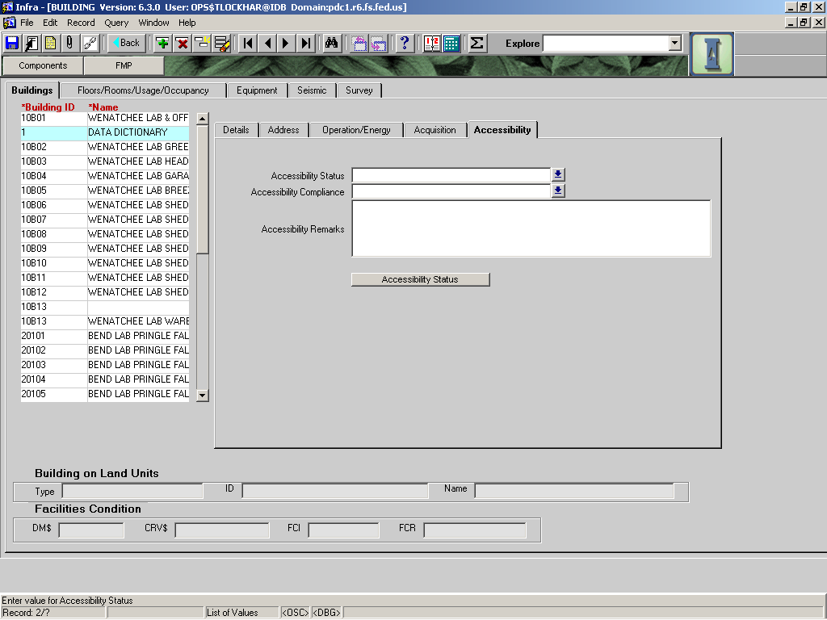

|  |  |  |  |  |  |  |  |  |  |
| --- | --- | --- | --- | --- | --- | --- | --- | --- | --- |
|  |  | | | | | | **Used in Tables:** | | |
| **Name:** | **ACCESSIBILITY STATUS** | | | | | |  | | |
|  |  | | | | | |  | | |
| **Definition:** | Whether a building is accessible to people with disabilities.  A building is accessible if it meets the accessibility regulations that were in place when the building was constructed, unless the building has been renovated. A renovated building is accessible if it meets the accessibility regulations that were in place when the building was renovated.  For help in determining whether a building is accessible, check with your forest or regional accessibility coordinator.  Note: In the list of values, do not use the Usable value. Accessible and Not Accessible are the valid responses for this field. | | | | | | | | |
|  |  | | | | | | | | |
| **Reference:** | ABA | | | | | | **Screen:** | |  |
|  |  | | | | | |  | |  |
| **Format:** |  | | | | | | **Unit of Measure:** | |  |
|  |  | | | | | |  | |  |
| **Data Type:** | varchar2 | **Size:** |  | |  |  | **Mandatory:** | | NO |
|  |  | | | | | |  | |  |
|  |  | | | | | | **Required:** | | **YES** |
| **Look Up:** | LOV | | | | | | | | |
|  |  | | | | | | | | |
| **Business Rules:** | If uncertainty exists regarding a building's accessibility status, check with your unit's accessibility coordinator or the RO. At a minimum, a building must provide accessible parking, entryway (ramp), front desk, and restrooms, to be considered accessible. In some instances, an elevator and other features are required as well. | | | | | | | | |
|  |  | | | | | | | | |
| **Valid Codes** | | | | | | | | | |
| **Code** | | | | **Description** | | | |  | |
| Accessible | | | | Building is fully accessible | | | |  | |
| Not Accessible | | | | Building is not accessible | | | |  | |
| Useable | | | | **DO NOT USE THIS OPTION** as it is invalid. | | | |  | |
|  | | | |  | | | |  | |
|  | | | |  | | | |  | |

|  |  |  |  |  |  |  |  |  |  |
| --- | --- | --- | --- | --- | --- | --- | --- | --- | --- |
|  |  | | | | | | **Used in Tables:** | | |
| **Name:** | **ACCESSIBILITY COMPLIANCE** | | | | | |  | | |
|  |  | | | | | |  | | |
| **Definition:** | Level of compliance of a LEASED building with the accessibility codes and guidelines | | | | | | | | |
|  |  | | | | | | | | |
| **Reference:** | ABA | | | | | | **Screen:** | |  |
|  |  | | | | | |  | |  |
| **Format:** |  | | | | | | **Unit of Measure:** | |  |
|  |  | | | | | |  | |  |
| **Data Type:** | varchar2 | **Size:** |  | |  |  | **Mandatory:** | | NO |
|  |  | | | | | | **Required:** | | NO |
| **Look Up:** | LOV | | | | | | | | |
|  |  | | | | | | | | |
| **Business Rules:** | **Used for LEASED buildings only.** | | | | | | | | |
|  |  | | | | | | | | |
| **Valid Codes** | | | | | | | | | |
| **Code** | | | | **Description** | | | |  | |
| FULL COMPLIANCE | | | |  | | | |  | |
| LESS THAN SUBSTANIAL COMPLIANCE | | | |  | | | |  | |
| SUBSTANIAL COMPLIANCE | | | |  | | | |  | |
| WAIVER | | | |  | | | |  | |

The ACCESSIBILITY gray button at the bottom of this form brings you to the old accessibility chart that needs to be updated. It is recommended that you do not use this till we receive further guidance.

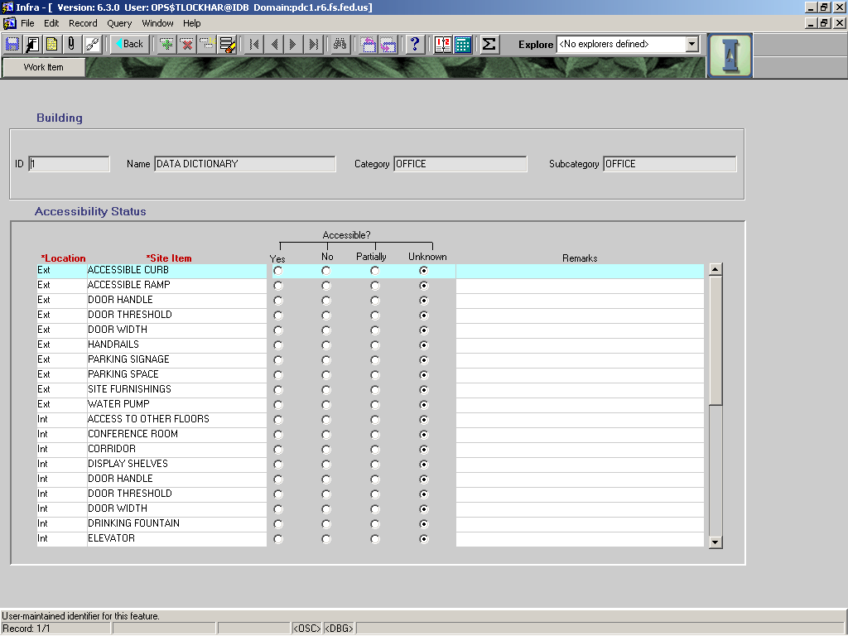

# FLOOR/ROOMS/USAGE/OCCUPANCY Tab

The Department added this tab in v6.3. At this time you are advised to wait for business rules for the FLOOR/ROOMS/USAGE areas. Even though OCCUPANCY data is required for all offices, and this data should be updated yearly with information from Human Resources, we need to wait for further direction from USDA.

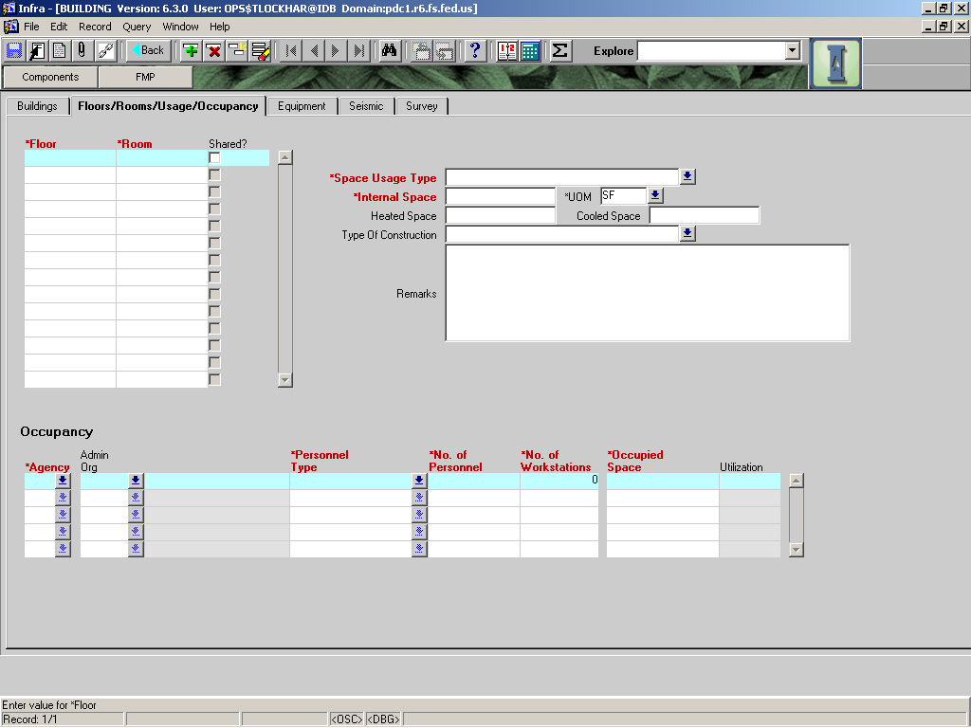

# EQUIPMENT Tab

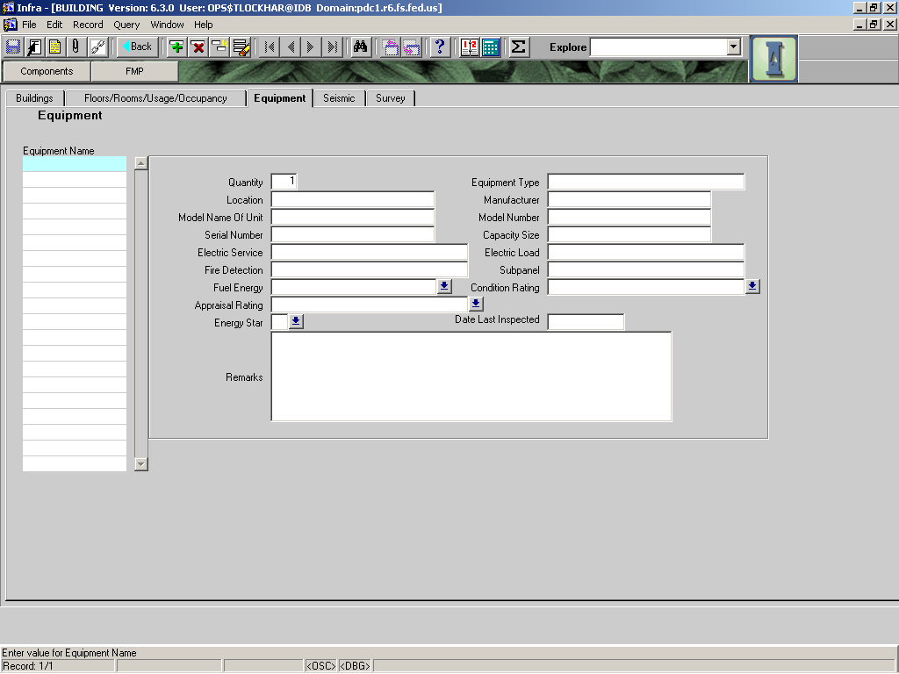

|  |  |  |  |  |  |  |  |
| --- | --- | --- | --- | --- | --- | --- | --- |
|  |  | | | | | **Used in Tables:** | |
| **Name:** | **Equipment Name** | | | | | ii_bldg_equipment | |
|  |  | | | | |  | |
| **Definition:** | User assigned name of the equipment | | | | | | |
|  |  | | | | | | |
| **Reference:** |  | | | | | **Screen:** | Equipment |
|  |  | | | | |  |  |
| **Format:** |  | | | | | **:** |  |
|  |  | | | | |  |  |
| **Data Type:** | CHAR | **Size::** | 60 | **:** |  | **Mandatory:** | No |
|  |  | | | | | **Required:** | No |
|  |  | | | | |  |  |
| **Look Up:** |  | | | | | | |
|  |  | | | | | | |
|  | | | | | | | |
| **Business Rules:** | 1. Enter the name that the local facility manager uses for this item.Enter multiple pieces of identical equipment as a group rather than entering each of them separately. For example, enter “Lighting Fixtures, 2x2 fluorescent” etc. 2. Enter a Fire Sprinkler System as a piece of equipment rather than entering each sprinkler head, pull station, alarm, etc separately. 3. Electric panel(s) and subpanel(s) may be entered as separate pieces of equipment. 4. For each electric panel entered, use Remarks to list the parent panel that feeds this panel and all subpanels served from this panel. | | | | | | |
|  |  | | | | | | |
| **Notes:** |  | | | | | | |

|  |  |  |  |  |  |  |  |
| --- | --- | --- | --- | --- | --- | --- | --- |
|  |  | | | | | **Used in Tables:** | |
| **Name:** | **QUANTITY** | | | | | ii_bldg_equipment | |
|  |  | | | | |  | |
| **Definition:** | Enter the number of this type of equipment. | | | | | | |
|  |  | | | | | | |
| **Reference:** |  | | | | | **Screen:** | Equipment |
|  |  | | | | |  |  |
| **Format:** | number | | | | | **:** |  |
|  |  | | | | |  |  |
| **Data Type:** | CHAR | **Size::** | 60 | **:** |  | **Mandatory:** | No |
|  |  | | | | | **Required:** | No |
|  |  | | | | |  |  |
| **Look Up:** |  | | | | | | |
|  |  | | | | | | |
|  | | | | | | | |
| **Business Rules:** |  | | | | | | |
|  |  | | | | | | |
| **Notes:** |  | | | | | | |

|  |  |  |  |  |  |  |  |
| --- | --- | --- | --- | --- | --- | --- | --- |
|  |  | | | | | **Used in Tables:** | |
| **Name:** | **Equipment Type** | | | | | ii_bldg_equipment | |
|  |  | | | | |  | |
| **Definition:** | The trade name or general identifier of the equipment. (eg HWH, Furnace F-1, DWF, air filter, belt, etc). | | | | | | |
|  |  | | | | | | |
| **Reference:** |  | | | | | **Screen:** | Equipment |
|  |  | | | | |  |  |
| **Format:** |  | | | | | **Unit of Measure:** |  |
|  |  | | | | |  |  |
| **Data Type:** | CHAR | **Size::** | 40 | **:** |  | **Mandatory:** | No |
|  |  | | | | | **Required:** | No |
|  |  | | | | |  |  |
| **Look Up:** |  | | | | | | |
|  |  | | | | | | |
|  | | | | | | | |
| **Business Rules:** | 1. When possible, copy equipment name and/or mark from equipment schedules on as-built drawings. | | | | | | |
|  |  | | | | | | |
| **Notes:** |  | | | | | | |

|  |  |  |  |  |  |  |  |
| --- | --- | --- | --- | --- | --- | --- | --- |
|  |  | | | | | **Used in Tables:** | |
| **Name:** | **Location** | | | | | ii_bldg_equipment | |
|  |  | | | | |  | |
| **Definition:** | The location of the equipment. | | | | | | |
|  |  | | | | | | |
| **Reference:** |  | | | | | **Screen:** | Equipment |
|  |  | | | | |  |  |
| **Format:** |  | | | | | **Unit of Measure:** |  |
|  |  | | | | |  |  |
| **Data Type:** | CHAR | **Size:** | 35 |  |  | **Mandatory:** | No |
|  |  | | | | | **Required:** | No |
| **Look Up:** |  | | | | | | |
|  |  | | | | | | |
|  | | | | | | | |
| **Business Rules:** | When possible, use room name or room number to match as-built floor plan drawing. | | | | | | |
|  |  | | | | | | |
| **Notes:** |  | | | | | | |

|  |  |  |  |  |  |  |  |
| --- | --- | --- | --- | --- | --- | --- | --- |
|  |  | | | | | **Used in Tables:** | |
| **Name:** | **Manufacturer** | | | | | ii_bldg_equipment | |
|  |  | | | | |  | |
| **Definition:** | The name of the manufacturer. | | | | | | |
|  |  | | | | | | |
| **Reference:** |  | | | | | **Screen:** | Equipment |
|  |  | | | | |  |  |
| **Format:** |  | | | | | **Unit of Measure:** |  |
|  |  | | | | |  |  |
| **Data Type:** | CHAR | **Size:** | 35 | **:** |  | **Mandatory:** | No |
|  |  | | | | | **Required:** | No |
|  |  | | | | |  |  |
| **Look Up:** |  | | | | | | |
|  |  | | | | | | |
|  | | | | | | | |
| **Business Rules:** |  | | | | | | |
|  |  | | | | | | |
| **Notes:** | Example: Trane Air Handling Unit | | | | | | |

|  |  |  |  |  |  |  |  |
| --- | --- | --- | --- | --- | --- | --- | --- |
|  |  | | | | | **Used in Tables:** | |
| **Name:** | **Model Name OF UNIT** | | | | | ii_bldg_equipment | |
|  |  | | | | |  | |
| **Definition:** | The model name of the equipment, if applicable. | | | | | | |
|  |  | | | | | | |
| **Reference:** |  | | | | | **Screen:** | Equipment |
|  |  | | | | |  |  |
| **Format:** |  | | | | | **Unit of Measure:** |  |
|  |  | | | | |  |  |
| **Data Type:** | CHAR | **Size:** | 35 |  |  | **Mandatory:** | No |
|  |  | | | | | **Required:** | No |
|  |  | | | | |  |  |
| **Look Up:** |  | | | | | | |
|  |  | | | | | | |
|  | | | | | | | |
| **Business Rules:** |  | | | | | | |
|  |  | | | | | | |
| **Notes:** |  | | | | | | |

|  |  |  |  |  |  |  |  |
| --- | --- | --- | --- | --- | --- | --- | --- |
|  |  | | | | | **Used in Tables:** | |
| **Name:** | **Model Number** | | | | | ii_bldg_equipment | |
|  |  | | | | |  | |
| **Definition:** | The model number of the equipment. | | | | | | |
|  |  | | | | | | |
| **Reference:** |  | | | | | **Screen:** | Equipment |
|  |  | | | | |  |  |
| **Format:** |  | | | | | **Unit of Measure:** |  |
|  |  | | | | |  |  |
| **Data Type:** | CHAR | **Size:** | 35 |  |  | **Mandatory:** | No |
|  |  | | | | | **Required:** | No |
|  |  | | | | |  |  |
| **Look Up:** |  | | | | | | |
|  |  | | | | | | |
|  | | | | | | | |
| **Business Rules:** |  | | | | | | |
|  |  | | | | | | |
| **Notes:** |  | | | | | | |

|  |  |  |  |  |  |  |  |
| --- | --- | --- | --- | --- | --- | --- | --- |
|  |  | | | | | **Used in Tables:** | |
| **Name:** | **Serial Number** | | | | | ii_bldg_equipment | |
|  |  | | | | |  | |
| **Definition:** | The serial number of the selected equipment. | | | | | | |
|  |  | | | | | | |
| **Reference:** |  | | | | | **Screen:** | Equipment |
|  |  | | | | |  |  |
| **Format:** |  | | | | | **Unit of Measure:** |  |
|  |  | | | | |  |  |
| **Data Type:** | CHAR | **Size:** | 35 |  |  | **Mandatory:** | No |
|  |  | | | | | **Required:** | No |
|  |  | | | | |  |  |
| **Look Up:** |  | | | | | | |
|  |  | | | | | | |
| **Business Rules:** |  | | | | | | |
|  |  | | | | | | |
| **Notes:** |  | | | | | | |

|  |  |  |  |  |  |  |  |
| --- | --- | --- | --- | --- | --- | --- | --- |
|  |  | | | | | **Used in Tables:** | |
| **Name:** | **Capacity Size** | | | | | ii_bldg_equipment | |
|  |  | | | | |  | |
| **Definition:** | Capacity of the unit, include measurement units. | | | | | | |
|  |  | | | | | | |
| **Reference:** |  | | | | | **Screen:** | Equipment |
|  |  | | | | |  |  |
| **Format:** |  | | | | | **Unit of Measure:** |  |
|  |  | | | | |  |  |
| **Data Type:** | CHAR | **Size::** | 35 |  |  | **Mandatory:** | No |
|  |  | | | | | **Required:** | No |
|  |  | | | | |  |  |
| **Look Up:** |  | | | | | | |
|  |  | | | | | | |
| **Business Rules:** |  | | | | | | |
|  |  | | | | | | |
| **Notes:** | Examples HWH 60 gallons Furn 125 MBH 80% eff | | | | | | |
|  |  | | | | | | |

|  |  |  |  |  |  |  |  |
| --- | --- | --- | --- | --- | --- | --- | --- |
|  |  | | | | | **Used in Tables:** | |
| **Name:** | **Electric Service** | | | | | ii_bldg_equipment | |
|  |  | | | | |  | |
| **Definition:** | The electrical service available to the ~~facillity~~ building in volts, amps and phase. | | | | | | |
|  |  | | | | | | |
| **Reference:** |  | | | | | **Screen:** | Equipment |
|  |  | | | | |  |  |
| **Format:** |  | | | | | **Unit of Measure:** |  |
|  |  | | | | |  |  |
| **Data Type:** | CHAR | **Size:** | 40 |  |  | **Mandatory:** | No |
|  |  | | | | | **Required:** | No |
|  |  | | | | |  |  |
| **Look Up:** |  | | | | | | |
|  |  | | | | | | |
| **Business Rules:** |  | | | | | | |
|  |  | | | | | | |
| **Notes:** | Note to programmer -- remove this field from the Equipment screen and place it on the Main screen | | | | | | |
|  |  | | | | | | |

|  |  |  |  |  |  |  |  |
| --- | --- | --- | --- | --- | --- | --- | --- |
|  |  | | | | | **Used in Tables:** | |
| **Name:** | **Electric Load** | | | | | ii_bldg_equipment | |
|  |  | | | | |  | |
| **Definition:** | The electrical load of this equipment in volts, amps, and phase. | | | | | | |
|  |  | | | | | | |
| **Reference:** |  | | | | | **Screen:** | Equipment |
|  |  | | | | |  |  |
| **Format:** |  | | | | | **Unit of Measure:** |  |
|  |  | | | | |  |  |
| **Data Type:** | CHAR | **Size:** | 40 |  |  | **Mandatory:** | No |
|  |  | | | | | **Required:** | No |
|  |  | | | | |  |  |
| **Look Up:** |  | | | | | | |
|  |  | | | | | | |
|  | | | | | | | |
| **Business Rules:** |  | | | | | | |
|  |  | | | | | | |
| **Notes:** |  | | | | | | |

|  |  |  |  |  |  |  |  |  |
| --- | --- | --- | --- | --- | --- | --- | --- | --- |
|  |  | | | | | | **Used in Tables:** | |
| **Name:** | **Fire Detection** | | | | | | ii_bldg_equipment | |
|  |  | | | | | |  | |
| **Definition:** | The type of automatic fire detection system for the building. | | | | | | | |
|  |  | | | | | | | |
| **Reference:** |  | | | | | | **Screen:** | Equipment |
|  |  | | | | | |  |  |
| **Format:** |  | | | | | | **Unit of Measure:** |  |
|  |  | | | | | |  |  |
| **Data Type:** | CHAR | **Size:** | | 40 |  |  | **Mandatory:** | No |
|  |  | | | | | |  |  |
| **Look Up:** | LOV | | | | | | | |
|  |  | | | | | | | |
| **Business Rules:** | 1. Additional features such as auto dialing, carbon monoxide detection, etc. should be listed in remarks. | | | | | | | |
|  |  | | | | | | | |
| **Notes:** |  | | | | | | | |
|  |  | | | | | | | |
| **Valid Codes** | | | | | | | | |
| **Code** | | | **Description** | | | | | |
| **Smoke – Ion – Bat** | | | Smoke detector only, Ionization type, battery | | | | | |
| **Smoke – Ion – HW** | | | Smoke – Ionization type (hard wired) | | | | | |
| **Smoke – Ion – HW/Bat** | | | Smoke – Ionization type (hard wired with battery backup) | | | | | |
| **Smoke – Photoelec – Bat** | | | Smoke - Photoelectric type (battery) | | | | | |
| **Smoke – Photoelec – HW** | | | Smoke - Photoelectric type (hard wired) | | | | | |
| **Smoke – Photoelec – HW/Bat** | | | Smoke - Photoelectric type (hard wired with battery backup) | | | | | |
| **Smoke – I&P – Bat** | | | Smoke – Ionization / Photoelectric Combo type, (battery) | | | | | |
| **Smoke – I&P – HW** | | | Smoke – Ionization / Photoelectric Combo type, (hard wired) | | | | | |
| **Smoke – I&P – HW/Bat** | | | Smoke – Ionization / Photoelectric Combo type, (hard wired with battery backup) | | | | | |
| **Heat – Bat** | | | Heat detector only, (battery) | | | | | |
| **Heat – HW** | | | Heat detector only, (hard wired) | | | | | |
| **Heat – HW/Bat** | | | Heat detector only, (hard wired with battery backup) | | | | | |
| **Smoke / Heat – Bat** | | | Smoke & Heat, (battery) | | | | | |
| **Smoke / Heat – HW** | | | Smoke & Heat, (hard wired) | | | | | |
| **Smoke / Heat – HW/Bat** | | | Smoke & Heat, (hard wired with battery backup) | | | | | |

|  |  |  |  |  |  |  |  |
| --- | --- | --- | --- | --- | --- | --- | --- |
|  |  | | | | | **Used in Tables:** | |
| **Name:** | **SubpaneL** | | | | | ii_bldg_equipment | |
|  |  | | | | |  | |
| **Definition:** | Identifies subpanels associated with the main electric panel. | | | | | | |
|  |  | | | | | | |
| **Reference:** |  | | | | | **Screen:** | Equipment |
|  |  | | | | |  |  |
| **Format:** |  | | | | | **Unit of Measure:** |  |
|  |  | | | | |  |  |
| **Data Type:** | CHAR | **Size::** | 40 | **:** |  | **Mandatory:** | No |
|  |  | | | | | **Required:** | No |
|  |  | | | | |  |  |
| **Look Up:** |  | | | | | | |
|  |  | | | | | | |
|  | | | | | | | |
| **Business Rules:** |  | | | | | | |
|  |  | | | | | | |
| **Notes:** | May list parent panel for this subpanel in the “Remarks” if desired. | | | | | | |

|  |  |  |  |  |  |  |  |  |
| --- | --- | --- | --- | --- | --- | --- | --- | --- |
|  |  | | | | | | **Used in Tables:** | |
| **Name:** | **Fuel Energy** | | | | | | ii_bldg_equipment | |
|  |  | | | | | |  | |
| **Definition:** | The type of fuel/energy that runs this unit. – list of values available | | | | | | | |
|  |  | | | | | | | |
| **Reference:** |  | | | | | | **Screen:** | Equipment |
|  |  | | | | | |  |  |
| **Format:** |  | | | | | | **Unit of Measure:** |  |
|  |  | | | | | |  |  |
| **Data Type:** | CHAR | | **Size:** | 40 | **:** |  | **Mandatory:** | No |
|  |  | | | | | | **Required:** | No |
|  |  | | | | | |  |  |
| **Look Up:** | LOV | | | | | | | |
|  |  | | | | | | | |
|  | | | | | | | | |
| **Business Rules:** |  | | | | | | | |
|  |  | | | | | | | |
| **Notes:** | It’s easy for programmers to add things to the LOV as they are needed. If you need more in the LOV, tell your User Board Rep to get it. In the mean time, use “Other” and include explanation in “Remarks.” | | | | | | | |
|  |  | | | | | | | |
| **Valid Codes** | | | | | | | | |
| **Code** | | **Description** | | | | | | |
| Diesel | | Diesel fuel oil | | | | | | |
| Electricity | | Excludes photovoltaic but includes commercial and other local generated electricity | | | | | | |
| Fuel Oil | | All fuel oils other than diesel | | | | | | |
| LP Gas | | Liquid propane, butane, etc | | | | | | |
| Natural Gas | | Commercial NG | | | | | | |
| Nuclear | | Possibly may be applicable in future | | | | | | |
| Other | | Use the “Remarks” field to describe | | | | | | |
| Photovoltaic | | Solar electric cells | | | | | | |
| Solar powered | | For space heating and for water heating | | | | | | |
| Wind | | For windmills, wind turbines, etc | | | | | | |
| Wood | | For wood burning equipment (stoves, boilers, etc) | | | | | | |
|  | |  | | | | | | |

|  |  |  |  |  |  |  |  |  |  |
| --- | --- | --- | --- | --- | --- | --- | --- | --- | --- |
|  |  | | | | | | **Used in Tables:** | | |
| **Name:** | **Condition Rating** | | | | | |  | | |
|  |  | | | | | |  | | |
| **Definition:** | The condition code for the selected component. | | | | | | | | |
|  |  | | | | | | | | |
| **Reference:** |  | | | | | | **Screens:** | |  |
|  |  | | | | | |  | |  |
| **Format:** |  | | | | | | **Unit of Measure:** | |  |
|  |  | | | | | |  | |  |
| **Data Type:** |  | **Size:** |  | |  |  | **Mandatory:** | | NO |
|  |  | | | | | | **Required:** | | No |
| **Look Up:** | LOV | | | | | | | | |
|  |  | | | | | | | | |
| **Business Rules:** | 1. | | | | | | | | |
|  |  | | | | | | | | |
| **Notes:** |  | | | | | | | | |
|  |  | | | | | | | | |
| **Valid Codes** | | | | | | | | | |
| **Code** | | | | **Description** | | | |  | |
| CRITICAL | | | | Critical, failed or failure is imminent | | | |  | |
| GOOD | | | | Good, like new condition; no repairs needed | | | |  | |
| POOR | | | | Poor; repairs/maintenance needed to protect investment | | | |  | |
| SATISFACTORY | | | | Satisfactory; very little if any repairs needed | | | |  | |
| REMOVAL | | | | To be removed | | | |  | |

|  |  |  |  |  |  |  |  |  |  |
| --- | --- | --- | --- | --- | --- | --- | --- | --- | --- |
|  |  | | | | | | **Used in Tables:** | | |
| **Name:** | **APPRAISAL RATING** | | | | | |  | | |
|  |  | | | | | |  | | |
| **Definition:** | The appraisal rating code for the selected component. | | | | | | | | |
|  |  | | | | | | | | |
| **Reference:** |  | | | | | | **Screen:** | |  |
|  |  | | | | | |  | |  |
| **Format:** |  | | | | | | **Unit of Measure:** | |  |
|  |  | | | | | |  | |  |
| **Data Type:** |  | **Size:** |  | |  |  | **Mandatory:** | | NO |
|  |  | | | | | | **Required:** | | No |
| **Look Up:** | LOV | | | | | | | | |
|  |  | | | | | | | | |
| **Business Rules:** | 1. | | | | | | | | |
|  |  | | | | | | | | |
| **Notes:** |  | | | | | | | | |
|  |  | | | | | | | | |
| **Valid Codes** | | | | | | | | | |
| **Code** | | | | **Description** | | | |  | |
| MAINTAIN | | | | Maintain as is, no major work planned | | | |  | |
| REMOVE | | | | Remove or eliminate | | | |  | |
| REPAIR | | | | Repair facility | | | |  | |
| REPLACE | | | | Replace with another unit | | | |  | |
| RETROFIT | | | | Retrofit – accessibility retrofit, modify facility/component to enable individuals with disabilities to participate in programs or activities | | | |  | |
| RELOCATE | | | | Relocate facility to more effective location. | | | |  | |

|  |  |  |  |  |  |  |  |  |  |
| --- | --- | --- | --- | --- | --- | --- | --- | --- | --- |
|  |  | | | | | | **Used in Tables:** | | |
| **Name:** | **ENERGY STAR** | | | | | | ii_bldg_equipment | | |
|  |  | | | | | |  | | |
| **Definition:** | An appliance or electrical device that has an energy star label. The Energy Star label, a symbol for energy efficiency, was created by the U.S. Environmental Protection Agency (EPA) and the U.S. Department of Energy (DOE) to help customers identify products that can save them money and protect the environment by saving energy. | | | | | | | | |
|  |  | | | | | | | | |
| **Reference:** |  | | | | | | **Screen:** | | Equipment |
|  |  | | | | | |  | |  |
| **Format:** |  | | | | | | **Unit of Measure:** | |  |
|  |  | | | | | |  | |  |
| **Data Type:** | Date | **Size:** | 10 | |  |  | **Mandatory:** | | No |
|  |  | | | | | | **Required:** | | No |
|  |  | | | | | |  | |  |
| **Look Up:** | LOV | | | | | | | | |
|  |  | | | | | | | | |
|  | | | | | | | | | |
| **Business Rules:** |  | | | | | | | | |
|  |  | | | | | | | | |
| **Notes:** |  | | | | | | | | |
| **Valid Codes** | | | | | | | | | |
| **Code** | | | | **Description** | | | |  | |
| Y | | | | Yes | | | |  | |
| N | | | | No | | | |  | |

|  |  |  |  |  |  |  |  |
| --- | --- | --- | --- | --- | --- | --- | --- |
|  |  | | | | | **Used in Tables:** | |
| **Name:** | **Date Last Inspected** | | | | | ii_bldg_equipment | |
|  |  | | | | |  | |
| **Definition:** | Date of last PROFESSIONAL INSPECTION of the equipment. | | | | | | |
|  |  | | | | | | |
| **Reference:** |  | | | | | **Screen:** | Equipment |
|  |  | | | | |  |  |
| **Format:** | MM/DD/YYYY | | | | | **Unit of Measure:** |  |
|  |  | | | | |  |  |
| **Data Type:** | Date | **Size:** | 10 |  |  | **Mandatory:** | No |
|  |  | | | | | **Required:** | No |
|  |  | | | | |  |  |
| **Look Up:** |  | | | | | | |
|  |  | | | | | | |
| **Business Rules:** |  | | | | | | |
|  |  | | | | | | |
| **Notes:** |  | | | | | | |

|  |  |  |  |  |  |  |  |
| --- | --- | --- | --- | --- | --- | --- | --- |
|  |  | | | | | **Used in Tables:** | |
| **Name:** | **Remarks (EQUIPMENT)** | | | | | ii_bldg_equipment | |
|  |  | | | | |  | |
| **Definition:** | Any remarks or comments about this equipment. | | | | | | |
|  |  | | | | | | |
| **Reference:** |  | | | | | **Screen:** | Equipment |
|  |  | | | | |  |  |
| **Format:** |  | | | | | **Unit of Measure:** |  |
|  |  | | | | |  |  |
| **Data Type:** | CHAR | **Size:** | 255 |  |  | **Mandatory:** | No |
|  |  | | | | | **Required:** | No |
|  |  | | | | |  |  |
| **Look Up:** |  | | | | | | |
|  |  | | | | | | |
| **Business Rules:** |  | | | | | | |
|  |  | | | | | | |
| **Notes:** |  | | | | | | |

# SEISMIC Tab

There are several required fields on this tab that need to be highlighted. All buildings need the Seismic Evaluation & Exempt Reason fields populated. Buildings that are not exempt from needing a seismic evaluation need the remaining fields populated.

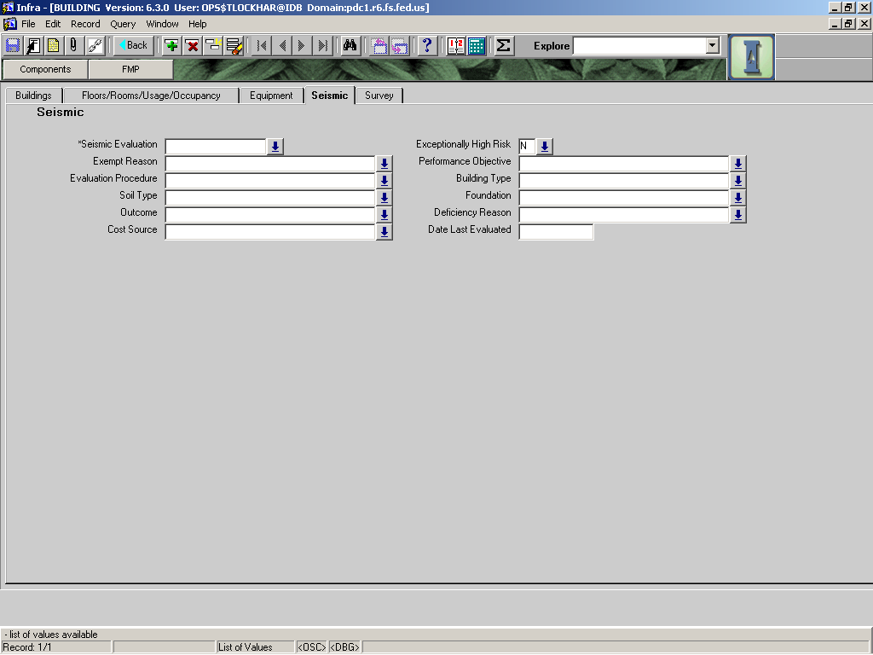

|  |  |  |  |  |  |  |  |  |  |
| --- | --- | --- | --- | --- | --- | --- | --- | --- | --- |
|  |  | | | | | | **Used in Tables:** | | |
| **Name:** | **SEISMIC EVALUATION** | | | | | | ii_bldg_seismic | | |
|  |  | | | | | |  | | |
| **Definition:** | Has a seismic evaluation been completed on this building? | | | | | | | | |
|  |  | | | | | | | | |
| **Reference:** |  | | | | | | **Screen:** | | Seismic |
|  |  | | | | | |  | |  |
| **Format:** |  | | | | | | **Unit of Measure:** | |  |
|  |  | | | | | |  | |  |
| **Data Type:** |  | **Size:** | 1 | |  |  | **Mandatory:** | | No |
|  |  | | | | | | **Required:** | | YES |
|  |  | | | | | |  | |  |
| **Look Up:** | LOV | | | | | | | | |
|  |  | | | | | | | | |
|  | | | | | | | | | |
| **Business Rules:** |  | | | | | | | | |
|  |  | | | | | | | | |
| **Notes:** |  | | | | | | | | |
| **Valid Codes** | | | | | | | | | |
| **Code** | | | | **Description** | | | |  | |
| UNKNOWN | | | | Unknown if evaluation has been performed | | | |  | |
| NO | | | | NO | | | |  | |
| NOT REQUIRED | | | | Building exempt from evaluation If this code is used, Exempt Reason field must be filled in. | | | |  | |
| YES | | | | YES | | | |  | |

|  |  |  |  |  |  |  |  |  |  |
| --- | --- | --- | --- | --- | --- | --- | --- | --- | --- |
|  |  | | | | | | **Used in Tables:** | | |
| **Name:** | **EXCEPTIONALLY HIGH RISK** | | | | | | ii_bldg_seismic | | |
|  |  | | | | | |  | | |
| **Definition:** | Building poses an exceptionally high risk (HER) to occupants or the public at large in the event of an earthquake. | | | | | | | | |
|  |  | | | | | | | | |
| **Reference:** | 7310 May 28, 1996 Letter describing USFS Seismic Safety Program | | | | | | **Screen:** | | Seismic |
|  |  | | | | | |  | |  |
| **Format:** |  | | | | | | **Unit of Measure:** | |  |
|  |  | | | | | |  | |  |
| **Data Type:** |  | **Size:** | 1 | |  |  | **Mandatory:** | | No |
|  |  | | | | | | **Required:** | | YES |
|  |  | | | | | |  | |  |
| **Look Up:** | LOV | | | | | | | | |
|  |  | | | | | | | | |
|  | | | | | | | | | |
| **Business Rules:** | YES if the building meets all of the EHR criteria as follows:   * Located in a high seismic area * Constructed with one of the following vulnerable model building types: * unreinforced masonry (NEHRP building type 15) * tilt-up concrete construction (NEHRP building type 11) * pre-cast concrete construction (NEHRP building type 12) * non-ductile reinforced concrete frame (NEHRP building type 8) constructed before 1978 * offices exceeding 10,000 GSF or essential buildings | | | | | | | | |
|  |  | | | | | | | | |
| **Notes:** |  | | | | | | | | |
| **Valid Codes** | | | | | | | | | |
| **Code** | | | | **Description** | | | |  | |
| NO | | | | NO | | | |  | |
| YES | | | | YES | | | |  | |

|  |  |  |  |  |  |  |  |  |  |
| --- | --- | --- | --- | --- | --- | --- | --- | --- | --- |
|  |  | | | | | | **Used in Tables:** | | |
| **Name:** | **EXEMPT REASON** | | | | | | ii_bldg_seismic | | |
|  |  | | | | | |  | | |
| **Definition:** | Indicates whether or not a building is exempt from the USFS Seismic Safety Program and describes the reason for the exemption. | | | | | | | | |
|  |  | | | | | | | | |
| **Reference:** | 7310 May 28, 1996 Letter describing USFS Seismic Safety Program | | | | | | **Screen:** | | Seismic |
|  |  | | | | | |  | |  |
| **Format:** |  | | | | | | **Unit of Measure:** | |  |
|  |  | | | | | |  | |  |
| **Data Type:** |  | **Size:** | 1 | |  |  | **Mandatory:** | | No |
|  |  | | | | | | **Required:** | | YES |
|  |  | | | | | |  | |  |
| **Look Up:** | LOV | | | | | | | | |
|  |  | | | | | | | | |
|  | | | | | | | | | |
| **Business Rules:** |  | | | | | | | | |
|  |  | | | | | | | | |
| **Notes:** |  | | | | | | | | |
| **Valid Codes** | | | | | | | | | |
| **Code** | | | | **Description** | | | |  | |
| 1STO<3000GSF | | | | Single story buildings of steel light frame or wood construction with an area of less than 3,000 gross square feet. | | | |  | |
| 5-YRS LIFE | | | | The remaining useful life of the building has been identified as being less than 5 years. | | | |  | |
| DEATCH DWELL | | | | Detached one or two family dwellings where Av<0.15. | | | |  | |
| DESIGNP-1990 | | | | Buildings constructed for the FS where the design was done after January 5, 1990. | | | |  | |
| FULLYREHABED | | | | Buildings that have been evaluated and had seismic retrofits completed that comply with the current codes in all four compliance categories. | | | |  | |
| INCIDENT USE | | | | Buildings used for storage of equipment, flammable and hazardous materials, and supplies, or intended for incidental human occupancy, or occupied by person for a total of less that 2 hours per day during season of use. | | | |  | |
| NOT EXEMPT | | | | Building is not exempt. | | | |  | |
| OTHER | | | | Other – describe briefly. Includes all towers. | | | |  | |
| POST-BENCHMK | | | | Buildings constructed after the dates below:  Building Type BOCA SBCCI UBC IBC  Steel Braces Frame 1991 1992 1989  All other 1988 1992 1977 | | | |  | |
| PRE-BENCHMK | | | | Buildings which have been evaluated and found to be safe in the four compliance categories. | | | |  | |

|  |  |  |  |  |  |  |  |  |  |
| --- | --- | --- | --- | --- | --- | --- | --- | --- | --- |
|  |  | | | | | | **Used in Tables:** | | |
| **Name:** | **PerFORMANCE OBJECTIVE** | | | | | | ii_bldg_seismic | | |
|  |  | | | | | |  | | |
| **Definition:** |  | | | | | | | | |
|  |  | | | | | | | | |
| **Reference:** |  | | | | | | **Screen:** | | Seismic |
|  |  | | | | | |  | |  |
| **Format:** |  | | | | | | **Unit of Measure:** | |  |
|  |  | | | | | |  | |  |
| **Data Type:** |  | **Size:** | 1 | |  |  | **Mandatory:** | | No |
|  |  | | | | | | **Required:** | | YES |
|  |  | | | | | |  | |  |
| **Look Up:** | LOV | | | | | | | | |
|  |  | | | | | | | | |
|  | | | | | | | | | |
| **Business Rules:** |  | | | | | | | | |
|  |  | | | | | | | | |
| **Notes:** |  | | | | | | | | |
| **Valid Codes** | | | | | | | | | |
| **Code** | | | | **Description** | | | |  | |
| DAMAGE CONTROL | | | |  | | | |  | |
| IMMEDIATE OCCUPANCY | | | |  | | | |  | |
| LIFE SAFETY | | | |  | | | |  | |

|  |  |  |  |  |  |  |  |  |  |
| --- | --- | --- | --- | --- | --- | --- | --- | --- | --- |
|  |  | | | | | | **Used in Tables:** | | |
| **Name:** | **EVALUATION PROCEDURE** | | | | | | ii_bldg_seismic | | |
|  |  | | | | | |  | | |
| **Definition:** | Describes the procedure used to evaluate seismic safety of this building. | | | | | | | | |
|  |  | | | | | | | | |
| **Reference:** | 7310 May 28, 1996 letter describing what criteria triggers which code. | | | | | | **Screen:** | | Seismic |
|  |  | | | | | |  | |  |
| **Format:** |  | | | | | | **Unit of Measure:** | |  |
|  |  | | | | | |  | |  |
| **Data Type:** |  | **Size:** | 1 | |  |  | **Mandatory:** | | No |
|  |  | | | | | | **Required:** | | No |
|  |  | | | | | |  | |  |
| **Look Up:** | LOV | | | | | | | | |
|  |  | | | | | | | | |
|  | | | | | | | | | |
| **Business Rules:** | Used only for buildings evaluated for seismic safety. | | | | | | | | |
|  |  | | | | | | | | |
| **Notes:** |  | | | | | | | | |
| **Valid Codes** | | | | | | | | | |
| **Code** | | | | **Description** | | | |  | |
| DNR | | | | Definitely Needs Rehabilitation. Buildings which are so obviously in need of seismic rehabilitation that they do not need an evaluation. | | | |  | |
| OTHER | | | | Other procedure used to evaluate seismic safety of building | | | |  | |
| USED RP4 | | | | Reference to RP4 means “Standards of Seismic Safety for Existing Federally Owned or Leased Buildings” published by the National Institute of Standards and Technology. | | | |  | |

|  |  |  |  |  |  |  |  |  |  |
| --- | --- | --- | --- | --- | --- | --- | --- | --- | --- |
|  |  | | | | | | **Used in Tables:** | | |
| **Name:** | **BUILDING TYPE** | | | | | | ii_bldg_seismic | | |
|  |  | | | | | |  | | |
| **Definition:** | Describes the building type based on definition in the National Earthquake Hazard Reduction Program (NEHRP). | | | | | | | | |
|  |  | | | | | | | | |
| **Reference:** |  | | | | | | **Screen:** | | Seismic |
|  |  | | | | | |  | |  |
| **Format:** |  | | | | | | **Unit of Measure:** | |  |
|  |  | | | | | |  | |  |
| **Data Type:** |  | **Size:** | 1 | |  |  | **Mandatory:** | | No |
|  |  | | | | | | **Required:** | | YES |
|  |  | | | | | |  | |  |
| **Look Up:** | LOV | | | | | | | | |
|  |  | | | | | | | | |
|  | | | | | | | | | |
| **Business Rules:** |  | | | | | | | | |
|  |  | | | | | | | | |
| **Notes:** |  | | | | | | | | |
| **Valid Codes** | | | | | | | | | |
| **Code** | | | | **Description** | | | |  | |
| CONCRETE INF | | | | Concrete Frame with Infill Shear Walls: These buildings are similar to Type 7 buildings except that the frame is reinforced concrete. | | | |  | |
| CONCRETE MNT | | | | Concrete Moment Frames: These buildings are similar to Type 3 buildings except that the frames are of concrete. | | | |  | |
| CONCRETE SHR | | | | Concrete Shear Walls: Typically these buildings are concrete bearing walls designed to resist vertical and horizontal forces. | | | |  | |
| OTHER | | | | Other: These buildings can not be defined by any of the above listed building types. | | | |  | |
| PRECAST CONC | | | | Pre-cast Concrete Frames with Concrete Shear Walls: These buildings contain floor and roof diaphragms typically composed of pre-cast concrete elements. The diaphragms are supported by pre-cast concrete girders and columns. | | | |  | |
| PRECAST/JILT | | | | Pre-cast/Tilt-up Concrete Walls With Lightweight Flexible Diaphragm: These buildings have a wood or metal deck roof diaphragm, which often is very large. That distributed lateral forces to pre-cast concrete shear walls. The walls are thin but relative heavy while the roofs are relatively light. | | | |  | |
| REINFORCEDPC | | | | Reinforced Masonry Bearing Walls with Pre-cast Concrete Diaphragms: These buildings have bearing walls similar to those of Type 13 buildings, but the roof and floors are composed of pre-cast concrete elements such as planks or tee beams and the pre-cast roof and floor elements are supported on interior beams and columns of steel or concrete (cast-in-place or pre-cast). | | | |  | |
| REINFORCEDWD | | | | Reinforced Masonry Bearing Walls with Wood or Metal Deck Diaphragms: These buildings have perimeter bearing walls or reinforced brick or concrete-block masonry. The floors and roofs are framed either with wood joists and beams or straight or diagonal sheathing or with beams with metal deck with or without a concrete fill. | | | |  | |
| STEEL BRACED | | | | Steel Braced Frame: These are similar to Type 3 buildings except the vertical components of the lateral-force-resisting system are braced frames rather than moment frames. | | | |  | |
| STEEL CONCRE | | | | Steel Frame with Concrete Shear Walls: The walls in these buildings are cast-in-place concrete and may be bearing walls. The steel frame is designed for vertical loads only. Lateral loads are transferred by diaphragms of almost any material to the shear walls. | | | |  | |
| STEEL INFEEL | | | | Steel Frame with Infill Shear Walls: The infill walls are offset from the exterior steel frames, wrap around them, and present a smooth exterior appearance with no indication of the frame. | | | |  | |
| STEEL LIGHT | | | | Steel Light Frame: These buildings are pre-engineered and fabricated with rigid frames. Shear elements can be either the roof and wall sheathing panels, an independent system of tension-on-rod bracing, or a combination of panels and bracing. | | | |  | |
| STEEL MOMENT | | | | Steel Moment Frame: These buildings have a frame of steel columns and beams. These may have beam –to-column connections of very small moment resisting capacity. The frame may be concealed by an exterior skin or wall. Diaphragms between steel frames may be of almost any material. | | | |  | |
| UNREINFORCED | | | | Un-reinforced Masonry Bearing Wall Building: These buildings are similar to Building Types 14 and 15 except the masonry walls are not reinforced. | | | |  | |
| WOOD COMMER | | | | Wood, Commercial and Industrial: These buildings are usually large open spaces which have few, if any, interior walls. | | | |  | |
| WOOD LIGHT | | | | Wood, Light Frame: The essential structural character of this type of repetitive framing by wood joists and wood studs. Loads are light and spans are small. | | | |  | |

|  |  |  |  |  |  |  |  |  |  |
| --- | --- | --- | --- | --- | --- | --- | --- | --- | --- |
|  |  | | | | | | **Used in Tables:** | | |
| **Name:** | **SOIL TYPE** | | | | | | ii_bldg_seismic | | |
|  |  | | | | | |  | | |
| **Definition:** | Describes the soil type in very general terms under this building. | | | | | | | | |
|  |  | | | | | | | | |
| **Reference:** |  | | | | | | **Screen:** | | Seismic |
|  |  | | | | | |  | |  |
| **Format:** |  | | | | | | **Unit of Measure:** | |  |
|  |  | | | | | |  | |  |
| **Data Type:** |  | **Size:** | 1 | |  |  | **Mandatory:** | | No |
|  |  | | | | | | **Required:** | | YES |
|  |  | | | | | |  | |  |
| **Look Up:** | LOV | | | | | | | | |
|  |  | | | | | | | | |
|  | | | | | | | | | |
| **Business Rules:** |  | | | | | | | | |
|  |  | | | | | | | | |
| **Notes:** |  | | | | | | | | |
| **Valid Codes** | | | | | | | | | |
| **Code** | | | | **Description** | | | |  | |
| ROCK | | | | Rock of any characteristic, either shale-like or crystalline in nature. Such materials may be characterized by a shear wave velocity of greater than 2,500 feet per second.  ---OR—  Stiff soil conditions where the soil depth is less than 200 feet and the soil types overlying rock are stable deposits of sands, gravel, or stiff clays. | | | |  | |
| SOFT CLAY | | | | More than 70 feet of soft clays or silts characterized by a shear wave velocity of less than 400 feet per second. | | | |  | |
| SOFT-MEDCLAY | | | | Soft-to medium-stiff clays and sands characterized by 30 feet or more of soft- to medium-stiff clays with or without intervening layers of sand or other cohesion-less soils. | | | |  | |
| STIFF CLAY | | | | Deep cohesion-less or stiff clay conditions including sites where the soil depth exceeds 200 feet and the soil types overlying rock are stable deposits of sands, gravels, or stiff clays. | | | |  | |

|  |  |  |  |  |  |  |  |  |  |
| --- | --- | --- | --- | --- | --- | --- | --- | --- | --- |
|  |  | | | | | | **Used in Tables:** | | |
| **Name:** | **FOUNDATION** | | | | | | ii_bldg_seismic | | |
|  |  | | | | | |  | | |
| **Definition:** | Describes the type of building foundation to use in the seismic safety program (more general than the “building Foundation” feature field. | | | | | | | | |
|  |  | | | | | | | | |
| **Reference:** |  | | | | | | **Screen:** | | Seismic |
|  |  | | | | | |  | |  |
| **Format:** |  | | | | | | **Unit of Measure:** | |  |
|  |  | | | | | |  | |  |
| **Data Type:** |  | **Size:** | 1 | |  |  | **Mandatory:** | | No |
|  |  | | | | | | **Required:** | | YES |
|  |  | | | | | |  | |  |
| **Look Up:** |  | | | | | | | | |
|  |  | | | | | | | | |
|  | | | | | | | | | |
| **Business Rules:** | To be filled in only for buildings evaluated for seismic safety. | | | | | | | | |
|  |  | | | | | | | | |
| **Notes:** |  | | | | | | | | |
| **Valid Codes** | | | | | | | | | |
| **Code** | | | | **Description** | | | |  | |
| DEEP | | | |  | | | |  | |
| SHALLOW | | | |  | | | |  | |
| OTHER | | | |  | | | |  | |

|  |  |  |  |  |  |  |  |  |  |
| --- | --- | --- | --- | --- | --- | --- | --- | --- | --- |
|  |  | | | | | | **Used in Tables:** | | |
| **Name:** | **OUTCOME** | | | | | | ii_bldg_seismic | | |
|  |  | | | | | |  | | |
| **Definition:** | Describes the results of the seismic evaluation on this building. | | | | | | | | |
|  |  | | | | | | | | |
| **Reference:** |  | | | | | | **Screen:** | | Seismic |
|  |  | | | | | |  | |  |
| **Format:** |  | | | | | | **Unit of Measure:** | |  |
|  |  | | | | | |  | |  |
| **Data Type:** |  | **Size:** | 1 | |  |  | **Mandatory:** | | No |
|  |  | | | | | | **Required:** | | YES |
|  |  | | | | | |  | |  |
| **Look Up:** | LOV | | | | | | | | |
|  |  | | | | | | | | |
|  | | | | | | | | | |
| **Business Rules:** | Only required for buildings evaluated for seismic safety. | | | | | | | | |
|  |  | | | | | | | | |
| **Notes:** |  | | | | | | | | |
| **Valid Codes** | | | | | | | | | |
| **Code** | | | | **Description** | | | |  | |
| DEFICIENT | | | | Seismic safety deficiencies noted in evaluation | | | |  | |
| OK | | | | No seismic safety deficiencies noted | | | |  | |

|  |  |  |  |  |  |  |  |  |  |
| --- | --- | --- | --- | --- | --- | --- | --- | --- | --- |
|  |  | | | | | | **Used in Tables:** | | |
| **Name:** | **DEFICIENCY REASON** | | | | | | ii_bldg_seismic | | |
|  |  | | | | | |  | | |
| **Definition:** | Indicates whether or not a building passed the seismic evaluation and if not shows the reason for failing the evaluation. | | | | | | | | |
|  |  | | | | | | | | |
| **Reference:** |  | | | | | | **Screen:** | | Seismic |
|  |  | | | | | |  | |  |
| **Format:** |  | | | | | | **Unit of Measure:** | |  |
|  |  | | | | | |  | |  |
| **Data Type:** |  | **Size:** | 1 | |  |  | **Mandatory:** | | No |
|  |  | | | | | | **Required:** | | YES |
|  |  | | | | | |  | |  |
| **Look Up:** | LOV | | | | | | | | |
|  |  | | | | | | | | |
|  | | | | | | | | | |
| **Business Rules:** | Required only for buildings evaluated for seismic safety. | | | | | | | | |
|  |  | | | | | | | | |
| **Notes:** |  | | | | | | | | |
| **Valid Codes** | | | | | | | | | |
| **Code** | | | | **Description** | | | |  | |
| FAILED ADJ | | | |  | | | |  | |
| FAILED GEO | | | |  | | | |  | |
| FAILED NONST | | | |  | | | |  | |
| FAILED STRUCT | | | |  | | | |  | |
| NOT CHECKED ADJ | | | |  | | | |  | |
| NOT CHECKED GEO | | | |  | | | |  | |
| NOT CHECKED NONST | | | |  | | | |  | |
| NOT CHECKED STRUCT | | | |  | | | |  | |
| PASSES ADJ | | | |  | | | |  | |
| PASSES GEO | | | |  | | | |  | |
| PASSES NONST | | | |  | | | |  | |
| PASSES STRUCT | | | |  | | | |  | |

|  |  |  |  |  |  |  |  |  |  |
| --- | --- | --- | --- | --- | --- | --- | --- | --- | --- |
|  |  | | | | | | **Used in Tables:** | | |
| **Name:** | **COST SOURCE** | | | | | | ii_bldg_seismic | | |
|  |  | | | | | |  | | |
| **Definition:** | Describes the source of the cost estimate used to develop seismic safety mitigation costs based on the evaluation. | | | | | | | | |
|  |  | | | | | | | | |
| **Reference:** |  | | | | | | **Screen:** | | Seismic |
|  |  | | | | | |  | |  |
| **Format:** |  | | | | | | **Unit of Measure:** | |  |
|  |  | | | | | |  | |  |
| **Data Type:** |  | **Size:** | 1 | |  |  | **Mandatory:** | | No |
|  |  | | | | | | **Required:** | | YES |
|  |  | | | | | |  | |  |
| **Look Up:** | LOV | | | | | | | | |
|  |  | | | | | | | | |
|  | | | | | | | | | |
| **Business Rules:** | Required only for buildings evaluated for seismic safety. | | | | | | | | |
|  |  | | | | | | | | |
| **Notes:** |  | | | | | | | | |
| **Valid Codes** | | | | | | | | | |
| **Code** | | | | **Description** | | | |  | |
| AGENCY | | | | A Forest Service-specific cost estimating procedure was used to develop the cost estimate. | | | |  | |
| DISPOSE | | | | Instead of being rehabilitated, the building would be abandoned and not replaced. Therefore, the cost reported is the demolition cost. | | | |  | |
| FEMA | | | | The estimate was developed using cost guide estimate Option II “Typical Costs”, FEMA 156 document. Volume II of “Typical Costs”, FEMA 157 was used to estimate nonstructural, etc.; costs. | | | |  | |
| REHAB | | | | Engineer developed a preliminary rehabilitation scheme appropriate for the specific structure and calculated the cost of proposed fix. | | | |  | |
| REPLACE | | | | Instead of being rehabilitated, the building would be replaced. Therefore, the cost reported is the replacement cost and not a rehabilitation cost. | | | |  | |

|  |  |  |  |  |  |  |  |
| --- | --- | --- | --- | --- | --- | --- | --- |
|  |  | | | | | **Used in Tables:** | |
| **Name:** | **DATE LAST EVALUATED** | | | | | ii_bldg_seismic | |
|  |  | | | | |  | |
| **Definition:** | Date seismic evaluation was completed on the building | | | | | | |
|  |  | | | | | | |
| **Reference:** |  | | | | | **Screen:** | Seismic |
|  |  | | | | |  |  |
| **Format:** | DD/MM/YYYY | | | | | **Unit of Measure:** |  |
|  |  | | | | |  |  |
| **Data Type:** | DATE | **Size:** | 1 |  |  | **Mandatory:** | No |
|  |  | | | | | **Required:** | YES |
|  |  | | | | |  |  |
| **Look Up:** |  | | | | | | |
|  |  | | | | | | |
|  | | | | | | | |
| **Business Rules:** | Required for those buildings that seismic safety was evaluated. | | | | | | |
|  |  | | | | | | |
| **Notes:** |  | | | | | | |

# SURVEY Tab

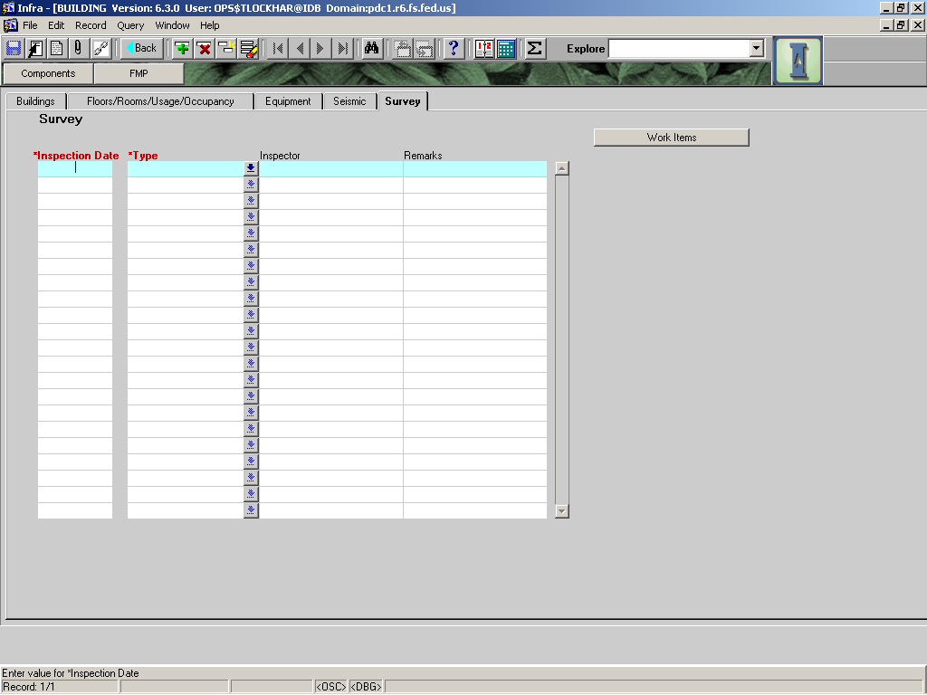

|  |  |  |  |  |  |  |  |
| --- | --- | --- | --- | --- | --- | --- | --- |
|  |  | | | | | **Used in Tables:** | |
| **Name:** | **INSPECTION Date** | | | | |  | |
|  |  | | | | |  | |
| **Definition:** | Date when inspection was performed | | | | | | |
|  |  | | | | | | |
| **Reference:** |  | | | | | **Screen:** | Survey |
|  |  | | | | |  |  |
| **Format:** | mm/dd/yyyy | | | | | **Unit of Measure:** |  |
|  |  | | | | |  |  |
| **Data Type:** | date | **Size:** | 10 |  |  | **Mandatory:** | **YES** |
|  |  | | | | | **Required:** | **YES** |
| **Look Up:** |  | | | | | | |
|  |  | | | | | | |
|  | | | | | | | |
| **Business Rules:** |  | | | | | | |
|  |  | | | | | | |
| **Notes:** |  | | | | | | |
|  |  | | | | | | |
|  |  | | | | | | |

|  |  |  |  |  |  |  |  |  |  |
| --- | --- | --- | --- | --- | --- | --- | --- | --- | --- |
|  |  | | | | | | **Used in Tables:** | | |
| **Name:** | **Type OF SURVEY** | | | | | |  | | |
|  |  | | | | | |  | | |
| **Definition:** | Type of survey or inspection performed | | | | | | | | |
|  |  | | | | | | | | |
| **Reference:** | FSH 7309.11, 30: FSH 7309.11, 40: FSH 6709.12, 10 | | | | | | **Screen:** | | Survey |
|  |  | | | | | |  | |  |
| **Format:** |  | | | | | | **Unit of Measure:** | |  |
|  |  | | | | | |  | |  |
| **Data Type:** | LOV | **Size:** |  | |  |  | **Mandatory:** | | **YES** |
|  |  | | | | | | **Required:** | | **YES** |
| **Look Up:** |  | | | | | | | | |
|  |  | | | | | | | | |
|  | | | | | | | | | |
| **Business Rules:** | Inspections are performed as directed in manuals and handbooks. | | | | | | | | |
|  |  | | | | | | | | |
| **Notes:** |  | | | | | | | | |
|  |  | | | | | | | | |
| **Valid Codes** | | | | | | | | | |
| **Code** | | | | **Description** | | | |  | |
| Acessibility_Survey | | | | Accessibility Survey | | | |  | |
| Asbestos_Management_Inspection | | | | Inspection of existing ACM’s | | | |  | |
| Condition_Survey | | | | Condition Survey | | | |  | |
| Health_and_Safety_Inspection | | | | Inspection to eliminate unsafe acts or conditions | | | |  | |
| Lead_Based_Paint | | | | Inspection of lead based paint | | | |  | |
| Real_Property_Survey | | | | Real Property Inspection | | | |  | |
| Vulnerability_Assessment | | | | Evaluate for appropriate physical security | | | |  | |

|  |  |  |  |  |  |  |  |  |
| --- | --- | --- | --- | --- | --- | --- | --- | --- |
|  |  | | | | | | **Used in Tables:** | |
| **Name:** | **Inspector** | | | | | |  | |
|  |  | | | | | |  | |
| **Definition:** | Name of the inspector and employers name | | | | | | | |
|  |  | | | | | | | |
| **Reference:** |  | | | | | **Screen:** | | Survey |
|  |  | | | | |  | |  |
| **Format:** |  | | | | | **Unit of Measure:** | |  |
|  |  | | | | |  | |  |
| **Data Type:** | varchar2 | **Size:** | 30 |  |  | **Mandatory:** | | No |
|  |  | | | | |  | |  |
|  |  | | | | | **Required:** | | No |
| **Look Up:** |  | | | | | | | |
|  |  | | | | | | | |
|  | | | | | | | | |
| **Business Rules:** | 1. Enter inspector’s name and whom he/she works for. | | | | | | | |
|  |  | | | | | | | |
| **Notes:** | Ex. P. Tubberville – USFS | | | | | | | |
|  | J. Smith – B & F Engineering | | | | | | | |
|  |  | | | | | | | |

|  |  |  |  |  |  |  |  |  |
| --- | --- | --- | --- | --- | --- | --- | --- | --- |
|  |  | | | | | | **Used in Tables:** | |
| **Name:** | **REMARKS SURVEY** | | | | | |  | |
|  |  | | | | | |  | |
| **Definition:** | Remarks regarding survey performed. | | | | | | | |
|  |  | | | | | | | |
| **Reference:** |  | | | | | **Screen:** | | Survey |
|  |  | | | | |  | |  |
| **Format:** |  | | | | | **Unit of Measure:** | |  |
|  |  | | | | |  | |  |
| **Data Type:** | varchar2 | **Size:** | 240 |  |  | **Mandatory:** | | No |
|  |  | | | | |  | |  |
|  |  | | | | | **Required:** | | No |
| **Look Up:** |  | | | | | | | |
|  |  | | | | | | | |
|  | | | | | | | | |
| **Business Rules:** |  | | | | | | | |
|  |  | | | | | | | |
| **Notes:** |  | | | | | | | |

# WORK ITEMS Tab

The **Feature Work Items screen** is accessed through the Survey tab. For additional information on how to enter work items see the soon to be released Buildings Work Item Quick Guide (expected out late Fall of 2005).

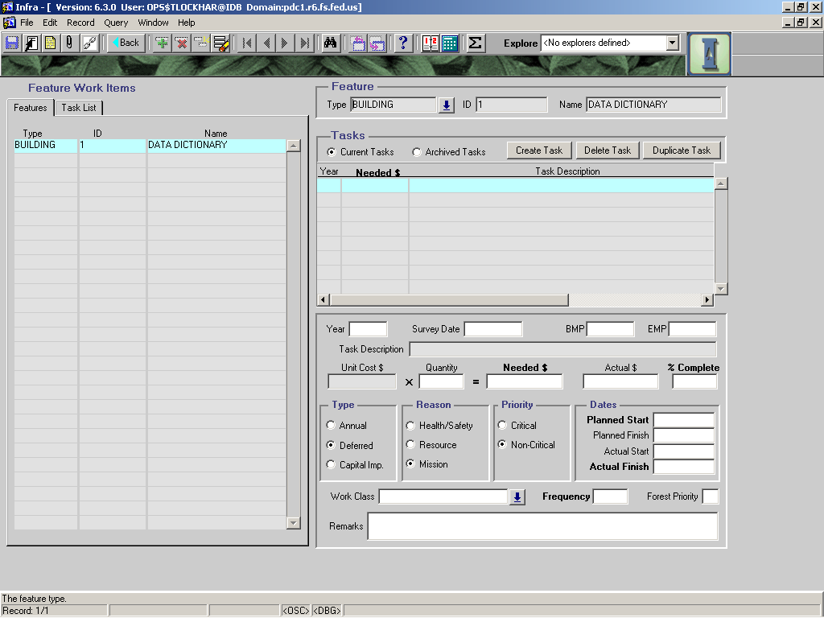

|  |  |  |  |  |  |  |  |  |
| --- | --- | --- | --- | --- | --- | --- | --- | --- |
|  |  | | | | | | **Used in Tables:** | |
| **Name:** | **FeatureS -- Type/ ID/ NAME** (top right section) | | | | | | ???? | |
|  |  | | | | | |  | |
| **Definition:** | . This field is auto-populated and displays information only. It cannot accept data or be edited. | | | | | | | |
|  |  | | | | | | | |
| **Reference:** |  | | | | | **Screen:** | | Work Item |
|  |  | | | | |  | |  |
| **Format:** |  | | | | | **Unit of Measure:** | |  |
|  |  | | | | |  | |  |
| **Data Type:** |  | **Size:** |  |  |  | **Mandatory:** | |  |
|  |  | | | | |  | |  |
|  |  | | | | | **Required:** | |  |
| **Look Up:** |  | | | | | | | |
|  |  | | | | | | | |
|  | | | | | | | | |
| **Business Rules:** |  | | | | | | | |
|  |  | | | | | | | |
| **Notes:** | This field is auto-populated and displays information only. It cannot accept data or be edited. | | | | | | | |

|  |  |  |  |  |  |  |  |  |
| --- | --- | --- | --- | --- | --- | --- | --- | --- |
|  |  | | | | | | **Used in Tables:** | |
| **Name:** | **TASKS -- Year** (middle right section) | | | | | | ?? | |
|  |  | | | | | |  | |
| **Definition:** | The fiscal year assigned to the task when it is entered into Infra. | | | | | | | |
|  |  | | | | | | | |
| **Reference:** |  | | | | | **Screen:** | | Work Item |
|  |  | | | | |  | |  |
| **Format:** | yyyy | | | | | **Unit of Measure:** | | ?? |
|  |  | | | | |  | |  |
| **Data Type:** | ??? | **Size:** | ??? |  |  | **Mandatory:** | | ?? |
|  |  | | | | |  | |  |
|  |  | | | | | **Required:** | |  |
| **Look Up:** |  | | | | | | | |
|  |  | | | | | | | |
|  | | | | | | | | |
| **Business Rules:** |  | | | | | | | |
|  |  | | | | | | | |
| **Notes:** |  | | | | | | | |
|  |  | | | | | | | |

|  |  |  |  |  |  |  |  |  |
| --- | --- | --- | --- | --- | --- | --- | --- | --- |
|  |  | | | | | | **Used in Tables:** | |
| **Name:** | **Needed $** | | | | | | II_TASKS | |
|  |  | | | | | |  | |
| **Definition:** | The amount of funds needed to complete the identified task. | | | | | | | |
|  |  | | | | | | | |
| **Reference:** |  | | | | | **Screen:** | | Work Item |
|  |  | | | | |  | |  |
| **Format:** |  | | | | | **Unit of Measure:** | | Dollars |
|  |  | | | | |  | |  |
| **Data Type:** | Number | **Size:** | 10 |  |  | **Mandatory:** | |  |
|  |  | | | | |  | |  |
|  |  | | | | | **Required:** | | Yes |
| **Look Up:** |  | | | | | | | |
|  |  | | | | | | | |
|  | | | | | | | | |
| **Business Rules:** | 1. The amount is based upon data entered by the user and must be supported by detailed notes (on paper or in a spreadsheet) or data in the Infra survey form. Development of cost estimates must be traceable so the estimate can survive audit scrutiny. | | | | | | | |
|  |  | | | | | | | |
| **Notes:** | Amount is based upon data entered by the user. Infra automatically populates this field by using that data. | | | | | | | |
|  |  | | | | | | | |

|  |  |  |  |  |  |  |  |  |
| --- | --- | --- | --- | --- | --- | --- | --- | --- |
|  |  | | | | | | **Used in Tables:** | |
| **Name:** | **Task Description** | | | | | | II_TASKS | |
|  |  | | | | | |  | |
| **Definition:** | A standard description of the identified task. | | | | | | | |
|  |  | | | | | | | |
| **Reference:** |  | | | | | **Screen:** | | Work Item |
|  |  | | | | |  | |  |
| **Format:** |  | | | | | **Unit of Measure:** | |  |
|  |  | | | | |  | |  |
| **Data Type:** | VARCHAR2 | **Size:** | 255 |  |  | **Mandatory:** | |  |
|  |  | | | | |  | |  |
|  |  | | | | | **Required:** | | Yes |
| **Look Up:** |  | | | | | | | |
|  |  | | | | | | | |
|  | | | | | | | | |
| **Business Rules:** |  | | | | | | | |
|  |  | | | | | | | |
| **Notes:** | 1. Auto-populated from task list on the left of the screen. Task must be selected from this list before the field is auto-populated. | | | | | | | |

|  |  |  |  |  |  |  |  |  |
| --- | --- | --- | --- | --- | --- | --- | --- | --- |
|  |  | | | | | | **Used in Tables:** | |
| **Name:** | **Year** (bottom right section) | | | | | | ?? | |
|  |  | | | | | |  | |
| **Definition:** | The year the task was entered into Infra. | | | | | | | |
|  |  | | | | | | | |
| **Reference:** |  | | | | | **Screen:** | | Work item |
|  |  | | | | |  | |  |
| **Format:** | yyyy | | | | | **Unit of Measure:** | |  |
|  |  | | | | |  | |  |
| **Data Type:** | ??? | **Size:** | ??? |  |  | **Mandatory:** | | ?? |
|  |  | | | | |  | |  |
|  |  | | | | | **Required:** | | Yes |
| **Look Up:** |  | | | | | | | |
|  |  | | | | | | | |
|  | | | | | | | | |
| **Business Rules:** |  | | | | | | | |
|  |  | | | | | | | |
| **Notes:** | Infra automatically populates the field from the last condition survey date on the survey screen. | | | | | | | |
|  |  | | | | | | | |

|  |  |  |  |  |  |  |  |  |
| --- | --- | --- | --- | --- | --- | --- | --- | --- |
|  |  | | | | | | **Used in Tables:** | |
| **Name:** | **Survey Date** | | | | | | ?? | |
|  |  | | | | | |  | |
| **Definition:** | The date the survey used to develop the annual and deferred maintenance estimates was performed. | | | | | | | |
|  |  | | | | | | | |
| **Reference:** |  | | | | | **Screen:** | | Work Item |
|  |  | | | | |  | |  |
| **Format:** | mm/dd/yyyy | | | | | **Unit of Measure:** | |  |
|  |  | | | | |  | |  |
| **Data Type:** | Date | **Size:** |  |  |  | **Mandatory:** | |  |
|  |  | | | | |  | |  |
|  |  | | | | | **Required:** | | Yes |
| **Look Up:** |  | | | | | | | |
|  |  | | | | | | | |
|  | | | | | | | | |
| **Business Rules:** |  | | | | | | | |
|  |  | | | | | | | |
| **Notes:** | 1. This field is auto-populated with the last condition survey date from the survey screen. | | | | | | | |
|  |  | | | | | | | |

|  |  |  |
| --- | --- | --- |
|  |  | **Used in Tables:** |
| **Name:** | **BMP** |  |
|  |  |  |
| **Definition:** | **Not Applicable to Buildings – Do Not Use This Field** | |
|  |  | |

|  |  |  |
| --- | --- | --- |
|  |  | **Used in Tables:** |
| **Name:** | **EMP** |  |
|  |  |  |
| **Definition:** | **Not Applicable to Buildings – Do Not Use This Field** | |
|  |  | |

|  |  |  |  |  |  |  |  |  |
| --- | --- | --- | --- | --- | --- | --- | --- | --- |
|  |  | | | | | | **Used in Tables:** | |
| **Name:** | **Unit Cost** | | | | | | II_TASK_UNIT_COST | |
|  |  | | | | | |  | |
| **Definition:** | The cost of the work item per unit. | | | | | | | |
|  |  | | | | | | | |
| **Reference:** |  | | | | | **Screen:** | | Work Items |
|  |  | | | | |  | |  |
| **Format:** |  | | | | | **Unit of Measure:** | | Dollars |
|  |  | | | | |  | |  |
| **Data Type:** | Number | **Size:** | 11 |  |  | **Mandatory:** | |  |
|  |  | | | | |  | |  |
|  |  | | | | | **Required:** | |  |
| **Look Up:** |  | | | | | | | |
|  |  | | | | | | | |
|  | | | | | | | | |
| **Business Rules:** |  | | | | | | | |
|  |  | | | | | | | |
| **Notes:** | This field displays unit cost information that has been loaded into Infra; it cannot accept data or be edited. Currently unit costs have not been loaded into Infra. However, RS Means costs will be loaded in the near future (late Fall of 2005). | | | | | | | |
|  |  | | | | | | | |

|  |  |  |  |  |  |  |  |  |
| --- | --- | --- | --- | --- | --- | --- | --- | --- |
|  |  | | | | | | **Used in Tables:** | |
| **Name:** | **QUANTITY** | | | | | | II_TASKS | |
|  |  | | | | | |  | |
| **Definition:** | The number of units being used in the estimate for the identified work item. | | | | | | | |
|  |  | | | | | | | |
| **Reference:** |  | | | | | **Screen:** | | Work Items |
|  |  | | | | |  | |  |
| **Format:** |  | | | | | **Unit of Measure:** | |  |
|  |  | | | | |  | |  |
| **Data Type:** | Number | **Size:** | 7 |  |  | **Mandatory:** | |  |
|  |  | | | | |  | |  |
|  |  | | | | | **Required:** | |  |
| **Look Up:** |  | | | | | | | |
|  |  | | | | | | | |
|  | | | | | | | | |
| **Business Rules:** |  | | | | | | | |
|  |  | | | | | | | |
| **Notes:** | 1. Quantity needs to be populated if the unit cost field is populated. | | | | | | | |
|  |  | | | | | | | |

|  |  |  |  |  |  |  |  |  |
| --- | --- | --- | --- | --- | --- | --- | --- | --- |
|  |  | | | | | | **Used in Tables:** | |
| **Name:** | **Needed $** | | | | | | II_TASK | |
|  |  | | | | | |  | |
| **Definition:** | The amount of money needed to eliminate the deferred maintenance under the task. | | | | | | | |
|  |  | | | | | | | |
| **Reference:** |  | | | | | **Screen:** | | Work Items |
|  |  | | | | |  | |  |
| **Format:** |  | | | | | **Unit of Measure:** | | Dollars |
|  |  | | | | |  | |  |
| **Data Type:** | Number | **Size:** | 10 |  |  | **Mandatory:** | |  |
|  |  | | | | |  | |  |
|  |  | | | | | **Required:** | | Yes |
| **Look Up:** |  | | | | | | | |
|  |  | | | | | | | |
|  | | | | | | | | |
| **Business Rules:** |  | | | | | | | |
|  |  | | | | | | | |
| **Notes:** | This field is automatically populated by Infra if Unit Cost field is populated. Alternatively, “Needed $” can be entered manually. | | | | | | | |

|  |  |  |  |  |  |  |  |  |
| --- | --- | --- | --- | --- | --- | --- | --- | --- |
|  |  | | | | | | **Used in Tables:** | |
| **Name:** | **ACTUAL $** | | | | | | II_TASK | |
|  |  | | | | | |  | |
| **Definition:** | The amount of money spent to date to eliminate the deferred maintenance identified under the task. | | | | | | | |
|  |  | | | | | | | |
| **Reference:** |  | | | | | **Screen:** | | Work Items |
|  |  | | | | |  | |  |
| **Format:** |  | | | | | **Unit of Measure:** | | Dollars |
|  |  | | | | |  | |  |
| **Data Type:** | Number | **Size:** | 10 |  |  | **Mandatory:** | |  |
|  |  | | | | |  | |  |
|  |  | | | | | **Required:** | | No |
| **Look Up:** |  | | | | | | | |
|  |  | | | | | | | |
|  | | | | | | | | |
| **Business Rules:** | 1. The actual dollars can be less than needed dollars. | | | | | | | |
|  |  | | | | | | | |
| **Notes:** | 1. The actual $ could be a small or large amount. If the actual $ eliminates/completes the task, the “% Complete” should be entered as 100%. | | | | | | | |

|  |  |  |  |  |  |  |  |  |  |
| --- | --- | --- | --- | --- | --- | --- | --- | --- | --- |
|  |  | | | | | | **Used in Tables:** | | |
| **Name:** | **% COMPLETE** | | | | | | II_TASKS | | |
|  |  | | | | | |  | | |
| **Definition:** | The percent of the work that has been completed with the actual $. | | | | | | | | |
|  |  | | | | | | | | |
| **Reference:** |  | | | | | **Screen:** | | Work Items | |
|  |  | | | | |  | | |  |
| **Format:** |  | | | | | **Unit of Measure:** | | |  |
|  |  | | | | |  | | |  |
| **Data Type:** | Number | **Size:** | 3 |  |  | **Mandatory:** | | | NO |
|  |  | | | | | **Required:** | | | YES |
| **Look Up:** |  | | | | | | | | |
|  |  | | | | | | | | |
|  | | | | | | | | | |
| **Business Rules:** | 1. A task that is 100% complete must have an actual finished date entered or the task will be rolled over at the end of the fiscal year into the next fiscal year. 2. Required if work has been done on this task. Do not populate if you haven’t spent money on the task or eliminated the task some other way. | | | | | | | | |
|  |  | | | | | | | | |
| **Notes:** |  | | | | | | | | |

|  |  |  |  |  |  |  |  |  |
| --- | --- | --- | --- | --- | --- | --- | --- | --- |
|  |  | | | | | | **Used in Tables:** | |
| **Name:** | **Type** | | | | | | II_TASK | |
|  |  | | | | | |  | |
| **Definition:** | The type of work being completed. It either is annual maintenance, deferred maintenance, or capital improvement. | | | | | | | |
|  |  | | | | | | | |
| **Reference:** |  | | | | | **Screen:** | | Work Items |
|  |  | | | | |  | |  |
| **Format:** |  | | | | | **Unit of Measure:** | |  |
|  |  | | | | |  | |  |
| **Data Type:** | VARCHAR2 | **Size:** | 20 |  |  | **Mandatory:** | |  |
|  |  | | | | | **Required:** | | Yes |
| **Look Up:** |  | | | | | | | |
|  |  | | | | | | | |
|  | | | | | | | | |
| **Business Rules:** |  | | | | | | | |
|  |  | | | | | | | |
| **Notes:** | **1. Annual Maintenance.** Work performed to maintain serviceability or repair failures during the year in which they occur. Includes preventive and/or cyclic maintenance performed in the year in which it is scheduled. Unscheduled or catastrophic failures of components or assets may need to be repaired as a part of annual maintenance. Annual maintenance may include repairs, preventative maintenance, and cyclic maintenance.  **2. Deferred Maintenance.** Maintenance that was not performed when it should have been or when it was scheduled. When allowed to accumulate without limits or consideration of useful life, deferred maintenance leads to deterioration of performance, increased costs to repair, and decrease in asset value. Deferred maintenance needs may be categorized as critical or noncritical at any point in time. Continued deferral of noncritical maintenance will normally result in an increase in critical deferred maintenance.  **3. Capital Improvement**. The construction, installation, or assembly of a new fixed asset, or the significant alteration, expansion, or extension of an existing fixed asset to accommodate a change of purpose. | | | | | | | |

|  |  |  |  |  |  |  |  |  |
| --- | --- | --- | --- | --- | --- | --- | --- | --- |
|  |  | | | | | | **Used in Tables:** | |
| **Name:** | **Reason** | | | | | | II_TASK | |
|  |  | | | | | |  | |
| **Definition:** | The reason that justified performing the work. | | | | | | | |
|  |  | | | | | | | |
| **Reference:** |  | | | | | **Screen:** | | Work Items |
|  |  | | | | |  | |  |
| **Format:** |  | | | | | **Unit of Measure:** | |  |
|  |  | | | | |  | |  |
| **Data Type:** | VARCHAR2 | **Size:** | 40 |  |  | **Mandatory:** | |  |
|  |  | | | | | **Required:** | | Yes |
| **Look Up:** |  | | | | | | | |
|  |  | | | | | | | |
|  | | | | | | | | |
| **Business Rules:** |  | | | | | | | |
|  |  | | | | | | | |
| **Notes:** | There are three justifications for performing work. They are:   1. Health and Safety: Addresses a threat to human health and safety that requires immediate interim abatement or long-term permanent abatement. 2. Resource Protection: Addresses a threat or risk of damage, obstruction, or negative impact to a natural or cultural resource. 3. Addresses a threat or risk to carry out the mission of the organization. Needs are related to administration and providing services (transportation, recreation, grazing, etc.) and are not covered by Health and Safety reasons or Resource protection. | | | | | | | |

|  |  |  |  |  |  |  |  |  |
| --- | --- | --- | --- | --- | --- | --- | --- | --- |
|  |  | | | | | | **Used in Tables:** | |
| **Name:** | **PRIORITY** | | | | | | II_TASK | |
|  |  | | | | | |  | |
| **Definition:** | The priority of the task to be completed. | | | | | | | |
|  |  | | | | | | | |
| **Reference:** |  | | | | | **Screen:** | | Work Items |
|  |  | | | | |  | |  |
| **Format:** |  | | | | | **Unit of Measure:** | |  |
|  |  | | | | |  | |  |
| **Data Type:** | VARCHAR2 | **Size:** | 40 |  |  | **Mandatory:** | |  |
|  |  | | | | | **Required:** | | Yes |
| **Look Up:** |  | | | | | | | |
|  |  | | | | | | | |
|  | | | | | | | | |
| **Business Rules:** |  | | | | | | | |
|  |  | | | | | | | |
| **Notes:** | The list of values consists of critical and non-critical.  1 Critical: A requirement that addresses a serious threat to public health or safety, a natural resource, or the ability of the organization carry out its mission. (Financial Health – Common Definitions for Maintenance and Construction Terms, July 22, 1998).  2. Non-critical: A requirement that addresses potential risk to public or employee safety or health, compliance with codes, standards, regulations etc., or needs that address potential adverse consequences to natural resources or mission accomplishment. (Financial Health – Common Definitions for Maintenance and Construction Terms, July 22, 1998). | | | | | | | |

|  |  |  |  |  |  |  |  |  |
| --- | --- | --- | --- | --- | --- | --- | --- | --- |
|  |  | | | | | | **Used in Tables:** | |
| **Name:** | **Planned Start** | | | | | | II_TASK | |
|  |  | | | | | |  | |
| **Definition:** | The date that work on the task is scheduled to start. | | | | | | | |
|  |  | | | | | | | |
| **Reference:** |  | | | | | **Screens:** | | Work Items |
|  |  | | | | |  | |  |
| **Format:** | mm/dd/yyyy | | | | | **Unit of Measure:** | |  |
|  |  | | | | |  | |  |
| **Data Type:** | Date | **Size:** |  |  |  | **Mandatory:** | |  |
|  |  | | | | | **Required:** | |  |
| **Look Up:** |  | | | | | | | |
|  |  | | | | | | | |
|  | | | | | | | | |
| **Business Rules:** |  | | | | | | | |
|  |  | | | | | | | |
| **Notes:** |  | | | | | | | |
|  |  | | | | | | | |

|  |  |  |  |  |  |  |  |  |
| --- | --- | --- | --- | --- | --- | --- | --- | --- |
|  |  | | | | | | **Used in Tables:** | |
| **Name:** | **Planned Finish** | | | | | | II_TASK | |
|  |  | | | | | |  | |
| **Definition:** | The date the work under the task is scheduled for completion. | | | | | | | |
|  |  | | | | | | | |
| **Reference:** |  | | | | | **Screen:** | | Work Items |
|  |  | | | | |  | |  |
| **Format:** | mm/dd/yyyy | | | | | **Unit of Measure:** | |  |
|  |  | | | | |  | |  |
| **Data Type:** | Date | **Size:** |  |  |  | **Mandatory:** | |  |
|  |  | | | | |  | |  |
|  |  | | | | | **Required:** | |  |
| **Look Up:** |  | | | | | | | |
|  |  | | | | | | | |
|  | | | | | | | | |
| **Business Rules:** |  | | | | | | | |
|  |  | | | | | | | |
| **Notes:** |  | | | | | | | |
|  |  | | | | | | | |

|  |  |  |  |  |  |  |  |  |
| --- | --- | --- | --- | --- | --- | --- | --- | --- |
|  |  | | | | | | **Used in Tables:** | |
| **Name:** | **ACTUAL START** | | | | | | II_TASK | |
|  |  | | | | | |  | |
| **Definition:** | The date the work under the task actually began. | | | | | | | |
|  |  | | | | | | | |
| **Reference:** |  | | | | | **Screen:** | | Work items |
|  |  | | | | |  | |  |
| **Format:** | mm/dd/yyyy | | | | | **Unit of Measure:** | |  |
|  |  | | | | |  | |  |
| **Data Type:** | Date | **Size:** | ??? |  |  | **Mandatory:** | |  |
|  |  | | | | |  | |  |
|  |  | | | | | **Required:** | |  |
| **Look Up:** |  | | | | | | | |
|  |  | | | | | | | |
|  | | | | | | | | |
| **Business Rules:** |  | | | | | | | |
|  |  | | | | | | | |
| **Notes:** |  | | | | | | | |
|  |  | | | | | | | |

|  |  |  |  |  |  |  |  |  |
| --- | --- | --- | --- | --- | --- | --- | --- | --- |
|  |  | | | | | | **Used in Tables:** | |
| **Name:** | **ACTUAL FINISH** | | | | | |  | |
|  |  | | | | | |  | |
| **Definition:** | The date the work under the task is actually completed. | | | | | | | |
|  |  | | | | | | | |
| **Reference:** |  | | | | | **Screen:** | | Work Items |
|  |  | | | | |  | |  |
| **Format:** | mm/dd/yyyy | | | | | **Unit of Measure:** | |  |
|  |  | | | | |  | |  |
| **Data Type:** | Date | **Size:** |  |  |  | **Mandatory:** | |  |
|  |  | | | | |  | |  |
|  |  | | | | | **Required:** | | Yes |
| **Look Up:** |  | | | | | | | |
|  |  | | | | | | | |
|  | | | | | | | | |
| **Business Rules:** | 1. This field must be populated when 100% of the task is completed. Only enter the date after the work is complete. | | | | | | | |
|  |  | | | | | | | |
| **Notes:** |  | | | | | | | |
|  |  | | | | | | | |

|  |  |  |  |  |  |  |  |  |  |
| --- | --- | --- | --- | --- | --- | --- | --- | --- | --- |
|  |  | | | | | | | **Used in Tables:** | |
| **Name:** | **Work Class** | | | | | | | II_TASKS | |
|  |  | | | | | | |  | |
| **Definition:** | The category that the work being performed falls under. See list of values under business rules. | | | | | | | | |
|  |  | | | | | | | | |
| **Reference:** |  | | | | | | **Screen:** | | Work Items |
|  |  | | | | | |  | |  |
| **Format:** | Consult LOV | | | | | | **Unit of Measure:** | |  |
|  |  | | | | | |  | |  |
| **Data Type:** | VARCHAR2 | **Size:** | 40 | |  |  | **Mandatory:** | |  |
|  |  | | | | | |  | |  |
|  |  | | | | | | **Required:** | |  |
| **Look Up:** |  | | | | | | | | |
|  |  | | | | | | | | |
| **Business Rules:** |  | | | | | | | | |
|  |  | | | | | | | | |
| **Notes:** |  | | | | | | | | |
|  |  | | | | | | | | |
| **Valid Codes** | | | | | | | | | |
| **Code** | | | | **Description** | | | | | |
| AC | | | | Accessibility | | | | | |
| CO | | | | Change of Occupancy | | | | | |
| EN | | | | Energy Conservation | | | | | |
| GM | | | | General Maintenance | | | | | |
| GE | | | | Gender Separate/Equal | | | | | |
| HA | | | | Hazardous/Toxic Substances | | | | | |
| CR | | | | Code Regulations | | | | | |
| HI | | | | Historic Preservation | | | | | |
| LI | | | | Life Safety | | | | | |
| NL | | | | New Location | | | | | |
| SE | | | | Security | | | | | |
| SI | | | | Seismic | | | | | |

|  |  |  |  |  |  |  |  |  |
| --- | --- | --- | --- | --- | --- | --- | --- | --- |
|  |  | | | | | | **Used in Tables:** | |
| **Name:** | **Frequency** | | | | | | II_TASK | |
|  |  | | | | | |  | |
| **Definition:** | The frequency at which annual maintenance tasks should be performed. | | | | | | | |
|  |  | | | | | | | |
| **Reference:** |  | | | | | **Screen:** | | Work Items |
|  |  | | | | |  | |  |
| **Format:** |  | | | | | **Unit of Measure:** | | Years |
|  |  | | | | |  | |  |
| **Data Type:** | Number | **Size:** | 7 |  |  | **Mandatory:** | |  |
|  |  | | | | |  | |  |
|  |  | | | | | **Required:** | |  |
| **Look Up:** |  | | | | | | | |
|  |  | | | | | | | |
|  | | | | | | | | |
| **Business Rules:** | 1. Enter the frequency in terms of years. Twice a year would be 0.5, every 5 years would be 5. | | | | | | | |
|  |  | | | | | | | |
| **Notes:** |  | | | | | | | |
|  |  | | | | | | | |

|  |  |  |  |  |  |  |  |  |  |
| --- | --- | --- | --- | --- | --- | --- | --- | --- | --- |
|  |  | | | | | | | **Used in Tables:** | |
| **Name:** | **Forest Priority** | | | | | | | II_TASK | |
|  |  | | | | | | |  | |
| **Definition:** | The priority the field unit assigns to completing the work. | | | | | | | | |
|  |  | | | | | | | | |
| **Reference:** |  | | | | | | **Screen:** | | Work Items |
|  |  | | | | | |  | |  |
| **Format:** |  | | | | | | **Unit of Measure:** | |  |
|  |  | | | | | |  | |  |
| **Data Type:** | VARCHAR2 | **Size:** | 1 | |  |  | **Mandatory:** | |  |
|  |  | | | | | |  | |  |
|  |  | | | | | | **Required:** | |  |
| **Look Up:** |  | | | | | | | | |
|  |  | | | | | | | | |
|  | | | | | | | | | |
| **Business Rules:** |  | | | | | | | | |
|  |  | | | | | | | | |
| **Notes:** | Use the following selections from the list of values:  1 -- Immediate life safety  2 -- Poses a health/safety issue but over time  3 -- Structural failure imminent  4 -- Codes/regulation violation  5 -- Critical maintenance -- if not fixed soon, could jeopardize the building  6 -- Energy Efficiency  7 -- General Maintenance  8 – Provides benefit, but not necessary | | | | | | | | |
|  |  | | | | | | | | |
| **Valid Codes** | | | | | | | | | |
| **Code** | | | | **Description** | | | | |  |
| 1 | | | | Immediate life safety | | | | |  |
| 2 | | | | Poses a health/safety issue but over time | | | | |  |
| 3 | | | | Structural failure imminent | | | | |  |
| 4 | | | | Codes/regulation violation | | | | |  |
| 5 | | | | Critical maintenance -- if not fixed soon, could jeopardize the building | | | | |  |
| 6 | | | | Energy Efficiency | | | | |  |
| 7 | | | | General Maintenance | | | | |  |
| 8 | | | | Provides benefit, but not necessary | | | | |  |

# COMPONENTS BUTTON

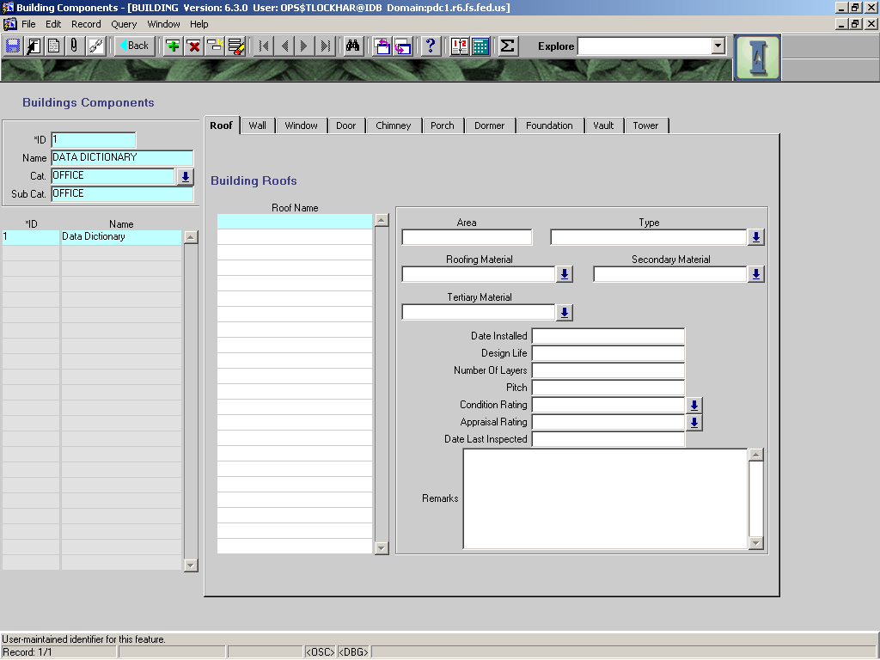

**COMPONENT – ROOF**

|  |  |  |  |  |  |  |  |  |  |
| --- | --- | --- | --- | --- | --- | --- | --- | --- | --- |
|  | | | |  | | | |  | |
|  |  | | | | | | **Used in Tables:** | | |
| **Name:** | **ROOF_NAME** | | | | | |  | | |
|  |  | | | | | |  | | |
| **Definition:** | **The name or identifier for a specific roof area according to roof type.** | | | | | | | | |
|  |  | | | | | | | | |
| **Reference:** |  | | | | | | **Screen:** | | Roof |
|  |  | | | | | |  | |  |
| **Format:** |  | | | | | | **Unit of Measure:** | |  |
|  |  | | | | | |  | |  |
| **Data Type:** |  | **Size:** |  | |  |  | **Mandatory:** | | No |
|  |  |  |  | |  |  |  | |  |
|  |  | | | | | | **Required:** | | No |
| **Look Up:** |  | | | | | | | | |
|  |  | | | | | | | | |
| **Business Rules:** | 1. **Roofs shall be split out according to roof type.** | | | | | | | | |
|  |  | | | | | | | | |
| **Notes:** |  | | | | | | | | |
|  |  | | | | | | | | |
|  |  | | | | | | | | |
| **Valid Codes** | | | | | | | | | |
| **Code** | | | | **Description** | | | |  | |
|  | | | |  | | | |  | |

|  |  |  |  |  |  |  |  |
| --- | --- | --- | --- | --- | --- | --- | --- |
|  |  | | | | | **Used in Tables:** | |
| **Name:** | **AREA** | | | | |  | |
|  |  | | | | |  | |
| **Definition:** | **The area of the selected roof.** | | | | | | |
|  |  | | | | | | |
| **Reference:** |  | | | | | **Screen:** | Roof |
|  |  | | | | |  |  |
| **Format:** |  | | | | | **Unit of Measure:** | Sq. Ft. |
|  |  | | | | |  |  |
| **Data Type:** |  | **Size:** |  |  |  | **Mandatory:** | NO |
|  |  | | | | |  |  |
|  |  | | | | | **Required:** | No |
| **Look Up:** |  | | | | | | |
|  |  | | | | | | |
| **Business Rules:** | 1. **Square footage is measured in square feet, not in roof squares.** | | | | | | |
|  |  | | | | | | |
| **Notes:** |  | | | | | | |

|  |  |  |  |  |  |  |  |  |  |
| --- | --- | --- | --- | --- | --- | --- | --- | --- | --- |
|  |  | | | | | | **Used in Tables:** | | |
| **Name:** | **ROOF TYPE** | | | | | |  | | |
|  |  | | | | | |  | | |
| **Definition:** | The type of roof or roof profile | | | | | | | | |
|  |  | | | | | | | | |
| **Reference:** |  | | | | | | **Screen:** | | Roof |
|  |  | | | | | |  | |  |
| **Format:** |  | | | | | | **Unit of Measure:** | |  |
|  |  | | | | | |  | |  |
| **Data Type:** |  | **Size:** |  | |  |  | **Mandatory:** | | NO |
|  |  | | | | | |  | |  |
|  |  | | | | | | **Required:** | | No |
| **Look Up:** | LOV | | | | | | | | |
|  |  | | | | | | | | |
| **Business Rules:** | 1. | | | | | | | | |
|  |  | | | | | | | | |
| **Notes:** |  | | | | | | | | |
|  |  | | | | | | | | |
| **Valid Codes** | | | | | | | | | |
| **Code** | | | | **Description** | | | |  | |
| COMPLEX | | | | **Roof with combination of roof types** | | | |  | |
| CROSS-GABLED | | | | **Roof with gables in cross directions** | | | |  | |
| FLAT | | | | **Flat roof style** | | | |  | |
| GABLED-FRONT | | | | **Roof with gable over front of building** | | | |  | |
| GABLES-SIDE | | | | **Roof with gables over side of building** | | | |  | |
| GAMBREL | | | | **Roof with gambrels** | | | |  | |
| HIPPED | | | | **Hipped roof** | | | |  | |
| MANSARD | | | | **Mansard roof** | | | |  | |
| NO INFO | | | | **No information on roof type** | | | |  | |
| OTHER | | | | **Roof type not otherwise listed** | | | |  | |
| SHED | | | | **Shed roof** | | | |  | |
| UNKNOWN | | | | **Roof type is unknown but could be determined with research** | | | |  | |

|  |  |  |  |  |  |  |  |  |  |
| --- | --- | --- | --- | --- | --- | --- | --- | --- | --- |
|  |  | | | | | | **Used in Tables:** | | |
| **Name:** | **ROOFING_MATERIAL** | | | | | |  | | |
|  |  | | | | | |  | | |
| **Definition:** | **The material of the outermost layer of roofing.** | | | | | | | | |
|  |  | | | | | | | | |
| **Reference:** |  | | | | | | **Screen:** | | Roof |
|  |  | | | | | |  | |  |
| **Format:** |  | | | | | | **Unit of Measure:** | |  |
|  |  | | | | | |  | |  |
| **Data Type:** |  | **Size:** |  | |  |  | **Mandatory:** | | No |
|  |  | | | | | |  | |  |
|  |  | | | | | | **Required:** | | No |
| **Look Up:** |  | | | | | | | | |
|  |  | | | | | | | | |
| **Business Rules:** | 1. **Roofing materials shall be described beginning with the outermost layer.** | | | | | | | | |
|  |  | | | | | | | | |
| **Notes:** |  | | | | | | | | |
|  |  | | | | | | | | |
|  |  | | | | | | | | |
| **Valid Codes** | | | | | | | | | |
| **Code** | | | | **Description** | | | |  | |
| ASPHALT SHGL | | | | Asphalt (Composition) Shingles | | | |  | |
| ASPHALT&GRAL | | | | Asphalt and Gravel | | | |  | |
| **CONCRETE SLAB** | | | | **Concrete slab** | | | |  | |
| **CONCRETE SHGL** | | | | **Concrete shingles/shakes** | | | |  | |
| **CONCRETE TILES** | | | | **Concrete tiles** | | | |  | |
| **ELASTOMERIC** | | | | **Single-ply elastomeric membrane** | | | |  | |
| FBRGLSS SHGL | | | | Fiberglass shingles | | | |  | |
| FIBERGLASS | | | | Fiberglass | | | |  | |
| FOAM | | | | Foam | | | |  | |
| MEMBRANE-BLS | | | | Membrane - ??? | | | |  | |
| MEMBRANE-FST | | | | Membrane - ??? | | | |  | |
| METAL SHEET | | | | Metal | | | |  | |
| METAL SHNGLS | | | | Metal shingles | | | |  | |
| **METAL STNDG SM** | | | | **Standing Seam metal roof** | | | |  | |
| **METAL TILES** | | | | **Metal Tiles** | | | |  | |
| OTHER | | | | Any material other than those listed | | | |  | |
| ROLLED | | | | Rolled roofing | | | |  | |
| SLATE | | | | Slate | | | |  | |
| **SOD** | | | | **Sod roof** | | | |  | |
| TILES | | | | Tiles **(Clay or composition)** | | | |  | |
| WOOD SHAKES | | | | Wood Shakes | | | |  | |
| WOOD SHNGLS | | | | Wood Shingles | | | |  | |

|  |  |  |  |  |  |  |  |  |  |
| --- | --- | --- | --- | --- | --- | --- | --- | --- | --- |
|  |  | | | | | | **Used in Tables:** | | |
| **Name:** | **SECONDARY_MATERIAL ROOFING** | | | | | |  | | |
|  |  | | | | | |  | | |
| **Definition:** | **Any roofing material used beneath the primary (outermost) material.** | | | | | | | | |
|  |  | | | | | | | | |
| **Reference:** |  | | | | | | **Screen:** | | Roof |
|  |  | | | | | |  | |  |
| **Format:** |  | | | | | | **Unit of Measure:** | |  |
|  |  | | | | | |  | |  |
| **Data Type:** |  | **Size:** |  | |  |  | **Mandatory:** | | NO |
|  |  | | | | | |  | |  |
|  |  | | | | | | **Required:** | | No |
| **Look Up:** | LOV | | | | | | | | |
|  |  | | | | | | | | |
| **Business Rules:** | 1. | | | | | | | | |
|  |  | | | | | | | | |
| **Notes:** |  | | | | | | | | |
|  |  | | | | | | | | |
|  |  | | | | | | | | |
| **Valid Codes** | | | | | | | | | |
| **Code** | | | | **Description** | | | |  | |
| ASPHALT SHGL | | | | Asphalt (Composition) Shingles | | | |  | |
| ASPHALT&GRAL | | | | Asphalt and Gravel | | | |  | |
| **CONCRETE SLAB** | | | | **Concrete slab** | | | |  | |
| **CONCRETE SHGL** | | | | **Concrete shingles/shakes** | | | |  | |
| **CONCRETE TILES** | | | | **Concrete tiles** | | | |  | |
| **ELASTOMERIC** | | | | **Single-ply elastomeric membrane** | | | |  | |
| FBRGLSS SHGL | | | | Fiberglass shingles | | | |  | |
| FIBERGLASS | | | | Fiberglass | | | |  | |
| FOAM | | | | Foam | | | |  | |
| MEMBRANE-BLS | | | | Membrane - ??? | | | |  | |
| MEMBRANE-FST | | | | Membrane - ??? | | | |  | |
| METAL SHEET | | | | Metal | | | |  | |
| METAL SHNGLS | | | | Metal shingles | | | |  | |
| **METAL STNDG SM** | | | | **Standing Seam metal roof** | | | |  | |
| **METAL TILES** | | | | **Metal Tiles** | | | |  | |
| OTHER | | | | Any material other than those listed | | | |  | |
| ROLLED | | | | Rolled roofing | | | |  | |
| SLATE | | | | Slate | | | |  | |
| SOD | | | | Sod roofing | | | |  | |
| TILES | | | | Tiles (Clay or composition) | | | |  | |
| WOOD SHAKES | | | | Wood Shakes | | | |  | |
| WOOD SHNGLS | | | | Wood Shingles | | | |  | |
|  | | | |  | | | |  | |

|  |  |  |  |  |  |  |  |  |  |
| --- | --- | --- | --- | --- | --- | --- | --- | --- | --- |
|  |  | | | | | | **Used in Tables:** | | |
| **Name:** | **TERTIARY_MATERIAL Roofing** | | | | | |  | | |
|  |  | | | | | |  | | |
| **Definition:** | **Any roofing material used below the secondary material.** | | | | | | | | |
|  |  | | | | | | | | |
| **Reference:** |  | | | | | | **Screen:** | | Roof |
|  |  | | | | | |  | |  |
| **Format:** |  | | | | | | **Unit of Measure:** | |  |
|  |  | | | | | |  | |  |
| **Data Type:** |  | **Size:** |  | |  |  | **Mandatory:** | | NO |
|  |  | | | | | |  | |  |
|  |  | | | | | | **Required:** | | No |
| **Look Up:** | LOV | | | | | | | | |
|  |  | | | | | | | | |
| **Business Rules:** | 1. | | | | | | | | |
|  |  | | | | | | | | |
| **Notes:** |  | | | | | | | | |
|  |  | | | | | | | | |
| **Valid Codes** | | | | | | | | | |
| **Code** | | | | **Description** | | | |  | |
| ASPHALT SHGL | | | | Asphalt (Composition) Shingles | | | |  | |
| ASPHALT&GRAL | | | | Asphalt and Gravel | | | |  | |
| **CONCRETE SLAB** | | | | **Concrete slab** | | | |  | |
| **CONCRETE SHGL** | | | | **Concrete shingles/shakes** | | | |  | |
| **CONCRETE TILES** | | | | **Concrete tiles** | | | |  | |
| **ELASTOMERIC** | | | | **Single-ply elastomeric membrane** | | | |  | |
| FBRGLSS SHGL | | | | Fiberglass shingles | | | |  | |
| FIBERGLASS | | | | Fiberglass | | | |  | |
| FOAM | | | | Foam | | | |  | |
| MEMBRANE-BLS | | | | Membrane - ??? | | | |  | |
| MEMBRANE-FST | | | | Membrane - ??? | | | |  | |
| METAL SHEET | | | | Metal | | | |  | |
| METAL SHNGLS | | | | Metal shingles | | | |  | |
| **METAL STNDG SM** | | | | **Standing Seam metal roof** | | | |  | |
| **METAL TILES** | | | | **Metal Tiles** | | | |  | |
| OTHER | | | | Any material other than those listed | | | |  | |
| ROLLED | | | | Rolled roofing | | | |  | |
| SLATE | | | | Slate | | | |  | |
| **SOD** | | | | **Sod Roofing** | | | |  | |
| TILES | | | | Tiles (Clay or composition) | | | |  | |
| WOOD SHAKES | | | | Wood Shakes | | | |  | |
| WOOD SHNGLS | | | | Wood Shingles | | | |  | |

|  |  |  |  |  |  |  |  |
| --- | --- | --- | --- | --- | --- | --- | --- |
|  |  | | | | | **Used in Tables:** | |
| **Name:** | **DATE INSTALLED** | | | | |  | |
|  |  | | | | |  | |
| **Definition:** | Date main roofing material was installed. | | | | | | |
|  |  | | | | | | |
| **Reference:** |  | | | | | **Screen:** | Roof |
|  |  | | | | |  |  |
| **Format:** | Mm/dd/yyyy | | | | | **Unit of Measure:** |  |
|  |  | | | | |  |  |
| **Data Type:** | Date | **Size:** |  |  |  | **Mandatory:** | NO |
|  |  | | | | |  |  |
|  |  | | | | | **Required:** | No |
| **Look Up:** |  | | | | | | |
|  |  | | | | | | |
| **Business Rules:** | 1. | | | | | | |
|  |  | | | | | | |
| **Notes:** |  | | | | | | |

|  |  |  |  |  |  |  |  |  |  |
| --- | --- | --- | --- | --- | --- | --- | --- | --- | --- |
|  |  | | | | | | **Used in Tables:** | | |
| **Name:** | **Design Life** | | | | | |  | | |
|  |  | | | | | |  | | |
| **Definition:** | The estimated life span of the selected roof. | | | | | | | | |
|  |  | | | | | | | | |
| **Reference:** |  | | | | | | **Screen:** | | Roof |
|  |  | | | | | |  | |  |
| **Format:** | 0000 | | | | | | **Unit of Measure:** | | Years |
|  |  | | | | | |  | |  |
| **Data Type:** | Num | **Size:** |  | |  |  | **Mandatory:** | | NO |
|  |  | | | | | |  | |  |
|  |  | | | | | | **Required:** | | No |
| **Look Up:** |  | | | | | | | | |
|  |  | | | | | | | | |
| **Business Rules:** | 1. **The life span should be estimated based on local conditions and other factors that could affect the life span suggested by the manufacturer.**   **----OR----**   1. **The life span should be that suggested by the manufacturer of the roofing material.** | | | | | | | | |
|  |  | | | | | | | | |
| **Notes:** | **Example: 15, 20, 50** | | | | | | | | |
|  |  | | | | | | | | |
| **Valid Codes** | | | | | | | | | |
| **Code** | | | | **Description** | | | |  | |
|  | | | |  | | | |  | |

|  |  |  |  |  |  |  |  |
| --- | --- | --- | --- | --- | --- | --- | --- |
|  |  | | | | | **Used in Tables:** | |
| **Name:** | **NUMBER OF LAYERS** | | | | |  | |
|  |  | | | | |  | |
| **Definition:** | The number of layers the roof selected has. | | | | | | |
|  |  | | | | | | |
| **Reference:** |  | | | | | **Screen:** | Roof |
|  |  | | | | |  |  |
| **Format:** |  | | | | | **Unit of Measure:** |  |
|  |  | | | | |  |  |
| **Data Type:** |  | **Size:** |  |  |  | **Mandatory:** | NO |
|  |  |  |  |  |  |  |  |
|  |  | | | | | **Required:** | No |
| **Look Up:** |  | | | | | | |
|  |  | | | | | | |
| **Business Rules:** | 1. | | | | | | |
|  |  | | | | | | |
| **Notes:** |  | | | | | | |

|  |  |  |  |  |  |  |  |
| --- | --- | --- | --- | --- | --- | --- | --- |
|  |  | | | | | **Used in Tables:** | |
| **Name:** | **Pitch** | | | | |  | |
|  |  | | | | |  | |
| **Definition:** | The slope of the selected roof. | | | | | | |
|  |  | | | | | | |
| **Reference:** |  | | | | | **Screen:** | Roof |
|  |  | | | | |  |  |
| **Format:** | **Rise:run** | | | | | **Unit of Measure:** |  |
|  |  | | | | |  |  |
| **Data Type:** |  | **Size:** |  |  |  | **Mandatory:** | NO |
|  |  | | | | |  |  |
|  |  | | | | | **Required:** | No |
| **Look Up:** |  | | | | | | |
|  |  | | | | | | |
| **Business Rules:** | 1. | | | | | | |
|  |  | | | | | | |
| **Notes:** |  | | | | | | |
|  |  | | | | | | |

|  |  |  |  |  |  |  |  |  |  |
| --- | --- | --- | --- | --- | --- | --- | --- | --- | --- |
|  |  | | | | | | **Used in Tables:** | | |
| **Name:** | **Condition Rating** | | | | | |  | | |
|  |  | | | | | |  | | |
| **Definition:** | The condition code for the selected component. | | | | | | | | |
|  |  | | | | | | | | |
| **Reference:** |  | | | | | | **Screens:** | | Wall  Chimney  Door  Dormer  Porch  Roof  Window  Foundation  Equipment  Vault |
|  |  | | | | | |  | |  |
| **Format:** |  | | | | | | **Unit of Measure:** | |  |
|  |  | | | | | |  | |  |
| **Data Type:** |  | **Size:** |  | |  |  | **Mandatory:** | | NO |
|  |  | | | | | |  | |  |
|  |  | | | | | | **Required:** | | No |
| **Look Up:** | LOV | | | | | | | | |
|  |  | | | | | | | | |
| **Business Rules:** |  | | | | | | | | |
|  |  | | | | | | | | |
| **Notes:** |  | | | | | | | | |
|  |  | | | | | | | | |
|  |  | | | | | | | | |
| **Valid Codes** | | | | | | | | | |
| **Code** | | | | **Description** | | | |  | |
| CRITICAL | | | | Critical, failed or failure is imminent | | | |  | |
| GOOD | | | | Good, like new condition; no repairs needed | | | |  | |
| POOR | | | | Poor; repairs/maintenance needed to protect investment | | | |  | |
| SATISFACTORY | | | | Satisfactory; very little if any repairs needed | | | |  | |
| TO BE REMOVED | | | | To be removed | | | |  | |

|  |  |  |  |  |  |  |  |  |  |
| --- | --- | --- | --- | --- | --- | --- | --- | --- | --- |
|  |  | | | | | | **Used in Tables:** | | |
| **Name:** | **Appraisal Rating** | | | | | |  | | |
|  |  | | | | | |  | | |
| **Definition:** | The appraisal rating code for the selected component. | | | | | | | | |
|  |  | | | | | | | | |
| **Reference:** |  | | | | | | **Screen:** | |  |
|  |  | | | | | |  | |  |
| **Format:** |  | | | | | | **Unit of Measure:** | |  |
|  |  | | | | | |  | |  |
| **Data Type:** |  | **Size:** |  | |  |  | **Mandatory:** | | NO |
|  |  | | | | | |  | |  |
|  |  | | | | | | **Required:** | | No |
| **Look Up:** | LOV | | | | | | | | |
|  |  | | | | | | | | |
| **Business Rules:** | 1. | | | | | | | | |
|  |  | | | | | | | | |
| **Notes:** |  | | | | | | | | |
|  |  | | | | | | | | |
|  |  | | | | | | | | |
| **Valid Codes** | | | | | | | | | |
| **Code** | | | | **Description** | | | |  | |
| MAINTAIN | | | | Maintain as is, no major work planned | | | |  | |
| REMOVE | | | | Remove or eliminate | | | |  | |
| REPAIR | | | | Repair facility | | | |  | |
| REPLACE | | | | Replace with another unit | | | |  | |
| RETROFIT | | | | Retrofit – **accessibility retrofit, modify facility/component to enable individuals with disabilities to participate in programs or activities** | | | |  | |
| **RELOCATE** | | | | **Relocate facility to more effective location.** | | | |  | |
|  | | | |  | | | |  | |

|  |  |  |  |  |  |  |  |
| --- | --- | --- | --- | --- | --- | --- | --- |
|  |  | | | | | **Used in Tables:** | |
| **Name:** | **DATE LAST INSPECTED** | | | | |  | |
|  |  | | | | |  | |
| **Definition:** | Date roof selected was last inspected | | | | | | |
|  |  | | | | | | |
| **Reference:** |  | | | | | **Screen:** | Roof |
|  |  | | | | |  |  |
| **Format:** | Mm/dd/yyyy | | | | | **Unit of Measure:** |  |
|  |  | | | | |  |  |
| **Data Type:** |  | **Size:** |  |  |  | **Mandatory:** | NO |
|  |  | | | | |  |  |
|  |  | | | | | **Required:** | No |
| **Look Up:** |  | | | | | | |
|  |  | | | | | | |
| **Business Rules:** | 1. | | | | | | |
|  |  | | | | | | |
| **Notes:** | **Isn’t this redundant with the condition survey inspection date?** | | | | | | |

|  |  |  |  |  |  |  |  |
| --- | --- | --- | --- | --- | --- | --- | --- |
|  |  | | | | | **Used in Tables:** | |
| **Name:** | **REMARKS ROOF** | | | | |  | |
|  |  | | | | |  | |
| **Definition:** | Any additional remarks or comments about selected roof | | | | | | |
|  |  | | | | | | |
| **Reference:** |  | | | | | **Screen:** | Roof |
|  |  | | | | |  |  |
| **Format:** |  | | | | | **Unit of Measure:** |  |
|  |  | | | | |  |  |
| **Data Type:** |  | **Size:** |  |  |  | **Mandatory:** | NO |
|  |  |  |  |  |  |  |  |
|  |  | | | | | **Required:** | No |
| **Look Up:** |  | | | | | | |
|  |  | | | | | | |
| **Business Rules:** | 1. | | | | | | |
|  |  | | | | | | |
| **Notes:** |  | | | | | | |
|  |  | | | | | | |

**COMPONENT – WALL**

|  |  |  |  |  |  |  |  |
| --- | --- | --- | --- | --- | --- | --- | --- |
|  |  | | | | | **Used in Tables:** | |
| **Name:** | **WALL NAME** | | | | |  | |
|  |  | | | | |  | |
| **Definition:** | Name or identifier for wall**.** | | | | | | |
|  |  | | | | | | |
| **Reference:** |  | | | | | **Screen:** | Wall |
|  |  | | | | |  |  |
| **Format:** |  | | | | | **Unit of Measure:** |  |
|  |  | | | | |  |  |
| **Data Type:** |  | **Size:** |  |  |  | **Mandatory:** | NO |
|  |  | | | | |  |  |
|  |  | | | | | **Required:** | No |
| **Look Up:** |  | | | | | | |
|  |  | | | | | | |
| **Business Rules:** |  | | | | | | |
|  |  | | | | | | |
| **Notes:** |  | | | | | | |

|  |  |  |  |  |  |  |  |  |  |
| --- | --- | --- | --- | --- | --- | --- | --- | --- | --- |
|  |  | | | | | | **Used in Tables:** | | |
| **Name:** | **Wall Material** | | | | | |  | | |
|  |  | | | | | |  | | |
| **Definition:** | The material used to construct the wall. | | | | | | | | |
|  |  | | | | | | | | |
| **Reference:** |  | | | | | | **Screen:** | | Wall |
|  |  | | | | | |  | |  |
| **Format:** |  | | | | | | **Unit of Measure:** | |  |
|  |  | | | | | |  | |  |
| **Data Type:** |  | **Size:** |  | |  |  | **Mandatory:** | | NO |
|  |  |  |  | |  |  |  | |  |
|  |  | | | | | | **Required:** | | No |
| **Look Up:** | LOV | | | | | | | | |
|  |  | | | | | | | | |
| **Business Rules:** | **1. Split wall id’s by wall surface and material types.** | | | | | | | | |
|  |  | | | | | | | | |
| **Notes:** |  | | | | | | | | |
|  |  | | | | | | | | |
|  |  | | | | | | | | |
| **Valid Codes** | | | | | | | | | |
| **Code** | | | | **Description** | | | |  | |
| ACRYLIC | | | | ACRYLIC | | | |  | |
| ADOBE | | | | ADOBE | | | |  | |
| ALUMINUMSIDE | | | | ALUMINUMSIDE | | | |  | |
| BRICK | | | | BRICK | | | |  | |
| COMBINATION | | | | COMBINATION | | | |  | |
| CONCRETE | | | | CONCRETE | | | |  | |
| CONCRETE BLK | | | | CONCRETE BLK | | | |  | |
| FIBERGLASS | | | | FIBERGLASS | | | |  | |
| LATH | | | | LATH | | | |  | |
| OTHER | | | | Other material not listed here | | | |  | |
| POLYPLASTIC | | | | POLYPLASTIC | | | |  | |
| ROCK/STONE | | | | ROCK/STONE | | | |  | |
| SHEET METAL | | | | SHEET METAL | | | |  | |
| STUCCO | | | | STUCCO | | | |  | |
| VINYL SIDING | | | | VINYL SIDING | | | |  | |
| WOOD OTHER | | | | WOOD OTHER | | | |  | |
| WOOD SIDING | | | | WOOD SIDING | | | |  | |
| WOOD-LOG | | | | WOOD-LOG | | | |  | |

|  |  |  |  |  |  |  |  |
| --- | --- | --- | --- | --- | --- | --- | --- |
|  |  | | | | | **Used in Tables:** | |
| **Name:** | **QUANTITY** | | | | |  | |
|  |  | | | | |  | |
| **Definition:** | Number of walls of this material | | | | | | |
|  |  | | | | | | |
| **Reference:** |  | | | | | **Screen:** | Wall |
|  |  | | | | |  |  |
| **Format:** |  | | | | | **Unit of Measure:** |  |
|  |  | | | | |  |  |
| **Data Type:** |  | **Size:** |  |  |  | **Mandatory:** | NO |
|  |  |  |  |  |  |  |  |
|  |  | | | | | **Required:** | No |
| **Look Up:** |  | | | | | | |
|  |  | | | | | | |
| **Business Rules:** | 1. Default is 1 (one). | | | | | | |
|  |  | | | | | | |
| **Notes:** | Would this be more useful as square foot of selected wall name? | | | | | | |

|  |  |  |  |  |  |  |  |  |  |
| --- | --- | --- | --- | --- | --- | --- | --- | --- | --- |
|  |  | | | | | | **Used in Tables:** | | |
| **Name:** | **Condition Rating** | | | | | |  | | |
|  |  | | | | | |  | | |
| **Definition:** | The condition code for the selected component. | | | | | | | | |
|  |  | | | | | | | | |
| **Reference:** |  | | | | | | **Screens:** | |  |
|  |  | | | | | |  | |  |
| **Format:** |  | | | | | | **Unit of Measure:** | |  |
|  |  | | | | | |  | |  |
| **Data Type:** |  | **Size:** |  | |  |  | **Mandatory:** | | NO |
|  |  | | | | | | **Required:** | | No |
| **Look Up:** | LOV | | | | | | | | |
|  |  | | | | | | | | |
| **Business Rules:** | 1. | | | | | | | | |
|  |  | | | | | | | | |
| **Notes:** |  | | | | | | | | |
|  |  | | | | | | | | |
| **Valid Codes** | | | | | | | | | |
| **Code** | | | | **Description** | | | |  | |
| CRITICAL | | | | Critical, failed or failure is imminent | | | |  | |
| GOOD | | | | Good, like new condition; no repairs needed | | | |  | |
| POOR | | | | Poor; repairs/maintenance needed to protect investment | | | |  | |
| SATISFACTORY | | | | Satisfactory; very little if any repairs needed | | | |  | |
| TO BE REMOVED | | | | To be removed | | | |  | |

|  |  |  |  |  |  |  |  |  |  |
| --- | --- | --- | --- | --- | --- | --- | --- | --- | --- |
|  |  | | | | | | **Used in Tables:** | | |
| **Name:** | **Appraisal Rating** | | | | | |  | | |
|  |  | | | | | |  | | |
| **Definition:** | The appraisal rating code for the selected component. | | | | | | | | |
|  |  | | | | | | | | |
| **Reference:** |  | | | | | | **Screen:** | |  |
|  |  | | | | | |  | |  |
| **Format:** |  | | | | | | **Unit of Measure:** | |  |
|  |  | | | | | |  | |  |
| **Data Type:** |  | **Size:** |  | |  |  | **Mandatory:** | | NO |
|  |  | | | | | | **Required:** | | No |
| **Look Up:** | LOV | | | | | | | | |
|  |  | | | | | | | | |
| **Business Rules:** | 1. | | | | | | | | |
|  |  | | | | | | | | |
| **Notes:** |  | | | | | | | | |
|  |  | | | | | | | | |
|  |  | | | | | | | | |
| **Valid Codes** | | | | | | | | | |
| **Code** | | | | **Description** | | | |  | |
| MAINTAIN | | | | Maintain as is, no major work planned | | | |  | |
| REMOVE | | | | Remove or eliminate | | | |  | |
| REPAIR | | | | Repair facility | | | |  | |
| REPLACE | | | | Replace with another unit | | | |  | |
| RETROFIT | | | | Retrofit – **accessibility retrofit, modify facility/component to enable individuals with disabilities to participate in programs or activities** | | | |  | |
| **RELOCATE** | | | | **Relocate facility to more effective location.** | | | |  | |
|  | | | |  | | | |  | |

|  |  |  |  |  |  |  |  |
| --- | --- | --- | --- | --- | --- | --- | --- |
|  |  | | | | | **Used in Tables:** | |
| **Name:** | **Date Last Inspected** | | | | |  | |
|  |  | | | | |  | |
| **Definition:** | Date the wall selected was last inspected | | | | | | |
|  |  | | | | | | |
| **Reference:** |  | | | | | **Screen:** | Wall |
|  |  | | | | |  |  |
| **Format:** | Mm/dd/yyyy | | | | | **Unit of Measure:** |  |
|  |  | | | | |  |  |
| **Data Type:** | date | **Size:** |  |  |  | **Mandatory:** | NO |
|  |  | | | | | **Required:** | No |
| **Look Up:** |  | | | | | | |
|  |  | | | | | | |
| **Business Rules:** | 1. | | | | | | |
|  |  | | | | | | |
| **Notes:** |  | | | | | | |

|  |  |  |  |  |  |  |  |
| --- | --- | --- | --- | --- | --- | --- | --- |
|  |  | | | | | **Used in Tables:** | |
| **Name:** | **Remarks WALL** | | | | |  | |
|  |  | | | | |  | |
| **Definition:** | Any other additional information or remarks about the selected wall. | | | | | | |
|  |  | | | | | | |
| **Reference:** |  | | | | | **Screen:** | Wall |
|  |  | | | | |  |  |
| **Format:** |  | | | | | **Unit of Measure:** |  |
|  |  | | | | |  |  |
| **Data Type:** | Varchar | **Size:** |  |  |  | **Mandatory:** | NO |
|  |  | | | | | **Required:** | No |
| **Look Up:** |  | | | | | | |
|  |  | | | | | | |
| **Business Rules:** | 1. | | | | | | |
|  |  | | | | | | |
| **Notes:** |  | | | | | | |

**COMPONENT – WINDOW**

|  |  |  |  |  |  |  |  |
| --- | --- | --- | --- | --- | --- | --- | --- |
|  |  | | | | | **Used in Tables:** | |
| **Name:** | **NAME OF WINDOW** | | | | |  | |
|  |  | | | | |  | |
| **Definition:** | An identifier or name for the window. | | | | | | |
|  |  | | | | | | |
| **Reference:** |  | | | | | **Screen:** | Window |
|  |  | | | | |  |  |
| **Format:** |  | | | | | **Unit of Measure:** |  |
|  |  | | | | |  |  |
| **Data Type:** |  | **Size:** |  |  |  | **Mandatory:** | NO |
|  |  | | | | | **Required:** | No |
| **Look Up:** |  | | | | | | |
|  |  | | | | | | |
| **Business Rules:** | 1. | | | | | | |
|  |  | | | | | | |
| **Notes:** |  | | | | | | |
|  |  | | | | | | |

|  |  |  |  |  |  |  |  |  |  |  |
| --- | --- | --- | --- | --- | --- | --- | --- | --- | --- | --- |
|  |  | | | | | | | **Used in Tables:** | | |
| **Name:** | **Window Type** | | | | | | |  | | |
|  |  | | | | | | |  | | |
| **Definition:** | The type or style of window | | | | | | | | | |
|  |  | | | | | | | | | |
| **Reference:** |  | | | | | | | **Screen:** | | Window |
|  |  | | | | | | |  | |  |
| **Format:** |  | | | | | | | **Unit of Measure:** | |  |
|  |  | | | | | | |  | |  |
| **Data Type:** | Varchar | **Size:** |  | | |  |  | **Mandatory:** | | NO |
|  |  | | | | | | | **Required:** | | No |
| **Look Up:** | LOV | | | | | | | | | |
|  |  | | | | | | | | | |
| **Business Rules:** | 1. | | | | | | | | | |
|  |  | | | | | | | | | |
| **Notes:** |  | | | | | | | | | |
|  |  | | | | | | | | | |
| **Valid Codes** | | | | | | | | | | |
| **Code** | | | | **Description** | | | | |  | |
| **AWNING** | | | | | **Three vertical opening panes, one on top of each other louver fashion** | | | | | |
| **BAY** | | | | | **Bay window extends out of the building’s wall line** | | | | | |
| CASEMENT | | | | | Window whose sashes open horizontally outward | | | | | |
| **COMBINATION CASEMENT** | | | | | **Combination of more fixed sash area than operating sash area** | | | | | |
| DOUBLE HUNG | | | | | Window where both sashes slide vertically one over the other | | | | | |
| **FRENCH CASEMENT** | | | | | **Window whose sashes open horizontally inward** | | | | | |
| **JALOUSIE** | | | | | **Has more than 3 sashes opening vertically (almost louvered), one on top of the other** | | | | | |
| **PICTURE** | | | | | **Contains all fixed sashes** | | | | | |
| **PROJECTED CASEMENT** | | | | | **Combination of more operating sash area than fixed sash area** | | | | | |
| SINGLE HUNG | | | | | Window where one sash slides vertically over another fixed sash | | | | | |
| **SKYLIGHT – DOME** | | | | | **Series of polygonal panels to form round polygonal dome** | | | | | |
| **SKYLIGHT – DOME CIRC** | | | | | **Has single circular domed panel** | | | | | |
| **SKYLIGHT – DOME POLY** | | | | | **Has multiple triangular panels forming multi-sided dome** | | | | | |
| **SKYLIGHT – DOME RECT** | | | | | **Has single rectangular shaped panel that is domed** | | | | | |
| **SKYLIGHT – FLAT FIXED** | | | | | **Has flat panels fixed** | | | | | |
| **SKYLIGHT – FLAT OPER** | | | | | **Has flat panels that may be opened** | | | | | |
| **SKYLIGHT – GRID** | | | | | **Square grid pattern of panels** | | | | | |
| **SKYLIGHT -- OTHER** | | | | | **Any other type of skylight not listed here** | | | | | |
| **SKYLIGHT – PITCH** | | | | | **Multiple rows of flat panels forming ridge with same pitch either side, ends may be hipped** | | | | | |
| **SKYLIGHT – RIDGE** | | | | | **Single row of flat panels forming ridge with same pitch on either side** | | | | | |
| **SKYLIGHT – SHED** | | | | | **Extends out from line of exterior wall line with a single pitched shed-roof type panels** | | | | | |
| **SKYLIGHT – VAULT** | | | | | **Has arcing panels set in series** | | | | | |
| **SLIDER – COMBO** | | | | | **Horizontal slider where more than one sash may slide over a fixed sash** | | | | | |
| SLIDERS **-- STD** | | | | | Standard single sash slides horizontally over other sash | | | | | |
| **STOREFRONT** | | | | | **Large area windows that are structural in nature** | | | | | |

|  |  |  |  |  |  |  |  |
| --- | --- | --- | --- | --- | --- | --- | --- |
|  |  | | | | | **Used in Tables:** | |
| **Name:** | **QUANTITY OF WINDOWS** | | | | |  | |
|  |  | | | | |  | |
| **Definition:** | Number of windows of this name/type on the building. | | | | | | |
|  |  | | | | | | |
| **Reference:** |  | | | | | **Screen:** | Window |
|  |  | | | | |  |  |
| **Format:** |  | | | | | **Unit of Measure:** |  |
|  |  | | | | |  |  |
| **Data Type:** |  | **Size:** |  |  |  | **Mandatory:** | NO |
|  |  | | | | | **Required:** | No |
| **Look Up:** |  | | | | | | |
|  |  | | | | | | |
| **Business Rules:** | 1. | | | | | | |
|  |  | | | | | | |
| **Notes:** | Default is 1 (one). | | | | | | |

|  |  |  |  |  |  |  |  |  |  |
| --- | --- | --- | --- | --- | --- | --- | --- | --- | --- |
|  |  | | | | | | **Used in Tables:** | | |
| **Name:** | **Light Pattern** | | | | | |  | | |
|  |  | | | | | |  | | |
| **Definition:** | The light pattern for the window. (Lights are window panes.) | | | | | | | | |
|  |  | | | | | | | | |
| **Reference:** |  | | | | | | **Screen:** | | Window |
|  |  | | | | | |  | |  |
| **Format:** | nnxnn | | | | | | **Unit of Measure:** | |  |
|  |  | | | | | |  | |  |
| **Data Type:** |  | **Size:** |  | |  |  | **Mandatory:** | | NO |
|  |  | | | | | | **Required:** | | No |
| **Look Up:** | **LOV propose deleting and allowing hand-entered** | | | | | | | | |
|  |  | | | | | | | | |
| **Business Rules:** | 1. enter the number of panes across by the number of panes down | | | | | | | | |
|  |  | | | | | | | | |
| **Notes:** |  | | | | | | | | |
|  |  | | | | | | | | |
| **Valid Codes** | | | | | | | | | |
| **Code** | | | | **Description** | | | |  | |
| SIX-OVER-SIX | | | | Six panes over six panes | | | |  | |
| TWO-OVER-TWO | | | | Two panes over two panes | | | |  | |

|  |  |  |  |  |  |  |  |  |  |
| --- | --- | --- | --- | --- | --- | --- | --- | --- | --- |
|  |  | | | | | | **Used in Tables:** | | |
| **Name:** | **Window Material** | | | | | |  | | |
|  |  | | | | | |  | | |
| **Definition:** | **Outermost material from which the window is constructed.** | | | | | | | | |
|  |  | | | | | | | | |
| **Reference:** |  | | | | | | **Screen:** | | Window |
|  |  | | | | | |  | |  |
| **Format:** |  | | | | | | **Unit of Measure:** | |  |
|  |  | | | | | |  | |  |
| **Data Type:** |  | **Size:** |  | |  |  | **Mandatory:** | | NO |
|  |  | | | | | | **Required:** | | No |
| **Look Up:** | LOV | | | | | | | | |
|  |  | | | | | | | | |
| **Business Rules:** | 1. | | | | | | | | |
|  |  | | | | | | | | |
| **Notes:** |  | | | | | | | | |
|  |  | | | | | | | | |
| **Valid Codes** | | | | | | | | | |
| **Code** | | | | **Description** | | | |  | |
| Aluminum | | | | Aluminum | | | |  | |
| Glass Inset | | | | Glass inset What is this? | | | |  | |
| Steel | | | | Steel | | | |  | |
| Wood | | | | Wood | | | |  | |
| **Vinyl** | | | | **Vinyl** | | | |  | |
| **Plastic** | | | | **Plastic** | | | |  | |
| **Fiberglass** | | | | **Fiberglass** | | | |  | |

|  |  |  |  |  |  |  |  |  |  |
| --- | --- | --- | --- | --- | --- | --- | --- | --- | --- |
|  |  | | | | | | **Used in Tables:** | | |
| **Name:** | **Secondary Material WINDOW** | | | | | |  | | |
|  |  | | | | | |  | | |
| **Definition:** | **Core material used to make the window.** | | | | | | | | |
|  |  | | | | | | | | |
| **Reference:** |  | | | | | | **Screen:** | | Window |
|  |  | | | | | |  | |  |
| **Format:** |  | | | | | | **Unit of Measure:** | |  |
|  |  | | | | | |  | |  |
| **Data Type:** |  | **Size:** |  | |  |  | **Mandatory:** | | NO |
|  |  | | | | | | **Required:** | | No |
| **Look Up:** | LOV | | | | | | | | |
|  |  | | | | | | | | |
| **Business Rules:** | 1. | | | | | | | | |
|  |  | | | | | | | | |
| **Notes:** |  | | | | | | | | |
|  |  | | | | | | | | |
| **Valid Codes** | | | | | | | | | |
| **Code** | | | | **Description** | | | |  | |
| Aluminum | | | | Aluminum | | | |  | |
| Glass Inset | | | | Glass inset | | | |  | |
| Steel | | | | Steel | | | |  | |
| Wood | | | | Wood | | | |  | |
| **Vinyl** | | | | **Vinyl** | | | |  | |
| **Plastic** | | | | **Plastic** | | | |  | |
| **Fiberglass** | | | | **Fiberglass** | | | |  | |
|  | | | |  | | | |  | |

|  |  |  |  |  |  |  |  |  |  |
| --- | --- | --- | --- | --- | --- | --- | --- | --- | --- |
|  |  | | | | | | **Used in Tables:** | | |
| **Name:** | **Tertiary Material Window** | | | | | |  | | |
|  |  | | | | | |  | | |
| **Definition:** | Any tertiary material used on the window | | | | | | | | |
|  |  | | | | | | | | |
| **Reference:** |  | | | | | | **Screen:** | | Window |
|  |  | | | | | |  | |  |
| **Format:** |  | | | | | | **Unit of Measure:** | |  |
|  |  | | | | | |  | |  |
| **Data Type:** |  | **Size:** |  | |  |  | **Mandatory:** | | NO |
|  |  | | | | | | **Required:** | | No |
| **Look Up:** |  | | | | | | | | |
|  |  | | | | | | | | |
| **Business Rules:** | 1. | | | | | | | | |
|  |  | | | | | | | | |
| **Notes:** |  | | | | | | | | |
|  |  | | | | | | | | |
| **Valid Codes** | | | | | | | | | |
| **Code** | | | | **Description** | | | |  | |
| Aluminum | | | | Aluminum | | | |  | |
| Glass Inset | | | | Glass inset | | | |  | |
| Steel | | | | Steel | | | |  | |
| Wood | | | | Wood | | | |  | |
| **Vinyl** | | | | **Vinyl** | | | |  | |
| **Plastic** | | | | **Plastic** | | | |  | |
| **Fiberglass** | | | | **Fiberglass** | | | |  | |
|  | | | |  | | | |  | |

|  |  |  |  |  |  |  |  |  |  |
| --- | --- | --- | --- | --- | --- | --- | --- | --- | --- |
|  |  | | | | | | **Used in Tables:** | | |
| **Name:** | **Condition Rating** | | | | | |  | | |
|  |  | | | | | |  | | |
| **Definition:** | The condition code for the selected component. | | | | | | | | |
|  |  | | | | | | | | |
| **Reference:** |  | | | | | | **Screens:** | |  |
|  |  | | | | | |  | |  |
| **Format:** |  | | | | | | **Unit of Measure:** | |  |
|  |  | | | | | |  | |  |
| **Data Type:** |  | **Size:** |  | |  |  | **Mandatory:** | | NO |
|  |  | | | | | | **Required:** | | No |
| **Look Up:** | LOV | | | | | | | | |
|  |  | | | | | | | | |
| **Business Rules:** | 1. | | | | | | | | |
|  |  | | | | | | | | |
| **Notes:** |  | | | | | | | | |
|  |  | | | | | | | | |
| **Valid Codes** | | | | | | | | | |
| **Code** | | | | **Description** | | | |  | |
| CRITICAL | | | | Critical, failed or failure is imminent | | | |  | |
| GOOD | | | | Good, like new condition; no repairs needed | | | |  | |
| POOR | | | | Poor; repairs/maintenance needed to protect investment | | | |  | |
| SATISFACTORY | | | | Satisfactory; very little if any repairs needed | | | |  | |
| TO BE REMOVED | | | | To be removed | | | |  | |

|  |  |  |  |  |  |  |  |
| --- | --- | --- | --- | --- | --- | --- | --- |
|  |  | | | | | **Used in Tables:** | |
| **Name:** | **APPRAISAL RATING** | | | | |  | |
|  |  | | | | |  | |
| **Definition:** | The appraisal rating code for the selected component. | | | | | | |
|  |  | | | | | | |
| **Reference:** |  | | | | | **Screen:** |  |
|  |  | | | | |  |  |
| **Format:** |  | | | | | **Unit of Measure:** |  |
|  |  | | | | |  |  |
| **Data Type:** |  | **Size:** |  |  |  | **Mandatory:** | NO |
|  |  | | | | | **Required:** | No |
| **Look Up:** |  | | | | | | |
|  |  | | | | | | |
| **Business Rules:** | 1. | | | | | | |
|  |  | | | | | | |
| **Notes:** |  | | | | | | |
|  |  | | | | | | |

|  |  |  |  |  |  |  |  |
| --- | --- | --- | --- | --- | --- | --- | --- |
|  |  | | | | | **Used in Tables:** | |
| **Name:** | **Date Last Inspected** | | | | |  | |
|  |  | | | | |  | |
| **Definition:** | The date that the window selected was last inspected. | | | | | | |
|  |  | | | | | | |
| **Reference:** |  | | | | | **Screen:** | Window |
|  |  | | | | |  |  |
| **Format:** | Mm/dd/yyyy | | | | | **Unit of Measure:** |  |
|  |  | | | | |  |  |
| **Data Type:** | Date | **Size:** |  |  |  | **Mandatory:** | NO |
|  |  | | | | | **Required:** | No |
| **Look Up:** |  | | | | | | |
|  |  | | | | | | |
| **Business Rules:** | 1. | | | | | | |
|  |  | | | | | | |
| **Notes:** |  | | | | | | |

|  |  |  |  |  |  |  |  |
| --- | --- | --- | --- | --- | --- | --- | --- |
|  |  | | | | | **Used in Tables:** | |
| **Name:** | **REMARKS WINDOW** | | | | |  | |
|  |  | | | | |  | |
| **Definition:** | Any additional comments or remarks about the selected window. | | | | | | |
|  |  | | | | | | |
| **Reference:** |  | | | | | **Screen:** | Window |
|  |  | | | | |  |  |
| **Format:** |  | | | | | **Unit of Measure:** |  |
|  |  | | | | |  |  |
| **Data Type:** | varchar | **Size:** |  |  |  | **Mandatory:** | NO |
|  |  | | | | | **Required:** | No |
| **Look Up:** |  | | | | | | |
|  |  | | | | | | |
| **Business Rules:** | 1. | | | | | | |
|  |  | | | | | | |
| **Notes:** | **Could add in light/pane materials.** | | | | | | |

**COMPONENT – DOOR**

|  |  |  |  |  |  |  |  |
| --- | --- | --- | --- | --- | --- | --- | --- |
|  |  | | | | | **Used in Tables:** | |
| **Name:** | **NAME OF DOOR** | | | | |  | |
|  |  | | | | |  | |
| **Definition:** | An identifier or name for the door | | | | | | |
|  |  | | | | | | |
| **Reference:** |  | | | | | **Screen:** | Door |
|  |  | | | | |  |  |
| **Format:** |  | | | | | **Unit of Measure:** |  |
|  |  | | | | |  |  |
| **Data Type:** | Varchar | **Size:** |  |  |  | **Mandatory:** | NO |
|  |  | | | | | **Required:** | No |
| **Look Up:** |  | | | | | | |
|  |  | | | | | | |
| **Business Rules:** | 1. | | | | | | |
|  |  | | | | | | |
| **Notes:** |  | | | | | | |

|  |  |  |  |  |  |  |  |  |  |
| --- | --- | --- | --- | --- | --- | --- | --- | --- | --- |
|  |  | | | | | | **Used in Tables:** | | |
| **Name:** | **Door Type** | | | | | |  | | |
|  |  | | | | | |  | | |
| **Definition:** | The type of door | | | | | | | | |
|  |  | | | | | | | | |
| **Reference:** |  | | | | | | **Screen:** | | Door |
|  |  | | | | | |  | |  |
| **Format:** |  | | | | | | **Unit of Measure:** | |  |
|  |  | | | | | |  | |  |
| **Data Type:** |  | **Size:** |  | |  |  | **Mandatory:** | | NO |
|  |  | | | | | | **Required:** | | No |
| **Look Up:** | LOV | | | | | | | | |
|  |  | | | | | | | | |
| **Business Rules:** | 1. | | | | | | | | |
|  |  | | | | | | | | |
| **Notes:** |  | | | | | | | | |
|  |  | | | | | | | | |
|  |  | | | | | | | | |
| **Valid Codes** | | | | | | | | | |
| **Code** | | | | **Description** | | | |  | |
| **ACCORDION** | | | | **Folds back on itself accordion style** | | | |  | |
| **BI-FOLD** | | | | **Divided in two sections to fold back on itself** | | | |  | |
| BOARD/BATTEN | | | | Leaf made with board and batten style | | | |  | |
| DECORATIVE LITE | | | | Has various lite patterns for decorative purposes | | | |  | |
| **DOUBLE ACTION** | | | | **Leaf swings open both directions** | | | |  | |
| DUTCH | | | | Door having two separate leaves, one over the other | | | |  | |
| GLASS | | | | Has large lite | | | |  | |
| GLASS & LOUVER | | | | Has large lite and louver | | | |  | |
| LOUVERED | | | | Has louver(s) | | | |  | |
| **MULT. PANEL** | | | | **Multiple inset panels with no lite** | | | |  | |
| **MULT. PANEL – LITE** | | | | **Multiple inset panels with lite** | | | |  | |
| NARROW LITE | | | | Has single narrow tall lite | | | |  | |
| **OTHER** | | | | **Other door not otherwise listed; describe in remarks** | | | |  | |
| **OVERHEAD – SECTIONAL** | | | | **Overhead garage door with sections** | | | |  | |
| **OVERHEAD -- SOLID** | | | | **Overhead garage door with no sections** | | | |  | |
| **REVOLVING** | | | | **Leaf fully revolves** | | | |  | |
| **SCREEN /STORM** | | | | **Screen door** | | | |  | |
| SINGLE PANEL – H | | | | Hollow core single panel flush door | | | |  | |
| SINGLE PANEL – S | | | | Solid core single panel flush door | | | |  | |
| **SLIDING PANEL** | | | | **Sliding door** | | | |  | |
| **T&G** | | | | **Leaf consists of tongue and groove** | | | |  | |
| VISION | | | | Has small lite | | | |  | |
| VISION & LOUVER | | | | Has small lite and louver | | | |  | |
| WIRED LITE | | | | Has wired glass lite | | | |  | |

|  |  |  |  |  |  |  |  |
| --- | --- | --- | --- | --- | --- | --- | --- |
|  |  | | | | | **Used in Tables:** | |
| **Name:** | **QUANTITY OF DOORS** | | | | |  | |
|  |  | | | | |  | |
| **Definition:** | Number of doors of this name/type. | | | | | | |
|  |  | | | | | | |
| **Reference:** |  | | | | | **Screen:** | Door |
|  |  | | | | |  |  |
| **Format:** |  | | | | | **Unit of Measure:** |  |
|  |  | | | | |  |  |
| **Data Type:** |  | **Size:** |  |  |  | **Mandatory:** | NO |
|  |  | | | | | **Required:** | No |
| **Look Up:** |  | | | | | | |
|  |  | | | | | | |
| **Business Rules:** | 1. | | | | | | |
|  |  | | | | | | |
| **Notes:** | Default value is 1 (one). | | | | | | |

|  |  |  |  |  |  |  |  |
| --- | --- | --- | --- | --- | --- | --- | --- |
|  |  | | | | | **Used in Tables:** | |
| **Name:** | **# Lights** | | | | |  | |
|  |  | | | | |  | |
| **Definition:** | Number of door lights (panes) in door. | | | | | | |
|  |  | | | | | | |
| **Reference:** |  | | | | | **Screen:** | Door |
|  |  | | | | |  |  |
| **Format:** |  | | | | | **Unit of Measure:** |  |
|  |  | | | | |  |  |
| **Data Type:** |  | **Size:** |  |  |  | **Mandatory:** | NO |
|  |  | | | | | **Required:** | No |
| **Look Up:** |  | | | | | | |
|  |  | | | | | | |
| **Business Rules:** | 1. | | | | | | |
|  |  | | | | | | |
| **Notes:** |  | | | | | | |

|  |  |  |  |  |  |  |  |  |  |
| --- | --- | --- | --- | --- | --- | --- | --- | --- | --- |
|  |  | | | | | | **Used in Tables:** | | |
| **Name:** | **DOOR MATERIAL** | | | | | |  | | |
|  |  | | | | | |  | | |
| **Definition:** | Outermost material of the door. | | | | | | | | |
|  |  | | | | | | | | |
| **Reference:** |  | | | | | | **Screen:** | | Door |
|  |  | | | | | |  | |  |
| **Format:** |  | | | | | | **Unit of Measure:** | |  |
|  |  | | | | | |  | |  |
| **Data Type:** |  | **Size:** |  | |  |  | **Mandatory:** | | NO |
|  |  | | | | | | **Required:** | | No |
| **Look Up:** | LOV | | | | | | | | |
|  |  | | | | | | | | |
| **Business Rules:** | 1. | | | | | | | | |
|  |  | | | | | | | | |
| **Notes:** |  | | | | | | | | |
|  |  | | | | | | | | |
| **Valid Codes** | | | | | | | | | |
| **Code** | | | | **Description** | | | |  | |
| ALUMINUM | | | | Aluminum sheet, corrugated, or panel | | | |  | |
| **NO INFO** | | | | **Delete** | | | |  | |
| OTHER | | | | Any other material not otherwise listed; describe in remarks | | | |  | |
| PLASTIC | | | | Plastic sheets | | | |  | |
| **PLYWOOD** | | | | **Plywood panels** | | | |  | |
| STEEL | | | | Steel sheet, corrugated, or panel | | | |  | |
| **TIN** | | | | **Terne (tin) plating** | | | |  | |
| **UNKNOWN** | | | | **Delete** | | | |  | |
| WOOD – UNKNOWN | | | | Unknown type of wood | | | |  | |
| **WOOD – LUAUN** | | | | **Luaun wood** | | | |  | |
| **WOOD – OAK** | | | | **Oak wood** | | | |  | |
| **WOOD – BIRCH** | | | | **Birch wood** | | | |  | |
| **WOOD – CEDAR/REDWOOD** | | | | **Cedar or redwood** | | | |  | |
| **WOOD – DOUG. FIR** | | | | **Douglas-fir or western hemlock** | | | |  | |
| **WOOD – PINE** | | | | **Pine, knotty or otherwise** | | | |  | |
| **WOOD – OTHER** | | | | **Any other type of wood** | | | |  | |

|  |  |  |  |  |  |  |  |  |  |
| --- | --- | --- | --- | --- | --- | --- | --- | --- | --- |
|  |  | | | | | | **Used in Tables:** | | |
| **Name:** | **Secondary Material DOOR** | | | | | |  | | |
|  |  | | | | | |  | | |
| **Definition:** | **Core material used in making the door (if applicable).** | | | | | | | | |
|  |  | | | | | | | | |
| **Reference:** |  | | | | | | **Screen:** | | Door |
|  |  | | | | | |  | |  |
| **Format:** |  | | | | | | **Unit of Measure:** | |  |
|  |  | | | | | |  | |  |
| **Data Type:** |  | **Size:** |  | |  |  | **Mandatory:** | | NO |
|  |  | | | | | | **Required:** | | No |
| **Look Up:** | LOV | | | | | | | | |
|  |  | | | | | | | | |
| **Business Rules:** | 1. | | | | | | | | |
|  |  | | | | | | | | |
| **Notes:** |  | | | | | | | | |
|  |  | | | | | | | | |
| **Valid Codes** | | | | | | | | | |
| **Code** | | | | **Description** | | | |  | |
| **ACCOUSTIC** | | | | **Accoustic type material for reducing sound** | | | |  | |
| ALUMINUM | | | | Aluminum | | | |  | |
| **FIBERGLASS** | | | | **Fiberglass** | | | |  | |
| **FOAM** | | | | **Foam core** | | | |  | |
| **KRAFT HONEYCOMB** | | | | **Kraft honeycomb** | | | |  | |
| **MINERAL** | | | | **Mineral** | | | |  | |
| NO INFO | | | | Delete | | | |  | |
| OTHER | | | | Material not otherwise listed | | | |  | |
| PLASTIC | | | | Plastic | | | |  | |
| STEEL | | | | Steel | | | |  | |
| UNKNOWN | | | | Unknown | | | |  | |
| **WOOD BLOCK** | | | | **Wood blocking** | | | |  | |
| WOOD **OTHER** | | | | Wood not otherwise listed | | | |  | |
| **WOOD PARTICLEBOARD** | | | | **Particleboard or waferboard** | | | |  | |

|  |  |  |  |  |  |  |  |  |  |
| --- | --- | --- | --- | --- | --- | --- | --- | --- | --- |
|  |  | | | | | | **Used in Tables:** | | |
| **Name:** | **TERTIARY MATERIAL DOOR** | | | | | |  | | |
|  |  | | | | | |  | | |
| **Definition:** | Any tertiary material used to make the door. | | | | | | | | |
|  |  | | | | | | | | |
| **Reference:** |  | | | | | | **Screen:** | | Door |
|  |  | | | | | |  | |  |
| **Format:** |  | | | | | | **Unit of Measure:** | |  |
|  |  | | | | | |  | |  |
| **Data Type:** |  | **Size:** |  | |  |  | **Mandatory:** | | NO |
|  |  | | | | | | **Required:** | | No |
| **Look Up:** | LOV | | | | | | | | |
|  |  | | | | | | | | |
| **Business Rules:** | 1. | | | | | | | | |
|  |  | | | | | | | | |
| **Notes:** | Suggest deleting. Doors have up to two materials no??? | | | | | | | | |
|  |  | | | | | | | | |
| **Valid Codes** | | | | | | | | | |
| **Code** | | | | **Description** | | | |  | |
| **ACCOUSTIC** | | | | **Accoustic type material for reducing sound** | | | |  | |
| ALUMINUM | | | | Aluminum | | | |  | |
| **FIBERGLASS** | | | | **Fiberglass** | | | |  | |
| **FOAM** | | | | **Foam core** | | | |  | |
| **KRAFT HONEYCOMB** | | | | **Kraft honeycomb** | | | |  | |
| **MINERAL** | | | | **Mineral** | | | |  | |
| NO INFO | | | | Delete | | | |  | |
| OTHER | | | | Material not otherwise listed | | | |  | |
| PLASTIC | | | | Plastic | | | |  | |
| STEEL | | | | Steel | | | |  | |
| UNKNOWN | | | | Unknown | | | |  | |
| WOOD BLOCK | | | | Wood blocking | | | |  | |
| WOOD **OTHER** | | | | Wood not otherwise listed | | | |  | |
| **WOOD PARTICLEBOARD** | | | | **Particleboard or waferboard** | | | |  | |

|  |  |  |  |  |  |  |  |  |  |
| --- | --- | --- | --- | --- | --- | --- | --- | --- | --- |
|  |  | | | | | | **Used in Tables:** | | |
| **Name:** | **Condition Rating** | | | | | |  | | |
|  |  | | | | | |  | | |
| **Definition:** | The condition code for the selected component. | | | | | | | | |
|  |  | | | | | | | | |
| **Reference:** |  | | | | | | **Screens:** | |  |
|  |  | | | | | |  | |  |
| **Format:** |  | | | | | | **Unit of Measure:** | |  |
|  |  | | | | | |  | |  |
| **Data Type:** |  | **Size:** |  | |  |  | **Mandatory:** | | NO |
|  |  | | | | | | **Required:** | | No |
| **Look Up:** | LOV | | | | | | | | |
|  |  | | | | | | | | |
| **Business Rules:** | 1. | | | | | | | | |
|  |  | | | | | | | | |
| **Notes:** |  | | | | | | | | |
|  |  | | | | | | | | |
|  |  | | | | | | | | |
| **Valid Codes** | | | | | | | | | |
| **Code** | | | | **Description** | | | |  | |
| CRITICAL | | | | Critical, failed or failure is imminent | | | |  | |
| GOOD | | | | Good, like new condition; no repairs needed | | | |  | |
| POOR | | | | Poor; repairs/maintenance needed to protect investment | | | |  | |
| SATISFACTORY | | | | Satisfactory; very little if any repairs needed | | | |  | |
| TO BE REMOVED | | | | To be removed | | | |  | |

|  |  |  |  |  |  |  |  |  |  |
| --- | --- | --- | --- | --- | --- | --- | --- | --- | --- |
|  |  | | | | | | **Used in Tables:** | | |
| **Name:** | **APPRAISAL RATING** | | | | | |  | | |
|  |  | | | | | |  | | |
| **Definition:** | The appraisal rating code for the selected component. | | | | | | | | |
|  |  | | | | | | | | |
| **Reference:** |  | | | | | | **Screen:** | | Roof  Door  Window  Foundation  Porch  Chimney  Wall  Tower  Dormer  Vault |
|  |  | | | | | |  | |  |
| **Format:** |  | | | | | | **Unit of Measure:** | |  |
|  |  | | | | | |  | |  |
| **Data Type:** |  | **Size:** |  | |  |  | **Mandatory:** | | NO |
|  |  | | | | | | **Required:** | | No |
| **Look Up:** | LOV | | | | | | | | |
|  |  | | | | | | | | |
| **Business Rules:** | 1. | | | | | | | | |
|  |  | | | | | | | | |
| **Notes:** |  | | | | | | | | |
|  |  | | | | | | | | |
|  |  | | | | | | | | |
| **Valid Codes** | | | | | | | | | |
| **Code** | | | | **Description** | | | |  | |
| MAINTAIN | | | | Maintain as is, no major work planned | | | |  | |
| REMOVE | | | | Remove or eliminate | | | |  | |
| REPAIR | | | | Repair facility | | | |  | |
| REPLACE | | | | Replace with another unit | | | |  | |
| RETROFIT | | | | Retrofit – **accessibility retrofit, modify facility/component to enable individuals with disabilities to participate in programs or activities** | | | |  | |
| **RELOCATE** | | | | **Relocate facility to more effective location.** | | | |  | |
|  | | | |  | | | |  | |

|  |  |  |  |  |  |  |  |
| --- | --- | --- | --- | --- | --- | --- | --- |
|  |  | | | | | **Used in Tables:** | |
| **Name:** | **Date Last Inspected** | | | | |  | |
|  |  | | | | |  | |
| **Definition:** | The date the door selected was last inspected. | | | | | | |
|  |  | | | | | | |
| **Reference:** |  | | | | | **Screen:** | Door |
|  |  | | | | |  |  |
| **Format:** | Mm/dd/yyyy | | | | | **Unit of Measure:** |  |
|  |  | | | | |  |  |
| **Data Type:** | Date | **Size:** |  |  |  | **Mandatory:** | NO |
|  |  | | | | | **Required:** | No |
| **Look Up:** |  | | | | | | |
|  |  | | | | | | |
|  | | | | | | | |
| **Business Rules:** | 1. | | | | | | |
|  |  | | | | | | |
| **Notes:** | Suggest deleting. | | | | | | |
|  |  | | | | | | |

|  |  |  |  |  |  |  |  |
| --- | --- | --- | --- | --- | --- | --- | --- |
|  |  | | | | | **Used in Tables:** | |
| **Name:** | **REMARKS DOOR** | | | | |  | |
|  |  | | | | |  | |
| **Definition:** | Any additional comments or remarks about the selected door. | | | | | | |
|  |  | | | | | | |
| **Reference:** |  | | | | | **Screen:** | Door |
|  |  | | | | |  |  |
| **Format:** |  | | | | | **Unit of Measure:** |  |
|  |  | | | | |  |  |
| **Data Type:** | Varchar | **Size:** |  |  |  | **Mandatory:** | NO |
|  |  | | | | | **Required:** | No |
| **Look Up:** |  | | | | | | |
|  |  | | | | | | |
| **Business Rules:** | 1. | | | | | | |
|  |  | | | | | | |
| **Notes:** |  | | | | | | |

**COMPONENT – CHIMNEY**

|  |  |  |  |  |  |  |  |
| --- | --- | --- | --- | --- | --- | --- | --- |
|  |  | | | | | **Used in Tables:** | |
| **Name:** | **CHIMNEY NAME** | | | | |  | |
|  |  | | | | |  | |
| **Definition:** | The identifier or name for the chimney. | | | | | | |
|  |  | | | | | | |
| **Reference:** |  | | | | | **Screen:** | Chimney |
|  |  | | | | |  |  |
| **Format:** |  | | | | | **Unit of Measure:** |  |
|  |  | | | | |  |  |
| **Data Type:** |  | **Size:** |  |  |  | **Mandatory:** | NO |
|  |  | | | | | **Required:** | No |
| **Look Up:** |  | | | | | | |
|  |  | | | | | | |
| **Business Rules:** | 1. | | | | | | |
|  |  | | | | | | |
| **Notes:** |  | | | | | | |
|  |  | | | | | | |

|  |  |  |  |  |  |  |  |
| --- | --- | --- | --- | --- | --- | --- | --- |
|  |  | | | | | **Used in Tables:** | |
| **Name:** | **QUANTITY OF CHIMNEYS** | | | | |  | |
|  |  | | | | |  | |
| **Definition:** | The number of chimneys of this name on the building. | | | | | | |
|  |  | | | | | | |
| **Reference:** |  | | | | | **Screen:** | Chimney |
|  |  | | | | |  |  |
| **Format:** |  | | | | | **Unit of Measure:** |  |
|  |  | | | | |  |  |
| **Data Type:** |  | **Size:** |  |  |  | **Mandatory:** | NO |
|  |  | | | | | **Required:** | No |
| **Look Up:** |  | | | | | | |
|  |  | | | | | | |
| **Business Rules:** | 1. | | | | | | |
|  |  | | | | | | |
| **Notes:** | The default is 1 (one). | | | | | | |
|  |  | | | | | | |

|  |  |  |  |  |  |  |  |  |  |
| --- | --- | --- | --- | --- | --- | --- | --- | --- | --- |
|  |  | | | | | | **Used in Tables:** | | |
| **Name:** | **Placement OF CHIMNEY** | | | | | |  | | |
|  |  | | | | | |  | | |
| **Definition:** | The placement or location of the chimney on the building. | | | | | | | | |
|  |  | | | | | | | | |
| **Reference:** |  | | | | | | **Screen:** | | Chimney |
|  |  | | | | | |  | |  |
| **Format:** |  | | | | | | **Unit of Measure:** | |  |
|  |  | | | | | |  | |  |
| **Data Type:** |  | **Size:** |  | |  |  | **Mandatory:** | | NO |
|  |  | | | | | | **Required:** | | No |
| **Look Up:** | LOV | | | | | | | | |
|  |  | | | | | | | | |
| **Business Rules:** | 1. | | | | | | | | |
|  |  | | | | | | | | |
| **Notes:** |  | | | | | | | | |
|  |  | | | | | | | | |
| **Valid Codes** | | | | | | | | | |
| **Code** | | | | **Description** | | | |  | |
| CENTER | | | | In center of building | | | |  | |
| EXTERIOR END | | | | Outside of wall lines on end of building | | | |  | |
| **EXTERIOR SIDE** | | | | Outside of wall lines on side of building | | | |  | |
| INTERIOR | | | | Within the wall lines | | | |  | |
| INTERIOR END | | | | Within the wall lines at end of building | | | |  | |
| NO INFO | | | | DO NOT USE. WE WILL BE DELETING THIS OPTION. | | | |  | |
| OTHER | | | | OTHER | | | |  | |
| UNKNOWN | | | | DO NOT USE. WE WILL BE DELETING THIS OPTION. | | | |  | |

|  |  |  |  |  |  |  |  |  |  |
| --- | --- | --- | --- | --- | --- | --- | --- | --- | --- |
|  |  | | | | | | **Used in Tables:** | | |
| **Name:** | **CHIMNEY MATERIAL** | | | | | |  | | |
|  |  | | | | | |  | | |
| **Definition:** | **The chimney’s outermost material.** | | | | | | | | |
|  |  | | | | | | | | |
| **Reference:** |  | | | | | | **Screen:** | | Chimney |
|  |  | | | | | |  | |  |
| **Format:** |  | | | | | | **Unit of Measure:** | |  |
|  |  | | | | | |  | |  |
| **Data Type:** |  | **Size:** |  | |  |  | **Mandatory:** | | NO |
|  |  | | | | | | **Required:** | | No |
| **Look Up:** | LOV | | | | | | | | |
|  |  | | | | | | | | |
| **Business Rules:** | 1. Need to add **ASBESTOS, CLAY, CONCRETE, CONCRETE BLOCK & PLASTER options.** | | | | | | | | |
|  |  | | | | | | | | |
| **Notes:** |  | | | | | | | | |
|  |  | | | | | | | | |
| **Valid Codes** | | | | | | | | | |
| **Code** | | | | **Description** | | | |  | |
| BRICK | | | | Brick | | | |  | |
| METAL | | | | Metal | | | |  | |
| NO INFO | | | | DO NOT USE. WE WILL BE DELETING THIS OPTION. | | | |  | |
| OTHER | | | | Material not otherwise listed | | | |  | |
| STONE | | | | Stone or rock | | | |  | |
| UNKNOWN | | | | DO NOT USE. WE WILL BE DELETING THIS OPTION. | | | |  | |

|  |  |  |  |  |  |  |  |  |  |
| --- | --- | --- | --- | --- | --- | --- | --- | --- | --- |
|  |  | | | | | | **Used in Tables:** | | |
| **Name:** | **Secondary Material CHIMNEY** | | | | | |  | | |
|  |  | | | | | |  | | |
| **Definition:** | Any secondary material used to make the chimney. | | | | | | | | |
|  |  | | | | | | | | |
| **Reference:** |  | | | | | | **Screen:** | | Chimney |
|  |  | | | | | |  | |  |
| **Format:** |  | | | | | | **Unit of Measure:** | |  |
|  |  | | | | | |  | |  |
| **Data Type:** |  | **Size:** |  | |  |  | **Mandatory:** | | NO |
|  |  | | | | | |  | |  |
|  |  | | | | | | **Required:** | | No |
| **Look Up:** | LOV | | | | | | | | |
|  |  | | | | | | | | |
| **Business Rules:** | 1. Need to add **ASBESTOS, CLAY, CONCRETE, CONCRETE BLOCK & PLASTER options.** | | | | | | | | |
|  |  | | | | | | | | |
| **Notes:** |  | | | | | | | | |
|  |  | | | | | | | | |
| **Valid Codes** | | | | | | | | | |
| **Code** | | | | **Description** | | | |  | |
| BRICK | | | | Brick | | | |  | |
| METAL | | | | Metal | | | |  | |
| NO INFO | | | | DO NOT USE. WE WILL BE DELETING THIS OPTION. | | | |  | |
| OTHER | | | | Material not otherwise listed | | | |  | |
| STONE | | | | Stone/rock | | | |  | |
| UNKNOWN | | | | DO NOT USE. WE WILL BE DELETING THIS OPTION. | | | |  | |

|  |  |  |  |  |  |  |  |  |  |
| --- | --- | --- | --- | --- | --- | --- | --- | --- | --- |
|  |  | | | | | | **Used in Tables:** | | |
| **Name:** | **TERTIARY MATERIAL CHIMNEY** | | | | | |  | | |
|  |  | | | | | |  | | |
| **Definition:** | Any tertiary material used to make the chimney. | | | | | | | | |
|  |  | | | | | | | | |
| **Reference:** |  | | | | | | **Screen:** | | Chimney |
|  |  | | | | | |  | |  |
| **Format:** |  | | | | | | **Unit of Measure:** | |  |
|  |  | | | | | |  | |  |
| **Data Type:** |  | **Size:** |  | |  |  | **Mandatory:** | | NO |
|  |  | | | | | |  | |  |
|  |  | | | | | | **Required:** | | No |
| **Look Up:** | LOV | | | | | | | | |
|  |  | | | | | | | | |
| **Business Rules:** | 1. Need to add **ASBESTOS, CLAY, CONCRETE, CONCRETE BLOCK & PLASTER options.** | | | | | | | | |
|  |  | | | | | | | | |
| **Notes:** |  | | | | | | | | |
|  |  | | | | | | | | |
| **Valid Codes** | | | | | | | | | |
| **Code** | | | | **Description** | | | |  | |
| BRICK | | | | Brick | | | |  | |
| METAL | | | | Metal | | | |  | |
| NO INFO | | | | DO NOT USE. WE WILL BE DELETING THIS OPTION. | | | |  | |
| OTHER | | | | Material not otherwise listed | | | |  | |
| STONE | | | | Stone/rock | | | |  | |
| UNKNOWN | | | | DO NOT USE. WE WILL BE DELETING THIS OPTION. | | | |  | |

|  |  |  |  |  |  |  |  |  |  |
| --- | --- | --- | --- | --- | --- | --- | --- | --- | --- |
|  |  | | | | | | **Used in Tables:** | | |
| **Name:** | **Condition Rating** | | | | | |  | | |
|  |  | | | | | |  | | |
| **Definition:** | The condition code for the selected component. | | | | | | | | |
|  |  | | | | | | | | |
| **Reference:** |  | | | | | | **Screens:** | |  |
|  |  | | | | | |  | |  |
| **Format:** |  | | | | | | **Unit of Measure:** | |  |
|  |  | | | | | |  | |  |
| **Data Type:** |  | **Size:** |  | |  |  | **Mandatory:** | | NO |
|  |  | | | | | |  | |  |
|  |  | | | | | | **Required:** | | No |
| **Look Up:** | LOV | | | | | | | | |
|  |  | | | | | | | | |
| **Business Rules:** | 1. | | | | | | | | |
|  |  | | | | | | | | |
| **Notes:** |  | | | | | | | | |
|  |  | | | | | | | | |
|  |  | | | | | | | | |
| **Valid Codes** | | | | | | | | | |
| **Code** | | | | **Description** | | | |  | |
| CRITICAL | | | | Critical, failed or failure is imminent | | | |  | |
| GOOD | | | | Good, like new condition; no repairs needed | | | |  | |
| POOR | | | | Poor; repairs/maintenance needed to protect investment | | | |  | |
| SATISFACTORY | | | | Satisfactory; very little if any repairs needed | | | |  | |
| TO BE REMOVED | | | | To be removed | | | |  | |

|  |  |  |  |  |  |  |  |  |  |
| --- | --- | --- | --- | --- | --- | --- | --- | --- | --- |
|  |  | | | | | | **Used in Tables:** | | |
| **Name:** | **Appraisal Rating** | | | | | |  | | |
|  |  | | | | | |  | | |
| **Definition:** | The appraisal rating code for the selected component. | | | | | | | | |
|  |  | | | | | | | | |
| **Reference:** |  | | | | | | **Screen:** | |  |
|  |  | | | | | |  | |  |
| **Format:** |  | | | | | | **Unit of Measure:** | |  |
|  |  | | | | | |  | |  |
| **Data Type:** |  | **Size:** |  | |  |  | **Mandatory:** | | NO |
|  |  | | | | | |  | |  |
|  |  | | | | | | **Required:** | | No |
| **Look Up:** | LOV | | | | | | | | |
|  |  | | | | | | | | |
| **Business Rules:** | 1. | | | | | | | | |
|  |  | | | | | | | | |
| **Notes:** |  | | | | | | | | |
|  |  | | | | | | | | |
| **Valid Codes** | | | | | | | | | |
| **Code** | | | | **Description** | | | |  | |
| MAINTAIN | | | | Maintain as is, no major work planned | | | |  | |
| REMOVE | | | | Remove or eliminate | | | |  | |
| REPAIR | | | | Repair facility | | | |  | |
| REPLACE | | | | Replace with another unit | | | |  | |
| RETROFIT | | | | Retrofit – accessibility retrofit, modify facility/component to enable individuals with disabilities to participate in programs or activities | | | |  | |
| **RELOCATE** | | | | Relocate facility to more effective location. | | | |  | |
|  | | | |  | | | |  | |

|  |  |  |  |  |  |  |  |
| --- | --- | --- | --- | --- | --- | --- | --- |
|  |  | | | | | **Used in Tables:** | |
| **Name:** | **Date Last *Professionally* Inspected** | | | | |  | |
|  |  | | | | |  | |
| **Definition:** | The date the chimney selected was last **professionally** inspected. | | | | | | |
|  |  | | | | | | |
| **Reference:** |  | | | | | **Screen:** | Chimney |
|  |  | | | | |  |  |
| **Format:** | Mm/dd/yyyy | | | | | **Unit of Measure:** |  |
|  |  | | | | |  |  |
| **Data Type:** | Date | **Size:** |  |  |  | **Mandatory:** | NO |
|  |  | | | | |  |  |
|  |  | | | | | **Required:** | No |
| **Look Up:** |  | | | | | | |
|  |  | | | | | | |
| **Business Rules:** | 1. | | | | | | |
|  |  | | | | | | |
| **Notes:** |  | | | | | | |

|  |  |  |  |  |  |  |  |
| --- | --- | --- | --- | --- | --- | --- | --- |
|  |  | | | | | **Used in Tables:** | |
| **Name:** | **REMARKS CHIMNEY** | | | | |  | |
|  |  | | | | |  | |
| **Definition:** | Any additional comments or remarks about the selected chimney. | | | | | | |
|  |  | | | | | | |
| **Reference:** |  | | | | | **Screen:** | Chimney |
|  |  | | | | |  |  |
| **Format:** |  | | | | | **Unit of Measure:** |  |
|  |  | | | | |  |  |
| **Data Type:** | Varchar | **Size:** |  |  |  | **Mandatory:** | NO |
|  |  | | | | |  |  |
|  |  | | | | | **Required:** | No |
| **Look Up:** |  | | | | | | |
|  |  | | | | | | |
| **Business Rules:** | 1. | | | | | | |
|  |  | | | | | | |
| **Notes:** |  | | | | | | |
|  |  | | | | | | |

**COMPONENT – PORCH**

|  |  |  |  |  |  |  |  |
| --- | --- | --- | --- | --- | --- | --- | --- |
|  |  | | | | | **Used in Tables:** | |
| **Name:** | **Porch Name** | | | | |  | |
|  |  | | | | |  | |
| **Definition:** | An identifier or name for the porch. | | | | | | |
|  |  | | | | | | |
| **Reference:** |  | | | | | **Screen:** | Porch |
|  |  | | | | |  |  |
| **Format:** |  | | | | | **Unit of Measure:** |  |
|  |  | | | | |  |  |
| **Data Type:** |  | **Size:** |  |  |  | **Mandatory:** | NO |
|  |  | | | | |  |  |
|  |  | | | | | **Required:** | No |
| **Look Up:** |  | | | | | | |
|  |  | | | | | | |
| **Business Rules:** | 1. | | | | | | |
|  |  | | | | | | |
| **Notes:** |  | | | | | | |

|  |  |  |  |  |  |  |  |  |  |
| --- | --- | --- | --- | --- | --- | --- | --- | --- | --- |
|  |  | | | | | | **Used in Tables:** | | |
| **Name:** | **Porch Type** | | | | | |  | | |
|  |  | | | | | |  | | |
| **Definition:** | The type of porch. | | | | | | | | |
|  |  | | | | | | | | |
| **Reference:** |  | | | | | | **Screen:** | | Porch |
|  |  | | | | | |  | |  |
| **Format:** |  | | | | | | **Unit of Measure:** | |  |
|  |  | | | | | |  | |  |
| **Data Type:** |  | **Size:** |  | |  |  | **Mandatory:** | | NO |
|  |  | | | | | |  | |  |
|  |  | | | | | | **Required:** | | No |
| **Look Up:** | LOV | | | | | | | | |
|  |  | | | | | | | | |
| **Business Rules:** | 1. | | | | | | | | |
|  |  | | | | | | | | |
| **Notes:** |  | | | | | | | | |
|  |  | | | | | | | | |
| **Valid Codes** | | | | | | | | | |
| **Code** | | | | **Description** | | | |  | |
| BALCONY | | | | **Platform projecting from an exterior wall** | | | |  | |
| DECK | | | | **A flat floored roofless area adjoining a building** | | | |  | |
| ENCLOSED | | | | **A porch with roof and walls on all sides.** | | | |  | |
| FULL WIDTH | | | | **???** | | | |  | |
| HALF WIDTH | | | | **???** | | | |  | |
| INSET | | | | **A porch set in between three exterior walls of the building.** | | | |  | |
| INTEGRAL | | | | **???** | | | |  | |
| NO INFO | | | | **Delete** | | | |  | |
| OTHER | | | | **Others not listed here** | | | |  | |
| PORTICO | | | | **Covered entry** | | | |  | |
| STOOP | | | | **Uncovered entry** | | | |  | |
| UNKNOWN | | | | **Delete** | | | |  | |
| WRAP AROUND | | | | **???** | | | |  | |
|  | | | |  | | | |  | |

|  |  |  |  |  |  |  |  |
| --- | --- | --- | --- | --- | --- | --- | --- |
|  |  | | | | | **Used in Tables:** | |
| **Name:** | **QUANTITY OF PORCHES** | | | | |  | |
|  |  | | | | |  | |
| **Definition:** | The number of porches of this name/type. | | | | | | |
|  |  | | | | | | |
| **Reference:** |  | | | | | **Screen:** | Porch |
|  |  | | | | |  |  |
| **Format:** |  | | | | | **Unit of Measure:** |  |
|  |  | | | | |  |  |
| **Data Type:** |  | **Size:** |  |  |  | **Mandatory:** | NO |
|  |  | | | | |  |  |
|  |  | | | | | **Required:** | No |
| **Look Up:** |  | | | | | | |
|  |  | | | | | | |
| **Business Rules:** | 1. | | | | | | |
|  |  | | | | | | |
| **Notes:** | The default is 1 (one). | | | | | | |
|  |  | | | | | | |

|  |  |  |  |  |  |  |  |  |  |
| --- | --- | --- | --- | --- | --- | --- | --- | --- | --- |
|  |  | | | | | | **Used in Tables:** | | |
| **Name:** | **Placement OF PORCH** | | | | | |  | | |
|  |  | | | | | |  | | |
| **Definition:** | The location of the porch on the building. | | | | | | | | |
|  |  | | | | | | | | |
| **Reference:** |  | | | | | | **Screen:** | | Porch |
|  |  | | | | | |  | |  |
| **Format:** |  | | | | | | **Unit of Measure:** | |  |
|  |  | | | | | |  | |  |
| **Data Type:** |  | **Size:** |  | |  |  | **Mandatory:** | | NO |
|  |  | | | | | |  | |  |
|  |  | | | | | | **Required:** | | No |
| **Look Up:** | LOV | | | | | | | | |
|  |  | | | | | | | | |
| **Business Rules:** | **1. Location is in relation to the building as a person standing in front looking at the front entrance.** | | | | | | | | |
|  |  | | | | | | | | |
| **Notes:** |  | | | | | | | | |
|  |  | | | | | | | | |
| **Valid Codes** | | | | | | | | | |
| **Code** | | | | **Description** | | | |  | |
| FRONT | | | |  | | | |  | |
| LEFT SIDE | | | |  | | | |  | |
| NO INFO | | | | Delete | | | |  | |
| NOT APPLICABLE | | | | Delete | | | |  | |
| OTHER | | | |  | | | |  | |
| REAR | | | |  | | | |  | |
| RIGHT SIDE | | | |  | | | |  | |
| UNKNOWN | | | | Delete | | | |  | |

|  |  |  |  |  |  |  |  |  |  |
| --- | --- | --- | --- | --- | --- | --- | --- | --- | --- |
|  |  | | | | | | **Used in Tables:** | | |
| **Name:** | **Condition Rating** | | | | | |  | | |
|  |  | | | | | |  | | |
| **Definition:** | The condition code for the selected component. | | | | | | | | |
|  |  | | | | | | | | |
| **Reference:** |  | | | | | | **Screens:** | | Wall  Chimney  Door  Dormer  Porch  Roof  Window  Foundation  Equipment  Vault |
|  |  | | | | | |  | |  |
| **Format:** |  | | | | | | **Unit of Measure:** | |  |
|  |  | | | | | |  | |  |
| **Data Type:** |  | **Size:** |  | |  |  | **Mandatory:** | | NO |
|  |  | | | | | | **Required:** | | No |
| **Look Up:** | LOV | | | | | | | | |
|  |  | | | | | | | | |
| **Business Rules:** | 1. | | | | | | | | |
|  |  | | | | | | | | |
| **Notes:** |  | | | | | | | | |
|  |  | | | | | | | | |
| **Valid Codes** | | | | | | | | | |
| **Code** | | | | **Description** | | | |  | |
| CRITICAL | | | | Critical, failed or failure is imminent | | | |  | |
| GOOD | | | | Good, like new condition; no repairs needed | | | |  | |
| POOR | | | | Poor; repairs/maintenance needed to protect investment | | | |  | |
| SATISFACTORY | | | | Satisfactory; very little if any repairs needed | | | |  | |
| TO BE REMOVED | | | | To be removed | | | |  | |

|  |  |  |  |  |  |  |  |  |  |
| --- | --- | --- | --- | --- | --- | --- | --- | --- | --- |
|  |  | | | | | | **Used in Tables:** | | |
| **Name:** | **APPRAISAL RATING** | | | | | |  | | |
|  |  | | | | | |  | | |
| **Definition:** | The appraisal rating code for the selected component. | | | | | | | | |
|  |  | | | | | | | | |
| **Reference:** |  | | | | | | **Screen:** | | Roof  Door  Window  Foundation  Porch  Chimney  Wall  Tower  Dormer  Vault |
|  |  | | | | | |  | |  |
| **Format:** |  | | | | | | **Unit of Measure:** | |  |
|  |  | | | | | |  | |  |
| **Data Type:** |  | **Size:** |  | |  |  | **Mandatory:** | | NO |
|  |  | | | | | | **Required:** | | No |
| **Look Up:** | LOV | | | | | | | | |
|  |  | | | | | | | | |
| **Business Rules:** | 1. | | | | | | | | |
|  |  | | | | | | | | |
| **Notes:** |  | | | | | | | | |
|  |  | | | | | | | | |
| **Valid Codes** | | | | | | | | | |
| **Code** | | | | **Description** | | | |  | |
| MAINTAIN | | | | Maintain as is, no major work planned | | | |  | |
| REMOVE | | | | Remove or eliminate | | | |  | |
| REPAIR | | | | Repair facility | | | |  | |
| REPLACE | | | | Replace with another unit | | | |  | |
| RETROFIT | | | | Retrofit – **accessibility retrofit, modify facility/component to enable individuals with disabilities to participate in programs or activities** | | | |  | |
| **RELOCATE** | | | | **Relocate facility to more effective location.** | | | |  | |
|  | | | |  | | | |  | |

|  |  |  |  |  |  |  |  |
| --- | --- | --- | --- | --- | --- | --- | --- |
|  |  | | | | | **Used in Tables:** | |
| **Name:** | **Date Last Inspected** | | | | |  | |
|  |  | | | | |  | |
| **Definition:** | The date the porch selected was last inspected. | | | | | | |
|  |  | | | | | | |
| **Reference:** |  | | | | | **Screen:** | Porch |
|  |  | | | | |  |  |
| **Format:** | Mm/dd/yyyy | | | | | **Unit of Measure:** |  |
|  |  | | | | |  |  |
| **Data Type:** | Date | **Size:** |  |  |  | **Mandatory:** | NO |
|  |  | | | | | **Required:** | No |
| **Look Up:** |  | | | | | | |
|  |  | | | | | | |
| **Business Rules:** | 1. | | | | | | |
|  |  | | | | | | |
| **Notes:** |  | | | | | | |

|  |  |  |  |  |  |  |  |
| --- | --- | --- | --- | --- | --- | --- | --- |
|  |  | | | | | **Used in Tables:** | |
| **Name:** | **REMARKS PORCH** | | | | |  | |
|  |  | | | | |  | |
| **Definition:** | Any additional comments or remarks about the selected porch. | | | | | | |
|  |  | | | | | | |
| **Reference:** |  | | | | | **Screen:** | Porch |
|  |  | | | | |  |  |
| **Format:** |  | | | | | **Unit of Measure:** |  |
|  |  | | | | |  |  |
| **Data Type:** | Varchar | **Size:** |  |  |  | **Mandatory:** | NO |
|  |  | | | | | **Required:** | No |
| **Look Up:** |  | | | | | | |
|  |  | | | | | | |
| **Business Rules:** | 1. | | | | | | |
|  |  | | | | | | |
| **Notes:** |  | | | | | | |

**COMPONENT – DORMER**

|  |  |  |  |  |  |  |  |
| --- | --- | --- | --- | --- | --- | --- | --- |
|  |  | | | | | **Used in Tables:** | |
| **Name:** | **Dormer Name** | | | | |  | |
|  |  | | | | |  | |
| **Definition:** | The name or identifier for this dormer. | | | | | | |
|  |  | | | | | | |
| **Reference:** |  | | | | | **Screen:** | Dormer |
|  |  | | | | |  |  |
| **Format:** |  | | | | | **Unit of Measure:** |  |
|  |  | | | | |  |  |
| **Data Type:** |  | **Size:** |  |  |  | **Mandatory:** | NO |
|  |  | | | | | **Required:** | No |
| **Look Up:** |  | | | | | | |
|  |  | | | | | | |
| **Business Rules:** | 1. | | | | | | |
|  |  | | | | | | |
| **Notes:** |  | | | | | | |

|  |  |  |  |  |  |  |  |
| --- | --- | --- | --- | --- | --- | --- | --- |
|  |  | | | | | **Used in Tables:** | |
| **Name:** | **QUANTITY OF DORMERS** | | | | |  | |
|  |  | | | | |  | |
| **Definition:** | The number of dormers of this name on this building. | | | | | | |
|  |  | | | | | | |
| **Reference:** |  | | | | | **Screen:** | Dormer |
|  |  | | | | |  |  |
| **Format:** |  | | | | | **Unit of Measure:** | Each |
|  |  | | | | |  |  |
| **Data Type:** | Num | **Size:** |  |  |  | **Mandatory:** | NO |
|  |  | | | | | **Required:** | No |
| **Look Up:** |  | | | | | | |
|  |  | | | | | | |
| **Business Rules:** | 1. | | | | | | |
|  |  | | | | | | |
| **Notes:** |  | | | | | | |

|  |  |  |  |  |  |  |  |
| --- | --- | --- | --- | --- | --- | --- | --- |
|  |  | | | | | **Used in Tables:** | |
| **Name:** | **Placement OF DORMER** | | | | |  | |
|  |  | | | | |  | |
| **Definition:** | A description of the placement of the dormer on this building. | | | | | | |
|  |  | | | | | | |
| **Reference:** |  | | | | | **Screen:** | Dormer |
|  |  | | | | |  |  |
| **Format:** |  | | | | | **Unit of Measure:** |  |
|  |  | | | | |  |  |
| **Data Type:** |  | **Size:** |  |  |  | **Mandatory:** | NO |
|  |  | | | | | **Required:** | No |
| **Look Up:** |  | | | | | | |
|  |  | | | | | | |
| **Business Rules:** | 1. | | | | | | |
|  |  | | | | | | |
| **Notes:** |  | | | | | | |

|  |  |  |  |  |  |  |  |  |  |
| --- | --- | --- | --- | --- | --- | --- | --- | --- | --- |
|  |  | | | | | | **Used in Tables:** | | |
| **Name:** | **Roof Shape** | | | | | |  | | |
|  |  | | | | | |  | | |
| **Definition:** | The shape of the dormer. | | | | | | | | |
|  |  | | | | | | | | |
| **Reference:** |  | | | | | | **Screen:** | | Dormer |
|  |  | | | | | |  | |  |
| **Format:** |  | | | | | | **Unit of Measure:** | |  |
|  |  | | | | | |  | |  |
| **Data Type:** |  | **Size:** |  | |  |  | **Mandatory:** | | NO |
|  |  | | | | | | **Required:** | | No |
| **Look Up:** | LOV | | | | | | | | |
|  |  | | | | | | | | |
| **Business Rules:** | 1. | | | | | | | | |
|  |  | | | | | | | | |
| **Notes:** |  | | | | | | | | |
|  |  | | | | | | | | |
| **Valid Codes** | | | | | | | | | |
| **Code** | | | | **Description** | | | |  | |
| COMPLEX | | | | **A roof with several styles.** | | | |  | |
| CROSS-GABLED | | | | **A roof with gables in perpendicular directions.** | | | |  | |
| FLAT | | | | **A flat roof. (Roof with pitch <1:12.)** | | | |  | |
| GABLED, FRONT | | | | **A roof with the gable to the front.** | | | |  | |
| GABLED, SIDE | | | | **A roof with the gable to the side.** | | | |  | |
| GAMBREL | | | | **A roof with 2 slopes on each of 2 sides, the lower steeper than the upper.** | | | |  | |
| HIPPED | | | | **A roof with sloping ends and sides.** | | | |  | |
| MANSARD | | | | **A roof with 2 slopes on each of the 4 sides, the lower steeper than the upper.** | | | |  | |
| NO INFO | | | | **Delete** | | | |  | |
| OTHER | | | | **Any roof not otherwise listed here.** | | | |  | |
| SHED | | | | **A roof sloping one single direction.** | | | |  | |
| UNKNOWN | | | | **Delete** | | | |  | |

|  |  |  |  |  |  |  |  |  |  |
| --- | --- | --- | --- | --- | --- | --- | --- | --- | --- |
|  |  | | | | | | **Used in Tables:** | | |
| **Name:** | **Condition Rating** | | | | | |  | | |
|  |  | | | | | |  | | |
| **Definition:** | The condition code for the selected component. | | | | | | | | |
|  |  | | | | | | | | |
| **Reference:** |  | | | | | | **Screens:** | |  |
|  |  | | | | | |  | |  |
| **Format:** |  | | | | | | **Unit of Measure:** | |  |
|  |  | | | | | |  | |  |
| **Data Type:** |  | **Size:** |  | |  |  | **Mandatory:** | | NO |
|  |  | | | | | | **Required:** | | No |
| **Look Up:** | LOV | | | | | | | | |
|  |  | | | | | | | | |
| **Business Rules:** | 1. | | | | | | | | |
|  |  | | | | | | | | |
| **Notes:** |  | | | | | | | | |
|  |  | | | | | | | | |
| **Valid Codes** | | | | | | | | | |
| **Code** | | | | **Description** | | | |  | |
| CRITICAL | | | | Critical, failed or failure is imminent | | | |  | |
| GOOD | | | | Good, like new condition; no repairs needed | | | |  | |
| POOR | | | | Poor; repairs/maintenance needed to protect investment | | | |  | |
| SATISFACTORY | | | | Satisfactory; very little if any repairs needed | | | |  | |
| TO BE REMOVED | | | | To be removed | | | |  | |

|  |  |  |  |  |  |  |  |  |  |
| --- | --- | --- | --- | --- | --- | --- | --- | --- | --- |
|  |  | | | | | | **Used in Tables:** | | |
| **Name:** | **Appraisal Rating** | | | | | |  | | |
|  |  | | | | | |  | | |
| **Definition:** | The appraisal rating code for the selected component. | | | | | | | | |
|  |  | | | | | | | | |
| **Reference:** |  | | | | | | **Screen:** | |  |
|  |  | | | | | |  | |  |
| **Format:** |  | | | | | | **Unit of Measure:** | |  |
|  |  | | | | | |  | |  |
| **Data Type:** |  | **Size:** |  | |  |  | **Mandatory:** | | NO |
|  |  | | | | | | **Required:** | | No |
| **Look Up:** | LOV | | | | | | | | |
|  |  | | | | | | | | |
| **Business Rules:** | 1. | | | | | | | | |
|  |  | | | | | | | | |
| **Notes:** |  | | | | | | | | |
|  |  | | | | | | | | |
| **Valid Codes** | | | | | | | | | |
| **Code** | | | | **Description** | | | |  | |
| MAINTAIN | | | | Maintain as is, no major work planned | | | |  | |
| REMOVE | | | | Remove or eliminate | | | |  | |
| REPAIR | | | | Repair facility | | | |  | |
| REPLACE | | | | Replace with another unit | | | |  | |
| RETROFIT | | | | Retrofit – accessibility retrofit, modify facility/component to enable individuals with disabilities to participate in programs or activities | | | |  | |
| RELOCATE | | | | Relocate facility to more effective location. | | | |  | |

|  |  |  |  |  |  |  |  |
| --- | --- | --- | --- | --- | --- | --- | --- |
|  |  | | | | | **Used in Tables:** | |
| **Name:** | **Date Last Inspected** | | | | |  | |
|  |  | | | | |  | |
| **Definition:** | The date the dormer selected was last inspected. | | | | | | |
|  |  | | | | | | |
| **Reference:** |  | | | | | **Screen:** | Dormer |
|  |  | | | | |  |  |
| **Format:** | Mm/dd/yyyy | | | | | **Unit of Measure:** |  |
|  |  | | | | |  |  |
| **Data Type:** | Date | **Size:** |  |  |  | **Mandatory:** | NO |
|  |  | | | | | **Required:** | No |
| **Look Up:** |  | | | | | | |
|  |  | | | | | | |
| **Business Rules:** | 1. | | | | | | |
|  |  | | | | | | |
| **Notes:** | Delete | | | | | | |
|  |  | | | | | | |

|  |  |  |  |  |  |  |  |
| --- | --- | --- | --- | --- | --- | --- | --- |
|  |  | | | | | **Used in Tables:** | |
| **Name:** | **REMARKS DORMER** | | | | |  | |
|  |  | | | | |  | |
| **Definition:** | Any additional comments or remarks about the selected dormer. | | | | | | |
|  |  | | | | | | |
| **Reference:** |  | | | | | **Screen:** | Dormer |
|  |  | | | | |  |  |
| **Format:** |  | | | | | **Unit of Measure:** |  |
|  |  | | | | |  |  |
| **Data Type:** | Varchar | **Size:** |  |  |  | **Mandatory:** | NO |
|  |  | | | | | **Required:** | No |
| **Look Up:** |  | | | | | | |
|  |  | | | | | | |
| **Business Rules:** | 1. | | | | | | |
|  |  | | | | | | |
| **Notes:** |  | | | | | | |

**COMPONENT - FOUNDATION**

|  |  |  |  |  |  |  |  |
| --- | --- | --- | --- | --- | --- | --- | --- |
|  |  | | | | | **Used in Tables:** | |
| **Name:** | **Foundation Name** | | | | |  | |
|  |  | | | | |  | |
| **Definition:** | An identifier or name for the foundation. | | | | | | |
|  |  | | | | | | |
| **Reference:** |  | | | | | **Screen:** | Foundation |
|  |  | | | | |  |  |
| **Format:** |  | | | | | **Unit of Measure:** |  |
|  |  | | | | |  |  |
| **Data Type:** |  | **Size:** |  |  |  | **Mandatory:** | NO |
|  |  | | | | | **Required:** | No |
| **Look Up:** |  | | | | | | |
|  |  | | | | | | |
| **Business Rules:** | 1. | | | | | | |
|  |  | | | | | | |
| **Notes:** |  | | | | | | |
|  |  | | | | | | |

|  |  |  |  |  |  |  |  |  |  |
| --- | --- | --- | --- | --- | --- | --- | --- | --- | --- |
|  |  | | | | | | **Used in Tables:** | | |
| **Name:** | **Foundation Type** | | | | | |  | | |
|  |  | | | | | |  | | |
| **Definition:** | The type of foundation. | | | | | | | | |
|  |  | | | | | | | | |
| **Reference:** |  | | | | | | **Screen:** | | Foundation |
|  |  | | | | | |  | |  |
| **Format:** |  | | | | | | **Unit of Measure:** | |  |
|  |  | | | | | |  | |  |
| **Data Type:** |  | **Size:** |  | |  |  | **Mandatory:** | | NO |
|  |  | | | | | | **Required:** | | No |
| **Look Up:** | LOV | | | | | | | | |
|  |  | | | | | | | | |
| **Business Rules:** | 1. | | | | | | | | |
|  |  | | | | | | | | |
| **Notes:** |  | | | | | | | | |
|  |  | | | | | | | | |
| **Valid Codes** | | | | | | | | | |
| **Code** | | | | **Description** | | | |  | |
| BASEMENT | | | | **Foundation wall fully accessible from the interior.** | | | |  | |
| CRAWL SPACE | | | | **Foundation wall partially accessible from the interior having height less than 5.5 feet.** | | | |  | |
| **GRADE BEAM** | | | | **A beam support with top at grade** | | | |  | |
| NO INFO | | | | **Delete** | | | |  | |
| OTHER | | | | **Any foundation type not already listed. Describe in remarks.** | | | |  | |
| PERIMETER | | | | **Perimeter beam** | | | |  | |
| POLE | | | | **Pole partially buried in excavated hole for both lateral and vertical support** | | | |  | |
| POST PIER | | | | **Column and pilaster vertical support system** | | | |  | |
| **SLAB** | | | | **???** | | | |  | |
| UNKNOWN | | | | **Delete** | | | |  | |

|  |  |  |  |  |  |  |  |  |  |
| --- | --- | --- | --- | --- | --- | --- | --- | --- | --- |
|  |  | | | | | | **Used in Tables:** | | |
| **Name:** | **Foundation Material** | | | | | |  | | |
|  |  | | | | | |  | | |
| **Definition:** | The primary material for the foundation | | | | | | | | |
|  |  | | | | | | | | |
| **Reference:** |  | | | | | | **Screen:** | | Foundation |
|  |  | | | | | |  | |  |
| **Format:** |  | | | | | | **Unit of Measure:** | |  |
|  |  | | | | | |  | |  |
| **Data Type:** |  | **Size:** |  | |  |  | **Mandatory:** | | NO |
|  |  | | | | | | **Required:** | | No |
| **Look Up:** | LOV | | | | | | | | |
|  |  | | | | | | | | |
| **Business Rules:** | 1. | | | | | | | | |
|  |  | | | | | | | | |
| **Notes:** |  | | | | | | | | |
|  |  | | | | | | | | |
| **Valid Codes** | | | | | | | | | |
| **Code** | | | | **Description** | | | |  | |
| BRICK | | | | Brick | | | |  | |
| CONCRETE | | | | Concrete | | | |  | |
| **CONCRETE -- BLK** | | | | Concrete modular units | | | |  | |
| LOG | | | | Whole log | | | |  | |
| MILLED LUMBER | | | | Milled lumber | | | |  | |
| **NO INFO** | | | | **Delete** | | | |  | |
| OTHER | | | | Material not otherwise listed | | | |  | |
| STEEL | | | | Structural Steel | | | |  | |
| STONE | | | | Stone/rock | | | |  | |
| **UNKNOWN** | | | | **Delete** | | | |  | |

|  |  |  |  |  |  |  |  |  |  |
| --- | --- | --- | --- | --- | --- | --- | --- | --- | --- |
|  |  | | | | | | **Used in Tables:** | | |
| **Name:** | **Secondary Material fOUNDATION** | | | | | |  | | |
|  |  | | | | | |  | | |
| **Definition:** | The secondary material for the foundation | | | | | | | | |
|  |  | | | | | | | | |
| **Reference:** |  | | | | | | **Screen:** | | Foundation |
|  |  | | | | | |  | |  |
| **Format:** |  | | | | | | **Unit of Measure:** | |  |
|  |  | | | | | |  | |  |
| **Data Type:** |  | **Size:** |  | |  |  | **Mandatory:** | | NO |
|  |  | | | | | | **Required:** | | No |
| **Look Up:** | LOV | | | | | | | | |
|  |  | | | | | | | | |
|  | | | | | | | | | |
| **Business Rules:** | 1. | | | | | | | | |
|  |  | | | | | | | | |
| **Notes:** | Could be reinforcement or core material. | | | | | | | | |
|  |  | | | | | | | | |
| **Valid Codes** | | | | | | | | | |
| **Code** | | | | **Description** | | | |  | |
| BRICK | | | | Brick | | | |  | |
| CONCRETE | | | | Concrete | | | |  | |
| **CONCRETE -- BLK** | | | | **Concrete modular blocks** | | | |  | |
| LOG | | | | Whole logs | | | |  | |
| MILLED LUMBER | | | | Milled lumber | | | |  | |
| **NO INFO** | | | | **Suggest deleting** | | | |  | |
| OTHER | | | | Material not otherwise listed | | | |  | |
| **STEEL** | | | | **Steel including re-bar** | | | |  | |
| STONE | | | | Stone or rock | | | |  | |
| UNKNOWN | | | | Material is not known | | | |  | |

|  |  |  |  |  |  |  |  |  |  |
| --- | --- | --- | --- | --- | --- | --- | --- | --- | --- |
|  |  | | | | | | **Used in Tables:** | | |
| **Name:** | **Tertiary Material Foundation** | | | | | |  | | |
|  |  | | | | | |  | | |
| **Definition:** | The tertiary material for the foundation | | | | | | | | |
|  |  | | | | | | | | |
| **Reference:** |  | | | | | | **Screen:** | | Foundation |
|  |  | | | | | |  | |  |
| **Format:** |  | | | | | | **Unit of Measure:** | |  |
|  |  | | | | | |  | |  |
| **Data Type:** |  | **Size:** |  | |  |  | **Mandatory:** | | NO |
|  |  | | | | | | **Required:** | | No |
| **Look Up:** | LOV | | | | | | | | |
|  |  | | | | | | | | |
| **Business Rules:** | 1. | | | | | | | | |
|  |  | | | | | | | | |
| **Notes:** |  | | | | | | | | |
|  |  | | | | | | | | |
| **Valid Codes** | | | | | | | | | |
| **Code** | | | | **Description** | | | |  | |
| BRICK | | | | Brick | | | |  | |
| CONCRETE | | | | Concrete | | | |  | |
| **CONCRETE -- BLK** | | | | **Concrete modular blocks** | | | |  | |
| LOG | | | | Whole logs | | | |  | |
| MILLED LUMBER | | | | Milled lumber | | | |  | |
| **NO INFO** | | | | **Suggest deleting** | | | |  | |
| OTHER | | | | Material not otherwise listed | | | |  | |
| **STEEL** | | | | **Steel including re-bar** | | | |  | |
| STONE | | | | Stone or rock | | | |  | |
| UNKNOWN | | | | Material is not known | | | |  | |

|  |  |  |  |  |  |  |  |  |  |
| --- | --- | --- | --- | --- | --- | --- | --- | --- | --- |
|  |  | | | | | | **Used in Tables:** | | |
| **Name:** | **Condition Rating** | | | | | |  | | |
|  |  | | | | | |  | | |
| **Definition:** | The condition code for the selected component. | | | | | | | | |
|  |  | | | | | | | | |
| **Reference:** |  | | | | | | **Screens:** | |  |
|  |  | | | | | |  | |  |
| **Format:** |  | | | | | | **Unit of Measure:** | |  |
|  |  | | | | | |  | |  |
| **Data Type:** |  | **Size:** |  | |  |  | **Mandatory:** | | NO |
|  |  | | | | | | **Required:** | | No |
| **Look Up:** | LOV | | | | | | | | |
|  |  | | | | | | | | |
| **Business Rules:** | 1. | | | | | | | | |
|  |  | | | | | | | | |
| **Notes:** |  | | | | | | | | |
|  |  | | | | | | | | |
| **Valid Codes** | | | | | | | | | |
| **Code** | | | | **Description** | | | |  | |
| CRITICAL | | | | Critical, failed or failure is imminent | | | |  | |
| GOOD | | | | Good, like new condition; no repairs needed | | | |  | |
| POOR | | | | Poor; repairs/maintenance needed to protect investment | | | |  | |
| SATISFACTORY | | | | Satisfactory; very little if any repairs needed | | | |  | |
| TO BE REMOVED | | | | To be removed | | | |  | |

|  |  |  |  |  |  |  |  |  |  |
| --- | --- | --- | --- | --- | --- | --- | --- | --- | --- |
|  |  | | | | | | **Used in Tables:** | | |
| **Name:** | **Appraisal Rating** | | | | | |  | | |
|  |  | | | | | |  | | |
| **Definition:** | The appraisal rating code for the selected component. | | | | | | | | |
|  |  | | | | | | | | |
| **Reference:** |  | | | | | | **Screen:** | |  |
|  |  | | | | | |  | |  |
| **Format:** |  | | | | | | **Unit of Measure:** | |  |
|  |  | | | | | |  | |  |
| **Data Type:** |  | **Size:** |  | |  |  | **Mandatory:** | | NO |
|  |  | | | | | | **Required:** | | No |
| **Look Up:** | LOV | | | | | | | | |
|  |  | | | | | | | | |
| **Business Rules:** |  | | | | | | | | |
|  |  | | | | | | | | |
| **Notes:** |  | | | | | | | | |
|  |  | | | | | | | | |
| **Valid Codes** | | | | | | | | | |
| **Code** | | | | **Description** | | | |  | |
| MAINTAIN | | | | Maintain as is, no major work planned | | | |  | |
| REMOVE | | | | Remove or eliminate | | | |  | |
| REPAIR | | | | Repair facility | | | |  | |
| REPLACE | | | | Replace with another unit | | | |  | |
| RETROFIT | | | | Retrofit – accessibility retrofit, modify facility/component to enable individuals with disabilities to participate in programs or activities | | | |  | |
| RELOCATE | | | | Relocate facility to more effective location. | | | |  | |

|  |  |  |  |  |  |  |  |
| --- | --- | --- | --- | --- | --- | --- | --- |
|  |  | | | | | **Used in Tables:** | |
| **Name:** | **Date Last Inspected** | | | | |  | |
|  |  | | | | |  | |
| **Definition:** | The date the foundation selected was last inspected. | | | | | | |
|  |  | | | | | | |
| **Reference:** |  | | | | | **Screen:** | Foundation |
|  |  | | | | |  |  |
| **Format:** | Mm/dd/yyyy | | | | | **Unit of Measure:** |  |
|  |  | | | | |  |  |
| **Data Type:** | Date | **Size:** |  |  |  | **Mandatory:** | NO |
|  |  | | | | | **Required:** | No |
| **Look Up:** |  | | | | | | |
|  |  | | | | | | |
| **Business Rules:** | 1. | | | | | | |
|  |  | | | | | | |
| **Notes:** |  | | | | | | |

|  |  |  |  |  |  |  |  |
| --- | --- | --- | --- | --- | --- | --- | --- |
|  |  | | | | | Used in Tables: | |
| **Name:** | **Remarks FOUNDATION** | | | | |  | |
|  |  | | | | |  | |
| **Definition:** | Any additional comments or remarks about the selected foundation. | | | | | | |
|  |  | | | | | | |
| **Reference:** |  | | | | | **Screen:** | Foundation |
|  |  | | | | |  |  |
| **Format:** |  | | | | | **Unit of Measure:** |  |
|  |  | | | | |  |  |
| **Data Type:** | Varchar | **Size:** |  |  |  | **Mandatory:** | NO |
|  |  | | | | | **Required:** | No |
| **Look Up:** |  | | | | | | |
|  |  | | | | | | |
| **Business Rules:** | 1. | | | | | | |
|  |  | | | | | | |
| **Notes:** |  | | | | | | |
|  |  | | | | | | |

**COMPONENT – VAULT**

|  |  |  |  |  |  |  |  |  |  |
| --- | --- | --- | --- | --- | --- | --- | --- | --- | --- |
|  |  | | | | | | **Used in Tables:** | | |
| **Name:** | **Vault Name** | | | | | |  | | |
|  |  | | | | | |  | | |
| **Definition:** | An identifier or name for the toilet vault. | | | | | | | | |
|  |  | | | | | | | | |
| **Reference:** |  | | | | | | **Screen:** | | Vault |
|  |  | | | | | |  | |  |
| **Format:** |  | | | | | | **Unit of Measure:** | |  |
|  |  | | | | | |  | |  |
| **Data Type:** |  | **Size:** |  | |  |  | **Mandatory:** | | NO |
|  |  | | | | | |  | |  |
|  |  | | | | | | **Required:** | | No |
| **Look Up:** |  | | | | | | | | |
|  |  | | | | | | | | |
| **Business Rules:** | 1. | | | | | | | | |
|  |  | | | | | | | | |
| **Notes:** |  | | | | | | | | |
|  |  | | | | | | | | |
| **Valid Codes** | | | | | | | | | |
| **Code** | | | | **Description** | | | |  | |
|  | | | |  | | | |  | |
|  | | | |  | | | |  | |
|  | | | |  | | | |  | |

|  |  |  |  |  |  |  |  |  |  |
| --- | --- | --- | --- | --- | --- | --- | --- | --- | --- |
|  |  | | | | | | **Used in Tables:** | | |
| **Name:** | **Material of vault** | | | | | |  | | |
|  |  | | | | | |  | | |
| **Definition:** | The material from which the toilet vault is constructed. | | | | | | | | |
|  |  | | | | | | | | |
| **Reference:** |  | | | | | | **Screen:** | | Vault |
|  |  | | | | | |  | |  |
| **Format:** |  | | | | | | **Unit of Measure:** | |  |
|  |  | | | | | |  | |  |
| **Data Type:** |  | **Size:** |  | |  |  | **Mandatory:** | | NO |
|  |  | | | | | |  | |  |
|  |  | | | | | | **Required:** | | No |
| **Look Up:** | LOV – proposed | | | | | | | | |
|  |  | | | | | | | | |
| **Business Rules:** | 1. | | | | | | | | |
|  |  | | | | | | | | |
| **Notes:** | Suggest using same list as foundation material. | | | | | | | | |
|  |  | | | | | | | | |
| **Valid Codes** | | | | | | | | | |
| **Code** | | | | **Description** | | | |  | |
| **BRICK** | | | | **Brick** | | | |  | |
| **CONCRETE – PRE-CAST** | | | | **Pre-cast concrete** | | | |  | |
| **CONCRETE – PRD-IN-PLC** | | | | **Poured in place concrete** | | | |  | |
| **FIBERGLASS** | | | | **Pre-molded fiberglass** | | | |  | |
| **METAL** | | | | **Metal (corrugated pipe)** | | | |  | |
| **OTHER** | | | | **Other material not listed here** | | | |  | |
| **PLASTIC** | | | | **Pre-molded plastic** | | | |  | |
| **STONE** | | | | **Stone** | | | |  | |

|  |  |  |  |  |  |  |  |
| --- | --- | --- | --- | --- | --- | --- | --- |
|  |  | | | | | **Used in Tables:** | |
| **Name:** | **CAPACITY** | | | | |  | |
|  |  | | | | |  | |
| **Definition:** | The **design** capacity of the vault **in gallons**. | | | | | | |
|  |  | | | | | | |
| **Reference:** |  | | | | | **Screen:** | Vault |
|  |  | | | | |  |  |
| **Format:** | 00000 | | | | | **Unit of Measure:** | Gallons |
|  |  | | | | |  |  |
| **Data Type:** | Numeric | **Size:** |  |  |  | **Mandatory:** | NO |
|  |  | | | | | **Required:** | No |
| **Look Up:** |  | | | | | | |
|  |  | | | | | | |
| **Business Rules:** | 1**. This is the capacity that the vault was designed to hold, not that it can actually hold.** | | | | | | |
|  |  | | | | | | |
| **Notes:** |  | | | | | | |
|  |  | | | | | | |

|  |  |  |  |  |  |  |  |  |  |
| --- | --- | --- | --- | --- | --- | --- | --- | --- | --- |
|  |  | | | | | | **Used in Tables:** | | |
| **Name:** | **Seats** | | | | | |  | | |
|  |  | | | | | |  | | |
| **Definition:** | The number of toilet seats associated with the vault. | | | | | | | | |
|  |  | | | | | | | | |
| **Reference:** |  | | | | | | **Screen:** | | Vault |
|  |  | | | | | |  | |  |
| **Format:** | 00 | | | | | | **Unit of Measure:** | | Each |
|  |  | | | | | |  | |  |
| **Data Type:** | Numeric | **Size:** |  | |  |  | **Mandatory:** | | NO |
|  |  | | | | | | **Required:** | | No |
| **Look Up:** |  | | | | | | | | |
|  |  | | | | | | | | |
| **Business Rules:** | 1. | | | | | | | | |
|  |  | | | | | | | | |
| **Notes:** |  | | | | | | | | |
|  |  | | | | | | | | |
| **Valid Codes** | | | | | | | | | |
| **Code** | | | | **Description** | | | |  | |
|  | | | |  | | | |  | |
|  | | | |  | | | |  | |

|  |  |  |  |  |  |  |  |  |  |
| --- | --- | --- | --- | --- | --- | --- | --- | --- | --- |
|  |  | | | | | | **Used in Tables:** | | |
| **Name:** | **Odor Control** | | | | | |  | | |
|  |  | | | | | |  | | |
| **Definition:** | The type of odor control used for the vault. | | | | | | | | |
|  |  | | | | | | | | |
| **Reference:** |  | | | | | | **Screen:** | | Vault |
|  |  | | | | | |  | |  |
| **Format:** |  | | | | | | **Unit of Measure:** | |  |
|  |  | | | | | |  | |  |
| **Data Type:** |  | **Size:** |  | |  |  | **Mandatory:** | | NO |
|  |  | | | | | | **Required:** | | No |
| **Look Up:** | **Proposed LOV** | | | | | | | | |
|  |  | | | | | | | | |
| **Business Rules:** | 1. | | | | | | | | |
|  |  | | | | | | | | |
| **Notes:** |  | | | | | | | | |
|  |  | | | | | | | | |
| **Valid Codes** | | | | | | | | | |
| **Code** | | | | **Description** | | | |  | |
| **SST** | | | | **Sweet smelling toilet design** | | | |  | |
| **Mechanized venting** | | | | **Mechanically vented** | | | |  | |
| **Solar – OTHER** | | | | **Venting by solar heating or vent pipe (other than SST)** | | | |  | |
| **Biodegradable** | | | | **Micro-organic breakdown of slurry** | | | |  | |
| **Chemical** | | | | **Chemical application to slurry** | | | |  | |
| **Other** | | | | **Other means not listed here** | | | |  | |
| **Unknown** | | | | **Not known** | | | |  | |

|  |  |  |  |  |  |  |  |
| --- | --- | --- | --- | --- | --- | --- | --- |
|  |  | | | | | **Used in Tables:** | |
| **Name:** | **Manufacturer** | | | | |  | |
|  |  | | | | |  | |
| **Definition:** | The name of the manufacturer of the vault, if available. | | | | | | |
|  |  | | | | | | |
| **Reference:** |  | | | | | **Screen:** | Vault |
|  |  | | | | |  |  |
| **Format:** |  | | | | | **Unit of Measure:** |  |
|  |  | | | | |  |  |
| **Data Type:** | Varchar | **Size:** |  |  |  | **Mandatory:** | NO |
|  |  | | | | | **Required:** | No |
| **Look Up:** |  | | | | | | |
|  |  | | | | | | |
| **Business Rules:** | 1. | | | | | | |
|  |  | | | | | | |
| **Notes:** |  | | | | | | |

|  |  |  |  |  |  |  |  |
| --- | --- | --- | --- | --- | --- | --- | --- |
|  |  | | | | | **Used in Tables:** | |
| **Name:** | **Model Number** | | | | |  | |
|  |  | | | | |  | |
| **Definition:** | The model number of the vault, if available. | | | | | | |
|  |  | | | | | | |
| **Reference:** |  | | | | | **Screen:** | Vault |
|  |  | | | | |  |  |
| **Format:** |  | | | | | **Unit of Measure:** |  |
|  |  | | | | |  |  |
| **Data Type:** | Varchar | **Size:** |  |  |  | **Mandatory:** | NO |
|  |  | | | | | **Required:** | No |
| **Look Up:** |  | | | | | | |
|  |  | | | | | | |
| **Business Rules:** | 1. | | | | | | |
|  |  | | | | | | |
| **Notes:** |  | | | | | | |

|  |  |  |  |  |  |  |  |
| --- | --- | --- | --- | --- | --- | --- | --- |
|  |  | | | | | **Used in Tables:** | |
| **Name:** | **Year Installed** | | | | |  | |
|  |  | | | | |  | |
| **Definition:** | The year the vault was installed or replaced. | | | | | | |
|  |  | | | | | | |
| **Reference:** |  | | | | | **Screen:** | Vault |
|  |  | | | | |  |  |
| **Format:** | Yyyy | | | | | **Unit of Measure:** |  |
|  |  | | | | |  |  |
| **Data Type:** | Date | **Size:** |  |  |  | **Mandatory:** | NO |
|  |  | | | | | **Required:** | No |
| **Look Up:** |  | | | | | | |
|  |  | | | | | | |
| **Business Rules:** | 1. | | | | | | |
|  |  | | | | | | |
| **Notes:** |  | | | | | | |
|  |  | | | | | | |

|  |  |  |  |  |  |  |  |  |  |
| --- | --- | --- | --- | --- | --- | --- | --- | --- | --- |
|  |  | | | | | | **Used in Tables:** | | |
| **Name:** | **Condition Rating** | | | | | |  | | |
|  |  | | | | | |  | | |
| **Definition:** | The condition code for the selected component. | | | | | | | | |
|  |  | | | | | | | | |
| **Reference:** |  | | | | | | **Screens:** | |  |
|  |  | | | | | |  | |  |
| **Format:** |  | | | | | | **Unit of Measure:** | |  |
|  |  | | | | | |  | |  |
| **Data Type:** |  | **Size:** |  | |  |  | **Mandatory:** | | NO |
|  |  | | | | | | **Required:** | | No |
| **Look Up:** | LOV | | | | | | | | |
|  |  | | | | | | | | |
| **Business Rules:** | 1. | | | | | | | | |
|  |  | | | | | | | | |
| **Notes:** |  | | | | | | | | |
|  |  | | | | | | | | |
|  |  | | | | | | | | |
| **Valid Codes** | | | | | | | | | |
| **Code** | | | | **Description** | | | |  | |
| CRITICAL | | | | Critical, failed or failure is imminent | | | |  | |
| GOOD | | | | Good, like new condition; no repairs needed | | | |  | |
| POOR | | | | Poor; repairs/maintenance needed to protect investment | | | |  | |
| SATISFACTORY | | | | Satisfactory; very little if any repairs needed | | | |  | |
| TO BE REMOVED | | | | To be removed | | | |  | |

|  |  |  |  |  |  |  |  |  |  |
| --- | --- | --- | --- | --- | --- | --- | --- | --- | --- |
|  |  | | | | | | **Used in Tables:** | | |
| **Name:** | **Appraisal Rating** | | | | | |  | | |
|  |  | | | | | |  | | |
| **Definition:** | The appraisal rating code for the selected component. | | | | | | | | |
|  |  | | | | | | | | |
| **Reference:** |  | | | | | | **Screen:** | |  |
|  |  | | | | | |  | |  |
| **Format:** |  | | | | | | **Unit of Measure:** | |  |
|  |  | | | | | |  | |  |
| **Data Type:** |  | **Size:** |  | |  |  | **Mandatory:** | | NO |
|  |  | | | | | | **Required:** | | No |
| **Look Up:** | LOV | | | | | | | | |
|  |  | | | | | | | | |
| **Business Rules:** | 1. | | | | | | | | |
|  |  | | | | | | | | |
| **Notes:** |  | | | | | | | | |
|  |  | | | | | | | | |
|  |  | | | | | | | | |
| **Valid Codes** | | | | | | | | | |
| **Code** | | | | **Description** | | | |  | |
| MAINTAIN | | | | Maintain as is, no major work planned | | | |  | |
| REMOVE | | | | Remove or eliminate | | | |  | |
| REPAIR | | | | Repair facility | | | |  | |
| REPLACE | | | | Replace with another unit | | | |  | |
| RETROFIT | | | | Retrofit – **accessibility retrofit, modify facility/component to enable individuals with disabilities to participate in programs or activities** | | | |  | |
| **RELOCATE** | | | | **Relocate facility to more effective location.** | | | |  | |
|  | | | |  | | | |  | |

|  |  |  |  |  |  |  |  |
| --- | --- | --- | --- | --- | --- | --- | --- |
|  |  | | | | | **Used in Tables:** | |
| **Name:** | **Date Last Inspected** | | | | |  | |
|  |  | | | | |  | |
| **Definition:** | The date the vault selected was last inspected. | | | | | | |
|  |  | | | | | | |
| **Reference:** |  | | | | | **Screen:** | Vault |
|  |  | | | | |  |  |
| **Format:** | Mm/dd/yyyy | | | | | **Unit of Measure:** |  |
|  |  | | | | |  |  |
| **Data Type:** | Date | **Size:** |  |  |  | **Mandatory:** | NO |
|  |  | | | | | **Required:** | No |
| **Look Up:** |  | | | | | | |
|  |  | | | | | | |
| **Business Rules:** | 1. | | | | | | |
|  |  | | | | | | |
| **Notes:** | **Suggest eliminating.** | | | | | | |

|  |  |  |  |  |  |  |  |
| --- | --- | --- | --- | --- | --- | --- | --- |
|  |  | | | | | **Used in Tables:** | |
| **Name:** | **REMARKS VAULT** | | | | |  | |
|  |  | | | | |  | |
| **Definition:** | Any additional comments or remarks about the selected vault. | | | | | | |
|  |  | | | | | | |
| **Reference:** |  | | | | | **Screen:** | Vault |
|  |  | | | | |  |  |
| **Format:** |  | | | | | **Unit of Measure:** |  |
|  |  | | | | |  |  |
| **Data Type:** | Varchar | **Size:** |  |  |  | **Mandatory:** | NO |
|  |  | | | | | **Required:** | No |
| **Look Up:** |  | | | | | | |
|  |  | | | | | | |
| **Business Rules:** | 1. | | | | | | |
|  |  | | | | | | |
| **Notes:** |  | | | | | | |

**COMPONENT – TOWER**

|  |  |  |  |  |  |  |  |
| --- | --- | --- | --- | --- | --- | --- | --- |
|  |  | | | | | **Used in Tables:** | |
| **Name:** | **Height** | | | | |  | |
|  |  | | | | |  | |
| **Definition:** | The height of the floor of the lookout cab above the tower base. | | | | | | |
|  |  | | | | | | |
| **Reference:** |  | | | | | **Screen:** | Tower |
|  |  | | | | |  |  |
| **Format:** | 000.00 | | | | | **Unit of Measure:** | Feet |
|  |  | | | | |  |  |
| **Data Type:** | Decimal | **Size:** |  |  |  | **Mandatory:** | NO |
|  |  | | | | | **Required:** | No |
| **Look Up:** |  | | | | | | |
|  |  | | | | | | |
| **Business Rules:** | 1. | | | | | | |
|  |  | | | | | | |
| **Notes:** |  | | | | | | |
|  |  | | | | | | |

|  |  |  |  |  |  |  |  |  |  |
| --- | --- | --- | --- | --- | --- | --- | --- | --- | --- |
|  |  | | | | | | **Used in Tables:** | | |
| **Name:** | **MATERIAL OF TOWER** | | | | | |  | | |
|  |  | | | | | |  | | |
| **Definition:** | The primary material used in the construction of the tower. | | | | | | | | |
|  |  | | | | | | | | |
| **Reference:** |  | | | | | | **Screen:** | | Tower |
|  |  | | | | | |  | |  |
| **Format:** |  | | | | | | **Unit of Measure:** | |  |
|  |  | | | | | |  | |  |
| **Data Type:** |  | **Size:** |  | |  |  | **Mandatory:** | | NO |
|  |  | | | | | | **Required:** | | No |
| **Look Up:** | LOV – proposed | | | | | | | | |
|  |  | | | | | | | | |
| **Business Rules:** | 1. | | | | | | | | |
|  |  | | | | | | | | |
| **Notes:** |  | | | | | | | | |
|  |  | | | | | | | | |
| **Valid Codes** | | | | | | | | | |
| **Code** | | | | **Description** | | | |  | |
| **CONCRETE** | | | | **Concrete** | | | |  | |
| **CONCRETE BLOCK** | | | | **Concrete modular blocks** | | | |  | |
| **OTHER** | | | | **Material other than those listed. Describe in remarks.** | | | |  | |
| **STEEL** | | | | **Steel** | | | |  | |
| **STONE** | | | | **Stone/Rock** | | | |  | |
| **TIMBER – TREATED** | | | | **Treated timber, whole or milled** | | | |  | |
| **TIMBER – UNTREATED** | | | | **Untreated timber, whole or milled** | | | |  | |
|  | | | |  | | | |  | |

|  |  |  |  |  |  |  |  |
| --- | --- | --- | --- | --- | --- | --- | --- |
|  |  | | | | | **Used in Tables:** | |
| **Name:** | **Cab Dimensions** | | | | |  | |
|  |  | | | | |  | |
| **Definition:** | The dimensions of the cab. | | | | | | |
|  |  | | | | | | |
| **Reference:** |  | | | | | **Screen:** | Tower |
|  |  | | | | |  |  |
| **Format:** | W x L x H | | | | | **Unit of Measure:** | Feet |
|  |  | | | | |  |  |
| **Data Type:** |  | **Size:** |  |  |  | **Mandatory:** | NO |
|  |  | | | | | **Required:** | No |
| **Look Up:** |  | | | | | | |
|  |  | | | | | | |
| **Business Rules:** | 1. | | | | | | |
|  |  | | | | | | |
| **Notes:** |  | | | | | | |
|  |  | | | | | | |

|  |  |  |  |  |  |  |  |  |  |
| --- | --- | --- | --- | --- | --- | --- | --- | --- | --- |
|  |  | | | | | | **Used in Tables:** | | |
| **Name:** | **Cab Material** | | | | | |  | | |
|  |  | | | | | |  | | |
| **Definition:** | The primary structural material of the cab or lookout tower. | | | | | | | | |
|  |  | | | | | | | | |
| **Reference:** |  | | | | | | **Screen:** | | Tower |
|  |  | | | | | |  | |  |
| **Format:** |  | | | | | | **Unit of Measure:** | |  |
|  |  | | | | | |  | |  |
| **Data Type:** |  | **Size:** |  | |  |  | **Mandatory:** | | NO |
|  |  | | | | | | **Required:** | | No |
| **Look Up:** | **LOV – PROPOSED** | | | | | | | | |
|  |  | | | | | | | | |
| **Business Rules:** | 1. | | | | | | | | |
|  |  | | | | | | | | |
| **Notes:** | **For more information on the cab, see individual building component screens.** | | | | | | | | |
|  |  | | | | | | | | |
| **Valid Codes** | | | | | | | | | |
| **Code** | | | | **Description** | | | |  | |
| **CONCRETE** | | | | **Concrete** | | | |  | |
| **CONCRETE BLOCK** | | | | **Concrete modular blocks** | | | |  | |
| **OTHER** | | | | **Material other than those listed. Describe in remarks.** | | | |  | |
| **STEEL** | | | | **Steel** | | | |  | |
| **STONE** | | | | **Stone/Rock** | | | |  | |
| **TIMBER – TREATED** | | | | **Treated timber, whole or milled** | | | |  | |
| **TIMBER – UNTREATED** | | | | **Untreated timber, whole or milled** | | | |  | |

|  |  |  |  |  |  |  |  |  |  |
| --- | --- | --- | --- | --- | --- | --- | --- | --- | --- |
|  |  | | | | | | **Used in Tables:** | | |
| **Name:** | **Operational Status** | | | | | |  | | |
|  |  | | | | | |  | | |
| **Definition:** | The operational status of the tower. | | | | | | | | |
|  |  | | | | | | | | |
| **Reference:** |  | | | | | | **Screen:** | | Tower |
|  |  | | | | | |  | |  |
| **Format:** |  | | | | | | **Unit of Measure:** | |  |
|  |  | | | | | |  | |  |
| **Data Type:** |  | **Size:** |  | |  |  | **Mandatory:** | | NO |
|  |  | | | | | | **Required:** | | No |
| **Look Up:** | LOV | | | | | | | | |
|  |  | | | | | | | | |
| **Business Rules:** | 1. | | | | | | | | |
|  |  | | | | | | | | |
| **Notes:** |  | | | | | | | | |
|  |  | | | | | | | | |
| **Valid Codes** | | | | | | | | | |
| **Code** | | | | **Description** | | | |  | |
| **EXISTING** | | | |  | | | |  | |
| **PLANNED** | | | |  | | | |  | |
| **IN INVENTORY** | | | |  | | | |  | |
| **UNDER CONSTRUCTION** | | | |  | | | |  | |
| **EXCESS** | | | |  | | | |  | |
| **OBLITERATED** | | | |  | | | |  | |
| **HISTORIC** | | | |  | | | |  | |
| **ABANDONED** | | | |  | | | |  | |
| OPEN | | | | **???** | | | |  | |
| CLOSED | | | | **???** | | | |  | |
| LIMITED | | | | **???** | | | |  | |
| POSTED | | | | **???** | | | |  | |
| **INACTIVE** | | | | **Feature existing but not being actively used.** | | | |  | |

# FMP BUTTON

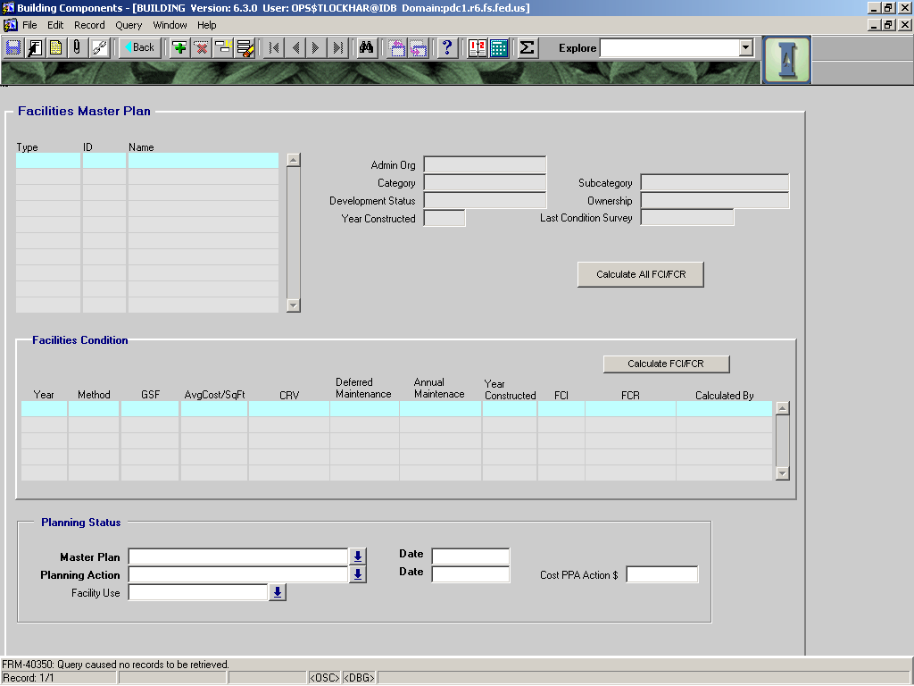

The Facilities Mast Plan (FMP) screen has three sections; building data, Facilities Condition, and Planning Status. The building data area is automatically populated from other areas of the module, and these fields cannot be edited here. The Facilities Condition data is also pulls data from other areas, but it also calculates a building’s Current Replacement Value, Facility Condition Index (FCI), and Facility Condition Rating (FCR). For further information on FCI/FCR data please read the **Facilities Master Plan (FMP) Screen QuickGuide** at:

<http://infra.wo.fs.fed.us/infra/training/quickguide/index.htm>

The Planning Status data fields are used by field staff to enter the disposition of a building based on the results of the Facilities Master Planning process and the subsequent Preliminary Project Analysis (PPA). This information is used to create a record of the planned use of all buildings on the unit.

|  |  |  |  |  |  |  |  |
| --- | --- | --- | --- | --- | --- | --- | --- |
|  |  | | | | | **Used in Tables:** | |
| **Name:** | **CRV** | | | | |  | |
|  |  | | | | |  | |
| **Definition:** | Current Replacement Value. The current cost of replacing the building. | | | | | | |
|  |  | | | | | | |
| **Reference:** |  | | | | | **Screen:** | FMP |
|  |  | | | | |  |  |
| **Format:** |  | | | | | **Unit of Measure:** |  |
|  |  | | | | |  |  |
| **Data Type:** | varchar2 | **Size:** |  |  |  | **Mandatory:** | **NO** |
|  |  | | | | | **Requirement** | **YES** |
| **Look Up:** | Auto-populated from data already entered. | | | | | | |
|  |  | | | | | | |
| **Business Rules:** | * 1. The current replacement value is automatically calculated by Infra using average replacement cost per gross sq. ft (per R.S. Means) based on building subcategory. | | | | | | |
|  |  | | | | | | |
| **Notes:** |  | | | | | | |
|  |  | | | | | | |

|  |  |  |  |  |  |  |  |
| --- | --- | --- | --- | --- | --- | --- | --- |
|  |  | | | | | **Used in Tables:** | |
| **Name:** | **FCI (Facility Condition Index)** | | | | |  | |
|  |  | | | | |  | |
| **Definition:** | Numeric value indicating the condition of a facility.  FCI = Total Deferred Maintenance/Current Replacement Value. | | | | | | |
|  |  | | | | | | |
| **Reference:** |  | | | | | **Screen:** | FMP |
|  |  | | | | |  |  |
| **Format:** |  | | | | | **Unit of Measure:** |  |
|  |  | | | | |  |  |
| **Data Type:** | varchar2 | **Size:** |  |  |  | **Mandatory:** | **NO** |
|  |  | | | | | **Requirement** | **YES** |
| **Look Up:** | Auto-populated based/system generated based on deferred maintenance and current replacement values in INFRA. | | | | | | |
|  |  | | | | | | |
| **Business Rules:** |  | | | | | | |
|  |  | | | | | | |
| **Notes:** |  | | | | | | |
|  |  | | | | | | |

|  |  |  |  |  |  |  |  |
| --- | --- | --- | --- | --- | --- | --- | --- |
|  |  | | | | | **Used in Tables:** | |
| **Name:** | **FCR (Facility Condition Rating)** | | | | |  | |
|  |  | | | | |  | |
| **Definition:** | Indicates condition of facility. | | | | | | |
|  |  | | | | | | |
| **Reference:** |  | | | | | **Screen:** | FMP |
|  |  | | | | |  |  |
| **Format:** |  | | | | | **Unit of Measure:** |  |
|  |  | | | | |  |  |
| **Data Type:** | varchar2 | **Size:** |  |  |  | **Mandatory:** | **NO** |
|  |  | | | | | **Requirement** | **YES** |
| **Look Up:** | Auto-populated based on FCI. | | | | | | |
|  |  | | | | | | |
| **Business Rules:** | 1. If FCI<0.05, the FCR is “GOOD”. 2. If 0.05<FCI<0.10, the FCR is “FAIR”. 3. If FCI > 0.10, the FCR is “POOR”. | | | | | | |
|  |  | | | | | | |
| **Notes:** |  | | | | | | |
|  |  | | | | | | |

|  |  |  |  |  |  |  |  |  |  |
| --- | --- | --- | --- | --- | --- | --- | --- | --- | --- |
|  |  | | | | | | **Used in Tables:** | | |
| **Name:** | **MASTER PLAN** | | | | | |  | | |
|  |  | | | | | |  | | |
| **Definition:** |  | | | | | | | | |
|  |  | | | | | | | | |
| **Reference:** |  | | | | | | **Screen:** | | FMP |
|  |  | | | | | |  | |  |
| **Format:** |  | | | | | | **Unit of Measure:** | |  |
|  |  | | | | | |  | |  |
| **Data Type:** |  | **Size:** |  | |  |  | **Mandatory:** | | **NO** |
|  |  | | | | | | **Required:** | | **YES** |
| **Look Up:** | LOV | | | | | | | | |
|  |  | | | | | | | | |
| **Business Rules:** | 1. | | | | | | | | |
|  |  | | | | | | | | |
| **Notes:** |  | | | | | | | | |
|  |  | | | | | | | | |
| **Valid Codes** | | | | | | | | | |
| Code | | | | Description | | | |  | |
| ACQUIRE | | | | ACQUIRE | | | |  | |
| DECOMMISSION | | | | DECOMMISSION | | | |  | |
| DEVELOP FOR ALTERNATIVE USE | | | | DEVELOP FOR ALTERNATIVE USE | | | |  | |
| RETAIN FOR EXISTING USE | | | | RETAIN FOR EXISTING USE | | | |  | |

|  |  |  |  |  |  |  |  |
| --- | --- | --- | --- | --- | --- | --- | --- |
|  |  | | | | | **Used in Tables:** | |
| **Name:** | **DATE** | | | | |  | |
|  |  | | | | |  | |
| **Definition:** |  | | | | | | |
|  |  | | | | | | |
| **Reference:** |  | | | | | **Screen:** | FMP |
|  |  | | | | |  |  |
| **Format:** | DD/MM/YYYY | | | | | **Unit of Measure:** |  |
|  |  | | | | |  |  |
| **Data Type:** |  | **Size:** |  |  |  | **Mandatory:** | **NO** |
|  |  | | | | | **Required:** | **YES** |
| **Look Up:** |  | | | | | | |
|  |  | | | | | | |
| **Business Rules:** | 1. | | | | | | |
|  |  | | | | | | |
| **Notes:** |  | | | | | | |
|  |  | | | | | | |

|  |  |  |  |  |  |  |  |  |  |
| --- | --- | --- | --- | --- | --- | --- | --- | --- | --- |
|  |  | | | | | | **Used in Tables:** | | |
| **Name:** | **PLANNING ACTION** | | | | | |  | | |
|  |  | | | | | |  | | |
| **Definition:** | The final action for the building as documented in the approved PPA. | | | | | | | | |
|  |  | | | | | | | | |
| **Reference:** |  | | | | | | **Screen:** | | FMP |
|  |  | | | | | |  | |  |
| **Format:** |  | | | | | | **Unit of Measure:** | |  |
|  |  | | | | | |  | |  |
| **Data Type:** |  | **Size:** |  | |  |  | **Mandatory:** | |  |
|  |  | | | | | | **Required:** | | **YES** |
| **Look Up:** | LOV | | | | | | | | |
|  |  | | | | | | | | |
| **Business Rules:** | 1. | | | | | | | | |
|  |  | | | | | | | | |
| **Notes:** |  | | | | | | | | |
|  |  | | | | | | | | |
| **Valid Codes** | | | | | | | | | |
| **Code (Master Plan: Planning Action)** | | | | **Description** | | | |  | |
| **ACQUIRE:** | | | |  | | | |  | |
| **LEASE** | | | | **LEASE** | | | |  | |
| **EXCHANGE** | | | | **EXCHANGE** | | | |  | |
| **CONSTRUCT** | | | | **CONSTRUCT** | | | |  | |
| **PURCHASE** | | | | **PURCHASE** | | | |  | |
|  | | | |  | | | |  | |
| **DECOMMISSION:** | | | |  | | | |  | |
| **DISPOSE** | | | | **DISPOSE** | | | |  | |
| **SELL** | | | | **SELL** | | | |  | |
| **EXCHANGE** | | | | **EXCHANGE** | | | |  | |
|  | | | |  | | | |  | |
| **DEVELOP FOR ALTERNATIVE USE:** | | | |  | | | |  | |
| **GRANGER-THYE** | | | | **GRANGER-THYE** | | | |  | |
| **REC FEE-DEMOS** | | | | **REC FEE-DEMOS** | | | |  | |
| **HERITAGE TRUST** | | | | **HERITAGE TRUST** | | | |  | |
| **CHANGE OF USE (SPECIFY)** | | | | **CHANGE OF USE (SPECIFY)** | | | |  | |
|  | | | |  | | | |  | |
| **RETAIN FOR EXISTING USE:** | | | |  | | | |  | |
| **UNCHANGED** | | | | **UNCHANGED** | | | |  | |
| **ADDITION** | | | | **ADDITION** | | | |  | |
| **REMODEL** | | | | **REMODEL** | | | |  | |

|  |  |  |  |  |  |  |  |
| --- | --- | --- | --- | --- | --- | --- | --- |
|  |  | | | | | **Used in Tables:** | |
| **Name:** | **DATE** | | | | |  | |
|  |  | | | | |  | |
| **Definition:** |  | | | | | | |
|  |  | | | | | | |
| **Reference:** |  | | | | | **Screen:** | FMP |
|  |  | | | | |  |  |
| **Format:** | DD/MM/YYYY | | | | | **Unit of Measure:** |  |
|  |  | | | | |  |  |
| **Data Type:** |  | **Size:** |  |  |  | **Mandatory:** |  |
|  |  | | | | | **Required:** | **YES** |
| **Look Up:** |  | | | | | | |
|  |  | | | | | | |
| **Business Rules:** | 1. | | | | | | |
|  |  | | | | | | |
| **Notes:** |  | | | | | | |
|  |  | | | | | | |

|  |  |  |  |  |  |  |  |
| --- | --- | --- | --- | --- | --- | --- | --- |
|  |  | | | | | **Used in Tables:** | |
| **Name:** | **COST PPA ACTION $** | | | | |  | |
|  |  | | | | |  | |
| **Definition:** |  | | | | | | |
|  |  | | | | | | |
| **Reference:** |  | | | | | **Screen:** | **FMP** |
|  |  | | | | |  |  |
| **Format:** |  | | | | | **Unit of Measure:** |  |
|  |  | | | | |  |  |
| **Data Type:** |  | **Size:** |  |  |  | **Mandatory:** | **NO** |
|  |  | | | | | **Required:** | **NO** |
| **Look Up:** | LOV | | | | | | |
|  |  | | | | | | |
| **Business Rules:** | 1. | | | | | | |
|  |  | | | | | | |
| **Notes:** |  | | | | | | |
|  |  | | | | | | |

|  |  |  |  |  |  |  |  |  |  |
| --- | --- | --- | --- | --- | --- | --- | --- | --- | --- |
|  |  | | | | | | **Used in Tables:** | | |
| **Name:** | **FACILITY USE** | | | | | |  | | |
|  |  | | | | | |  | | |
| **Definition:** | The building is either used by the staff of one program (Single Use), or several programs (Multiple Use). | | | | | | | | |
|  |  | | | | | | | | |
| **Reference:** |  | | | | | | **Screen:** | | FMP |
|  |  | | | | | |  | |  |
| **Format:** |  | | | | | | **Unit of Measure:** | |  |
|  |  | | | | | |  | |  |
| **Data Type:** |  | **Size:** |  | |  |  | **Mandatory:** | | NO |
|  |  | | | | | | **Required:** | | NO |
| **Look Up:** | LOV | | | | | | | | |
|  |  | | | | | | | | |
| **Business Rules:** | 1. | | | | | | | | |
|  |  | | | | | | | | |
| **Notes:** |  | | | | | | | | |
|  |  | | | | | | | | |
| **Valid Codes** | | | | | | | | | |
| **Code** | | | | **Description** | | | |  | |
| SINGLE USE | | | | SINGLE USE | | | |  | |
| MULTIPLE USE | | | | MULTIPLE USE | | | |  | |