Project Name: Stellar Wings
Viktor Fries, Lukas Hoffman, Brandon Huzil, Jared Thompson
CS 458

Introduction
Our goal for this project is to create a fast-paced spaceship combat game. This will be in an arena type environment that is populated with many “AI” controlled enemy ships, asteroids, and other hazardous objects. The user will pilot a spaceship in a first-person view within the cockpit. The cockpit will feature various controls/switches that the user can interact with to fire weapons, toggle different weaponry and other miscellaneous features for the ship. The arena will spawn various enemies in waves that the user will have to destroy. The user can find power-ups that will aid in the battle by providing more damage, shields, and additional weapons.

Our development strategy for our development project is to have group members to focus on their individual tasks. If a member is experiencing difficulty, another will assist or possibly switch roles if we find ourselves more conformable with other tasks. The priority for the project will be to implement the mechanics and gameplay over the aesthetics.

Inspiration
Other video games that we are referencing include: Elite Dangerous (Frontier Developments), Galaxy on Fire 2 (Deep Silver FISHLABS), and Star Wars: TIE Fighter (Lucas Arts).

We would like our game to look similar to the following screenshot (Elite Dangerous ,https://www.youtube.com/watch?v=l1sbz4C8Foc – ~7 min mark) with less overall asteroid density, and scattered throughout the arena more.
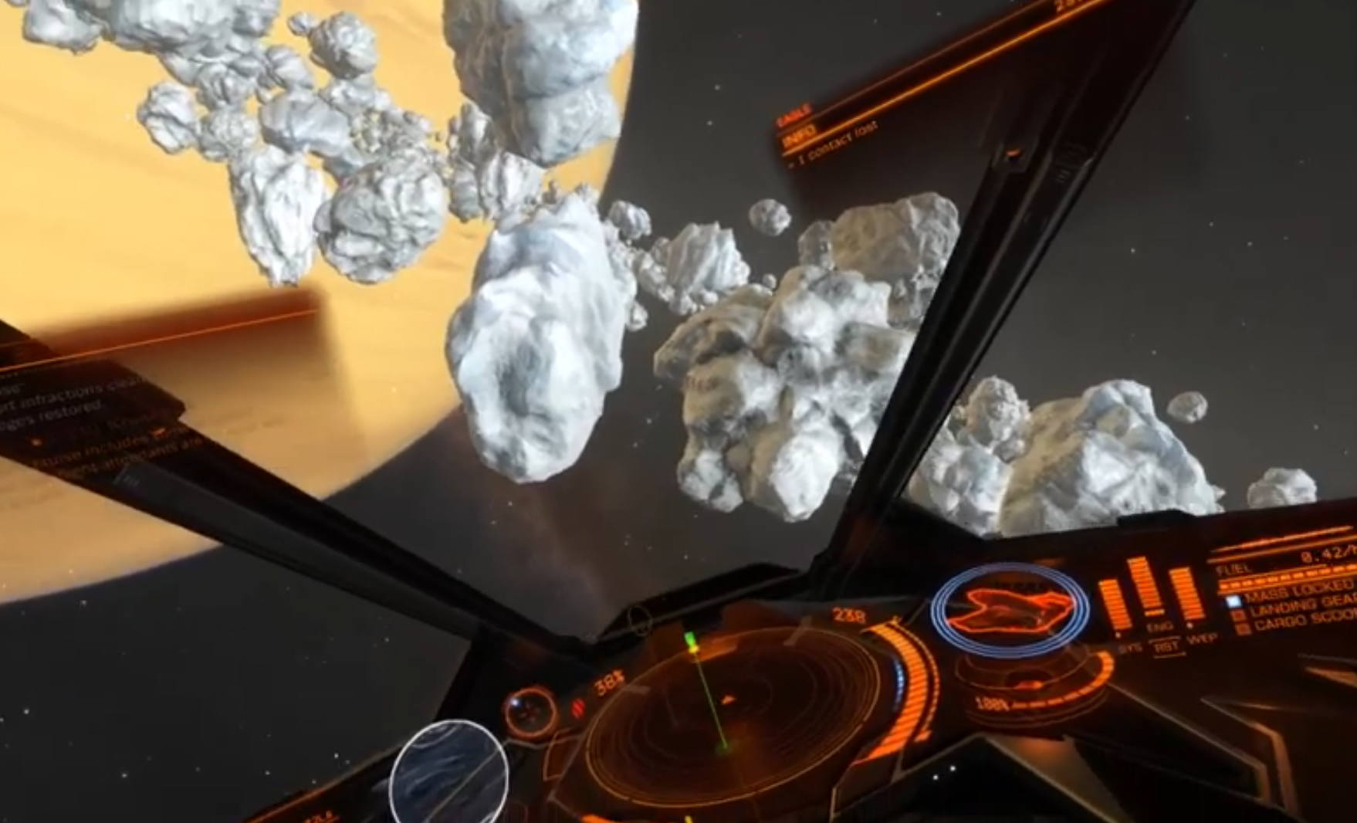

The interior of the ship is similar to how we would like to implement our own as well. The console, UI, etc will help reduce motion sickness that a user may experience.

Group Members & Tasks
Name | Tasks
Viktor Fries | 3D Modeling of assets and interior cockpit design in the ship
Lukas Hoffman | Physics/collision scripting
Brandon Huzil | Enemy and asteroid pathing and general scripting
Jared Thompson | General scripting for game mechanics

Milestones
Milestone 1 | Interactive cockpit designed (switches can be pressed, levers can be pulled, etc)
Milestone 2 | Populated and moving environment (asteroids, other ships, etc)
Milestone 3 | Barebones combat implementation (Weapons that fire, take damage) – MVP
Milestone 4 | Polishing, additional ships, variety, adding visual effects to better user’s immersion –Target & Vertical Slice
Milestone 5/6 | Additional game modes, objectives, or a multiplayer aspect – Stretch
Milestone 5/6 | Additional game modes, objectives or a multiplayer aspect – Stretch

Difficulty
Our project will provide a sufficient challenge for each member of the group. No one has experience with Unity, game design, or anything related to VR in general. Viktor has prior experience with some modeling, but the others do not. In terms of C#, nobody has extensive experience coding/scripting in the language.

