India general elections result analysis 2024

Total Seats

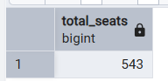

What is the total number of seats available for elections in each state

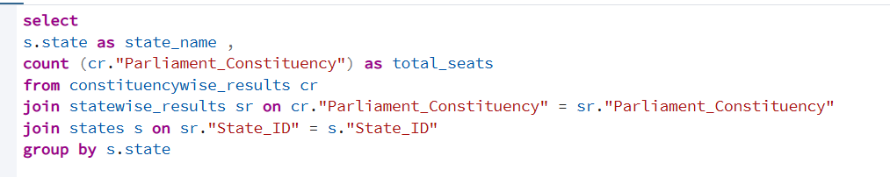
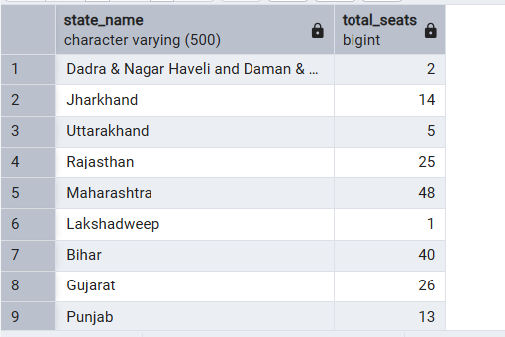

Total Seats Won by NDA Allianz

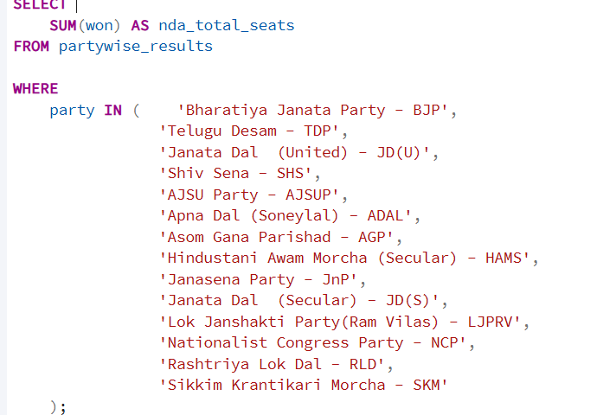
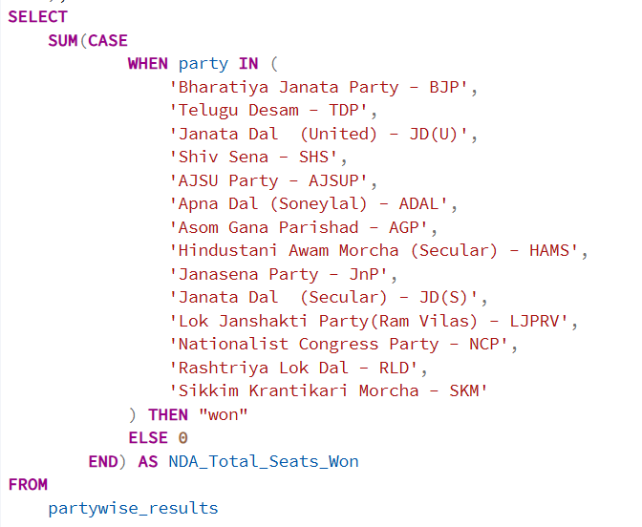
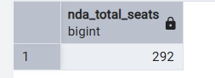
Seats Won by NDA Allianz Parties

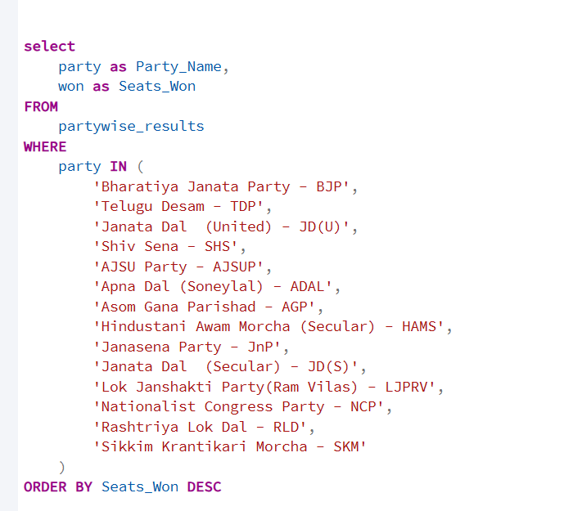

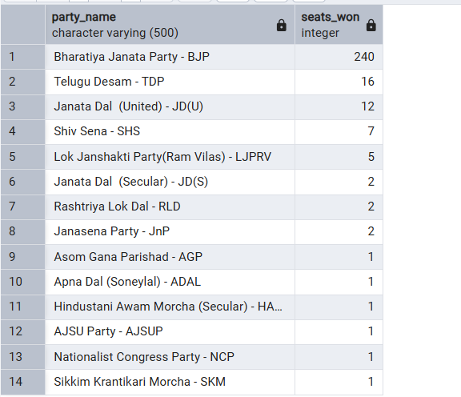

\

Total Seats Won by I.N.D.I.A. Allianz

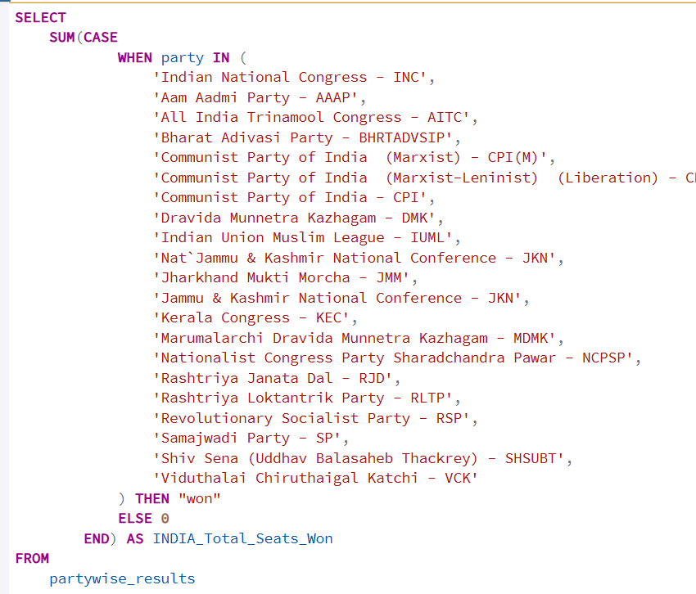

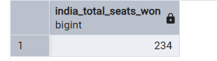

Seats Won by I.N.D.I.A. Allianz Parties

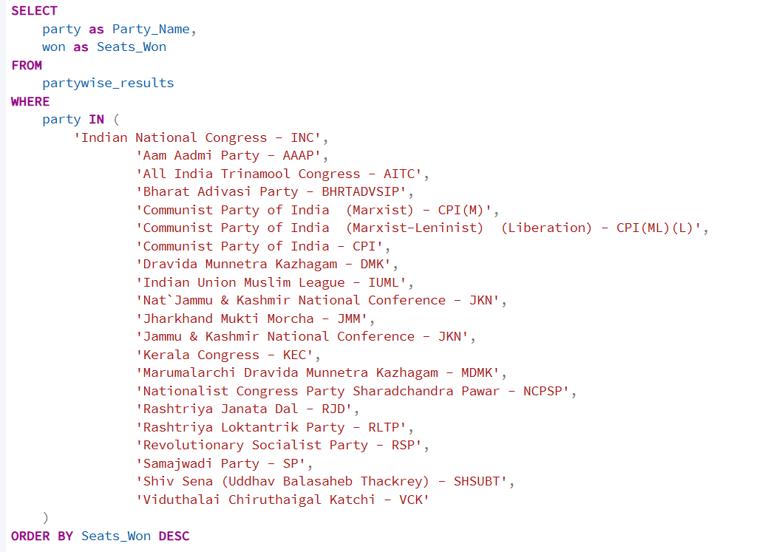

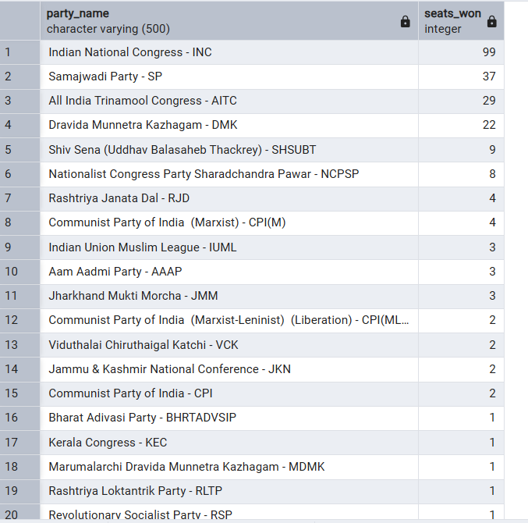

Which party alliance (NDA, I.N.D.I.A, or OTHER) won the most seats across all states?

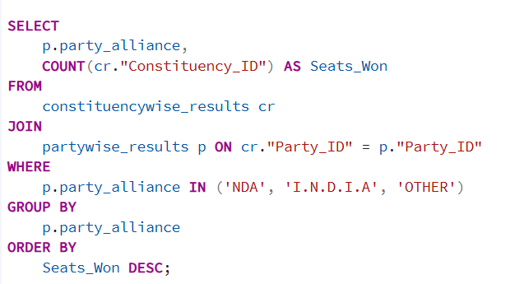

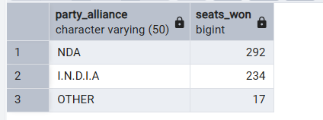
Winning candidate's name, their party name, total votes, and the margin of victory for a specific state and constituency?

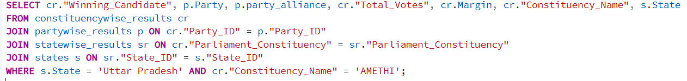

What is the distribution of EVM votes versus postal votes for candidates in a specific constituency?

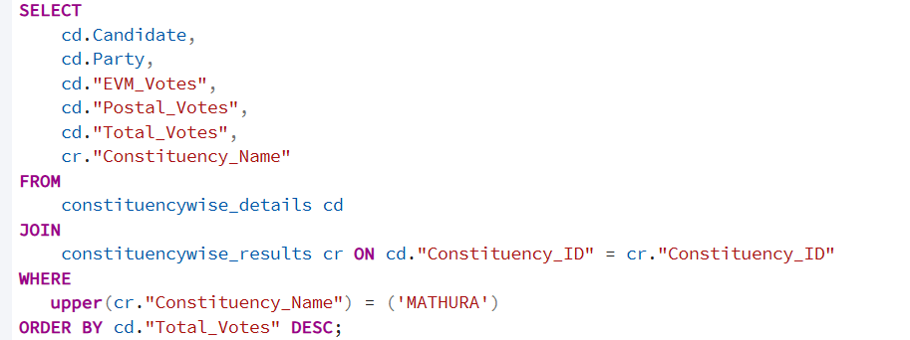

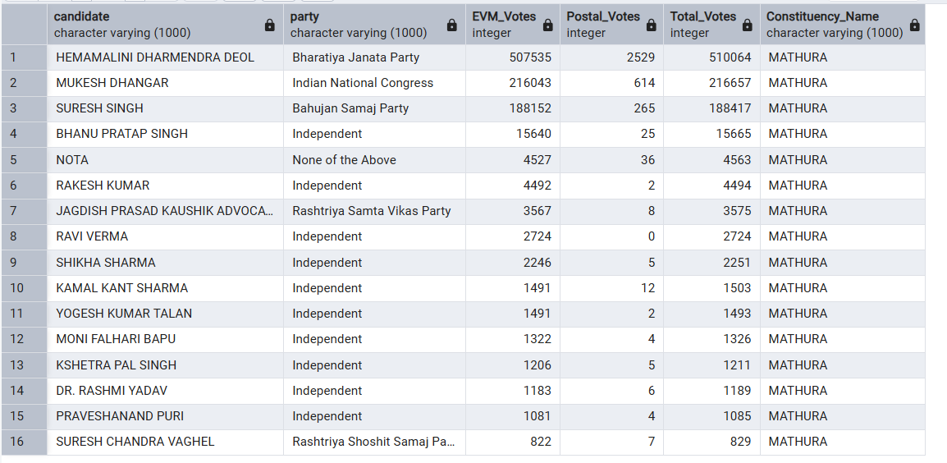

Which parties won the most seats in s State, and how many seats did each party win?

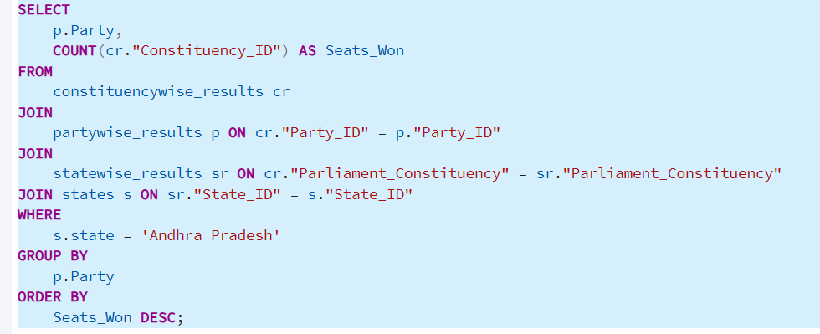

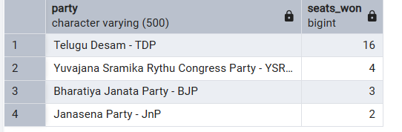

What is the total number of seats won by each party alliance (NDA, I.N.D.I.A, and OTHER) in each state for the India Elections 2024

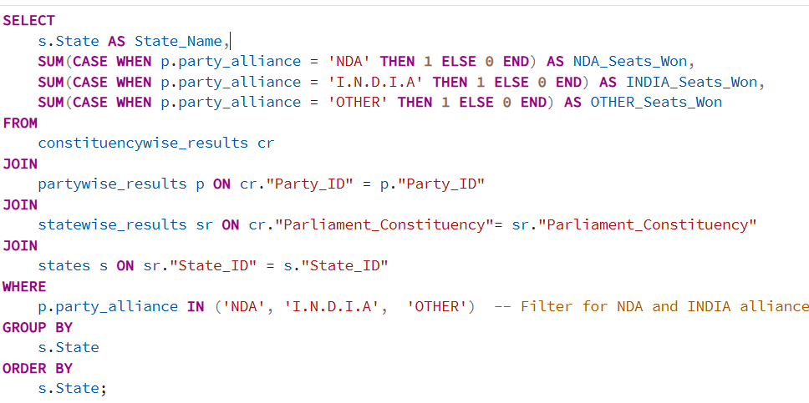

What is the total number of seats won by each party alliance (NDA, I.N.D.I.A, and OTHER) in each state for the India Elections 20


