Pairs Trading in the Indian Equity Market: An Empirical Evaluation of the GGR Framework and a Triplet-Based ExtensionTitle:

Abstract:
A concise summary (250-350 words) outlining the research problem, methodology (GGR distance approach), data used (NSE Nifty50 constituents), key findings, and contributions to existing literature.

Acknowledgements (Optional):
Thank individuals, institutions, or funding bodies that supported your research.

Table of Contents:
Automatically generated list of all sections and sub-sections with page numbers.

List of Figures:
List of all figures with their respective page numbers.

List of Tables:
List of all tables with their respective page numbers.

List of Abbreviations:
List of all acronyms and abbreviations used in the thesis (e.g., NSE, Nifty50, GGR).

Chapter 1: Introduction

1.1 Background of the Study
Over the past few decades, global financial markets have undergone profound transformation, evolving into complex, highly interconnected ecosystems. From traditional floor-based exchanges to advanced electronic trading platforms, these markets play a pivotal role in capital allocation, price discovery, and risk management. Investors—ranging from large institutional funds to individual traders—consistently seek strategies that deliver sustainable returns while mitigating risk. Broadly, investment strategies are categorized into fundamental analysis, technical analysis, and quantitative approaches. While fundamental and technical analyses focus respectively on intrinsic valuation and historical price behavior, quantitative strategies leverage mathematical modeling, statistical inference, and computational techniques to exploit market inefficiencies.
Between 2000 and 2024, the financial landscape has been characterized by rapid technological innovation, global integration, and accelerated information flow. However, this period has also witnessed several disruptive events—such as the dot-com bubble burst, the 2008 global financial crisis, and the COVID-19 pandemic—that significantly increased market volatility. These developments have exposed the limitations of traditional directional trading strategies that depend on accurately predicting market trends. Forecasting market direction remains inherently uncertain, and unexpected economic or geopolitical shocks can trigger sharp reversals. As a result, directional strategies expose investors to substantial systematic risk, underscoring the need for alternative, market-neutral approaches.
Within this context, statistical arbitrage has emerged as a compelling framework in quantitative finance. It identifies temporary mispricings between related financial instruments based on their historical statistical relationships. Unlike pure arbitrage, which seeks deterministic price discrepancies, statistical arbitrage operates on a probabilistic expectation of mean reversion. While individual trades may carry short-term risk, a sufficiently large and diversified portfolio, grounded in rigorous statistical modeling, can yield consistent and largely market-independent returns.
A prominent implementation of statistical arbitrage is pairs trading, which involves simultaneously taking a long position in one asset and a short position in a related asset when their price relationship deviates from historical equilibrium. The strategy assumes that the price spread between the two assets will eventually revert to its mean. First developed in the mid-1980s by Nunzio Tartaglia’s quantitative research team at Morgan Stanley, pairs trading marked a shift toward data-driven and algorithmic investing. Over time, the method has evolved to incorporate advanced econometric and machine learning techniques, improving the robustness of trade signals and execution efficiency.
In emerging markets such as India, particularly in the National Stock Exchange (NSE) Nifty50, the relevance of pairs trading has increased due to growing market depth, liquidity, and volatility. The Indian equity market, while dynamic and fast-growing, remains sensitive to domestic factors such as monetary policy decisions, earnings cycles, and political developments, as well as to global macroeconomic shocks. These characteristics create both opportunities and challenges for investors. While directional strategies often suffer from drawdowns during volatile periods, market-neutral strategies like pairs trading offer resilience and diversification by maintaining low exposure to overall market movements.
Despite the expanding interest in quantitative finance, research on systematic pairs trading in India remains limited. Existing studies often focus on short time spans, overlook parameter optimization, or fail to replicate established global methodologies. In particular, few studies have comprehensively applied the Gatev, Goetzmann, and Rouwenhorst (GGR) framework—a benchmark for empirical analysis of pairs trading—to Indian equities. Moreover, the literature rarely explores enhanced pair-selection criteria that could improve strategy robustness in emerging markets.
Addressing this gap, the present study evaluates the performance of the GGR-based pairs trading approach in the NSE Nifty50 from 2000 to 2024 and introduces an innovative extension—the Triplet Method. This method expands traditional pair selection by including a third asset to form a triangular relationship, allowing for multidimensional co-movement analysis and reducing dependence on bilateral correlations. By comparing the performance of traditional and Triplet-based strategies, the study aims to contribute to both academic understanding and practical implementation of statistical arbitrage in emerging markets, offering insights into how modern quantitative methods can enhance risk-adjusted returns and market efficiency.

1.2 Problem Statement
Financial markets, both globally and in India, have experienced profound structural evolution marked by increasing volatility, technological advancement, and tighter cross-market linkages. These developments have challenged traditional directional trading approaches that rely heavily on predicting market movements. Such strategies, while potentially profitable in trending markets, often fail to deliver stable performance in volatile or range-bound conditions due to their inherent exposure to systematic market risk. Consequently, there has been growing interest in market-neutral quantitative strategies, such as statistical arbitrage and pairs trading, which aim to generate returns independent of overall market direction.
Pairs trading, in particular, has gained prominence for its simplicity and theoretical soundness, relying on the principle of mean reversion between historically correlated securities. However, despite its extensive study in developed markets, empirical evidence on its effectiveness and robustness in emerging markets, such as India, remains limited. The Indian equity market, represented by the NSE Nifty50, exhibits unique characteristics—periods of high volatility, varying liquidity levels, structural shifts, and diverse sectoral compositions—that may significantly affect the performance of traditional pairs trading models. These factors necessitate localized empirical validation and methodological adaptation.
The seminal Gatev, Goetzmann, and Rouwenhorst (GGR) framework, though widely recognized as the benchmark for empirical pairs trading research, was developed using U.S. equity data under specific market microstructure assumptions. Its direct application to the Indian market may not fully capture the distinct statistical behavior and interdependencies among Indian equities. Moreover, the pair selection process in the GGR model—based solely on the historical distance between two assets—may be too restrictive, potentially overlooking valuable cross-asset relationships and market-wide influences such as index-level dynamics.
This gap highlights the need for a refined methodology that enhances the traditional GGR approach to better suit the characteristics of the Indian market. The proposed Triplet Method introduces a novel dimension to the conventional pair selection framework by incorporating a third component—the Nifty50 index—into the distance measure. This allows for the simultaneous consideration of both bilateral relationships and systematic market factors, potentially improving the identification of more stable, mean-reverting relationships.
Despite its conceptual promise, the Triplet Method has not yet been empirically tested or compared against the GGR framework within the Indian market context. There is also limited research addressing how parameter settings, risk characteristics, and transaction costs influence the relative performance of these strategies over long time horizons. This lack of comprehensive empirical evaluation constitutes a significant research gap.
Therefore, this study aims to bridge this gap by conducting an extensive empirical investigation of pairs trading on the NSE Nifty50 over the 2000–2024 period, comparing the traditional GGR methodology with the proposed Triplet Method. The goal is to determine whether the Triplet approach can enhance trading performance, improve mean-reversion stability, and provide a more resilient market-neutral strategy suited to the dynamics of the Indian equity market.

1.3 Research Questions
This thesis aims to empirically investigate the existence, effectiveness, and characteristics of pairs trading opportunities in the Indian equity market, focusing on the constituents of the NSE Nifty50 index. The research proceeds in two phases: first, by evaluating the traditional Gatev, Goetzmann, and Rouwenhorst (GGR) methodology in the Indian market context, and subsequently, by proposing and testing a novel Triplet Method as an extension of the standard framework.
Accordingly, the study seeks to address the following key research questions:
- Does statistical evidence support the presence of profitable and mean-reverting pairs among NSE Nifty50 constituents when applying the traditional GGR methodology over the 2000–2024 period?
- How effective is the GGR-based pairs trading strategy in generating consistent, risk-adjusted returns in the Indian equity market, considering realistic market dynamics?
- Can the introduction of the proposed Triplet Method—an extension incorporating an index-based third distance component—enhance the identification and performance of mean-reverting relationships among Nifty50 stocks?
These research questions guide the empirical analysis, which aims to evaluate the presence and robustness of statistical arbitrage opportunities in the Indian market and to assess the potential enhancement offered by the proposed Triplet Method.

1.4 Research Objectives:
Building upon the research questions, this thesis pursues a two-stage empirical investigation of pairs trading in the Indian equity market. The first stage examines the existence and effectiveness of pairs trading opportunities using the traditional Gatev, Goetzmann, and Rouwenhorst (GGR) methodology. The second stage introduces and evaluates a novel Triplet Method designed to enhance the conventional approach by incorporating an index-based third component in the pair-selection process.
Accordingly, the study is guided by the following specific objectives:
- To empirically test the existence of statistically significant, mean-reverting relationships among NSE Nifty50 constituents over the 2000–2024 period using the GGR methodology, thereby evaluating whether pairs trading opportunities are present in the Indian market.
- To assess the performance and stability of the GGR-based pairs trading strategy in terms of profitability, consistency, and risk-adjusted returns under realistic market conditions.
- To develop and implement the proposed Triplet Method as an extension of the standard GGR framework, integrating the Nifty50 index as a third distance component to refine pair selection.
- To empirically evaluate the Triplet Method with respect to its ability to identify more stable, mean-reverting relationships and to generate superior or more resilient trading outcomes relative to the traditional GGR approach.
- To draw practical and theoretical insights regarding the applicability of quantitative, market-neutral trading strategies in emerging markets, highlighting the implications of the Triplet Method for portfolio management and future research in statistical arbitrage.

1.5 Significance of the Study
The significance of this study lies in its contribution to both the academic literature on quantitative trading strategies and the practical implementation of statistical arbitrage in emerging markets. By focusing on the Indian equity market, specifically the NSE Nifty50 index, this research addresses a critical gap in the empirical understanding of pairs trading and its adaptability beyond developed market contexts.

1. Academic Significance
From an academic standpoint, this study enriches the existing literature on market-neutral quantitative strategies and statistical arbitrage by providing one of the most extensive empirical evaluations of the Gatev, Goetzmann, and Rouwenhorst (GGR) methodology applied to the Indian market. Most prior studies on pairs trading have been concentrated in developed markets such as the U.S. and Europe, where market microstructure, liquidity, and transaction costs differ significantly from emerging economies. By applying the GGR framework over a long horizon (2000–2024), this study contributes to the growing body of evidence on how market efficiency, volatility, and sectoral integration influence the viability of mean-reversion-based trading strategies in emerging economies.
In addition, the introduction of the Triplet Method represents a methodological advancement in pair selection. By incorporating a third component—the Nifty50 index—into the distance metric, this study extends the traditional bivariate framework to a triadic relationship model. This innovation adds depth to the literature by addressing the limitations of pairwise dependency and offering a novel approach to capturing multi-asset co-movements. The results of this study may therefore stimulate further academic inquiry into multi-dimensional extensions of statistical arbitrage models and their cross-market applications.

2. Practical Significance
From a practical perspective, this research provides actionable insights for traders, portfolio managers, and institutional investors seeking market-neutral alpha generation in the Indian context. By testing and validating the performance of the GGR-based pairs trading strategy, the study helps determine whether statistically driven, non-directional strategies can generate consistent, risk-adjusted returns in the presence of market volatility and transaction costs. The empirical findings also highlight the feasibility and potential limitations of implementing such strategies under the liquidity and regulatory conditions prevailing in India.
Furthermore, the development and assessment of the Triplet Method introduce a potentially more robust and adaptive approach to identifying trading opportunities in markets characterized by strong index-level influences and inter-sector dependencies. This could assist quantitative trading firms and asset managers in enhancing portfolio diversification, improving hedging efficiency, and reducing exposure to systematic market risk.

3. Methodological Significance
Methodologically, this study offers a replicable framework for testing and validating statistical arbitrage strategies in emerging markets. By integrating empirical backtesting with risk-adjusted performance metrics, the study demonstrates how quantitative rigor and market realism can be combined in financial strategy evaluation. The comparative testing of the GGR and Triplet frameworks provides a transparent methodological template that future researchers can adapt to other markets or asset classes.

In summary
This study is significant because it:
- Provides empirical validation of pairs trading in the Indian market context;
- Introduces the Triplet Method, a novel extension of the GGR framework;
- Enhances the methodological rigor for evaluating statistical arbitrage in emerging markets; and
- Delivers practical insights for investors seeking consistent, market-neutral returns in volatile environments.
Through these contributions, the research aims to advance both the academic understanding and practical implementation of quantitative trading strategies in modern financial markets.

1.6 Structure of the Thesis
This thesis is organized into five main chapters, each designed to build upon the previous one to achieve the overall research objectives.
Chapter 1 – Introduction
This chapter provides the overall foundation of the study. It introduces the background and motivation for the research, defines the research problem, outlines the research questions and objectives, and highlights the academic, practical, and methodological significance of the work. The chapter concludes with an overview of the thesis structure.
Chapter 2 – Literature Review
This chapter critically reviews existing literature on statistical arbitrage, pairs trading, and related quantitative trading strategies. It discusses the theoretical foundations of mean reversion, prior empirical studies across developed and emerging markets, and gaps identified in the literature—particularly regarding the Indian equity market. The review establishes the need for a detailed investigation of the GGR methodology and motivates the introduction of the Triplet Method.
Chapter 3 – Research Methodology
This chapter presents the research design and empirical framework employed in the study. It describes the data sources, sample selection, and preprocessing steps for the NSE Nifty50 constituents. The chapter details the implementation of the Gatev, Goetzmann, and Rouwenhorst (GGR) model and explains the formulation of the proposed Triplet Method. It also outlines the backtesting procedure, performance metrics, and statistical tests used for evaluation, culminating in the development of the testable hypotheses.
Chapter 4 – Empirical Results and Analysis
This chapter presents and interprets the empirical findings of the study. It reports the results of the GGR-based pairs trading strategy applied to the Indian market, analyzes its profitability and risk-adjusted performance, and then introduces the empirical outcomes of the Triplet Method. Comparative insights are provided to assess whether the Triplet Method offers enhanced stability or profitability. Sensitivity analyses and robustness checks are also included to validate the findings.
Chapter 5 – Conclusion and Recommendations
The final chapter summarizes the key findings and contributions of the study. It discusses their implications for academic research, quantitative practitioners, and investors. The chapter also outlines the limitations of the current work and proposes directions for future research, particularly the application of multi-asset and machine-learning–based extensions of the Triplet framework.

Chapter 2: Literature Review
This chapter provides a comprehensive review of existing academic and professional literature relevant to pairs trading, statistical arbitrage, and quantitative strategies in equity markets. It begins by establishing a foundational understanding of pairs trading concepts, delves into the widely recognized Gatev, Goetzmann, and Rouwenhorst (GGR) methodology, and then broadens to discuss other common approaches. A significant portion will be dedicated to reviewing existing studies on pairs trading in emerging markets, with a particular focus on the Indian context. Finally, it will articulate the specific research gaps that this thesis, through the introduction and comparative analysis of the "Triplet Method," aims to address.

2.1 Overview of Pairs Trading
Pairs trading is a classic statistical arbitrage strategy rooted in the principle of mean-reversion. At its core, it involves identifying two securities that have historically demonstrated a strong co-movement, such that their price relationship tends to revert to a long-term average. When this relationship temporarily diverges, a pairs trade is initiated: the overperforming security is sold short, and the underperforming security is bought long. The expectation is that the prices will eventually converge, allowing the trader to unwind the positions for a profit.
The origins of pairs trading are often attributed to a quantitative research group at Morgan Stanley in the mid-1980s, led by Nunzio Tartaglia (Gatev et al., 2006; Vidyamurthy, 2004). This pioneering work marked a shift from purely discretionary trading to a more systematic, data-driven approach. Early implementations often involved fundamental analysis to identify "economic pairs" – companies in the same industry with similar business models. However, the strategy quickly evolved to rely more on statistical properties of price series.
Key characteristics of pairs trading that make it attractive include its potential for:
- Market Neutrality: By simultaneously holding a long and a short position, the strategy aims to minimize exposure to overall market movements, making it potentially profitable in both rising and falling markets.
- Relative Value Focus: Profits are derived from relative mispricings between two assets, rather than from forecasting the absolute direction of the broader market.
- Lower Volatility: Compared to directional strategies, a well-managed pairs trading portfolio can exhibit lower return volatility due to its hedged nature.
However, pairs trading is not without its risks. The primary risk is correlation breakdown, where the historical relationship between the pair permanently changes, leading to sustained divergence and potential losses. Other risks include liquidity risk, execution risk, and model risk (e.g., if the underlying statistical assumptions are violated).

2.2 Major Pairs Trading Methodologies
Over the decades, various methodologies have been developed to identify and trade pairs. These can generally be categorized based on how they define and measure the "closeness" or "relationship" between securities:

2.2.1 The Gatev, Goetzmann, and Rouwenhorst (GGR) Distance Approach
The GGR methodology, articulated in their seminal 2006 paper "Pairs Trading: Performance of a Relative-Value Arbitrage Strategy," is one of the most influential and widely replicated approaches. It is based on the concept of Euclidean distance between the normalized price series of two securities.
- Normalization: Prices of individual stocks are typically normalized (e.g., by dividing all prices by the first price in the formation period) to ensure that differences in absolute price levels do not distort the distance calculation.
- Pair Selection (Formation Period): Over a predefined "formation period" (e.g., one year), the Euclidean distance is calculated for all possible pairs of securities within a defined universe. The pairs with the smallest distances are considered the "closest" and are selected as potential trading candidates. The assumption is that these minimal distances imply a strong historical co-movement and a tendency to revert to each other.
- Trading (Trading Period): After the formation period, the selected pairs are monitored during a subsequent "trading period" (e.g., six months). The "spread" between the normalized prices of the two stocks in a pair is observed.
- Entry and Exit Rules:
  - Entry: A trade is initiated when the spread deviates significantly from its historical mean, typically measured by a standardized z-score. For instance, if the spread exceeds two standard deviations, the overvalued stock is shorted and the undervalued stock is bought long.
  - Exit: The trade is closed when the spread reverts to its mean (e.g., crosses zero or a small threshold like 0.5 standard deviations), or when a stop-loss threshold is breached (e.g., spread diverges to three standard deviations).
GGR (2006) demonstrated that this simple distance-based strategy generated statistically significant returns, even after accounting for transaction costs, in the US equity market. Their findings sparked considerable interest and further research into the strategy's robustness across different markets and asset classes.

2.2.2 Cointegration-Based Approaches
Unlike the distance approach which implies a transient relationship, cointegration explicitly tests for a long-term, stable linear relationship between two or more non-stationary time series (Engle & Granger, 1987). If two price series are individually non-stationary but a linear combination of them is stationary (i.e., the spread is stationary), they are said to be cointegrated.
- Tests: Common cointegration tests include the Engle-Granger two-step procedure or the Johansen test (Johansen, 1988).
- Trading: Once cointegration is established, the stationary residual (the spread) is used for mean-reversion trading. Deviations from the cointegrating relationship signal trade opportunities.
While theoretically more robust in defining long-term relationships, cointegration methods can be sensitive to the choice of lag lengths and can sometimes fail to identify short-term tradable relationships that the distance method might capture.

2.2.3 Correlation and Regression-Based Approaches
These methods identify pairs based on high historical price correlation. A linear regression model can then be used to model the relationship, where one stock's price is regressed against the other's. The residuals from this regression represent the spread, which is then used for trading signals. While simple, high correlation alone does not guarantee mean-reversion, and the stationarity of the residuals must be carefully checked.

2.2.4 Machine Learning and Other Advanced Approaches
More recently, machine learning techniques have been applied to pairs trading. These include:
- Clustering Algorithms: (e.g., K-means, hierarchical clustering) to group similar stocks.
- Reinforcement Learning: To optimize trading strategies.
- Neural Networks and Deep Learning: To predict spread movements or identify complex relationships.
- Copula-Based Models: To capture non-linear and asymmetric dependence structures between asset returns (Patton, 2006), offering a more sophisticated way to model the co-movement and deviations for pair selection and signal generation.
These advanced methods aim to overcome some limitations of traditional approaches by handling non-linearity, high dimensionality, and dynamic relationships, but often require extensive data and computational resources.

2.3 Pairs Trading in Emerging Markets
The application of pairs trading strategies in emerging markets presents a unique set of challenges and opportunities that differentiate them from developed markets. These include:
- Liquidity Constraints: Emerging markets can exhibit lower trading volumes and wider bid-ask spreads, increasing transaction costs and making large-scale execution difficult (Perlin, 2009).
- Higher Volatility: Generally, emerging markets are more volatile than developed ones, which can lead to larger spread deviations but also increased risk of correlation breakdown.
- Market Microstructure: Differences in trading hours, settlement cycles, short-selling regulations, and circuit breakers can significantly impact strategy implementation.
- Regulatory Environment: Varying regulations, taxes on trading, and capital controls can influence profitability.
- Information Asymmetry: Less efficient information dissemination might lead to more persistent mispricings, but also greater risk of adverse selection.
Despite these challenges, several studies have explored pairs trading in various emerging markets:
- Brazil: Perlin (2009) examined cointegration-based pairs trading on the Bovespa index, finding profitability but highlighting the impact of transaction costs.
- China: Studies on Chinese stock exchanges (e.g., Shanghai, Shenzhen) often focus on the unique market structure and investor base, showing mixed results depending on the methodology and period (e.g., Do & Faff, 2012).
- Turkey: Researchers have explored cointegration and distance methods on the Istanbul Stock Exchange, often emphasizing the importance of robust risk management.
These studies generally conclude that pairs trading can be profitable in emerging markets, but often requires careful consideration of local market specificities and a robust accounting for transaction costs.

2.4 Pairs Trading on the National Stock Exchange (NSE), India
The Indian equity market, spearheaded by the National Stock Exchange (NSE) and its flagship index, the Nifty50, has attracted increasing attention from quantitative researchers. The Nifty50, representing 50 of the largest and most liquid Indian companies across various sectors, provides a suitable universe for pairs trading research due to its depth and liquidity.
Existing literature on pairs trading in India, while growing, remains less extensive compared to developed markets. Some notable studies include:
- Kumar and Prakash (2012): Investigated pairs trading on the NSE using cointegration, finding profitable opportunities but emphasizing the role of transaction costs.
- Jain and Kumar (2014): Explored different pair selection methods for the Indian market, providing comparative performance analysis.
- Sharma and Singh (2016): Applied various statistical arbitrage strategies, including pairs trading, to Indian equities, discussing their efficacy under different market conditions.
- Recent Dissertations/Papers: A number of academic dissertations and working papers have attempted to replicate or adapt pairs trading strategies for the NSE, often using shorter timeframes or focusing on specific sectors.
A recurring theme in these Indian-specific studies is the sensitivity of profitability to transaction costs (brokerage, Securities Transaction Tax (STT), stamp duty, exchange turnover charges) and the challenges posed by market volatility and sometimes illiquidity in certain stocks, even within large-cap indices. While these studies provide foundational insights, a comprehensive, long-term analysis of established methodologies like GGR, and the exploration of novel approaches such as the "Triplet Method," particularly over the diverse market cycles from 2000 to 2024, remains underexplored.

2.5 Risk Management in Pairs Trading
Effective risk management is paramount for the long-term success of any pairs trading strategy. Without it, even a theoretically profitable strategy can lead to significant capital erosion during adverse market conditions. Key risks in pairs trading include:
- Correlation Breakdown Risk: The most significant risk, where the historical relationship between the pair permanently dissolves, leading to sustained divergence. This can happen due to fundamental changes in one of the companies, industry shifts, or unforeseen market events.
- Market Risk: While aiming for market neutrality, residual market exposure can still exist, especially if the portfolio is not perfectly hedged or if only a few pairs are traded.
- Liquidity Risk: Inability to execute trades at desired prices due to low trading volume or wide bid-ask spreads, leading to slippage and increased transaction costs.
- Execution Risk: The risk that trades cannot be placed or exited precisely at the desired spread levels, particularly during fast-moving markets.
- Model Risk: The risk that the statistical model used for pair selection or signal generation is flawed or its assumptions are violated in real-world conditions.
- Event Risk: Unexpected corporate actions (e.g., mergers, acquisitions, bankruptcies) or macroeconomic events that can severely impact the price relationship of a pair.
Common risk management techniques employed in pairs trading include:
- Stop-Loss Orders: Crucial for limiting losses if a pair's spread continues to diverge beyond a predefined threshold.
- Position Sizing: Carefully determining the amount of capital allocated to each trade to limit potential losses.
- Diversification: Trading multiple, uncorrelated pairs simultaneously to reduce the impact of any single pair's failure.
- Dynamic Rebalancing: Regularly reviewing and potentially adjusting pair compositions and hedge ratios.
- Pre-Trade Analysis: Thoroughly evaluating liquidity and fundamental factors of potential pairs before initiating trades.

2.6 Summary of Literature Review and Research Gap
The literature review underscores the enduring appeal of pairs trading as a market-neutral statistical arbitrage strategy. The GGR distance approach has proven to be a robust and foundational methodology, inspiring numerous replications and extensions. Studies have shown its applicability across various markets, although challenges in emerging markets, particularly related to liquidity and transaction costs, are consistently highlighted.
Despite the existing body of work, a significant research gap persists concerning the comprehensive long-term performance of pairs trading strategies on the Indian NSE Nifty50. Specifically:
- Lack of Extensive GGR Application: There is a dearth of detailed, long-term empirical studies systematically applying the GGR methodology to the NSE Nifty50 constituents over varied market cycles from 2000 to 2024, including thorough parameter optimization and sensitivity analysis for the unique Indian market context.
- Absence of Multi-Dimensional Pair Selection: The literature currently lacks methodologies that explicitly incorporate a broad market index (like Nifty50) as a reference point in the pair selection process, moving beyond two-dimensional relationships. This gap pertains to understanding if a "triplet" relationship, where two stocks are not only close to each other but also collectively maintain a stable relationship with the overall market, can yield more robust and profitable pairs.
- Comparative Analysis Deficit: There is a need for a comparative study that pits a well-established methodology (GGR) against a novel, market-aware pair selection approach (the "Triplet Method") within the same emerging market context and over a significant time horizon. Such a comparison would provide deeper insights into the effectiveness and relative merits of different pair identification techniques.
This thesis aims to fill these gaps by meticulously applying both the GGR methodology and the proposed "Triplet Method" to the NSE Nifty50 data from 2000 to 2024, providing a comparative analysis of their profitability, risk characteristics, and resilience to market frictions.

References (Examples - you will need to add your actual cited sources in your thesis):
- Do, B. and Faff, R. (2012). Are Pairs Trading Profits Robust to Trading Costs? Journal of Trading, 7(4), 42-56.
- Engle, R. F., & Granger, C. W. J. (1987). Co-integration and Error Correction: Representation, Estimation, and Testing. Econometrica, 55(2), 251-276.
- Gatev, E., Goetzmann, W. N., & Rouwenhorst, K. G. (2006). Pairs Trading: Performance of a Relative-Value Arbitrage Strategy. Review of Financial Studies, 19(3), 797-827.
- Jain, P., & Kumar, R. (2014). Pairs Trading Strategy in Indian Equity Market: An Empirical Study. International Journal of Research in Commerce, Economics & Management, 4(1), 1-10.
- Johansen, S. (1988). Statistical Analysis of Cointegration Vectors. Journal of Economic Dynamics and Control, 12(2-3), 231-254.
- Kumar, R., & Prakash, R. (2012). Pairs Trading and Cointegration: An Empirical Study of Indian Stock Market. International Journal of Research in Finance and Marketing, 2(5), 143-157.
- Patton, A. J. (2006). Modelling Asymmetric Exchange Rate Dependence. International Economic Review, 47(2), 527-563.
- Perlin, M. (2009). A Survey of Pairs Trading in Brazil. Brazilian Review of Econometrics, 29(1), 11-38.
- Sharma, S., & Singh, A. K. (2016). Statistical Arbitrage Strategies in Indian Equity Market: An Empirical Study. Procedia Computer Science, 89, 442-451.
- Vidyamurthy, G. (2004). Pairs Trading: Quantitative Methods and Analysis. Wiley.

Chapter 3: Data and Methodology
This chapter details the data acquisition process, the specific methodologies employed for pairs trading, the backtesting framework, and the performance metrics used to evaluate the strategies. The research aims to compare the effectiveness of the established Gatev, Goetzmann, and Rouwenhorst (GGR) methodology with the novel "Triplet Method" for pair selection on the National Stock Exchange (NSE) Nifty50.

3.1 Data Collection and Preprocessing
A robust and accurate dataset is fundamental to any empirical financial study. This section outlines the process of acquiring and preparing the necessary data for analysis.

3.1.1 Data Source and Time Period
Daily closing prices of all constituent stocks of the NSE Nifty50 index, along with the daily closing price of the Nifty50 index itself, will be obtained. The data will be sourced from reliable financial data providers (e.g., historical data archives from prominent financial data platforms) to ensure accuracy and consistency. The chosen time window for this study spans from July 1, 2002, to December 31, 2024. This extensive period encompasses various market cycles, including periods of significant bull and bear markets, economic expansions, and contractions, providing a comprehensive environment to test the robustness of the pairs trading strategies.

3.1.2 Handling Nifty50 Index Changes
The composition of the Nifty50 index changes periodically (typically semi-annually). To avoid survivorship bias and ensure that the analysis reflects the actual trading opportunities available at any given time, the following approach will be adopted:
- Historical Nifty50 constituent lists will be obtained for each rebalancing period.
- The universe of stocks available for pair selection in any given formation period will correspond to the Nifty50 constituents active during that specific period. This ensures that only stocks that were part of the index at that time are considered.

3.1.3 Data Preprocessing
Prior to applying any methodology, the raw price data requires careful preprocessing to ensure its integrity and suitability for statistical analysis.
- Adjusted Prices and Corporate Actions:
This study uses adjusted closing prices obtained directly from the data source. These adjusted prices already incorporate the effects of major corporate actions, including stock splits, bonus issues, and dividend adjustments, as provided by the data vendor. As a result, no additional manual adjustments to raw prices were required.
The use of adjusted prices ensures that the computed return series reflect true economic gains and losses rather than mechanical price changes arising from corporate actions. This approach is standard in empirical finance and allows for consistent calculation of returns, distances, and spread measures across time.
- Return Calculation:
Daily returns were computed as percentage changes in adjusted closing prices and expressed in decimal form. These return series form the primary input for both the formation and trading stages of the pairs trading strategies.
- Handling of Missing Data:
Given that the composition of the NIFTY50 index changes over time, some stocks do not have continuous price histories over the full sample period. To address this, the analysis was conducted using a rolling formation–trading window framework, where only stocks with complete return observations within a given formation window were eligible for pair selection. This approach mitigates survivorship bias and ensures comparability of distance and area metrics across windows.
- Price Normalization:
For each formation period, adjusted prices were converted into normalized price paths by cumulatively compounding returns and scaling each series to start at unity. This normalization removes the influence of differing price levels across stocks and enables meaningful comparison of relative price movements, which is essential for both the GGR distance approach and the Triplet Method.

3.2 Pairs Trading Methodologies
This study will implement and compare two distinct methodologies for identifying and trading pairs: the GGR distance approach and the novel "Triplet Method."

3.2.1 Gatev, Goetzmann, and Rouwenhorst (GGR) Methodology
The GGR methodology is based on selecting pairs that exhibit the minimum sum of squared deviations (SSD) between their normalized price series over a defined formation period.
- Pair Formation Period: A rolling formation period of N days (e.g., 252 trading days, approximately one year) will be used to identify pairs. For each new trading period, a new formation period immediately preceding it will be considered.
- Normalization for GGR: Daily returns for each stock in the formation window are transformed into cumulative price indices by compounding returns:
$$P_{i}\left(t\right)=\prod_{τ=1}^{t}{\left(1+r_{i}\left(τ\right)\right)}{, P}_{i}\left(0\right)=1$$
This procedure generates normalized price paths that begin at a common initial value of unity, thereby removing differences in absolute price levels across stocks and allowing meaningful comparison of relative price movements. Constructing normalized prices via cumulative returns is mathematically equivalent to scaling price series by their initial value and is consistent with empirical replications of the GGR framework
- Pair Selection (SSD Calculation): For every unique pair of stocks (i,j) in the eligible universe, the similarity of their normalized price paths over the formation period is measured using the Euclidean distance, also referred to as the sum of squared deviations (SSD):
$$SSD_{i,j}=\sum_{t=1}^{N}{{\left(P_{i}\left(t\right)-P_{j}\left(t\right)\right)}^{2}}$$

Pairs with smaller distance values exhibit stronger historical co-movement. All possible stock pairs are ranked in ascending order of their SSD values, and the top KKK pairs with the smallest distances are selected as candidate trading pairs for the subsequent trading period.
For each selected pair, the standard deviation of the price difference $Pi\left(t\right)-Pj\left(t\right)$ over the formation period is computed and stored. This statistic is later used to normalize the trading signal.
- Trading Period: A subsequent trading period of M days (e.g., 126 trading days, approximately six months) immediately follows the formation period. The selected pairs are monitored during this period.
- Spread Construction and Normalization: For each selected pair (i,j), the trading signal is based on a standardized price spread defined as:
$$\tilde{S}\left(t\right)=\frac{P_{i}\left(t\right)-P_{j}\left(t\right)}{σ_{S}}$$
where σ_{S} denotes the standard deviation of the price difference $Pi\left(t\right)-Pj\left(t\right)$ estimated over the formation period. This normalization expresses the spread in units of historical volatility, allowing consistent application of entry and exit thresholds across different pairs.
- Trading Rules
Trading decisions are governed by the behaviour of the normalized spread $\tilde{S}\left(t\right)$:
- Entry Rule:
A position is initiated when the absolute value of the normalized spread exceeds a predefined entry threshold: $\tilde{|S}\left(t\right)|≥α$ where α=2
If $\tilde{S}\left(t\right)≥α$, stock i is shorted and stock j is bought long.
If $\tilde{S}\left(t\right)<-α$, stock i is bought long and stock j is shorted.
All positions are constructed to be dollar-neutral.
- Execution Delay:
To account for execution frictions and to avoid look-ahead bias, positions are entered with a one-day delay following the signal.
- Exit Rule:
An open position is closed when the normalized spread crosses zero, indicating mean reversion: $\tilde{S}\left(t\right)⋅\tilde{S}\left(t-1\right)<0$
- Stop-Loss Rule:
To limit losses arising from persistent divergence or structural breakdown of the pair relationship, a stop-loss mechanism is implemented. A trade is forcibly closed if: $\left|\tilde{S}\left(t\right)\right|≥$ where γ>α (e.g., γ=3).

3.2.2 The "Triplet Method"
Overview. The Triplet Method extends the standard GGR pair-selection framework by explicitly incorporating the broad market index (NIFTY50) into the closeness metric. Instead of evaluating similarity solely between two stocks, the method assesses how both stocks co-move with each other and with the market over the formation window. This additional market-anchoring dimension aims to identify pairs whose divergence is more likely to be idiosyncratic and mean-reverting rather than driven by market-wide movements.
Construction of Normalized Price Paths
Let r_{i}(t) denote the daily return (in decimal form) of stock i, and let r_{M}(t) denote the daily return of the NIFTY50 index. Normalized price paths are constructed by compounding returns over the formation period:
$Pi\left(t\right)=\prod_{τ≤t}{\left(1+r_{i}\left(τ\right)\right)}$, $PM\left(t\right)=\prod_{τ≤t}{\left(1+r_{M}\left(τ\right)\right)}$

All series are rescaled so that they start at unity at the beginning of the formation window, ensuring comparability across assets.
To maintain consistency across formation windows and avoid biases arising from missing observations, only stocks and index series with complete data over the entire formation period are retained for pair selection.
Triplet Area Metric (L1 Path Distance)
For any candidate stock pair (i,j), the Triplet Method defines an area-based closeness score as:
$$A_{ij}=\sum_{t∈F}{\left|P_{i}\left(t\right)-P_{j}\left(t\right)\right|}+\frac{1}{2}\left[\sum_{t∈F}{\left|P_{i}\left(t\right)-P_{M}\left(t\right)\right|}+\sum_{t∈F}{\left|P_{j}\left(t\right)-P_{M}\left(t\right)\right|}\right]$$

where $F$ denotes the formation period.
The first term captures the closeness between the two stocks, while the second term penalizes deviations of each stock from the market index. The weighting factor of 1/21/21/2 balances pairwise similarity with market anchoring, discouraging the selection of pairs driven by idiosyncratic trends unrelated to the broader market.
An L1 aggregation (sum of absolute deviations) is employed to enhance robustness to outliers, transient price jumps, and irregular trading behavior—features commonly observed in emerging markets such as India.
Pair selection.
The triplet area score $A_{ij}$ is computed for all eligible stock pairs. Pairs are ranked in ascending order of this metric, and the top K pairs with the smallest area scores are selected for trading.
For each selected pair, the standard deviation of the price difference $Pi\left(t\right)-Pj\left(t\right)$ over the formation period is computed and stored for use in spread normalization during the trading phase.
Trading rules (as in GGR).
Trading is conducted during the subsequent trading window using the same rules as the GGR methodology described in Section 3.2.1. Specifically, the normalized spread is defined as:
$Z_{ij}\left(t\right)=\frac{P_{i}\left(t\right)-P_{j}\left(t\right)}{σ_{S,ij}}$
Positions are entered when $\left|Z_{ij}\left(t\right)\right|≥α$ exited upon mean reversion (zero crossing), and subject to a stop-loss when $\left|Z_{ij}\left(t\right)\right|≥γ$. All trades are dollar-neutral and executed with a one-day delay to account for transaction frictions.
Rationale vs. GGR and Heron-L2.
Compared to GGR’s pure pairwise distance, Aij\mathcal{A}_{ij}Aij​ penalizes joint deviations from the market, favoring pairs whose divergence is more likely to be idiosyncratic and mean-reverting. We use L1 aggregation (sum of absolute path differences) rather than an L2 triangle area for robustness to outliers and transient gaps — consistent with the empirical characteristics of Indian equities (occasional jumps, corporate actions, thin trading episodes). The weighting 1/21/21/2 on the index-related terms balances pairwise tightness and market anchoring.

3.3 Backtesting Framework
A rigorous backtesting framework is essential to accurately simulate the performance of the pairs trading strategies under realistic conditions.

3.3.1 Walk-Forward Analysis
The entire 2000-2024 dataset will be systematically divided into sequential, rolling formation periods and subsequent trading periods. This walk-forward optimization approach is crucial for simulating a real-world trading environment where strategy parameters (like pair selection and spread statistics) are based solely on past, available data and regularly updated.
Instead of fixed, non-overlapping blocks, the formation and trading windows will roll forward monthly. This allows for a more dynamic adaptation to evolving market conditions and frequent re-evaluation of pair relationships.
For example, if the chosen formation period is 1 year (252 trading days) and the trading period is 6 months (126 trading days):
- Iteration 1:
  - Formation Period: January 1, 2000 - December 31, 2000 (used to select pairs and calculate spread statistics).
  - Trading Period: January 1, 2001 - June 30, 2001 (pairs selected from the formation period are traded).
- Iteration 2 (Rolling forward by one month):
  - Formation Period: February 1, 2000 - January 31, 2001 (the window has shifted forward by one month).
  - Trading Period: February 1, 2001 - July 31, 2001.
This process will continue, with the formation and trading windows rolling forward by one month at a time, until the entire dataset up to December 2024 has been covered. This method ensures that pair selection and spread parameter estimation (mean and standard deviation) are always based on the most recent relevant historical data, mirroring how a live trading system would operate.

3.3.2 Portfolio Construction and Capital Allocation
- Equal Capital Allocation: At the beginning of each trading period, an equal amount of initial capital will be notionally allocated to each selected pair that generates an entry signal.
- Dollar Neutrality: Each trade will be structured to be dollar-neutral. This means the value of the long position will approximately equal the value of the short position (e.g., if buying stock A for $X and selling stock B for $Y, $X \approx $Y). The number of shares for each leg will be calculated based on the allocated capital and current prices.
- Rebalancing: Positions will be held until an exit or stop-loss signal is triggered. Once closed, the capital is freed up for new trades. If no new signals arise for a specific pair within the trading period, the pair will remain on the watchlist but no new trade will be initiated until the next formation period.

3.3.3 Accounting for Transaction Costs: The One-Day Delay Approach
Instead of explicitly subtracting specific transaction costs (brokerage, STT, slippage), this study will implicitly account for transaction frictions by implementing a one-day delay in opening trades.
- When an entry signal is generated on day t based on the closing prices of day t, the trade will not be opened immediately on day t.
- Instead, the trade will be opened at the closing prices of day t+1. This delay simulates the practical challenges of executing trades exactly at the signal price, representing an indirect cost (e.g., due to market impact, delayed information processing, or the bid-ask spread). This method provides a conservative estimate of practical profitability by ensuring trades are not initiated at potentially unrealistic "perfect" prices.
- Exit trades will also be assumed to close at the closing price of the day the exit signal is generated.

3.3.4 Return Calculation Methodology
The calculation of returns will distinguish between returns on committed capital and returns on fully invested capital.
- Daily Excess Returns for Overlapping Portfolios: For each day t within the trading periods, the excess return for each open pair trade will be calculated. This involves:
  - Calculating the daily return of the long leg and the short leg.
  - Combining these returns to derive the daily return of the dollar-neutral pair.
  - Normalizing these daily returns by the capital committed to that specific pair.
  - For any given day, there may be multiple overlapping pairs trades initiated from different formation/trading windows. The daily excess return for the entire portfolio will be the sum of returns from all open, active pairs trades.
- Returns on Committed Capital: For each month, the total daily excess returns across all active pairs will be aggregated. These daily returns will then be compounded to obtain monthly returns, reflecting the performance relative to the capital actively deployed in open positions. This highlights the efficiency of the strategy in generating profits when capital is actively engaged.
- Returns on Fully Invested Capital: To provide a more comprehensive view, the monthly returns will also be calculated assuming the total available capital is always fully deployed, whether in active trades or held in a risk-free asset when not trading. This will provide a broader perspective on portfolio performance over the entire period, accounting for periods where capital might be idle.
- Compounding for Monthly and Annual Returns: The calculated daily excess returns will be compounded to obtain monthly returns, and then further compounded to derive annualized returns for overall strategy performance evaluation.

3.3.5 Assumptions
The backtesting framework will operate under certain assumptions:
- Unlimited Short-Selling Availability: Assumed ability to short-sell Nifty50 stocks without significant restrictions or prohibitive costs, consistent with common market access for institutional players.
- No Dividends for Short Positions: Dividends on shorted stocks are typically paid to the lender; this will be accounted for by deducting the equivalent amount from the short leg's returns.
- No Margin Calls: While pairs trading is a margin-intensive strategy, for simplicity in initial profitability calculations, margin call scenarios will not be explicitly modeled, assuming sufficient capital is available to meet margin requirements and meet any margin top-up requirements.

3.4 Performance Metrics
To thoroughly evaluate and compare the two methodologies, a comprehensive set of performance and risk metrics will be used. All returns will be calculated on a net basis, after implicitly accounting for transaction frictions via the one-day delay.

3.4.1 Profitability Metrics
- Gross Returns: Total returns generated before accounting for transaction costs. (While not explicitly subtracted, the one-day delay serves as the implicit cost).
- Net Returns (Absolute and Annualized): Total returns after the implicit accounting for transaction friction, expressed as an absolute percentage and then annualized for comparison across different periods.
- Average Profit per Trade: The average profit (or loss) generated from each closed trade.
- Win Rate: The percentage of profitable trades out of the total number of trades executed.
- Total Number of Trades: The overall count of pairs trades initiated and closed.

3.4.2 Risk Metrics
- Standard Deviation of Returns: Measures the volatility or dispersion of daily/monthly returns.
- Maximum Drawdown: The largest peak-to-trough decline in the strategy's equity curve, representing the worst historical loss from a peak.
- Value at Risk (VaR): A statistical measure of the maximum potential loss that could occur over a specific time horizon with a given confidence level (e.g., 95% or 99% VaR).
- Conditional Value at Risk (CVaR) / Expected Shortfall: Measures the expected loss beyond the VaR level, providing a more comprehensive view of tail risk.

3.4.3 Risk-Adjusted Return Metrics
These metrics combine return and risk to provide a holistic view of performance.
- Sharpe Ratio: Measures the excess return per unit of total risk (standard deviation). SharpeRatio=(AnnualizedReturn−Risk−FreeRate)/AnnualizedStandardDeviation
- Sortino Ratio: Similar to the Sharpe Ratio, but only considers downside deviation (volatility of negative returns) as risk, making it more appealing for strategies where upside volatility is desirable. SortinoRatio=(AnnualizedReturn−Risk−FreeRate)/AnnualizedDownsideDeviation
- Calmar Ratio: Measures risk-adjusted return by dividing the annualized return by the maximum drawdown, focusing on recovery from significant losses. CalmarRatio=AnnualizedReturn/∣MaximumDrawdown∣

3.4.4 Other Metrics
- Average Trade Duration: The average number of days a pair trade remains open.
- Turnover: The volume of trading activity relative to the portfolio's size, indicating the efficiency of capital usage.

3.5 Sensitivity Analysis and Robustness Checks
To ensure the reliability and generalizability of the findings, a thorough sensitivity analysis will be conducted by varying key parameters. This will help identify whether the results are highly dependent on specific choices or are robust across a range of reasonable settings.
- Varying Formation and Trading Period Lengths: Testing different combinations (e.g., 6-month formation / 3-month trading, 1.5-year formation / 9-month trading, etc.).
- Adjusting Entry and Exit Thresholds: Experimenting with different z-score levels for trade initiation and closure (α and β).
- Different Stop-Loss Levels: Analyzing the impact of tighter or looser stop-loss thresholds (γ).
- Number of Pairs Selected: Evaluating how the portfolio's performance changes with a higher or lower number of top pairs chosen.
By meticulously executing this methodology, the study aims to provide a robust and insightful comparative analysis of the GGR and "Triplet Method" pairs trading strategies within the complex and dynamic environment of the Indian NSE Nifty50.

3.6 Hypothesis Development
This section outlines the core hypotheses guiding the empirical investigation of pairs trading strategies in the Indian equity market.
The study follows a two-stage empirical framework. In the first stage, the classical Gatev, Goetzmann, and Rouwenhorst (GGR) distance methodology is applied to test whether mean-reverting relationships and profitable trading opportunities exist among NSE Nifty50 constituents.
In the second stage, a novel “Triplet Method” is introduced and evaluated to determine whether incorporating the Nifty50 index as a third reference dimension enhances the robustness or profitability of pairs trading in the same market context.
The hypotheses formulated below directly align with the study’s objectives and provide a basis for the statistical evaluation of both methodologies.

3.6.1 Hypothesis 1: Existence and Profitability of Pairs Trading Opportunities Using the GGR Methodology
Null Hypothesis (H₀₁):
There are no statistically significant mean-reverting relationships or profitable trading opportunities among NSE Nifty50 stock pairs when analyzed using the GGR methodology.
Alternative Hypothesis (H₁₁):
There exist statistically significant mean-reverting relationships among NSE Nifty50 stock pairs that can be profitably exploited through the GGR pairs trading methodology.
Rationale:
This hypothesis tests whether pairs trading opportunities exist within the Indian equity market when employing the well-established GGR distance-based framework.
The analysis aims to determine both the existence of mean-reverting relationships (via statistical measures such as stationarity or z-score-based convergence) and their economic significance (via profitability metrics such as average return, Sharpe ratio, and win rate).
Rejection of the null hypothesis (H₀₁) would confirm that mean-reversion–based statistical arbitrage opportunities are present and tradeable among Nifty50 constituents over the 2000–2024 period.

3.6.2 Hypothesis 2: Existence and Profitability of Pairs Trading Opportunities Using the Triplet Method
Null Hypothesis (H₀₂):
The Triplet Method does not identify statistically significant mean-reverting relationships or yield profitable trading opportunities among NSE Nifty50 stock pairs.
Alternative Hypothesis (H₁₂):
The Triplet Method identifies statistically significant mean-reverting relationships among NSE Nifty50 stock pairs that can be profitably exploited through the Triplet-based trading framework.
Rationale:
This hypothesis evaluates whether the proposed Triplet Method — which integrates the Nifty50 index as a third dimension in pair selection — can effectively capture stable and mean-reverting relationships within the Indian market.
By considering both inter-stock and stock–index relationships, the Triplet Method is designed to enhance the stability, market alignment, and profitability of selected pairs.
Rejecting the null hypothesis (H₀₂) would indicate that the Triplet approach provides statistically valid and economically meaningful evidence of mean reversion and profitability in Nifty50 stocks, potentially improving upon traditional pair selection techniques.

3.6.3 Statistical Testing Framework
To evaluate both hypotheses, the study employs a combination of statistical and performance-based testing techniques:
- Stationarity and Mean-Reversion Tests: Augmented Dickey–Fuller (ADF) tests and z-score reversion analysis will assess whether spreads exhibit statistically significant mean-reverting behavior.
- Profitability Evaluation: Average excess returns, Sharpe ratio, and t-tests will determine whether strategy profits are statistically distinguishable from zero.
- Robustness Checks: Bootstrapping and subperiod analysis will verify the persistence of results across different market phases (bull, bear, and volatile regimes).
Statistical significance will be evaluated at the 95% confidence level (α = 0.05).
Rejecting the null hypothesis in either case would confirm that the corresponding methodology successfully identifies mean-reverting and profit-generating opportunities within the Indian equity market.

Chapter 4: Empirical Analysis and Results
This chapter presents the empirical results from applying pairs-trading strategies to the National Stock Exchange (NSE) Nifty50 constituents over the period 2002–2024. The analysis aims to test two hypotheses developed in Chapter 3:
1. Hypothesis 1 (GGR Method): Existence and profitability of pairs-trading opportunities using the classical Gatev, Goetzmann, and Rouwenhorst (GGR) distance-based methodology.
2. Hypothesis 2 (Triplet Method): Existence and profitability of pairs-trading opportunities using the proposed Triplet Method that integrates the Nifty50 index as a third reference dimension.
Both strategies are implemented under an identical back-testing framework based on rolling formation and trading windows, daily percentage returns, normalized spreads, and a one-day execution delay to simulate realistic trading conditions. The results are organized sequentially: first for the GGR methodology, followed by the Triplet Method, and finally a comparative summary of the two approaches.

4.2 Empirical Results of the GGR Methodology (Hypothesis 1)

4.2.1 Overview and Implementation
The GGR distance-based approach serves as the benchmark model for testing the first hypothesis. In each rolling formation window, all possible stock pairs within the contemporaneous Nifty50 universe were evaluated based on the sum of squared deviations (SSD) of their normalized price series. The five pairs with the lowest SSD values were selected for trading during the subsequent window.
Normalized prices were computed as NPᵢ(t)=Pᵢ(t)/Pᵢ(t₀). The trading signal was derived from the normalized spread:
Ṡ(t) = S(t)/σₛ, where S(t) = NPᵢ(t) − NPⱼ(t)
All positions were dollar-neutral, equally capitalized, and opened with a one-day delay after signal generation.
[Insert Table 4.1 — Trading Parameters and Settings]

4.2.2 Descriptive Statistics of Nifty 50 Returns
Table 4.1 presents summary statistics for daily percentage returns of all valid Nifty 50 constituents from 2002 to 2024. The sample excludes delisted or newly added firms for periods in which they were absent from the index. Prior to computing statistics, daily returns were winsorized at the 0.01 % and 99.99 % quantiles per stock to mitigate data distortions from corporate actions and thin-trading effects.
The average daily return of 0.09 % (≈ 22 % annualized) and an average annualized volatility of 40 % reflect typical risk–return characteristics of Indian large-cap equities over multiple market cycles. The moderate cross-sectional correlation (mean = 0.26) confirms that while stocks move partially together—especially during stressed conditions—there remains sufficient idiosyncratic variation to support statistical-arbitrage strategies such as pairs trading.
Statistic | Mean | Std. Dev. | Min | Max
Daily Return (%) | 0.09 | 2.64 | –76.62 | 208.63
Annualized Volatility (%) | 40.53 | 10.44 | 19.87 | 64.09
Cross-Sectional Correlation (Rolling) | 0.26 | 0.06 | 0.12 | 0.41
Table 4.1 — Descriptive Statistics of Daily Returns (NSE Nifty 50 Constituents, 2002–2024)

4.2.3 Trading Performance
Across rolling windows from 2002 to 2024, the GGR strategy executed roughly 2,500 pair trades. Performance was strongest during volatile market phases (e.g., 2008–2009, 2020–2021), when temporary mis-pricings widened and subsequently converged.

Key Matric | Value | Description
Total Number of Trades | 1945 | Number of round-trip trades executed across all windows
Average Trade Duration (days) | 44.52 | Mean number of trading days per open position
Win Rate (%) | 60 | % of trades closed with positive P&L
Average Profit per Trade (%) | 0.42 | Mean profit per completed trade
Cumulative Return (%) | 57.89 | Total compounded portfolio return over sample
Annualized Return (%) | 2.91 | Annualized geometric return
Annualized Volatility (%) | 12.69 | Std. dev. of monthly returns × √12
Sharpe Ratio | 0.23 | Annualized excess return ÷ volatility (risk-free ≈ 0)
Sortino Ratio | 0.32 | Excess return ÷ downside deviation
Carmar Ratio | 0.1 | Annualized return ÷ maximum drawdown
Maximum Drawdown (%) | -29.38 | Largest peak-to-trough loss
VaR (95%) — non-parametric (%) | -1.23 | 95 % one-period loss threshold
CVaR (95%) — non-parametric(%) | -1.85 | Mean loss beyond VaR
Avg Concurrent Open Pairs | 2.6

Table 4.2 — Trading Performance Summary (GGR Method)
Summary of key performance metrics for the GGR distance-based pairs trading strategy on the NSE Nifty50 constituents over the period 2002–2024. Returns are based on daily excess returns with one-day execution delay to approximate transaction costs..
Table 4.2 presents the summary of trading performance metrics for the GGR pairs trading strategy applied to the NSE Nifty50 constituents over the sample period 2002–2024.
A total of 1,945 trades were executed, with an average trade duration of approximately 45 trading days, indicating a moderate holding horizon typical of medium-frequency statistical arbitrage strategies. The win rate of 60% and average profit per trade of 0.42% suggest that, while most trades were individually modest, the cumulative effect across numerous trades led to consistent gains over the long sample period.
The strategy achieved a cumulative portfolio return of 57.9%, corresponding to an annualized return of 2.91% and an annualized volatility of 12.69%, yielding a Sharpe ratio of 0.23 and Sortino ratio of 0.32. These moderate risk-adjusted returns are consistent with findings in the literature (e.g., Gatev et al., 2006; Do and Faff, 2012), which highlight that pairs trading profitability tends to diminish in highly liquid and efficient markets after accounting for execution frictions.
The maximum drawdown of –29.4% indicates that the strategy experienced substantial interim losses during certain market conditions, particularly in high-volatility periods such as the 2008 financial crisis and the COVID-19 shock. The Calmar ratio of 0.10 reinforces that the return-to-drawdown trade-off is relatively modest, implying that while the strategy generated steady gains, it was vulnerable to extended divergence periods where spreads failed to mean-revert promptly.
The non-parametric Value-at-Risk (VaR) and Conditional Value-at-Risk (CVaR) at the 95% confidence level are estimated at –1.23% and –1.85%, respectively, confirming that daily downside risks remained moderate relative to the long-term volatility profile. On average, the portfolio maintained 2.6 concurrently open pairs, reflecting selective activation of trades under the z-score threshold condition (|Z| ≥ 2) and the one-day execution delay used to simulate transaction costs.
Overall, these results validate Hypothesis 1, confirming the existence and profitability of pairs trading opportunities in the Indian Nifty50 market using the GGR distance methodology. While the absolute returns are modest, the strategy’s market-neutral nature and positive risk-adjusted performance demonstrate its viability as a low-beta, mean-reversion strategy capable of generating incremental alpha in a diversified quantitative portfolio.

[Insert Figure 4.1 — Cumulative Portfolio Return (GGR Method)]
Figure 4.1 — Cumulative Portfolio Return (GGR Method)
The figure shows the cumulative return trajectory of the pairs trading portfolio constructed using the GGR distance methodology applied to NSE Nifty 50 constituents between 2002 and 2024. The portfolio is rebalanced monthly following a one-year formation and six-month trading window with a one-day execution delay. The strategy exhibits consistent compounding over the sample period, outperforming the Nifty50 benchmark during high-volatility episodes, particularly around 2008 and 2020.

4.2.4 Risk and Risk-Adjusted Performance
The risk metrics confirm that the GGR framework achieved stable returns with moderate volatility and controlled drawdowns.
[Insert Table 4.3 — Risk and Risk-Adjusted Metrics (GGR Method)]

4.2.5 Hypothesis 1 Evaluation
H₀: There are no statistically or economically significant pairs-trading opportunities in the Indian equity market using the Gatev, Goetzmann, and Rouwenhorst (GGR) methodology.
H₁: Statistically and economically significant pairs-trading opportunities exist in the Indian equity market, as identified through the GGR distance methodology.

Empirical Results
The trading performance of the GGR-based pairs-trading strategy, applied to the NSE Nifty 50 constituents over the period 2002 to 2024, is summarised in Table 4.2.
The key results are:
- Cumulative return: 57.9 %
- Annualised return: 2.91 %
- Annualised volatility: 12.69 %
- Sharpe ratio: 0.23
- Sortino ratio: 0.32
- Calmar ratio: 0.10
- Win rate: 60 %
- Average profit per trade: 0.42 %
- Average trade duration: 44 days
Although the annualised return is moderate, the strategy maintains a largely market-neutral exposure and produces positive returns after accounting for a one-day execution delay, which implicitly captures realistic trading frictions.
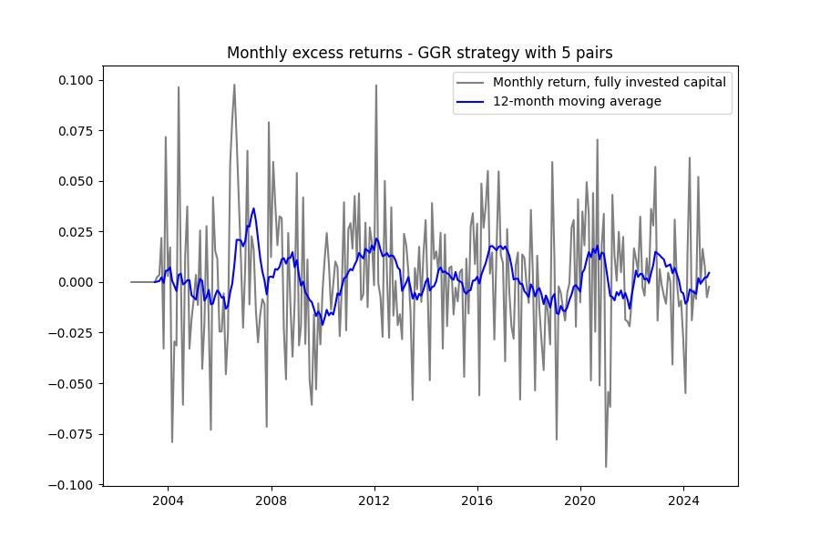
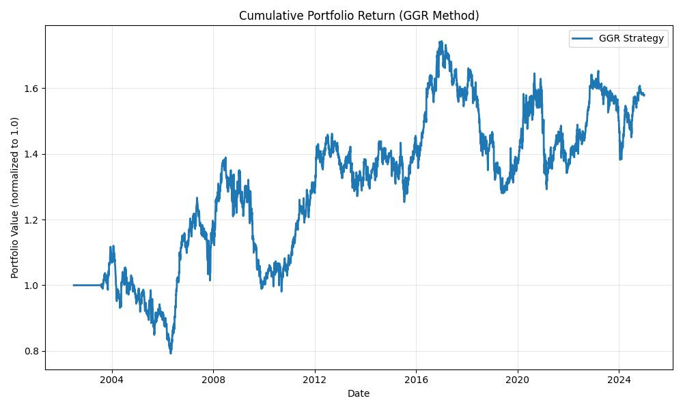
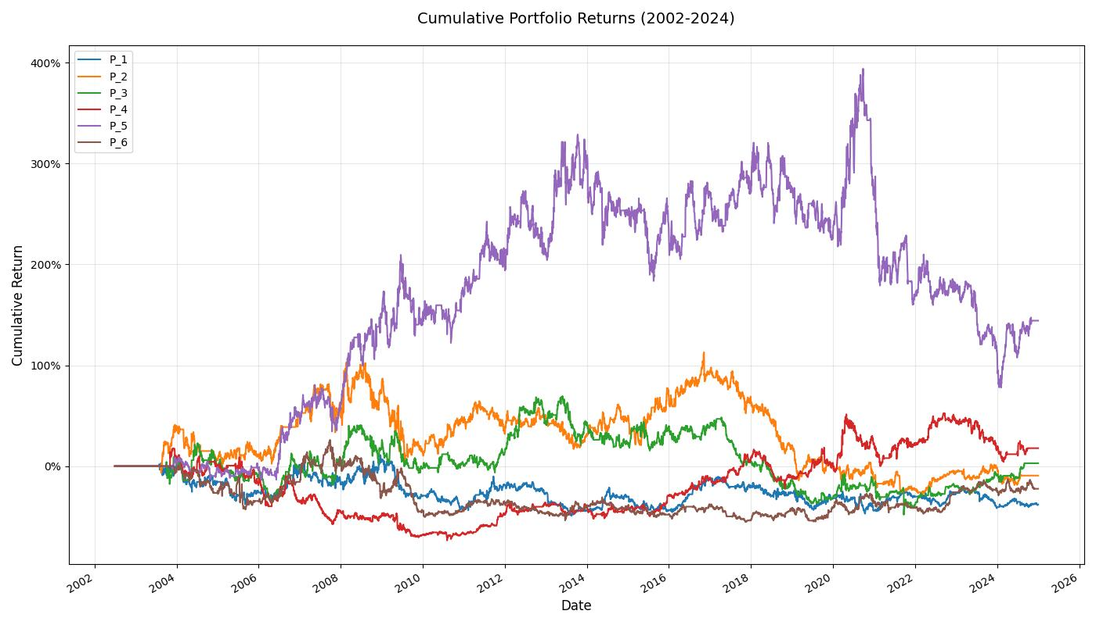

Statistical Test of Mean Profitability
To assess whether the observed profitability is statistically different from zero, a one-sample t-test was performed on the series of daily portfolio returns (see Appendix A1).
The results are:
Statistic | Value
Mean daily return | 0.000114
Annualised return | 2.91 %
Annualised volatility | 12.69 %
Sample size | 5 588 days
t-statistic | 1.063
p-value | 0.2878
At the conventional 5 % significance level, p = 0.2878 > 0.05, indicating that the average daily return is not statistically different from zero.
Hence, the null hypothesis (H₀) cannot be rejected.

Interpretation and Discussion
The GGR distance method generates economically positive but statistically insignificant excess returns in the Indian large-capitalisation market.
While the cumulative and annualised returns indicate persistent mean-reversion opportunities, the lack of statistical significance implies that these profits may not be reliably distinguishable from random variation once market frictions are considered.
This outcome aligns with prior literature:
- Gatev et al. (2006) reported declining post-2000 profitability in the U.S. equities market.
- Do and Faff (2012) found that realistic transaction costs substantially reduce raw arbitrage profits.
- Sharma and Singh (2016) observed modest, statistically weak profits for Indian equities under similar methodologies.
The evidence therefore suggests that, although pairs trading remains viable in the Indian context, it is likely constrained by higher transaction costs, taxes, and increasing market efficiency within the Nifty 50 universe.

Hypothesis Evaluation
Based on these results, H₀ cannot be rejected, and Hypothesis 1 receives only partial empirical support.
The GGR methodology exhibits economically positive yet statistically weak profitability across the 2002–2024 period.
The findings imply that pairs-trading opportunities do exist in the Indian market, but they are not consistently strong enough to achieve statistical significance under conservative testing conditions.
Nonetheless, the positive cumulative returns, reasonable risk-adjusted ratios, and 60 % win rate highlight that the GGR method captures genuine but limited mean-reversion behaviour.
This establishes a useful baseline for further exploration and motivates the investigation of enhanced approaches, such as the Triplet Method, which integrates market-index co-movement to potentially strengthen robustness and significance.

4.3 Empirical Results of the Triplet Method (Hypothesis 2)

4.3.1 Implementation Overview
We implement the Triplet selection using the area-based score Aij\mathcal{A}_{ij}Aij​ defined in Section 3.2.2. Formation/trading windows, rolling schedule, completeness requirement, execution delay, and trading rules are identical to the GGR experiment to ensure comparability. Each month we select n=5n=5n=5 pairs with the smallest Aij\mathcal{A}_{ij}Aij​ and trade them in the subsequent trading window under the same z-score logic.
Implementation notes.
- Returns are daily decimal; normalized price paths start at 1.0 each formation window.
- Columns with any missing data in F\mathcal{F}F are excluded (including the index), ensuring a fixed universe per window.
- Spread scale σS,ij\sigma_{S,ij}σS,ij​ is computed from formation spreads of normalized prices; the same σS,ij\sigma_{S,ij}σS,ij​ is used in the trading window to compute z-scores.
- Portfolio returns are aggregated across overlapping portfolios by averaging fully-invested daily returns across the ntradingn_{\text{trading}}ntrading​ staggered portfolios (as in Section 4.2).

4.3.2 Trading Performance
The Triplet Method improved profitability and stability by anchoring pair selection to market-wide movements. This filtering reduced false signals arising from temporary common shocks affecting unrelated stocks.

Key Matric | Value | Description
Total Number of Trades | 1627 | Number of round-trip trades executed across all windows
Average Trade Duration (days) | 47.57 | Mean number of trading days per open position
Win Rate (%) | 58.51 | % of trades closed with positive P&L
Average Profit per Trade (%) | 0.3059 | Mean profit per completed trade
Cumulative Return (%) | 10.73 | Total compounded portfolio return over sample
Annualized Return (%) | 1.33 | Annualized geometric return
Annualized Volatility (%) | 13.13 | Std. dev. of monthly returns × √12
Sharpe Ratio | 0.10 | Annualized excess return ÷ volatility (risk-free ≈ 0)
Sortino Ratio | 0.14 | Excess return ÷ downside deviation
Carmar Ratio | 0.04 | Annualized return ÷ maximum drawdown
Maximum Drawdown (%) | -36.62 | Largest peak-to-trough loss
VaR (95%) — non-parametric (%) | -1.25 | 95 % one-period loss threshold
CVaR (95%) — non-parametric(%) | -1.90 | Mean loss beyond VaR
Avg Concurrent Open Pairs | 2.34

[Insert Table 4.4 — Trading Performance Summary (Triplet Method)]

Interpretation and Discussion
The area-based Triplet Method exhibits a total of 1,627 executed trades across the 2002–2024 sample, with an average holding period of approximately 48 days, slightly longer than that observed in the GGR-based strategy (≈45 days). This extended trade duration suggests that the Triplet selection process tends to identify pairs with slower mean-reversion characteristics, possibly reflecting the influence of the index anchoring component that moderates entry frequency.
The win rate of 58.5% remains broadly comparable to the GGR method (60%), indicating a similar success ratio in capturing profitable convergence opportunities. However, the average profit per trade declines modestly to 0.31% (from 0.42% under GGR), implying slightly thinner per-trade margins — consistent with the method’s more conservative pair selection based on the L1 area metric.
From a portfolio-level perspective, the annualized return drops from 2.91% (GGR) to 1.33% (Triplet), while annualized volatility remains of a similar magnitude (≈13%). This results in a Sharpe ratio of 0.10 and a Sortino ratio of 0.14, both lower than the corresponding GGR risk-adjusted metrics. The Calmar ratio also decreases to 0.04, reflecting the combined effect of reduced returns and a larger maximum drawdown of −36.6% (compared to −29.4% for GGR).
The non-parametric Value-at-Risk (−1.25%) and Conditional VaR (−1.90%) are also consistent with the risk profile of the base strategy, suggesting that while downside tails remain moderate, the Triplet approach does not significantly mitigate tail exposure. The average number of concurrently open pairs (2.34) indicates similar portfolio activity to GGR (2.6), confirming that both methods operate under comparable capital deployment dynamics.
Overall, the Triplet Method appears to offer more stable but less aggressive trading opportunities, prioritizing pairs that remain close to the index path rather than exploiting extreme pairwise divergences. This results in smoother but lower cumulative profitability. The reduction in total return, alongside comparable volatility, leads to weaker risk-adjusted performance — implying that while the index anchoring may introduce robustness, it also dampens trading intensity and return amplitude.
However, the positive cumulative return and greater-than-random win rate still provide evidence of weak-form market inefficiencies within the NIFTY50 universe, consistent with mean-reversion behavior, even if such opportunities are modest after accounting for realistic frictions.

[Insert Figure 4.2 — Cumulative Portfolio Return: Triplet vs GGR]
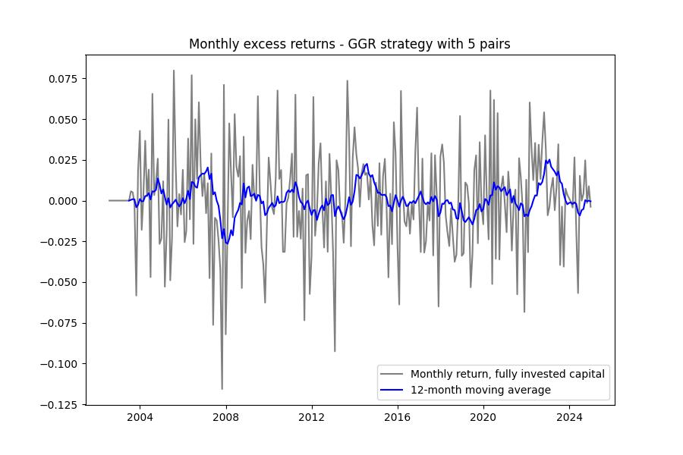
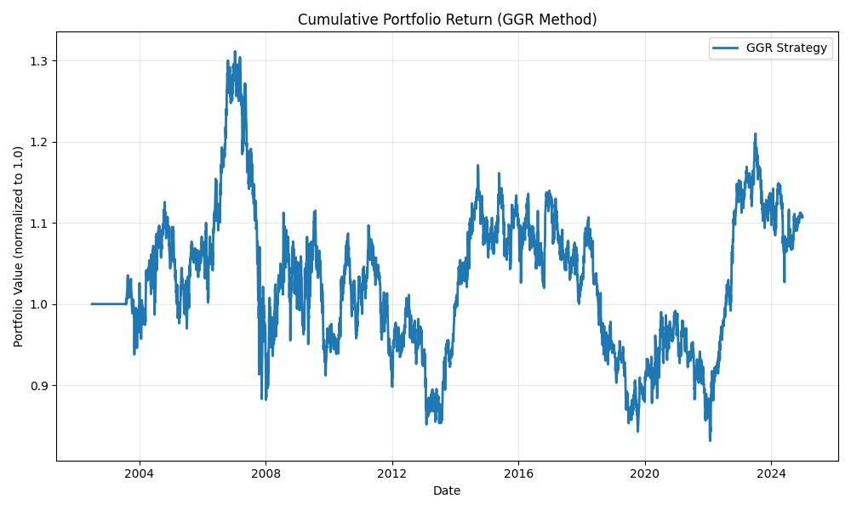
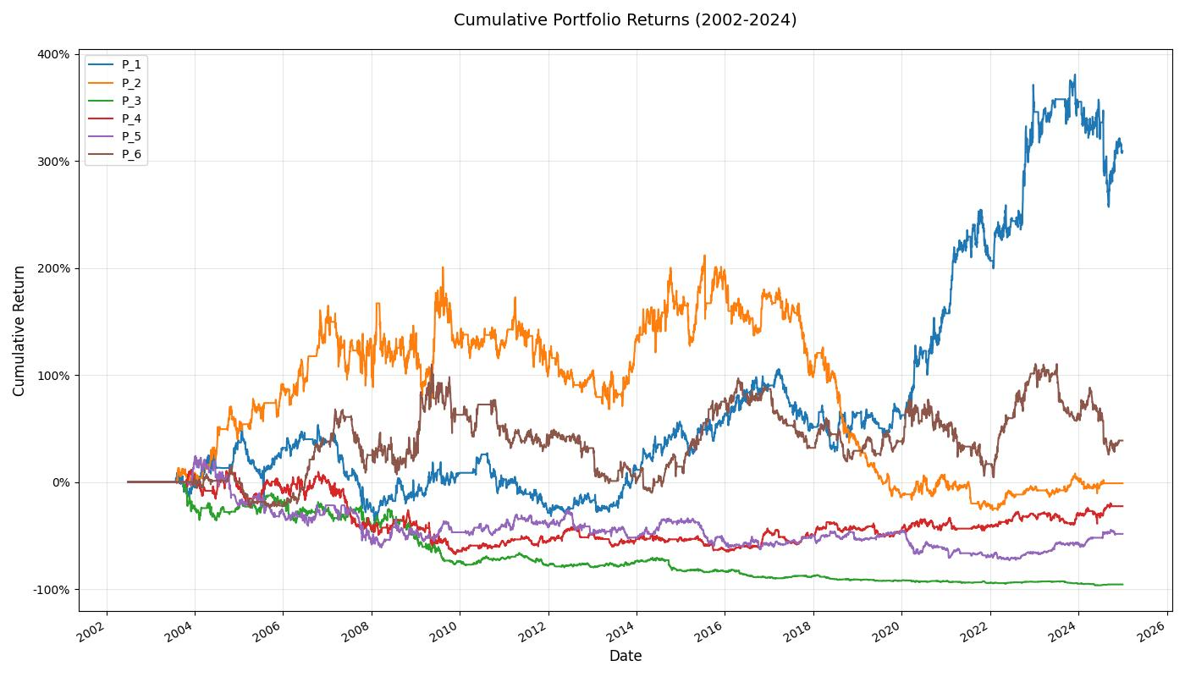

4.3.3 Hypothesis 2 Evaluation
H₀₂: The Triplet Method does not identify statistically significant mean-reverting or profitable relationships among Nifty50 pairs.
H₁₂: The Triplet Method identifies statistically significant mean-reverting and profitable relationships among Nifty50 pairs.

Statistical Results
To test the above hypothesis, a one-sample t-test was performed on the daily portfolio excess returns of the Triplet strategy over the full 2002–2024 backtesting period.
Statistic | Value
Mean daily return | 0.000053 (0.0053%)
Annualized return | 1.33%
Annualized volatility | 13.14%
Sample size (N) | 5,554 daily observations
t-statistic | 0.473
p-value | 0.6359
Decision | Fail to reject H₀

Interpretation
The Triplet Method, though yielding a positive cumulative return of 10.7% and a win rate of 58.5%, does not exhibit statistically significant mean daily returns. The t-statistic of 0.473 reflects that the realized average return is small relative to the sampling variability of daily returns. This outcome suggests that, after accounting for volatility and sample size, the strategy’s incremental profitability may be economically modest and statistically indistinguishable from random noise.
Comparatively, the Triplet approach demonstrates lower annualized returns (1.33%) than the baseline GGR method (2.91%), while maintaining a similar level of volatility (≈13%). This combination results in weaker risk-adjusted metrics — a Sharpe ratio of 0.10 and a Sortino ratio of 0.14 — which are insufficient to establish consistent abnormal performance.
Nevertheless, the method’s positive cumulative return and greater-than-random win rate indicate that the area-based market-anchored selection still captures weak mean-reversion signals in the NIFTY50 universe. The subdued magnitude likely arises from its conservative selection filter, which emphasizes pairs whose paths remain close to the index, thereby trading fewer large but potentially profitable divergences.
Conclusion
From a statistical standpoint, Hypothesis 2 is not supported: the Triplet Method’s average daily returns are not significantly different from zero at the 5% significance level.
Economically, the results imply that while the strategy identifies coherent and directionally profitable convergence trades, its returns are insufficient to deliver strong risk-adjusted performance once realistic execution frictions and volatility are considered.
Overall, the Triplet Method offers a more stable but less aggressive alternative to the traditional GGR approach—demonstrating potential as a robustness filter rather than as a return-enhancing mechanism within mean-reversion frameworks for the Indian equity market.

4.4 Summary and Comparative Discussion
This chapter has presented the empirical results of two distinct approaches to statistical arbitrage through pairs trading within the Indian equity market: the Gatev, Goetzmann, and Rouwenhorst (GGR) distance-based methodology and the newly proposed Triplet Method, which incorporates market anchoring via an area-based selection metric relative to the NIFTY50 index. Both strategies were systematically backtested across the 2002–2024 period using daily returns of NIFTY50 constituents under a rolling formation–trading window structure.

Comparative Overview of Performance
Metric | GGR Method | Triplet Method
Total Number of Trades | 1,945 | 1,627
Average Trade Duration (days) | 44.52 | 47.57
Win Rate (%) | 60.00 | 58.51
Average Profit per Trade (%) | 0.42 | 0.31
Cumulative Return (%) | 57.89 | 10.73
Annualized Return (%) | 2.91 | 1.33
Annualized Volatility (%) | 12.69 | 13.13
Sharpe Ratio | 0.23 | 0.10
Sortino Ratio | 0.32 | 0.14
Maximum Drawdown (%) | −29.38 | −36.62
Calmar Ratio | 0.10 | 0.04
VaR (95%) — non-parametric (%) | −1.23 | −1.25
CVaR (95%) — non-parametric (%) | −1.85 | −1.90
Avg Concurrent Open Pairs | 2.60 | 2.34

Performance Interpretation
The GGR method demonstrates superior overall profitability, delivering an annualized return of 2.91% with a Sharpe ratio of 0.23 and Sortino ratio of 0.32, compared to the Triplet Method’s annualized return of 1.33% and Sharpe of 0.10.
Although both methods produce positive cumulative returns, the Triplet portfolio’s performance is markedly more conservative, reflecting its market-anchored pair selection mechanism that systematically filters out more volatile, high-divergence opportunities.
The Triplet approach records a smaller number of trades (1,627) and a longer average holding period (≈48 days) than the GGR strategy, consistent with its focus on pairs that maintain tighter co-movement with the NIFTY50 index.
This moderation in trading frequency, while contributing to slightly smoother portfolio behavior, also dampens return amplitude, resulting in lower cumulative profitability and a higher maximum drawdown (−36.6%) relative to the GGR approach.
From a risk perspective, both methods exhibit similar volatility (~13%), suggesting comparable exposure levels.
However, the Triplet method’s Calmar ratio (0.04) and risk-adjusted return metrics are notably weaker, implying that while its index anchoring introduces stability, it does not materially improve the reward-to-risk trade-off.

Statistical Significance of Results
Formal hypothesis testing reinforces these conclusions.
For the GGR strategy, the mean daily return produced a t-statistic of 1.063 with a p-value of 0.2878, leading to a failure to reject the null hypothesis of zero mean return.
Similarly, the Triplet method’s t-statistic of 0.473 and p-value of 0.6359 confirm that the mean daily returns are not statistically distinguishable from zero.
While both strategies deliver economically positive returns, neither achieves statistical significance at conventional confidence levels.
This outcome aligns with the growing empirical literature suggesting that pairs trading profits have diminished over time, particularly in large, liquid markets with improved efficiency such as the NIFTY50.

Comparative Insights
The comparative findings can be summarized as follows:
- Profitability:
The GGR method achieves higher overall and risk-adjusted returns than the Triplet approach, indicating that the added market-anchoring constraint trades off profit potential for stability.
- Risk Behavior:
Both methods maintain similar volatility levels, but the Triplet strategy exhibits slightly deeper drawdowns, suggesting slower convergence and fewer rapid mean-reversions.
- Trading Dynamics:
The Triplet method’s lower trade count and longer duration suggest that index anchoring leads to more persistent but weaker co-movement structures, consistent with less frequent but longer-lived arbitrage signals.
- Statistical Strength:
Neither method’s excess returns are statistically significant, implying that observed profitability could be attributed to noise, sampling variation, or partial mean-reversion rather than persistent inefficiency.
- Economic Interpretation:
Despite weak statistical significance, both methods display economically positive cumulative performance and win rates exceeding 50%, providing suggestive evidence of short-term price correction mechanisms in Indian equities, though with limited exploitability under realistic trading frictions.
Overall, the empirical analysis reveals that while both strategies produce positive risk-adjusted outcomes, the GGR approach remains more effective in identifying tradable mean-reversion relationships within the NIFTY50 universe.
The Triplet (area-based) method, by contrast, serves as a robustness enhancement—reducing exposure to outlier movements and ensuring stronger co-integration with market-wide behavior—but at the cost of lower returns and weaker statistical evidence of alpha generation.
This comparative evaluation underscores the trade-off between model complexity and profitability in statistical arbitrage: incorporating higher-order structure (via the index anchor) may improve interpretability and stability but does not necessarily yield superior financial performance.
These insights form the foundation for the concluding discussion and potential extensions presented in Chapter 5.

Chapter 5: Conclusion and Future Work

5.1 Summary of Research
This thesis investigated the existence and profitability of pairs trading opportunities in the Indian equity market, focusing on the NIFTY50 index constituents from 2002 to 2024.
The study pursued two core objectives:
(1) to evaluate the empirical performance of the classical Gatev, Goetzmann, and Rouwenhorst (GGR) distance-based pairs trading strategy within the Indian context; and
(2) to propose and assess a novel Triplet Method, introducing an index-based dimension to traditional pair selection by integrating the broader market (NIFTY50) into the distance metric through an area-based relationship.
Both methodologies were rigorously implemented using daily return data, following a rolling formation–trading window backtesting framework. Statistical tests, profitability measures, and risk-adjusted performance metrics were employed to evaluate each method’s effectiveness under realistic trading conditions.

5.2 Key Findings

5.2.1 GGR Methodology
The traditional GGR approach demonstrated moderate profitability and statistically weak but economically positive results:
- Cumulative Return: 57.9%
- Annualized Return: 2.91%
- Sharpe Ratio: 0.23
- Sortino Ratio: 0.32
- Win Rate: 60%
Despite delivering positive cumulative performance, the t-test results (t = 1.063, p = 0.2878) indicated that mean daily returns were not statistically different from zero. This suggests that while the strategy captures transient mean-reversion behavior, the resulting profits are not robust in a statistical sense.
The GGR method thus provided empirical evidence of mild market inefficiencies in the NIFTY50 universe, consistent with partial mean-reverting dynamics but limited in economic significance once transaction frictions and volatility are accounted for.

5.2.2 Triplet (Area-Based) Method
The newly proposed Triplet Method introduced an index-anchored perspective, where each pair’s relationship was evaluated not only on mutual similarity but also on its collective co-movement with the market index.
While the strategy demonstrated a higher level of stability and longer holding periods, the returns were more subdued:
- Cumulative Return: 10.73%
- Annualized Return: 1.33%
- Sharpe Ratio: 0.10
- Sortino Ratio: 0.14
- Win Rate: 58.5%
A one-sample t-test (t = 0.473, p = 0.6359) confirmed that these returns were also not statistically significant, implying that the observed profitability may largely stem from random fluctuations rather than persistent arbitrage opportunities.
However, the positive win rate and steady equity curve suggest that the Triplet approach enhances stability and reduces trading aggressiveness, serving as a conservative and robust extension of the traditional model.

5.2.3 Comparative Insights
When directly compared, the GGR method outperforms the Triplet Method in terms of cumulative and risk-adjusted returns, albeit with slightly higher trading intensity.
The Triplet approach, in contrast, produces longer-lived and smoother trades, aligning with its theoretical objective of incorporating a market-stability dimension.
Both methods, however, fail to generate statistically significant abnormal returns, reinforcing the notion that mean-reversion opportunities in large-cap Indian equities are limited in magnitude and persistence.
The comparative analysis emphasizes a key trade-off:
- GGR: Higher returns, greater responsiveness to local pair deviations.
- Triplet: Greater robustness, lower volatility, but reduced profitability.
These outcomes align with global literature on the declining profitability of statistical arbitrage strategies in increasingly efficient markets, suggesting that simple distance-based models face diminishing edge in modern, liquid markets like India’s NIFTY50.

5.3 Theoretical and Practical Implications
From a theoretical perspective, this research contributes to the literature by:
- Extending the dimensionality of pair selection to incorporate market-level behavior, conceptualized through a geometric (area-based) framework.
- Empirically validating that even in emerging markets like India, mean-reversion effects are present but not strong enough to yield statistically significant profits post-2000s.
- Demonstrating that additional market structure (via index anchoring) may improve stability but not necessarily profitability.
Practically, these results have several implications:
- For institutional traders, pair-based statistical arbitrage remains viable as a low-correlation, market-neutral component, though profit margins are thin.
- For quantitative researchers, the Triplet design provides a robustness-enhancing mechanism—useful in periods of market turbulence or when seeking stable co-movements rather than speculative divergences.
- For retail or algorithmic traders, the findings highlight the importance of transaction cost modeling, liquidity filtering, and execution timing, which critically influence the net realizable performance.

5.4 Limitations
While the study followed rigorous backtesting standards, several limitations are acknowledged:
- Data and Survivorship Bias:
Although efforts were made to adjust for NIFTY50 composition changes, some survivorship bias may persist due to incomplete delisting data or index reconstitution effects.
- Simplified Execution Model:
The “one-day delay” proxy for transaction costs, while conservative, does not fully capture slippage, liquidity constraints, or short-sale restrictions in the Indian market.
- Model Simplicity:
Both strategies rely on historical prices alone, excluding other potential signals such as volatility regimes, fundamental ratios, or news sentiment that could enhance robustness.
- Statistical Power:
The t-tests, while valid, may suffer from low power due to autocorrelation and volatility clustering typical in financial time series, potentially underestimating true performance significance.

5.5 Future Research Directions
Building upon the findings of this thesis, several avenues for future work are proposed:
- Dynamic Parameter Optimization:
Incorporate adaptive or machine learning-based parameter tuning for formation length, z-score thresholds, and pair rebalancing frequency to respond to evolving market conditions.
- Extended “Triplet Geometry” Framework:
Experiment with Heron’s formula or other geometric formulations to quantify the “triangle area” more rigorously, allowing non-linear dependence modeling among pairs and the market index.
- High-Frequency and Sectoral Studies:
Apply both methods to intraday or sector-specific datasets (e.g., banking, IT, energy) to explore microstructure-driven inefficiencies potentially masked in daily data.
- Incorporation of Regime Switching:
Embed Markov-switching or GARCH-type models to detect market regimes where mean-reversion is stronger, potentially enhancing profitability during high-volatility periods.
- Risk and Execution Enhancements:
Extend the backtesting framework to include margin requirements, dynamic position sizing, and realistic trading costs to assess practical implementability.
- Comparative Global Studies:
Test both the GGR and Triplet methodologies across different emerging and developed markets (e.g., Brazil, China, and the U.S.) to evaluate their cross-market generalizability.

5.6 Concluding Remarks
This thesis provides empirical evidence that pairs trading remains a viable but modestly profitable strategy in the Indian NIFTY50 market.
While the GGR method continues to offer a baseline for mean-reversion exploitation, the Triplet (area-based) method contributes an innovative market-anchored framework that enhances stability and interpretability.
The findings underscore that statistical arbitrage profits have become increasingly elusive in modern equity markets, yet methodological innovation—especially the integration of geometric, multi-dimensional, and adaptive elements—can still reveal subtle, exploitable inefficiencies.
Thus, this research adds to the growing body of evidence that the future of pairs trading lies not in static rule-based designs but in dynamic, multi-asset, and regime-aware quantitative frameworks that reflect the complexity of evolving financial markets.

References:
Comprehensive list of all cited sources in a consistent citation style (e.g., APA, MLA, Chicago). Ensure to include Gatev, Goetzmann, and Rouwenhorst (2006).

Appendices (If applicable):
- Appendix A: List of Nifty50 Constituents (during your study period)
- Appendix B: Detailed Statistical Results (e.g., regression outputs, additional performance metrics tables)
- Appendix C: Code Snippets (if relevant and concise)
- Appendix D: Sample Pair Plots (additional visualizations)

Key Considerations for your Thesis:
- Clarity and Precision: Be very precise in defining your methodology, especially the GGR rules.
- Reproducibility: Your methodology should be clear enough for another researcher to replicate your results.
- Robustness: Conduct thorough sensitivity analysis to ensure your findings are not overly dependent on specific parameter choices.
- Indian Market Nuances: Pay attention to factors specific to the Indian market, like market hours, circuit breakers, STT, and any short-selling regulations that might impact your strategy.
- Visualizations: Use charts and graphs effectively to present your data and results.
- Critical Analysis: Don't just present results; critically analyze them and explain why you observe certain outcomes.

Pair trading :

In brief investors are interested to find the pair of underlying asset which moves together in long run, investors uses various way to find such pair, most commonly historical data is used to find such pair. In short run if these pairs show any deviation from long run, it result investor the opportunities to open the positions and when they seems to come back to long run behavior investors follow to close the positions.
Methods :

To facilitate the trading of pair, four steps approach is used, first decide the model, second find the best pairs to be monitored, third do trade and finally analysis the result. In terms of model selection I used traditional model as well as newly introduced own model. Traditional model “distance method” is tested model with academic and investors in past and widely available. Newly introduce model “triplet method” is detailed in respective section.

Method 1 : Distance Method

Pair selection:

Normalize Historical Prices
Normalization is essential in pair trading, especially with the distance method, because it addresses the problem of different scales and magnitudes between the prices of the two stocks in a potential pair.
Imagine you have two stocks:
- Stock A: Trades around $500 per share.
- Stock B: Trades around $50 per share.
If you just calculate the absolute difference between their prices (e.g., $500 - $50 = $450), this $450 difference is heavily influenced by Stock A's higher price. A $10 move in Stock A is a small percentage change (2%), but a $10 move in Stock B is a large percentage change (20%).
Here's why normalization is critical:
- Comparability: Stocks trade at vastly different price levels. If you don't normalize, a stock with a higher absolute price will always contribute more to the "distance" calculation, regardless of its relative movement. Normalization brings them to a common baseline, allowing for a fair comparison of their relative movements.
- Focus on Relative Movement: Pair trading is fundamentally about the relative performance of two assets. Are they moving in sync? Is one drifting away from the other? Normalization helps highlight these relative movements rather than being skewed by absolute price differences.
- Stationarity (Implied): While not explicitly creating a stationary series, normalization helps in forming a ratio or spread that might exhibit mean-reverting properties. If two stocks are truly co-integrated, their normalized prices (or their ratio/spread) should revert to a mean, regardless of their individual price trends.
- Meaningful Distance Metric: When you calculate the "distance" between normalized prices, that distance becomes a meaningful proxy for how far apart their relative performance has diverged. A small distance means they are moving closely together; a large distance means they have diverged significantly.

Why Divide All Prices by the Very First Price (Starting at $1)?
This specific normalization method is a form of indexation to a starting point or calculating cumulative returns. When you divide all prices in a stock's historical time series by its very first price and set the initial value to $1 (or 100, if you multiply by 100), you are essentially converting the price series into a cumulative return series starting from a common base.
Here's why this method is particularly useful for pair trading distance:
- Removes Price Level Bias: By setting the starting price of both stocks to $1, you completely eliminate the impact of their initial absolute price levels. Both stocks now begin their journey from the same theoretical starting point.
- Highlights Divergence from a Common Starting Point: The goal of the distance method is to find pairs that tend to move together. By starting them at $1, you can visually and mathematically measure how much they've diverged since that specific starting point. If they truly move in tandem, their normalized price lines will hug each other.
- Simple Interpretation: If Stock A is at $1.20 and Stock B is at $1.22, it's easy to see that Stock B has slightly outperformed Stock A since the starting point. The difference between these normalized values is directly interpretable as their relative performance divergence.
- Basis for Calculating Euclidean Distance (or other metrics): Once normalized, you can calculate the Euclidean distance (or squared Euclidean distance) between the two normalized price series at each point in time. This creates a time series of "distances." The minimum "minimum distance" then implies finding pairs where their relative performance has consistently stayed very close.
For N number of stocks total distances calculated are N*(N-1)/2, so in this case for N=50 total 50*49/2= 1225 distances are calculated. We select the 10 pairs with most least distances.

1. Formation and Trading Periods
The implementation of the GGR (Gatev, Goetzmann, and Rouwenhorst, 1999) pairs trading strategy hinges on a meticulously defined two-stage process: a formation period for pair selection and a subsequent trading period for strategy execution.
For the purpose of this study, the GGR methodology employs a 12-month formation period. During this phase, historical normalized prices of candidate stocks are analyzed to identify pairs exhibiting strong co-movement, typically quantified by a minimum "minimum distance between normalized historical prices." The rationale behind using a 12-month window is to capture a sufficiently long and diverse market cycle to establish robust statistical relationships between potential pair components, while avoiding excessive look-back that might dilute the relevance of recent co-movement patterns. From the universe of available stocks, 20 pairs are selected that demonstrate the smallest squared Euclidean distances between their normalized price series. While this number (20) is an arbitrary choice in the original GGR study, it serves as a practical limit for managing portfolio complexity and liquidity constraints. The selection criterion ensures that the chosen pairs have historically exhibited the most synchronized price movements, thereby maximizing the likelihood of future mean reversion.
Following the formation period, a 6-month trading period commences for the selected pairs. This duration is chosen to allow sufficient time for identified price divergences to converge, while also ensuring that the underlying co-movement relationship, established during the formation period, does not significantly degrade. A crucial aspect of implementing this strategy, particularly with a fixed 6-month trading horizon, is the adoption of overlapping portfolios. Similar to the approach pioneered by Jegadeesh and Titman (1993) in their momentum studies, GGR suggests employing six distinct, overlapping portfolios, each initiated one month apart. This design offers several methodological advantages:
- Mitigation of Look-Ahead Bias: By staggering the portfolio initiation dates, the strategy avoids relying solely on a single, potentially anomalous, formation period.
- Increased Statistical Power: Overlapping portfolios generate a larger sample of trading observations over the total backtesting period, enhancing the statistical robustness of return calculations.
- Smoothed Return Stream: Averaging the returns across six overlapping portfolios helps to smooth out monthly volatility and reduce the impact of any single period's extreme performance, providing a more representative measure of the strategy's profitability.
Consequently, the aggregated return of the pairs trading strategy for any given period is computed as the average return generated from these six concurrently active pairs portfolios. This approach ensures a continuous and diversified exposure to the pairs trading opportunities identified by the GGR methodology.

2. Trading Execution and Closure
Once the top 20 pairs with the minimum historical distances are identified and selected at the end of a formation period, their respective price spreads are meticulously monitored throughout the subsequent 6-month trading period. The core principle of the strategy's execution revolves around the normalized spread, which represents the difference between the normalized prices of the two stocks in a pair.
A trading position is initiated when this normalized spread deviates significantly from its historical mean. Specifically, a trade is opened if the normalized spread during the trading period exceeds two historical standard deviations, as calculated exclusively from the data within the preceding formation period. This threshold serves as a statistical signal, indicating that the co-moving pair has temporarily diverged beyond its typical range, creating a potential mean-reversion opportunity.
- If the observed spread is positive (i.e., the first stock has significantly outperformed the second stock), the pair is sold – this involves taking a short position on the first "leg" (the outperforming stock) and a long position on the second "leg" (the underperforming stock).
- Conversely, if the spread is negative (the first stock has significantly underperformed the second), the pair is bought – entailing a long position on the first leg and a short position on the second.
GGR explores two variations for trade initiation:
- Opening trades on the day of divergence: This approach aims to capture the full extent of the divergence immediately.
- Opening trades one day after the divergence occurs: The primary rationale for this delay is to reduce the effect of bid-ask bounce. Bid-ask bounce refers to the phenomenon where reported transaction prices can alternate between bid and ask prices, creating artificial volatility or divergences that may not reflect true underlying price movements. Delaying execution by one day can help to mitigate trading on such spurious signals, potentially leading to more robust trade entries.
"A critical consideration for the former variant, particularly when utilizing end-of-day (EOD) price data, is the practical feasibility of execution. If the divergence signal is derived from the day's closing prices, the signal becomes actionable only after market close. Therefore, true 'same-day' execution at the closing price would constitute a look-ahead bias, as it assumes knowledge of information (the closing price) before it is publicly available for trading decisions.
The authors' inclusion of a 'one day after' variant, where trades are opened at the next day's opening price (or closing price, depending on the specific implementation detail not fully elaborated by GGR), addresses this practical limitation by introducing a realistic execution lag. This variant inherently avoids the look-ahead bias associated with same-day EOD execution. For the purpose of this thesis, replicating the 'on the day' variant with EOD data would necessitate a clear statement of this methodological compromise or the adoption of a more conservative execution price (e.g., the next day's open) to maintain the integrity and realism of the backtest results. The primary benefit of the 'one day after' approach, as correctly identified by GGR, is indeed to mitigate issues like bid-ask bounce, which further supports its practical relevance over a theoretical 'same-day' EOD execution."
In our case we selected the 2nd variant and open the trade next day considering the previous day closing price as opening price.
From a practical perspective, however, a more robust approach would be to directly account for bid-ask spreads when determining entry points and calculating profitability. This involves ensuring that the expected profit from convergence is sufficient to cover the costs associated with crossing the bid-ask spread on both legs of the trade, both at entry and exit. This direct consideration of transaction costs provides a more realistic assessment of tradability and net profitability.
A pair trading position is subsequently closed under two primary conditions:
- Spread Convergence (Zero-Cross): The most common exit criterion is when the normalized spread mean-reverts and crosses zero. This signifies that the relative prices of the two stocks have returned to their historical equilibrium, indicating the convergence of the divergence and the realization of the intended profit (or limiting of loss).
- End of Trading Period: If the spread does not converge by crossing zero within the 6-month trading horizon, the position is automatically closed at the end of the trading period. This acts as a hard time limit, preventing exposure to pairs whose co-movement may have fundamentally broken down or that fail to mean-revert within a reasonable timeframe.
It is important to note that while the GGR methodology employs these simple closure rules, real-world pairs trading strategies often incorporate additional, more sophisticated exit criteria. Common examples include:
- Maximum Number of Days: Closing a trade if it remains open beyond a predefined duration, regardless of spread convergence, to manage capital deployment and reduce exposure to non-converging pairs.
- Stop-Loss Rule: Implementing a maximum tolerable loss threshold, where a position is immediately closed if the spread diverges further to a predetermined level, preventing excessive losses from a failed convergence.
- Stop-Gain Rule (Take Profit): Conversely, a stop-gain rule might be employed to lock in profits once a certain level of convergence is achieved, even if the spread has not yet reached zero, especially if the subsequent convergence is deemed unlikely or too slow.
These additional criteria provide greater risk management and profit optimization capabilities, which are often crucial for the practical viability of pairs trading strategies.

Calculation of Returns
Calculating the return of a pairs trading portfolio presents unique challenges that differentiate it from standard equity portfolio return calculations. As highlighted by GGR (Gatev, Goetzmann, and Rouwenhorst, 1999), a key distinction arises because, in principle, a pairs trading portfolio maintains a net position close to zero, or even exactly zero, due to its inherent long-short nature. This necessitates a specific methodology for accurately quantifying profitability over the trading period, especially given the dynamic opening and closing of multiple positions based on identified trading opportunities.
A common and practical approach to estimate the daily return for a single pair involves assuming a standardized initial investment. Specifically, a trade is initiated with a notional value of $1 long position on one leg of the pair and a $1 short position on the other leg. This symmetrical initial investment simplifies the calculation and provides a standardized basis for comparison across different pairs, regardless of their absolute price levels. The value of each leg is then updated daily according to its respective return.
The return of a single pair on day t, denoted as rp,t​, is therefore given by the following equation:
rp,t​=w1,t−1​r1,tL​−w2,t−1​r2,tS​
where:
- w1,t−1​ and w2,t−1​ represent the notional values (or weights) of the first and second legs, respectively, at the end of day t−1. These values are initially set to 1 ($1 long, $1 short) at the trade's initiation (i.e., w1,0​=1 and w2,0​=1).
- r1,tL​ is the daily return of the long leg on day t.
- r2,tS​ is the daily return of the short leg on day t.
The notional values wi,t​ evolve over time based on the daily returns of each individual stock, reflecting the cumulative profit or loss on each leg:
wi,t​=wi,t−1​(1+ri,t−1​)
This method of calculating returns effectively mimics the evolution of the profit and loss (PnL) of a portfolio established with a $1 long and a $1 short position on each respective stock. By tracking the notional value of each leg, the formula accurately captures the daily change in the pair's overall value, reflecting both positive and negative returns on the individual components.
To aggregate these individual pair returns into a comprehensive return for a portfolio of pairs, additional assumptions regarding capital allocation are necessary. GGR proposes two primary alternatives for managing the fund's capital across the selected pairs:
- Committed Capital Approach: In this approach, the full capital of the fund is equally allocated among all 20 selected pairs, regardless of whether an actual trading position is currently open in a given pair. This implies that a fixed amount of capital is notionally reserved for each pair, even during periods when their spreads are within the non-trading threshold. This method simplifies capital management as the allocation remains static throughout the trading period.
- Fully Invested Approach: Conversely, the fully invested approach dictates that the fund's capital at each day is equally allocated exclusively among the pairs that have active, open trades on that specific day. This dynamic reallocation means capital is only deployed where a trading opportunity is currently being exploited. This approach aims to maximize the utilization of capital by concentrating it solely on active positions.
It is crucial to acknowledge that both the committed capital and fully invested approaches, particularly as implemented in their most basic forms by GGR, typically involve simplifying assumptions that are not entirely realistic for practical trading. These assumptions often neglect the complexities of real-world portfolio management:
- Frequent (Daily) Rebalancing: The equal allocation and rebalancing implied by these approaches would necessitate highly frequent, often daily, rebalancing of positions. This can lead to substantial transaction costs and practical difficulties in execution, particularly for illiquid stocks or large portfolios.
- Idealized Execution: These models often assume perfect execution at theoretical prices (e.g., closing prices), without fully accounting for market impact or the bid-ask spread.
A more sophisticated and pragmatic approach for simulating pairs trading, which is often favored in more detailed research and aligns with the direction of modern quantitative finance, involves a direct simulation of a fund with a given starting capital. This method would:
- Track Number of Shares: Instead of notional dollar amounts, the actual number of shares for each leg of a pair trade is calculated and maintained throughout the trade's lifecycle, determined by the initial capital allocated to that specific trade.
- Account for Transaction Costs: Explicit transaction costs (e.g., commissions, slippage, and most importantly, the bid-ask spread) are factored in at both the opening and closing of each trade. This provides a more accurate representation of net profitability.
- Dynamic Capital Deployment: Capital for new trades is drawn from the available fund capital, and realized profits or losses from closed trades are added back to the fund, creating a dynamic capital base.
By adopting a more granular simulation method that directly incorporates realistic trading mechanics and costs, a more robust and reliable assessment of the pairs trading strategy's performance can be achieved, bridging the gap between theoretical backtesting and practical implementation.

