762 DATA MINING & PROJECT

- All SAS code: Provided as separate pdf file: Prof762_Model

2. HISTOGRAMS: Non-Transformed & Transformed Continuous Variables

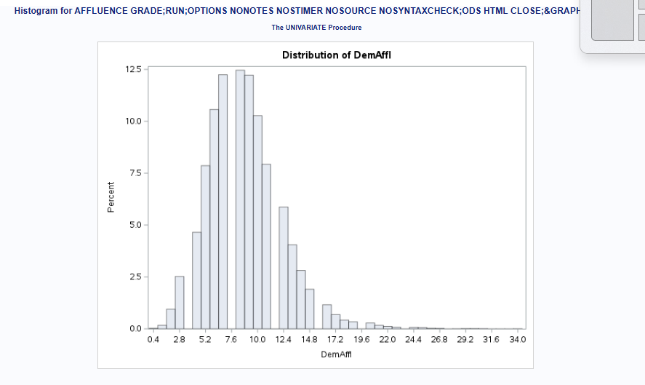

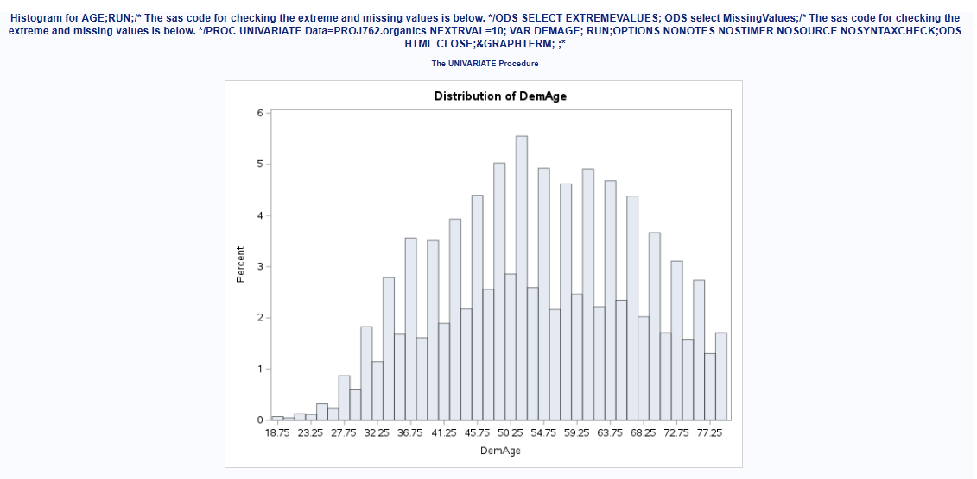

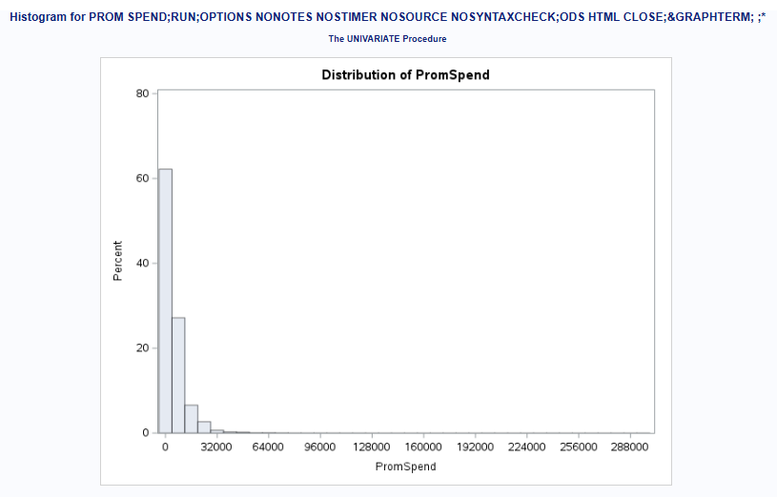
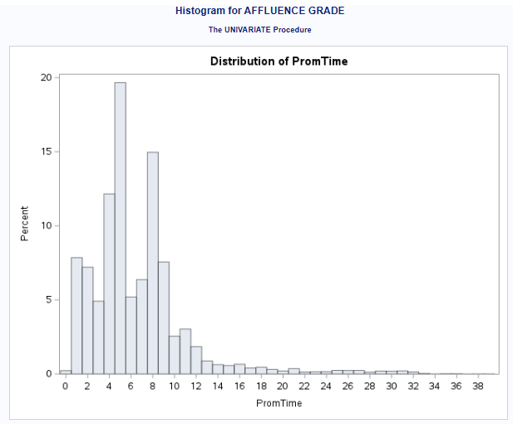

HISTOGRAMS of LOG Transformed Variables
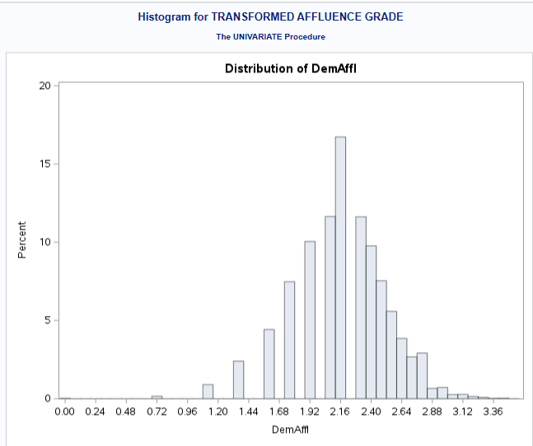
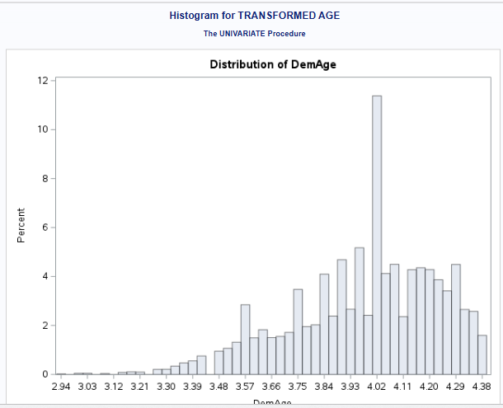

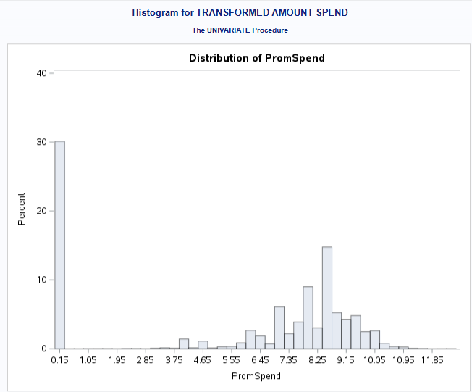
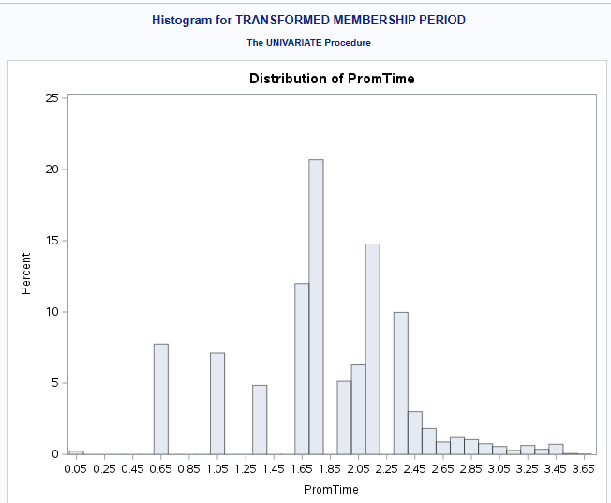i

3. MISSING VALUES & SKEWED DISTRIBUTIONS
 | Variables with Missing Values | Variables with Skewed Distribution
1 | DemClusterGroup (674) | DemAffl – Positively Right skewed
2 | DemGender (2513) | DemAge – Negligently Right skewed
3 | DemReg (466) | PromSpend: Positively Right skewed
4r | DemTVReg (465) | PromTime – Strongly Positively Right skewed
5 | DemAffl (1085)
6 | DemAge (1059)
7 | PromTime (281)

4. FIRST ROUND VARIABLE SELECTION
 | SELECTED VARIABLES
1 | DEMGENDER
2 | DEMAFFL
3 | DEMAGE
4 | DUMPLATNUM
5 | DEMAFFL_IND
6 | DEMAGE_IND

5. MODELS USED
No. | MODELS USED
1 | Logistic Regression
2 | Support Vector Machine
3 | Neural Network

6. TABLE SUBMISSION: PRECISION/RECALL/ACCURACY – NON-TRANSFORMED VARIABLES

7. TRANSFORMED VARIABLES SELECTION with MODEL MEASUREMENTS
Id | VARIABLES
1 | DEMAFFL
2 | DEMAGE
3 | DEMGENDER
4 | DUMPLATNUM

8. ANALYSIS OF LOG TRANFORMATION vs NON-LOG TRANSFORMATION
Overall, the results indicate that log transformation produced a modest but consistent performance gains when compared to the non-transformed models, particularly in terms of Accuracy and Recall for the positive class (class = 1) – that a customer subscribed to purchase organic products. The most notable improvement was in the base neural network model: Recall increased from 0.299 to 0.444, and accuracy rose from 80.23% to 81.28%.
Conclusively, log transformation made a positive difference especially with the Neural Network model. The improvements, though modest are consistent across all evaluated metrics (Recall, Precision, Accuracy, F1-Score) suggesting that the transformation likely helped normalize skewed features or reduce outlier influence, enabling the models to learn better patterns.
9. NOTHING ELSE

