
October Social Media Plan / Ideas

- This is a guide with ideas and suggestions for your social posts throughout October.
- Canva Templates (feel free to amend if you want to): PLEASE CLICK USE TEMPLATE AS NEW DESIGN - https://canva.link/sy7j7l1gwusz31u

- Some posts are created for you, but we encourage you to try and create your own from the ideas given.
- We encourage you to create your own captions to ensure they are personal and local to your office. Add emojis too if needed.
- Remember that you cannot put links in an Instagram caption.

Day | Content Idea | Copy | Image
1st October | Home help | Home is where we like things done our way. 🏡  This #InternationalDayOfOlderPersons, we’re celebrating the familiar routines that help make home feel like home.  From preparing meals to light housekeeping and shopping, our Home Help service can lend a hand with everyday tasks, helping older adults continue living life their way.  Because when everyday tasks are taken care of, there’s more opportunity to enjoy Weekends Well Spent with the people who matter most.  Discover Home Help from Home Instead [office]: [insert link] | 
2nd October | Family carers | Caring for someone you love can become part of everyday life.  Our recent research found that 38% of family carers rarely get time for themselves at the weekend.  Having the right support can help share some of that responsibility, while helping your loved one stay safe, well and independent at home.  At Home Instead [office], we’ll take time to understand what support works for you and your family, helping create more opportunities to enjoy Weekends Well Spent together.  Find out more here: [insert link] | 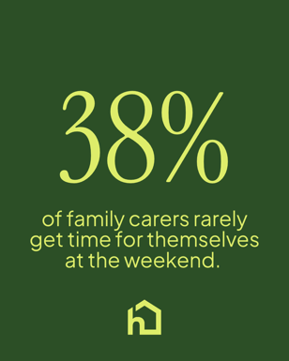
3rd October | Teaser post | 📺 Love Your Weekend returns tomorrow!  We’re proud to once again sponsor ITV’s Love Your Weekend, celebrating hobbies, the countryside and quality time together.  We can’t wait for another series full of inspiration for Weekends Well Spent.  Will you be watching?  #LoveYourWeekend #LoveYourWeekendAgain #ProudSponsors | 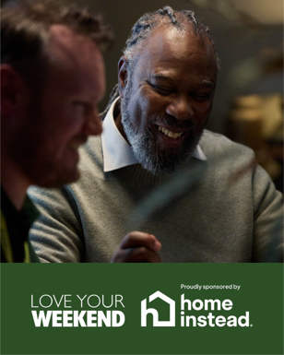
5th October | Family life | Sometimes, you just want to be their daughter, son or partner again.  Our recent research found that 44% of family carers say caring has changed their relationship with the person they support.  Our Care Professionals can help share caring responsibilities, creating more opportunities for conversations, shared interests and Weekends Well Spent together.  If you are considering additional support for your loved one, talk to our local team: [insert link]  #LoveYourWeekend #LoveYourWeekendAgain #WeekendsWellSpent | 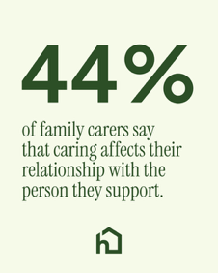
7th October | Time to fill your cup | Weekends are a time to recharge.  Our recent research found that 46% of family carers who receive professional care say it reduces stress for the whole family.  Our Care Professionals can give you more time to relax, make plans or simply enjoy your weekend, knowing your loved one has the support they need at home.  Because everyone deserves Weekends Well Spent.  If you’d like to find out more about Home Instead [office] and the support available, please visit: [insert link]  #LoveYourWeekend #LoveYourWeekendAgain #WeekendsWellSpent | 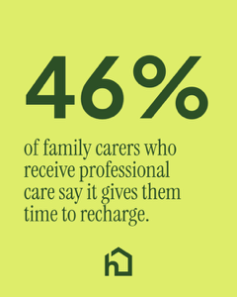
9th October | Weekends Well Spent | 83.6 million hours.  That’s the estimated amount of weekend leisure time lost every week to family caring responsibilities across Britain, based on Home Instead’s latest YouGov research.*  Every family deserves time to enjoy weekends together, whether that’s sharing a favourite hobby, getting outdoors or simply spending time with the people they love.  That’s why we’re proud to champion Weekends Well Spent.  Find out how Home Instead [office] can help families create more meaningful moments together: [insert link]  #WeekendsWellSpent #LoveYourWeekend #LoveYourWeekendAgain  Estimated national figure calculated by the client using YouGov survey data. | 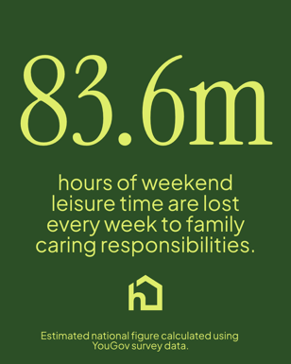
10th October | 41% of family carers | There’s room for shared moments, too. 💚  Our recent research found that 41% of family carers spend more time providing care than enjoying leisure activities with the person they support.  With the right support, families can have more opportunities to enjoy the things they have always loved doing together, from a favourite programme to an afternoon out.  Helping families enjoy more Weekends Well Spent. 💚  Visit our website [insert link] or get in touch with our team on [insert number].  #LoveYourWeekend #LoveYourWeekendAgain #WeekendsWellSpent | 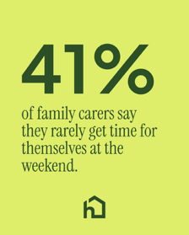
13th October | Care Professional support | Balancing work with caring for someone you love isn’t always easy.  This #NationalWorkLifeWeek, we’re thinking about the family carers fitting caring responsibilities around meetings, commutes and everything else life brings.  You don’t have to wait until you’re running on empty to ask for support.  Find out how Home Instead [office] could help: [insert link] | 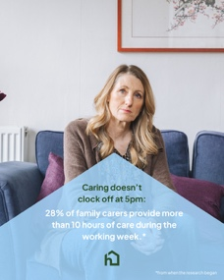
16th October | Caring for ‘you’ too | What would you do with more time for you?  Taking time for yourself isn’t selfish, it’s important. Having the right support can help you recharge and spend more meaningful time with the people you love.  Let us know in the comments! | 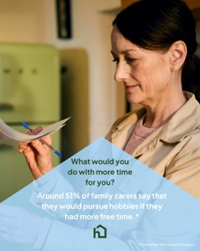
17th October | Love Your Weekend - new episodes | Love Your Weekend is back on our screens! 📺  The nation’s favourite gardener, Alan Titchmarsh, returns to celebrate the best of British countryside, culture, manufacturing and more.  As proud sponsors of ITV’s Love Your Weekend, Home Instead is celebrating Weekends Well Spent and creating more opportunities for families to enjoy meaningful moments together.  Will you be tuning in this weekend?  #WeekendsWellSpent #LoveYourWeekend #LoveYourWeekendAgain #ProudSponsors | 
20th October | Autumn wonders | Autumn has its own pleasures. 🍁  Crisp walks, cosy afternoons, comfort food and evenings spent with good company.  However you spend your weekend, we hope it’s one that’s well spent.💚  What do you enjoy most about this time of year?  #WeekendsWellSpent #LoveYourWeekend #LoveYourWeekendAgain #ProudSponsors | 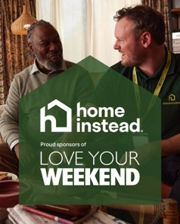
21st October | Local weekend recommendations | We’re looking for weekend inspiration in [location]! 🍂  📍 Where would you recommend for a relaxed afternoon with someone you love?  Share your favourite local spot in the comments and help inspire more Weekends Well Spent.  #WeekendsWellSpent #LoveYourWeekend #LoveYourWeekendAgain #ProudSponsors | 
23rd October | Favourite way to spend a weekend | [Client name] and Care Professional [name] recently enjoyed [insert activity] together at [insert local place].  It’s moments like these that make Weekends Well Spent.  How do you like to spend your weekends in [location]? Tell us in the comments.  #WeekendsWellSpent #LoveYourWeekend #LoveYourWeekendAgain | 
24th October | End of British Summer Time -Facebook poll | More time to love your weekend! 🕓💚  The clocks go back in the early hours of tomorrow morning, giving us an extra hour this weekend.  How will you spend yours?  A Well-earned lie-in  B. Getting out in the countryside  C. Spending time with the people I love  D. Cosying up with a good book or TV show  Here’s to Weekends Well Spent.  #WeekendsWellSpent #LoveYourWeekend #LoveYourWeekendAgain | A graphic isn’t required for a Facebook poll.
25th October | Client testimonial | Support can mean more time to enjoy being with the people you love. 💚  Thank you to [insert name] for sharing what care from Home Instead has meant to their family and how it has created more opportunities for Weekends Well Spent together.  #WeekendsWellSpent #LoveYourWeekend #LoveYourWeekendAgain | 
28th October | Describing a perfect weekend | What does your perfect weekend look like? 🍂  Whether it’s getting outdoors, sharing a favourite hobby or simply enjoying time together, we’d love to know.  Share your perfect weekend in the comments!  #WeekendsWellSpent #LoveYourWeekend #LoveYourWeekendAgain | 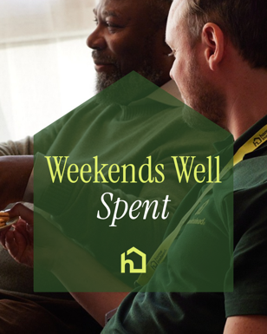
31st October | Halloween weekend | Carving out time for a little Halloween weekend fun? 🎃  Companionship Care can be as simple as decorating a pumpkin, choosing a film to watch or having a chat over a cuppa and a sweet treat.  Because care at home isn’t only about practical help. Sometimes, it’s about helping families enjoy meaningful moments together and creating more Weekends Well Spent.  Find out more about Companionship Care from Home Instead [office]: [insert link]  #WeekendsWellSpent #LoveYourWeekend #LoveYourWeekendAgain | 

