Software Requirements Specification
for
Measurement Process Simulator
Version 1.0 approved
Prepared by Bahar Nisa Tuğrul
Table of Contents
Table of Contents ii
1. Introduction 1
1.1 Purpose 1
1.2 Scope 1
2. Overall Description 2
2.1 Product Perspective 2
2.2 Product Functions 2
2.3 Constraints 2
3. Functional Requirements 3
3.1 User Profiling 3
3.2 Scenario Definition 3
3.3 Automated Scoring 3
3.4 Performance Analysis 3
4. Non-functional Requirements 4
4.1 Usability (UI) 4
4.2 Reliability 4
4.3 Maintainability 4
5. System Design (Analysis Models) 4
5.1 Use Case Diagram 4
5.2 Activity Diagram 5
5.3 Class Diagram 5

Introduction

Purpose

This document defines the software requirements for a Java Swing-based wizard application designed to simulate the ISO/IEC 15939 software measurement process.

Scope
The application facilitates user profiling, quality scenario definition, automated metric scoring, and comprehensive performance analysis.

Overall Description

Product Perspective

A standalone desktop application built using the Model-View-Controller (MVC) architectural pattern to ensure clean separation between logic and UI.

Product Functions
User identification and validation.
- Scenario-based quality modeling (Health/Education).
- Linear normalization of raw quality data.
- Visual gap analysis and reporting.

2.3 Constraints

The system must be developed using only standard Java SE libraries. All measurement data and scenarios are hard-coded.

Functional Requirements

User Profiling

The system shall collect and validate the user’s name, school, and session name before proceeding to the next step.

Scenario Definition

The system shall allow users to select between "Product/Process" types and "Health/Education" modes to load specific quality scenarios.
3.3 Automated Scoring
The system shall automatically calculate scores (1.0 - 5.0) for each metric based on their direction (Higher is Better / Lower is Better).

Performance Analysis
The system shall calculate weighted averages for each quality dimension and identify the lowest-performing area for Gap Analysis.

Non-functional Requirements
4.1 Usability (UI)
The interface shall utilize a CardLayout to implement a wizard-style workflow, featuring a progress indicator for user guidance.
4.2 Reliability
The system shall perform input validation at each step to prevent data loss or incomplete profiles.
4.3 Maintainability
The software shall be modularized into distinct Model, View, and Controller packages to facilitate future updates.

System Design (Analysis Models)

Use Case Diagram
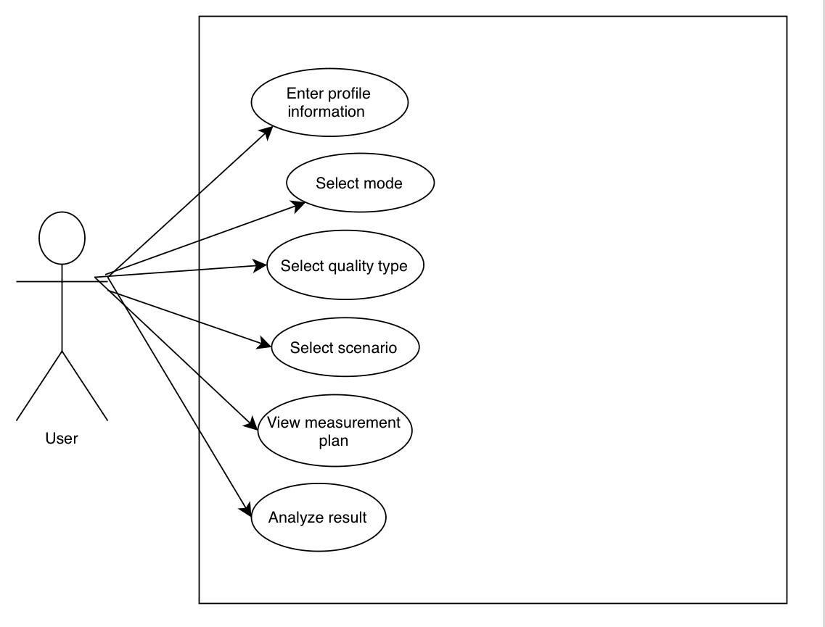
This diagram illustrates the interactions between the User and the System, specifically focusing on the goal-driven actions such as defining quality parameters and viewing analysis results.

Activity Diagram
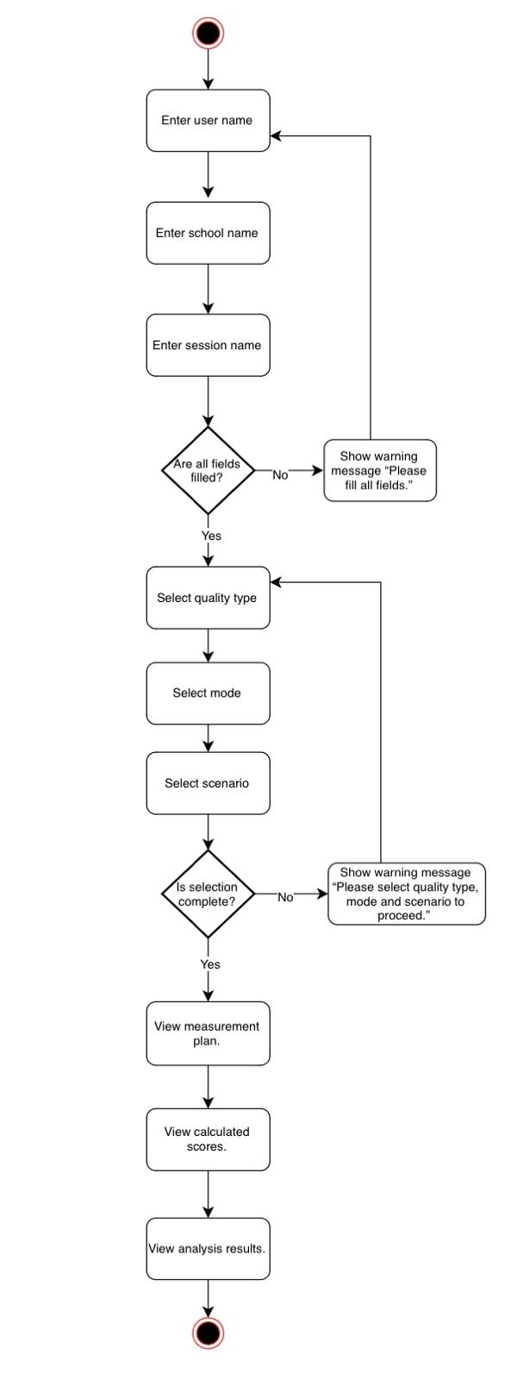
This model represents the dynamic flow of the application, showing the sequence of steps from Step 1 (Profile) to Step 5 (Analysis) including decision points for data validation.

Class Diagram
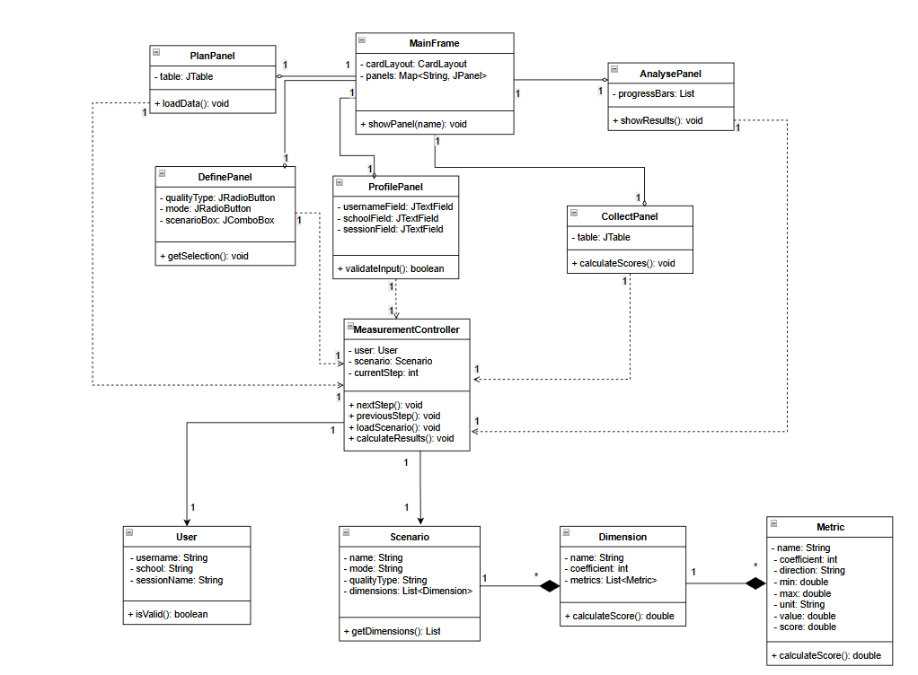
This diagram defines the static structure of the system, showcasing the MVC relationship, class attributes, and the composition of Scenarios, Dimensions, and Metrics.

