Rumor Propagation Modeling Using Cell-DEVS
Bahareh Pourahmad
1. Introduction and Motivation
The spread of information and rumors is a common phenomenon in social systems, communication networks, and distributed environments. Individuals interact locally with their neighbors, but these simple local interactions can produce complex global behavior. Studying rumor propagation helps us understand how information moves through a population and how initial conditions affect the speed and pattern of spread.
In this project, rumor propagation is modeled using the Cell-DEVS formalism and implemented in the Cadmium simulation framework. Cell-DEVS is appropriate for this type of problem because it represents the system as a grid of interacting cells, where each cell changes state according to local rules and neighbor influence.
The objective of this work is to simulate rumor propagation in a two-dimensional population grid and analyze the effect of different initial conditions on the propagation process.This model is inspired by classical rumor propagation models in the literature, particularly those based on epidemic-like spreading processes where individuals transition from unaware to active spreaders and eventually become inactive. Similar approaches have been studied in network-based rumor models such as Zanette (2002), where local interactions between individuals lead to global diffusion patterns. The model used in this work is a simplified version adapted to a spatial grid using the Cell-DEVS formalism.
2. Conceptual Model Description
The system is represented as a two-dimensional cellular grid. Each cell corresponds to one individual in the population. Individuals interact only with nearby neighbors.
The neighborhood used in this model is the Moore neighborhood, which includes the eight surrounding cells. This means that each individual can be influenced by any adjacent neighbor.
Each cell can be in one of three states:
State | Meaning
0 | Unaware of the rumor
1 | Spreading the rumor
2 | Inactive, no longer spreading

At the beginning of the simulation, only a small number of individuals are initialized as rumor spreaders, while the remaining cells are unaware. During the simulation, rumor spreaders influence nearby unaware individuals, causing the rumor to propagate through the grid.
This conceptual model captures a simplified but meaningful information diffusion process: individuals first receive the rumor, then spread it for some time, and finally become inactive.
3. Formal Cell-DEVS Specification
The rumor propagation model is implemented as a Cell-DEVS system in which each cell evolves according to local transition rules and timing behavior.
Each cell has:
- a state from the set {0, 1, 2},
- a neighborhood defined by surrounding cells,
- a transition function based on the current state and neighbor states,
- an output delay that defines when state updates occur.
The behavior of each cell is defined through the Cell-DEVS functions localComputation and outputDelay.
Cell = <X, Y, S, N, δ, D>
The transition rules are as follows:
The transition rules can be expressed formally as:

δ(s, N) =
{
1, if s = 0 and ∃ neighbor ∈ N such that neighbor = 1
2, if s = 1
2, if s = 2
}
These rules model a simple rumor-spreading mechanism in which information spreads locally and eventually stops when individuals become inactive.
The Cell-DEVS model can be formally defined as:

where:
X = ∅ (no external input),
Y = {0, 1, 2} (output states),
S = {0, 1, 2} (cell states),
N = Moore neighborhood (8 adjacent cells),
δ = local transition rule,
D = fixed delay time.

The local transition function δ is defined as:

If s = 0 and at least one neighbor is in state 1 → s = 1
If s = 1 → s = 2
If s = 2 → s = 2
The delay function D is constant for all state transitions.
The model follows the Cell-DEVS formalism, which is an extension of the DEVS framework for spatially distributed systems. The use of a fixed delay ensures synchronous updates across all cells, allowing consistent propagation behavior over the grid.
4. Implementation
The model was implemented in C++ using the Cadmium Cell-DEVS framework.
The project includes the following main components:
Folder/File | Purpose
src/ | C++ implementation files
model/ | Model configuration and rule files
viewer/ | Simulation output logs
scripts/ | Data processing and visualization scripts
viewer/ | Local visualization files
The main model files are:
- src/rumorCell.hpp, which defines the atomic Cell-DEVS behavior,
- src/rumor_coupled.hpp, which defines the coupled grid model,
- src/main.cpp, which builds and runs the simulation.
The model configuration is defined using JSON files stored in the model/ folder. These files specify the grid size, initial conditions, and neighborhood structure.
The behavior of each cell is implemented using the localComputation function, which updates the cell state according to the transition rules and neighbor states. The outputDelay function controls the timing of state changes.
The simulation generates output files such as:
- viewer/state.txt
- viewer/output_messages.txt
These files are used later for analysis and visualization.
The simulation is executed in discrete time steps, where all cells update their states simultaneously according to the defined rules. The grid size and initial conditions are specified in the configuration JSON file.
Each cell evaluates its neighbors using the Moore neighborhood and applies the localComputation function to determine the next state. The model uses a synchronous update mechanism to ensure consistent state transitions across the grid.
5. Experimental Setup
To study the behavior of the rumor propagation system, several simulation scenarios were considered.
Experiment 1: Single Rumor Source
In the first experiment, the rumor starts from a single source cell. This scenario shows how the rumor spreads outward from one origin point through local interactions.
Experiment 2: Multiple Rumor Sources
In the second experiment, the rumor starts from multiple cells located in different parts of the grid. This allows observation of how parallel propagation regions accelerate the spread.
Experiment 3: Larger Grid
In the third experiment, the grid size is increased to represent a larger population. This experiment shows how system size influences propagation time and coverage.
These experiments make it possible to compare the propagation dynamics under different initial conditions and population sizes.
6. Experimental Frame
The experimental frame defines the conditions under which the model is observed and analyzed. In this work, the experimental frame consists of:
- Input conditions: initial distribution of rumor spreaders in the grid
- System parameters: grid size (e.g., 20×20, 40×40), neighborhood type (Moore), and fixed delay
- Observed variables: number of spreading cells over time, propagation speed, and final coverage
- Simulation duration: sufficient number of steps to reach steady state
The experiments are designed to evaluate how different initial conditions (single vs multiple sources) and system size affect the behavior of rumor propagation.
7. Simulation Results and Analysis
The simulation results were recorded in the generated log files and visualized using a local viewer and animation tools.
As shown in Figure 1, rumor propagation follows a wave-like pattern expanding outward from the initial source. As shown in Figure 2, multiple sources create several propagation fronts that accelerate the spread. Figure 3 illustrates the final stage where most cells become inactive after receiving the rumor.
In the single-source scenario, the rumor spreads outward in a wave-like pattern from the initial source. The active spreading region expands gradually and then becomes inactive behind the propagation front.
In the multiple-source scenario, the rumor spreads significantly faster because several active regions appear simultaneously. This reduces the time required to cover the grid.
In the larger-grid scenario, the overall behavior remains similar, but the propagation requires more simulation steps to reach distant cells because the population is larger.
Table 1 summarizes the observed behavior across different experiments.
Experiment | Initial Sources | Grid Size | Propagation Time (steps)
Single source | 1 | 20×20 | ~40
Multiple sources | 4 | 20×20 | ~20
Larger grid | 1 | 40×40 | ~80

The results show that increasing the number of initial sources significantly reduces propagation time, while increasing grid size increases the number of steps required for full coverage.
These results confirm that local interactions between neighboring individuals generate global propagation behavior across the grid.
In addition to varying initial conditions and grid size, the experimental setup can be interpreted as variations of the original model specification. Although the transition rules remain unchanged, modifying the number of initial spreaders and the spatial configuration effectively changes the system dynamics. These variations demonstrate how the same formal model can produce different global behaviors depending on the experimental frame.
8. Visualization Results
The model outputs were visualized using a local web-based viewer and generated images from the simulation output.
Three representative stages of the simulation were used to illustrate the propagation process.

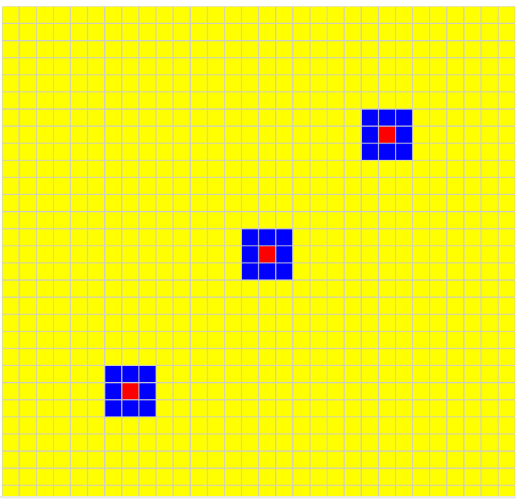
Figure 1: Early stage of rumor propagation. Yellow cells represent unaware individuals, blue cells represent spreaders, and red cells represent inactive individuals. In the early stage, most cells are still unaware of the rumor. A small active front of rumor spreaders appears around the initial rumor sources, and some cells have already become inactive after spreading the rumor.
Caption: Early stage of rumor propagation. Yellow cells represent unaware individuals, blue cells represent active spreaders, and red cells represent inactive individuals.

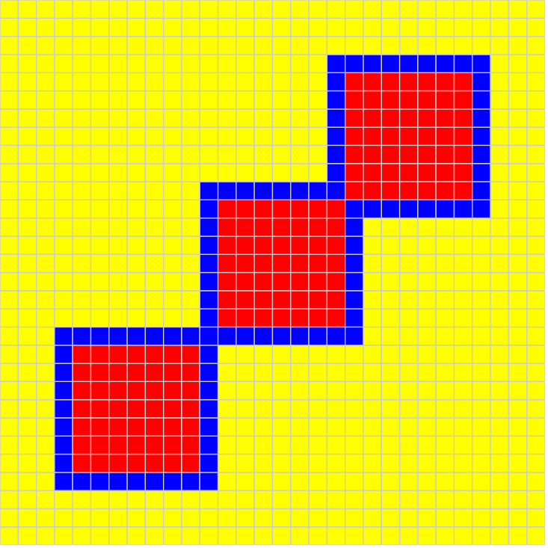

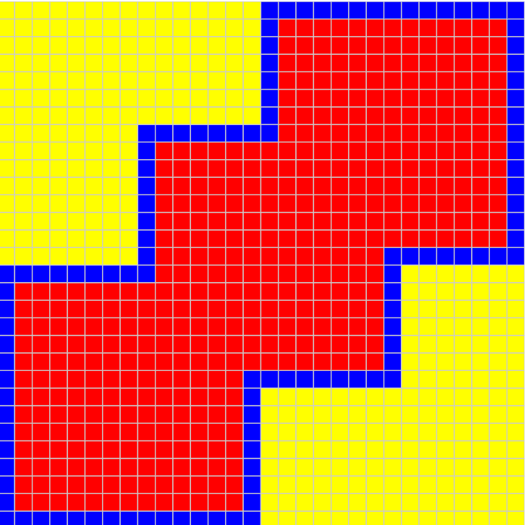
Figure 2. Intermediate Stage of Propagation
In the intermediate stage, the rumor has spread farther across the grid. Multiple propagation regions can be seen, showing how the rumor continues to expand through local interactions.
Caption: Intermediate stage of rumor propagation. The rumor expands from several active fronts, increasing the overall speed of spread.
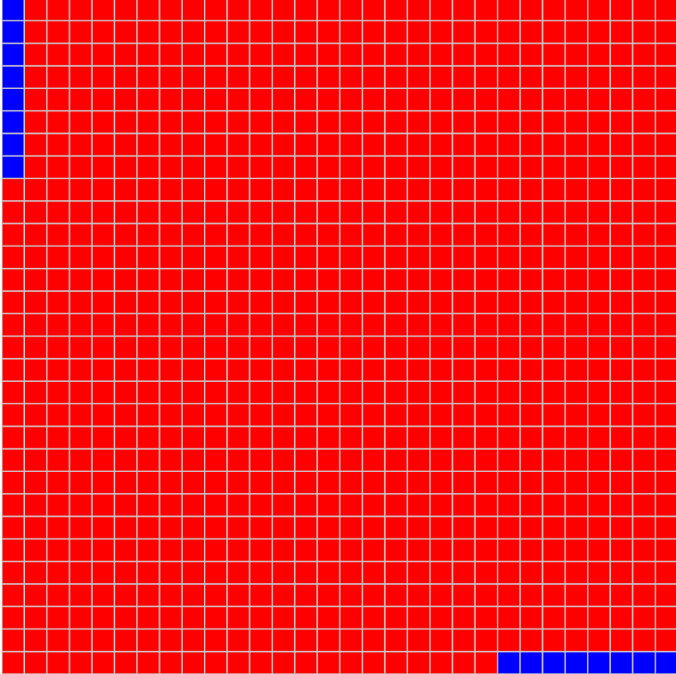

Figure 3. Final Stage of Propagation
In the final stage, most individuals have already received the rumor and become inactive. Only a small number of active spreaders remain, or the spread has nearly completed.
Caption: Final stage of rumor propagation. Most cells have become inactive after receiving and spreading the rumor, indicating near-complete coverage of the grid.
The visualization clearly shows the time evolution of the rumor-spreading process. The state colors make it easy to identify active propagation fronts and final coverage patterns.
The local visualization can be opened by running a local web server in the viewer directory:

cd viewer
python3 -m http.server 8000
Then open the following URL in a web browser:
http://localhost:8000
9. Scripts and Data Processing
Several Python scripts were used to process simulation outputs and generate visual results.
These scripts perform tasks such as:
- converting simulation logs into structured CSV files,
- generating viewer-compatible data files,
- creating animation outputs from the simulation results.
This processing pipeline makes it easier to analyze the simulation behavior and present the results visually.
Each script is designed to support a specific stage of the simulation workflow. For example, execution scripts are used to run the simulation with different configurations, while data processing scripts convert raw log files into structured formats for analysis. Visualization scripts generate figures and animations that illustrate the evolution of the system over time. These scripts allow reproducibility of the experiments and facilitate result interpretation.
10. Discussion
The model demonstrates how simple local rules can produce realistic large-scale behavior. Even though each individual cell only reacts to nearby neighbors, the rumor spreads across the entire population in an organized propagation pattern.
The experiments also show that initial conditions strongly influence the system behavior. Increasing the number of initial rumor sources leads to faster spread, while increasing the grid size increases the time required for full propagation.
This confirms that Cell-DEVS is a suitable formalism for modeling distributed dynamic systems with local interactions.
11. Conclusion
This project presented a Cell-DEVS model of rumor propagation implemented in Cadmium.
The model successfully represents a population as a two-dimensional grid of interacting individuals and simulates rumor spreading through local neighborhood influence. The results show that the number of initial rumor sources and the grid size both affect the speed and pattern of propagation.
The simulation outputs and visualizations confirm that the model behaves according to the defined transition rules. Overall, this work demonstrates that Cell-DEVS provides an effective and flexible approach for studying rumor propagation and other information diffusion processes.

12. Files Included in the Submission
The submission includes:
- source code for the atomic and coupled models,
- model configuration files,
- scripts for execution and visualization,
- log files showing execution results,
- local visualization files,
- generated figures and animation results,
- the final report.
- video files showing simulation results and system evolution,

References:
Zanette, D.H. (2002). Dynamics of rumor propagation on small-world networks. Physical Review E, 65(4), 041908.
Daley, D.J., and Kendall, D.G. (1965). Stochastic rumours. Journal of the Institute of Mathematics and Its Applications, 1(1), 42–55.

