Data Semantics
Assignemnt 1 :
1. When is her birthday?
PREFIX dbr: <http://dbpedia.org/resource/>
PREFIX dbo: <http://dbpedia.org/ontology/>

SELECT ?birthDate
WHERE {
dbr:Jennifer_Aniston dbo:birthDate ?birthDate .
}
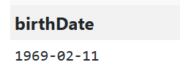
2. Where was she born ?
PREFIX dbr: <http://dbpedia.org/resource/>
PREFIX dbo: <http://dbpedia.org/ontology/>
PREFIX rdfs: <http://www.w3.org/2000/01/rdf-schema#>

SELECT ?personName ?birthPlaceName
WHERE {
dbr:Jennifer_Aniston rdfs:label ?personName .
dbr:Jennifer_Aniston dbo:birthPlace ?birthPlace .
?birthPlace rdfs:label ?birthPlaceName .

FILTER(LANG(?personName) = "en")
FILTER(LANG(?birthPlaceName) = "en")
}
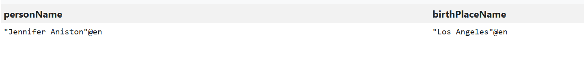
3. Who is recorded as Jennifer Aniston's spouse in DBpedia?
PREFIX dbr: <http://dbpedia.org/resource/>
PREFIX dbo: <http://dbpedia.org/ontology/>
PREFIX rdfs: <http://www.w3.org/2000/01/rdf-schema#>

SELECT DISTINCT ?personName
WHERE {
{
dbr:Jennifer_Aniston dbo:spouse ?person .
}
UNION
{
dbr:Jennifer_Aniston dbo:partner ?person .
}

?person rdfs:label ?personName .
FILTER(LANG(?personName) = "en")
}
Answer :

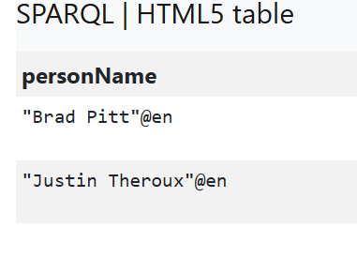
4. How many films did she star in?
PREFIX dbr: <http://dbpedia.org/resource/>
PREFIX dbo: <http://dbpedia.org/ontology/>

SELECT (COUNT(DISTINCT ?film) AS ?numberOfFilms)
WHERE {
?film dbo:starring dbr:Jennifer_Aniston .
?film a dbo:Film .
}
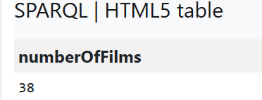
5. How old were Jennifer Aniston's partners?
PREFIX dbr: <http://dbpedia.org/resource/>
PREFIX dbo: <http://dbpedia.org/ontology/>
PREFIX rdfs: <http://www.w3.org/2000/01/rdf-schema#>

SELECT DISTINCT ?personName ?birthDate
(YEAR(NOW()) - YEAR(?birthDate) AS ?age)
WHERE {
{
dbr:Jennifer_Aniston dbo:spouse ?person .
}
UNION
{
dbr:Jennifer_Aniston dbo:partner ?person .
}

?person dbo:birthDate ?birthDate .
?person rdfs:label ?personName .

FILTER(LANG(?personName) = "en")
}
ORDER BY ?personName
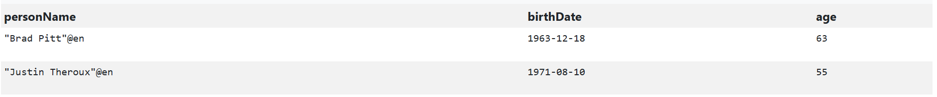
6. Which television series starring Jennifer Aniston has the highest number of episodes?
PREFIX dbr: <http://dbpedia.org/resource/>
PREFIX dbo: <http://dbpedia.org/ontology/>
PREFIX rdfs: <http://www.w3.org/2000/01/rdf-schema#>

SELECT DISTINCT ?seriesName ?numberOfEpisodes
WHERE {
?series dbo:starring dbr:Jennifer_Aniston .
?series dbo:numberOfEpisodes ?numberOfEpisodes .
?series rdfs:label ?seriesName .

FILTER(LANG(?seriesName) = "en")
}
ORDER BY DESC(?numberOfEpisodes)
LIMIT 1

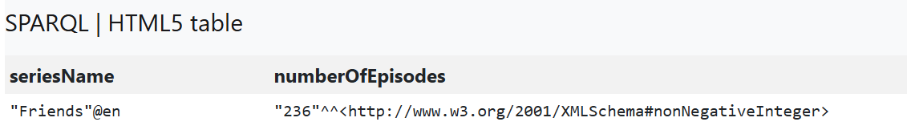
7. What is the genre of the Friends series?
PREFIX dbr: <http://dbpedia.org/resource/>
PREFIX dbo: <http://dbpedia.org/ontology/>
PREFIX rdfs: <http://www.w3.org/2000/01/rdf-schema#>

SELECT DISTINCT ?genreName
WHERE {
dbr:Friends dbo:genre ?genre .
?genre rdfs:label ?genreName .

FILTER(LANG(?genreName) = "en")
}
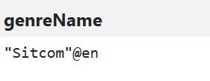
8. Who are the main actors starred in Friends series?
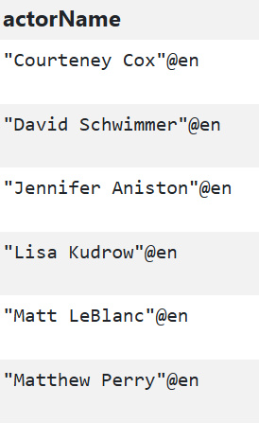
PREFIX dbr: <http://dbpedia.org/resource/>
PREFIX dbo: <http://dbpedia.org/ontology/>
PREFIX rdfs: <http://www.w3.org/2000/01/rdf-schema#>

SELECT DISTINCT ?actorName
WHERE {
dbr:Friends dbo:starring ?actor .
?actor rdfs:label ?actorName .

FILTER(LANG(?actorName) = "en")
}
ORDER BY ?actorName

9. How many seasons does the Friends series have??
PREFIX dbr: <http://dbpedia.org/resource/>
PREFIX dbo: <http://dbpedia.org/ontology/>

SELECT ?numberOfSeasons
WHERE {
dbr:Friends dbo:numberOfSeasons ?numberOfSeasons .
}
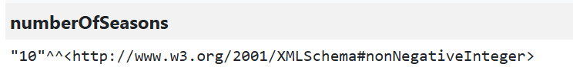
9. whan was frineds series first released ?
PREFIX dbr: <http://dbpedia.org/resource/>
PREFIX dbo: <http://dbpedia.org/ontology/>

SELECT ?releaseDate
WHERE {
dbr:Friends dbo:releaseDate ?releaseDate .
}
