Ontology modifying :

Ontology Extension

Creation of New Classes
The ontology was extended by creating two additional classes:
- Person
- Student
The Student class was modeled as a subclass of Person.
Additionally, a new organizational subclass named University was created under the Organization class.
The resulting hierarchy became:
Thing
├── GeoEntity
├── Organization
│ ├── Company
│ ├── Non-profit Organization
│ └── University
└── Person
└── Student

Creation of Individuals
Several individuals were added to populate the ontology and support semantic querying and reasoning.

Student Individuals
- Bahareh
- Sophia

University Individuals
- Milano_University
- Bicocca_University

City Individuals
- Milan
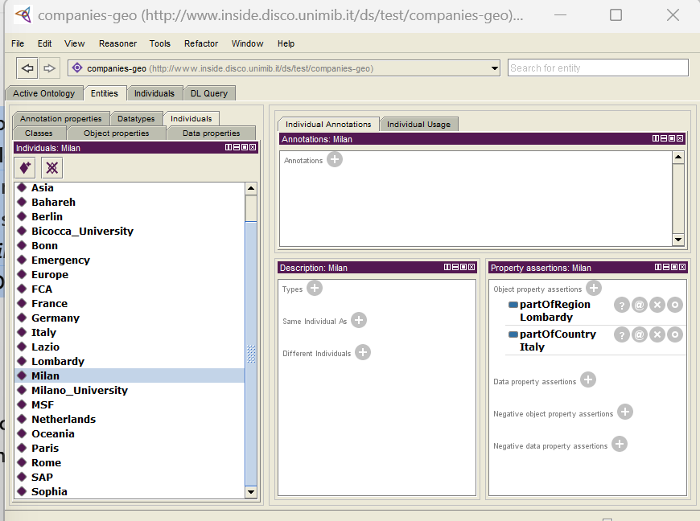
- Rome

Object Properties
Several semantic object properties were created to model relationships between ontology entities.

friendOf
Represents friendship relations between people.
- Domain: Person
- Range: Person
- Characteristic: Symmetric
The symmetric characteristic allows the reasoner to infer reciprocal friendship relations automatically.
Example triple:
Bahareh friendOf Sophia

hasBirthplace
Represents the birthplace of a person.
- Domain: Person
- Range: City
Example triples:
Bahareh hasBirthplace Milan
Sophia hasBirthplace Rome

attendsUniversity
Represents the university attended by a student.
- Domain: Student
- Range: University
Example triples:
Bahareh attendsUniversity Milano_University
Sophia attendsUniversity Bicocca_University
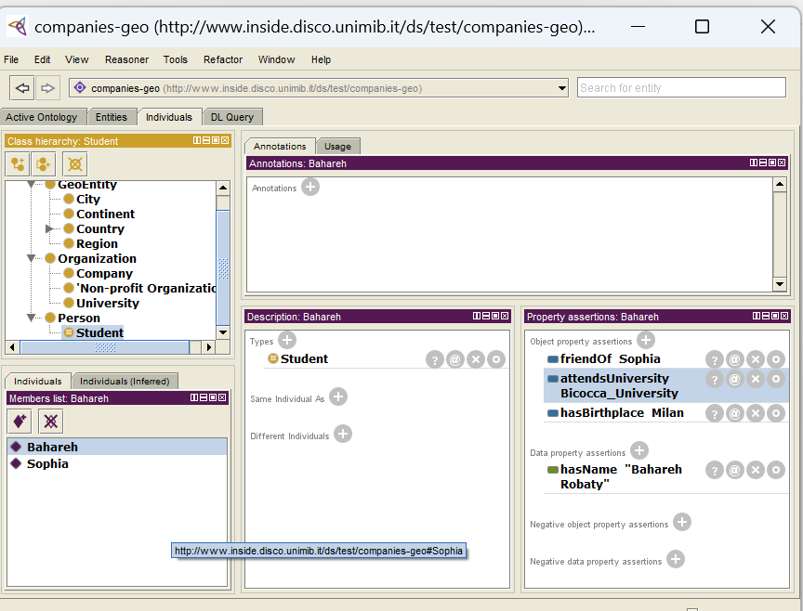

Data Properties
Two data properties were additionally defined.

hasName
Stores textual names for people.
- Domain: Person
- Range: xsd:string
Example triples:
Bahareh hasName "Bahareh Robaty"
Sophia hasName "Sophia Jackson"

hasAddress
Stores textual addresses for universities.
- Domain: University
- Range: xsd:string
Example triples:
Milano_University hasAddress "Milan, Italy"
Bicocca_University hasAddress "Milan, Italy"


RDF Triple Modeling
The ontology relationships were modeled using RDF-style triples in the form:
Subject — Predicate — Object
Examples include:
Bahareh attendsUniversity Milano_University
Sophia hasBirthplace Rome
Bahareh friendOf Sophia
These triples collectively formed the semantic knowledge graph of the ontology.

Semantic Validation and Ontology Reasoning
The HermiT reasoner was used to validate ontology consistency and infer implicit semantic knowledge.
Initially, an inconsistency was detected when the object America was assigned as the birthplace of a person while the hasBirthplace property required the range to be a City. Since America was classified as a Continent, the ontology became inconsistent.
The object property:
hasBirthplace
was defined with:
- Domain: Person
- Range: City
An inconsistency occurred when the following assertion was added:
Sophia hasBirthplace America
However, within the ontology:
America rdf:type Continent
while the property hasBirthplace required the object to belong to the City class.
Additionally, the ontology defined the following disjoint class restriction:
City disjointWith Continent
As a result, the reasoner detected a logical contradiction and marked the ontology as inconsistent.
This example demonstrated how range restrictions and disjoint class constraints are used for semantic validation.

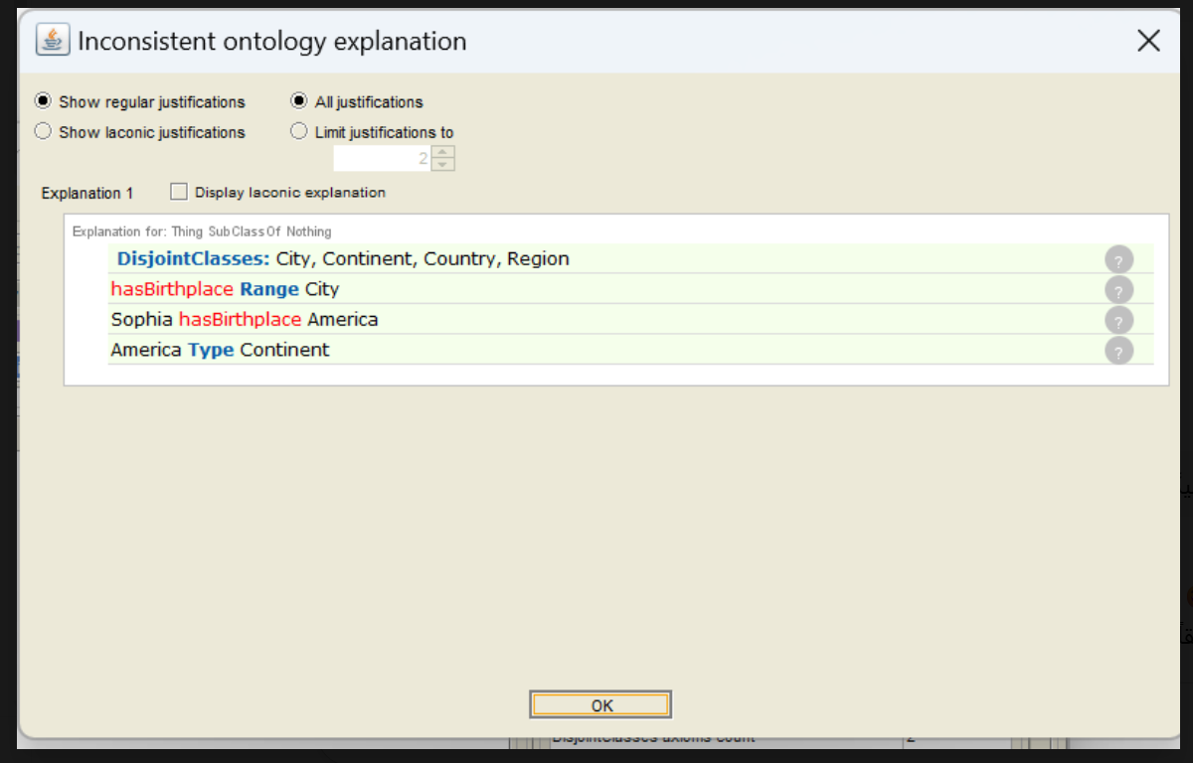
Another inconsistency occurred when the individual Sophia was simultaneously classified as both a Student and a University. This violated semantic modeling constraints because those classes represent fundamentally different entity types.
The inconsistency was resolved by removing the incorrect University type assertion from Sophia.

Inference Discussion
because the friendOf property was configured as symmetric, the reasoner automatically inferred reciprocal friendship relations.
For example:
Bahareh friendOf Sophia
allowed the reasoner to infer:
Sophia friendOf Bahareh
These results demonstrate the power of semantic reasoning in ontology-based systems.

Querying and Validation
The ontology was queried using DL Query in Protégé to validate semantic relationships and inferred knowledge.
Several example queries were executed.
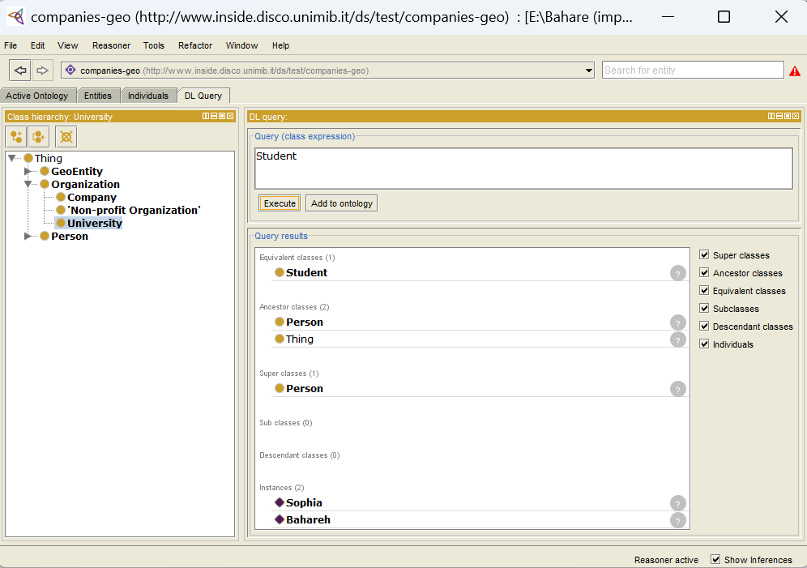

Query 1
Student
Result:
- Bahareh
- Sophia

Query 2
Person
Result:
- Bahareh
- Sophia
This query demonstrated subclass inference.
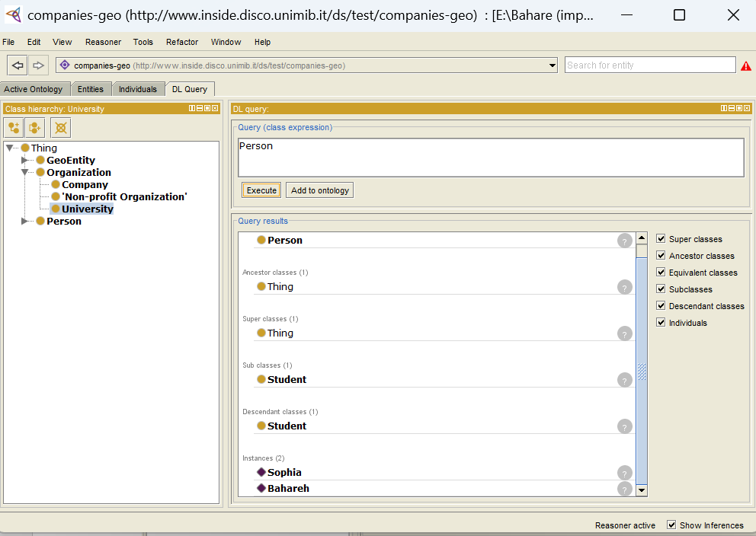

Query 3
Student and attendsUniversity value Milano_University
Result:
The student who attends the Milano University.
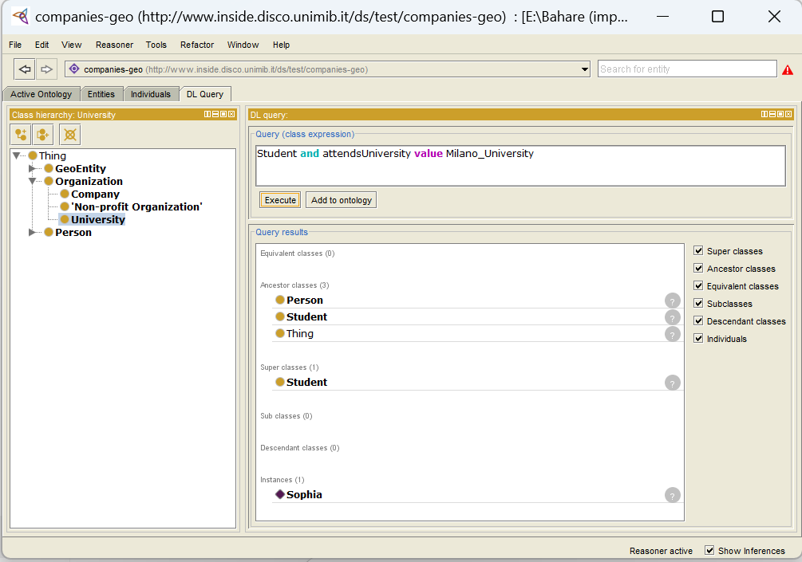

Some improvements :

Additional Ontology Improvements and Semantic Enhancements
To further improve the ontology and increase its semantic expressiveness, several advanced ontology modeling features were implemented. These enhancements strengthened the reasoning capabilities of the ontology and improved semantic validation.

1. Inverse Property Definition
An inverse property relationship was introduced between the object properties:
attendsUniversity
and
hasStudent
The hasStudent property was created with:
- Domain: University
- Range: Student
The property was then configured as the inverse of attendsUniversity.
This semantic definition enabled the ontology reasoner to automatically infer reverse relationships. For example, after explicitly inserting:
Bahareh attendsUniversity Milano_University
the reasoner automatically inferred:
Milano_University hasStudent Bahareh
without manually adding the relation.
This improvement demonstrated successful inverse-property reasoning and automatic semantic inference.

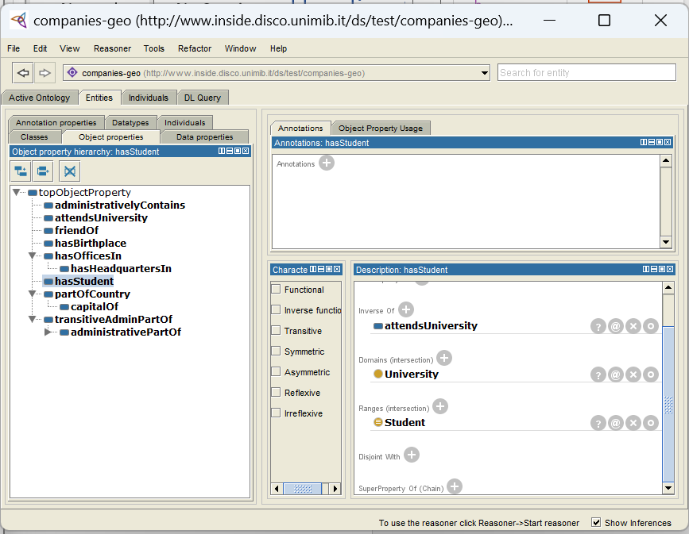

2. Functional Property Restriction
The object property:
hasBirthplace
was configured as a Functional Property.
This semantic restriction ensures that each person can have only one birthplace. The ontology reasoner uses this constraint to detect inconsistent or contradictory assertions.
For example, assigning multiple birthplaces to the same individual would create a logical inconsistency within the ontology.
This enhancement improved semantic validation and ontology consistency checking.
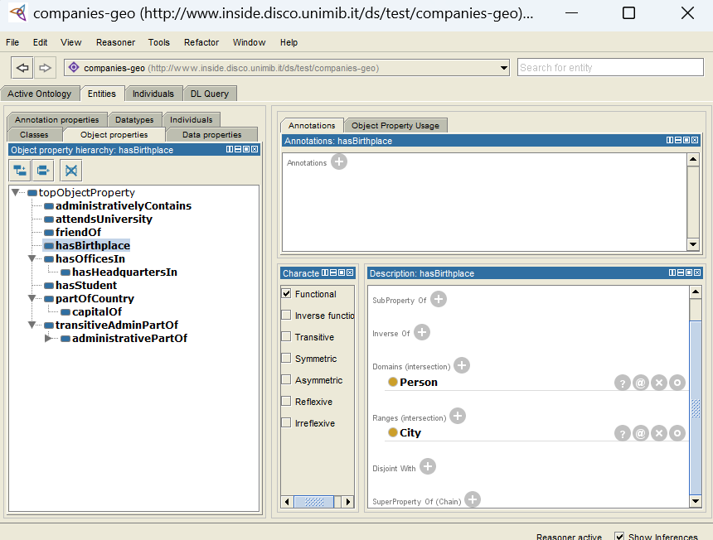

3. Disjoint Class Constraints
Disjoint class restrictions were added between:
Student
and
University
This semantic constraint ensures that no individual can simultaneously belong to both classes.
For example, if an address is assigned to Bahareh using the hasAddress property, the ontology should not interpret Bahareh as both a Student and a University. Since the domain of hasAddress is University, the disjoint constraint allows the reasoner to detect this contradiction and report an ontology inconsistency instead of accepting an incorrect classification.
Because Student and University were defined as disjoint classes, the reasoner successfully detected the contradiction and reported an ontology inconsistency.
This demonstrated the effectiveness of semantic constraints and logical validation in ontology engineering.


